PSP0 Project Plan Summary
Student | 201831990542-周智豪 | Date | 2020.10.05
Program | Calculate the Mean and Standard deviation | Program # | 1
Instructor | 李旻朔 | Language | Python

Time in Phase (min.) | Plan |  | Actual |  | To Date |  | To Date %
Planning | 10 |  | 5 |  | 5 |  | 5.8%
Design | 10 |  | 15 |  | 20 |  | 23.2%
Code | 25 |  | 35 |  | 55 |  | 63.9%
Compile | 1 |  | 1 |  | 56 |  | 65.1%
Test | 10 |  | 15 |  | 71 |  | 82.6%
Postmortem | 10 |  | 15 |  | 86 |  | 100%
Total | 76 |  | 86 |  | 86 |  | 100%
Defects Injected |  |  | Actual |  | To Date |  | To Date %
Planning |  |  | 5 |  | 5 |  | 12.2%
Design |  |  | 5 |  | 10 |  | 24.4%
Code |  |  | 15 |  | 25 |  | 61.0%
Compile |  |  | 1 |  | 26 |  | 63.4%
Test |  |  | 15 |  | 41 |  | 100%
Total Development |  |  | 41 |  | 41 |  | 100%
Defects Removed |  |  | Actual |  | To Date |  | To Date %
Planning |  |  | 5 |  | 5 |  | 12.2%
Design |  |  | 5 |  | 10 |  | 24.4%
Code |  |  | 15 |  | 25 |  | 61.0%
Compile |  |  | 1 |  | 26 |  | 63.4%
Test |  |  | 15 |  | 41 |  | 100%
Total Development |  |  | 41 |  | 41 |  | 100%
After Development |  |  | 5 |  | 10

PSP Time Recording Log
Student | 201831990542-周智豪 | Date | 2020.10.05
Program | Calculate the Mean and Standard deviation | Program # | 1
Instructor | 李旻朔 | Language | Python

Project | Phase | Start Date and Time | Int. Time | Stop Date and Time | Delta  Time | Comments
1 | Planning | 10.05 09:00 | / | 10.05 09:15 | 15
1 | Design | 10.05 09:20 | / | 10.05 09:45 | 25
1 | Code | 10.05 10.05 | / | 10.05 10:40 | 35 | Learn the data structure in python
1 | Compile | 10.05 10:45 | / | 10.05 10:46 | 1
1 | Test | 10.05 10:50 | / | 10.05 10:55 | 15 | Test 2 sets of the data
1 | Postmortem | 10.05 11:00 | / | 10.05 11:15 | 15 | Reformat and check

PSP Defect Recording Log
Defect Types
10 Documentation | 60 Checking
20 Syntax | 70 Data
30 Build, Package | 80 Function
40 Assignment | 90 System
50 Interface | 100 Environment
Student | 201831990542-周智豪 | Date | 2020.10.05
Program | Calculate the Mean and Standard deviation | Program # | 1
Instructor | 李旻朔 | Language | Python

 | Project |  |  | Date |  | Number |  | Type |  | Inject |  | Remove |  | Fix Time |  | Fix Ref.
 | 1 |  |  | 2020.10.05 |  | 1 |  | 20 |  | Code |  | Code |  | 4 |  | X
Description: |  |  | Some syntax errors linked list data structure in the python, such as head, next, etc.
 | Project |  |  | Date |  | Number |  | Type |  | Inject |  | Remove |  | Fix Time |  | Fix Ref.
 | 1 |  |  | 2020.10.05 |  | 2 |  | 60 |  | Code |  | Code |  | 4 |  | X
Description: |  |  | When I checked the structure of the linked list and checked the error message, I found that
the linked lists of some methods were not connected, so I needed to check the linked list methods
 | Project |  |  | Date |  | Number |  | Type |  | Inject |  | Remove |  | Fix Time |  | Fix Ref.
 | 1 |  |  | 2020.10.05 |  | 3 |  | 100 |  | Test |  | Test |  | 10 |  | X
Description: |  |  | When I am testing, I will use spaces to separate the input data, which causes my program
to read the spaces as the input data, resulting in the linked list data not only wanted, but also redundant
Space separator, etc.
 | Project |  |  | Date |  | Number |  | Type |  | Inject |  | Remove |  | Fix Time |  | Fix Ref.
 | 1 |  |  | 2020.10.05 |  | 4 |  | 80 |  | Code |  | Code |  | 3 |  | X
Description: |  |  | When I was calculating the standard deviation, there was a little error in my logic formula,
which caused the calculated result to deviate from the expected

Program Source Code
# !/usr/bin/python3
# -*- coding: utf-8 -*-
"""
@Author : Zed
@Version : V1.0.0
------------------------------------
@File : program1.py
@Description :
@CreateTime : 2020-10-5 10:16
------------------------------------
@ModifyTime :
"""
import math

class item (object):
def __init__(self, data):
self.data = data
self.next = None

class SLinkList(object):

def __init__(self, size = 100):
self.link = [item(None) for i in range(size + 1)] # 申请size大小的节点空间[0,1,2,...,size]，其中下标0的节点作为头结点
self.link[0].next = None # 表示空表
self.link[0].space = 1 # 指向第一个节点，因为初始化时第一个节点为空闲节点

i = 1
while i < size:
self.link[i].next = i+1 # 利用空闲节点连成一个新的表，并且头结点的space始终指向下一个空闲的节点
i += 1

self.link[i].next = None # 空闲表尾指向None

self.length = 0 # 链表长度
self.rear = 0 # 表尾指针

def createSLinkList_R(self, data):
if self.length > 0: # 非空表无需创建
print("THIS SLINKLIST IS NOT NULL")
return

for each in data:
if not self.append(each):
print("CreateR: NO SPACE!")
return

def locateElement(self, data):
i = self.link[0].next
while i and self.link[i] != data:
i = self.link[i].next
return i

def malloc_SL(self):
i = self.link[0].space
if self.link[0].space:
self.link[0].space = self.link[i].next

return i

def free_SL(self, k):
self.link[k].data = None
self.link[k].next = self.link[0].space
self.link[0].space = k

def append(self, data):
node_index = self.malloc_SL()

if not node_index:
print("Append: NO SPACE!")
return False

self.link[node_index].data = data
self.link[node_index].next = None
self.link[self.rear].next = node_index
self.rear = node_index
self.length += 1
return node_index

def traversal(self):
print("DATA:\t", end = '')
index = self.link[0].next
while index:
if self.link[index].next is not None:
print(self.link[index].data, end = ' , ')
else:
print(self.link[index].data)
index = self.link[index].next

def detail(self):
print("\nDETAIL:")
index = self.link[0].next
count = 1
while index:
print("SN:\t%d\tDATA:\t%s\tADDR:\t%d\tNEXT:\t%s" % \
(count, self.link[index].data, index, str(self.link[index].next)))
index = self.link[index].next
count += 1

print("Length:\t%d\nRear:\t%d\n" % (self.length, self.rear))

def mean(self):
length = self.length
sum = 0
index = self.link[0].next
while index:
sum += self.link[index].data
index = self.link[index].next
return sum/length

def standardDeviation(self):
avg = self.mean()
length = self.length
index = self.link[0].next
sumMiddle = 0
while index:
sumMiddle += (self.link[index].data - avg) ** 2
index = self.link[index].next
return math.sqrt(sumMiddle / (length -1))

if __name__ == '__main__':
SL = SLinkList()
inputList = input("INPUT DATA(split with ,) :\t").split(",")
data_str = [float(inputList[i]) for i in range(len(inputList))]
SL.createSLinkList_R(data_str)
SL.traversal()
while True:
opt = input("\nInput a number： 1. Calculate Mean 2. Calculate Standard Deviation 3. View the linked list structure 4. Exit\nOPTION:\t")
if opt == '1':
print("Mean: %.2f" % SL.mean())

elif opt == '2':
print("Standard Deviation %.2f" %SL.standardDeviation())
elif opt == '3':
SL.detail()
elif opt == '4':
break
else:
print("Re-Input a number !")
TEST Result1
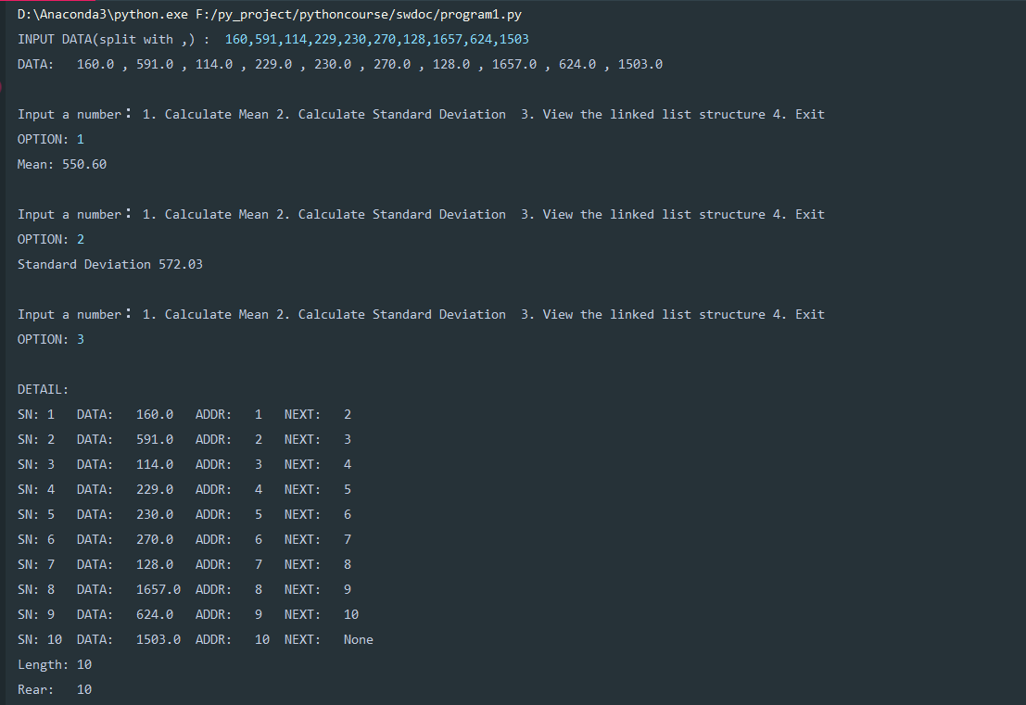

TEST Result 2
