Marcus Her, Cory Nelson, Nou Chai Thao
Professor Duerre
CSS 355
4/28/2026

Final Bank EBNF Project
For our final project, we built a full banking application, including designing our own EBNF grammar and implementing it in Python. The language allows a user to interact with bank accounts through a menu-driven interface. The program supports depositing money, withdrawing money, checking a balance, creating a new account, and switching between accounts. The project is made up of six classes: BankAccount, Token, ASTNode, Lexer, Parser, and Interpreter, along with a main program file called banking.py and a specification testing file called spec_testing.py.
We divided the work evenly among ourselves. Each person was responsible for the classes and files listed next to their names.
Names | Responsibility
Marcus | Token.py, ASTNode.py, Lexer.py, Parser.py
Cory | BankAccount.py, banking.py
Nou Chai | Interpreter.py, spec_testing.py

When the program starts, ten accounts are loaded automatically so the user can begin testing right away. The table below lists each account number and the owner's name. These accounts are created in the create_hard_coded_accounts function inside banking.py.
Account Number | Name & Balance
CN123456 | Cory Nelson - $500.00
NT654321 | Nouchai Thao - $1200.00
MH246810 | Marcus Her – $875.00
BW135790 | Brian Wilson - $640.00
DT112233 | Dana Thomas - $1500.00
EK445566 | Emily King - $920.00
FR778899 | Frank Roberts - $300.00
GH990011 | Grace Hill - $2100.00
IJ223344 | Isaac Johnson - $760.00
KL556677 | Karen Lewis - $1340.00

The grammar for the Banking DSL was written in Extended Backus-Naur Form (EBNF). It defines every valid input the program will accept. The grammar starts with the program rule, which requires either an account number or the EXIT keyword, followed by zero or more commands. Each command is selected by entering a menu number from 1 through 6. The Lexer and Parser use this grammar to classify and structure every command the user enters.

digit ::= "0" | "1" | "2" | "3" | "4" | "5" | "6" | "7" | "8" | "9" ;

letter ::= "A" | "B" | "C" | "D" | "E" | "F" | "G" | "H" | "I" | "J" | "K" | "L" | "M" | "N"
| "O" | "P" | "Q" | "R" | "S" | "T" | "U" | "V" | "W" | "X" | "Y" | "Z" ;

integer ::= digit, {digit} ;

amount ::= integer, [ ".", digit, {digit}] ;

name ::= letter, {letter} ;

account_number ::= letter, letter, digit, digit, digit, digit, digit, digit ;

exit ::= "EXIT" ;

menu_choice ::= "1" | "2" | "3" | "4" | "5" | "6" | exit ;

deposit ::= "1", amount ;

withdrawal ::= "2", amount ;

check_balance ::= "3" ;

create_account ::= "4", name, name, account_number, amount ;

check_other_account ::= "5", account_number ;

exit_program ::= "6" | exit ;

command ::= deposit | withdrawal | check_balance | create_account | check_other_account | exit_program ;

program ::= (account_number | exit), {command} ;

The program follows a pipeline design. When the user enters a command, it travels through four stages before any action is taken on a bank account.
The Lexer receives the raw input string and splits it on whitespace. Each word is classified as a Token using regular expressions that match the EBNF rules. The result is an ordered list of Token objects passed to the Parser.
The Parser reads the token list and builds an Abstract Syntax Tree (AST) made up of ASTNode objects. Each private method in the Parser corresponds to one EBNF grammar rule. If the token stream does not match the grammar, the Parser returns an ERROR node instead of crashing.
The Interpreter walks the AST and calls the appropriate BankAccount methods. For example, a DEPOSIT node causes the Interpreter to call deposit() on the active account with the amount stored in the child AMOUNT node.
The BankAccount class stores account data privately and exposes methods for depositing, withdrawing, and checking the balance. All data is accessed through getters and setters.
The chart below shows the relationship between the files and classes in the program. banking.py sits at the top and coordinates all other components.

File Name | Role
Banking.py (main) | Runs the menu
BankAccount.py | Stores the account data such as deposit, withdraw, and balance
Lexer.py | Tokeni THROUGze the input string
Token.py | Holds one word as a type + value
Parser.py | Builds the AST from the Token
ASTNode.py | One node in the AST
Interpreter.py | Reads AST and executes the commands
Spec_testing.py | Runs the unit test on BankAccount and the DSL pipeline

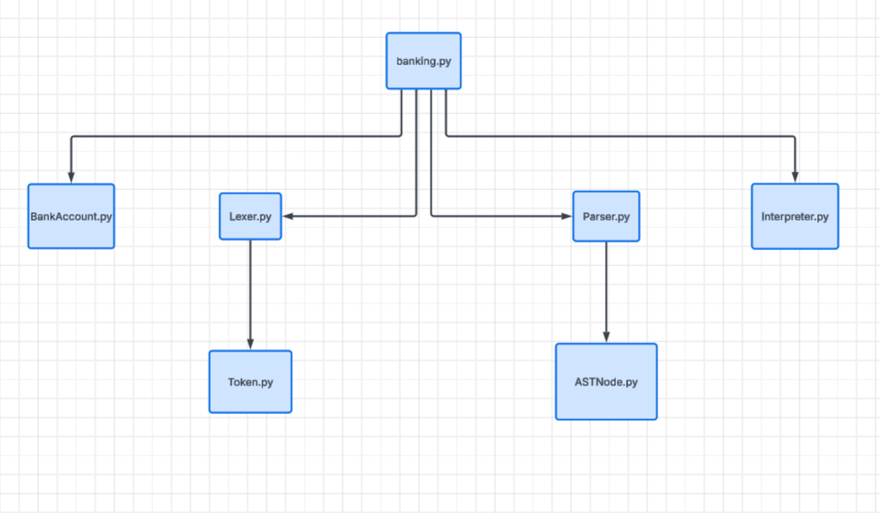

Token.py
Defines the Token class and seven token-type constants. A Token is a labeled container pairing a type string (such as MENU_CHOICE or ACCOUNT_NUMBER) with a value. All fields are private and accessed through getters.
ASTNode.py
Defines the ASTNode class used to build the Abstract Syntax Tree. Each node stores a type label, an optional value, and an optional list of child nodes. The __build_repr method recursively prints the tree with indentation for readable output.
Lexer.py
Defines the Lexer class. The tokenize method splits the input on whitespace and passes each word to __classify_word, which tests four compiled regex patterns in priority order. EXIT is checked first so it is not misclassified as a name. Account numbers are checked before plain names for the same reason. An EOF token is appended at the end of every list.
Parser.py
Defines the Parser class. Each private method maps to one EBNF grammar rule. The entry point parse() calls __parse_program(), which reads the account number or EXIT token, then loops consuming commands until EOF. Menu choice digits route to the matching command parser through __route_command(). Bad input produces an ERROR node with a descriptive message.
Interpreter.py
Defines the Interpreter class. It walks the AST returned by the Parser and calls the appropriate BankAccount methods based on node type. A DEPOSIT node triggers a deposit, a WITHDRAWAL node triggers a withdrawal, and so on.
BankAccount.py
Defines the BankAccount class with private fields for first name, last name, account number, and balance. The account number is validated with a regular expression requiring two letters matching the customer's initials followed by six digits. Deposit and withdrawal methods validate the amount before updating the balance.
Banking.py
The main program file. The main function loads ten hardcoded accounts, then runs a while loop presenting a numbered menu. User input is passed to the Lexer and Parser to produce an AST, which the Interpreter then executes against the active BankAccount.
Spec_testing.py
The specification testing file. Uses Python's unittest module to test deposit and withdrawal results, balance accuracy, and account number validation. A menu loop lets the user run all tests at once or select individual tests.
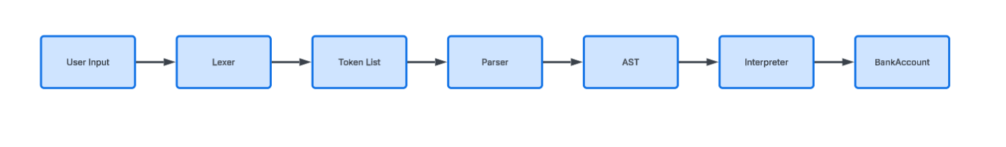

Requirements
Python 3.10 or higher must be installed.
No third-party packages are required. All imports are from the Python standard library.

Step 1 - Download the files
Unzip the project folder. Make sure all of the following files are in the same directory: banking.py, BankAccount.py, Token.py, ASTNode.py, Lexer.py, Parser.py, Interpreter.py, and spec_testing.py.

Step 2 - Open a terminal
Open a terminal or command prompt and navigate to the folder containing the project files. On Windows you can use PowerShell. On Mac or Linux use Terminal.

Step 3 - Run the banking application
Type the following command and press Enter:

python banking.py

The program will greet you and ask for an account number. Enter one of the account numbers from the Pre-Loaded Accounts table in Section 3. You will then see a menu with options 1-6. Type the number for the action you want and follow the prompts. Type EXIT at any prompt to leave the program.

Step 4 - Run the specification tests
Type the following command and press Enter:

python spec_testing.py

A menu will appear with options to run all tests, run a single test, or exit. Each test prints a detailed message showing what was tested, the expected value, the actual value, and whether the test passed or failed.

The table below summarizes every token type the Lexer can produce and gives an example of each.
Token | Description
ACCOUNT_NUMBER | Example: CN123456 – two letters followed by six digits
MENU_CHOICE | 1, 2, 3, 4, 5, or 6, - Single digit menu
AMOUNT | 500.00 or 1200 – Integer or decimal dollar value
NAME | Marcus or Her – letters only, used for first and last names
EXIT | EXIT – prompted by the users will exit the program
EOF | End of stream – Lexer marking the end of the input
INVALID | Anything that doesn’t match anything above

Works Cited
Bredikhin, CodePulse. "Writing a Programming Language — The Lexer." YouTube, 11 May 2022, https://www.youtube.com/watch?v=Eythq9848Fg.

Callahan, Jack. "How to Write a Programming Language." YouTube, 3 Mar. 2021, https://www.youtube.com/watch?v=HuVg1trQC64.

Krajnak, M. "EBNF Test." https://mdkrajnak.github.io/ebnftest/. Accessed [Date].

