CPE 4020 – Device Networks, Fall 2023

**Business Plan: Home Automation**

Group 2:

Switches get Stitches

Hanson Chaney

Cooper Newlin

Chris Turner

Karolyn Seredick

Rodrigo Corral

Date: November 9, 2023

Electrical and Computer Engineering

Kennesaw State University

Faculty: Professor David Levine

# Executive Summary

## Background:

In this era of ever-advancing technology, it's only natural that our homes should be advancing too. The catch is that using the smart devices from big businesses allows connectivity using their proprietary apps, but in doing so, these businesses save your data to databases that release their data to third parties. Imagine your door being unlocked and you are away from home, and your information is leaked. There are major security risks including a coordinated burglary of your home. Homeowners need a way to hide their data from these third parties.

My team’s proposal to resolve this issue is a user-friendly app that puts you in control of your entire smart home, lights, locks, your home's temperature, and more. What makes us stand out is our homegrown server product. With us, there's no need to share your data with corporate giants like Google or Apple. This allows you the convenience of home automation without giving up your right to privacy and security.

## Introduction:

In recent decades, technology has progressed at an astonishing pace, exceeding the expectations of many. However, this rapid advancement has brought with it a concerning issue: the intrusion of privacy by large corporations seeking to collect personal information. As a result, potential customers often hesitate to embrace home automation, fearing the compromise of their privacy.

To address this critical concern, our team has devised a cutting-edge solution: the implementation of in-home automation through a localized server hub. Through doing so, the hub is connected to the router/modem, and your appliances communicate to the hub through TCP. This innovative approach ensures that your data remains securely within the confines of your home, guaranteeing complete protection against any potential data breaches. Our solution minimizes the impact on your internet signal's bandwidth, ensuring uninterrupted internet access as well as provides reliable, error-checked data transmission, guaranteeing that commands and information sent to your appliances are accurate and complete. By adopting this solution, you can enjoy the myriad benefits of home automation without sacrificing your personal privacy.

# Business Description

## Business Information:

We are Switches-Make-Fixes, and as the name entails, our innovative solutions are designed for your smart home automation needs. Our business supplies many solutions; however, our specialty is in personal homes for those that wish to upgrade their home to an IOT convenient future. The scope of our products is, but not limited to app design, circuit wiring, diagraming/design, networking, and software automation. At Switches-Make-Fixes, we are dedicated to transforming houses into smart, efficient, and secure homes. Our mission is to empower homeowners with cutting-edge home automation solutions that enhance their quality of life, streamline daily routines, and reduce environmental impact. We strive to create a seamless and interconnected living environment where comfort, convenience, and sustainability converge. Join us in simplifying your day-to-day life, we would love to get connected!



# Marketing Plan

## Target Market:

Our target market is property owners who want the ability to control and monitor the devices on their property. Whether it be doors, lights, or other appliances, our smart home system provides a simple and convenient way to control a property. While this system could be used in large buildings, our focus will be on small properties like homes or small businesses. By using our product in a small property, the customer can more easily monitor and control things rather than having to monitor many items in a large property. As a new business, we feel we would also be able to cater more to smaller projects rather than large scale ones.

## Competition:

-Google: Google makes many IoT devices that can be used in a residential setting. They have door sensors, window sensors, smart hubs, etc.

-Amazon: Creator of Alexa, a massively popular and useful device that can be used to control items in a home or business. They also provide their own IoT service.

-LG: Creator of ThinQ, an application that can be used to control appliances in a home.

-Samsung: Samsung makes many IoT devices, mainly for entertainment. They released Bixby, a service that can be used on smartphones or household appliances.

## Advertising:

Since there are many different options available, we want to advertise to our targeted audience. Switches-Make-Fixes could talk to real estate agents to see if they are interested in setting up home automation for places that are rented out to save money on bills. Switches-Make-Fixes could find more of a market on Airbnb to contact homeowners who may be interested in home automation for their rental properties. Finally, we would advertise on local build boards since we are a smaller company. We want to target residential areas so small yard signs or door hangers would also be a great idea.

# Product/Service Description

## Product Overview:

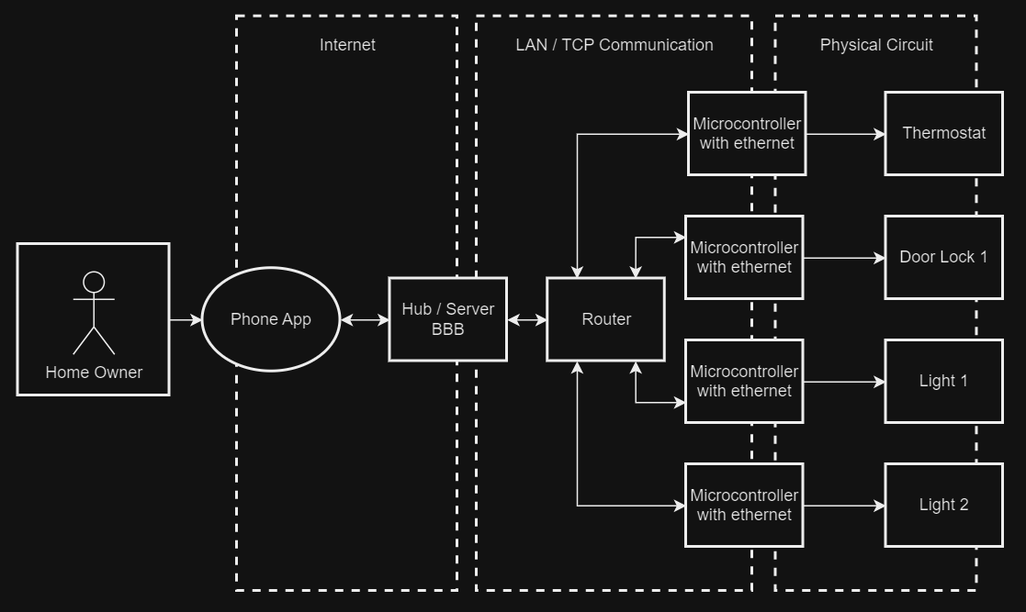

Our product is a phone app with hub that will allow users to send automation data such as temperature, light status, lock status, etc. from the phone to the hub over Wi-Fi so they can remotely manage their home!

The server will be connected to the various microcontrollers via a TCP connection that can control the different automation processes. These connections to the microcontrollers are how the network will be created and is what allows the user’s inputs in the app to reach all of the services for full home automation.

By creating this network, the homeowner has access to a localized server which allows for the data to stay within the home and safe from potential privacy attacks that would let their data get in the hands of people like “Trudy”.

## Unique Factor:

Our product stands out because it takes advantage of a centralized user interface that will provide the user with the opportunity to control multiple automated systems as opposed to forcing them to download multiple apps for each system. The user interface will be easy to use so that even users who are not tech-savvy can take advantage of our product.

A centralized app for the different automation processes could also potentially help our target audience save more money because there’s less chance for them to forget things like turning the lights off or changing the thermostat’s temperature if everything is in one place. The fact that this is a localized server also means that you don’t have to worry about data leaks revealing sensitive information about your home! With those who are comfortable setting up devices to the localized network, the sky is the limit, if your hub supports the bandwidth, you can connect other devices such as garage door sensors, stereo receivers, alarm systems and many more with unique control through the app.

# Proof of Concept (CPE 4020 Project)

## System Idea:

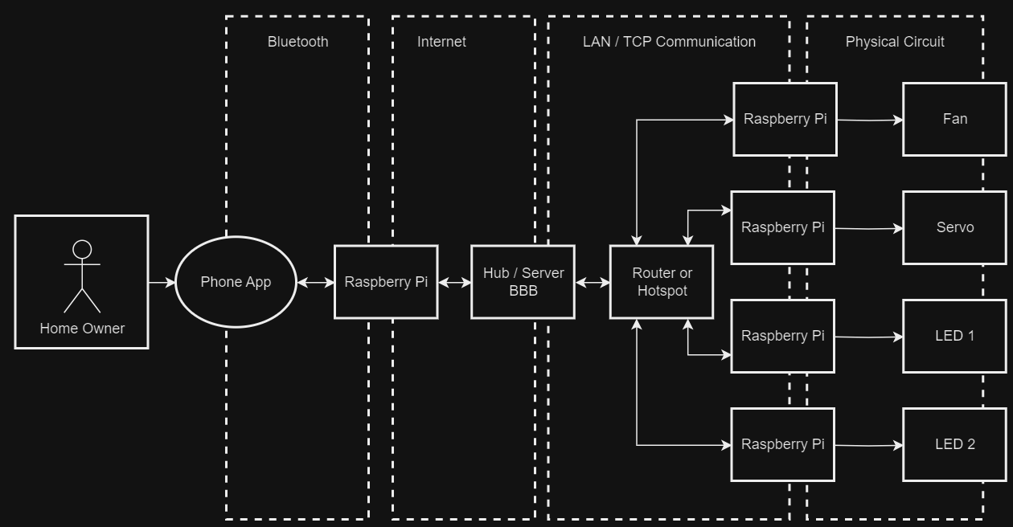

We are planning to simulate this product idea as proof of concept using the hardware in the diagram. We will make a phone app connected to the raspberry pi through Bluetooth to send data over internet to the beagle bone. The phone app with raspberry pi will simulate the actual phone. The “phone” will be the client connecting to the server (the hub/BBB) which is connected through the internet via Wi-Fi. The hub would then connect to the microcontrollers (Raspberry Pis) via TCP to control the circuit. So, the user would send data to turn off and on Green LED (LED 1), off and on Red LED (LED 2), move the servomotor to an “unlock” or “lock” mode to simulate the door, and turn the fan to simulate turning off and on the thermostat to simulate different home functions.

In an ideal sense, this is how we would want to have the project work as. Depending on if parts of the project are possible, we may have to cut off or change some of the system. For example, if we couldn’t get an actual mobile app to work then we would need to simulate that with another laptop with code. Another situation is that we haven’t worked with a switch on hand, so we don’t necessarily know the process of setting one up yet. Also, we are not sure that the microcontrollers can work through ethernet, so we may just have one or two circuits connected to the BBB in that scenario.

## Limitations

1.) Instead of bothering with port forwarding or a dynamic DNS for server connection, we will be using a local network (BBB as server, pi's as clients)

Port forwarding and creating a dynamic DNS server would be very difficult to demonstrate on campus as well as involves many security risks.

2.) Using Wi-Fi from the app to the hub (BBB), we are no longer using an ethernet switch and instead are using TCP connection for our microcontrollers

IOT appliances are wireless, so it would be better to control these circuits over LAN to better simulate our product.

3.) The GPIO ports on the RPI do not support enough current to spin our motor-controlled fan, so instead we will be powering the heating pad and temperature sensor circuit to simulate the thermostat of the house.

Give or take, some circuits may be taken out or re-arranged to simulate our services of setting up wireless appliances.

4.) All data sent and received through our server will be displayed on the app, this way we avoid a Node-Red, AWS cloud, or similar webpage for data privacy and include the user to access or control each component.

The phone app will simulate a cloud service between hub to phone thus giving more control to the user with no risk of a third-party company accessing your data.

## Relevancy

Our project includes communication between client and server, LAN connections, TCP protocols, as well as packet sending protocols. Since data will be sent on the same port and IP, we need to keep in mind the traffic of packets on our network. We plan to use message queuing on the server side since the clients will send data on the same port.

# Individuals’ Contributions

Hanson: Outline of document, Diagrams, Proof of Concept (CPE 4020 Project)

Chris: Business Description, Limitations

Cooper: Outline of document, Marketing Plan

Rodrigo: Product/Service Description,

Karolyn: Executive Summary