CPE 4020 – Device Networks, Fall 2023

Business Plan: Home Automation

Group 2:

Switches get Stitches

Hanson Chaney

Cooper Newlin

Chris Turner

Karolyn Seredick

Rodrigo Corral

Date: November 9, 2023

Electrical and Computer Engineering

Kennesaw State University

Faculty: Professor David Levine

# Table of Contents

Table of Contents 1

I. Executive Summary 2

1.1- Our Product 3

II. Market Sections 3

2.1- Competitive Analysis 3

2.2- Market Strategy 3

III. Design 4

3.1- Product/Service Description 4

IV. Conclusion 5

V. Individual Contributions 5

# Executive Summary

## 1.1- Our Product

The Internet of Things (IoT) has rapidly transformed the way we interact with technology, connecting devices and systems to enhance efficiency and convenience across various industries. From smart cities to healthcare, IoT has become a driving force, seamlessly integrating the physical and digital realms. As the number of interconnected devices continues to grow, IoT has ushered in a new era of possibilities, creating smart environments that respond intelligently to user needs.

In the context of home automation, the expansion of IoT devices has introduced challenges related to data security, privacy concerns, and dependence on cloud-based solutions. Many homeowners face issues associated with latency, reliance on external servers, and potential vulnerabilities in transmitting sensitive information over the internet. We propose to counter these problems with a locally hosted home automation system which aims to address the challenges by providing homeowners with a robust, secure, and self-contained solution. Users can enjoy the benefits of a smart home without compromising on security or experiencing delays due to internet connectivity issues. This solution not only empowers homeowners with greater control over their connected devices but also contributes to a more responsive smart home automation.

# Market Sections

## 2.1- Competitive Analysis

Our product has many competitors in this market due to the need and convenience of having a product like this at your fingertips. The following will describe some of those competitors and the products that they make for home automation.

* Google: Google makes many IoT devices that can be used in a residential setting. They have door sensors, window sensors, smart hubs, etc.
* Amazon: Creator of Alexa, a massively popular and useful device that can be used to control items in a home or business. They also provide their own IoT service.
* LG: Creator of ThinQ, an application that can be used to control appliances in a home.
* Samsung: Samsung makes many IoT devices, for entertainment. They released Bixby, a service that can be used on smartphones or household appliances.

## 2.2- Market Strategy

Since there are many different options available, we want to advertise to our targeted audience. Switches-Make-Fixes could talk to real estate agents to see if they are interested in setting up home automation for places that are rented out to save money on bills. Switches-Make-Fixes could find more of a market on Airbnb to contact homeowners who may be interested in home automation for their rental properties. Finally, we would advertise on local build boards since we are a smaller company. We want to target residential areas so small yard signs or door hangers would also be a great idea.

# Design

## 3.1- Product/Service Description

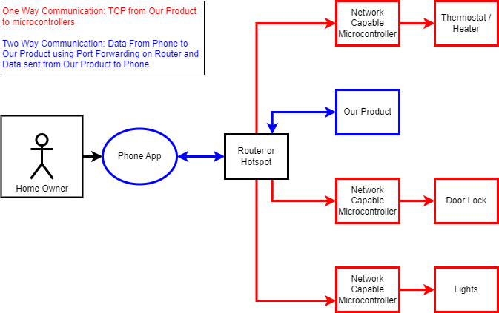

Our product is a phone app with hub that will allow users to send automation data such as temperature, light status, lock status, etc. from the phone to the hub over Wi-Fi so they can remotely manage their home!

The server will be connected to the various microcontrollers via a TCP connection that can control the different automation processes. These connections to the microcontrollers are how the network will be created and allow the user’s inputs in the app to reach all the services for full home automation.

By creating this network, the homeowner has access to a localized server which allows for the data to stay within the home and safe from potential privacy attacks that would let their data get in the hands of people like “Trudy.”

# Conclusion

In conclusion, Switches-Make-Fixes presents a compelling solution to the challenges posed by the expanding IoT home automation. Privacy and security concerns associated with IoT devices and cloud computing are addressed with the product’s locally hosted system. Our product stands out by ensuring user data remains within the confines of the home network. We hope our product will be usable for at home automation or peace of mind for rental properties with growth into business or large corporation at later stages.

Though initial innovations are limited, the potential implementation of our product is near limitless. The advancement of IoT devices is leading the future of technology and Switches-Make-Fixes has joined the race for cutting-edge innovations.

# Individual Contributions

Hanson Chaney – Worked on outlining the presentation, report, and helped with bugs on TCP messages on the client side. Also implemented circuits to TCP client code.

Chris Turner – Raspberry pi python scripts to allow the multiple circuits to communicate with the BeagleBone Black script for local network communication.

Rodrigo Corral – Created the circuits and code to control the LED and Servo motor. Helped with the PowerPoint presentation.

Karolyn Seredick – Assisted with the PowerPoint presentation and directed the writing of the final report.

Cooper Newlin – Created the App for our product. Wrote the BeagleBone Black server scripts, python code for processing and sending messages between clients and server, and helped troubleshoot Raspberry Pi python scripts.