Control Flow (cont'd)

Switch Activity

Switch is a type of control flow statement that is used to make a choice when we have various options available and we want to execute one option.

In other words, we use switch in place of an If statement when we need at least 3 potential courses of action.

**Switch Example 1**

The following switch example will be based on a hypothetical scenario where an int32 variable named players is passed to the activity’s expression. Depending on how many players are available, the application tells the user the best matching sport to play:

* With 11 players, there is enough for a cricket team.
* With 15 players, a hurling team could be assembled.
* With 6 players, a hockey team could be formed.
* If there is no match, the user is told to take everyone surfing.

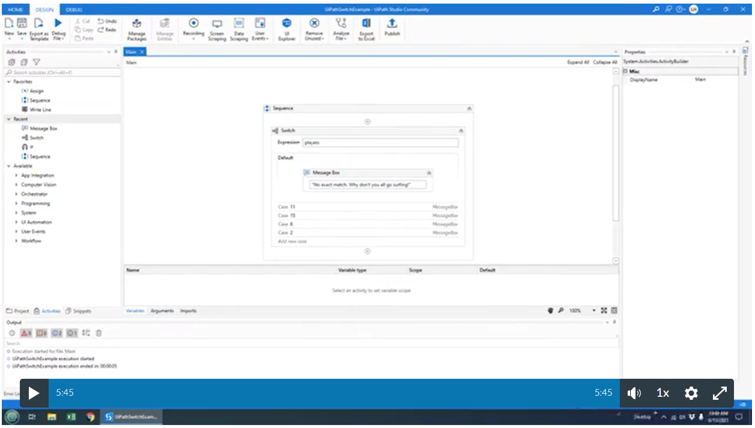Video source: cameron Mckenzi

**Key Takeaways**

* Like any other UiPath activity, we can search for it in the activity panel and drag & drop it to the workflow design.
* The activity consists of a **conditional expression** and a **collection of cases**, each containing a corresponding activity or set of activities.

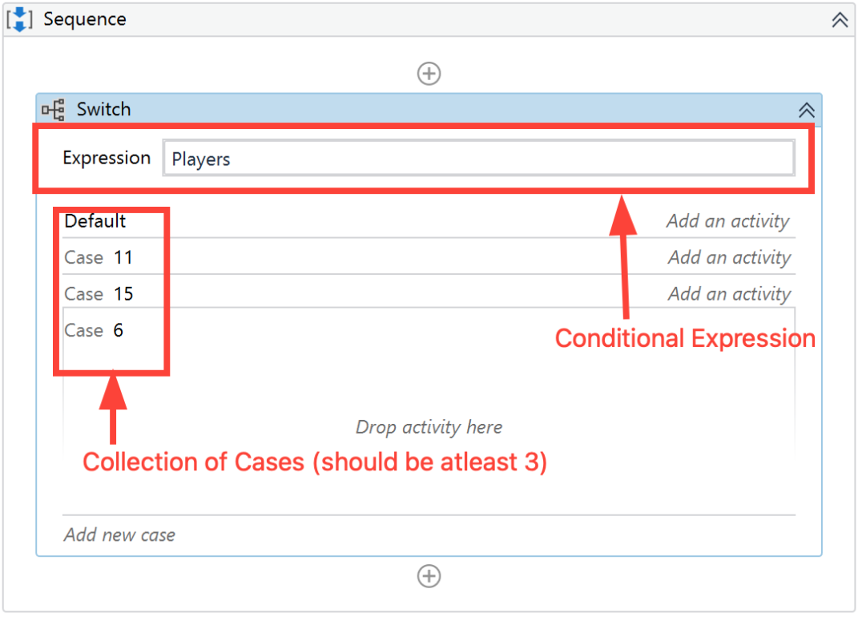

* Unlike in an IF activity, where the conditional expression can only be of a boolean type. By default, the Switch Activity uses an int32 argument but we can also change it to **Boolean**, **Object**, **String** etc. from the Properties panel under **TypeArgument** list as shown in the following screenshot:

In our example we didn’t change it because we were dealing with integers.

* The Switch activity executes a **single case** in the collection, based on its match with the **conditional expression**. If the condition does not match any of the cases, the **Default** one is executed.
* We can only have one**Default case**.If no Default case is added, the project is executed, but the activity does not return any output.

**Example 2:**

In the previous example, we saw how to create a switch activity with an int32 argument in the expression. Now let’s look at another example but this time with a string argument in the expression field.

In this example, we’ll also assume a hypothetical scenario where we’ll automate a customer care call process. The caller/user will be prompted to choose from an array of options and based on the option they choose we’ll display a message. We’ll present the user with the following options and their display message:

* **Jitambulishe** -  ​​"Please repeat these phrase: 'At Safaricom, My voice is my password' "
* **Sim Card Queries** - "What's your Sim Card query?"
* **Mpesa** - "Please hold on as we connect you to our next available agent..."
* **Get PUK** - "Your PUK will be sent shortly"

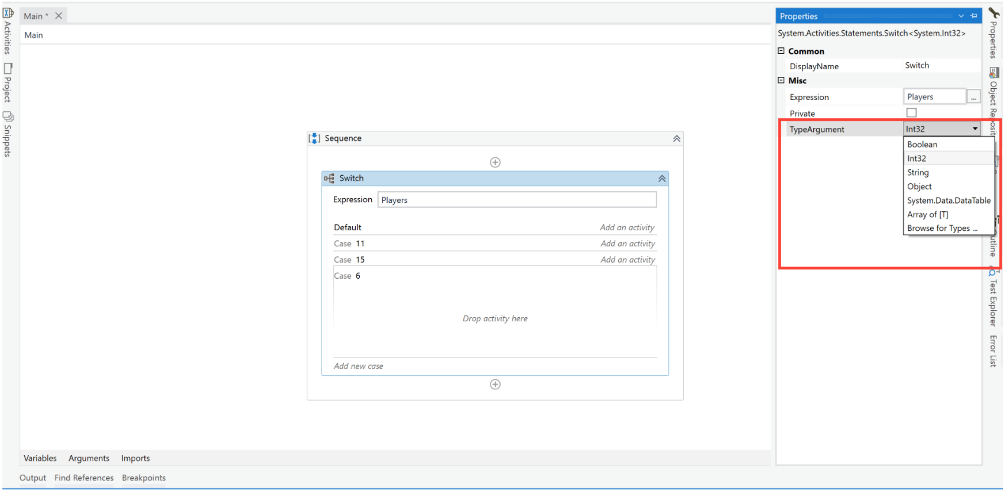

Now let’s get to building our automation

**Step 1**: Create a **blank process** and give it an appropriate name.

**Step 2**: Add a new **Sequence** to the main workflow.

**Step 3**: From the activity panel, search and drag **Input Dialog** activity inside the sequence activity. This activity will allow us to present the user with the options.

**Step 4**: Open the **Properties panel** of the Input Dialog activity. We’ll do the following modifications

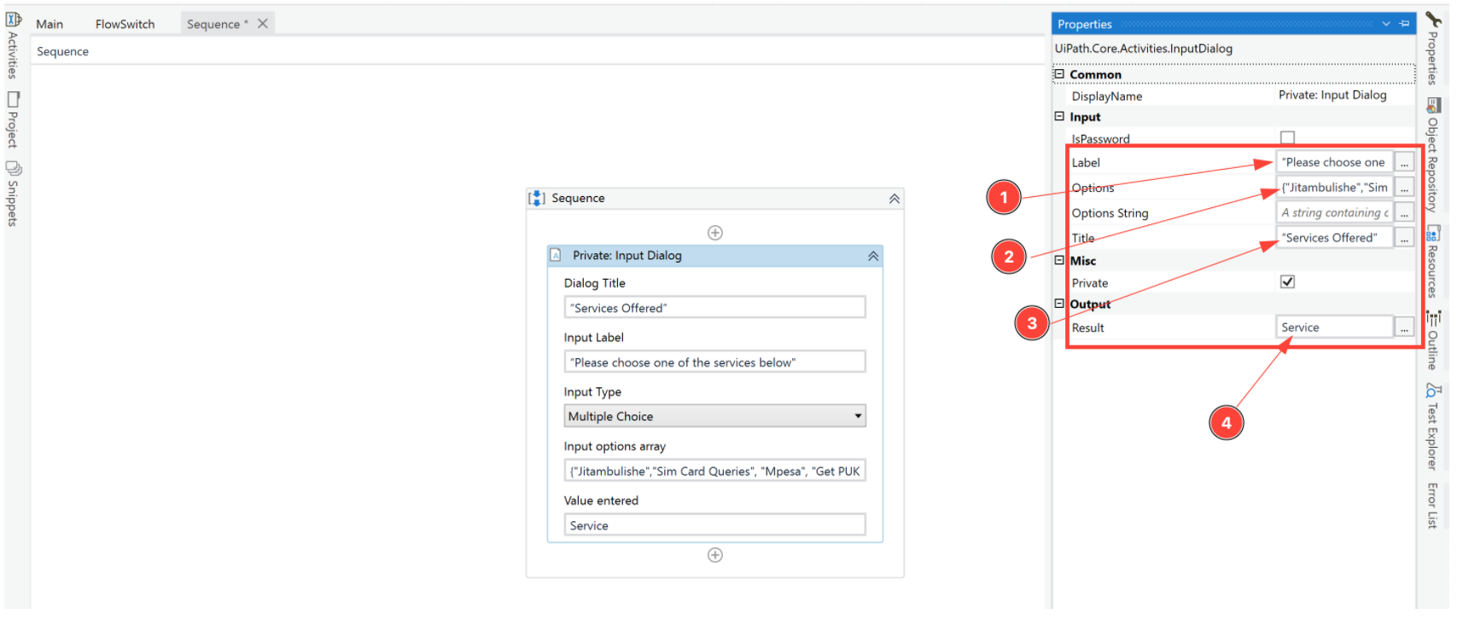

1. In the **Label field**, type “Please choose one of the services below"
2. Next, we’ll add the options that the user will choose from. In the **options** **field,**add an array of strings that the user will choose from. {"Jitambulishe","Sim Card Queries", "Mpesa", "Get PUK"}
3. In the **Title field**, type “Services Offered”
4. Finally, in the **Result** field create a variable using CTRL + K. Name the variable *service*. This variable will be used to store the user’s choice from the Input Dialog activity.

**Step 5**: From the Activities panel, search and drag the **Switch Activity** inside the sequence but below the Input Dialog activity.

**Step 6**: In the **Properties panel** of the **Switch Activity**, Perform the following modifications

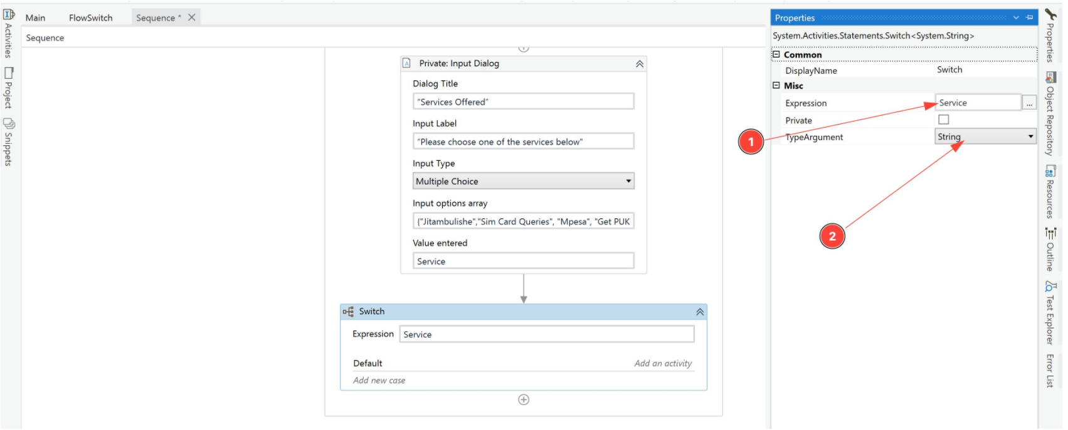

1. In the **Expression** field, set it to the **Service** variable we created in the Input Dialog activity. The switch activity will look inside the Service variable to match the option the user has chosen with the cases(that we’ll create shortly).
2. Change the **TypeArgument** field to be **String** from the dropdown menu. By default this field is set to int32, we are changing it to string because earlier on we created an array of strings from which the user is choosing from. Hence whichever option the user chooses will be of type String.

**Step 7**: Let’s define what happens when the user does not choose any of the options we’ve presented them with. To do this we’ll use the **Default** Section. Click on the Default section and Add a **Message Box** activity from the activities panel inside the Default section.

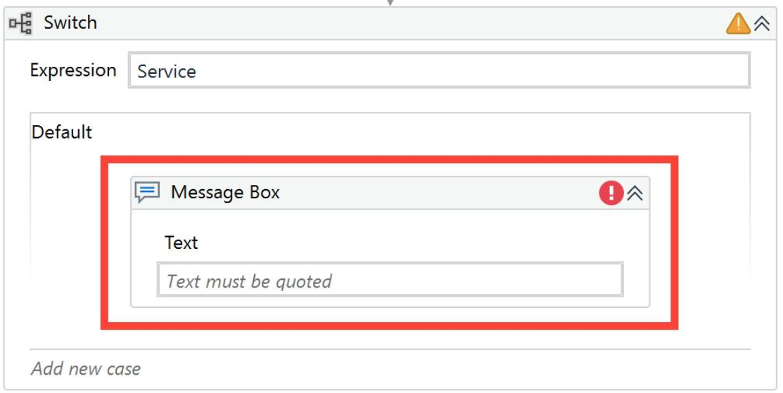

**Step 8**: In the **text** field of the message box, type "Oops, seems like you haven't chosen any option. Please try again". This message will be displayed to the user in the event that they don’t choose any option.

**Step 9**: Next, let’s create our first case. Click on ‘Add new case’ and as the case value type in *Jitambulishe.*As you may have noticed this is the first element in the array of strings we gave to the user as options. **Note**: For the switch activity to match it needs to be **Exactly** the same as the one the user will pick. This means that the switch activity is **case-sensitive.**

**Step 10:**Next, we’ll add the message that will be displayed to the user if they pick the Jitambulishe option. Add a Message Box inside the Jitambulishe case. In the text field of the message box, type "Please repeat this phrase: 'At Safaricom, My voice is my password' "

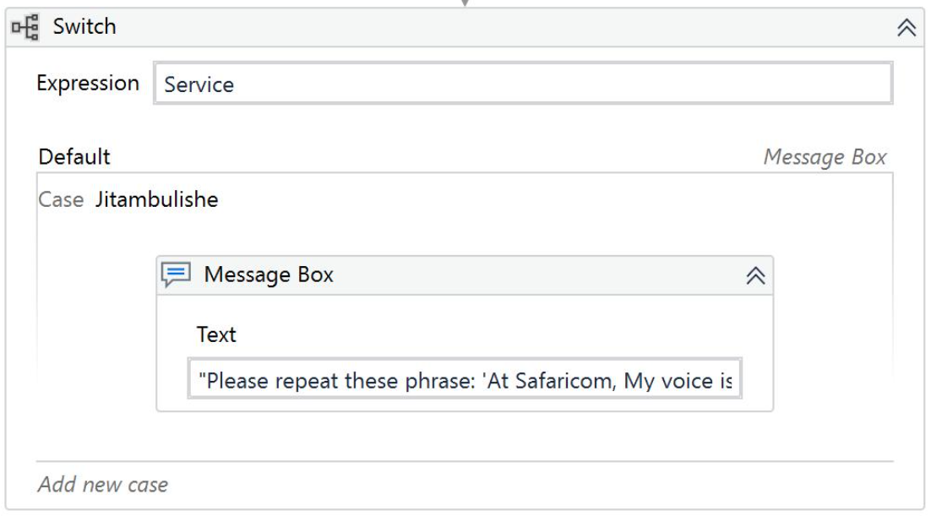

**Step 11**: Add a new case and type the case value as *Sim Card Queries.* Also, add a **Message Box** activity inside this new case and in the **text** field, type "What's your Sim Card query?"

**Step 12**: Add another case and put its value as Mpesa. Add a message box activity inside the case with the text: "Please hold on as we connect you to our next available agent..."

**Step 13**: Let’s add the final case with its value as Get PUK. Just like we did the previous ones, add a message box activity with the text: "Your PUK will be sent shortly". Your whole automation should look like this

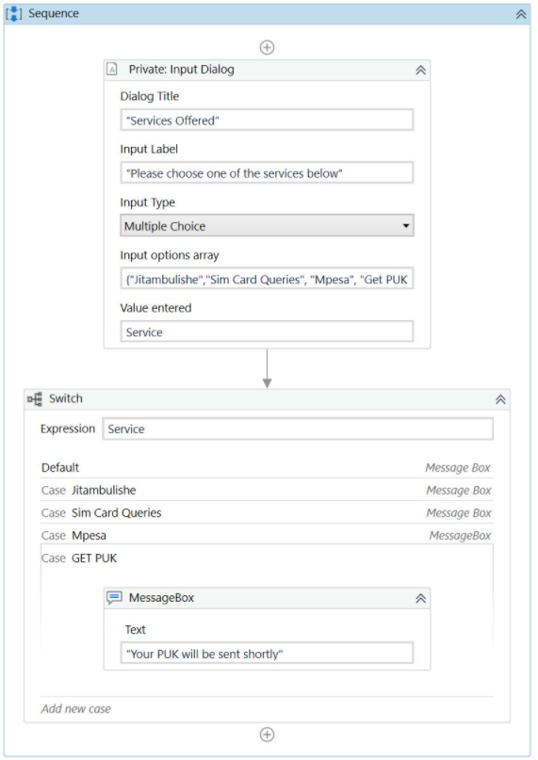

**Step 14**: Save the workflow and click on RUN (CTRL + F6). The automation should display a different message to the user depending on the option the user picked.