**PRACTICAL – 8**

**AIM :**

**TO IMPLEMENT TOWER OF HANOI PROBLEM IN PROLOG**

**HISTORY**

* The Tower of Hanoi puzzle was invented by the French mathematician Edouard Lucas in 1883. He was inspired by a legend that tells of a Hindu temple where the puzzle was presented to young priests.
* At the beginning of time, the priests were given three poles and a stack of 64 gold disks, each disk a little smaller than the one beneath it. Their assignment was to transfer all 64 disks from one of the three poles to another, with two important constraints.
* They could only move one disk at a time, and they could never place a larger disk on top of a smaller one.
* The priests worked very efficiently, day and night, moving one disk every second. When they finished their work, the legend said, the temple would crumble into dust and the world would vanish.

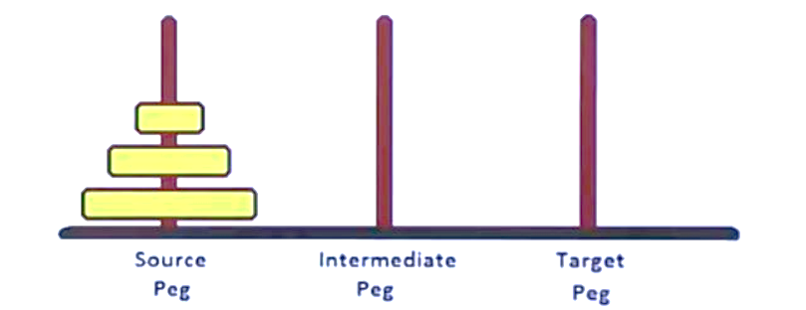**PROBLEM STATEMENT**

Given a game board with three pegs and a set of disks of different diameters all stacked from smallest to largest on the leftmost (Initial) peg, move all of the disks to the rightmost (Final) peg. Number of disks can vary from case to case.

**CONSTRAINTS**

* Only one disk can be moved at a time.
* A larger diameter disk can never be placed on a smaller disk.

**ILLUSTRATION**

FOR 3 DISKS:

* Step 1 : Shift first disk from 'A' to 'C'.
* Step 2 : Shift second disk from 'A' to 'B'.
* Step 3 : Shift first disk from 'C' to 'B'.
* Step 4 : Shift first disk from 'A' to 'C'.
* Step 5 : Shift second disk from 'B' to 'A'.
* Step 6 : Shift first disk from 'B' to 'C'.
* Step 6 : Shift first disk from 'A' to 'C'.

[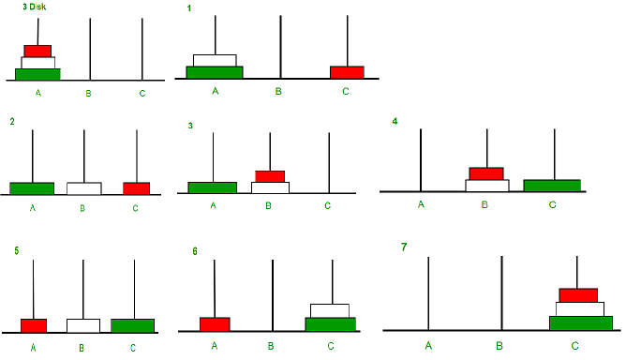](https://media.geeksforgeeks.org/wp-content/uploads/tower-of-hanoi.png)

**The pattern here is :**

* Shift 'n-1' disks from 'A' to 'B'.
* Shift last disk from 'A' to 'C'.
* Shift 'n-1' disks from 'B' to 'C'.

Now, we can construct an algorithm using a Recursive approach!

**RECURSION**

In computer science, recursion is a method of solving a problem where the solution depends on solutions to smaller instances of the same problem.Such problems can generally be solved by iteration, but this needs to identify and index the smaller instances at programming time. Recursion solves such recursive problems by using functions that call themselves from within their own code. The approach can be applied to many types of problems, and recursion is one of the central ideas of computer science.

**ALGORITHM**

START

TowerOfHanoi(disk, source, destination, intermediate)

IF disk == 1, THEN

move disk from source to destination

ELSE

TowerOfHanoi(disk - 1, source, intermediate , destination)

move disk from source to destination

TowerOfHanoi(disk - 1, intermediate, destination, source)

END IF

END

STOP

**CODE**

/*

    PROLOG PROJECT

    TOPIC : TOWER OF HANOI

    BY : INDERPREET SINGH (C018325)

*/

/*

    main FUNCTION

    CALLED BY THE USER

    USING THE SWI-PROLOG TERMINAL

    DISPLAYS THE ENTRY MESSAGE

    PASSES THE PARAMETERS GIVEN BY USER

    TO THE MOVE FUNCTION

*/

main(N,X,Y,Z) :-

    nl,

    nl,

    write('-------------WELCOME-------------'),

    nl,

    write('---------TOWER OF HANOI----------'),

    nl,

    write('----INDERPREET SINGH(CO18325)----'),

    nl,

    nl,

    nl,

    /* CALL THE MOVE FUNCTION */

    /*

        PARAMETERS PASSED ARE :

            N : NO. OF DISKS IN THE INTIAL STATE / PEG

            X : INTITAL STATE / PEG

            Y : NTERMEDIATE STATE / PEG

            Z : FINAL STATE / PEG

    */

    move(N,X,Y,Z).

/*

    move FUNCTION WHEN ONLY ONE DISK IS LEFT IN THE PEG

    X : STATE IN WHICH THE DISK IS LEFT

    Y : STATE WHERE THE DISK NEEDS TO BE PLACED

*/

move(1,X,Y,_) :-

    write('MOVE THE TOP DISK FROM:'),

    nl,

    write(X),

    nl,

    write('PLACE IT AT'),

    nl,

    write(Y),

    nl,

    nl.

/*

    move FUNCTION WHEN FOR N DISKS

    IT IS RECURSIVE FUNCTION

*/

move(N,X,Y,Z) :-

    N>1,

    M is N-1,

    move(M,X,Z,Y),

    move(1,X,Y,_),

    move(M,Z,Y,X).

**OUTPUT**

