**Chandigarh COLLEGE OF ENGINEERING & TECHNOLOGY**

2018(1st SEMESTER)

**SECOND GENERATION COMPUTERS(1959-1964)**

**SUBMITTED TO: prof. SUDHAKAR KUMAR**

**BY:ISHAN GAMBHIR(CO18326)**

***The period of second generation was from 1959-1965. In this generation, transistors were used that were cheaper, consumed less power, more compact in size, more reliable and faster than the first generation machines made of vacuum tubes. In this generation, magnetic cores were used as the primary memory and magnetic tape and magnetic disks as secondary storage devices.***

***In this generation, assembly language and high-level programming languages like FORTRAN, COBOL were used. The computers used batch processing and multiprogramming operating system.***

***The main features of second generation are −***

1. ***Use of transistors***
2. ***Reliable in comparison to first generation computers***
3. ***Smaller size as compared to first generation computers***
4. ***Generated less heat as compared to first generation computers***
5. ***Consumed less electricity as compared to first generation computers***
6. ***Faster than first generation computers***
7. ***Still very costly***
8. ***AC required***
9. ***Supported machine and assembly languages***

***Some computers of this generation were −***

1. ***IBM 1620***
2. ***IBM 7094***
3. ***CDC 1604***
4. ***CDC 3600***
5. ***UNIVAC 1108***

***The Vacuum Tube's Replacement***

***.*** 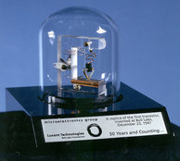

***Second generation computers can be characterized largely by their use of transistors.  They replaced the job of vacuum tubes through the 1950s and 1960s.  Vacuum tubes generated too much heat, were very large, and proved to be unreliable. Ultimately, they served as an update for using less power and space. It acted as a transmitter and resistor (ergo its name; ‘trans’, ‘istor').  Its inventors were scientists at the Bell Telephone Laboratories in New Jersey. John Bardeen, William Shockley, and Walter Brattain wanted to make a more efficient and useful amplifier, and in 1952, a transistor was first put to use as a Sonotone hearing aid.  
  
Computers of this generation essentially used magnetic cores for primary storage and magnetic disks/ tape for secondary memory.***

***Transistors Used in Computers; IBM 7000 Series***

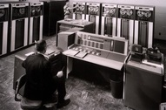

***The IBM 7000 series was developed throughout the 1950s and early 1960s. They were labeled as computers for “large scale scientific and technological applications.” These computers were much more compatible compared to the IBM 700 series because of their use of transistors. They had higher input/ output speed, using disk and tape. Languages supported by the computers’ operating systems included FORTRAN, COBOL, SORT/MERGE, etc.***

***Other Transistorized Computers; CDC Computers***

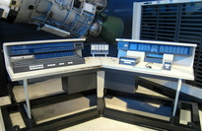

***Designed by Seymour Cray and others at Control Data Corporation, the CDC 1604 is credited as one of the first successfully transistorized computers. In 1960, the first 1604 was delivered to the US Navy, and by 1964 more than fifty were built. They used 48-bit words of magnetic core memory, and each 48-bit contained 24-bit instructions.  In 1604, the CDC 3000 series succeeded the 1604. All second generation CDC computers used core memory.***

***UNIVAC 1107***

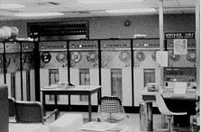

***The new UNIVAC series began with UNIVAC 1107 made my Sperry Rand in 1962. The second generation computer UNIVAC was still quite massive, but very quiet. Its central processor was 36-bit architecture, which was able to perform arithmetic equations in one 4- microsecond cycle time. It printed cards 600 lines per minute but was known for jamming. All executions were started by reading punch cards. Memory access time was eight microseconds per word. Soon came the UNIVAC 1108, which would mark the start of the third generation.***