COA GROUP 5

GROUP MEMBERS:

Kankanala Siva Sai Amrutha- 21CS02005
Prisha Srinidi- 21CS01057
Meesala Aakanksha- 21CS01056
Meruva Yashna- 21CS01039
Bharati Pradhan- 21CS01009

1. What is the runtime for each configuration?
Example: Plot showing the IPC on Y-axis and application name on X-axis, Legend: Different warp schedulers.

GRAPHS FOR DIFFERENT WARP SCHEDULING ALGORITHMS FOR GLOBAL AND SHARED MEMORY

IPC vs. APPLICATION TYPE FOR DIFFERENT WARP SCHEDULING ALGORITHMS

LRR:

GTO:

2 LEVEL ACTIVE:

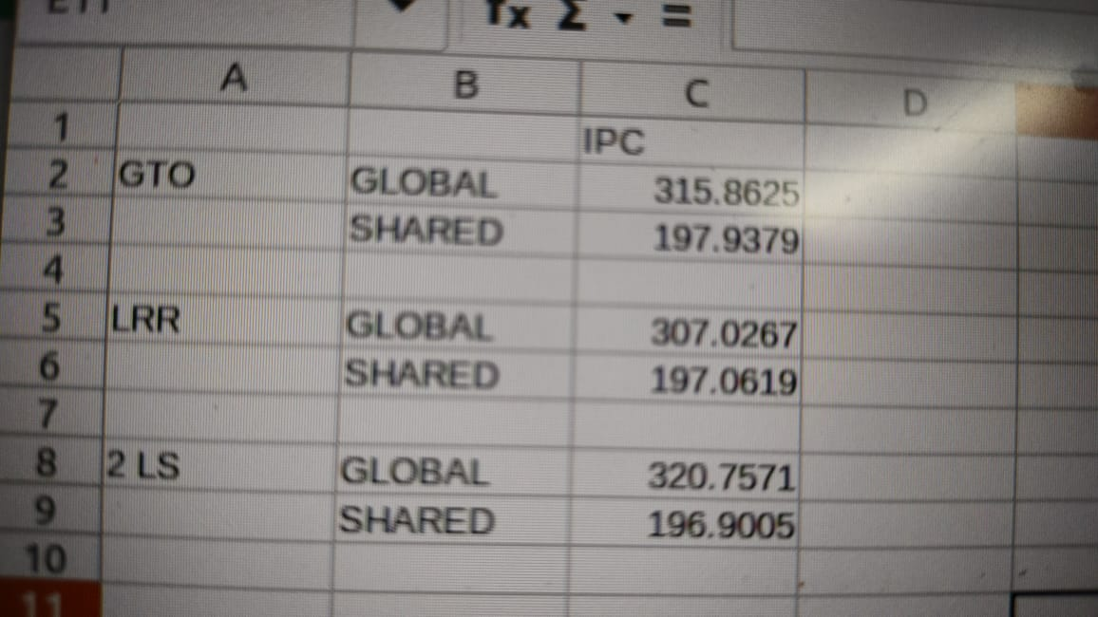

2. Do you notice any correlation between the L1D, L2 and DRAM Statistics in the output/log file of gpgpusim for both the implementations (shared memory vs global memory). Mention your observations with supporting data.

- Shared Memory Implementation: In a shared memory implementation of matrix multiplication, data is often loaded into shared memory in smaller chunks (tiles) to exploit data reuse within a thread block. This can lead to reduced global memory traffic, which might affect the following statistics:
- L1D Cache Statistics: With shared memory, the L1 cache might see reduced traffic due to the reuse of data stored in shared memory. L1 cache hits could increase, and the L1 miss rate might decrease.
- L2 Cache Statistics: L2 cache usage could also decrease due to the reduced need to fetch data from global memory. However, if the shared memory usage increases and some data eviction occurs, it might lead to more L2 cache traffic.
- DRAM Statistics: The use of shared memory might decrease the overall global memory access rate, resulting in lower DRAM traffic. This could potentially lead to a decrease in DRAM bandwidth utilization.
- Global Memory Implementation: In a global memory implementation of matrix multiplication, each thread accesses data from global memory directly. This can result in more frequent global memory accesses, which might impact the following statistics:
- L1D Cache Statistics: In this case, the L1 cache might see higher traffic due to the frequent global memory accesses. L1 cache hit rates might decrease, and the L1 miss rate could increase.
- L2 Cache Statistics: Similarly, L2 cache traffic might increase due to the higher demand for data fetched from global memory. The L2 cache hit rate could also decrease.
- DRAM Statistics: The global memory implementation could lead to increased DRAM traffic due to the higher frequency of global memory accesses. This might result in higher DRAM bandwidth utilization.
It's important to note that the exact correlation between these statistics would depend on various factors, including the specific architecture of the GPU, memory hierarchy, cache sizes, memory access patterns, and optimization techniques applied during matrix multiplication implementation.
To obtain accurate correlations for your specific case, you would likely need to use a GPU simulator like GPGPU-Sim and perform detailed experiments by varying parameters, memory access patterns, and implementation strategies. This would help you analyze the effects of different memory configurations on L1D, L2 cache, and DRAM statistics for both shared memory and global memory implementations of matrix multiplication.

