**Protocol for automatically detecting, numbering, and individually-exporting large tissue slices using QuPath**

This example protocol uses the image: “jb160203a d2t1 slide 20 - 2016-06-18 00.30.49.ndpi”, which can be found here: <https://zenodo.org/record/5362598>. This image is of transverse sections through the planarian worm, *Schmidtea mediterranea*. The tissue slices are automatically detected and a bounding box placed around each; each is then numbered (which can also be manually edited if needed) and exported as an individual .tiff image for subsequent analysis (in this case, registration to create a 3D stack of the organism).

This protocol uses the open source toolkit: QuPath ([https://qupath.github.io/)](https://qupath.github.io/)

1. Open QuPath and create a project. Load all your images in there… then everything can be saved in that project - scripts, outputs, everything...
2. Define a classifier… go to Classify > Pixel Classification > Create Thresholder… example settings for associated image are shown in the following image.  
   **The label ‘Tissue’ (just go to Annotations tab and then ‘…’ button and ‘add class’) was added.

1. ‘Create Objects’ … example settings for associated image are shown in the following image:

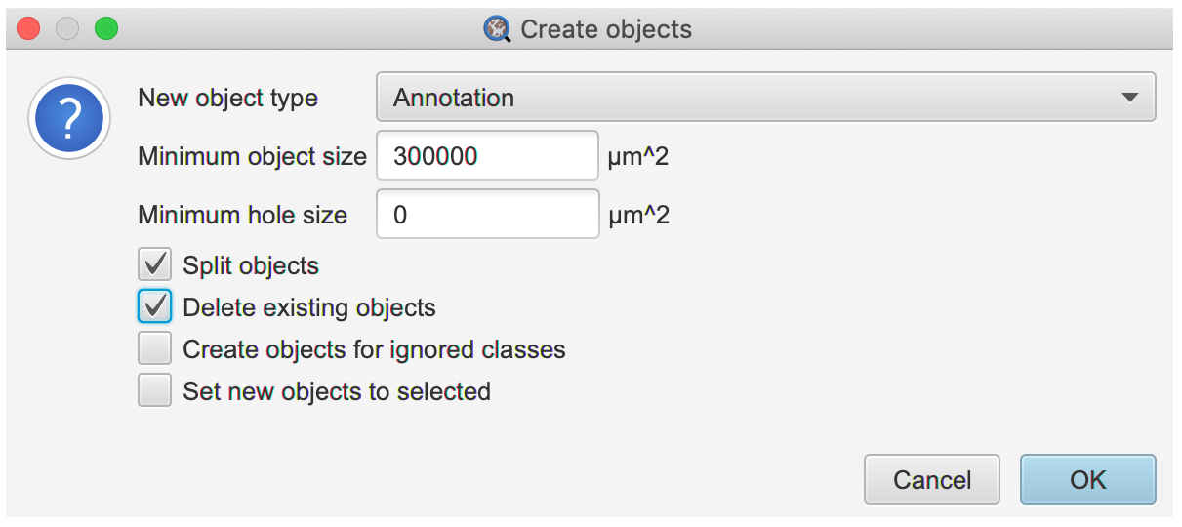

1. Run the Script01-detectTissues-fixBoundingBoxes-numberOrder.groovy script. Note: bounding box size can be altered in this script if needed.
2. (Optional) Run the Script02-optional-manual-reorder.groovy if you want to reorder the tissue numbers manually.
3. Run the Script03-export.groovy script. (This script saves the original file names and the order # in a folder called “Export”.)