# DESIGN AND ANALYSIS OF ALGORITHMS

# LAB FILE

**Submitted by –**

**Name-Prabhat Mishra**

**Sap_id-500120575**

**Enrolment No-R2142231785**

**Batch-52**

**3rd Semester,**

**BTech CSE**

**UPES Dehradun, Uttarakhand**

**CONTENTS**

|  |  |  |  |
| --- | --- | --- | --- |
| **Sl no.** | **Experiments** | **Page No.** | **Remarks** |
| **1.** | Implement the insertion inside iterative and recursive Binary search tree and compare their  performance. | 4 |  |
| **2.** | Implement divide and conquer based merge sort and quick sort algorithms and  compare their performance for the same set of elements. | 10 |  |
| **3.** | Compare the performance of Strassen method of matrix multiplication with  traditional way of matrix multiplication. | 16 |  |
| **4.** | Implement the activity selection problem to get a clear understanding of greedy  approach. | 23 |  |
| **5.** | Get a detailed insight of dynamic programming approach by the implementation of  Matrix Chain Multiplication problem and see the impact of parenthesis positioning  on time requirements for matrix multiplication. | 27 |  |
| **6.** | Compare the performance of Dijkstra and Bellman ford algorithm for the single  source shortest path problem. | 29 |  |
| **7.** | Through 0/1 Knapsack problem, analyse the greedy and dynamic programming  approach for the same dataset. | 33 |  |
| **8.** | Implement the sum of subset. | 39 |  |
| **9.** | Compare the Backtracking and Branch & Bound Approach by the implementation  of 0/1 Knapsack problem. Also compare the performance with dynamic  programming approach. | 41 |  |
| **10.** | Compare the performance of Rabin-Karp, Knuth-Morris-Pratt and naive string-matching algorithms. | 46 |  |
| **11.** | My GitHub Link. | 52 |  |

**EXPERIMENT 1**

**Implement the insertion inside iterative and recursive Binary search tree and compare their performance.**

**CODE:**

**Recursive BST:**

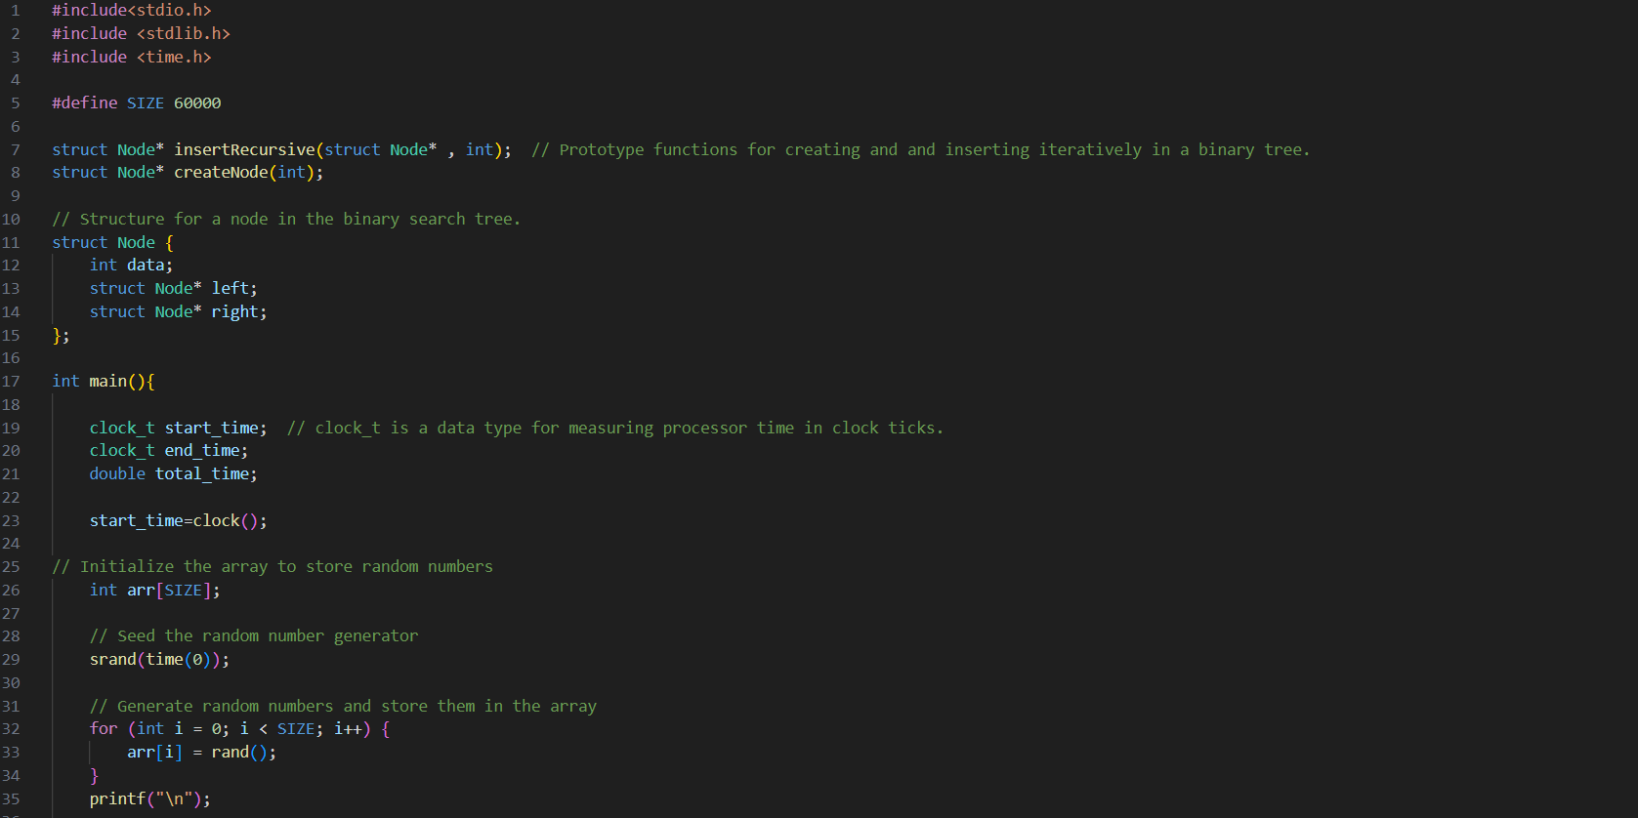

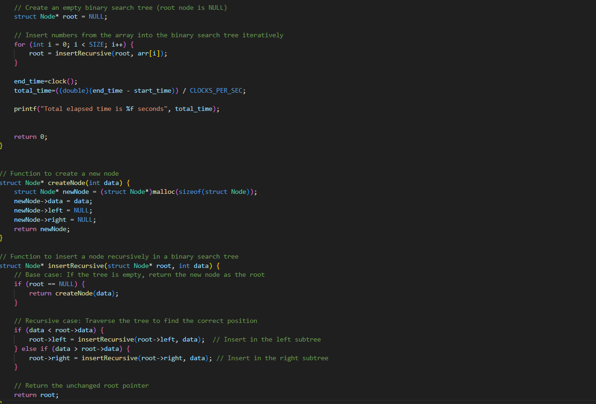

**ITERATIVE BST:**

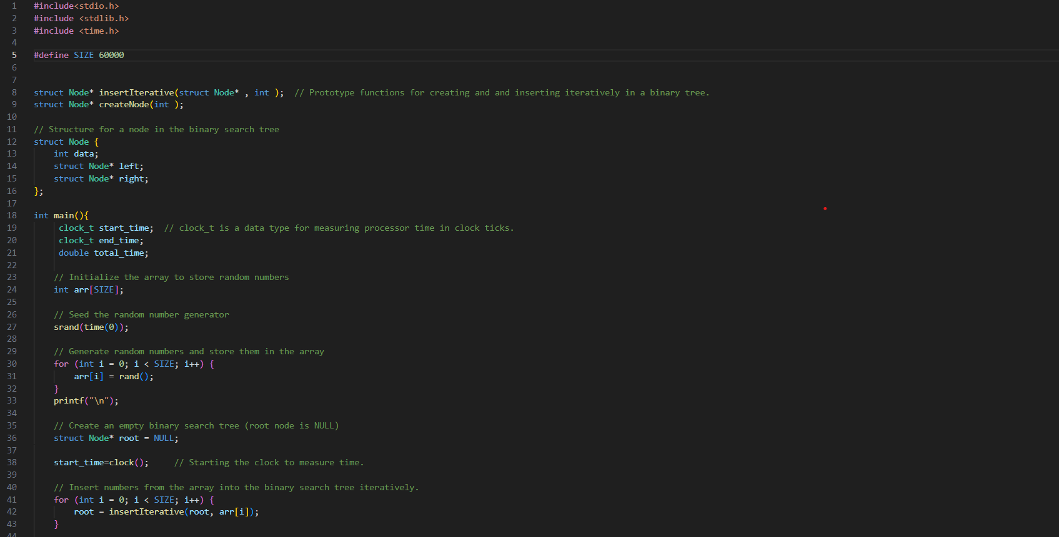

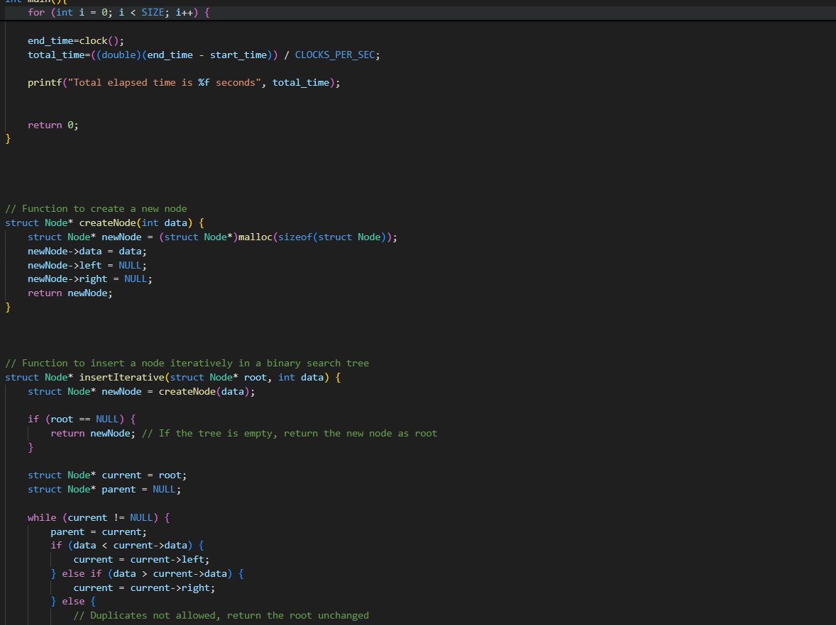

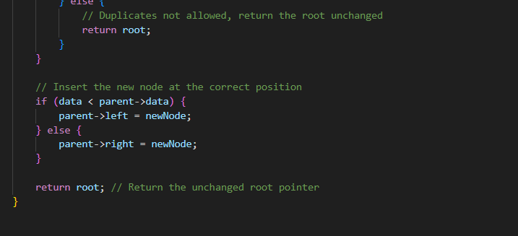

**OUTPUTS:**

**RECURSIVE BST:**

**1. N=10000**

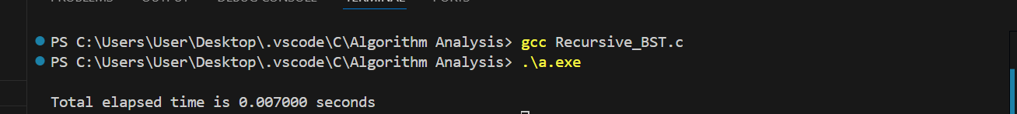

**2. N=20000**

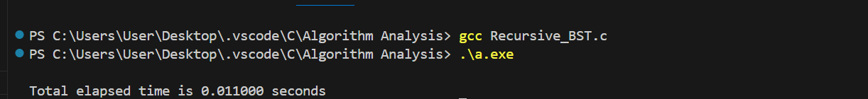

**3. N=30000**

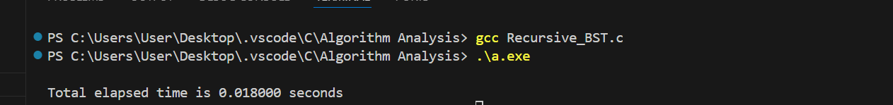

**4. N=40000**



**5. N=50000**

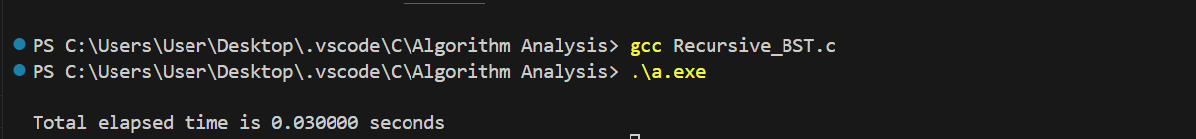

**6. N=60000**

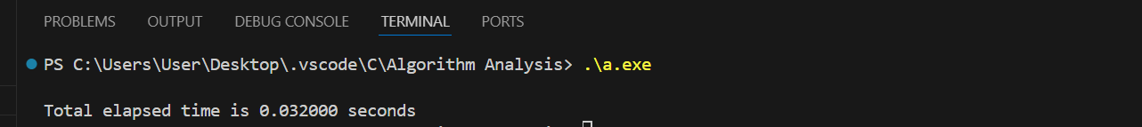

**ITERATIVE BST:**

**1. N=10000**

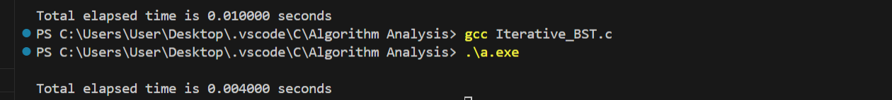

**2. N=20000**

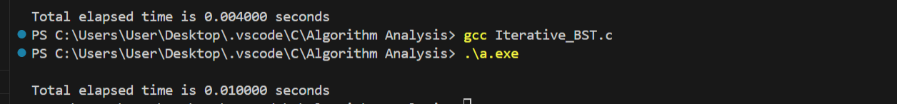

**3. N=30000**

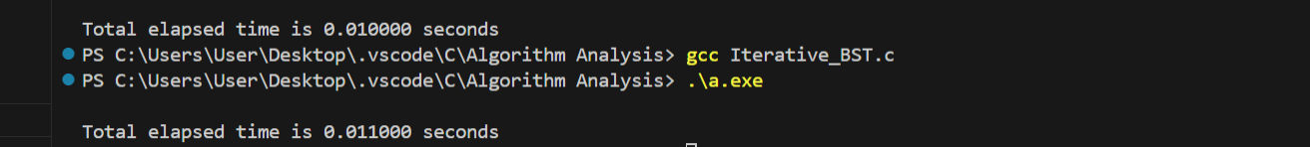

**4. N=40000**

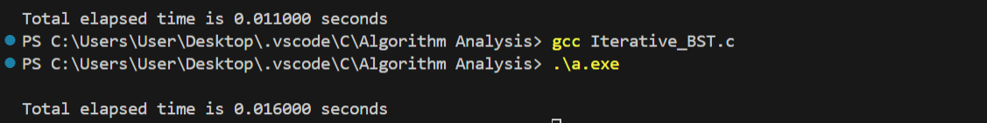

**5. N=50000**

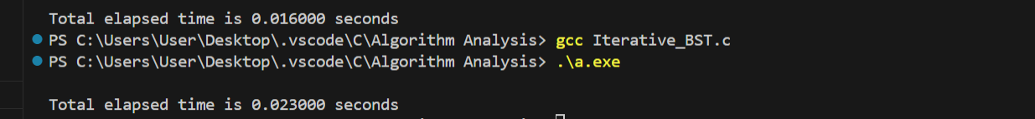

**6. N=60000**

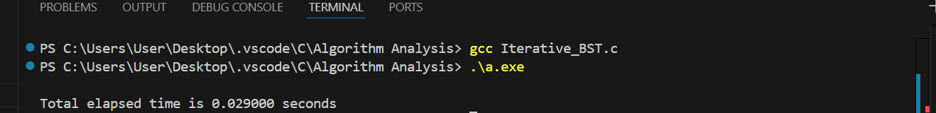

**GRAPH ANALYSIS:**

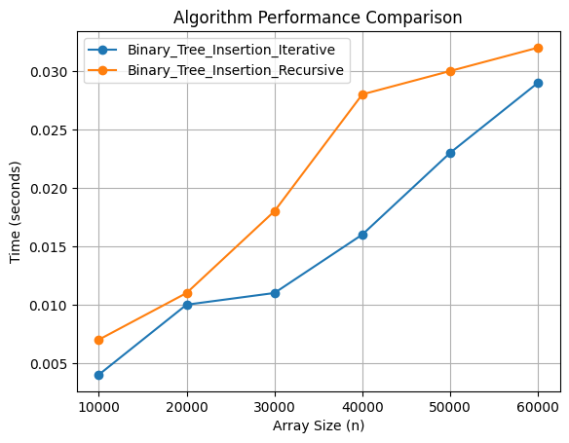

**EXPERIMENT 2**

**Implement divide and conquer based merge sort and quick sort algorithms and compare their performance for the same set of elements.**

**CODE:  
MERGE SORT:**

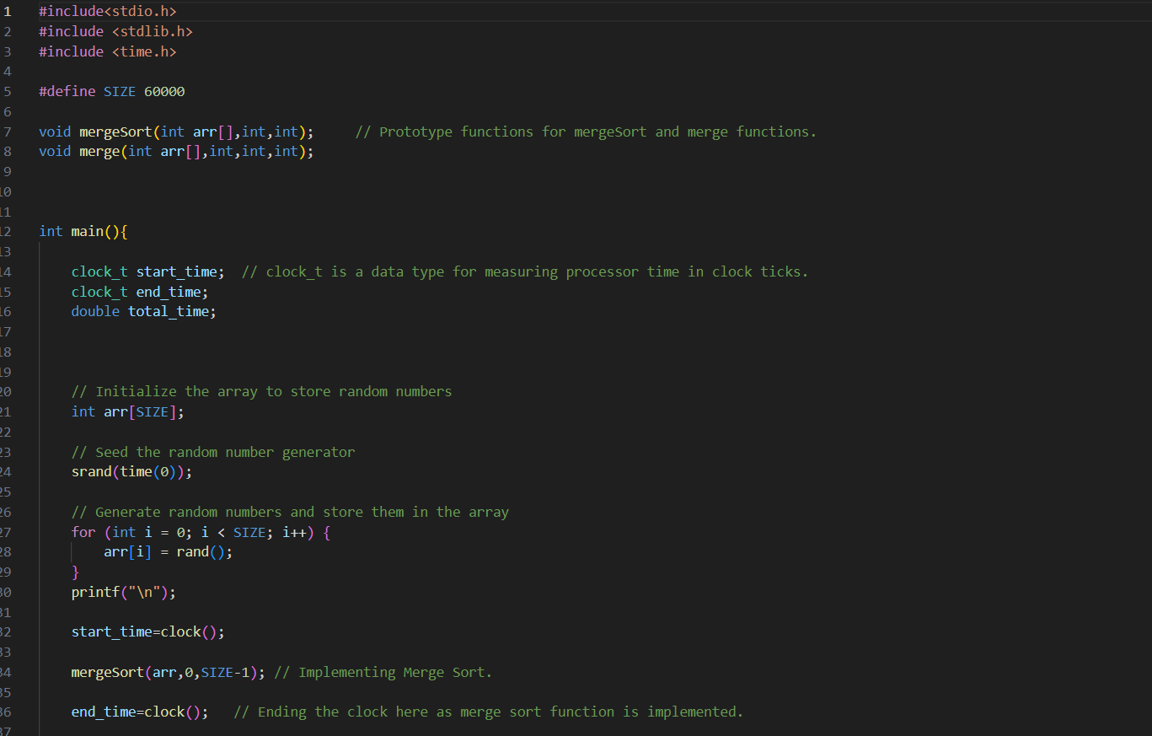

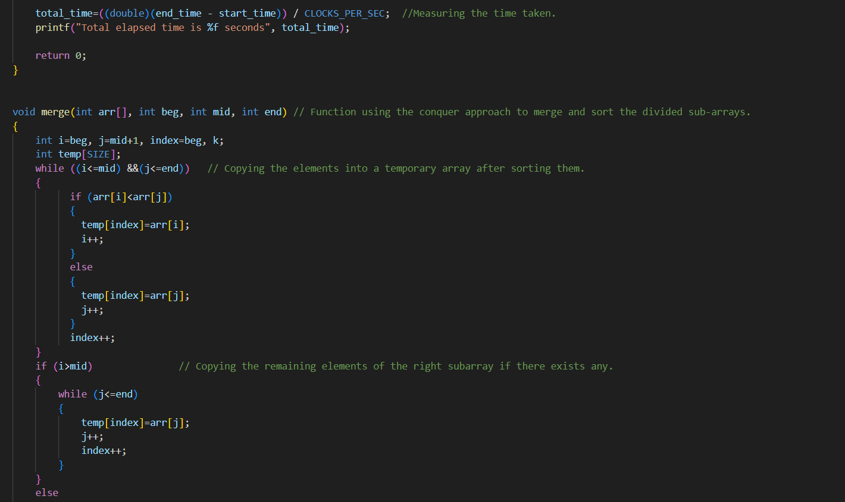

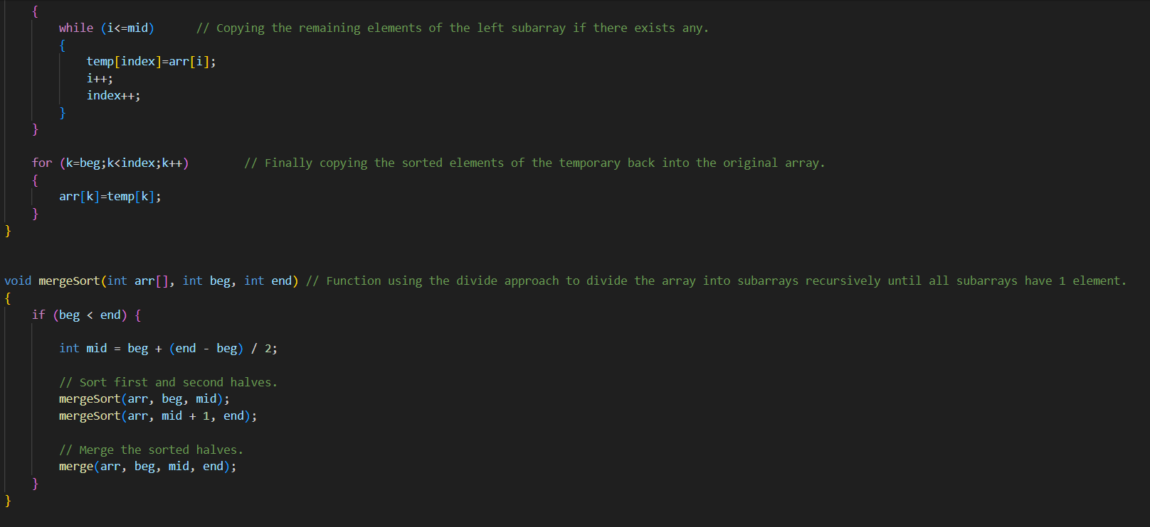

**QUICK SORT:**

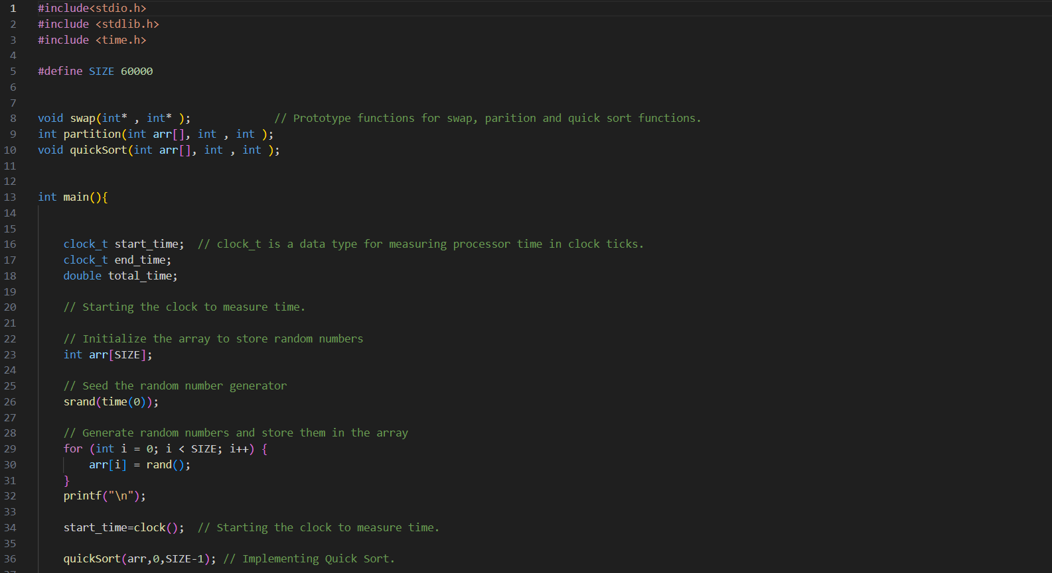

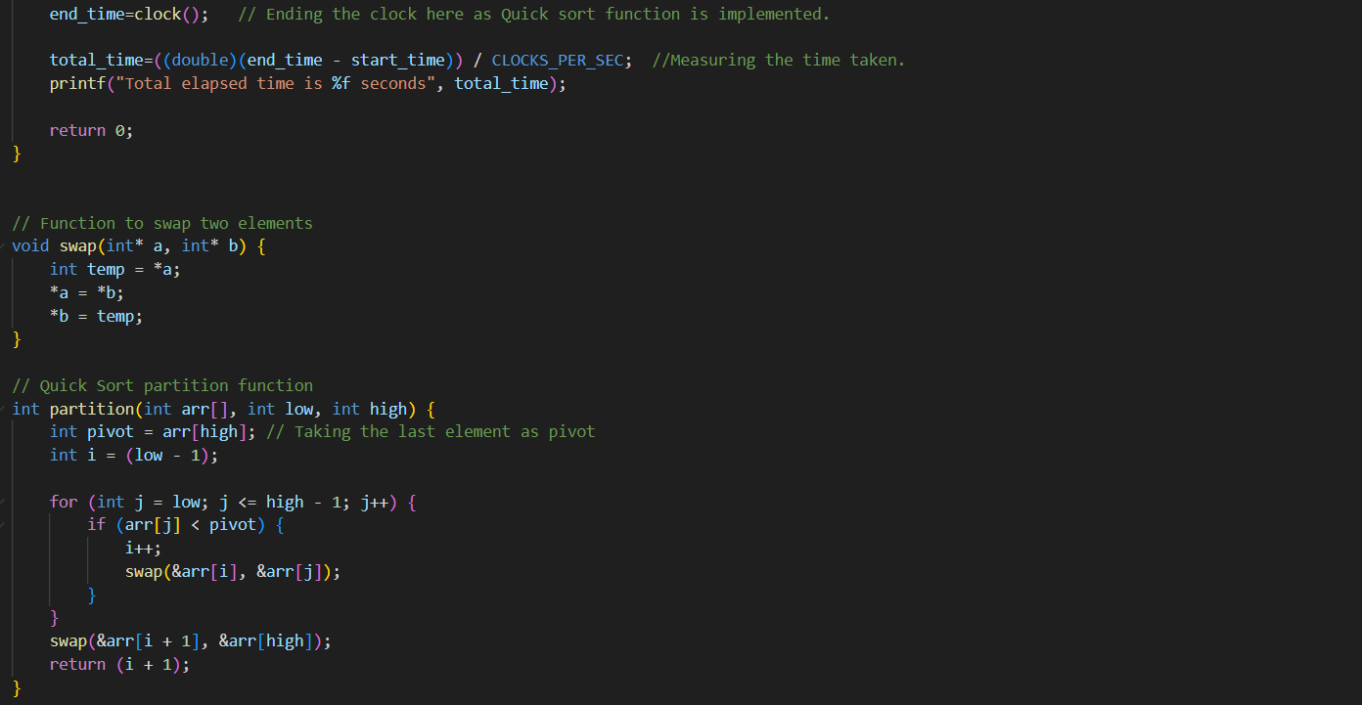

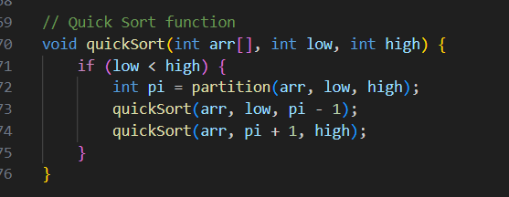

**OUTPUTS:**

**MERGE SORT:**

**1. N=10000**



**2. N=20000**



**3. N=30000**



**4. N=40000**



**5. N=50000**



**6. N=60000**



**QUICK SORT**

**1. N=10000**



**2. N=20000**



**3. N=30000**

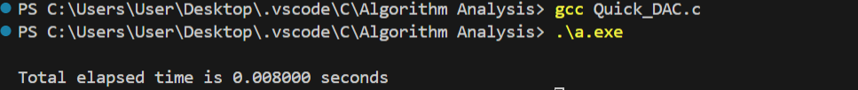

**4. N=40000**



**5. N=50000**

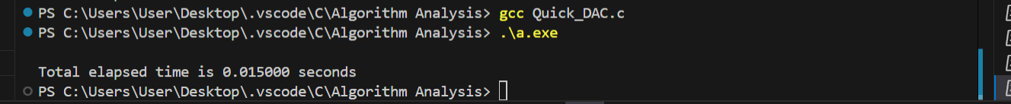

**6. N=60000**



**GRAPH ANALYSIS:**

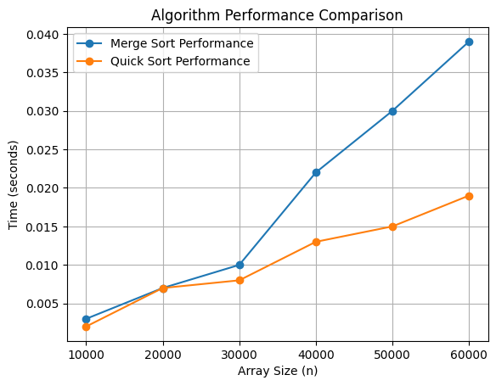

**EXPERIMENT 3**

**Compare the performance of Strassen method of matrix multiplication with traditional way of matrix multiplication.**

**CODE:**

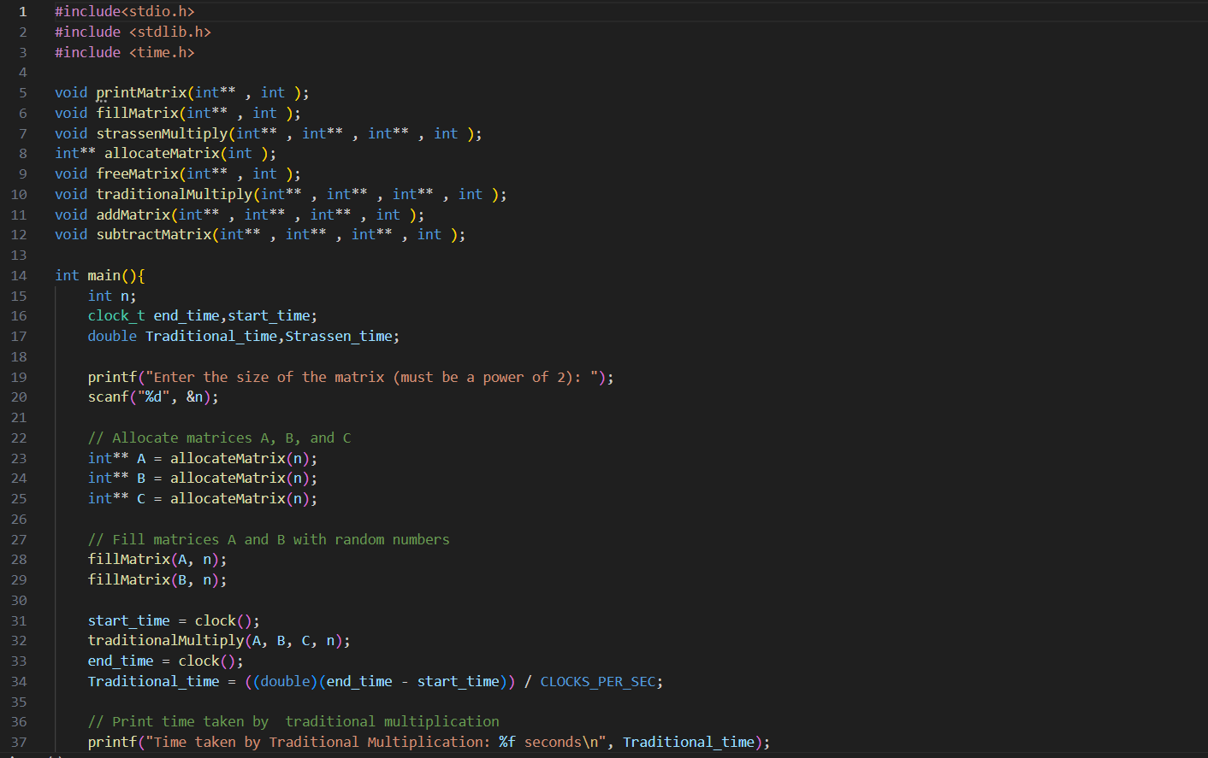

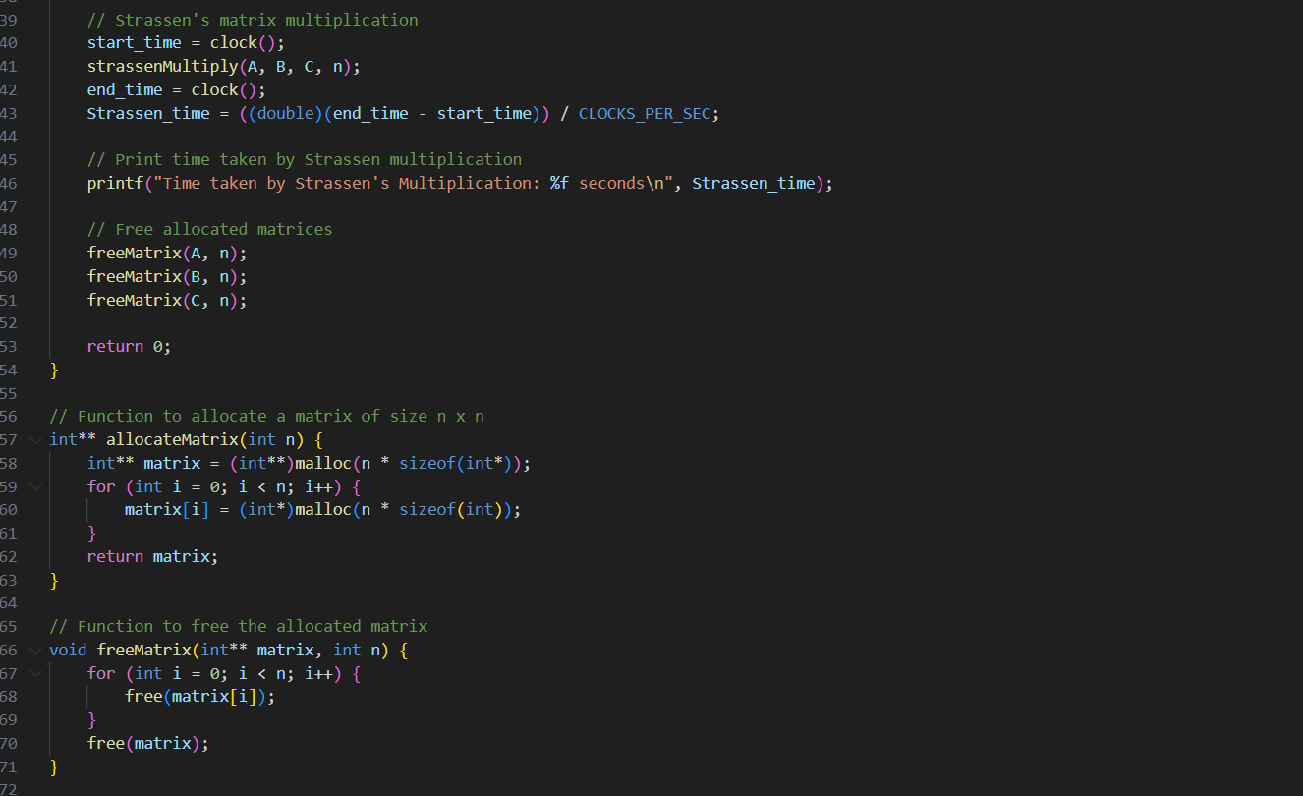

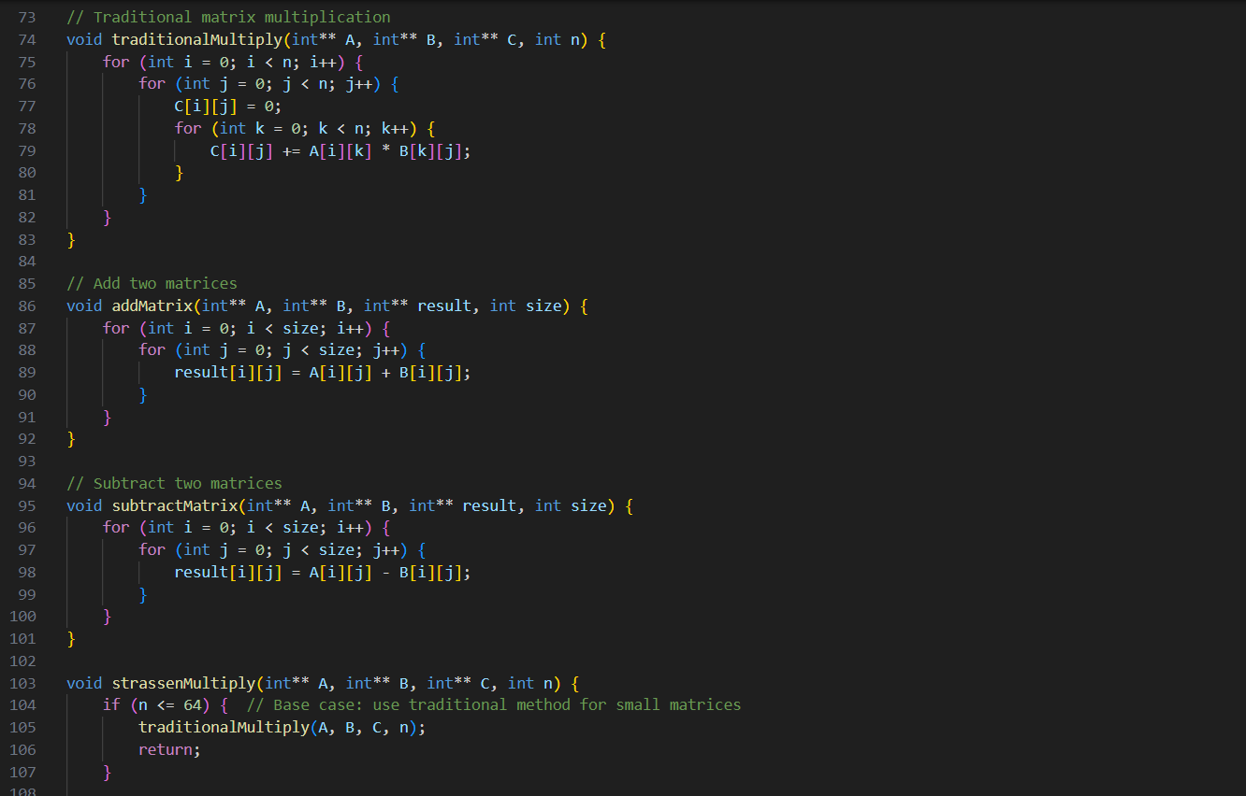

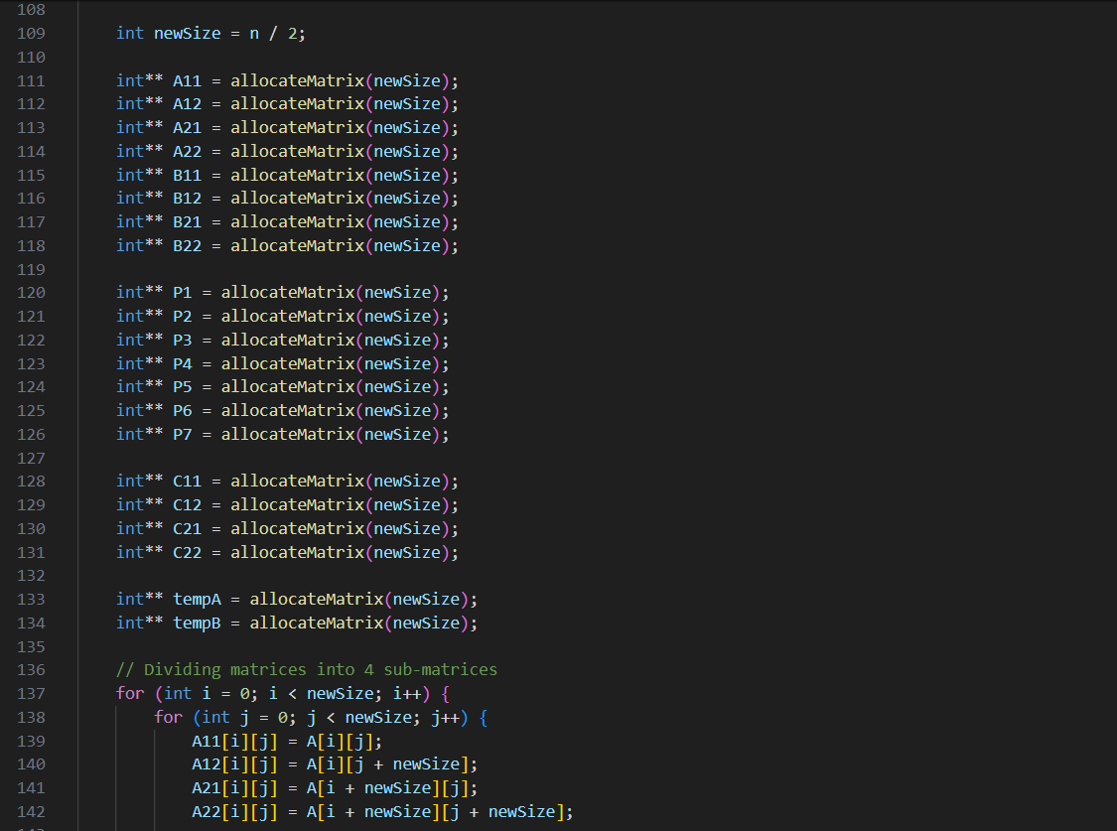

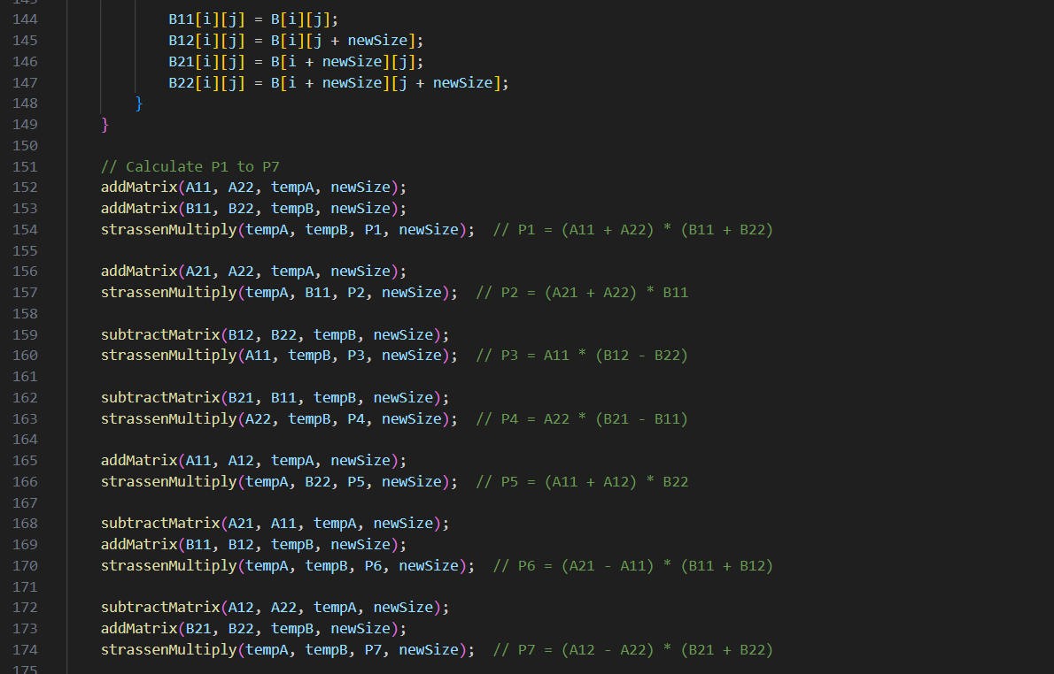

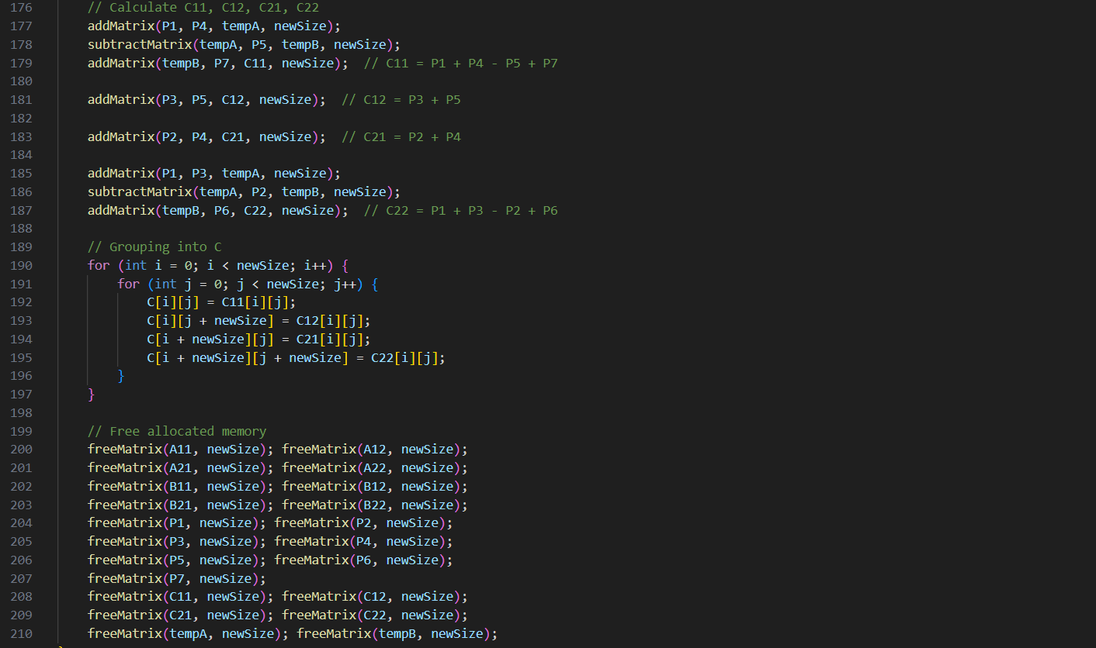

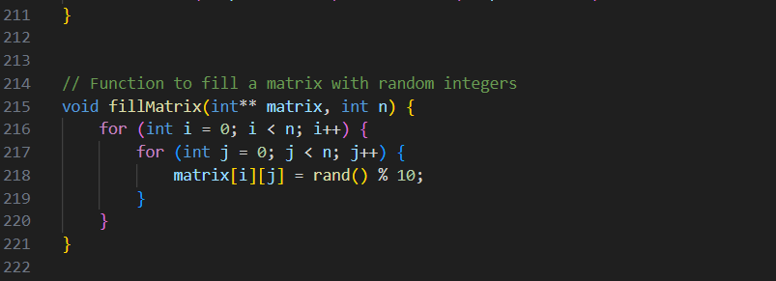

**OUTPUTS:**

**1.**

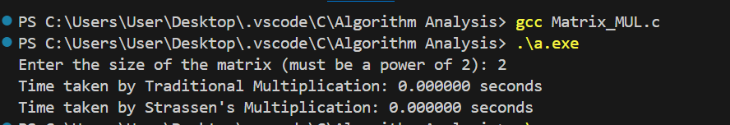

**2.**

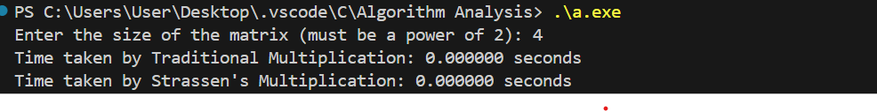

**3.**

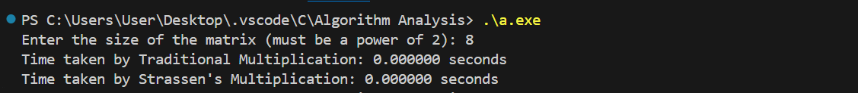

**4.**



**5.**



**6.**

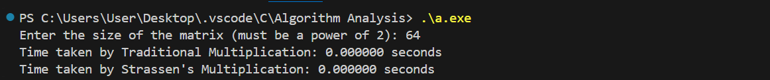

**7.**



**8.**



**9.**



**10.**



**11.**

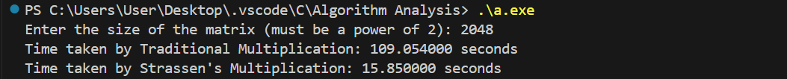

**12.**



**GRAPH ANALYSIS:**

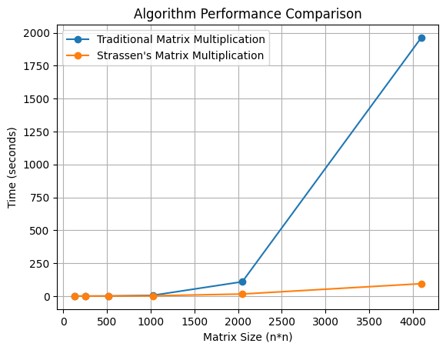

**EXPERIMENT 4**

**Implement the activity selection problem to get a clear understanding of greedy approach.**

**CODE:**

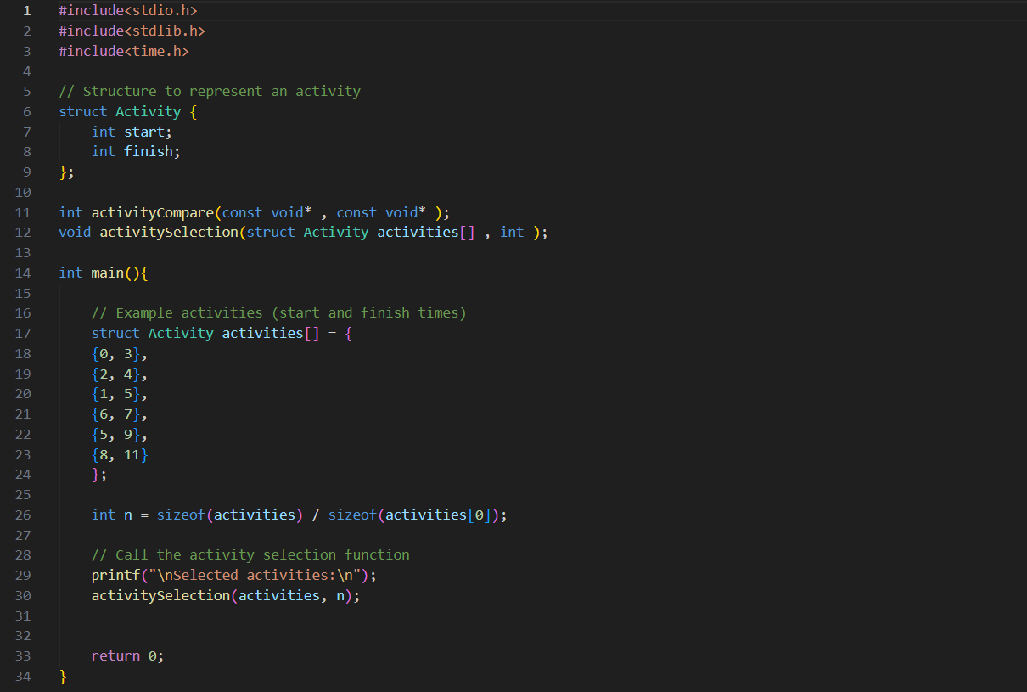

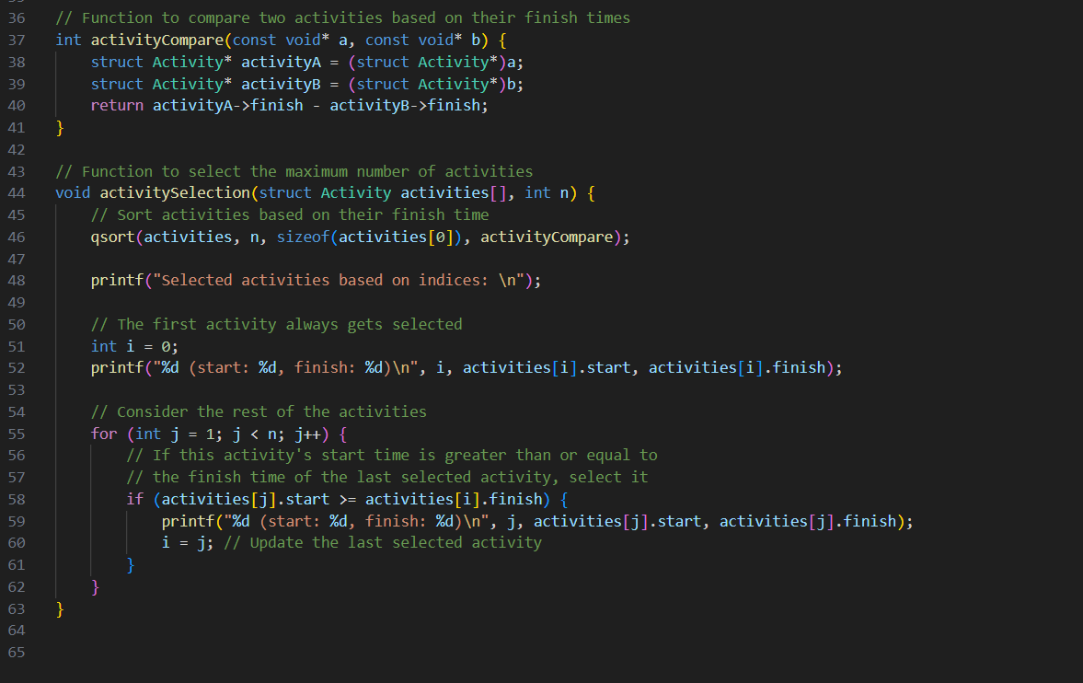

**OUTPUTS:**

**1.**

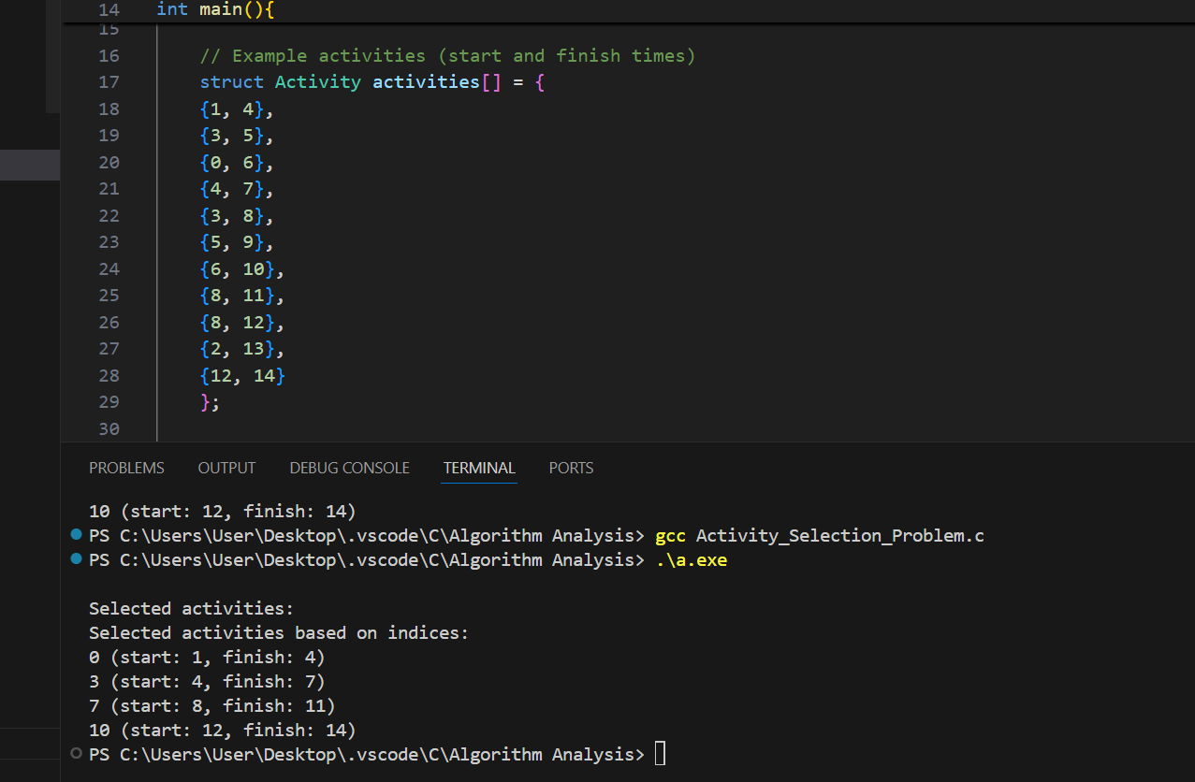

**2.**

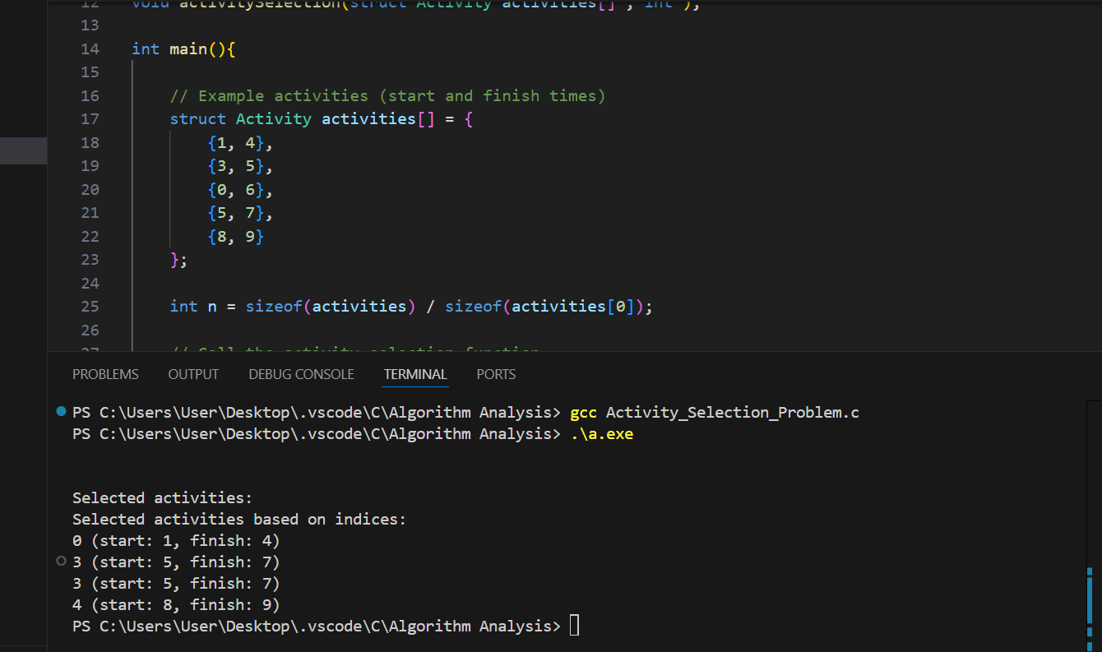

**3.**

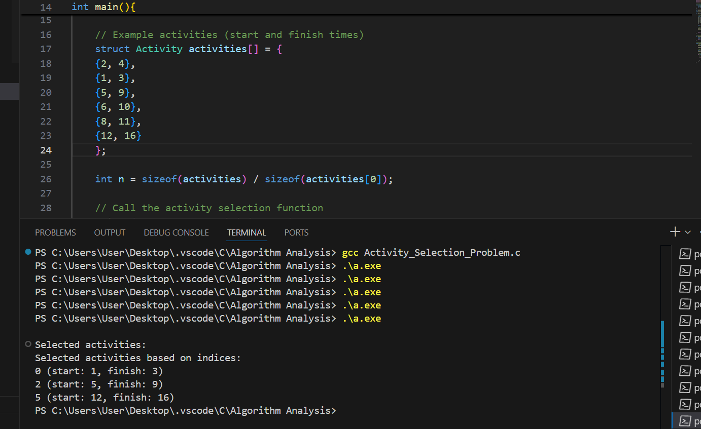

**4.**

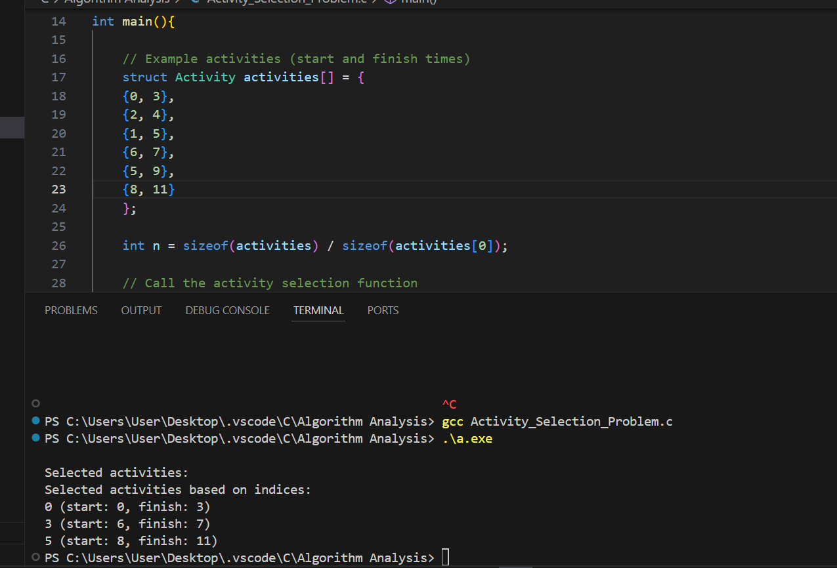

**EXPERIMENT 5**

**Get a detailed insight of dynamic programming approach by the implementation of Matrix Chain Multiplication problem and see the impact of parenthesis positioning on time requirements for matrix multiplication.**

**CODE:  
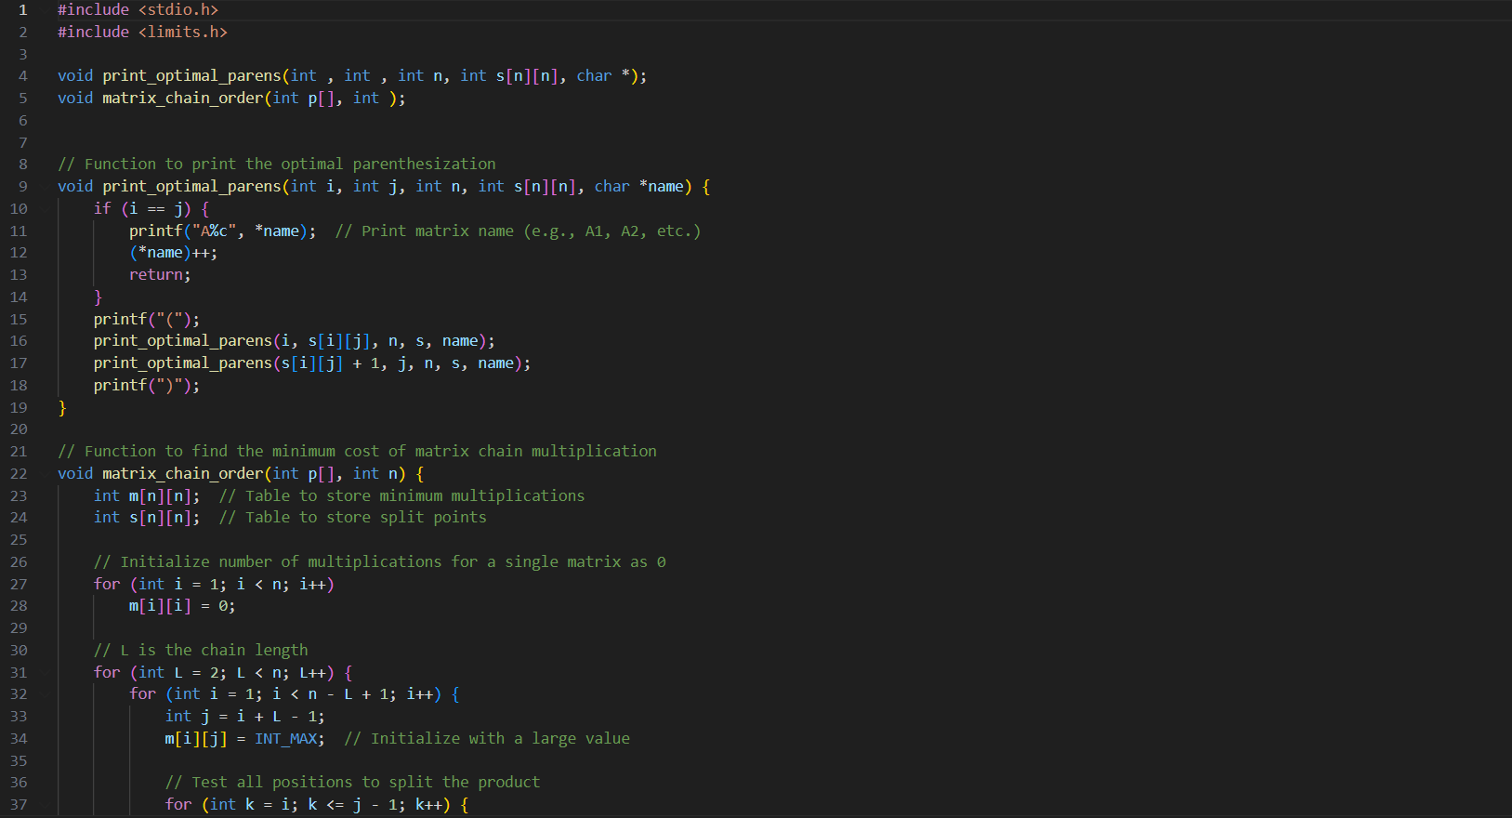**

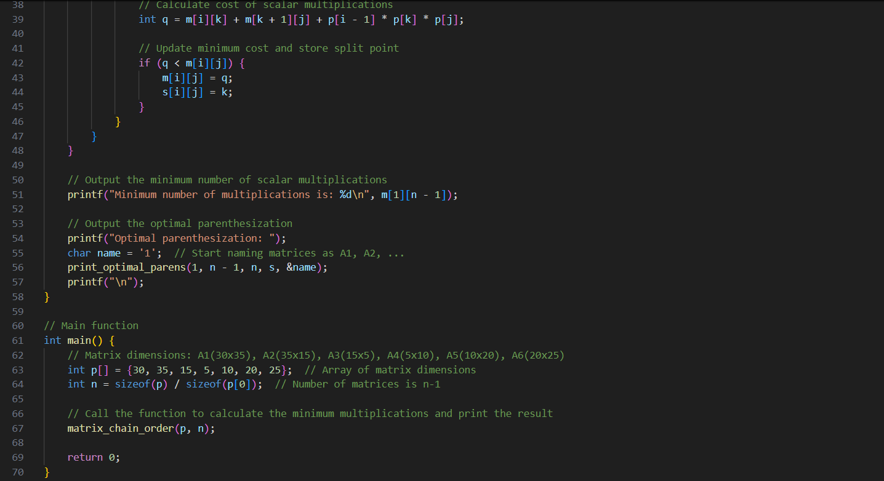

**OUTPUT:**

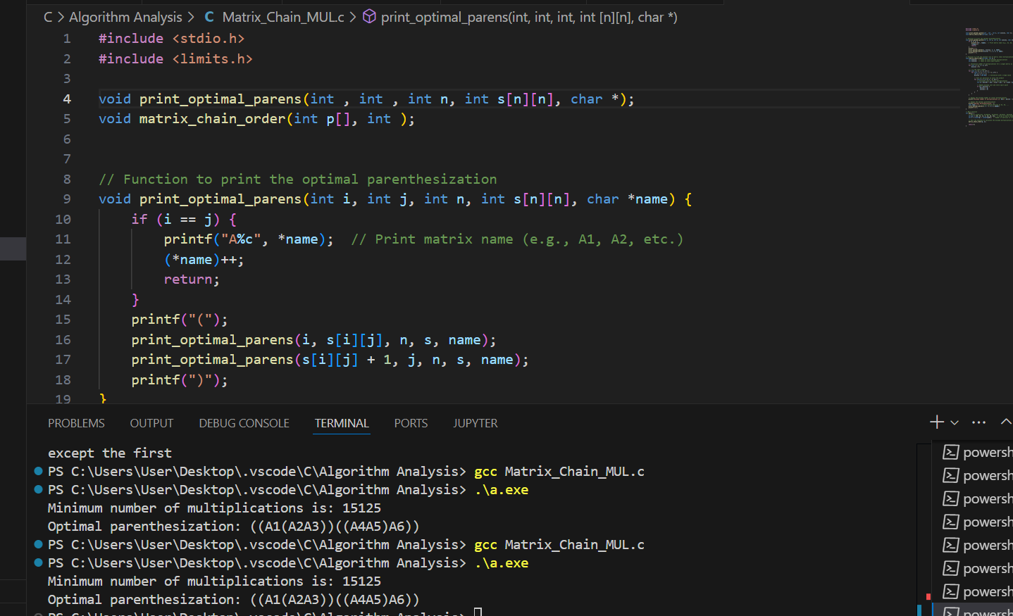

**EXPERIMENT 6**

**Compare the performance of Dijkstra and Bellman ford algorithm for the single source shortest path problem.**

**CODE:**

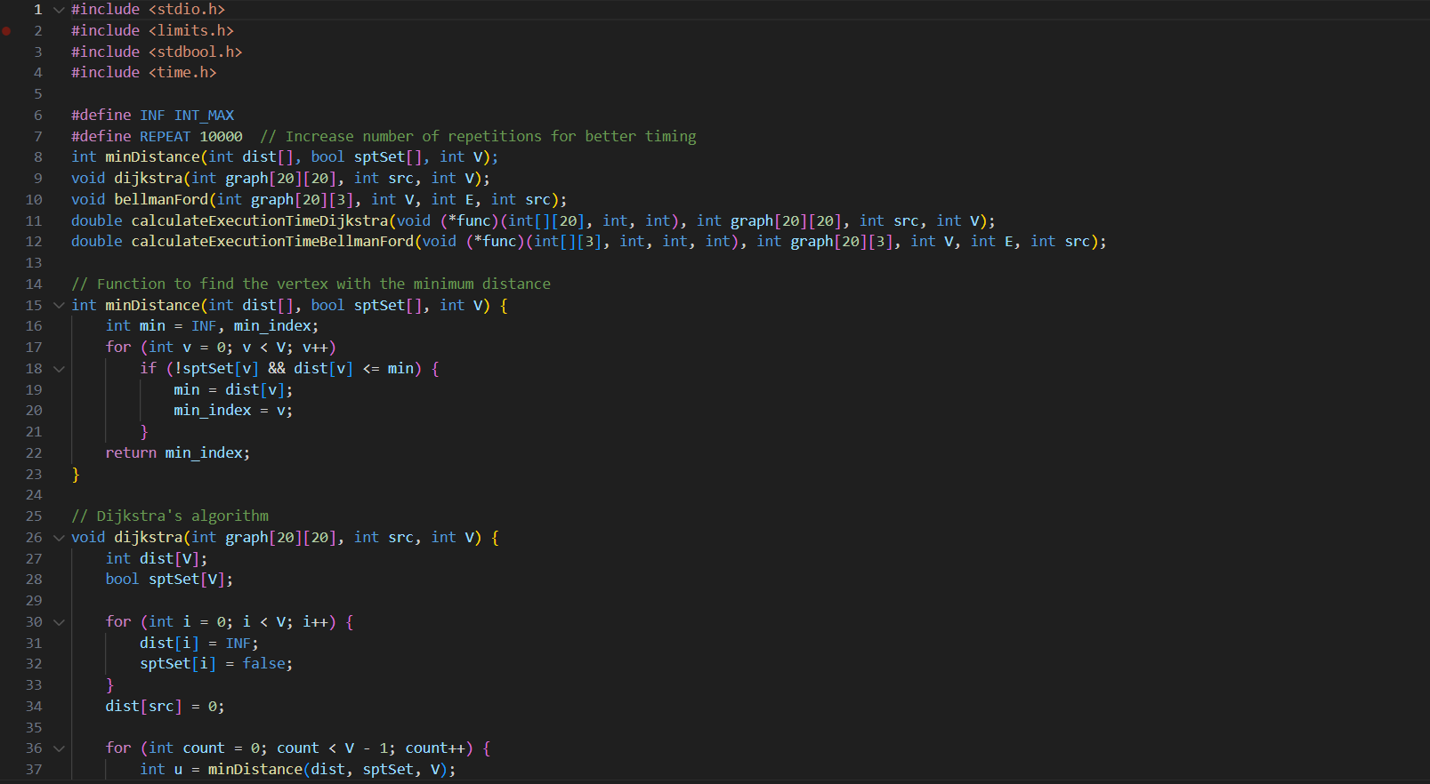

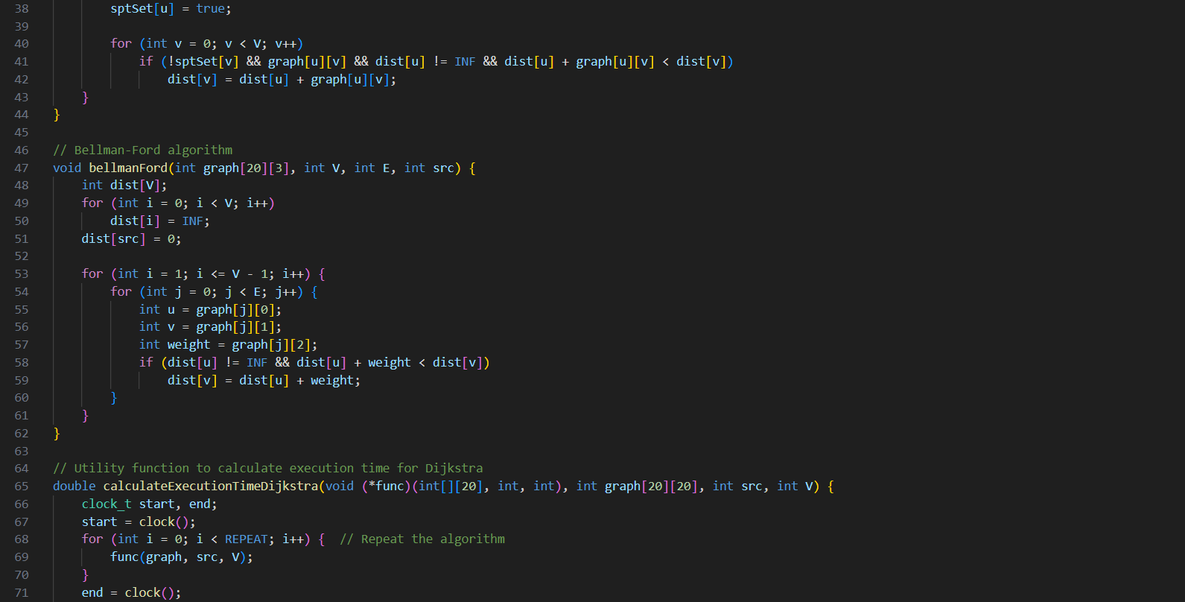

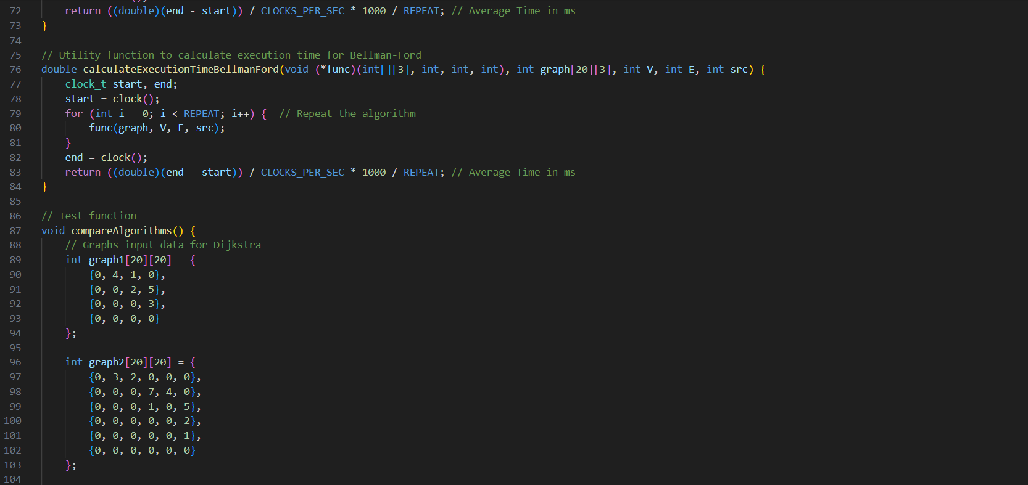

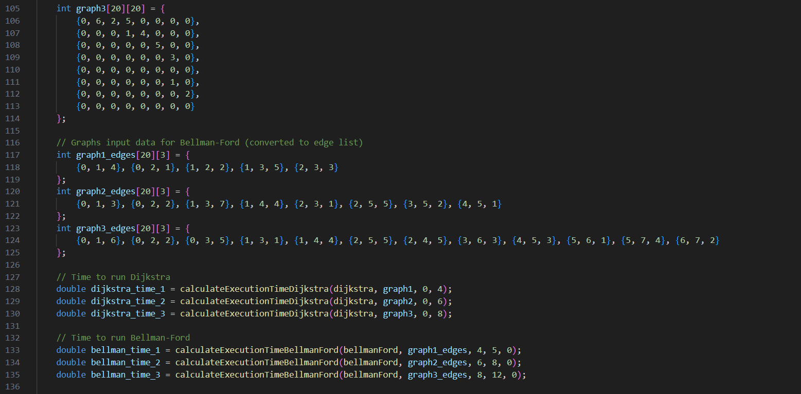

**OUTPUT:**

**GRAPH ANALYSIS:**

**EXPERIMENT 7**

**Through 0/1 Knapsack problem, analyse the greedy and dynamic programming approach for the same dataset.**

**CODE:**

**OUTPUTS:  
1.**

**2.**

**3.**

**4.**

**5.**

**EXPERIMENT 8**

**Implement the sum of subset.**

**CODE:**

**OUTPUT:**

**EXPERIMENT 9**

**Compare the Backtracking and Branch & Bound Approach by the implementation of 0/1 Knapsack problem. Also compare the performance with dynamic programming approach.**

**CODE:**

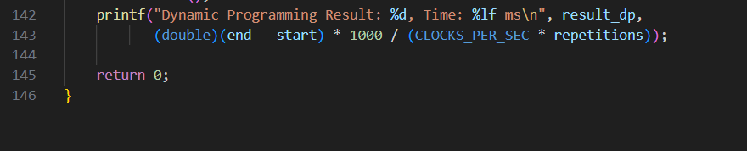

**OUTPUTS:**

**1.**

**2.**

**3.**

**GRAPH ANALYSIS:**

**EXPERIMENT 10**

**Compare the performance of Rabin-Karp, Knuth-Morris-Pratt and naive string-matching algorithms.**

**CODE:**

**OUTPUTS:**

**1.**

**2.**

**3.**

**4.**

**5.**

**GRAPH ANALYSIS:**

**MY GITHUB LINK:**

https://github.com/COBR-A/Algorithm_lab_3_sem_500120575