Blob feature extraction and tracking in fusion simulation data

Tom Peterka and Hanqi Guo

Fusion experiments are performed in a multi-billion-dollar Tokamak reactor to confine plasma in a magnetic field. During each experiment, the Tokamak can enter dangerous disruption states, violently damaging the plasma-facing wall and inducing large magnetic forces in surrounding metallic structures. Significant research has been performed to develop methods to predict such occurrence of disruption, but little research has been reported using graph or topology theory, which can improve prediction speed and accuracy.

During a simulation, a large number of time-series data (up to a few terabytes per second) are computed at microsecond granularity. The XGC code computes the kinetics at the edge of the Tokamak while the GENE code computes the kinetics in the core. Both codes are 5D kinetic particle codes. The particles are ions and electrons, and the 5 dimensions include 3 position and 2 velocity dimensions. The two codes are coupled in an approximately 3 cm wide area in which they exchange fluid properties that have been resampled onto a mesh.

We are developing analysis and visualization algorithms to robustly extract and track blob features in the Tokamak simulations. We would like to first mathematically define blobs as topological critical points in every single 2D mesh plane, i.e. maxima, minim, and saddles in the Morse-Smale complex theory. We then associate the blobs across all 2D planes and over time based on the theories. We are also developing event graphs of births, deaths, mergers, and bifurcations in the spirit of those shown in Figure 1, which are the result of blob tracking done on experimental microscopy rather than simulations.

Regions of high turbulence that can damage the Tokamak, so called “blobs,” can run along the edge wall down toward the diverter and damage it. Hence, it is necessary to detect blobs, compute statistics over them to rule out low-energy insignificant ones, and track the high-energy blobs across time steps. The noisiness of the models together with the high rates make this a challenging computer science problem, for which no good automatic and reliable method exists.

While those raw data can be independently analyzed or combined in a multi-dimensional array, a graph representation of measured data can provide a new way to explain evolution, track changes, detect anomalies, and help uncover hidden cause-and-effect relationships. Tracking blobs with merging and splitting events is needed to understand how events evolve and either become disruptive or remain normal; how to trace unstable plasma bifurcation or turbulence; how to relate different types of events from different codes; and whether cause-and-effect can be derived from heterogeneous simulation codes are all questions that we want to study.

We are also developing in situ blob tracking that couples with the XGC/GENE code. We are going to integrate the analysis code with the ADIOS 2.0 framework, and get access to the simulation outputs during the run. We expect to extract finer details in the simulation data than previously possible with in situ processing.

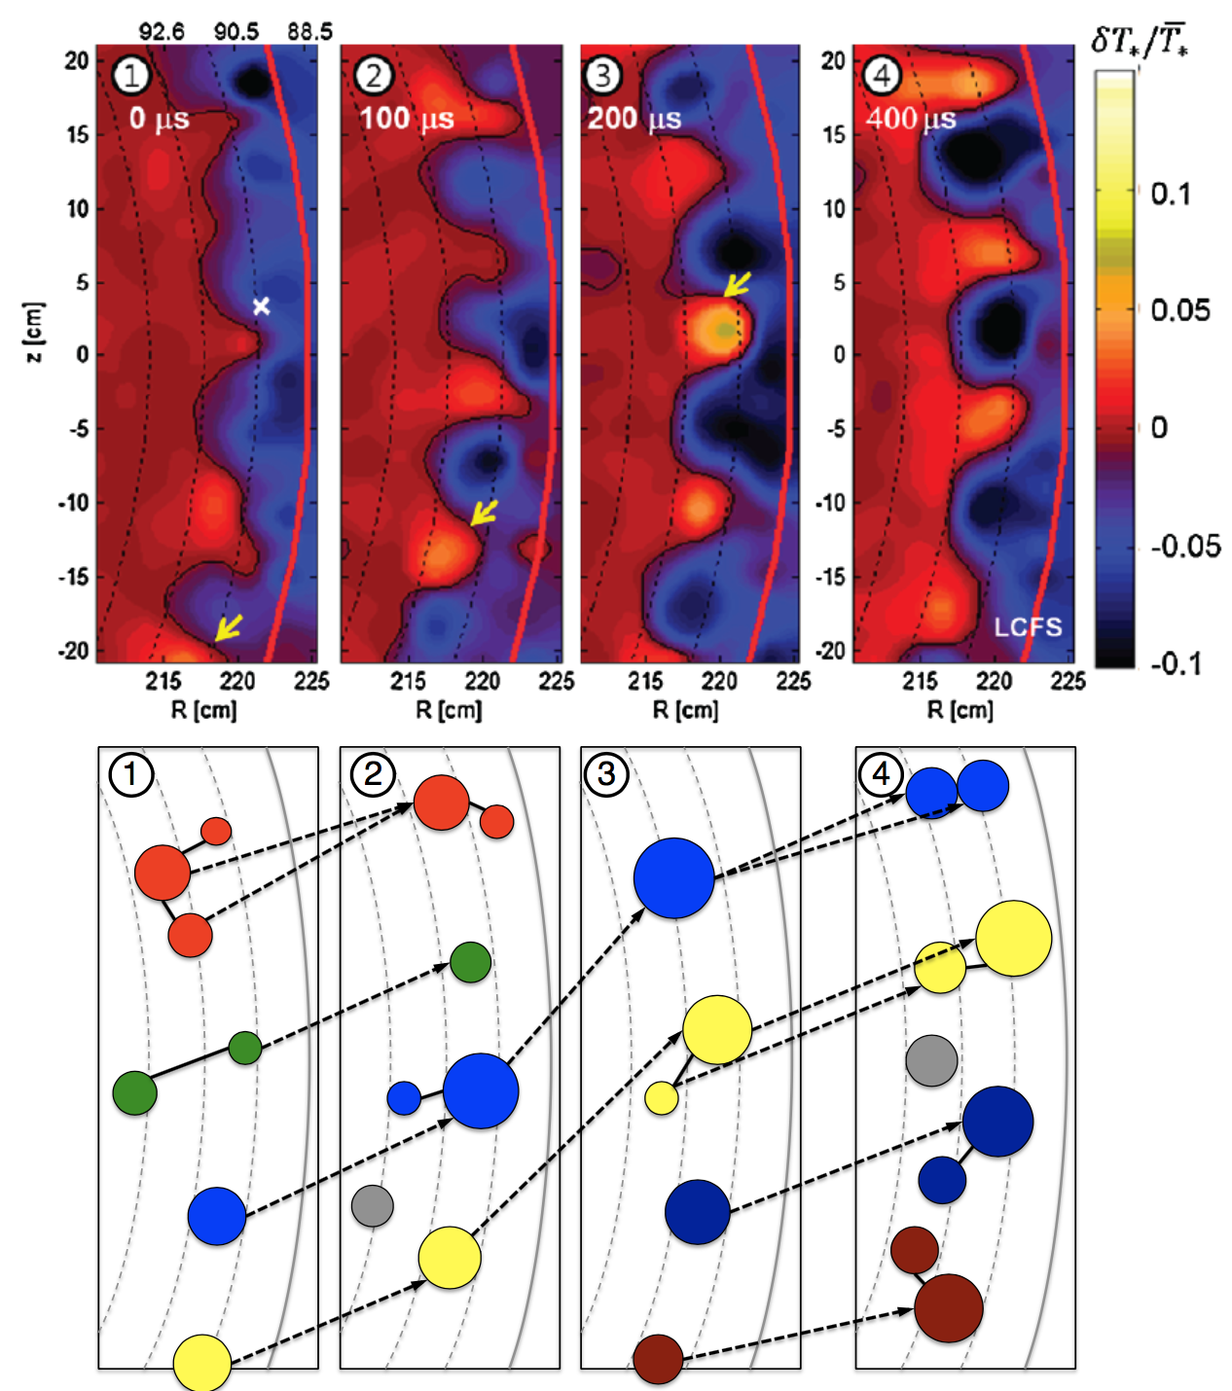

Figure 1. Top: ECEI images captured over 400μs [1]. Bottom: Blob tracking using colored nodes and node sizes to represent different toroidal groups and intensity of blobs. [image courtesy S. Klasky]

[1] Yun, G. S. and Lee, W. and Choi, M. J. and Lee, J. and Park, H. K. and Tobias, B. and Domier, C. W. and Luhmann, N. C. and Donné, A. J. H. and Lee, J. H. Two-dimensional visualization of growth and burst of the edge-localized filaments in KSTAR h-mode plasmas. Physcal Review Letters, 107:045004, Jul 2011.