My Awesome Report

Marcela Alfaro Córdoba

## Introduction

This report uses the **tidyverse** package along with the *SAFI* dataset, which has columns that include:

* village
* interview_date
* no_members
* years_liv
* respondent_wall_type
* rooms

Or if you prefer:

1. village
2. interview_date
3. no_members
4. years_liv
5. respondent_wall_type
6. rooms

Or if you want to add sections:

* village
  + Name of village
* interview_date
  + Date of interview
* no_members
  + How many family members lived in a house
* years_liv
  + How many years respondent has lived in village or neighbouring village
* respondent_wall_type
  + Type of wall of house
* rooms
  + Number of rooms in house

We can also add a caption.

| Village | Member Association | Mean Number of Members |
| --- | --- | --- |
| Chirodzo | no | 8.062500 |
| Chirodzo | yes | 7.818182 |
| God | no | 7.133333 |
| God | yes | 8.000000 |
| Ruaca | no | 7.178571 |
| Ruaca | yes | 9.500000 |

Now we can make an informative statement on the means of each village, and include the mean values as in-line R-code. For example:

The average household size in the village of Chirodzo is 7.08

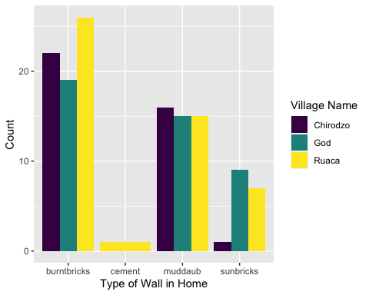

I made this plot while attending an awesome Data Carpentries workshop where I learned a ton of cool stuff!