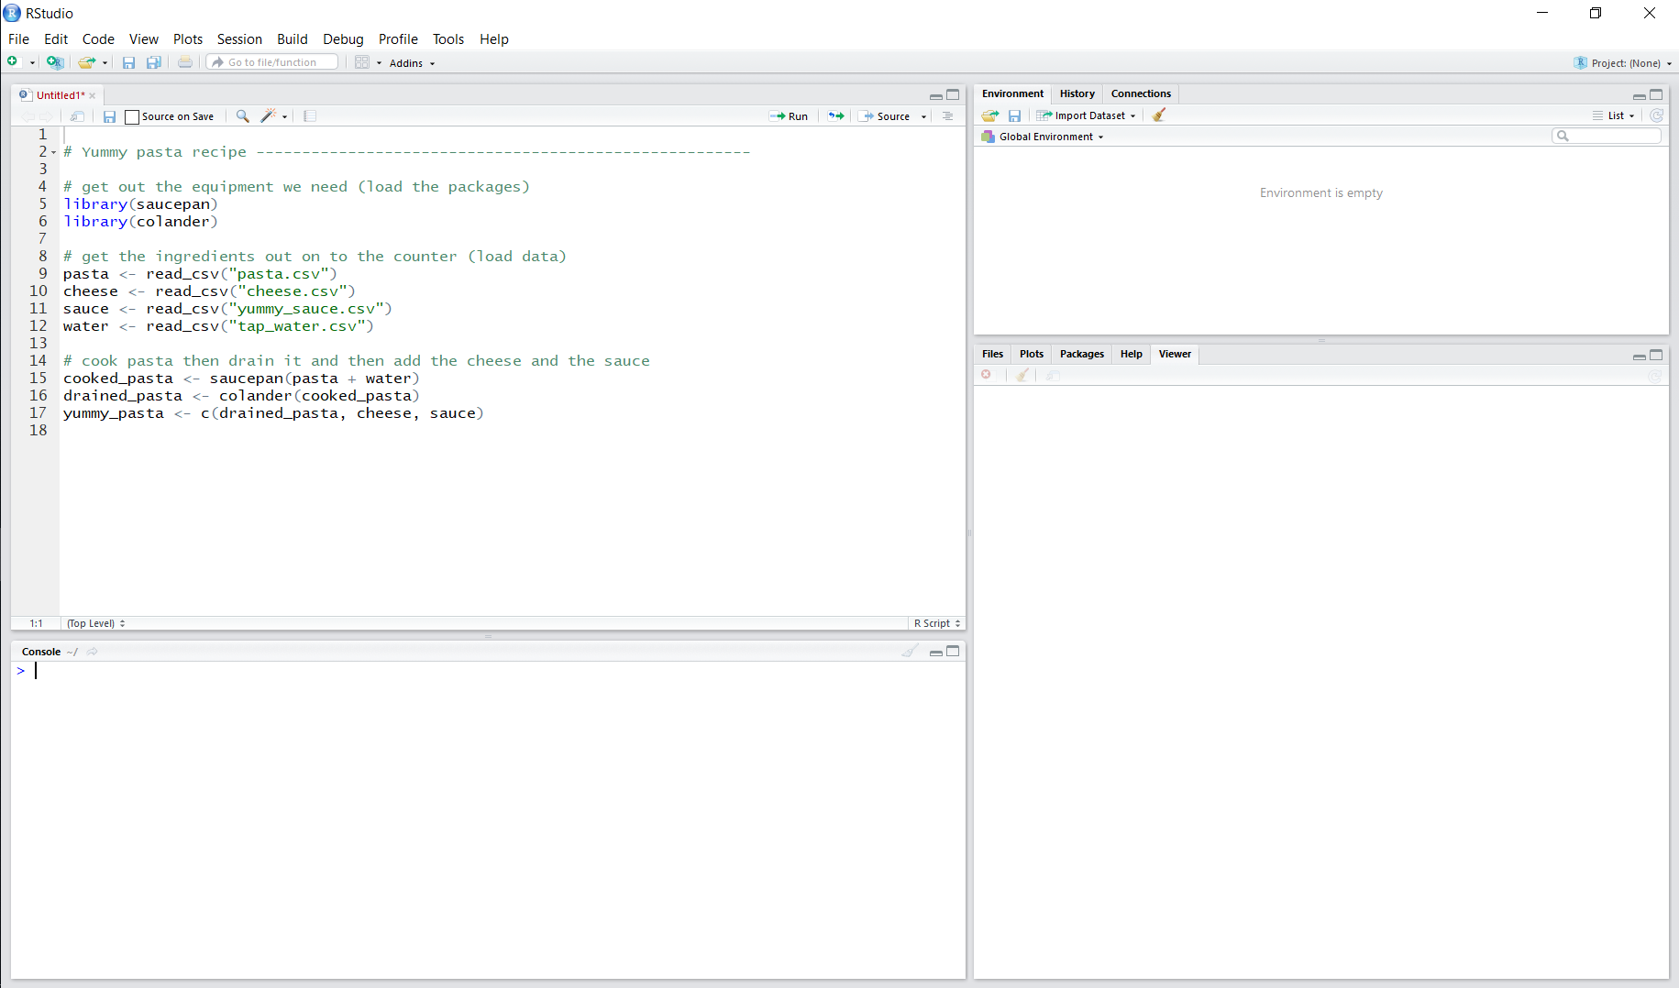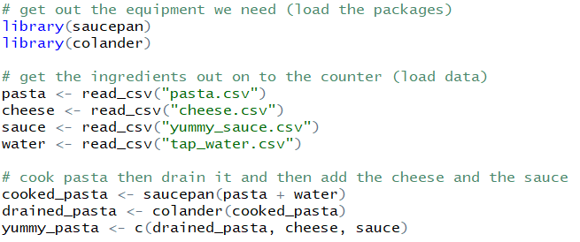

**Scripts are recipes (records) of how to do things.**

Write and save your recipes here so that R knows what to cook.

**The console is where the cooking happens - send recipes here (run code) to cook them.**

You can cook here without using a recipe, but you’ll struggle to remember exactly how to recreate the dish in the future.

It’s better to use a recipe!

**The environment is like the kitchen counter - you can put ingredients (data) and finished dishes (model outputs) here to use while you cook.**

**Files are like ingredients in your cupboard - you need to get them out on to the kitchen counter (the environment) to use them.**

The files that you need can be specified in the recipe so you know exactly what you need to get out.

**Packages are like tools - when you need to use a saucepan, you go out and buy one that someone has already designed and made [**install.packages()**].**

**Each time you want to use that pan, you just take it out of the cupboard [**library()**].**

