PROJECT REPORT ON
"TURBINE SYSTEM IN THERMAL POWER PLANT"

AT NTPC LIMITED, KANIHA TALCHER
FORPARTIAL FULFILLMENT OF

INTERNSHIP (2025-2026}




NATIONAL THERMAL POWER CORPORATION LIMITED INDIRA GANDHI INSTITUTE OF TECHNOLOGY, SARANG

GUIDED BY:

Pramod Chandra Bhutia
(C&L) NTPC Kaniha
SUBMITTED BY:
Snehaprava Sahoo
6th Semester, B.Tech ( Civil Engineering )
Redg.No.: 2301105179

CERTIFICATE

This is to certify that Snehaprava Sahoo , a student of
6th Semester B.Tech. (Civil Engineering) from INDIRA GANDHI INSTITUTE OF TECHNOLOGY, SARANG, has undergone his industrial training at TSTPS, NTPC Ltd., Kaniha Talcher, from 25th may 2026 , to 20th June 2026.
During her training period, he successfully completed his project work on "Turbine System in Power Plant" at NTPC Ltd. in Kaniha Talcher.
His performance was excellent, and he maintained the utmost discipline during his training period at NTPC Ltd., Kaniha Talcher.
We wish him all success in his future career.

Pramod Chandra Bhutia

ACKNOWLEDGEMENT

"It is not possible to prepare a project report without the assistance and encouragement of other people. This one is certainly no exception."
At the very outset of this report, I would like to express my sincere and heartfelt obligation towards all the people who have helped me in this endeavour. Without their active guidance, help, cooperation, and encouragement, I would not have made headway in my industrial training.

I am ineffably indebted to Mr Pramod Chandra Bhutia , for his conscientiousness and encouragement to accomplish this assignment.

I am extremely thankful and express my gratitude to all my faculty guides. I extend my gratitude to NTPC Ltd., Kaniha, and the HR-EDC Department of NTPC Ltd., Kaniha, for giving me this opportunity. I also acknowledge, with a deep sense of reverence, my gratitude towards my parents, who have always supported me morally as well as economically.

Any omission in this brief acknowledgement does not mean a lack of gratitude.

Thanking You,

Snehaprava Sahoo

CONTENTS

- NTPC
- TALCHER SUPER THERMAL POWER STATION (TSTPS}
- COAL-FIRED THERMAL POWER PLANT
- WORKING OF THE THERMAL POWER PLANT
- POLLUTION CONTROL OF THE COAL THERMAL POWER PLANT
- ADVANTAGES AND DISADVANTAGES
- STEAM TURBINE
WORKING PRINCIPLE RANKING CYCLE TURBINE OPERATION
- TYPES OF STEAM TURBINE
IMPULSE TURBINE REACTION TURBINE
- PORTION OF STEAM TURBINE
HP TURBINE IPTURBINE LP TURBINE
- LOSSES IN STEAM TURBINE
- PROCESS SURVEILLANCE
- COMPONENTS OF STEAM TURBINE TURBINE CASING TURBINE ROTORS
TURBINE BLADES STEAM NOZZLE
TURBINE BARRING DEVICE TURBINE BEARING
  - RADIAL BEARING
  - THRUST BEARING TURBINE SEALS
  - SHAFT SEAL
  - BLADE SEAL GOVERNOR
- COMPOUNDING OF STEAM TURBINE NECESSITY OF COMPOUNDING
- TYPES OF COMPOUNDING
VELOCITY COMPOUNDING OF IMPULSE TURBINE PRESSURE COMPOUNDING OF IMPULSE TURBINE PRESSURE-VELOCITY COMPOUNDING OF IMPULSE TURBINE PRESSURE COMPOUNDING OF REACTION TURBINE
- INCREASING STEAM TURBINE POWER GENERATION EFFICIENCY
- CONCLUSION AND REFERENCE

NTPC LIMITED:

NTPC Limited, formerly known as National Thermal Power Corporation Limited, is an Indian government owned electrical utility company. It engaged in the business of generation of electricity and aloud activities I teach in company incorporated under the Companies Act 1956 and each under the ownership of ministry of power Government of India the headquarters of the company is situated at New Delhi. NTPC's core business is the generation and scale of electricity to state on Power Distribution companies and state electricity borders in India. The company also undertakes consultancy and turnkey project contract that involve engineering project management, construction management and operation and management of power plants.
The company has also ventured into oil and gas exploration and coal mining activities. It is the largest power company in India with anelectric power generating company of 62,086 MW. Although the company has approx. 16% of the total national company contributes to over 25% of total power generation due to its focus on operating its power plants at higher efficiency level (approx. 80.2% against the national PLF rate of 64.5%). NTPC currently produce 25 billion units of electricity per month.
NTPC currently operates 55 power station (24 coal, 7 combined cycle gas/liquid fuel, 2 Hydro, One wind, and 11 solar projects). Further it has 9 coal and one gas station on bye joint ventures or subsidiaries.
It was founded by Government of India in 1975, which now holds 54.74% of its equity shares on 30 June 2016 (after advertisement of its stake in 2004,2010,2013,2014,2016 and 2017)
In May 2010, NTPC was conferred Maharatna status by the union government of India, one of the only for companies to be awarded this status. It is ranked 400th in the service global 2000 for 2016.

TALCHER SUPER THERMAL POWER STATION:

Talcher Super Thermal Power Station or NTPC Talcher Kaniha located in Angul distance of the Indian in state of Odisha is the first-mega power plant of India to have an installed generation capacity of 3000MW. The power plant is one of the coal-based power plants of NTPC. The coal for the power plant is sourced from Lingraj block and Kaniha coal block of Mahanadi coalfields Ltd. Source of water for the power plant is from Samal Barrage reservoir on Brahmani river.
The plant supplies power to Indian states of Odisha, Andhra Pradesh, Karnataka, Telangana as well as Bihar and West Bengal. The East South interconnection of the Indian power grid starts from NTPC Kaniha and ends at Kolar in Karnataka. This being a DC link is one of its kind in India up till now there are only 3 installed HVDC system presents in India. The southern grid is weakly interconnected to the National Grid of India through the Talcher-Kolar HVDC system in the East.

COAL FIRED THERMAL POWER PLANT:

Coal-based power plants are a type of power plant that use coal combustion to generate electricity. Countries like South Africa use coal for 94% of their electricity, and China and India used 72-75% of coal for their electricity needs; however, The amount of coal China dwarfs in other countries. There are use provides about 40% of the world's electricity, and they are mainly used in developing countries.
The use of coal provides electricity to those who didn't have it before, which helps to increase the quality of life and reduce poverty in those areas; however, it produces a large number of varies pollutants that are used in the air. Reduce quality and contributes to climate change.

REHEATER Al TOR

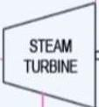
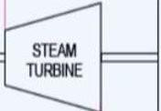
STEAM

BOILER
C
FUEL
ffi
2
0_{z} 0
I.)
w
Su:>ERHEATER
J; l1
EJ
A.U
GAS
I GRATE I
[ BLEEDING
CONDENSER

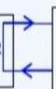
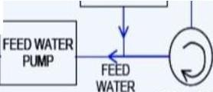
COt,OfNSATE

MAKEUP
WATERTAN<
COOLING TOWER OR RIVER

FLU1 A.i1

GAS GAS
AR FR0.4
ATMOSPHERE
, , FEE_{T}D _{E}WA_{R}TER
FEED
WATER, .

CONDENSATE PLM>

WORKING OF COAL BASED POWER PLANT:

The work of the coal power plant being with the arrival of coal from the coal mines buy a train. The coal is then transported to the power plant to be convert into a powder form. The main reason behind converting into powered it to increase the efficiency of burning by increasing its contact area exposed to higher in the burner as compared to solid coal.

This coal dust is feed through a blower in the boiler; the thermal energy released from this
Fuel is used to boil water up 1000-degree Fahrenheit thus converting it into high pressure steam that is transferred to turbine. This energy is used to generate electricity through a generator. Due to such high rpm the voltage output of the generator approximately 24,000 Volt which can be transferred to about 40,000 volts by transmission cables. The stream is expanded one by one in 3 consecutive turbines to take pole advantages of the pressure energy. These turbines actually turn at high rpm which convert pressure energy into mechanical energy. The temperature of this water is kept under safe range so that it does not harm the aquatic life of the water bodies. Furthermore, to extract heat from this team the cold water of the reservoir or river is pump in to the condenser and after heat exchange it is pumped back into the water body.

MAIN COMPONENTS:

0 l .CONVEYOR BELT:

Coal from the Coal storage area are transported to the plant through a large conveyor belt the load carrying capacity of this belt is very high because very large quantities of coal are required every day.

PULVERIZING UNIT:

The coal transported by conveyor cannot be used in the same way as previously converted to powder, also known as inflicted coal. It is designed to rotate in a cylindrical tank at high speed with several spherical steel balls and it thus convert into powder the pulverizing plant also has a close enhanced coal storage and can store up to 30 hours of coal reserves.

BOILER:

The inflicted coal is fed into the boiler through large fans flowing hot air. The boiler consists of several water-field taps, and these tubes boil water up 1000 °Fahrenheit and the flames in the boiler go up to 50 meters.

TURBINE:

High-pressure steam at 1000°Fahrenheit from the boiler and 3500 pounds per square inch of pressure is then fed to the steam turbine, which converts it pressurized energy into Mechanical energy.

O5.GENERATOR:
A generator uses the mechanical energy generated by the turbine to generate electricity at significantly higher voltages.
06.CONOENSER:
The steam leaving the turbines is condensed into a condenser which is pumped back into the boiler. Cold water from a water source (River) or expansion processes is used to cool steam into water.

POLLUTION CONTROL OF COAL BASED THERMAL POWER PLANT:
The biggest drawback of a coal power plant is its fly ash contained are the release of sulphur dioxide during coal bearing. All coal-fired power plants are always under the scrutiny of agencies involved in environmental pollution. Also, there is always pressure on developing countries to keep their division level under control.
Smoke-blowing ash is removed by mechanical process, sulphur dioxide is removed by reaction with lime, thus converting it intogypsums, which can be used in agricultural field & many. There is other application. The entire process takes place in scrubber that is located between the boiler and the chimney.
A mixture of lime and water is sprayed on the smoke emanating from the boiler, reducing the amount of ash boiling in the air by 1% and reducing the amount of sulphur dioxide by 93%. Replated fly ash can also be used in making concrete and other anti-skid rod materials. In some coal power plant Nitrogen dioxide are also remove from the smoke. ATS passed into cars through catalytic converter to remove nitrogen dioxide.
The catalytic converter consists of layer of ammonia. When nitrogen dioxide pass through these layers, it reacts with ammonia and converted into nitrogen and water. Nitrogen is released into the atmosphere because the amount of nitrogen in the air we breathe is 71%, so it is quite safe.

ADVANTAGES:
- It is one of the most reliable sources of energy, considering other power plants that depends on whether condition, such as wind power plants and hydropower plants.
- It is the cheapest sourced of energy available to produces electricity for good economic development of the country.

- It's and products such as gypsum and precipitated ash can be used in many applications.
- It is available in plenty, so there will beno interruptions in producing in the coming years.
- Keeping India mind this energy generation tools in employing large part of the population.

DISADVANTAGES:

- It pollutes the environment by releasing harmful gas search as sulphur dioxide and nitrogen dioxide.
  - Coal mines leave people with their own homes, as it is not safe to live in an area with mines.
  - These gases have a harmful greenhouse effect who is most dangerous things given the current environment conditions.
- The carbon material release from the chimney in the form of fly ash well the environment in the most adverse way.

STEAM TURBINE:
A steam turbine is an engine that converts heat energy from pressurized steam into mechanical energy where the steam is expanded in the turbine in multiple stages to generate the required work which is then converted to electrical energy. Steam turbine engines are used to produce electricity and drive countless machines worldwide (used as the prime move 4 pumps compressor and other Shaft-driven equipment). The capacity of steam turbines can vary from a few kilowatts to several 100 megawatts. Sri Charles A person develop the fast-modern steam turbine in 1884. The power in steam turbine is generated by the rate of change of momentum of a high velocity jet of steam impinging on a curved blade that is free to rotate.
Steam turbines are one of the oldest and most versatile prime moves technologies remaining in general use. The drive controllers' machine and produce power in many plants worldwide. Steam turbines has been used for more than 120 years, when they replaced reciprocating steam engines because their higher efficiencies and lower costs. The capacity of steam turbine can range for 20 kilowatts to several 100 megawatts (MW) for large drivers.
The steam turbine is used to produce the maximum amount of mechanical power using the minimum amount of steam in a compact driver arrangement, usually in direct-drive configuration. Speed variation or speed adjustment capabilities are also important for
steam turbines. Currently, steam turbines are widely use in different driver application for mechanical drives on power generation unit and produce nearly !million (MW) for capacity worldwide.
The steam turbines rotor is spinning component that has wheels and blades attached to it. The blade is component that extra energy from this steam.

WORKING PRINCIPLE OF STEAM TURBINES:
The heat energy of steam is converted to mechanical work while expanding in the turbine. Steam is generated inside a boiler. The expansion of steam takes place through a series of fixed blades (Nozzles) and moving blades. The working of steam is based on the thermodynamic cycle called Rankine cycle.

RANKINE CYCLE:
Rankine cycle is an idealized thermodynamic cycle of a heat engine that converts heat into mechanical work while undergoing a phase change. The concept is developed by William John Macqueen Rankine, a Scottish polymath and Glasgow university professor. It is an idealized cycle in which friction losses in each of the four components are neglected.
The heat from an external source is supplied to a closed loop that normally uses water the working fluid.
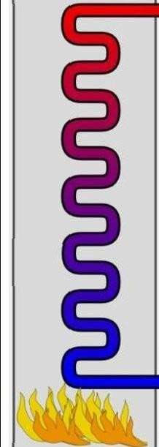
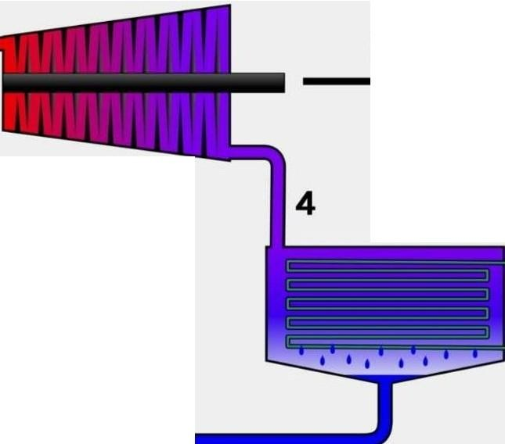
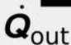

3
.
Wturbine
Wpump
.
2
.
. .. ,••-•Qin
l
ffi
1
- PROCESS 1-2 ISENTROPIC COMPRESSION -ADIABATIC PUMPING:
The working Fluid is pumped from low to high pressure. The Fluid being liquid this stage, the pump requires little input energy.
- PROCESS 2-3 CONSTANT PRESSURE HEAT ADDITION IN A BOILER- ISOBARICHEAT SUPPLY:
The high-pressure liquid entered a boiler where it is heated at constant pressure by external heat source to become a dry saturated vapor(steam). The required energy input can easily be calculated graphically, using an enthalpy- entropy chart (Mollier diagram or at h-s chart), or numerically using steam tables.
- PROCESS 3-4 ISENTROPIC EXPENSION -ADIABATIC EXPANSION:
The dry saturated vapor expands through a turbine, generating power. The temperature and pressure of the vapour are reduced causing some condensation.
- PROCESS 4-1 CONSTANT PRESSURE HEAT REJECTION IN CONDENSER- ISOBARIC HEAT REJESTION:
The wet vapour then enters air condenser, when it is condensed at a constant pressure to become a saturated liquid.
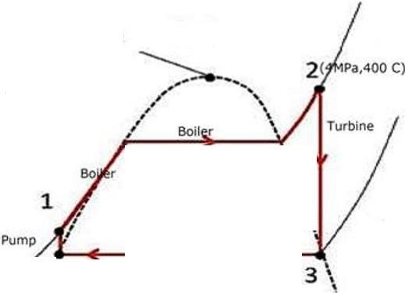
T

CritiClll Point

Te p.

I
,/0
I

Condenser

,.
''\ \

'''
'
''
Entropy ^{s}

MODIFIED RANKINE CYCLE:
The Rankine cycle has been modified to produce more output work by introducing two stage steam turbines, using intermediate heating. Basically, in this modified Rankine cycle, the full expansion of steam is interrupted in the high-pressure turbine and steam is discharged after partial expansion. The reason for the early release is that at the lower pressure the specific volume of steam is high. In order to accommodate such rapidly expanding steam, large cylinder volume is necessary and the extra work obtained is very small.
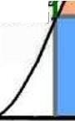
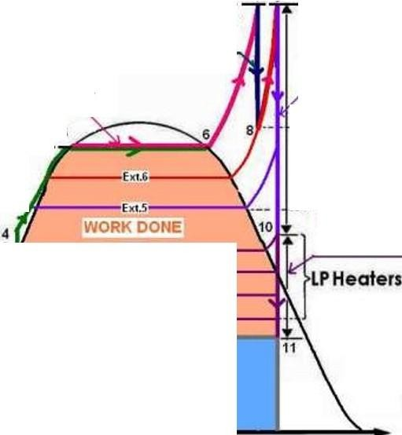
540°c ₇ ₉

Expansion
In HPT
166.7 Kg/cm²
Expansion
In IPT
...
320°c
6
..
I
::,
G>
}PHealers
..
E
G.>.
Q.
G>
Ext.5

Ext.4
E•l.3
bt.2
0 Ext.I
f--1
Expansion
In LPT
HEAT REJECTED
2
0.1 Kg/cm Abs.

.
.
0.

..

Entropy-S

STEAM TURBINE OPERATION:
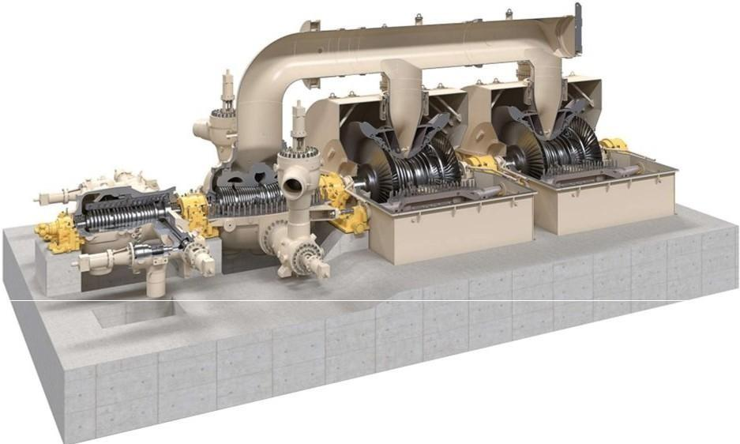
Steam is first heated in a steam generation system (for example, in boilers or Waste heat recovery system) where it reaches high temperature, around 400 °Celsius to 600°Celsius.
The first valve that the steam encounters as it travels from this steam generation system to this steam turbine is the main stop valve (main trip orshut down valve), which is either fully opened or fully closed. This valve obtained does not control this steam flow other than to

completely stop it.

Control or throttling valve in different arrangement and configuration are also used to control this steam inlet. Combined trip and throttle valve are also common. In many steam turbines at least two independent trip valves should be provided for proper redundancy. These valves are immediately ahead update steam turbine and are design to withstand the full temperature and pressure of the steam. These valves are necessary because, if the mechanical load is lost, the steam turbine would rapidly over-speed and destroy itself. This is an Occasional occurrence. An unusual root-cause, such as coupling failure, might result in this. Other accidents are possible supporting they need for two or three independent stop valves, which bring safety and reliability but add cost to the system.

Steam turbine drive are equipped with throttling bars are nozzle governors to modulate steam flow and achieve variable speed operation. This steam turbine drive is capable for serving the same function as a variable speed drive electric motor driver. Steam turbine can usually operate off course broad speed reigns and do not fail when overloaded. They also produce the high starting torque required for constant torque Lords search as with positive displacement pumps or compressors. The steam hits the first row of blades add pressure so high that it can produce torque with just a small surface area. The steams impact causes the rotor to turn. As the steam turbine stages progress however the steam loses pressure and energy, therefore, requiring increasingly large surface areas. For this reason, the blades' sizes increase with each stage. When the steam leaves the turbine, its temperature has dropped and it has lost almost all its elevated pressure. Some of the pressure drop also occur across the diaphragm, which is a component between the outer wall and inner web. The diaphragm's partitions direct the steam towards the rotating blades.

The steam should strike the blades at the specific angle that will maximize the use full work up the steam's pressure. This is where nozzles come into play. Stationary rings of nozzles are placed between the blade wheels to "turn" the steam at the optimal angle for striking the blades. A thrust bearing is mounted at one end of the main shaft to maintain its axial position and keep the moving parts from colliding with the stationary parts. The journal bearing supports the main shaft and restricts eat from springing out of its casing at high speeds.

An exhaust hood guides steam from the last stage of the steam turbine, and it is designed to minimize pressure loss, which would decrease the thermal efficiency of the steam
turbine. After the steam leaves the exhaust section, it enters a condenser, where it is cooled to a liquid state. The process of condensing the steam usually creates a vacuum, which then brings in more steam from the steam turbine. The water is returned to the steam generation system, reheated and reused. The governor is a device that controls the turbines speed. Modern steam turbines have an electronic governor that uses sensors to monitor the speed by examining the rotor teeth.

TYPES OF STEAM TURBINES:

QI. IMPULSE TURBINE:
In this type of turbine, The Superheated steam is projected at high velocity from fixed nozzles in the cashing. when the steam strikes and blades (sometimes coaled buckets), it causes the turbine shaft two rotate. The high pressure and intermediate pressure stages of a steam turbine are usually impulse turbines. The entire pressure drops of steam take place in stationary nozzles only. Though the theoretical impulse blades have zero pressure drop in the moving blades, practically, for the flow to take place across the moving blades, there must be a small pressure drop across the moving blades also.
In impulse turbines, the steam expands through the nozzle, where are most of the pressure potential energy is converted to kinetic energy. The high velocity steam from fixed nozzles impacts the blades changes its direction, which in turn applies a Force. The resulting impulse drives the blades forward, causing the rotor to turn. The main feature of these turbines is that the pressure drop per single stage can be quite large, allowing for large blades and a smaller number of stages. Except for low power applications, turbine blades are arranged in multiple stages in series, coaled Compounding Which greatly improves Efficiency at low speeds.
Modern steam turbines frequently employee both reaction and impulse in the same unit typically varying the degree of reaction and impulse from the blade root to its periphery. The rotor blades are usually designed like an impulse Blade at the rot and like a reaction blade at the tip.
Since the Curtis stages produce the pressure and temperature of the fluid to a moderate level Significantly with a high proportion of work for stage. A usual arrangement is to provide on the high-pressure side one or more Curtis stages, followed by Rateau or reaction staging. In generally, when friction is taken into account reaction stages the reaction stage is found to be a most efficient, followed by Rateau and Curtis in that order. Frictional losses are significant for Curtis's stages, since these are proportional to steam velocity squared. The reason that frictional losses are less significant in the reaction stage lies in the fact that the steam expands continuously and therefore flow velocities are lower.

02. REACTION TURBINE:
In this type of steam turbine, the steam passes from fixed blades of the stator through the shaped rotor blades nozzles causing a reaction and rotating the turbine shaft. The low-pressure stage of a steam turbine is usually a reaction type turbine. This steam
having already expanded through the high and intermediate stages of the turbine is now of low pressure and temperature, ideally suited to a reaction turbine
In reaction turbines, the steam expands through the fixed nozzle, where the pressure potential energy isconverted to kinetic energy. The high-velocity steam from fixed nozzles impacts the blades (nozzles), changes their direction and undergoes further expansion. The change in its direction and the steam acceleration applies a force. The resulting impulse drives the blades forward, causing the rotor to turn. There is no net change in steam velocity across the stage but with a decrease in both pressure and temperature, reflecting the work performed in the driving of the rotor. In this type of turbine, the pressure drops take place in a number of stages, because the pressure drop in a single stage is limited.
The main feature of this type of turbine is that in contrast to the impulse turbine, the pressure drop per stage is lower so the blades become smaller and the number of stages increases. On the other hand, reaction turbines are usually more efficient, i.e., they have higher "isentropic turbine efficiency". The reaction turbine was invented by Sir Charles Parsons and is known as the Parsons turbine.
In the case of steam turbines, such as would be used for electricity generation, a reaction turbine would require approximately double the number of blade rows as an impulse turbine, for the same degree of thermal energy conversion. Whilst this makes the reaction turbine much longer and heavier, the overall efficiency of a reaction turbine is slightly higher than the equivalent impulse turbine for the same thermal energy conversion.
Modern steam turbines frequently employ both reaction and impulse in the same unit, typically varying the degree of reaction and impulse from the blade root to its periphery. The rotor blades are usually designed like an impulse blade at the rot and like a reaction blade at the tip.

PORTIONS OF STEAM TURBINE:
A typical steam turbine has 3 major portions, to extract maximum possible energy of steam and convert it into mechanical energy. Though they are portions of a turbine but are referred as turbine as the process of exposing vanes to steam and acquiring rotational energy is one after the other but not simultaneously. The 3 major portions are
- High Pressure turbine (HP)
- Intermediate Pressure turbine (IP)
- Low Pressure turbine (LP)

0I.HP TURBINE (HIGH PRESSURE):
HP turbine is of double cylinder construction. Outer casing is barrel type without any axial/radial flanges. This kind of design prevents any mass accumulation and thermal stresses. Also, perfect rotational symmetry permits moderate wall thickness of nearly equal strength at all sections. The inner casing axially split and kinematically supported by outer casing. It carries the guide blades. The space between casings is filled with the main steam. Because of low differential pressure, flanges and connecting bolts are smaller in size. Barrel design facilitates flexibility of operation in the form of short start-up times and higher rate load changes even at high steam temperature conditions. For a typical SOOMW, at HPT the temperature of steam would be around 540°C and pressure 166.7kg/cm²•

02.IP TURBINE (INTERMEDIATE PRESSURE):
IP turbine is of double flow construction. Attached to axially split out casing is an inner casing axially split, kinematically supported and carrying the guide blades. The hot reheat steam enters die inner casing through top and bottom centre. Arrangement of inner casing confines high inlet steam condition to admission breach of the casing. The joint of outer casing is subjected to lower pressure and temperature at the exhaust. For a typical SOOMW at IPT the temperature of steam would be around 540°C and pressure 39.6kg/cm².

03.LP TURBINE (LOW PRESSURE):
Double flow LP turbine is of three shell design. All shells are axially split and are of rigid welded construction. The inner shell taking the first rows of guide blades is attached kinematically in the middle shell. Independent of outer shed middle shell is supported at four points on longitudinal beams. Two rings carrying the last guide blade rows are also attached to the middle shell. For a typical SOOMW at LPT the temperature of steam would be around 136°C and pressure -0.86kg/cm²•

LOSSES IN STEAM TURBINE:
- Residual velocity loss.
- Losses in regulating valves.
- Loss due to steam friction in nozzle.
- Loss due to leakage.
- Loss due to mechanical friction.
- Loss due to wetness of steam.
- Radiation loss.

STEAM PROTECTION TURBINE MEANS:
- Over speed trip.
- Master Trip.
- LP Trip.
- Low Lubricating Oil Pressure Trip.
- High Bearing Temp Trip.
- High Vibration Trip.
- High Axial Displacement Trip.
- Relief Valve in Exhaust.

PROCESS SURVEILLANCE:
WHY WE SHOULD MONITOR CLOSELY?
Accurate measurement and tracking of parameters like temperature, pressure, and flow are important the plant safety and performance. Information collected at specific measuring points can be used to:
- Avoid Metallurgical Failures:
Temperatures need to be maintained below components melting points in order to avoid metallurgical failure. Too-high temperatures can also lead to creep deformation in the rotating blades.
- Determine Efficiency and Performance:
Calculate the efficiency of the turbine by knowing the inlet and exit temperatures, as well as the flow rate at the nozzle. When a turbine exhaust isused as heat input to a steam cycle, engineers can also estimate the performance of the heat recovery steam generator (HRSG) by using the temperature and flow measurement of the turbine exhaust.
- Detect inefficiencies:
High exhaust temperatures and flow changes can be symptoms of an upset mode of turbine operation. If a flow measurement device picks up irregularities, the plant operator can perform a diagnostic to identify the underlying causes.
- Calculate Residual Life:
Tracking temperatures over time allows to calculate how much life the component has left and to plan maintenance and replacements.

COMPONENTS OF STEAM TURBINE:
0 I .TURBINE CASINGS:
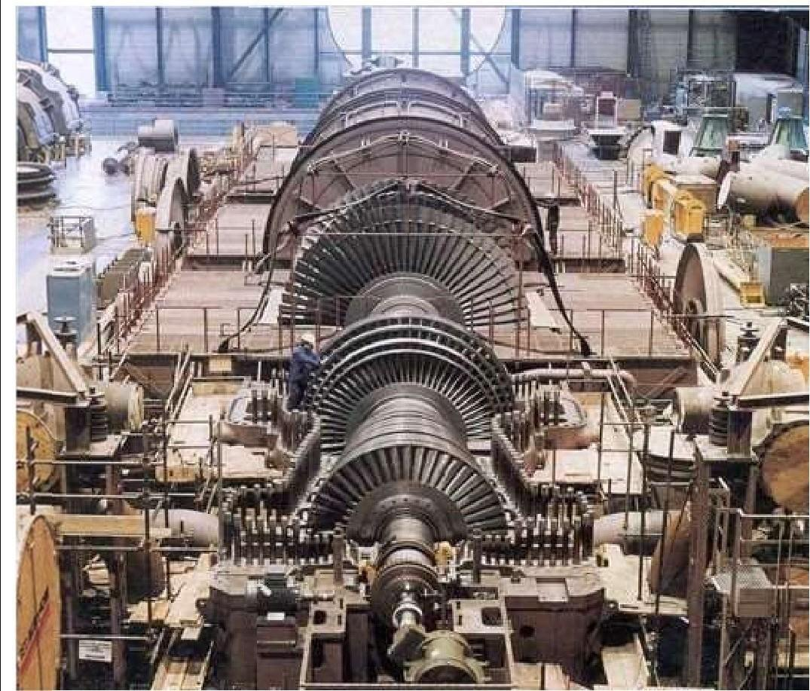
The casing shape and construction details depend on whether it is a High Pressure (HP) or Low Pressure (LP) casings. For low and moderate inlet steam pressure up to 120 bar, a single shell casing is used. With rise in inlet pressure the casing thickness as to be increasing. Handling such heavy casing is very difficult also the turbine as to slowly brought up to the operating temperature. Otherwise undue internal stress or distortions to the thick casing may arise. To over this for high pressure and temperature application double casing is used. In the double casing inner casing is for High pressure and the outer casing is for hold the low pressure.
Most of the turbine have casings with a horizontal split type. Due to horizontal split it easy for assembling and dismantling for maintenance of the turbine. Also maintain proper axial and radial clearance between the rotor and stationary parts. Usually, the turbine casings are heavy to withstand the high pressures and temperatures. It is general practice the thickness of walls and flanges decrease from the inlet to exhaust end due to the decrease in steam pressure from inlet to exhaust. Large casings for low-pressure turbines are of welded
plate construction, while smaller LP casings are of cast iron, which may be used for temperatures up to 230°C.
Casings for intermediate pressures are generally of cast carbon steel able to withstand up to 425°C. The high-temperature high-pressure casings for temperatures exceeding 550° C are of cast alloy steel such as 3 Cr 1 Mo (3% Chromium + 1% Molybdenum). The turbine casings are subjected to maximum temperatures and under constant pressure. Hence the material of casing shall subject high "Creep". The casing joints are made of steam tight by matching the flange faces very exactly and very smoothly, without the use of gaskets.
Dowel pins are used to secure exact alignment of the casing flange joints. The casing contains grooves for fixing the diaphragms (for impulse turbines}, or for the stationary blades (reaction turbines).

TURBINE ROTORS:
The rotor is main prime mover which converted heat energy to mechanical energy. The rotor is designed to us withstand
- Centrifugal load due to its own mass & stage components such as blades, shrouds, tie wires etc.
- The torque due to expansion of steam in the steam path and the work done on blading rotor.
- Rotor must transmit the torque to another rotor chain & generator.
- Must capable of withstand cyclic stresses developed due to rotation.
- Must capable of withstand thermal stresses for continues operation.
- The rotor must be thermal stable and resist tendency to bow in allowable limit during operation.
- There are three type of rotor practically used in utility are, mono-block built up &
welded rotors.

The steam turbine rotors must be designed with the most care as it is mostly the highly stressed component in the turbine. The design of a turbine rotor depends on the operating principle of the turbine.
The Impulse Turbine, in which the pressure drops across the stationary blades. The stationary blades are mounted in the diaphragm and the moving blades fixed or forged on the rotor. Steam leakage is in between the stationary blades and the rotor. The leakage rate is controlled by labyrinth seals. This construction requires a disc rotor.
The Reaction Turbine has pressure drops across the moving as well as across the stationary blades. The disc rotor would create a large axial thrust across each disc. Hence disc rotors are not used in the reaction turbine. For this application a drum rotor is used to eliminate
the axial thrust caused by the discs, but not the axial thrust causes by the differential pressure across the moving blades. Due to this the configuration of the reaction turbine is more complicated.
DISC TYPE ROTORS:
This type of rotor is largely used in steam turbines. The disc type rotors are made by forging process. Normally the forged rotors weight is around 50% higher than the final
machined rotors.
ORUM TYPE ROTORS:
Initially, the reaction turbine rotors are made by the solid forged drum type rotor. The Rotors are heavy and rigid construction. Due to this, the inertia of the rotor is very high when compared with the disc type rotor of the same capacity. To overcome this nowadays the hollow drum type rotors are used instead of solid rigid rotors. Usually this type of rotor is made of two species of construction. In some special case are the rotor ismade of up a multi-piece construction. The drums are machined both outside and inside to get perfect rotor balance.
- TURBINE BLADES:
The efficiency of the turbine depends on more than anything else on the design of turbine blades. The impulse blades must be designed to convert the kinetic energy of the steam into mechanical energy. The same goes for the reaction blades, which further more must convert pressure energy to kinetic energy.
The entire turbine is provided with reaction blading. The stationary and moving blades of the HP and IP sections and the front rows of the LP turbines are design with integrally milled inverted T-roots and shrouds. The last stages of the LP turbine are fitted with twist drop forged moving blades with fir-tree rotors engaging in grooves in the shaft with last stage stationary blades made for sheet steel.
The blades are strong enough to withstand the following factors:
  - High temperature and stresses due to the pulsating steam load.
  - Stress due to centrifugal force.
  - Erosion and corrosion resistance.

Depend upon the pressure region the blades are also classified as follow. Refer above the figure for rotor pressure region
  - High Pressure (HP) blades
  - Intermediate Pressure (IP) blades
  - Low Pressure (LP) blades

The turbine blades are made up of chromium-nickel steel or 17 Cr 13 Ni-steel
- STEAM NOZZLE:
Nozzles are used to guide the steam to hit the moving blades and to convert the pressure
energy into the kinetic energy. In the case of small impulse turbine, the nozzles are located in the lower half of the casing. But in the case of the larger turbine the nozzles are located on the upper half of the casing.
STATIONARY BLADES (DIAPHRAGMS):
All stages following the control stage have the nozzles located in diaphragms. The diaphragms are in halves and fitted into grooves in the casing. Anti-rotating pin or locking pieces in the upper part of the casing prevent the diaphragm to rotate.
All modern diaphragms are of all-welded construction. The stationary blades in reaction turbines are fitted into grooves in the casing halves, keys as shown lock the blades in place. In some cases, the blades have keys or serration on one side of the root and a caulking strip on the other side of the root is used to tighter the blades solidly in the grooves.
TWISTED BLADES:
This type of blades is used in the last stage of a large multistage steam turbine. These are the largest blade in the turbine and contribute around 10% of the turbine total output. Due to larger in size, these types of blades are subjected to high centrifugal and bending forces. To overcome these forces twisted construction is used.
SHROUDS:
1. Shrouds are used to reinforce the turbine blades free ends to reduce vibration and leakage. This is done by reverting a flat endeavour the blades refer figure. In some cases, especially at the early stages, the shroud may be integral with the blade. When the blades are very long as in the case of the last stage of the LP turbine. The rotor blades are further reinforced by using lacing wires (caulking wires which circumferentially connects all the blades at a desired radius and shrouding it eliminated.
OS.TURBINE BARRING DEVICE:
When a turbine is left cold and at standstill, the weight of the rotor will tend to bend the rotor slightly. If left at the standstill while the turbine is still hot, the lower half of the rotor will cool off faster than the upper half and the rotor will bend upwards "hog". In both cases,
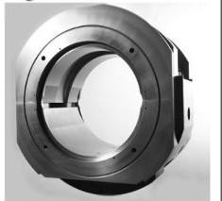
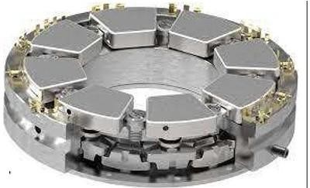
the turbine would be difficult if not impossible to start up. To overcome the problem the manufacturer supplies the larger turbines with a turning or barring gear consisting of an electric motors or hydraulic system.

Before a cold turbine is started up it should be on the barring gear for approximately three hours. When a turbine is shut down, it should be barred for the next 24 hours. It a hydrogen-cooled generator is involved the turbine should be kept on barring gear to prevent excessive loss of hydrogen. All barring gears are interlocked with a lubricating oil pressure switch and an engagement limit switch operated by the engagement handle.
06.TURBINE BEARINGS:
One of the steam turbine basic part is bearing. They are two types of bearings used based on the type of load act on them
- Radial Bearing
- Thrust Bearing
RADIAL BEARINGS:
For small turbines mostly equipped with anti-friction type bearings. Widely used anti-friction bearings are the self-aligning spherical ball or roller bearing with flooded type lubrication is used
In the case of medium turbines used plain journal bearing. They may be ring lubricated sleeve bearings with bronze or Babbitt lining. Both flooded and force types are employed.
For larger turbines, the radial bearing will bea tilting pad type. The number of pads per bearing will be selected based on the weight of the rotor. For these types of bearing forced lubrication is used.
THRUST BEARINGS:
The main two purposes of the thrust bearing are:

- To keep the rotor in anexact position in the casing.
- To absorb axial thrust on the rotor dueto steam flow.

The thrust bearing is located on the free end of the rotor or wecan say at the steam inlet of the turbine. The axial thrust force is very small for impulse turbines. This is due to the presence of pressure-equalizing holes in the rotor discs to balance the thrust force generated across the disc. A simple thrust bearing such as a ball bearing for small turbines and radial babbitt facing on journal bearings are commonly used in small and medium-sized turbines. Tilling pad type thrust bearings are used-the large steam turbines.
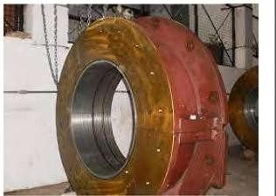
In the case of the reaction turbine, the pressure drop across the moving blades creates a heavy axial thrust force in the direction of steam flow through the turbine. Due to greater thrust force, the heavy-duty thrust bearing such as tilting pad type thrust bearings are used. The axial thrust in reaction turbines can be nearly reduced by installing "balance or dummy pistons".

As we have seen the purpose the thrust bearing not only taking the thrust load and also to maintain the position of the rotor. The axial position of the rotor is vital, and an axial position indicator often applied to the thrust bearing. As a normal practice the axial position of rotor exceeds 0.3 mm alarm and shutdown at 0.6 mm (These valves are thumb rule, it may change with respect to manufacturer and turbine model).
07.TURBINE SEALS:
Seals are used to reduce the leakage of steam between the rotary and stationary parts of the steam turbine. Depend upon the location of the seal, the seals are classified as two types, they are
- Shaft Seal
- Blade Seal
SHAFT SEALS:
Shaft seals are used to prevent the steam leakage where the shafts extend through the casing. In the case of a small turbine (as per API 611) carbon rings are used as shaft seal up to the surface speed of the shaft is S0m/s. The carbon ring is made up of three segments butting together tightly under the pressure of a garter spring. The carbon rings are free-floating in the housing and an anti-rotating pin is used to prevent the rotation of carbon ring seal.
Due to the self-lubrication properties of the carbon rings, they maintain a close clearance with the shaft.
For larger steam turbines (as per API 612) labyrinth seal is used as shaft seals. In the case of condensing steam turbine to prevent the air ingression at the shaft seal by Gland condenser and ejector arrangements (as per API 612).
BLADE SEALS:
Blade seals are used to prevent the steam leakage between the diaphragm and the shaft. The efficiency of the turbine depends largely on the blade seals. Labyrinth seals are used as blade seals in the small and large turbines. In case of a large steam turbine, spring-loaded
labyrinth seals are used.

The seals are made up of brass or stainless steel. Also, the sharp edge gives better sealing and rubs off easily without excessive heating in case of a slightly eccentric shaft. Some labyrinth seals are very simple others are complicated.

OS.GOVERNOR:
The governor is one of the steam turbine basic parts. Its main function is to control the operation of a steam turbine. Generally, the governor is classified as two type
- Speed-sensing governor
- Pressure sensing or load governor
SPEED SENSING GOVERNOR:
Speed-sensing governors are used in power generation application to maintain a constant speed with respect to the load change in governor. Droop is one of the important characteristics of this governor selection.
PRESSURE-SENSITIVE GOVERNOR:
These are applied to back pressure and extraction turbines in connection with the speed-sensitive governor.
They are three types of governor used in steam turbine

- Mechanical Governor
- Hydro-mechanical Governor
- Electronic Governor

COMPOUNDING OF STEAM TURBINES:
Compounding of steam turbine is the strategies in which energy from the steam is extracted in a number of stages rather than a single stage in a turbine. A compounded steam turbine has multiple stages i.e., it has more than one set of nozzles and rotors, in series, keyed to the shaft or fixed to the casing, so that either the steam pressure or the jet velocity is absorbed by the turbine in number of stages.

NECESSITY OF COMPOUNDING:
Compounding of steam turbines used to reduce the rotor speed. It is the process by which rotor speed come to its desired value. A multiple system of rotors is connected in series
keyed to a common shaft and the steam pressure or velocity is absorbed in stages as it flows over the blades. The steam produced in the boiler has sufficiently high enthalpy when superheated. In all turbines the blade velocity is directly proportional to the velocity of the steam passing over the blade. Now, if the entire energy of the steam is extracted in one stage, i.e., if the steam is expanded from the boiler pressure to the condenser pressure in a single stage, then its velocity will be very high. Hence the velocity of the rotor (to which the blades are keyed) can reach to about 30,000 rpm, which is too high for practical uses because of very high vibration. Moreover, at such high speeds the centrifugal forces are immense, which can damage the structure. Hence, compounding is needed. The high velocity steam just strikes on a single ring of rotor that causes wastage of steam ranging 10% to 12%. To overcome the wastage of steam, compounding of steam turbine is used.

TYPES OF COMPOUNDING:
In an impulse steam turbine compounding can be achieved in the following three ways:

- Velocity Compounding
- Pressure Compounding
- Pressure-Velocity Compounding

In a reaction turbine compounding can be achieved only by pressure compounding.

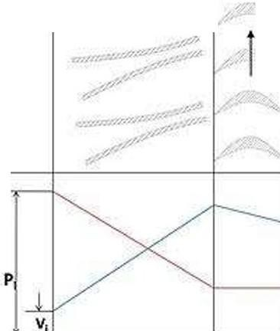
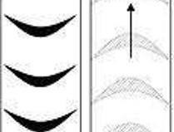
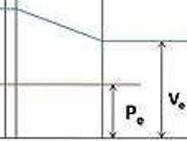
VELOCITY COMPOUNDING OF IMPULSE TURBINE:

M
NOZZLE
M"'Moving
Blade
F= Fixed
Blade
F
M
The velocity compounded impulse turbine was first proposed by CG Curtis to solve the problem of single stage impulse turbine for use of high pressure and temperature steam. The rings of moving blades are separated by rings of fixed blades. The moving blades are
keyed to the turbine shaft and the fixed blades are fixed to the casing. The high-pressure steam coming from the boiler is expanded in the nozzle first. The Nozzle converts the pressure energy of the steam into kinetic energy. The total enthalpy drops and hence the pressure drop occurs in the nozzle. Hence, the pressure thereafter remains constant.
This high velocity steam is directed on to the first set (ring) of moving blades. As the steam flows over the blades, due to the shape of the blades, it imparts some of its momentum to the blades and loses some velocity. Only a part of the high kinetic energy is absorbed by these blades. The remainder is exhausted on to the next ring of fixed blade. The function of the fixed blades is to redirect the steam leaving from the first ring of moving blades to the second ring of moving blades. There is no change in the velocity of the steam as it passes through the fixed blades. The steam then enters the next ring of moving blades, this process is repeated until practically all the energy of the steam has been absorbed.
A schematic diagram of the Curtis stage impulse turbine, with two rings of moving blades one ring of fixed blades is shown in figure 1. The figure also shows the changes in the pressure and the absolute steam velocity as it passes through the stages
where,

Pi=Pressure of steam at inlet Vi=Velocity of steam at inlet Po=pressure of steam at outlet Vo=velocity of steam at outlet
In the above figure there are two rings of moving blades separated by a single of ring of
fixed blades. As discussed earlier the entire pressure drop occurs in the nozzle, and there are no subsequent pressure losses in any of the following stages. Velocity drop occurs in the moving blades and not in fixed blades.
DISADVANTAGES OF VELOCITY COMPOUNDING:
- Due to the high steam velocity there are high friction losses.
- Work produced in the low-pressure stages is much less.
- The designing and fabrication of blades which can withstand such high velocities is difficult.

PRESSURE COMPOUNDING OF IMPULSE TURBINE:
The pressure compounded Impulse turbine is also called as Rateau turbine, after its inventor. This is used to solve the problem of high blade velocity in the single-stage impulse
turbine. It consists of alternate rings of nozzles and turbine blades. The nozzles are fitted to the casing and the blades are keyed to the turbine shaft.
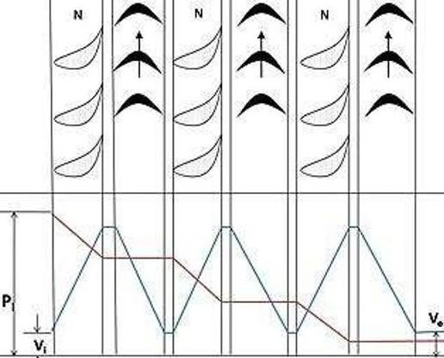
M M M

M=Moving
Blide
N=NOZlle

In this type of compounding the steam is expanded in a number of stages, instead of just one (nozzle) in the velocity compounding. It is done by the fixed blades which act as nozzles. The steam expands equally in all rows of fixed blade. The steam coming from the boiler is fed to the first set of fixed blades i.e., the nozzle ring. The steam is partially expanded in the nozzle ring. Hence, there is a partial decrease in pressure of the incoming steam. This leads to an increase in the velocity of the steam. Therefore, the pressure decreases and velocity increases partially in the nozzle.
This is then passed over the set of moving blades. As the steam flows over the moving blades nearly all its velocity is absorbed. However, the pressure remains constant during this process. After this it is passed into the nozzle ring and is again partially expanded. Then it is fed into the next set of moving blades, and this process is repeated until thecondenser pressure is reached. This process has been illustrated in figure 3.
where, the symbols have the same meaning as given above.
It is a three-stage pressure compounded impulse turbine. Each stage consists of one ring of fixed blades, which act as nozzles, and one ring of moving blades. As shown in the figure pressure drop takes place in the nozzles and is distributed in many stages. An important point to note here is that the inlet steam velocities to each stage of moving blades are essentially equal. It is because the velocity corresponds to the lowering of the pressure.
Since, in a pressure compounded steam turbine only a part of the steam is expanded in

each nozzle, the steam velocity is lower than of the previous case. It can be explained mathematically from the following formula i.e.,
vz vz
where,-} + h1 = f
+ h2

V1= absolute exit velocity of fluid h1= enthalpy of fluid at exit
V2= absolute entry velocity of fluid h2= enthalpy of fluid at entry
One can see from the formula that only a fraction of the enthalpy is converted into velocity in the fixed blades. Hence, velocity is very less as compared to the previous case.
DISADVANTAGES OF PRESSURE COMPOUNDING:
- The disadvantage is that since there is pressure drop in the nozzles, it has to be made air-tight.
- They are bigger and bulkier in size 34 inches;

PRESSURE-VELOCITY COMPOUNDED IMPULSE TURBINE:
It is a combination of the above two types of compounding. The total pressure drop of the steam is divided into a number of stages. Each stage consists of rings of fixed and moving blades. Each set of rings of moving blades is separated by a single ring of fixed blades. In each stage there is one ring of fixed blades and 3-4 rings of moving blades. Each stage acts as a velocity compounded impulse turbine.
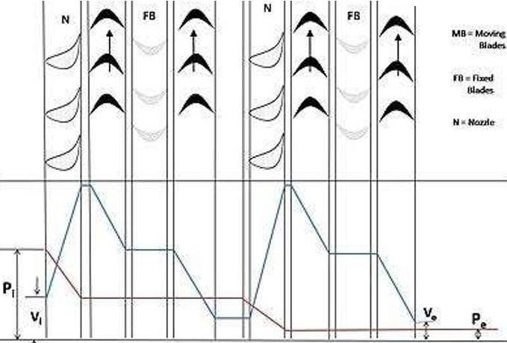
MB MB MB MS

The fixed blades act as nozzles. The steam coming from the boiler is passed to the first ring of fixed blades, where it gets partially expanded. The pressure partially decreases and the
velocity rises correspondingly. The velocity is absorbed by the following rings of moving blades until it reaches the next ring of fixed blades and the whole process is repeated once again.
This process is shown diagrammatically in figure 5 where, symbols have their usual meaning.

PRESSURE COMPOUNDING OF REACTION TURBINE:
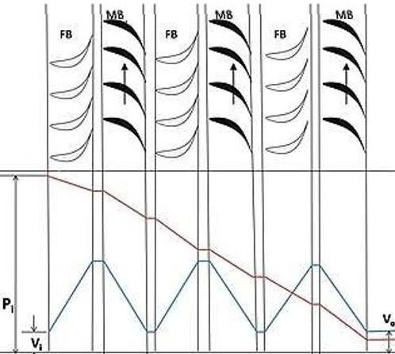

As explained earlier a reaction turbine is one in which there is pressure and velocity, loss in the moving blades. The moving blades have a converging steam nozzle. Hence when the steam passes over the fixed blades, it expands with decrease in steam pressure and increase in kinetic energy. This type of turbine has a number of rings of moving blades attached to the rotor and an equal number of fixed blades attached to the casing. In this type of turbine, the pressure drops take place in a number of stages. The steam passes over a series of alternate fixed and moving blades. The fixed blades act as nozzles i.e., they change the direction of the steam and also expand it. Then steam is passed on the moving blades, which further expand the steam and also absorb its velocity
This is explained in figure where, symbols have the same meaning as above.

INCREASING STEAM TURBINE POWER GENERATION EFFICIENCY:
With more than 1,300 steam-turbine power plants in the country at least 30 years old, electric utilities and independent power producers today must optimize these plants to improve efficiencies to reduce operating and maintenance (O&M) costs, and to remain competitive. The aim of every steam turbine design is an optimum efficiency operation
characterizing an optimal energy conversion. Overall efficiency of a steam turbine power plant, however, strongly depends on the turbine performance. Thus any improvement, however slight, can increase power availability, decrease equipment and component costs, and generate sizeable operating savings. In today's highly competitive and deregulated market, optimizing steam turbine operation is no longer a goal but, rather, a necessity for power producers to remain competitive. For some aging steam turbine power plants, refitting them with gas turbine systems will boost availability. For others, however, it may be more cost effective to upgrade existing steam turbines rather than replace them. Since a steam turbine's efficiency ultimately depends on its condition, relative to its design, as a turbine's condition deteriorates with use its efficiency degenerates proportionately. A thorough evaluation of a steam turbine's design and operating condition can help increase a plant's efficiency by identifying improvements in one or more of three areas:

- Combustion to improve fuel utilization and minimize environmental impact.
- Heat transfer and aerodynamics to improve turbine blade life and performance.
- Materials to permit longer life and higher operating temperatures for more efficient systems.
- The number of stages utilized can range from the fewest possible to develop the load reliably to the thermodynamically optimum selection.
- Spill bands can be utilized to minimize throttling losses.
- High-efficiency nozzle/bucket profiles are available to reduce friction losses.
- To reduce the pressure within the exhaust casing, exhaust flow guides are available.

CONCLUSION

Industrial training, being an integral part of the engineering curriculum, provides not only easier understanding but also helps acquaint an individual with technologies. It exposes an individual to the practical aspects of all things, which differ considerably from theoretical models. During my training, I gained a lot of practical knowledge that otherwise could have been exclusive to me. The practical exposure required here will pay rich dividends to me when I set foot on the path as an engineer. The training at NTPC Ltd., Kaniha, was altogether an exotic experience, since work, culture, and mutual cooperation were excellent here.
Moreover, the fruitful results of adherence to quality control, awareness of safety, and employees' well-being were evident, which is much more evident here. All the minor and major sections of the thermal project had been visited and understood to the best of my knowledge. I believe that this training has made me well versed in the various processes in the power plant. As far as I think, there is a long way to go before we use our newest and ever-improving technologies to increase efficiency because the stocks of coal are dwindling and they are not going to last forever. It's imperative that we start shouldering the burden together to see a shining and sustainable future for India.

REFERENCE

  - https://www.ntpc.co.in/
  - https://en.wikipedia.org/wiki/NTPC Limited
  - https://en.wikipedia.org/wiki/Talcher Super Thermal Power Station

