

**Elements of AIML**

**Lab Assignment 1 on 7th November**

**Name:** Harsh Vishwakarma

Course: **B.Tech. C.S.E.**

**Batch**: 12

**Sap.id.:** 500119184

**Enrollment no.:** R2142230383

**TOPIC – CREATING A GITHUB**

**REPOSITORY**

**Step 1-**  We will create a account in GitHub.

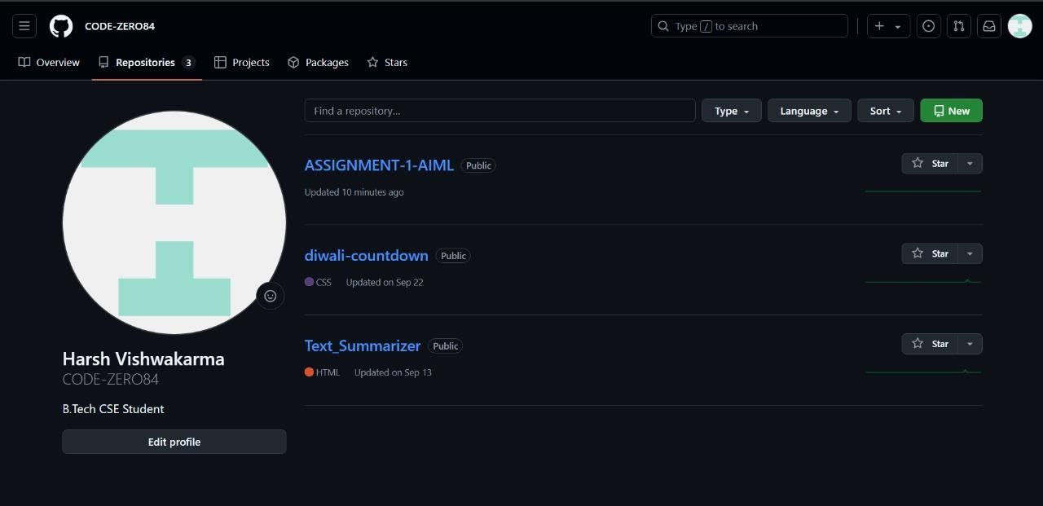

**Step 2-** We will create a Repository named “Assignment

1 AIML” and Branched”Main”

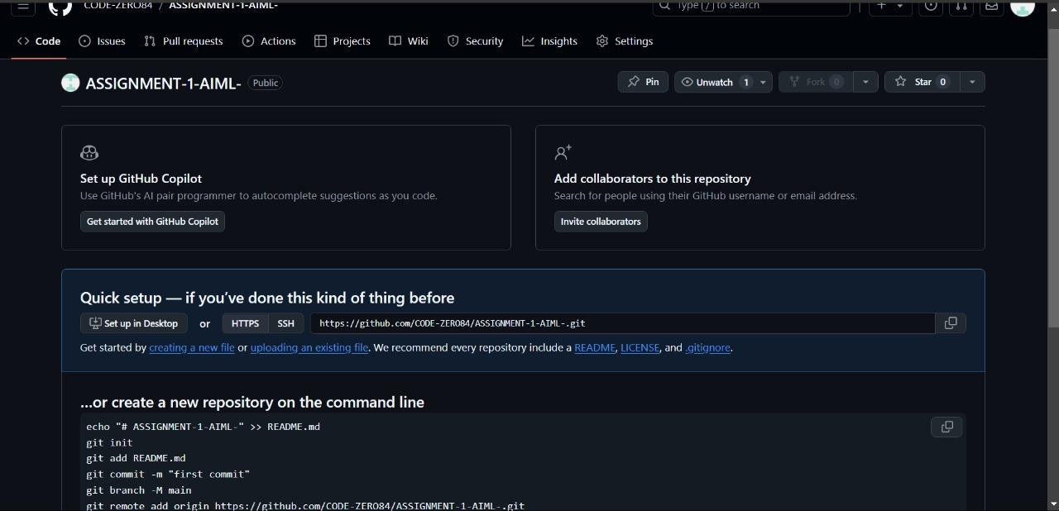

**Step 3**- we will create a text file named “Hello.txt” with our normal words and then attached in this branch.

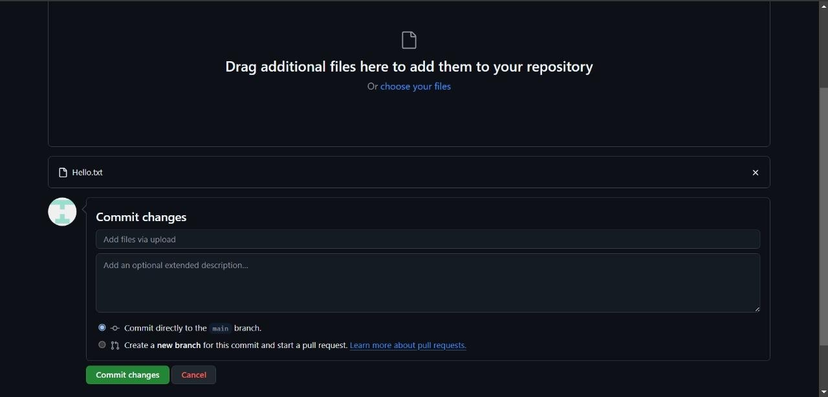

**Step 4**- After the text file upload we will run it on out GitHub.

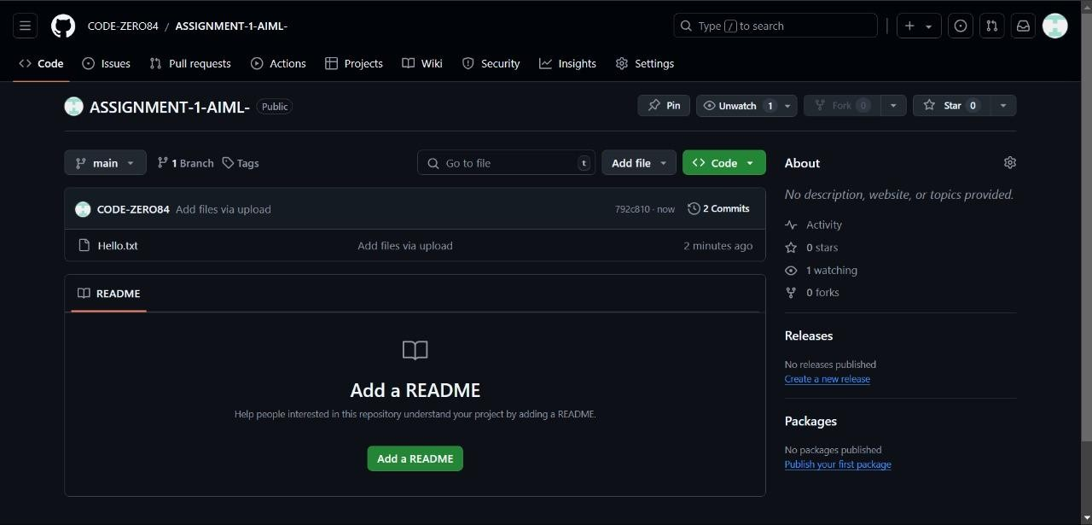

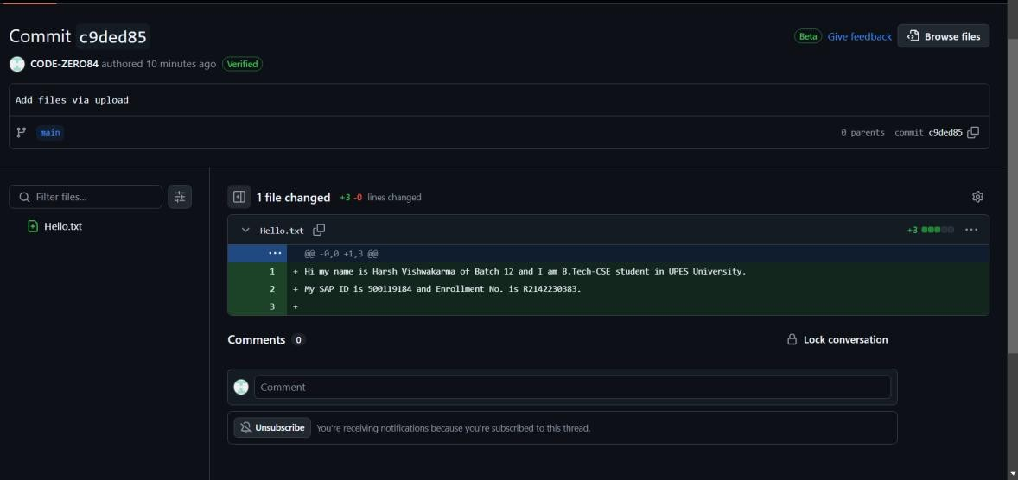

ZERO HUNGER DATASET:

**Introduction:-**

The Zero Hunger dataset aligns with the United Nations' Sustainable Development Goal (SDG) #2, which is to achieve "Zero Hunger." This goal aims to eradicate hunger, improve food security, enhance nutrition, and promote sustainable agriculture worldwide. The dataset provides vital indicators that relate to food availability, nutrition levels, agricultural productivity, and the prevalence of undernourishment across different regions and time periods.

**Purpose:-**

The dataset is intended to facilitate data-driven insights into global hunger trends, helping policymakers, researchers, and development organizations understand the current food security landscape and its challenges. By analyzing this dataset, stakeholders can identify factors contributing to hunger, assess the impact of various interventions, and design targeted solutions to reduce hunger and promote sustainable agricultural practices.

**Dataset Used:-**

The Zero Hunger dataset typically includes multiple indicators across different regions and time frames. Common variables may include:

* **Entity**: Country or region name.
* **Year**: Time reference for the data.
* **Prevalence of undernourishment (% of population)**: The proportion of the population that is undernourished.
* **Combined figures (kg/capita/year)**: A metric possibly indicating food production, consumption, or availability.
* **Region and Source**: Region classifications and data sources for better contextualization.

This dataset may contain other food security and agriculture-related indicators, making it suitable for time-series and cross-sectional analysis.

**Libraries Used:-**

For analyzing the Zero Hunger dataset in Python, the following libraries are commonly employed:

* **Pandas**: For data loading, cleaning, and manipulation.
* **NumPy**: For numerical operations and handling arrays.
* **Scikit-learn**: For modeling, including classification, regression, and metrics evaluation.
* **Imbalanced-learn (imblearn)**: Specifically, **SMOTE** (Synthetic Minority Oversampling Technique) is used to handle class imbalances.
* **Matplotlib / Seaborn**: For data visualization to illustrate trends and insights clearly.

**CODE:-**

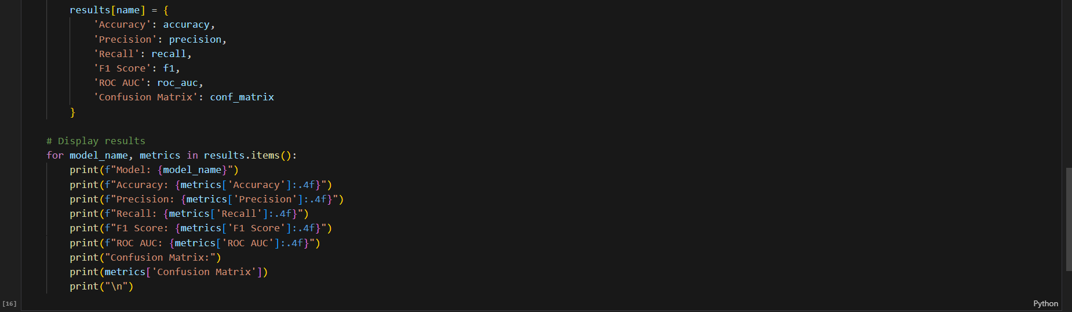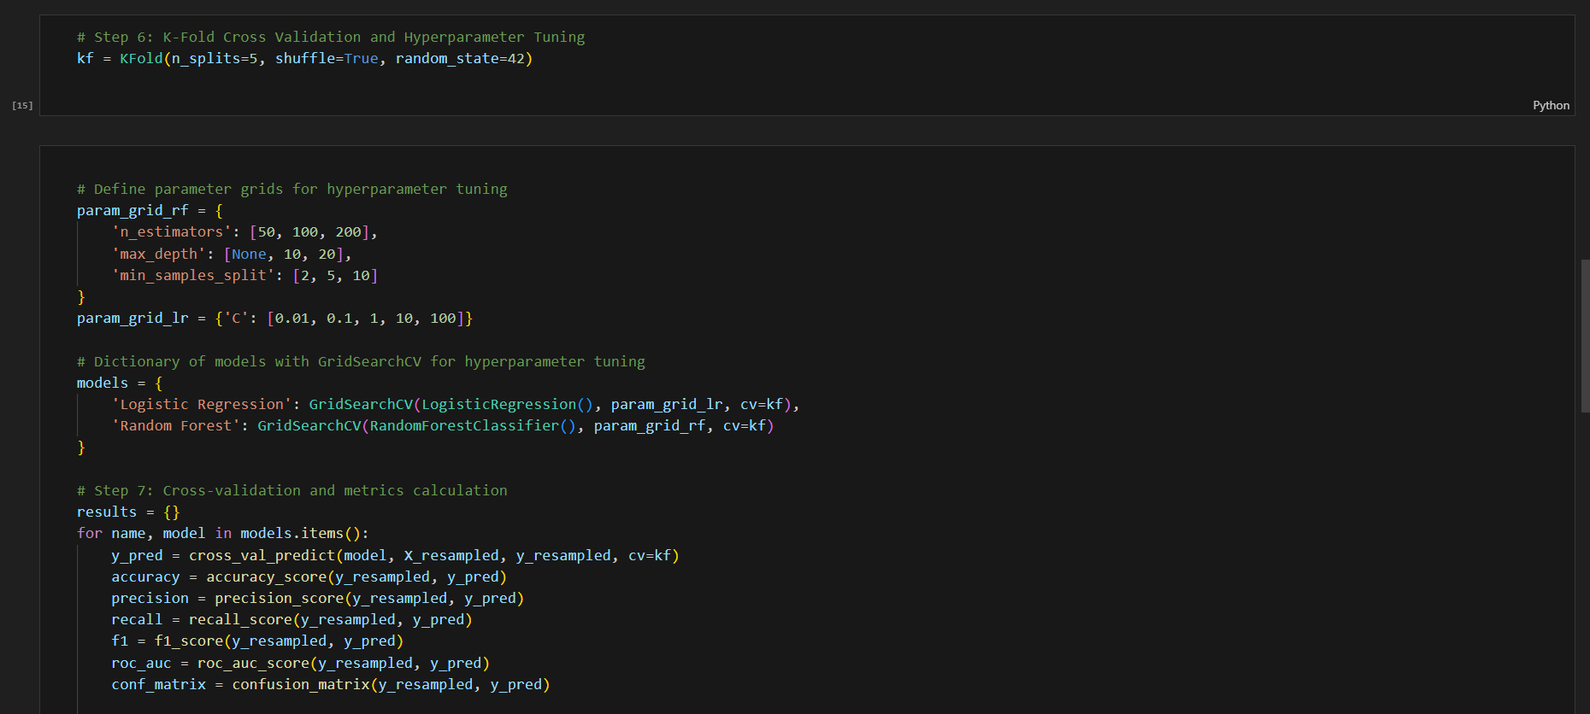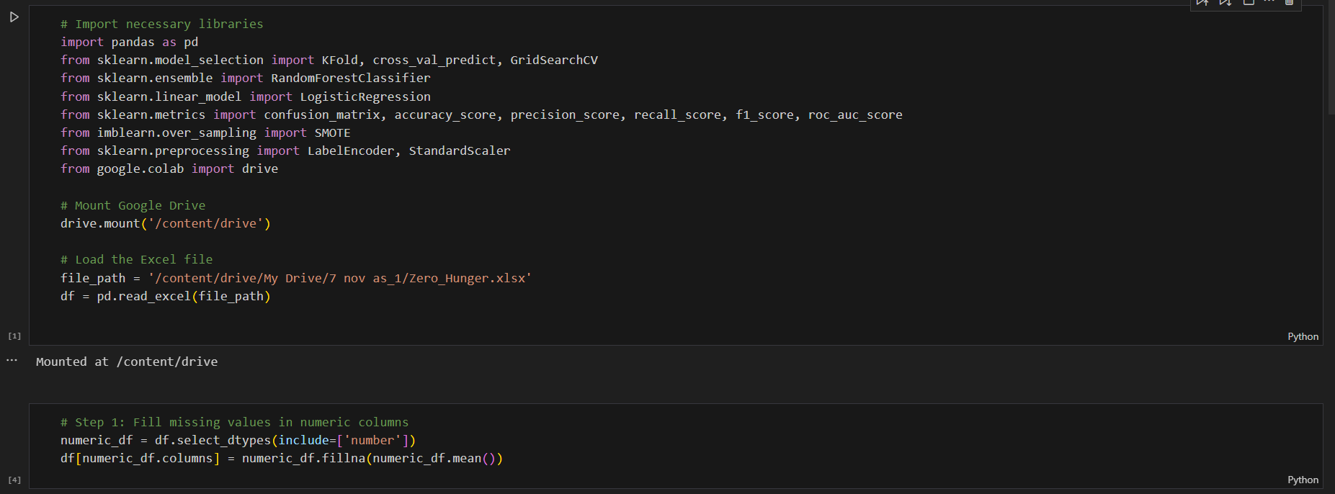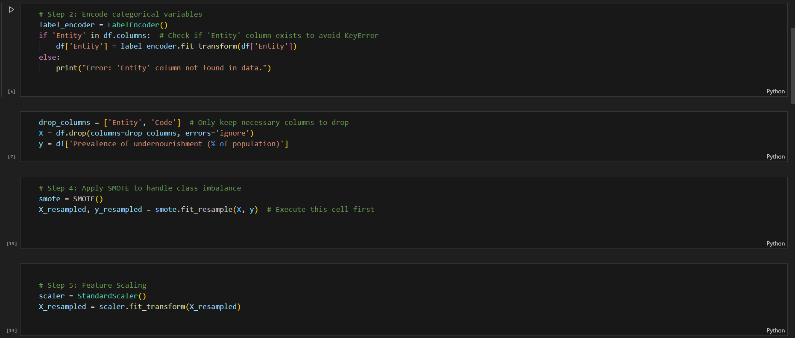

**OUTPUT:-**

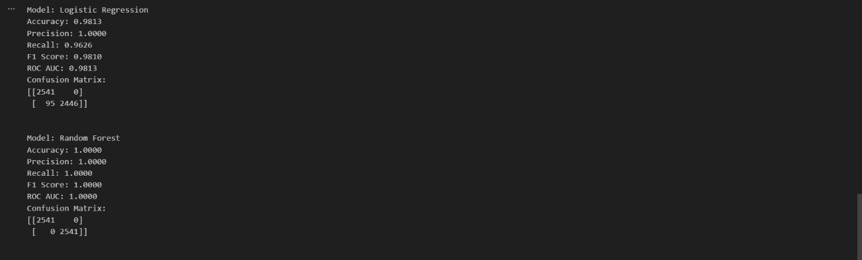

**Summary:-**

The Zero Hunger dataset offers a comprehensive view of global food security metrics, supporting in-depth analyses and visualizations to understand hunger patterns. By applying machine learning algorithms and statistical analysis to this dataset, researchers can explore the impact of factors influencing hunger and food security and assess the effectiveness of interventions across regions. Ultimately, this dataset serves as a valuable resource for supporting data-driven decisions in pursuit of the goal of zero hunger.