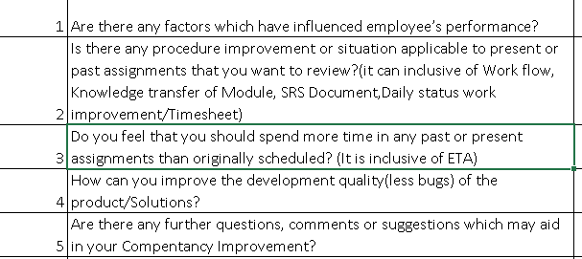  
  
Ans:1

-Yes, Unable to use YouTube. It is useful in Angular.

Ans:2

-Yes, By workflow training session we understood how to design workflow and got overview of implementation of it. I request to assign task for implementation gradually.

Ans:3

-Yes, Sometimes.

Ans:4

-NA

Ans:5

-NA

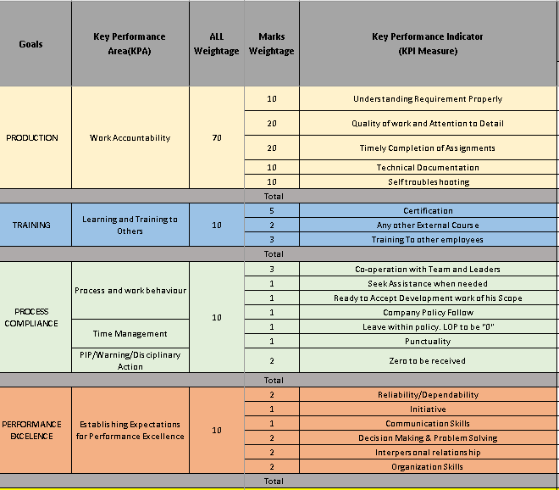

1. 3
2. 3.5
3. 3.5
4. 3.5
5. 3.5
6. 1
7. 2.75
8. 4
9. 3.75
10. 4
11. 5
12. 5
13. 0
14. 3
15. 0
16. 3—
17. 3.5
18. 4
19. 4
20. 4
21. 3.5