

**Project: HSE Management System**

**Module Name: System Configuration**

|  |  |
| --- | --- |
| **Document Reference No** | **Revision No** |
| ASK-SWARE-P-110-01 | Rev 0 |

Table of Contents

**1.** **Document Control** 3

1.1. Change History 3

1.2. Management Review 3

**2.** **System Structure and Configuration Requirement Specification Introduction** 4

2.1. Background 4

2.2. Document Purpose 4

2.3. Scope 4

**3.** **HSE Management System - Organizational Hierarchy** 4

**4.** **HSE Management System - Role Level Hierarchy and Permission** 7

**5.** **Login Page** 8

**6.** **Employee Management** 9

**7.** **Users Management** 12

1. **Document Control**
   1. Change History

|  |  |  |  |
| --- | --- | --- | --- |
| **Version** | **Date** | **Author** | **Change** |
| Rev 0 | 01 April 2021 | Mishant Lakdawala | Initial Creation |
|  |  |  |  |
|  |  |  |  |

* 1. Management Review

**Process Owners**

|  |  |  |  |
| --- | --- | --- | --- |
| **Role** | **Name** | **Signed** | **Date** |
| Business Process Owners | Subodh Kumar |  |  |
| Business Process Owners | Piyush Mistry |  |  |

1. **System Structure and Configuration Requirement Specification Introduction**
   1. Background

This HSE Management System Requirements Specification (SRS) document defines the incremental business requirements and processes on top of current global template for HSE Management System. Where it transpires that further detail is required, this will be documented as Appendices subsequently. Possible examples of further documentation include:

* Any additional detail pertaining to requirements contained in the SRS that the project team deemed to be formally documented.

Any changes to the scope contained in this document resulting from new requirements coming to light, or from amendments to original requirements, will be documented subsequently, and will be subjected to a change management and control process. Major changes may adversely affect the timescales and/or the resource planning for the project.

This document contains the requirements considering the below requirements to be achieved in common System Configuration for all modules and all plants/ sites in HSE Management System for Navin Fluorine.

* 1. Document Purpose

The main objective of this document is to have software specification of System Configuration required by client. This will give surety to requester regarding the request, requirement and output.

* 1. Scope

The scope of this SRS will cover the System Organization Structure and Role Level hierarchy from HSE Management.

1. **HSE Management System - Organizational Hierarchy**

*Objective:*

* System should support different levels of hierarchy to manage the routine HSE procedural operations.

*Process Map or Work-flow:*

* N/A

*Screenshot(s):*

* HSE Hierarchy for Departments as shown in below screen **[Figure: 3.1]**

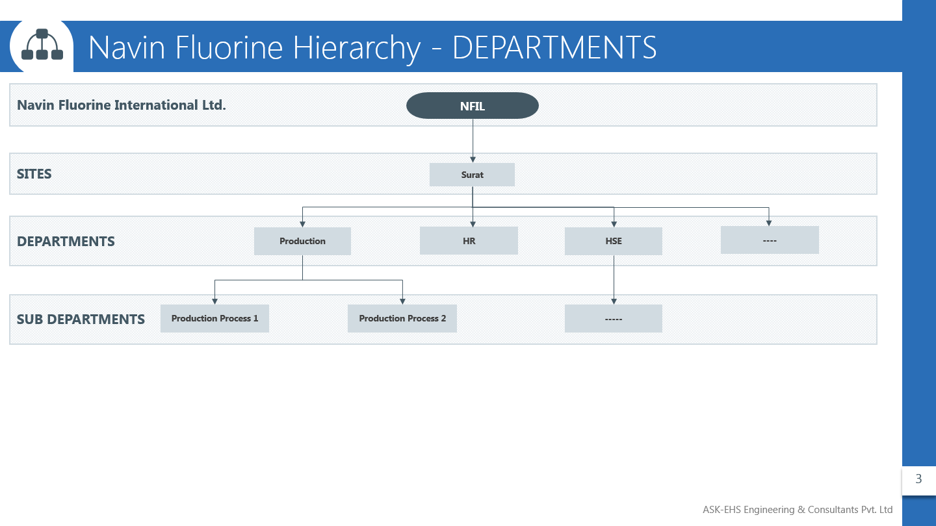

[Figure: 3.1]

* HSE Hierarchy for Plant/ Area as shown in below screen **[Figure: 3.2]**

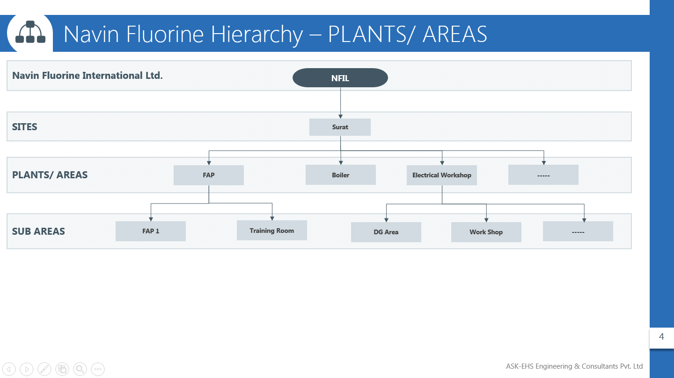

[Figure: 3.2]

* HSE Hierarchy for Agencies as shown in below screen **[Figure: 3.3]**

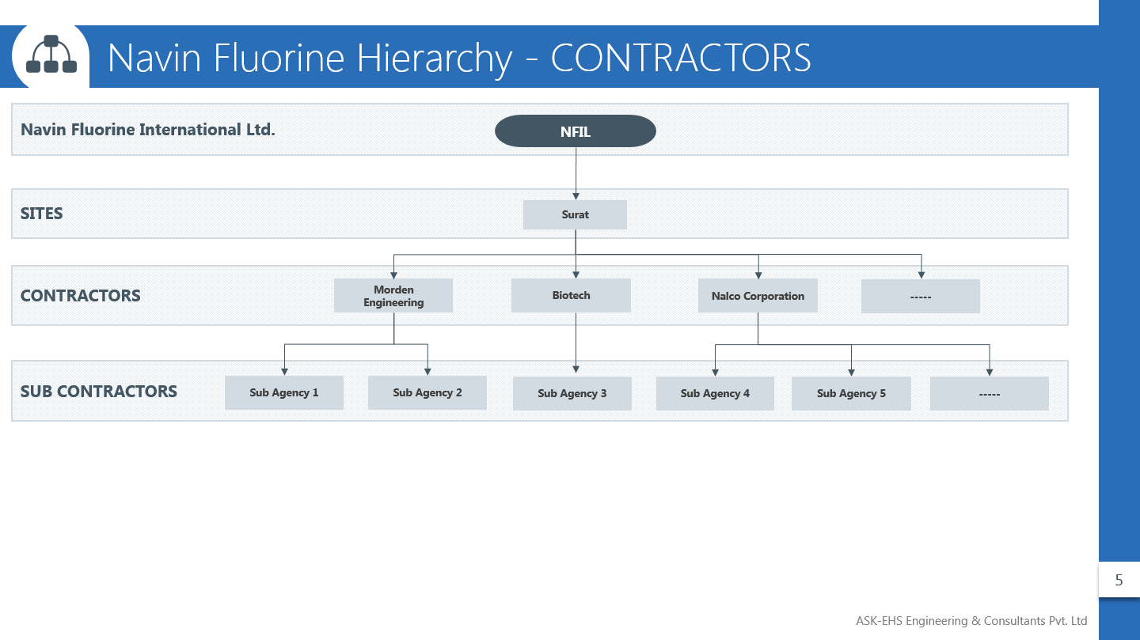

[Figure: 3.3]

*Business rule(s):*

* Software must support 9 level hierarchies to manage all HSE related operations.
* Level should include:
* Levels must be supported in below hierarchy:

|  |  |
| --- | --- |
| **Level Name** | **Level** |
| Administrator | 1 |
| Corporate | 2 |
| Site | 3 |
| Departments | 4 |
| Plant/Area | 5 |
| Contractors | 6 |
| Sub-Departments | 7 |
| Sub-Plant/Area | 8 |
| Sub-Contractors | 9 |

* Each level must have defined users to perform the required level of tasks related to HSE work cycle, which should include checkups, reporting, reminders, performance evaluation and closures.

*Open Questions:*

1. **HSE Management System - Role Level Hierarchy and Permission**

*Objective:*

* Provide appropriate and equivalent access of HSE Management software modules to specific set of users/ employees

*Process Map or Work-flow:*

* N/A

*Screenshot(s):*

* Role Level Hierarchy as shown in below screen **[Figure: 4.1]**

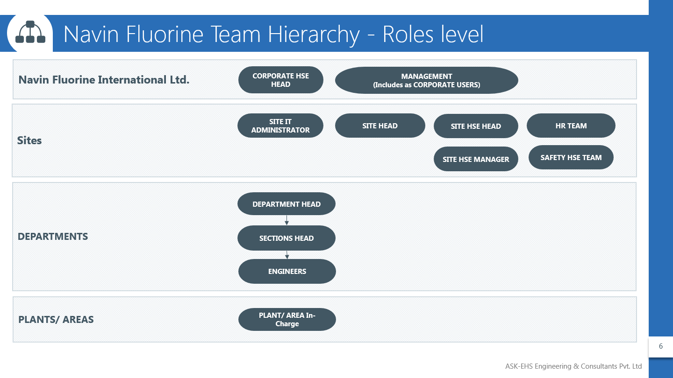

[Figure: 4.1]

*Business rule(s):*

* Software should provide access to safe team at different levels with different access rights.
* Navin fluorine international ltd. is required to have access from corporate level up to Departments/ Areas levels.
* As shown in below screen **[Figure: 4.2]** is the possible HSE team role level hierarchy access matrix that shall be supported by the software.

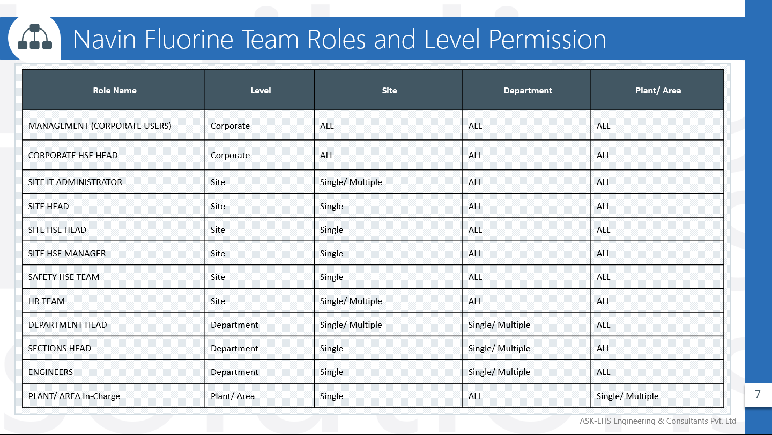

[Figure: 4.2]

* Access roles should be configurable, and can be changed updated as per requirements.
* Here, **ALL** denotes Permission to access all Sites/ Departments/ Sub-department/ Area/ Sub- Area/ Contractors/Sub-contractors and **Single** Permission to access single Sites/Departments/Sub-department/ Area/ Sub-Areas/ Contractors / Sub- contractors.

*Open Questions:*

1. **Login Page**

*Objective:*

* To Login in software with valid credentials and perform analysis and record HSE related data with software.

*Process Map or Work-flow:*

* N/A

*Screenshot(s):*

* Login Page as shown in below screen **[Figure: 5.1]**

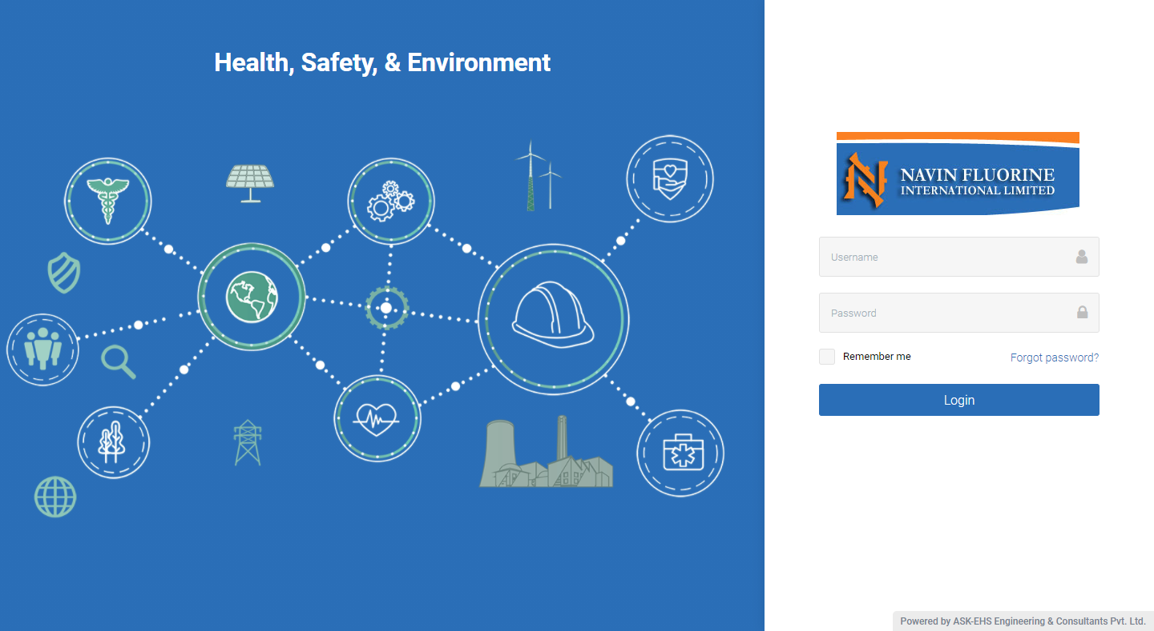

[Figure: 5.1]

*Business rule(s):*

* Any employee of Navin Fluorine with valid login credential shall be able to login in software to perform HSE related activity. Such users that are provided with valid login credentials are referred to as “Power Users”.
* User shall be identified in software with valid and unique Username.

*Open Questions:*

1. **Employee Management**

*Objective:*

* To create new Employee in the HSE Management system.

*Process Map or Work-flow:*

* N/A

*Screenshot(s):*

* New Employee creation Page for Employee as shown in below screen **[Figure: 6.1]**

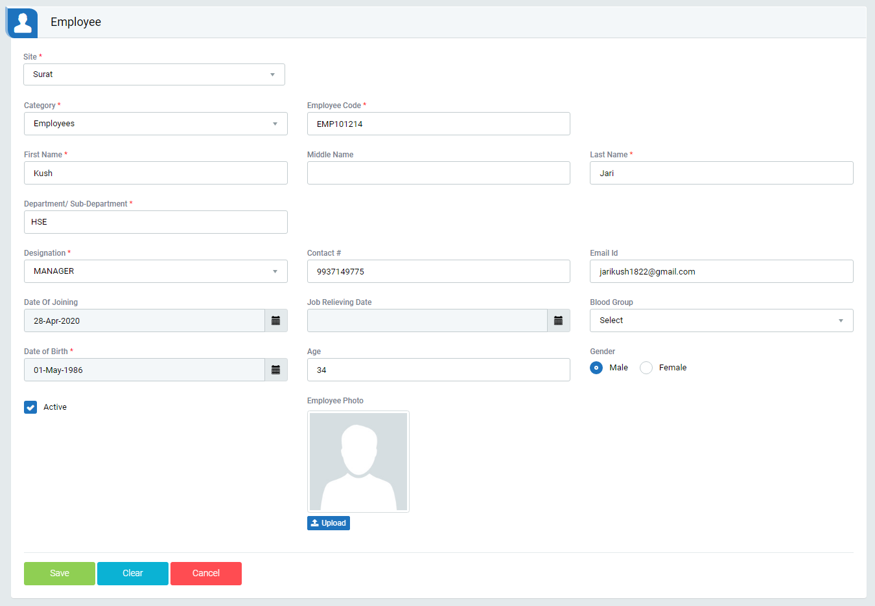

[Figure: 6.1]

* New Employee creation Page for Contractor Employee as shown in below screen **[Figure: 6.2]**

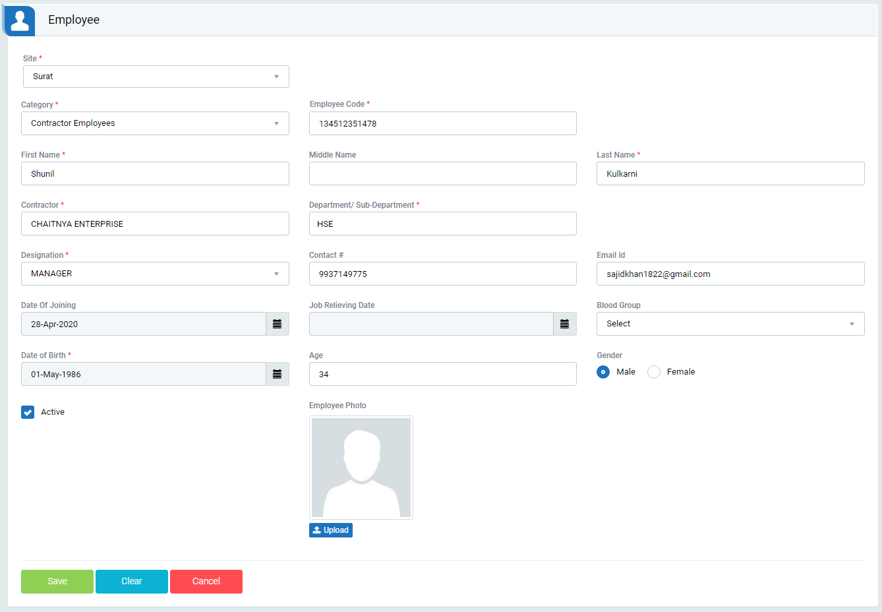

[Figure: 6.2]

*Business rule(s):*

* To create new employee select plant from dropdown.
* Select Employment Type from dropdown.
* Enter employee’s first, middle and last name.
* Select Department / Contractor Company by entering first three letters.
* Select Designation / Category Type from dropdown.
* Enter Date of birth and Age to auto populate from DOB.
* Above mentioned fields are mandatory to submit employee’s details or create new employee.
* Created Employee’s record display in below screen [Figure: 6.3]

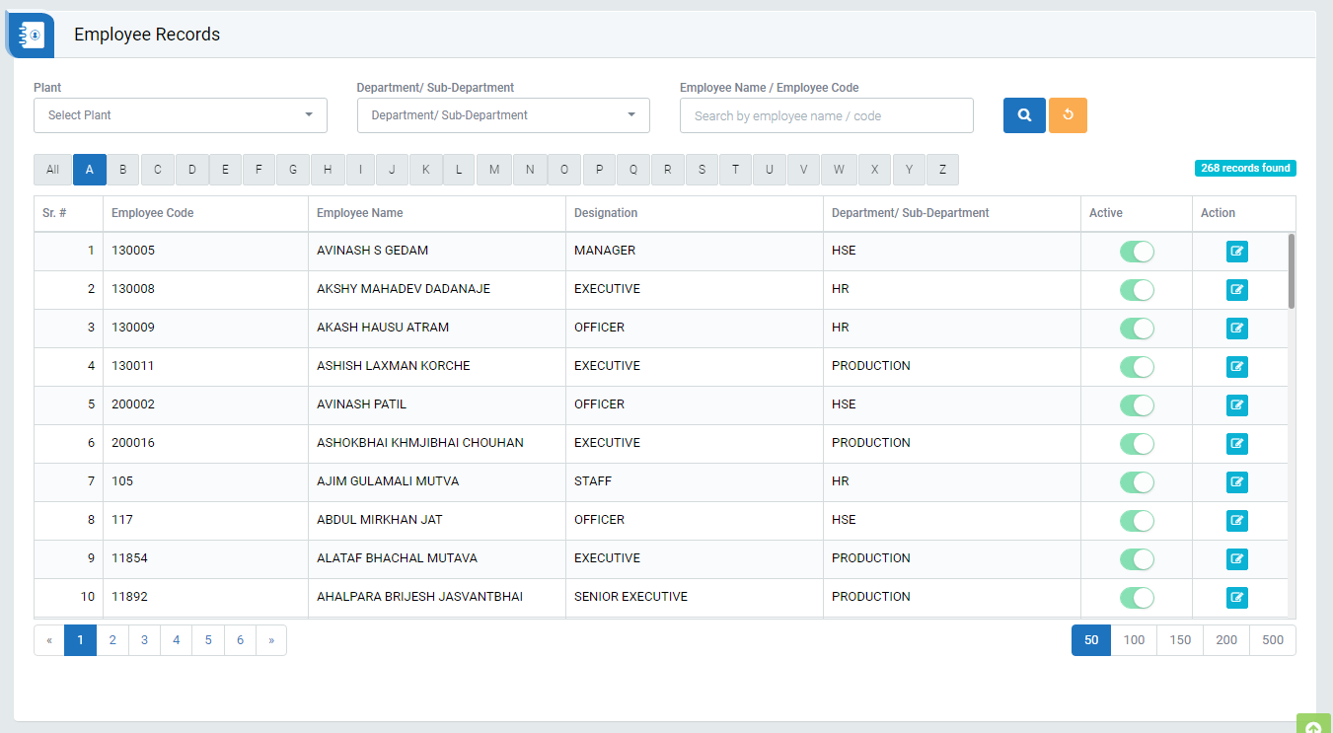

[Figure: 6.3]

*Open Questions:*

1. **Users Management**

*Objective:*

* To create user of added Employee in the HSE Management system.

*Process Map or Work-flow:*

* N/A

*Screenshot(s):*

* New User creation Page as shown in below screen **[Figure: 7.1]**

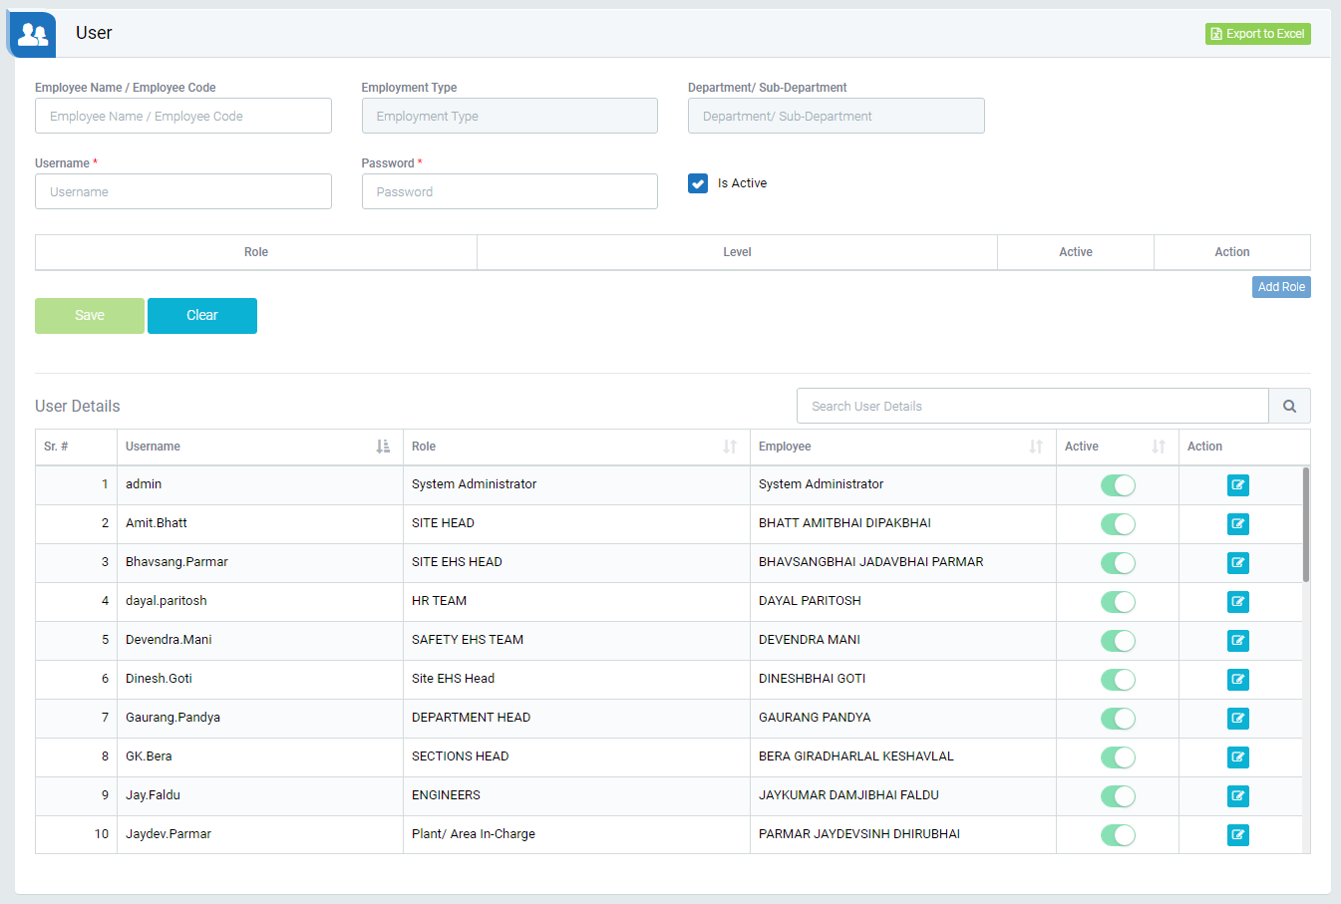

[Figure: 7.1]

*Business rule(s):*

* To create new user enter employee name/code and select the employee.
* Enter username and password.
* Click on Add Role button and select user roles and its level.
* Mark as Active and click on save button under the Action field.
* Click on Submit button to save users details or create new user.
* Created users detail will display in the user details section.

**[End of Document]**