

**Project: HSE Management System**

**Module Name: CAPA Management**

|  |  |
| --- | --- |
| **Document Reference No** | **Revision No** |
| ASK-SWARE-P-110-03 | Rev 0 |

Table of Contents

**1.** **Document Control** 3

1.1. Change History 3

1.2. Management Review 3

**2.** **CAPA Management Requirement Specification Introduction** 4

2.1. Background 4

2.2. Document Purpose 4

2.3. Scope 4

**3.** **HSE Management System - Organizational Hierarchy** 4

**4.** **HSE Management System - Role Level Hierarchy and Permission** 4

**5.** **CAPA Management Requirements** 5

5.1. CAPA Management Master 5

5.2. CAPA Action Items Management – (HSE Module wise) 5

5.2.1. Assigned CAPA Action 6

5.2.2. Review CAPA Action 10

5.3. Action Items Search 12

5.4. CAPA Action Matrix and Analytics charts reporting 13

5.5. Email Alert Notification 17

1. **Document Control**
   1. Change History

|  |  |  |  |
| --- | --- | --- | --- |
| **Version** | **Date** | **Author** | **Change** |
| Rev 0 | 21 August 2020 | Mishant Lakdawala | Initial Creation |
|  |  |  |  |
|  |  |  |  |

* 1. Management Review

**Process Owners**

|  |  |  |  |
| --- | --- | --- | --- |
| **Role** | **Name** | **Signed** | **Date** |
| Business Process Owners | Subodh Kumar |  |  |
| Business Process Owners | Piyush Mistry |  |  |

1. **CAPA Management Requirement Specification Introduction**
   1. Background

This HSE Management System Requirement Specification (SRS) document defines the incremental business requirements and processes on top of current global template for HSE System. Where it transpires that further detail is required, this will be documented as Appendices subsequently. Possible examples of further documentation include:

* Any additional detail pertaining to requirements contained in the SRS that the project team deemed to be formally documented.

Any changes to the scope contained in this document resulting from new requirements coming to light, or from amendments to original requirements, will be documented subsequently, and will be subjected to a change management and control process. Major changes may adversely affect the timescales and/or the resource planning for the project.

This document contains the requirements considering the below requirements to be achieved in CAPA Management module of HSE Management System for Navin Fluorine. The web application should be device responsive and can also be used using android device browsers.

* 1. Document Purpose

The main objective of this document is to have software specification of modules required by client. This will give surety to requester regarding the request, requirement and output.

* 1. Scope

The scope of this SRS will cover the CAPA Management module from HSE Management.

1. **HSE Management System - Organizational Hierarchy**

System should support different levels of hierarchy to manage the routine HSE procedural operations. Please refer finalized document reference no of system configuration (**Signoff_SystemConfiguration_Rev0_20210331.docx)** for more details.

1. **HSE Management System - Role Level Hierarchy and Permission**

Provide appropriate and equivalent access of HSE Management software modules to specific set of users/ employees. Please refer finalized document reference no of system configuration (**Signoff_SystemConfiguration_Rev0_20210331.docx)** for more details.

1. **CAPA Management Requirements**
   1. CAPA Management Master

*Objective:*

* System should support CAPA master details.

*Process Map or Work-flow:*

* N/A

*Screenshot(s):*

* N/A

*Business rule(s):*

* Refer CAPA master data sheet (**NFIL_Pre-requisite data format for CAPA.xlsx**) for more details.

*Open Questions:*

* 1. CAPA Action Items Management – (HSE Module wise)

*Objective:*

* To manage and track CAPA action items assigned to a system user in the system.

*Process Map or Work-flow:*

* CAPA of Incident/ Near-miss work-flow as shown in below screen **[Figure: 5.3.1]**

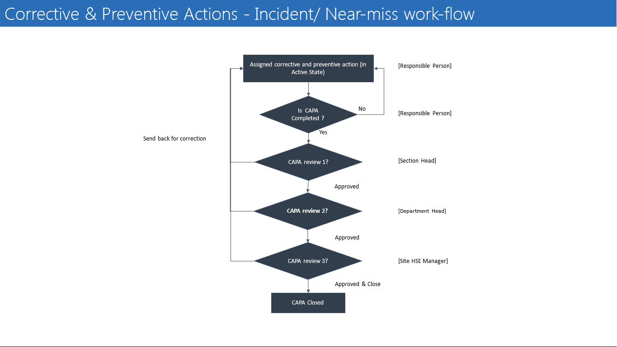

[Figure: 5.3.1]

*Open Questions:*

* + 1. Assigned CAPA Action

*Screenshot(s):*

* Assigned CAPA Action Items against the HSE Activity modules as shown in below screen **[Figure: 5.3.1.1]**

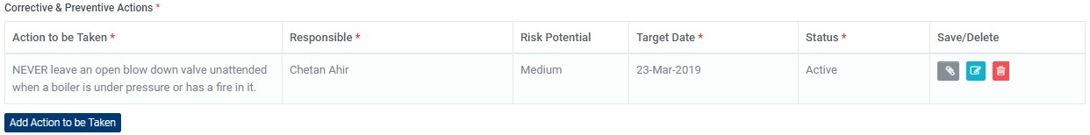

[Figure: 5.3.1.1]

User can add action item(s) against an HSE activity such as Incident/ Near-miss Investigation, etc. Assign the action item(s) to the responsible person who will conduct it. Action item can be assigned to Any System User.

* Perform CAPA Action Items as shown in below screen **[Figure: 5.3.1.2]**

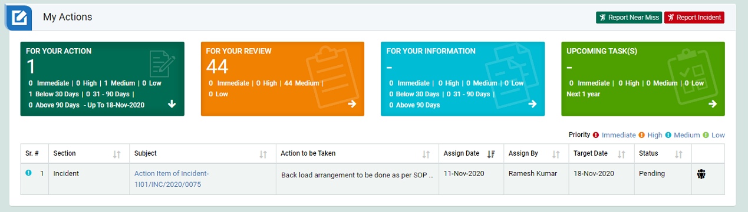

[Figure: 5.3.1.3]

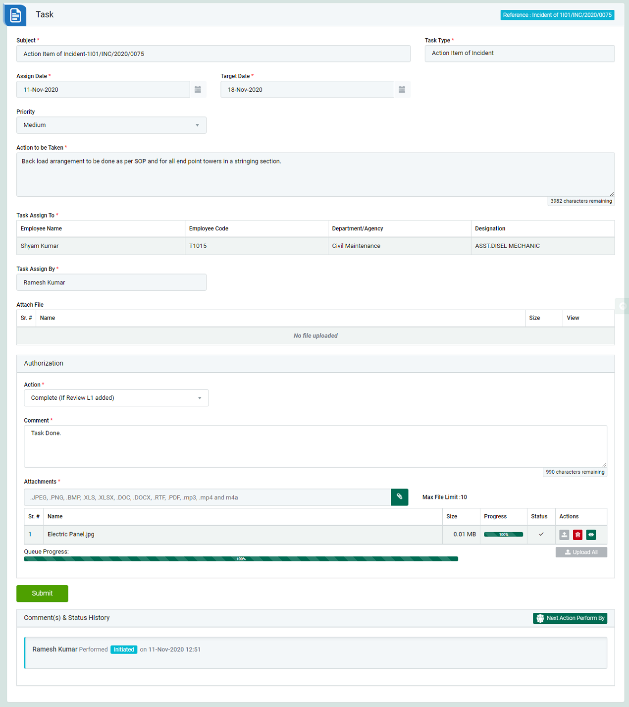

[Figure: 5.3.1.4 (For Thermal & Renewable)]

*Business rule(s):*

* Login as the user to whom action item is assigned and go to My Action screen. There are four section provided to view and take action against tasks which are mentioned below:
* For Thermal and Renewable Site users shall use Action Items as shown in above screen **[Figure: 5.3.1.4]**
* **FOR YOUR ACTIONS:** Display “Incident/Near Miss”, and action items which needs to be performed. Also the tasks which are saved as draft are displayed here. User will update final information and submit it for further action.
* Click on a particular subject in subject column in “FOR YOUR ACTIONS” section to open the task in different tab.
* To take action against a particular Action Item report select Action from drop down list as below
* **FOR YOUR ACTION:** Display “Incident/Near Miss”, and action items (CAPA) which needs to be performed. It also displays the tasks which are saved as draft. User will update final information and submit it for further action. (This section is displayed by default)
* **FOR YOUR REVIEW:** Display the tasks such as “Incident/Near Miss”, including action items which needs to be reviewed. The tasks will be displayed to reviewer for review where reviewer will take action against it.
* **FOR YOUR INFORMATION:** Display all the tasks such as “Incident/Near Miss”, to creator/requester with their current status. User can view the task details by clicking subject in “Subject” column.
* **UPCOMING TASK(S):** Display future tasks which are planned already.
* When subject of “Action Items (CAPA)” in subject column in “REVIEW ACTIONS” section is clicked “CAPA Action Item” screen will be opened in different tab.
* **In-Progress:** If the concerned person is still working on the task then the select the status as In-Progress.
* **Revise Date:** This option allow user to change End Date. If date is revised then the task will be reviewed by the person who assigned and Complete (If Review L1 added): Select complete if the task is completed. The task will review by “Department Head” first, and then the task will be reviewed by “Site EHS Head”.
* **Complete (If Review L1 added):** Select complete if the task is completed. The task will be reviewed by “Line Manager” first, and then the task will be reviewed by “Department Head”.
* Click Update button to update the task details as per the selected action.
* Action Items (CAPA) report numbering format “**[SiteCode]/ [ModuleCode]/ [Year]/ [Number of Action Items (CAPA)]”** should be auto generated after submit the New Task**.**

Example;

Surat Site: **SRT/INC/2021/0001**

Surat Site: **SRT/NM/2021/0002**

*Open Questions:*

* + 1. Review CAPA Action

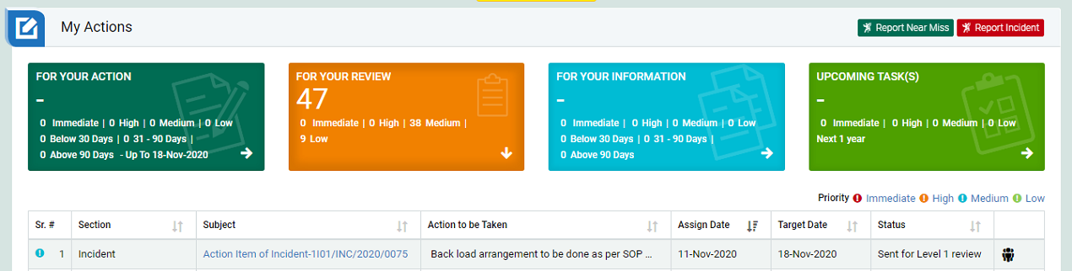

[Figure: 5.3.2.1]

* Login as Review role user and go to My Action screen
* There are four section provided to view and take action against tasks which are mentioned below :
* **FOR YOUR ACTION:** Display “Incident/Near Miss”, and action items (CAPA) which needs to be performed. It also displays the tasks which are saved as draft. User will update final information and submit it for further action. (This section is displayed by default)
* **FOR YOUR REVIEW**: Display the tasks such as “Incident/Near Miss”, including action items which needs to be reviewed. The tasks will be displayed to reviewer for review where reviewer will take action against it.
* **FOR YOUR INFORMATION**: Display all the tasks such as “Incident/Near Miss”, to creator/requester with their current status. User can view the task details by clicking subject in “Subject” column.
* **UPCOMING TASK(S):** Display future tasks which are planned already.
* Click on a particular subject in subject column in “REVIEW ACTIONS” section to open the task in different tab.

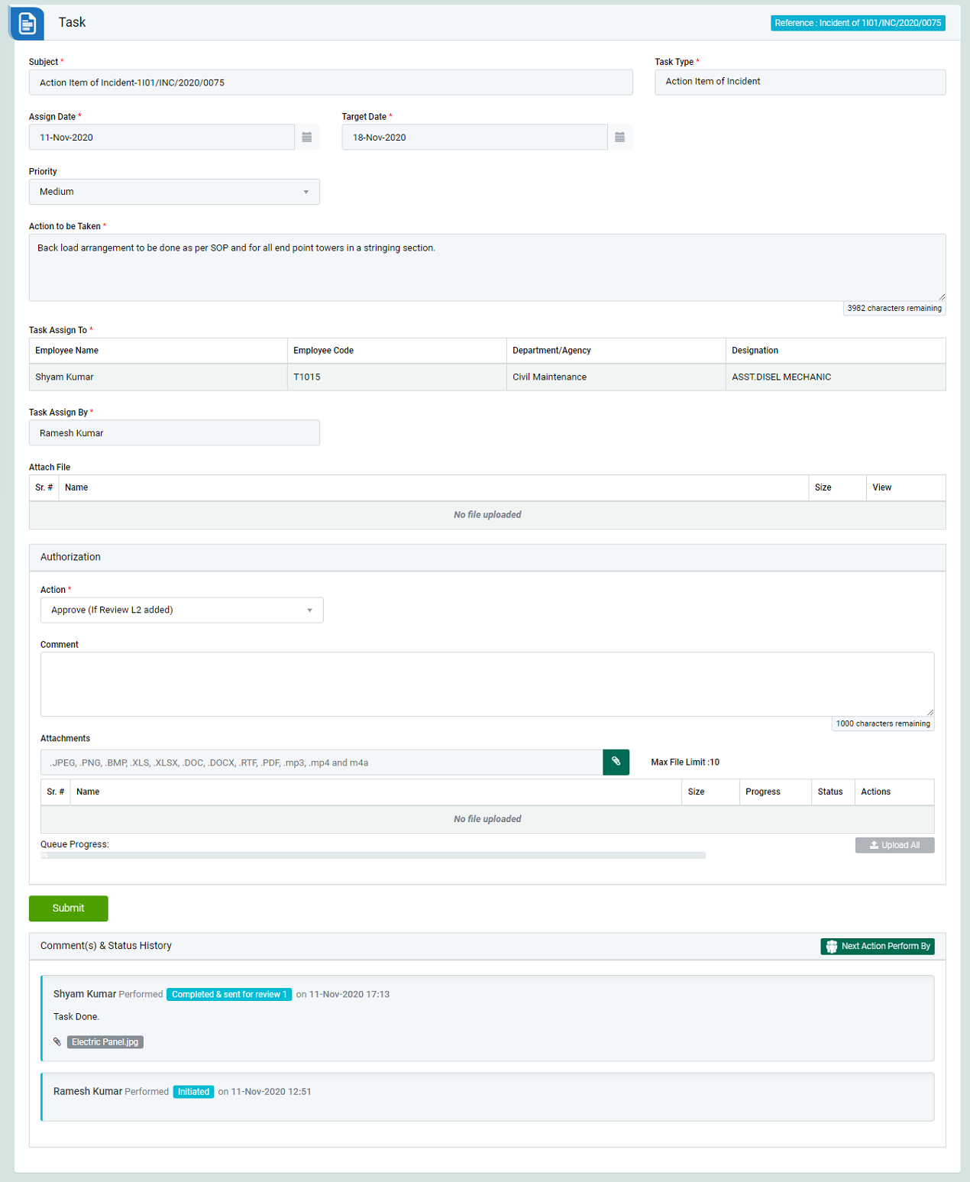

[Figure: 5.3.2.2 (For Thermal & Renewable)]

* To take action against a particular observation report selects Action from drop down list as below:
* **Approve (If Review L2 added):** The particular task is approved by “Section Head” first. Then the task will be reviewed by “Department Head”.
* **Approve & Closed:** The particular task is approved & closed by “Site HSE Manager”.
* **Reconsidered/ Reject:** To reject an Action Items (CAPA) report. If a report is reconsidered, it will go back to the person who reported it. In this case comment is mandatory to enter.
* Click Submit button to update the task details as per the selected action.

Note:

* The fields marked with * are mandatory to be filled.
* If action item is completed by “SECTION HEAD”, then the action item will be reviewed by next reviewer if present. If action item is assigned to a particular function, then all the Department Head of that function can perform on that task. Any one of the Department Head can assign same task to other person.
  1. Action Items Search

*Objective:*

* System should support to search results of Action Items (CAPA) which help of different filter options.

*Process Map or Work-flow:*

* N/A

*Screenshot(s):*

* Action Items Search page as shown in below screen **[Figure: 5.4.1]**

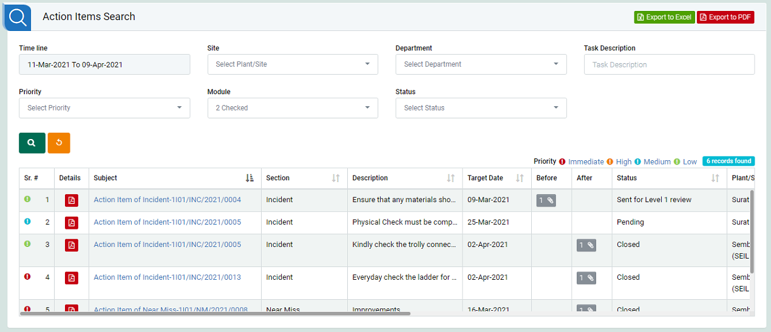

[Figure: 5.4.1]

*Business rule(s):*

* Provide search filter options: Time-line, Site, Department, Task Description, Priority, Responsible Person, Module, and Status.
* Provide search result columns: Sr. #, Details PDF button, Subject, Section, Description, Target Date, Before Attachment, After Attachment, and Status.
* Should be able to select filter options and search result of Action Items.
* Should be able to generate Action Items (CAPA) detail PDF format from software when required.
* Should be able to generate summary export the report in Excel and PDF format from software when required.

*Open Questions:*

* 1. CAPA Action Matrix and Analytics charts reporting

*Objective:*

* System should support and generate different types of Matrix as well as Analytics’ reports. To view module-specific statistical data in real-time

*Process Map or Work-flow:*

* N/A

*Screenshot(s):*

* Action Items Matrix report **[Figure: 5.5.1]**

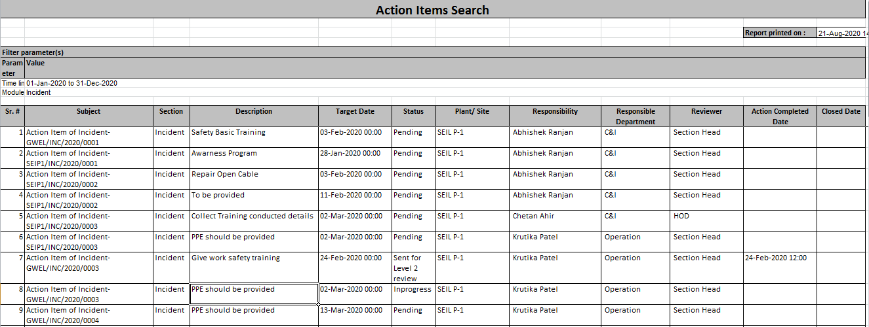

[Figure: 5.5.1]

* Department wise CAPA Data Analysis **[Figure: 5.5.2]**

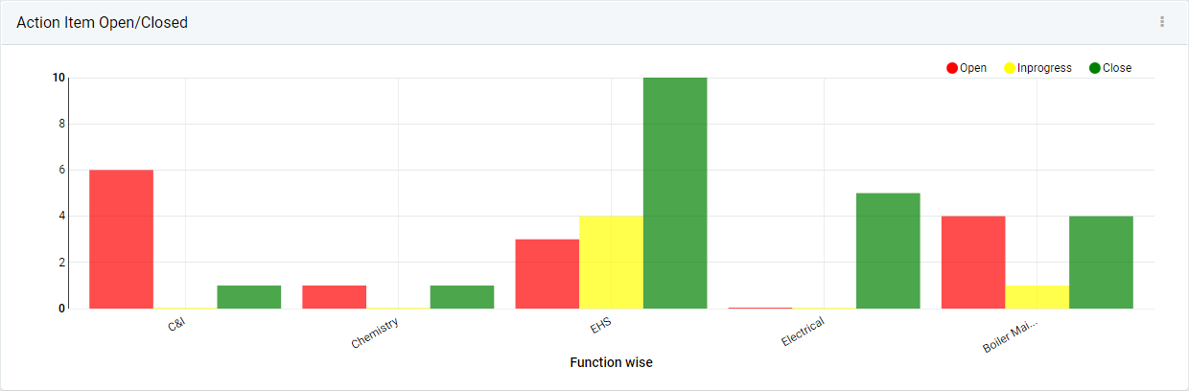

[Figure: 5.5.2]

* HSE Activity (HSE Module) wise CAPA Data Analysis **[Figure: 5.5.3]**

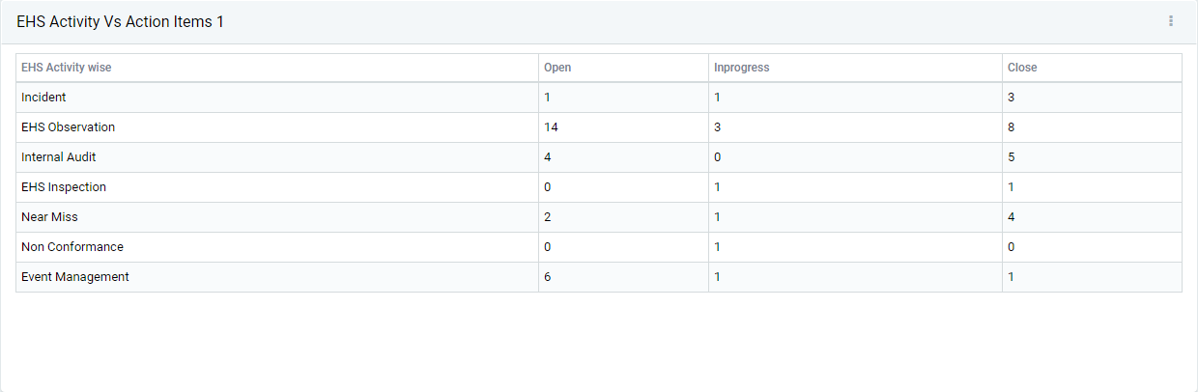

[Figure: 5.5.3]

* Priority wise CAPA Data Analysis **[Figure: 5.5.4]**

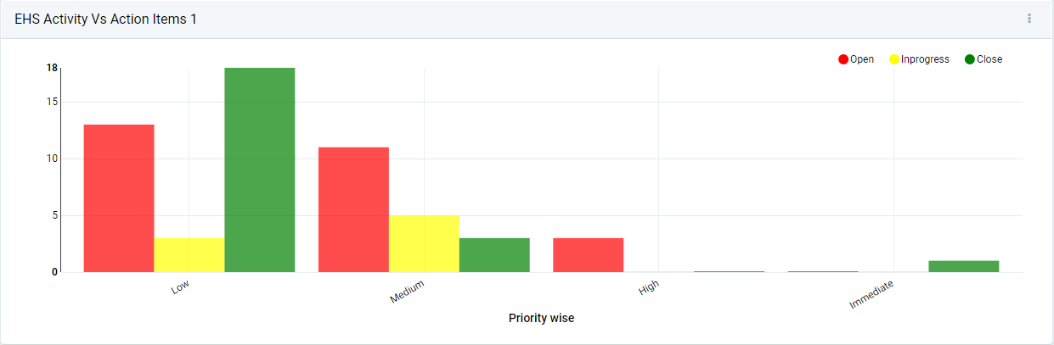

[Figure: 5.5.4]

*Business rule(s):*

* Should be able to export the matrix report in Excel and export the chart in image format from software when required.
* An extensive list of module-specific dashboard charts that are based on carefully tailored ready-to-use KPIs giving useful insights in real-time are available within the system
* Every individual power user can personalize their own respective Analytics Dashboard with the charts that are most applicable to them
* The charts are highly customizable. A single chart can be configured to create a separate view capturing a different piece of information
* Example: HSE Chart can be customized to display – Site wise incidents this year, Plant/Area wise CAPA, Department wise CAPA, and Priority wise CAPA etc.
* Such Granular level customization can be achieved by changing the chart-specific filter settings as shown in the image below

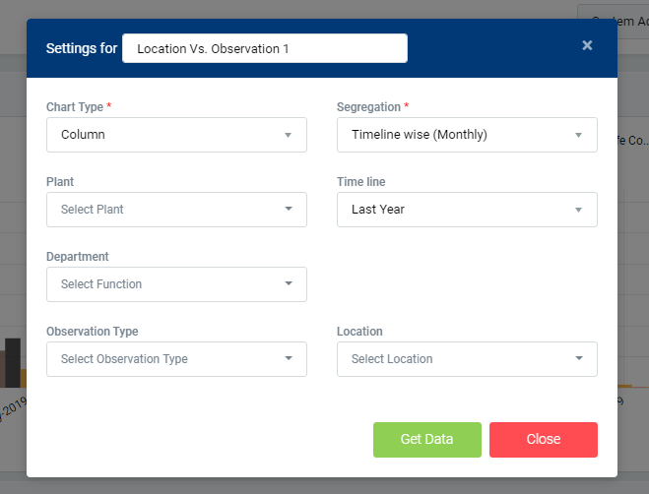

* Chart Type*:* It defines how the data would be represented on the chart. Example: Data represented in tabular manner or as Column or Bar
* Segregation: It defines the criteria based on which the data would be plotted on the chart. Example: For a chart showing incident statistics, if segregation is selected as Department-wise, then the chart shall display incident statistics (on Y-axis) for the various functions (on X-axis)
* Filters: Filter(s) can be used to further refine the data that is being displayed. Continuing from the above example, if one of the provided filter’s - Time line is set to ‘This month’, then the chart showing incident statistics, shall display incident statistics (on Y-axis) for the various functions (on X-axis) that have occurred in the current month
* Note: The options available for selection for segregation and the filters selection shall vary based on the module-specific chart
* The chart data can be exported as image/excel sheet which can be used, say, to be included in annual safety performance presentations (PPTs), etc.
* System facilitates to drill down into details from the chart. Example: For a chart showing Action Items, clicking on the ‘Open’ action items data shall take the user to a page where all the action items that are open shall be displayed in a consolidated view
* Provision exists to enable every individual power user to decide the default dashboard that shall be presented to the user upon successful login. This preference can be done from ‘Set Default Dashboard’ link which is located under the User Profile menu. The available choices are ‘Analytics Dashboard’ and ‘Task Dashboard’.

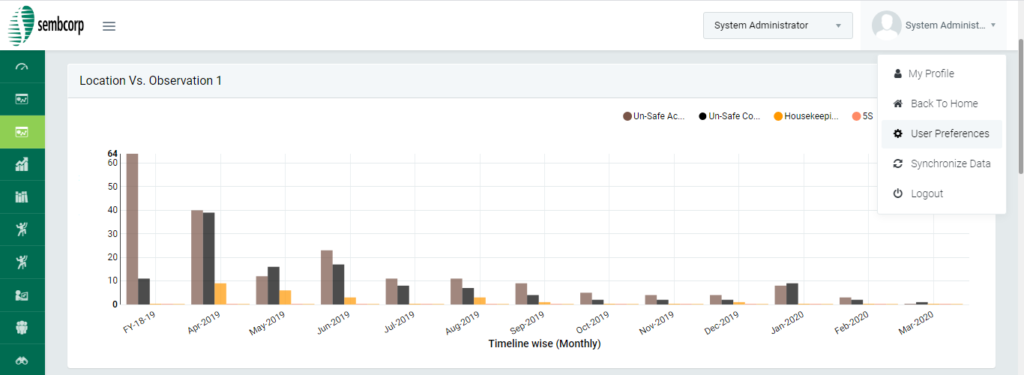

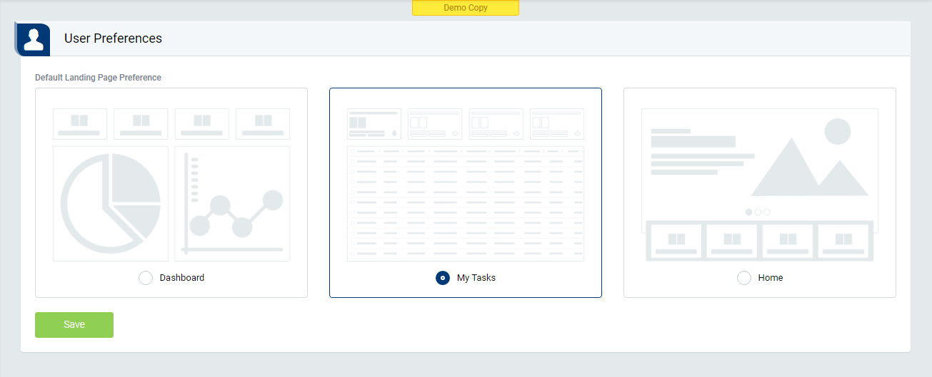

*Open Questions:*

* 1. Email Alert Notification

*Objective:*

* System should support to send Email Alert Notification to system role users in form of Email.

*Process Map or Work-flow:*

* N/A

*Screenshot(s):*

* N/A

*Business rule(s):*

* Refer below email alert stages wise email alert matrix going to concern system role users for Incident/ Near-miss CAPA Management.

|  |  |  |  |
| --- | --- | --- | --- |
| **Module Name** | **Email Alert Stages** | **Send To Mail (To whom?)** | **Send Cc Mail (To Whom?)** |
| CAPA Actions | Action Item Assigned | 1. Responsible Person |  |
| CAPA Actions | Action Item sent for Line Manager Review | 1. Section Head (Particular Department) |  |
| CAPA Actions | Action Item Approved by Line Manager | 1. Responsible Person |  |
| CAPA Actions | Action Item Reconsider by Line Manager | 1. Responsible Person |  |
| CAPA Actions | Action Item sent for Department Head Review | 1. Department Head (Particular Department) |  |
| CAPA Actions | Action Item Approved by Department Head | 1. Responsible Person |  |
| CAPA Actions | Action Item Reconsider by Department Head | 1. Responsible Person |  |
| CAPA Actions | Action Item sent for Head-Safety Review | 1. Site HSE Manager (Particular Site) |  |
| CAPA Actions | Action Item Approved & Closed by Head-Safety | 1. Responsible Person | 1. Section Head (Particular Department)  2. Department Head (Particular Department)  3. Site HSE Manager (Particular Site) |
| CAPA Actions | Action Item Reconsider by Site HSE Manager | 1. Responsible Person | 1. Section Head (Particular Department)  2. Department Head (Particular Department)  3. Site HSE Manager (Particular Site) |

*Open Questions:*

**[End of Document]**