**1 :** Manage proper naming convention for variable methods and function according to SQL table and fields.

**2 :** Remove unnecessary space and must use region for long methods,functions and commented code.

Region Example :

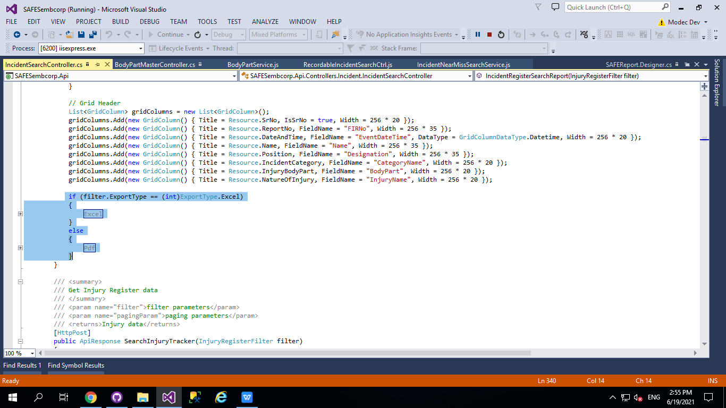

**3 :** Add comment when change in existing code.

**4 :** Use Http get for bind controls like DropDownlist,Checkboxlist,Radiolist and Normal Get Methods

Only use when there are only 2 3 input parameters with less records from UI

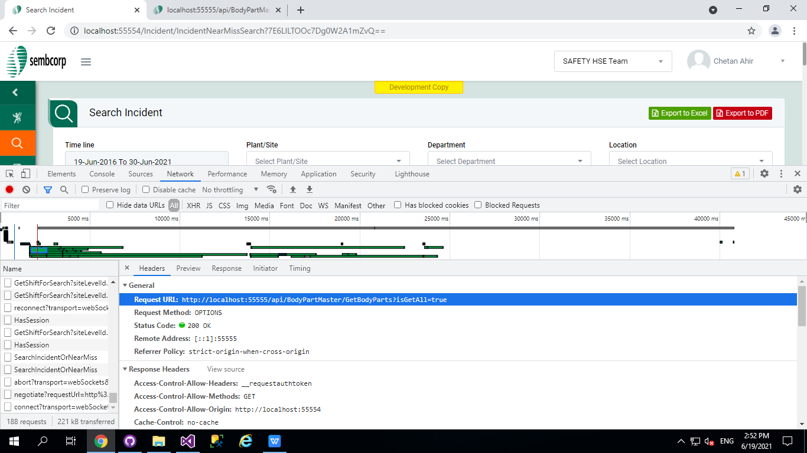

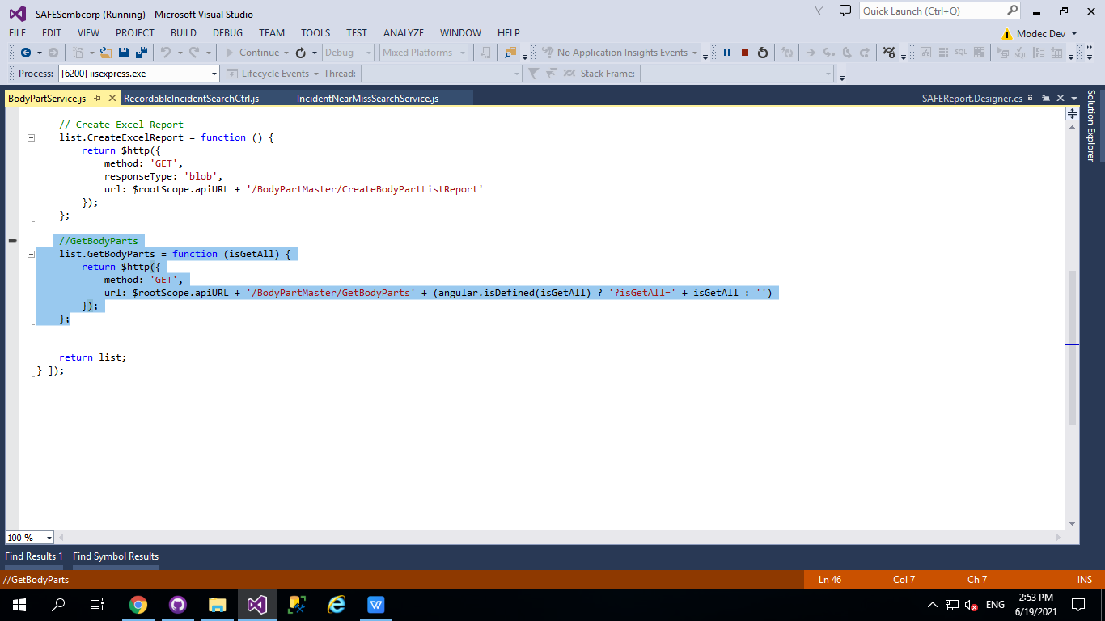

**5 :** Use Http Post for search page api.

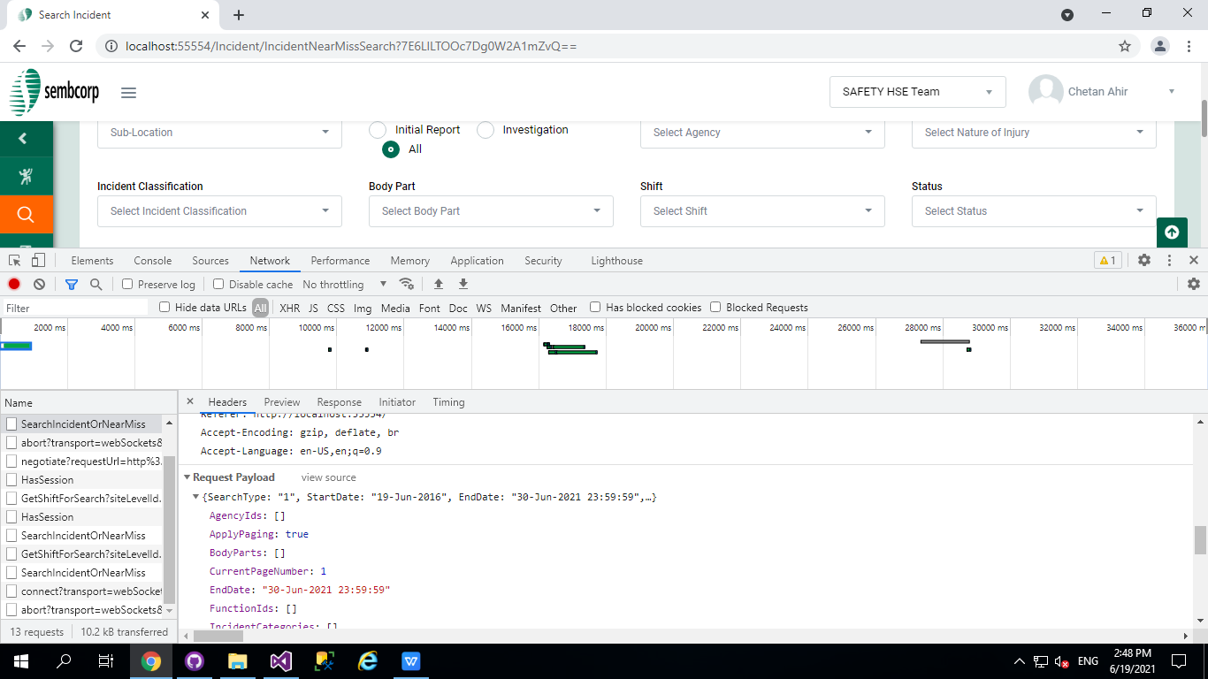

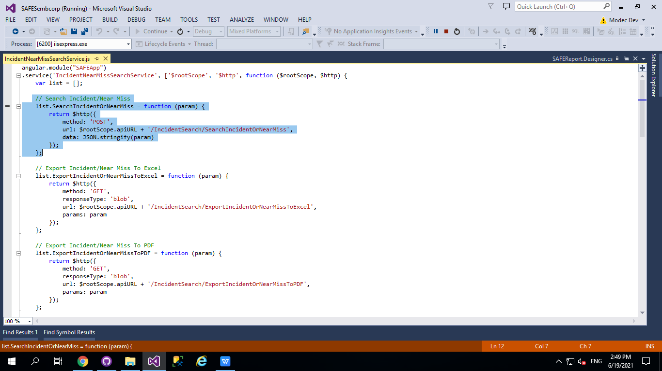

**6 :** Must use transaction with try catch and Elmah Error Log for DML Operation like insert update delete.

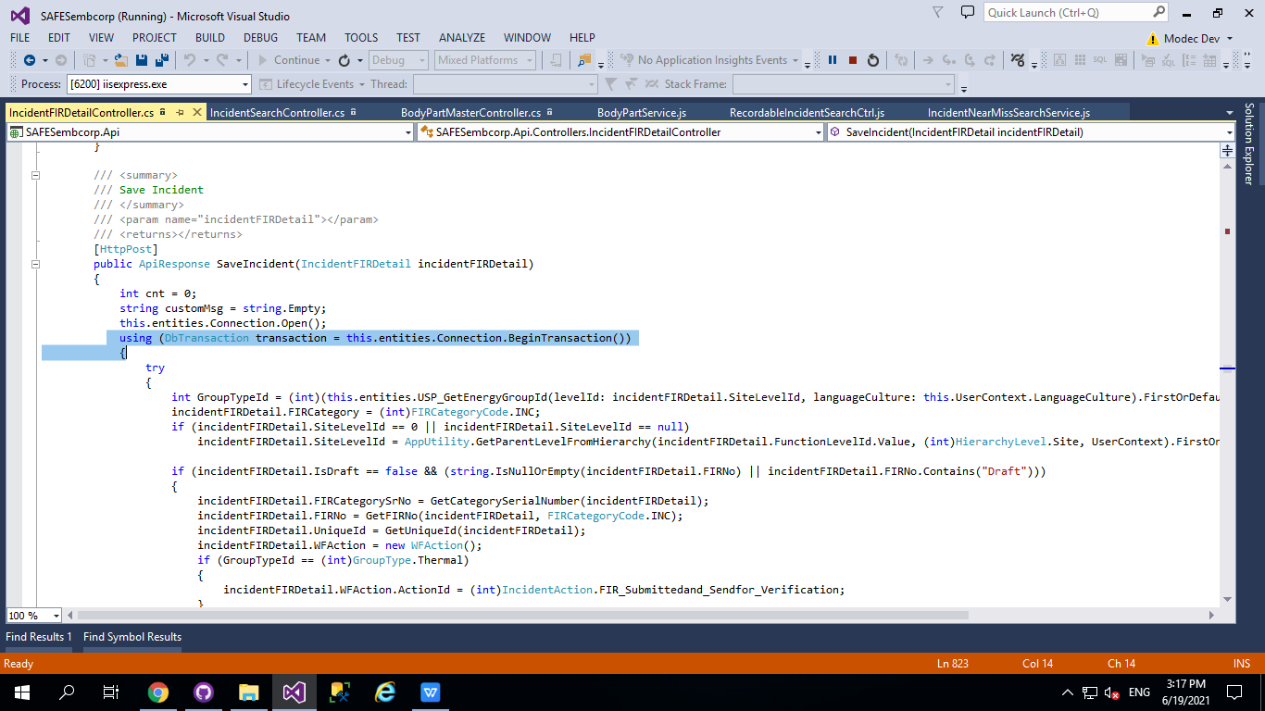

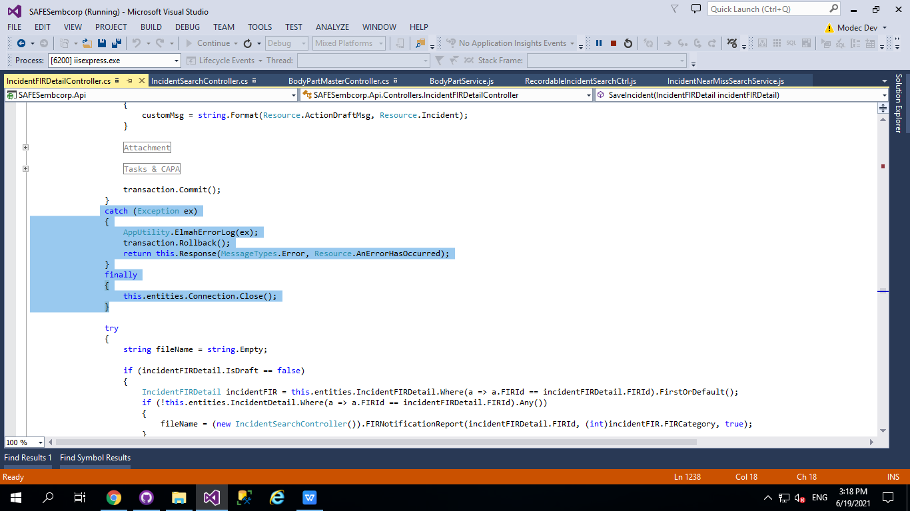

**7 :** Must use Stored Procedure for Fetch Records (Ex.Search page,Export to Excel,Reports) with paging parameter.

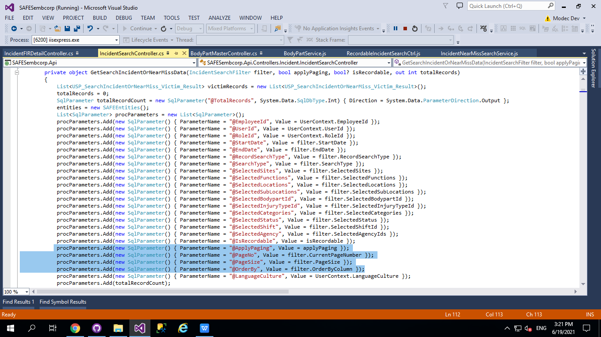

**8 :** Create common method for site dept and for other common results.

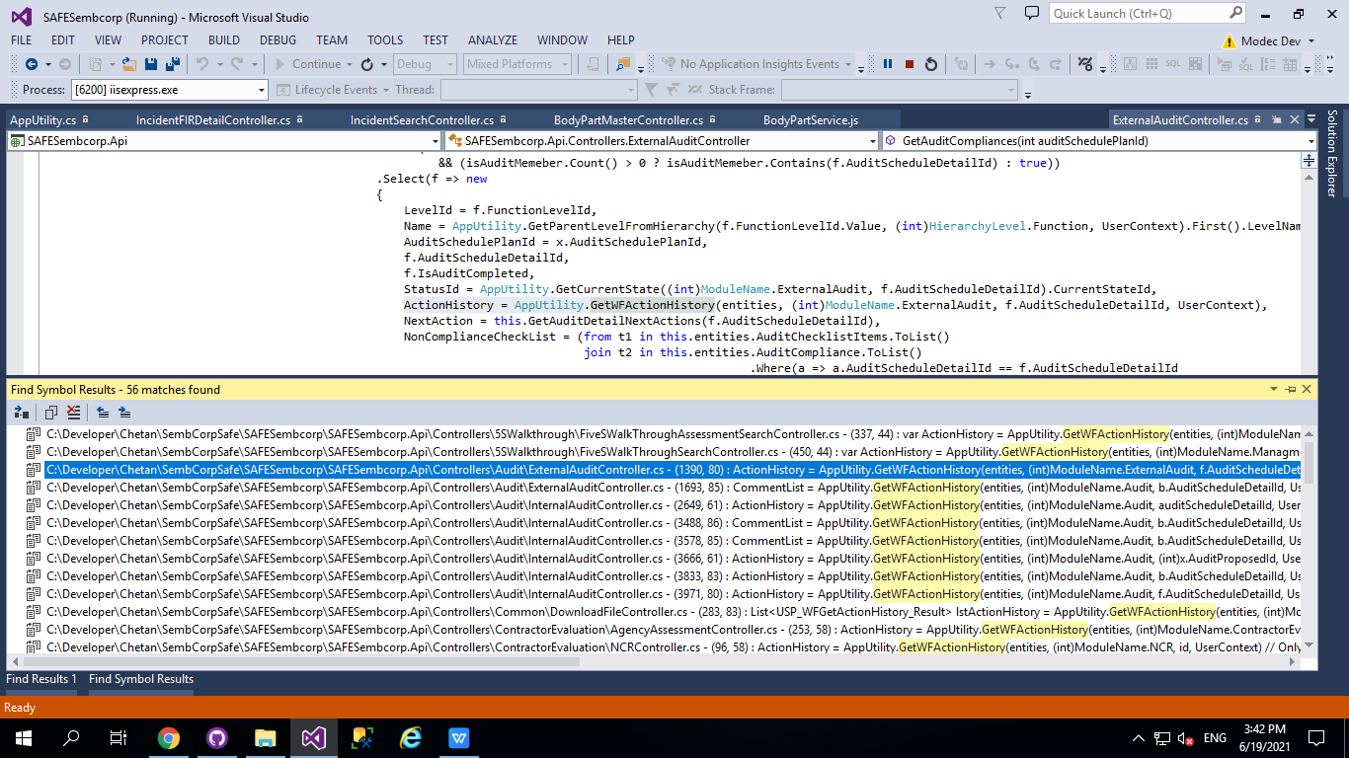

**9 :** Do Not use asEnumrable() and ToList() when fetching data.

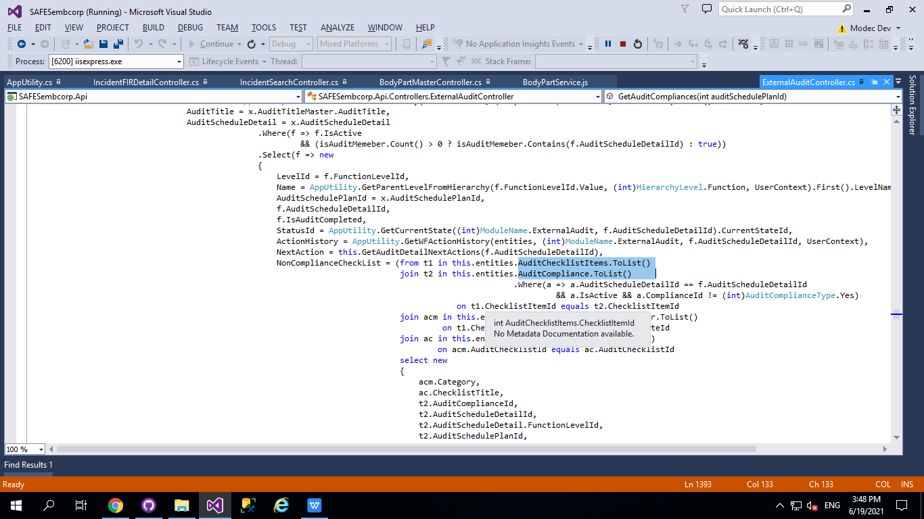

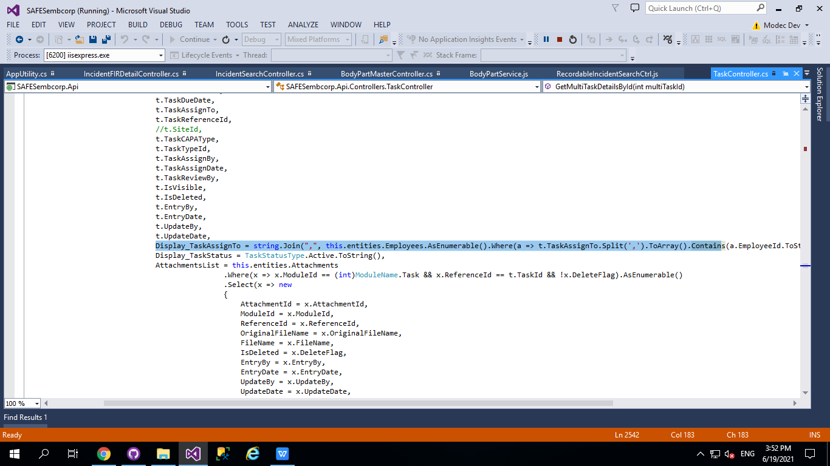

**10 :** Save Every Date Field in UTC Format

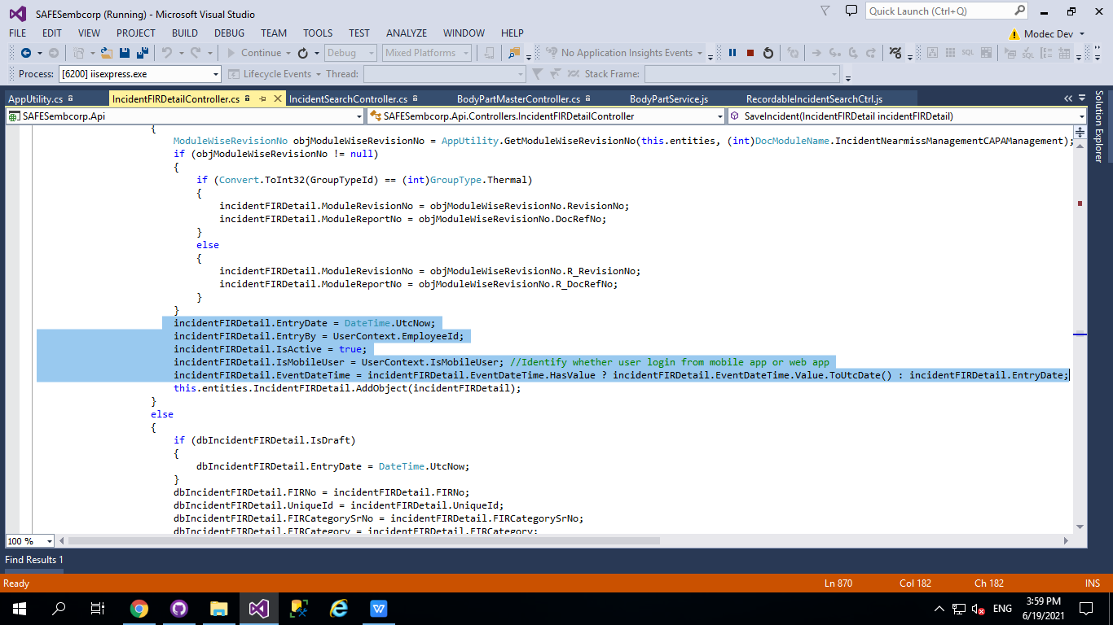

Need to convert in normal date when received from api

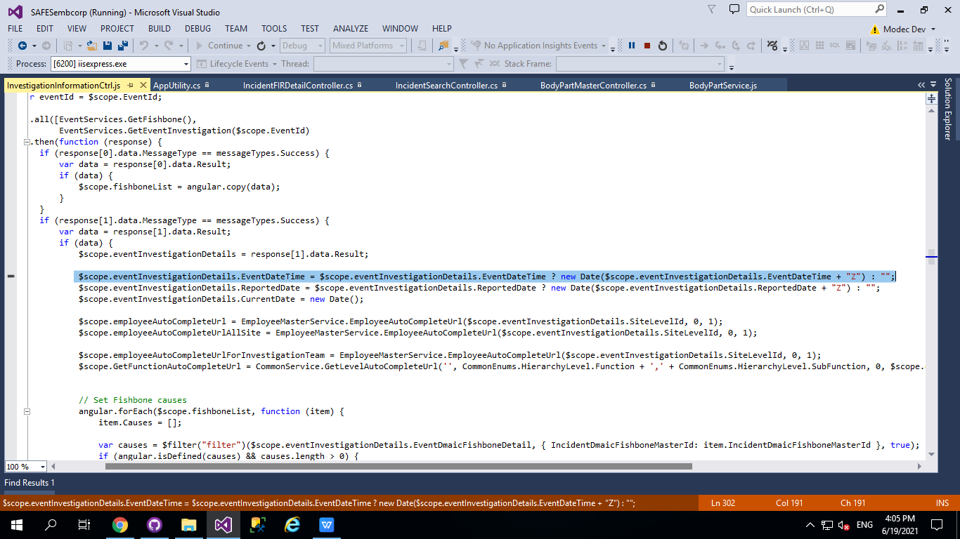

Need to convert date in api format when save update

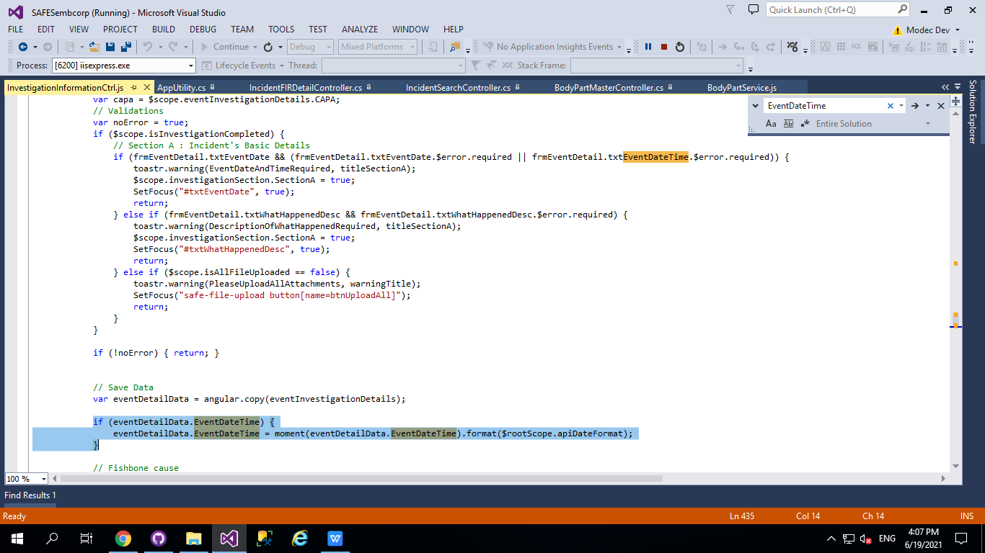

**11 :** Use out parameter when result is common.

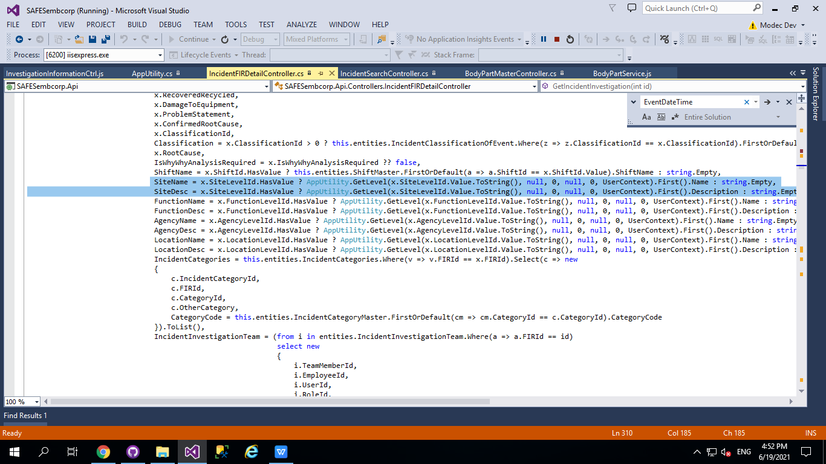

**12 :** Must use $q method for call in sequentially.

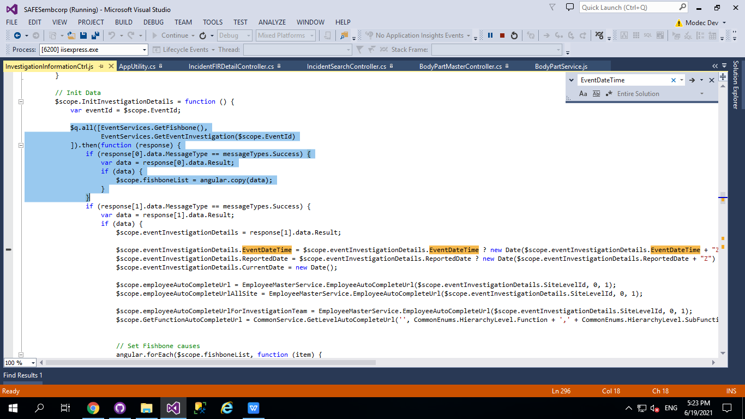

**13 :** Apply all validation in UI and if required then in JS File.

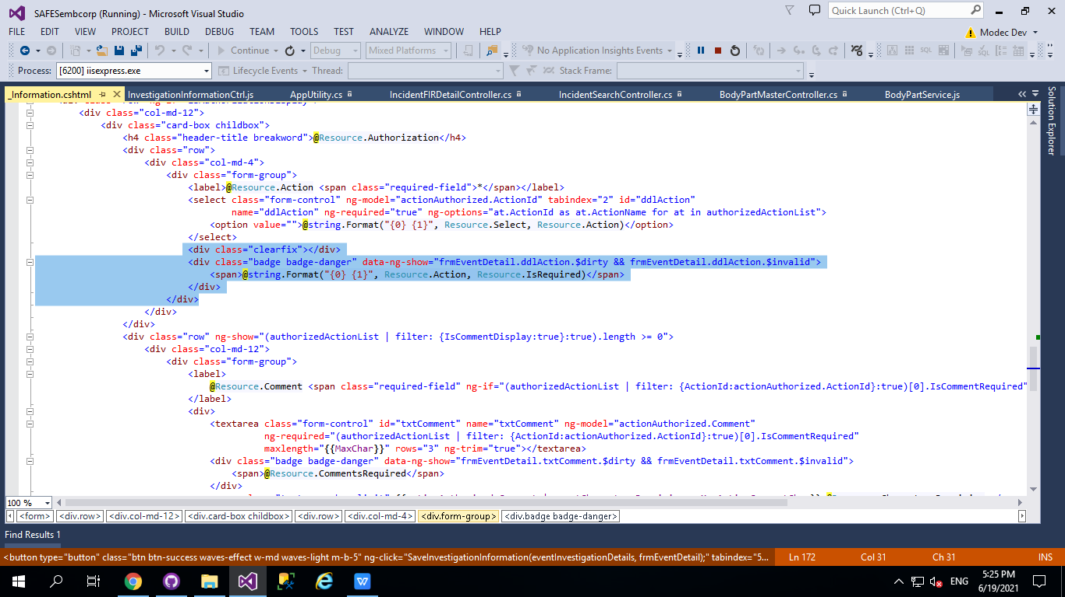

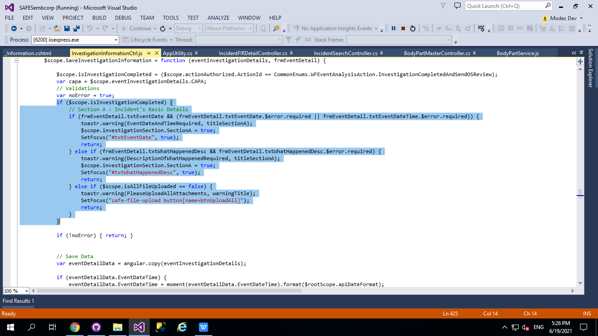

**14 :** Add Table value in proper enum when required for validation in **api** and **js** file.

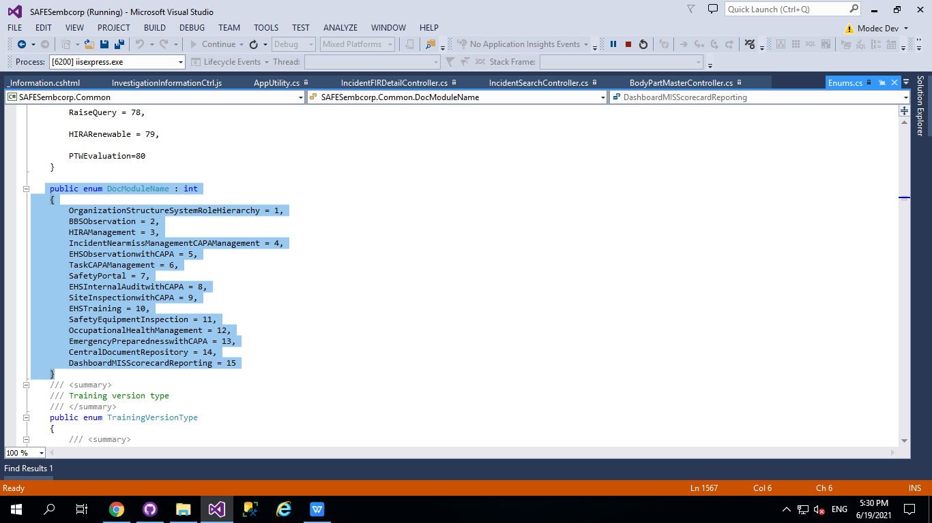

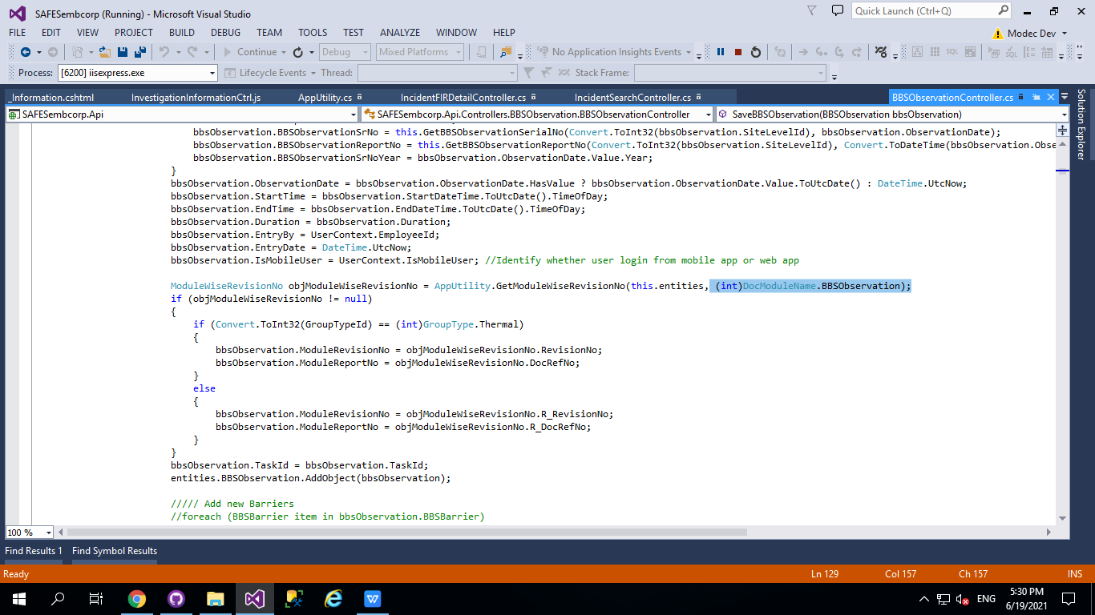

**15 :** Use resource for any field name, label name or any custom messages.

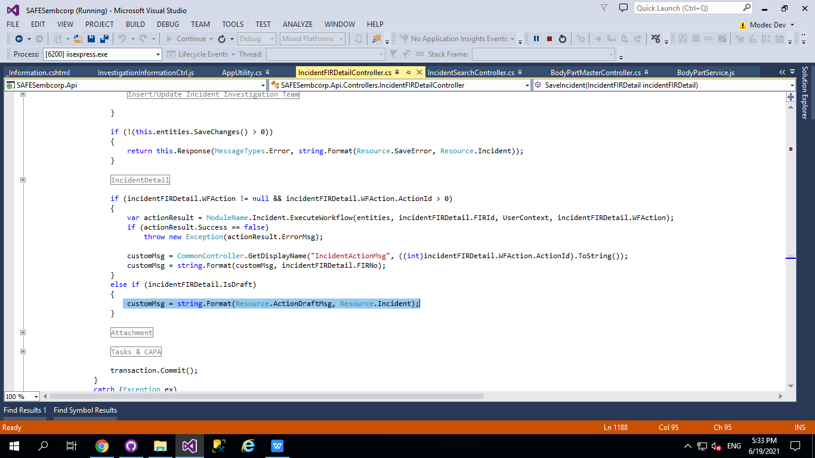

**16 :** Add all SP in Report edmx.

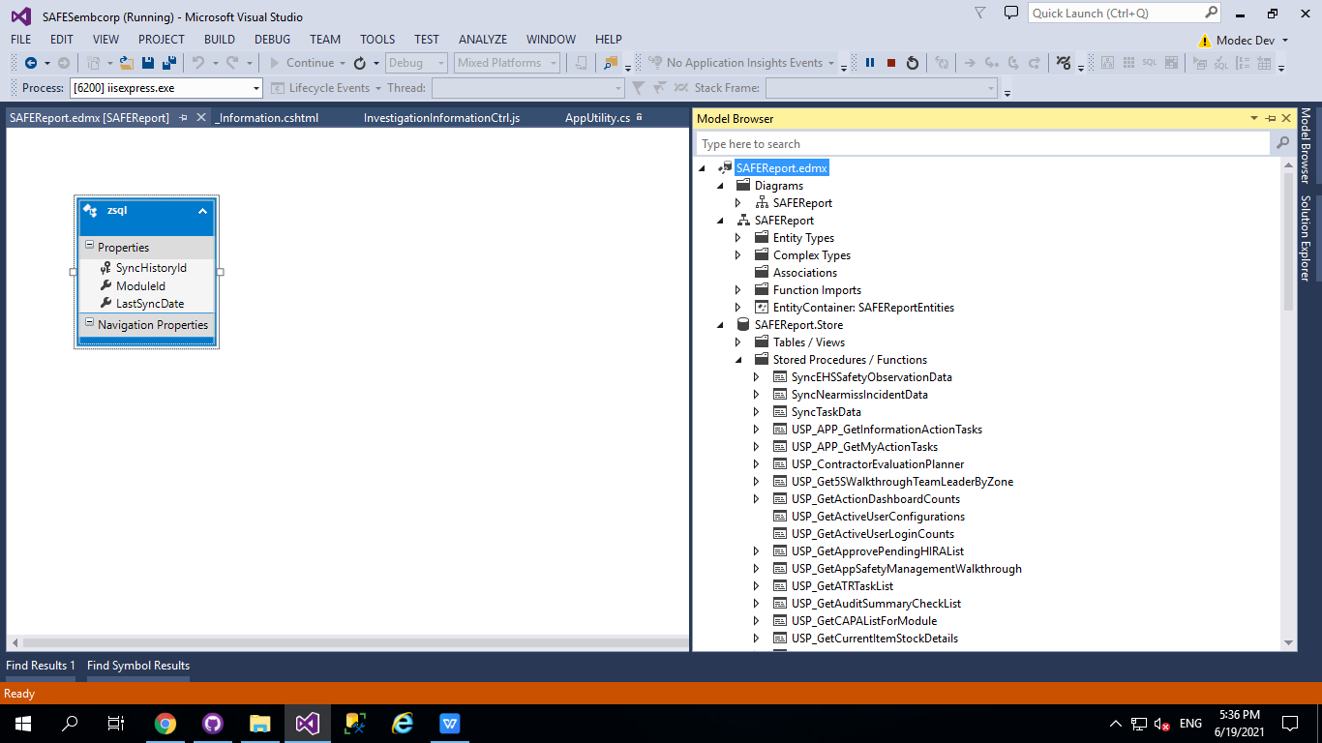

**[End of Document]**