Thermodynamic Feasibility Testing of Useful Work Claims
  - CL 202 Project Team | Chemical Engineering Thermodynamics
ABSTRACT We developed a Python tester that compares proposed useful-work claims with thermodynamic limits for heat engines, mechanical harvesters, ideal blackbody radiation and isothermal reactions. The program checks energy and entropy balances when the boundary data support them. A plain-language input layer extracts quantities for review and passes the normalized inputs to the same solver as the JSON interface. For the two coffee-brewing assignments at roll suffix 100, the reversible electrical power ceilings were 1.153 and 2.584 kW, respectively. Independent calculations reproduced both ceilings. Published data and theory supplied further comparisons for all four domains. The results distinguish claims that exceed a physical limit from those that need more data or a different model.
Keywords thermodynamic feasibility, second law, reversible work, waste heat, energy harvesting

Introduction
A proposed device can conserve energy and still demand more useful work than its source can deliver. The difference matters in waste-heat recovery, where temperature and entropy constrain the useful fraction of the heat. Finite heat streams add a further complication because their temperatures change during heat transfer [1]. The CL 202 assignments use this distinction to ask whether recovered electricity can brew coffee at a specified rate [2,3].
The tester reports feasible within the model, not feasible, or insufficient data or model required. Where entropy generation is available, its sign distinguishes reversible, irreversible and impossible states.

Theory and Methodology

Thermal balances
For a cyclic engine, take heat supplied, heat rejected and useful work out as positive magnitudes. The First Law gives the rejected heat when it is missing. With two fixed reservoirs, the entropy balance and the reversible work ceiling follow directly.
Q̇_{H} = Ẇ + Q̇_{C}
Ṡ_{gen} = Q̇_{C} / T_{C} − Q̇_{H} / T_{H}
Ẇ_{rev} = Q̇_{H} (1 − T_{C} / T_{H})
For sensible, isobaric changes, the stream enthalpy change is the integral of Cₚ with temperature. The entropy change is the integral of Cₚ/T. Their magnitude ratio gives an effective temperature for the specified change. This ratio preserves the heat-to-entropy relation over that interval.

Coffee assignment boundaries
Base encloses a cyclic device and both water streams in a steady adiabatic boundary. The cold outlet implied by the claim follows from the energy balance. The strict ceiling instead solves for a cold outlet at which the stream entropy changes cancel, with the same hot duty, cold flow and cold inlet.
Modified models sensible cooling of a gas with linear Cₚ and heat rejection into isothermally melting wax. The wax temperature equals the ratio of its fusion enthalpy to fusion entropy. The resulting gas-to-wax bound assumes negligible gas pressure change and uses the wax at its melting point.

Models for Other Energy Sources
Mechanical output is bounded by the recoverable mechanical power at the converter input. If the resource is specified as energy per step or event, the power is that energy multiplied by event rate. Input and output are averaged over the same interval. In the published knee-harvester comparison, the input is shaft-side mechanical power [4].
The ideal radiation route calculates incident power from irradiance and effective collection area. For undiluted blackbody radiation, with r equal to ambient temperature divided by source temperature, the exergy fraction is 1 − 4r/3 + r⁴/3 [5]. The ceiling is the incident power times this fraction.
At fixed temperature and pressure, the signed maximum non-expansion work out per mole of forward reaction is −ΔᵣG. Multiplying by the reaction extent rate gives the reversible power. Positive ΔᵣG requires external work in the forward direction. The Gibbs energy must refer to the stated direction and operating conditions. The corresponding reversible cell potential obeys the IUPAC sign convention [6].

Computational Details
The engine integrates constant and linear heat capacities analytically. Built-in checks also exercise adaptive Simpson integration and bracketed bisection. Assignment builders derive inputs from the roll suffix. The language layer quotes source quantities, normalizes their units, and asks for missing or conflicting data. Both routes call the same Python engine as the JSON interface.

Results and Discussion

Coffee assignment benchmarks
The brewing load uses 0.25 L per cup, a 65 K water temperature rise and an 85% electrical-to-thermal efficiency. Each liter requires about 320 kJ of electricity.
Table 1. Coffee-brewing benchmarks at X = 100.
Quantity | Base | Modified
Heat input (kW) | 16.000 | 12.000
Claimed power (kW) | 1.000 | 1.333
Effective hot temperature (K) | 324.48 | 398.26
Effective cold temperature (K) | 301.13 | 312.50
Reversible ceiling (kW) | 1.153 | 2.584
Maximum coffee (L/h) | 12.97 | 29.07
The Base effective cold temperature describes the claimed states. Its strict ceiling uses the reversible outlet.
Base water entered the device at 57.75 °C and the cold stream left at 30.98 °C under the claim. The reversible cold outlet was 30.91 °C. The strict Base ceiling corresponds to 0.778 kg of powder per hour at 60 g/L. The Modified ceiling applies while the wax absorbs heat at 312.50 K. A finite wax inventory requires regeneration for sustained operation.
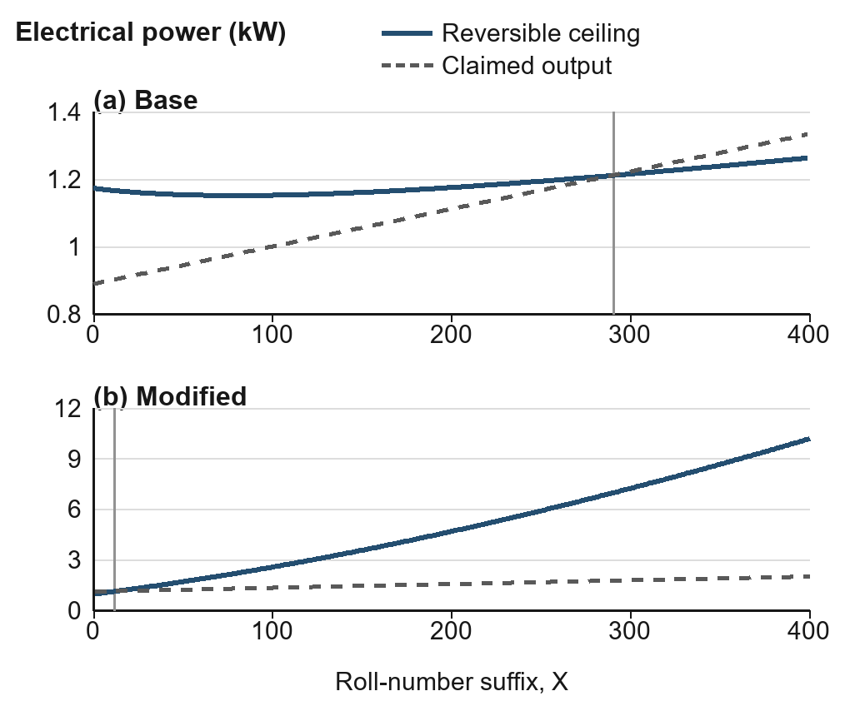
Figure 1. Claimed power and reversible ceilings across the allowed suffixes. Vertical markers show the first Base rejection (291) and first Modified pass (012).

Independent and Published Comparisons
Table 2. Reference and program results.
Case | Unit | Ref. | Code | Δ
Base ceiling [2] | kW | 1.1531 | 1.1531 | ≈0
Modified ceiling [3] | kW | 2.5839 | 2.5839 | ≈0
Water Δh [7] | kJ/kg | 175.018 | 175.100 | +0.082
Knee harvester [4] | W | 2.40 | 4.40 | +2.00
Radiation [5] | kW | 1.86667 | 1.86667 | 0
Fuel cell [7,8] | kW | 2.37161 | 2.37141 | −0.00020
Δ is code minus reference. For the knee harvester it is the gap between the ideal ceiling and measured electrical output.
The two assignment power ceilings agreed with independent balance calculations to less than 4 × 10⁻¹⁴ kW. The constant-Cₚ model predicted 175.100 kJ/kg for liquid water heated from 298.15 to 340 K at 1 bar, compared with 175.018 kJ/kg from JANAF. The 0.047% difference reflects the constant-property approximation and the resolution of the table [7].
The mechanical comparison used the single-device ergometer results for generative braking. The measured 2.4 W electrical output fell below the 4.4 W ceiling derived from the reported mechanical input [4].
For 2 kW incident radiation at 6000 K with a 300 K environment, the published blackbody expression gives 1.86667 kW. This checks the implementation of the ideal model [5]. For H₂ + ½O₂ → H₂O(l), the JANAF Gibbs energy at 298.15 K and 1 bar gives 2.37141 kW at 0.01 mol/s. The 1.229 V NETL reference gives 2.37161 kW at the same extent rate using two electrons per reaction. The difference is 0.0084%, consistent with the rounded voltage and reference-state conventions [6–8].

Software Verification
The benchmark sweep evaluated each valid suffix. Base passed for 000–290 and failed for 291–399. Modified failed for 001–011 and passed for 012–400 when no separate server heat budget was specified. The tests check both endpoint ranges and compare the Base verdict with the independently evaluated strict ceiling.
The walking scenario asked for recoverable mechanical input and claimed electrical output. After receiving 4 J per step, 120 steps per minute and a 5 W claim, it converted cadence to 2 s⁻¹ and returned an 8 W ceiling. The exported case reproduced the result through the JSON interface. A 9 W claim failed. Missing data, ambiguous ranges and a claim at the reversible limit were also exercised.
The verification run passed 19 project tests and 16 engine self-checks. Offline parsing covers the walking demonstration and the assignments. Broader extraction uses the optional OpenAI provider, exercised here with simulated responses. A live test requires credentials.

Limitations
A full energy or entropy balance requires complete boundary data. The mechanical, radiation and reaction routes test their resource ceilings and mark these balances as unevaluated. When the engine infers rejected heat, the zero First Law residual follows by construction.
The thermal examples use idealized property models and a steady device boundary. They omit exchanger pinch and size, parasitic loads, pressure loss and ORC working-fluid selection. The mechanical test depends on measured or stated recoverable input. The radiation result applies to the ideal blackbody model, and the reaction route requires an operating-condition Gibbs energy.
The conclusions apply to the supplied thermodynamic model. Device sizing, stability, kinetics and economics require additional information.

Conclusions
The same engine reproduces the two coffee assignment ceilings and supports bounded mechanical, radiation and reaction claims. Separating quantity extraction from thermodynamic calculations makes the reported input assumptions visible and lets plain-language cases be reproduced with JSON. The benchmark comparisons verify the implemented relations and show where measured performance lies below an ideal ceiling.

Reproducibility
Run these commands from the project folder. The first reproduces Table 1 and the second reproduces Table 2.
python run_mock_assignments.py 100
python validate_benchmarks.py
python -m unittest

References
[1] Bejan, A., and Alebrahim, A. The Extraction of Power from a Hot Stream. Int. J. Energy Res. 2001, 25, 507–518. DOI 10.1002/er.700.
[2] Chemical Engineering Thermodynamics CL 202. Assignment 1 Base. Course handout, 2026.
[3] Chemical Engineering Thermodynamics CL 202. Assignment 1 Modified. Course handout, 2026.
[4] Li, Q., Naing, V., and Donelan, J. M. Development of a Biomechanical Energy Harvester. J. Neuroeng. Rehabil. 2009, 6, 22. DOI 10.1186/1743-0003-6-22.
[5] Petela, R. Exergy of Undiluted Thermal Radiation. Sol. Energy 2003, 74, 469–488. DOI 10.1016/S0038-092X(03)00226-3.
[6] International Union of Pure and Applied Chemistry. Standard Electromotive Force. In Compendium of Chemical Terminology, 5th ed., 2025. DOI 10.1351/goldbook.S05913.
[7] Chase, M. W., Jr. NIST–JANAF Thermochemical Tables, 4th ed. J. Phys. Chem. Ref. Data, Monograph 9, 1998. Table H-065, Water at 1 Bar. janaf.nist.gov/tables/H-065.html.
[8] EG&G Technical Services, Inc. Fuel Cell Handbook, 7th ed. U.S. Department of Energy, National Energy Technology Laboratory, 2004. DOE/NETL-2004/1206, pp 2-4–2-5.

