## Enhancing Sales Performance and Maximizing Market Share by Strategic Sales Analysis

**A Mid-Term report for the BDM capstone Project**

Submitted by

Name: Areeba Farooqui Roll number: 22f1001053.



IITM Online BS Degree Program,

Indian Institute of Technology, Madras, Chennai Tamil Nadu, India, 600036

**Contents**

1. Executive Summary and Title 3
2. Proof of originality of the Data (Primary Data - survey link, 3

photograph, letter from organization, etc.)

1. Metadata 6
   * Descriptive Statistics
2. Detailed explanation of analysis process 9
3. Results and Findings (Graphs and other Pictorial Representation 9

Preferred and with words)

# Executive Summary and Title (200 Words):

Bombay Medical Store is a prominent wholesale supplier based in Fatehpur, known for its extensive range of medical products catered to retail outlets and small businesses. Located at

G.T. Road - 212601, The medical store operates in the B2B sector, focusing on enhancing profitability and expanding its client base. The company's mission is to streamline its operations and implement strategies that support sustainable growth.

The data which is collected for this project consists of the sales data in which there’s information about the products and their types along with their cost price, selling price, opening and closing stock. There is also the invoice data where there are names of the firms mentioned where the orders have been sent to and their invoice value along with their taxable amount.

This project aims to analyse sales performance and profitability across different product categories at Bombay Medical Store. Key challenges include understanding factors affecting profitability, such as pricing strategies and customer preferences. Insights into these areas will drive informed decision-making within the organization. The project's main objectives are to evaluate sales performance, analyse profitability across product categories, and understand retailer behaviour. This involves identifying the most and least profitable products and refining pricing strategies to boost overall profitability.

The approach involves meticulous data cleaning to ensure accuracy and reliability, which is essential for deriving meaningful insights. By examining sales data and market trends, the project aims to highlight high-performing products and develop strategies to enhance sales of underperforming items. Expected outcomes aim to improve the performance of less popular products, thus optimizing sales strategies and increasing the company's profitability. Utilising analytical frameworks such as the Pareto Principle, ABC Analysis, and SWOT Analysis will provide valuable insights and strategic direction. These methodologies will help prioritize efforts, identify key areas for improvement, and capitalize on growth opportunities within the company's product offerings.

Adopting value-based pricing strategies guarantees profitable transactions while aligning with customer preferences, creating advantages for both sellers and customers. By

implementing these pricing strategies, the medical store will ensure transactions are not only profitable but also appealing to their client base, driving long-term loyalty. With clean and organized data, the company will be able to make more informed decisions regarding inventory management, pricing, and sales strategies. This enhanced decision-making

capability will support them in maintaining optimal stock levels, preventing overstocking and stockouts, and ensuring that pricing strategies reflect market dynamics and customer demand.

# Proof Of Originality of Data:

### Letter Of Authentication:

BOMBAY MEDICAL STORE

WHOLESALE CHEMIST & DRUGGIST

G.T. ROAD Fatehpur – 212601

June 09, 2024

To,

Prof. Vignesh Muthuvijayan

COORDINATOR, IIT MADRAS B.S. Degree Program

Chennai, 6000036

Dear sir,

I hope this letter finds you well.

This is to ensure that BOMBAY MEDICAL STORE has provided Ms. Areeba Farooqui with the data and other information required to successfully complete her project. I would like to emphasise that the data provided by Bombay Medical Store is original and sourced directly from our organization.

Ms. Areeba Farooqui has been granted access to the necessary datasets and information to support her project endeavours. As the owner of Bombay Medical Store, I Karan Rastogi, assure you the authenticity and integrity of the provided data. We are confident that the data will contribute

significantly to the success and credibility of her project. We are glad to help her to achieve her project goals.

Sincerely,



Karan Rastogi, Store Owner

Bombay Medical Store

G.T. ROAD , FATEHPUR[U.P.] - 212601

### Primary Data- Survey Link:

To access the data used for the project, [click here](https://docs.google.com/spreadsheets/d/1EbC-ecI-VcK9g84a-PEiDlKiGnH2SK03/edit?usp=sharing&ouid=104563319701507914598&rtpof=true&sd=true).

### Photographs of the organization:

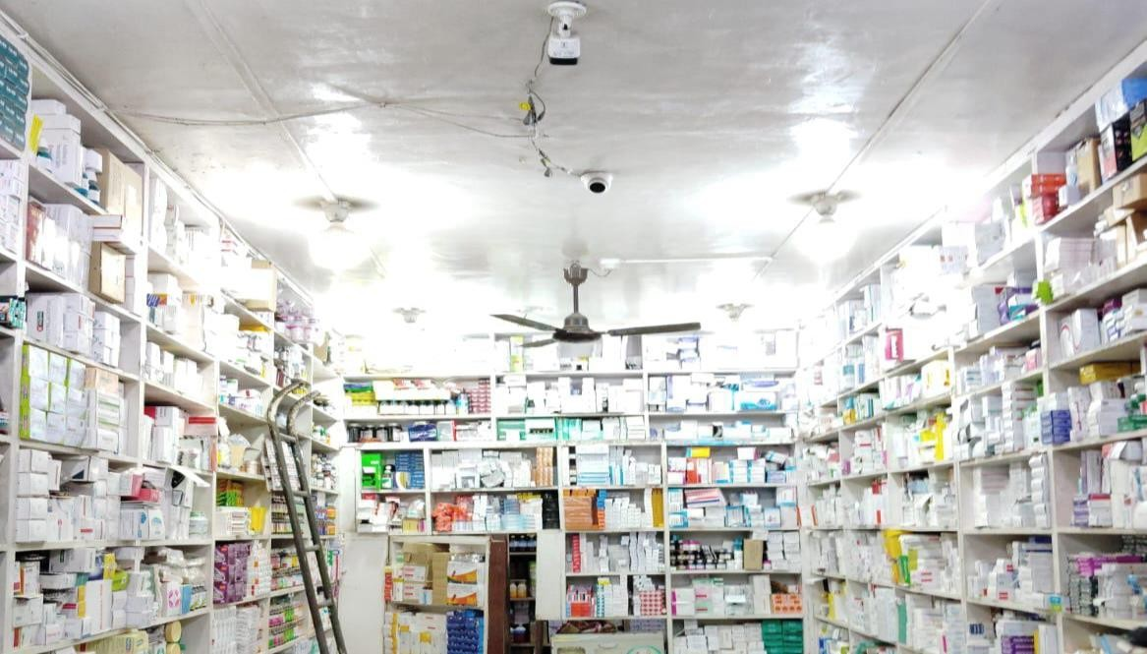

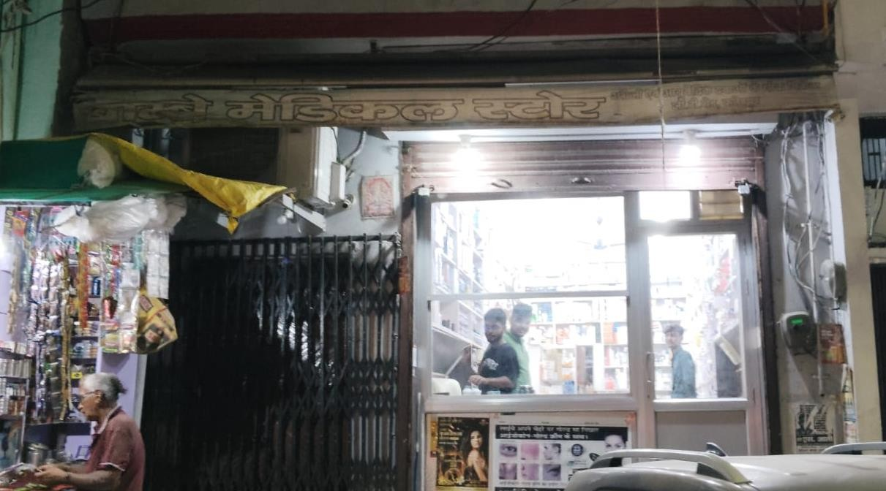

* 1. **Video interaction with the owner:**

The video of the interaction with the store owner can be accessed from [here.](https://drive.google.com/file/d/1Pv2lt9aJGoe0GAPjyY1HPNjlCqzUn7NT/view?usp=sharing)

# Metadata and Descriptive Statistics:

***Sales data:*** It captures all the transactions from October 2023 to March 2024 which is the latest proper data available as of now, including the products name and their

ordered and sale quantities. It also has the opening and closing stock of the products. Overall it’s also the stock statement of all the six months.

* **Date:** The date on which the specific products are purchased and sold.
* **Months:** The month in which the orders were made.
* **Product Name:** The name of all the products for which the transactions are made.
* **Units:** The type in which the products are. For example, 1*10 means one strip of 10 tablets.
* **Opening Stock:** The amount of quantity of products present at the start of the day.
* **Purchase Qty.:** The quantity of products purchased on the given day.
* **Total Products:** The sum of opening stock and purchase qty.
* **Sale Qty.:** The number of each product sold on a day.
* **Closing Qty:** The quantity of products left at the end of the day.
* **Cost Price:** The cost at which each unit is purchased.
* **Selling Price:** The cost at which each unit is sold.
* **Profit (per product):** The profit made on selling each unit of the product.
* **Revenue:** The total price generated by selling the products (Sale Qty.).
* **Total Profit:** The total profit made by the store on that particular order (Profit per product times the sale quantity).

***Invoice data:*** It contains the information about the invoices like their numbers and on which date they have been made from October 2023 to March 2024 along with the

name of the places where the Bombay Medical Store sends their products.

* **GSTN/UIN of Recipient:** This column has unique names for each of the place where the orders are sent from the store.
* **Receiver Name:** This column contains the name of the firm or the shop where the products have been sent to.
* **Invoice No.:** It is a unique code provided to each store which receives the orders for ease of identification on invoices.
* **Invoice Date:** The date on which each invoice has been made for every receiver.
* **Invoice Value:** The amount for which the invoice has been prepared.
* **Place of Supply:** It contains the city codes of the receiver store/firm.
* **Reverse Charge:** It has a “N” value which indicates that no products have been sent back.
* **Invoice Type:** It indicates the type of transaction is been made. The value “Regular B2B” means the transaction is business to business.
* **Rate:** The rate at which each order in the invoice had been made.
* **Taxable Value:** It is the amount of the transaction on which tax is calculated. It is the net amount of goods or services sold before any tax is applied.

***Product Revenue Month vise:*** It allows us to see which products are sold in which months and what profit they made. As the Bombay Medical Store has very wide range of products, most of the products are unique and very less amount of same products are ordered and purchased. Some columns are same as the sales data.

* **Product Names:** This column contains the names of unique products present all over the dataset.
* **Selling Price:** The selling price of each product.
* **Cost Price:** The cost price of each product.
* **Total Units Sold:** The sum of number of each unique product sold.
* **Units sold in each month from Oct-23 to Mar-24:** There are six

columns each having the number of units sold of each unique product of every month.

* **Profit per month:** It also has six columns each having the profit made by every unique product in a month.
* **Total Profit:** It is the sum of total profit made by each product in all the six months.

It also has the average number of products sold and the average profit made by the Bombay Medical Store along with their average values month wise.

## Descriptive Statistics:

* 1. Average Products Sold (each month, total): The average number of products sold from October 2023 to March 2024 is 245.50 in total with 60.31, 52.84, 25.81, 42.16, 32.40, 32.16 as the average units of products sold in each month Oct, Nov, Dec, Jan, Feb, Mar respectively.
  2. Average Profit (Oct, Nov, Dec, Jan, Feb, Mar, Total): The average profits generated in October, November, December, January, February, March are Rs.1295.44, Rs.1430.99, Rs.749.66, Rs.1188.61, Rs.1178.97, Rs.844.64

respectively. The average total profit from October to March is Rs.6683.21. These values provide the average profit achieved during each month and the overall profitability trend in the six months.

* 1. Unique Products: The store provides an overall total of 3024 unique products which indicate their high range of products in the inventory.
  2. Number of Firms: There are a total of 144 unique firms/shops from where the orders are placed and the products are sent to them as soon as possible.
  3. Average Invoice Value: The average invoice value of all the months from October 2023 to March 2024 is Rs.6374.70.
  4. Most Demanded Product: In this wide variety of products, the product which is sold the highest number of times is BUDECART RESP.5 which is sold 77935 units in all over these six months.
  5. Maximum Invoices: The maximum number of products are sent to SHIVAM MEDICAL STORE from BOMBAY MEDICAL STORE in these six months and the number of invoices made for the same is 423.
  6. Standard Deviation: The standard Deviation in selling price of the store is

85.49 which is not very high which indicates the selling price is closer to the average and has less risk associated with the selling prices.

Descriptive analysis is a fundamental method in data analysis that focuses on summarizing and describing key features of a dataset. It involves organizing, summarizing, and presenting data in a meaningful way to uncover patterns, trends, and insights. This analysis typically

includes measures such as central tendency (mean, median, mode) to describe the typical value, measures of dispersion (like range, variance, and standard deviation) to indicate the

spread of data points, and graphical representations (histograms, box plots, etc.) to visually illustrate distributions and relationships. Descriptive analysis forms the foundation for

understanding data characteristics before further exploration or modelling, providing a clear image of the dataset's structure and behaviour.

# Detailed explanation of analysis process:

The analytical approach for this project primarily utilized Excel Sheets and VS Code to extract meaningful conclusions from sales and invoice data from BOMBAY MEDICAL

STORE. Excel Sheets were instrumental in manipulating the data, while VS Code was used for intricate data cleaning and advanced analytical tasks. The most demanding and

challenging phase of the project centred on data cleansing, encompassing tasks such as

managing missing data points, removing unnecessary data and restructuring data to facilitate thorough analysis.

Following the completion of data cleaning, the project shifted its focus towards extracting meaningful insights from the refined dataset. Descriptive statistics were pivotal during this stage, offering essential metrics such as mean selling price, average order value, and variability in selling prices (standard deviation). These statistical measures were instrumental in uncovering comprehensive sales patterns, as well as pinpointing any irregularities or exceptional data points within the dataset.

Visualizations played a crucial role in presenting the data effectively and informatively.

Graphs and charts were employed to uncover trends, patterns, and correlations within the

dataset. Notably, the Pareto Principle was utilized to spotlight top-performing products that made substantial contributions to overall sales, aiding in strategic insights and decision- making processes.

Using these analytical techniques, the project sought to distinguish successful products from those requiring enhancement. By employing methods such as data refinement, descriptive statistical analysis, and visual representation, the project gained a thorough grasp of the BOMBAY MEDICAL STORE's sales performance. This insight facilitated informed

decision-making aimed at improving profitability and refining product strategies.

1. Results and Findings (Graphs and other pictorial representations):

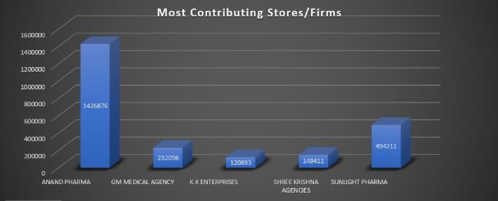

X-axis -Names of firms/stores

Y-axis – The total sum of invoice Value

This stacked column chart displays the names of the stores which have contributed the most in the revenue generation of Bombay Medical Store in the six months from October 2023 – March 2024 and the sum of the total invoice value calculated for them in this period of time.

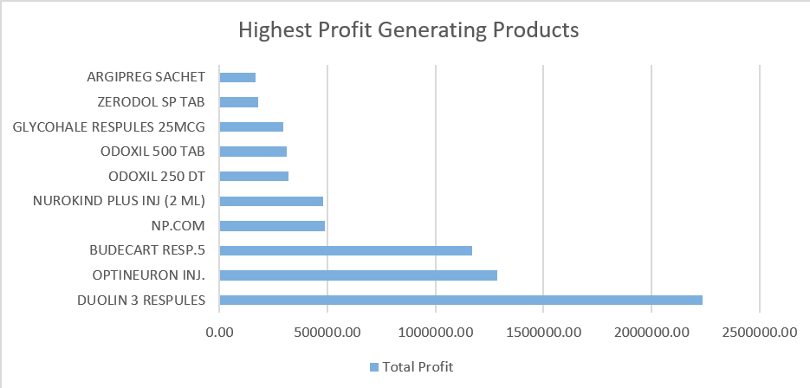

X-axis – Total profit made by the product in the six months (Oct’23 – Mar’24) Y-axis – Names of the most profit generating products.

This bar chart displays the top products which have helped the Bombay Medical Store in achieving their maximum profit target in half a year.

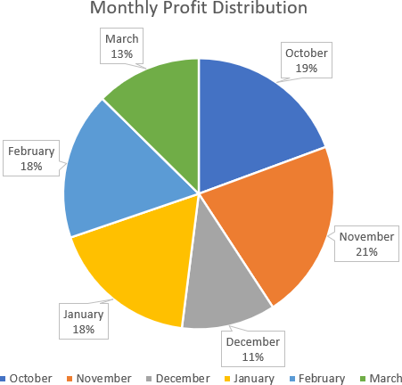

This pie chart illustrates the distribution of monthly profit percentage of the months from October 2023 to March 2024.

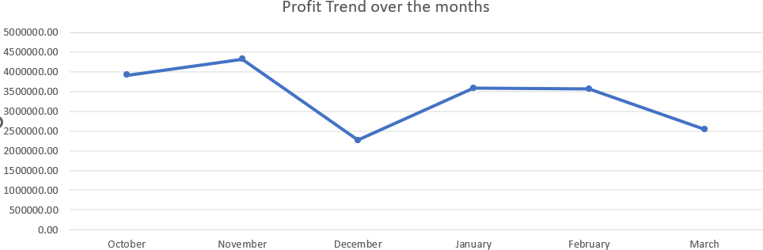

X-axis – Names of months

Y-axis – Profit in each month

This line graph displays the trend of their total profit made monthly.

More detailed analysis of the data will be done and added to the Final Report of the BDM Capstone Project.