**GURU NANAK PUBLIC SCHOOL**



ROLL NO -

NAME - V DURGEHSHWAR RAO

CLASS - XII SC B.

SUBJECT - COMPUTER SCIENCE

SUB CODE – 083

PROJECT GUIDE:MR JOGESWAR MOHANTY

GURUNANAK PUBLIC SCHOOL

ROURKELA

SUNDERGARH DIST.

ODISHA

GURUNANAK PUBLIC SCHOOL



**CERTIFICATE**

This is to certify that Cadet **VDURGESHWARRAO** Roll No:

_______ has successfully completed the project Work entitled **MEDICAL INVENTORY SYSTEM** in the subject **Computer Science (083)** laid down in the regulations of CBSE for the purpose   of    Practical   Examination in Class XII to be held in **GURUNANAK PUBLIC SCHOOL**

On ___________

(JOGESHWAR MOHANTY)

PGT Comp Sci

***Master IC***

***Examiner:***

***Name: _______________***

***Signature:***

|  |  |  |
| --- | --- | --- |
| SRNO | **DESCRIPTION** | **PAGE NO.** |
| 1 | ACKNOWLEDGEMENT | 3 |
| 2 | INTRODUCTION | 5 |
| 3 | OBJECTIVES OF PROJECT | 6 |
| 4 | PROPOSED SYSTEM | 7 |
| 5 | SYSTEM DEVELOPMENT LIFE CYCLE (SDLC) | 8 |
| 6 | PHASES OF SYSTEM DEVELOPMENT LIFE CYCLE | 9 |
| 7 | SOURCE CODE | 12 |
| 8 | OUTPUT | 16 |
| 9 | TESTING | 27 |
| 10 | HARDWARE AND SOFTWARE REQUIREMENTS | 29 |
| 11 | BIBLIOGRAPHY | 30 |
| DIG IN FOR MORE INFO | | |

TABLE OF CONTENTS

ACKNOWLEDGEMENT

Apart from the efforts of me, the success of any project depends largely on the encouragement and guidelines of many others. I take this opportunity to express my gratitude to the people who have been instrumental in the successful completion of this project.

I express deep sense of gratitude to almighty God for giving me strength for the successful completion of the project.

I express my heartfelt gratitude to my parents for constant encouragement while carrying out this project.

I gratefully acknowledge the contribution of the individuals who contributed in bringing this project up to this level, who continues to look after me despite my flaws,

I am overwhelmed to express my thanks to The Administrative Officer for providing me an infrastructure and moral support while carrying out this project in the school.

My sincere thanks to Mr. Jogeshwar Mohanty, Master In-charge, A guide, Mentor .The guidance and support received from all the members who contributed and who are contributing to this project, was vital for the success of the project. I am grateful for their constant support and help.

PROJECT ON CREATING MEDICAL INVENTORY SYSTEM

**INTRODUCTION**

This is an offline based computer program, that allows User to enter or store medicine records, patient records and employee records ..

For that I created 3 tables using Python and MYSQL (“import mysql.connector as sqlctr” ) 1st table is for storing medical records 2nd table for patient records And last one for employee records

It Allows to You(user) to enter medicine records, patient records and employee records or view the same.

For More Please Run the code or see the output at page number :

OBJECTIVES OF THE PROJECT

The objective of this project is to let the students apply the programming knowledge into a real- world situation/problem and exposed the students how programming skills helps in developing a good software.

1. Write programs utilizing modern software tools.
2. Apply object-oriented programming principles effectively when developing small to medium sized projects.
3. Write effective procedural code to solve small to medium sized problems.
4. Write effective procedural code to solve small to medium sized problems
5. Students will demonstrate a breadth of knowledge in computer science, as exemplified in the areas of systems, theory and software development.
6. Students will demonstrate ability to conduct research or applied Computer Science project, requiring writing and presentation skills which exemplify scholarly style in computer science.

.

PROPOSED SYSTEM

Today one cannot afford to rely on the fallible human beings of be really wants to stand against today’s merciless competition where not to wise saying “to err is human” no longer valid, it’s out-dated to rationalize your mistake. So, to keep pace with time, to bring about the best result without malfunctioning and greater efficiency so to replace the unending heaps of flies with a much-sophisticated hard disk of the computer.

One has to use the data management software. Software has been an ascent in atomization various organisations. Many software products working are now in markets, which have helped in making the organizations work easier and efficiently. Data management initially had to maintain a lot of ledgers and a lot of paperwork has to be done but now software production this organization has made their work faster and easier. Now only this software has to be loaded on the computer and work can be done.

This prevents a lot of time and money. The work becomes fully automated and any information regarding the organization can be obtained by clicking the button. Moreover, now it’s an age of computers of and automating such an organization gives the better look.

SYSTEM DEVELOPMENT LIFE CYCLE

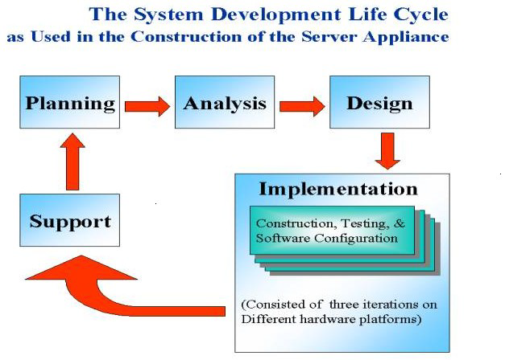

The systems development life cycle is a project management technique that divides complex projects into smaller, more easily managed segments or phases. Segmenting projects allows managers to verify the successful completion of project phases before allocating resources to subsequent phases.

Software development projects typically include initiation, planning, design, development, testing, implementation, and maintenance phases. However, the phases may be divided differently depending on the organization involved.

For example, initial project activities might be designated as request, requirements-definition, and planning phases, or initiation, concept-development, and planning phases. End users of the system under development should be involved interviewing the output of each phase to ensure the system is being built to deliver the needed functionality.

PHASES OF SYSTEM DEVELOPMENT OF LIFE CYCLE

**INITIATION PHASE**

The Initiation Phase begins when a business sponsor identifies a need or an opportunity.

The purpose of the Initiation Phase is to:

* Identify and validate an opportunity to improve business accomplishments of the organization or a deficiency related to a business need.
* Identify significant assumptions and constraints on solutions to that need.
* Recommend the exploration of alternative concepts and methods to satisfy the need including questioning the need for technology, i.e., will a change in the business process offer a solution?
* Assure executive business and executive technical sponsorship. The Sponsor designates a Project Manager and the business need is documented in a Concept Proposal. The Concept Proposal includes information about the business process and the relationship to the Agency/Organization.
* Infrastructure and the Strategic Plan. A successful Concept Proposal results in a Project Management Charter which outlines the authority of the project manager to begin

the project.

Careful oversight is required to ensure projects support strategic business objectives and resources are effectively implemented into an organization's enterprise architecture. The initiation phase begins when an opportunity to add, improve, or correct a system is identified and formally requested through the presentation of a business case. The business case should, at a minimum, describe a proposal’s purpose, identify expected benefits, and explain how the proposed system supports one of the organization’s business strategies. The business case should also identify alternative solutions and detail as many informational, functional, and network requirements as possible.

**PICTORIAL REPRESENTATION OF SDLC:**

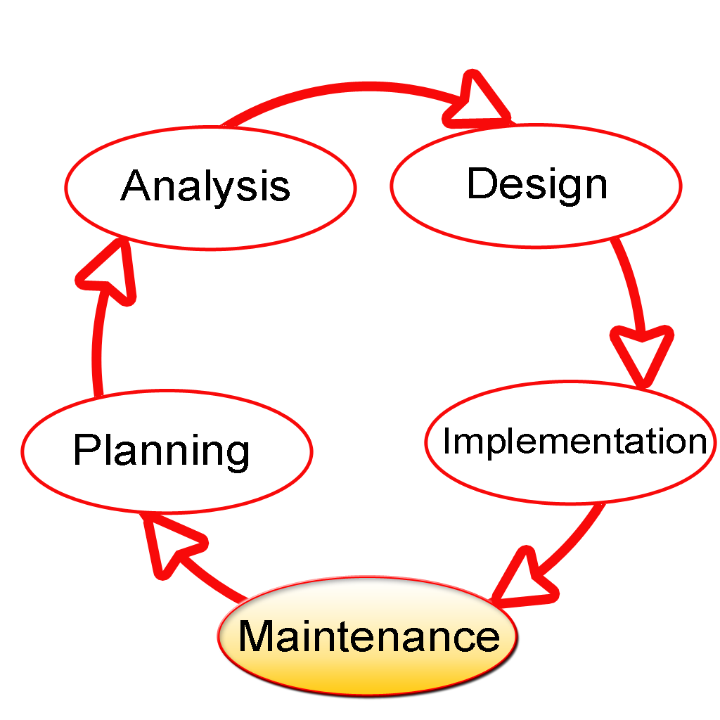

**PLANNING PHASE**

The planning phase is the most critical step in completing development, acquisition, and maintenance projects. Careful planning, particularly in the early stages of a project, is necessary to coordinate activities and manage project risks effectively. The depth and formality of project plans should be commensurate with the characteristics and risks of a given project. Project plans refine the information gathered during the initiation phase by further identifying the specific activities and resources required to complete a project.

**REQUIREMENTSANALYSIS PHASE**

This phase formally defines the detailed functional user requirements using high-level requirements identified in the Initiation, System Concept, and Planning phases. It also delineates the requirements in terms of data, system performance, security, and maintainability requirements for the system. The requirements are defined in this phase to a level of detail sufficient for systems design to proceed. They need to be measurable, testable, and relate to the business need or opportunity identified in the Initiation Phase. The requirements that will be used to determine acceptance of the system are captured in the Test and Evaluation Masterplan.

**DESIGN PHASE**

The design phase involves converting the informational, functional, and network requirements identified during the initiation and planning phases into unified design specifications that developers use to script programs during the development phase. Program designs are constructed in various ways. Using a top-down approach, designers first identify and link major program components and interfaces, then expand design layouts as they identify and link smaller subsystems and connections

* Identifying potential risks and defining mitigating design features.
* Performing a security risk assessment.
* Developing a conversion plan to migrate current data to the new system.
* Determining the operating environment.
* Defining major subsystems and their inputs and outputs.
* Allocating processes to resources.
* Preparing detailed logic specifications for each software module. The result is a draft System Design Document which captures the preliminary design for the system.
* Everything requiring user input or approval is documented and reviewed by the user. Once these documents have been approved by the Agency CIO and Business Sponsor, the final System Design Document is created to serve as the Critical/Detailed Design for the system.
* This document receives a rigorous review by Agency technical and functional representatives to ensure that it satisfies the business requirements. Concurrent with the development of the system design, the Agency Project Manager begins development of the Implementation Plan, Operations and Maintenance Manual, and the Training Plan.

**DEVELOPMENT PHASE**

The development phase involves converting design specifications into executable programs. Effective development standards include requirements that programmers and other project participants discuss design specifications before programming begins.

* Translating the detailed requirements and design into system components.
* Testing individual elements (units) for usability.
* Preparing for integration and testing of the IT system.

**INTEGRATION AND TEST PHASE**

Subsystem integration, system, security, and user acceptance testing is conducted during the integration and test phase. The user, with those responsible for quality assurance, validates that the functional requirements, as defined in the functional requirements document, are satisfied by the developed or modified system. OIT Security staff assesses the system security and issue a security certification and accreditation prior to installation/implementation.

**IMPLEMENTATION PHASE**

This phase is initiated after the system has been tested and accepted by the user. In this phase, the system is installed to support the intended business functions. System performance is compared to performance objectives established during the planning phase. Implementation includes user notification, user training, installation of hardware, installation of software onto production computers, and integration of the system into daily work processes. This phase continues until the system is operating in production in accordance with the defined user requirements.

**OPERATIONS AND MAINTENANCE PHASE**

The system operation is on-going. The system is monitored for continued performance in accordance with user requirements and needed system modifications are incorporated. Operations continue as long as the system can be effectively adapted to respond to the organization’s needs. When modifications or changes are identified, the system may re-enter the planning phase.

SOURCE CODE

*from* datetime *import* datetime *as* dt

*from* sqlmodule *import* *

*# Connection From Sql Server*

pw = input("Enter Server Password : ")

cs = connect_server(pw)

*try*:

    q1 = "create database if not exists Medical_Store_DB;"

    execute_query(cs[0], q1)

*except*:

*pass*

cd = connect_database(cs[1])

*# Date And Time*

x = str(dt.now())

date = x.split()

*if* cs[2] == 1:

    print("Login Sucess")

    print("\t\t\t\t\tWelcome To VDR Pharma")

*while* True:

        print("------------")

        print("Medicines info")

        print("------------")

        print("1. Medicines records")

        print("2. Medicines Details")

        print("------------")

        print("Patient info")

        print("------------")

        print("3. Patients records")

        print("4. Veiw Patient Detail")

        print("5. Delete patient detail")

        print("------------")

        print("Employees info")

        print("------------")

        print("6. Employee records")

        print("7. Employee details")

        print("----------------------------")

        print("8. EXIT")

        s = input("Enter Your Choice : ")

*if* s == "1":

            print()

            print("=====================================================")

*# Medicines records*

            q0 = "use Medical_Store_DB"

            q1 = """create table if not exists Medicine_records(Medicine_name varchar(20),Medicine_group varchar(20),Date_of_Manufacture varchar(30),Date_of_Expiry varchar(30),qty int(20),date_and_time varchar(50));"""

*# Entries*

            md_nm = input("Enter Medicine Name : ").capitalize()

            md_gp = input("Enter Medicine Group : ").capitalize()

            ct = int(input("Enter Medicine Quantity : "))

            mfg = input("Enter Date of Manufacture[YYYY-MM-DD] : ")

            exp = input("Enter Date of Expiry[YYYY-MM-DD] : ")

            q2 = f"""insert into Medicine_records values("{md_nm}","{md_gp}","{mfg}","{exp}",{ct},"{x}");"""

            execute_query(cd, q0)  *# A function That Executes Above query*

            execute_query(cd, q1)  *# A function That Executes Above query*

            execute_query(cd, q2)  *# A function That Executes Above query*

            print("-------------------")

            print("Sucessfully Stored")

            print("-------------------")

            print("=====================================================")

            print()

*elif* s == "2":

            print()

            print("Medicines Details")

            print("=====================================================")

*# Medicines Details*

            q0 = "use Medical_Store_DB"

            q1 = "select * from Medicine_records;"

            data = read_query(cd, q1)

            all = []

            expire = []

            not_expire = []

*for* i *in* data:

                dat = i[-3].split()

*if* str(dat[0]) == date[0]:

                    expire.append(i)

*elif* i != date:

                    not_expire.append(i)

                all.append(i)

*while* True:

                s = input("1.Do You Want to See Expired Medicine\n2.Do You Want To see Non-Expired Medicine\n3.Do You Want to See All Medicine Data\n4.EXIT\nEnter Your Choice : ")

*if* s == "1":

                    print("Expired Medicines")

                    print("===========================================================")

*for* i *in* expire:

                        print(i)

                    print("===========================================================")

*elif* s == "2":

                    print("Non-Expired Medicines")

                    print("===========================================================")

*for* i *in* not_expire:

                        print(i)

                    print("===========================================================")

*elif* s == "3":

                    print("All Medicines")

                    print("===========================================================")

*for* i *in* all:

                        print(i)

                    print("===========================================================")

*elif* s == "4":

*break*

*else*:

                    print("Invalid Syntax")

            print("=====================================================")

            print()

*elif* s == "3":

            print()

            print("==================================================")

*# Patients records*

*# Entries*

            name = input("Enter Patient' Name : ").capitalize()

            age = input("Enter Patient's age : ")

            addr = input("Enter Patient's Address : ").capitalize()

            ph_no = input("Enter Patient's Phone Number : ")

            md_nm = input(

                "Enter Medicine Purchased By Patient : ").capitalize()

*# For Reading Count Of Medicine*

            q3 = f"""select * from Medicine_records where Medicine_name="{md_nm}";"""

            rd = read_query(cd, q3)

*if* rd != []:  *# If User Enter A invalid Medicine name then it throws an error*

*# I took The Max Medicine count as 100*

*if* int(rd[0][-2]) > 0 and int(rd[0][-2]) <= 100:

*# Sql Code for Creating Table*

                    q0 = "use Medical_Store_DB"

                    q1 = """create table if not exists patient_records(name varchar(20),age varchar(8),address varchar(30),ph_no varchar(20),Medicine_name varchar(20),date_time varchar(30));"""

*# Sql Code For Storing Data in Database*

                    q2 = f"""insert into patient_records values("{name}","{age}","{addr}","{ph_no}","{md_nm}","{x}");"""

*# For updating Medicine Count im Medicine_record*

                    val = int(rd[0][-2])-1

                    q3 = f"""update Medicine_records set qty={val} where Medicine_name="{md_nm}";"""

                    execute_query(

                        cd, q0)  *# A function That Executes Above query*

*# A function That Executes Above query*

                    execute_query(cd, q1)

*# A function That Executes Above query*

                    execute_query(cd, q2)

*# A function That Executes Above query*

                    execute_query(cd, q3)

                    print("-------------------")

                    print("Sucessfully Stored")

                    print("-------------------")

                    print("==================================================")

                    print()

*else*:

                    print("Medicine Not Avaiable")

*else*:

                print("Invalid Medicine Name")

*elif* s == "4":

*# Veiw Patient Detail*

            print()

            print("===========================================================")

            q0 = "use Medical_Store_DB"

            q1 = """select * from patient_records;"""

            rd = read_query(cd, q1)

            print(

                "NAME\t  AGE  ADDRESS\t\t  PHONE NUMBER  Medicine NAME\t AT DATE AND TIME")

*for* i *in* rd:

                print("----------------------------------------------------")

                print(i[0]+"\t"+i[1]+" "+i[2]+"\t"+i[3]+"\t"+i[4]+"\t"+i[5])

            print("----------------------------------------------------")

            print("===========================================================")

            print()

*elif* s == "5":

*# Delete patient detail*

            print()

            print("===========================================================")

            nm = input("Enter Patient's Name : ")

            ph_no = input("Enter Phone Number : ")

*try*:

                q0 = "use Medical_Store_DB"

                q1 = f"""delete from patient_records where name="{nm}"&& ph_no="{ph_no}";"""

                execute_query(cd, q0)

                execute_query(cd, q1)

                print("-------------------")

                print("Sucessfully Deleted")

                print("-------------------")

*except*:

                print("Error Occured")

            print("===========================================================")

            print()

*elif* s == "6":

*# Employee records*

            print()

            print("===========================================================")

            q0 = "use Medical_Store_DB"

            q1 = """create table if not exists employees_records(name varchar(20),age varchar(8),profession varchar(30),ph_no varchar(10),address varchar(20),joined_at_date_time varchar(30));"""

            name = input("Enter Employee's Name : ")

            age = input("Enter Employee's age : ")

            pro = input("Enter Employee's Profession : ")

            ph_no = input("Enter Employee's Phone Number : ")

            addr = input("Enter Employee's Address  :")

            q2 = f"""insert into employees_records values("{name}","{age}","{pro}","{ph_no}","{addr}","{x}");"""

            execute_query(cd, q0)  *# A function That Executes Above query*

            execute_query(cd, q1)  *# A function That Executes Above query*

            execute_query(cd, q2)  *# A function That Executes Above query*

            print("-------------------")

            print("Sucessfully Stored")

            print("-------------------")

            print("===========================================================")

            print()

*elif* s == "7":

            print()

            print("===========================================================")

            q0 = "use Medical_Store_DB"

            q1 = """select * from employees_records;"""

            rd = read_query(cd, q1)

            print("NAME\t  AGE  PROFESSION\t  PHONE NUMBER  ADDRESS\t\t AT DATE AND TIME")

*for* i *in* rd:

                print("----------------------------------------------------")

                print(i[0]+"\t"+i[1]+" "+i[2]+"\t"+i[3]+"\t"+i[4]+"\t"+i[5])

            print("----------------------------------------------------")

            print("===========================================================")

            print()

*elif* s == "8":

*break*

*else*:

            print("Enter A Valid Option")

*else*:

    print("Try Again")

OUTPUT

Enter Server Password : #Enter Your Sql Password Here

Login Sucess

Welcome To VDR Pharma

------------

Medicines info

------------

1. Medicines records

2. Medicines Details

------------

Patient info

------------

3. Patients records

4. Veiw Patient Detail

5. Delete patient detail

------------

Employees info

------------

6. Employee records

7. Employee details

----------------------------

8. EXIT

Enter Your Choice : 1

=====================================================

Enter Medicine Name : paracetamol

Enter Medicine Group : fever

Enter Medicine Quantity : 100

Enter Date of Manufacture[YYYY-MM-DD] : 2022-01-12

Enter Date of Expiry[YYYY-MM-DD] : 2024-10-12

-------------------

Sucessfully Stored

-------------------

=====================================================

------------

Medicines info

------------

1. Medicines records

2. Medicines Details

------------

Patient info

------------

3. Patients records

4. Veiw Patient Detail

5. Delete patient detail

------------

Employees info

------------

6. Employee records

7. Employee details

----------------------------

8. EXIT

Enter Your Choice : 1

=====================================================

Enter Medicine Name : azithromycin 500mg

Enter Medicine Group : cough and cold

Enter Medicine Quantity : 100

Enter Date of Manufacture[YYYY-MM-DD] : 2015-08-22

Enter Date of Expiry[YYYY-MM-DD] : 2022-08-22

-------------------

Sucessfully Stored

-------------------

=====================================================

------------

Medicines info

------------

1. Medicines records

2. Medicines Details

------------

Patient info

------------

3. Patients records

4. Veiw Patient Detail

5. Delete patient detail

------------

Employees info

------------

6. Employee records

7. Employee details

----------------------------

8. EXIT

Enter Your Choice : 2

Medicines Details

=====================================================

1.Do You Want to See Expired Medicine

2.Do You Want To see Non-Expired Medicine

3.Do You Want to See All Medicine Data

4.EXIT

Enter Your Choice : 1

Expired Medicines

===========================================================

('Azithromycin 500mg', 'Cough and cold ', '2015-08-22', '2022-08-22', 100, '2022-08-22 20:56:39.388270')

===========================================================

1.Do You Want to See Expired Medicine

2.Do You Want To see Non-Expired Medicine

3.Do You Want to See All Medicine Data

4.EXIT

Enter Your Choice : 2

Non-Expired Medicines

===========================================================

('Paracetamol', 'Fever', '2022-01-12', '2024-10-12', 100, '2022-08-22 20:56:39.388270')

===========================================================

1.Do You Want to See Expired Medicine

2.Do You Want To see Non-Expired Medicine

3.Do You Want to See All Medicine Data

4.EXIT

Enter Your Choice : 3

All Medicines

===========================================================

('Paracetamol', 'Fever', '2022-01-12', '2024-10-12', 100, '2022-08-22 20:56:39.388270')

('Azithromycin 500mg', 'Cough and cold ', '2015-08-22', '2022-08-22', 100, '2022-08-22 20:56:39.388270')

===========================================================

1.Do You Want to See Expired Medicine

2.Do You Want To see Non-Expired Medicine

3.Do You Want to See All Medicine Data

4.EXIT

Enter Your Choice : 4

=====================================================

------------

Medicines info

------------

1. Medicines records

2. Medicines Details

------------

Patient info

------------

3. Patients records

4. Veiw Patient Detail

5. Delete patient detail

------------

Employees info

------------

6. Employee records

7. Employee details

----------------------------

8. EXIT

Enter Your Choice : 3

==================================================

Enter Patient' Name : Jhanvi

Enter Patient's age : 32

Enter Patient's Address : Rkl,sector-13

Enter Patient's Phone Number : 7658344352

Enter Medicine Purchased By Patient : paracetamol

-------------------

Sucessfully Stored

-------------------

==================================================

------------

Medicines info

------------

1. Medicines records

2. Medicines Details

------------

Patient info

------------

3. Patients records

4. Veiw Patient Detail

5. Delete patient detail

------------

Employees info

------------

6. Employee records

7. Employee details

----------------------------

8. EXIT

Enter Your Choice : 2

Medicines Details

=====================================================

1.Do You Want to See Expired Medicine

2.Do You Want To see Non-Expired Medicine

3.Do You Want to See All Medicine Data

4.EXIT

Enter Your Choice : 2

Non-Expired Medicines

===========================================================

('Paracetamol', 'Fever', '2022-01-12', '2024-10-12', 99, '2022-08-22 20:56:39.388270')

===========================================================

1.Do You Want to See Expired Medicine

2.Do You Want To see Non-Expired Medicine

3.Do You Want to See All Medicine Data

4.EXIT

Enter Your Choice : 4

=====================================================

------------

Medicines info

------------

1. Medicines records

2. Medicines Details

------------

Patient info

------------

3. Patients records

4. Veiw Patient Detail

5. Delete patient detail

------------

Employees info

------------

6. Employee records

7. Employee details

----------------------------

8. EXIT

Enter Your Choice : 4

===========================================================

NAME AGE ADDRESS PHONE NUMBER Medicine NAME AT DATE AND TIME

----------------------------------------------------

Jhanvi 32 Rkl,sector-13 7658344352 Paracetamol 2022-08-22 20:56:39.388270

----------------------------------------------------

===========================================================

------------

Medicines info

------------

1. Medicines records

2. Medicines Details

------------

Patient info

------------

3. Patients records

4. Veiw Patient Detail

5. Delete patient detail

------------

Employees info

------------

6. Employee records

7. Employee details

----------------------------

8. EXIT

Enter Your Choice : 5

===========================================================

Enter Patient's Name : Jhanvi

Enter Phone Number : 7658344352

-------------------

Sucessfully Deleted

-------------------

===========================================================

------------

Medicines info

------------

1. Medicines records

2. Medicines Details

------------

Patient info

------------

3. Patients records

4. Veiw Patient Detail

5. Delete patient detail

------------

Employees info

------------

6. Employee records

7. Employee details

----------------------------

8. EXIT

Enter Your Choice : 6

===========================================================

Enter Employee's Name : Sher Shing

Enter Employee's age : 35

Enter Employee's Profession : pharmacist

Enter Employee's Phone Number : 3244226456

Enter Employee's Address :Jagda,Rkl

-------------------

Sucessfully Stored

-------------------

===========================================================

------------

Medicines info

------------

1. Medicines records

2. Medicines Details

------------

Patient info

------------

3. Patients records

4. Veiw Patient Detail

5. Delete patient detail

------------

Employees info

------------

6. Employee records

7. Employee details

----------------------------

8. EXIT

Enter Your Choice : 7

===========================================================

NAME AGE PROFESSION PHONE NUMBER ADDRESS AT DATE AND TIME

----------------------------------------------------

Sher Shing 35 pharmacist 3244226456 Jagda,Rkl 2022-08-22 20:56:39.388270

----------------------------------------------------

===========================================================

------------

Medicines info

------------

1. Medicines records

2. Medicines Details

------------

Patient info

------------

3. Patients records

4. Veiw Patient Detail

5. Delete patient detail

------------

Employees info

------------

6. Employee records

7. Employee details

----------------------------

8. EXIT

Enter Your Choice : 8

TESTING

Software Testing is an empirical investigation conducted to provide stakeholders with information about the quality of the product or service under test[1] , with respect to the context in which it is intended to operate. Software Testing also provides an objective, independent view of the software to allow the business to appreciate and understand the risks at implementation of the software. Test techniques include, but are not limited to, the process of executing a program or application with the intent of finding software bugs.

 It can also be stated as the process of validating and verifying that a software program/application/product meets the business and technical requirements that guided its design and development, so that it works as expected and can be implemented with the same characteristics. Software Testing, depending on the testing method employed, can be implemented at any time in the development process, however the most test effort is employed after the requirements have been defined and coding process has been completed.

HARDWARE AND SOFTWARE REQUIREMENTS

I.OPERATING SYSTEM : WINDOWS 7 AND ABOVE

II. PROCESSOR : PENTIUM(ANY) OR AMD

ATHALON (3800+- 4200+ DUALCORE)

III. MOTHERBOARD : 1.845 OR 915,995 FOR PENTIUM 0R MSI

K9MM-V VIAK8M800+8237R PLUS CHIPSET FOR AMD ATHALON

IV. RAM : 512MB+

V. Hard disk : SATA 40 GB OR ABOVE

VI. CD/DVD r/w multi drive combo: (If back up required)

VII. FLOPPY DRIVE 1.44 MB : (If Backup required)

VIII. MONITOR 14.1 or 15 -17 inch

IX. Key board and mouse

X. Printer : (if print is required – [Hard copy])

**SOFTWARE REQUIREMENTS:**

1. Windows OS
2. Python
3. MY SQL

BIBLIOGRAPHY

1. ***Computer science With Python - Class XII By: Sumita Arora***
2. ***A Project Report On Medical Store Management System (MSMS)***

***By : MR JOGESHWAR MOHANTY***

1. ***Website:*** [***Explore My Website For More***](https://codevdr.github.io/v/)

***\*\*\****