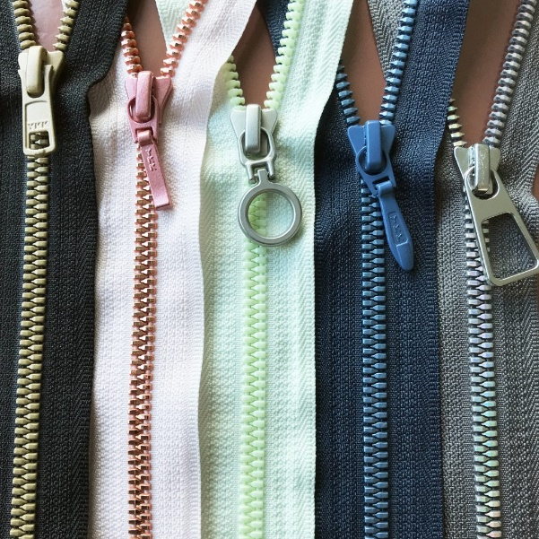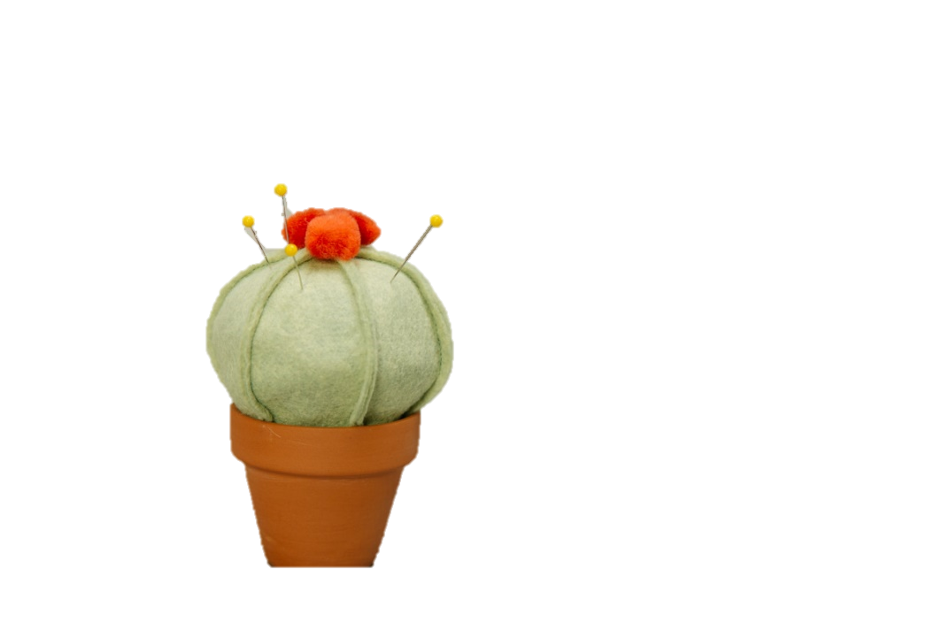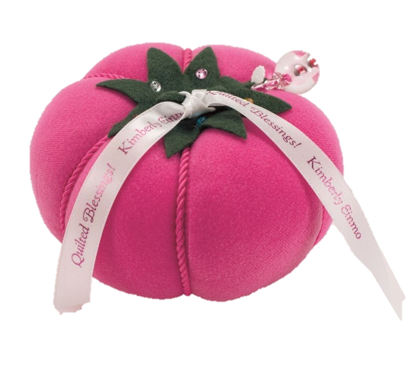

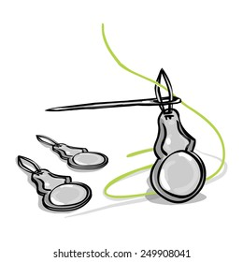

**Submitted to:  
Dr. Richard Gallano**

**Submitted by:  
Justin C. Pamparo**

**BTVTED FSM-2A**

**SPECIAL EDUCATION**

**ZIPPER**

A zipper is a fastening or unfastening device that is used to open or close parts of clothing. o

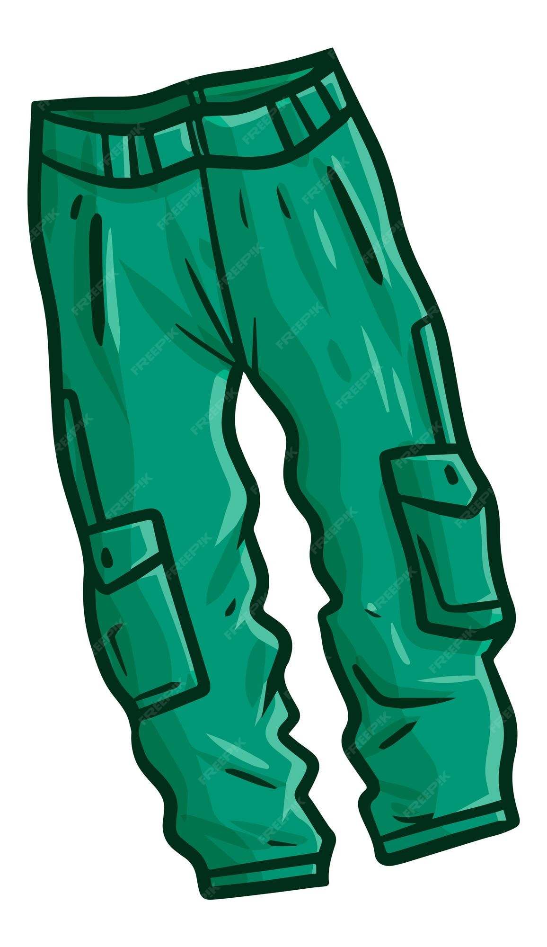

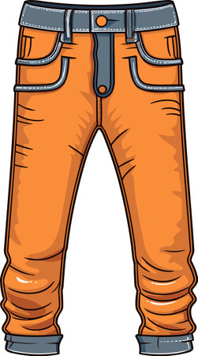

**SEWING NEEDLES**

The most commonly used hand sewing needles are called sharps. Sharps have a medium length.

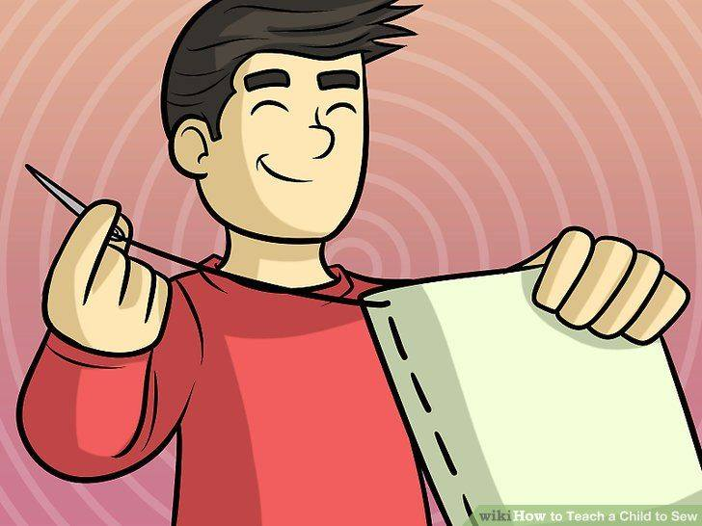

**SEWING BUTTONS**

Sewing buttons are a type of fastener attached to a garment in order to secure an opening either by passing it through a loop or a buttonhole.

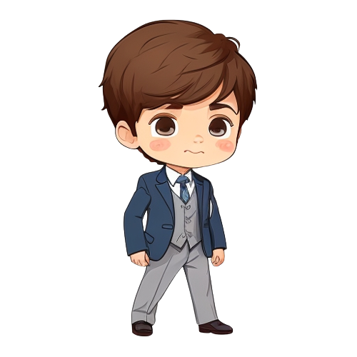

**SEWING THREAD**

Sewing thread is the yarn used to combine two or more fabric pieces together in garments, accessories, and other textile products.

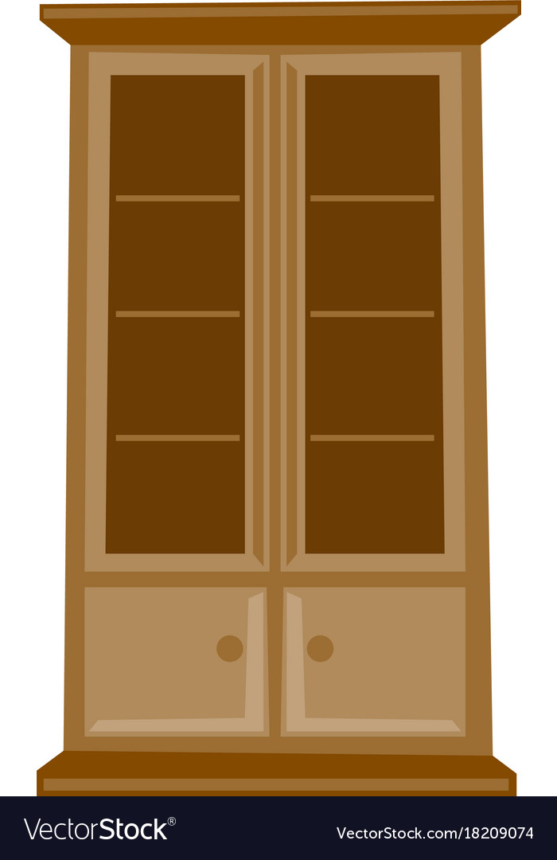

**SEWING BUTTONS**

The most common use of a tape measure is to take body measurements, but you can use it for any measuring task.

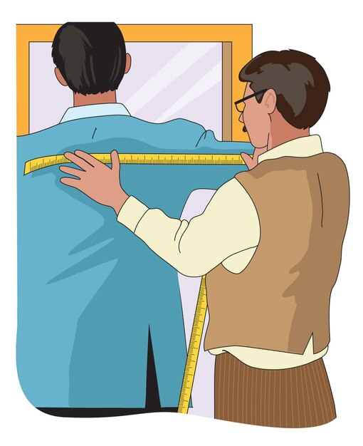

**PINS**

Pins are used all the time in sewing projects to hold patterns to fabric, temporarily hold seams before stitching and for basting layers together when making a quilt.

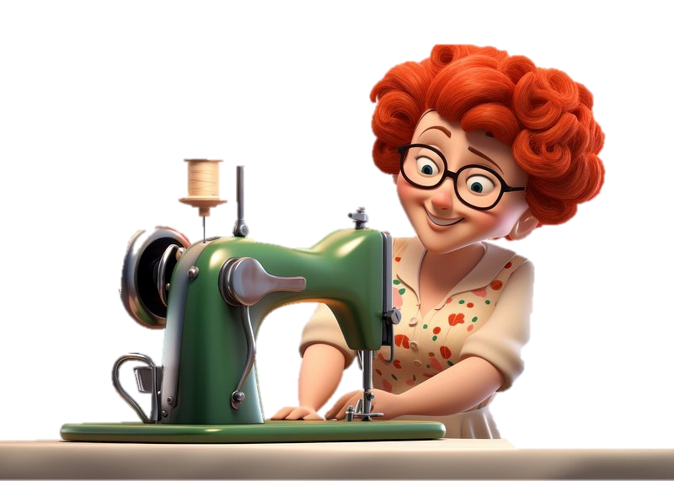

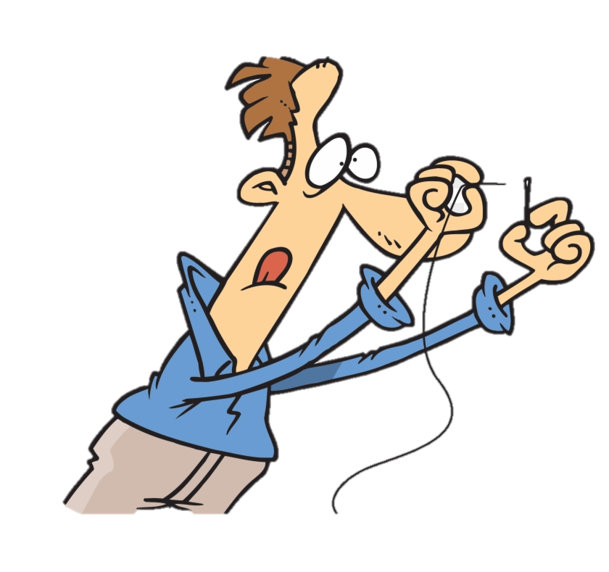

Failing eyesight or just being tired can make threading a sewing needle difficult. It doesn't have to be. Use a [needle threader](https://www.thesprucecrafts.com/how-to-use-a-needle-threader-2978092) to solve the problem.

**NEEDLE THREADER**

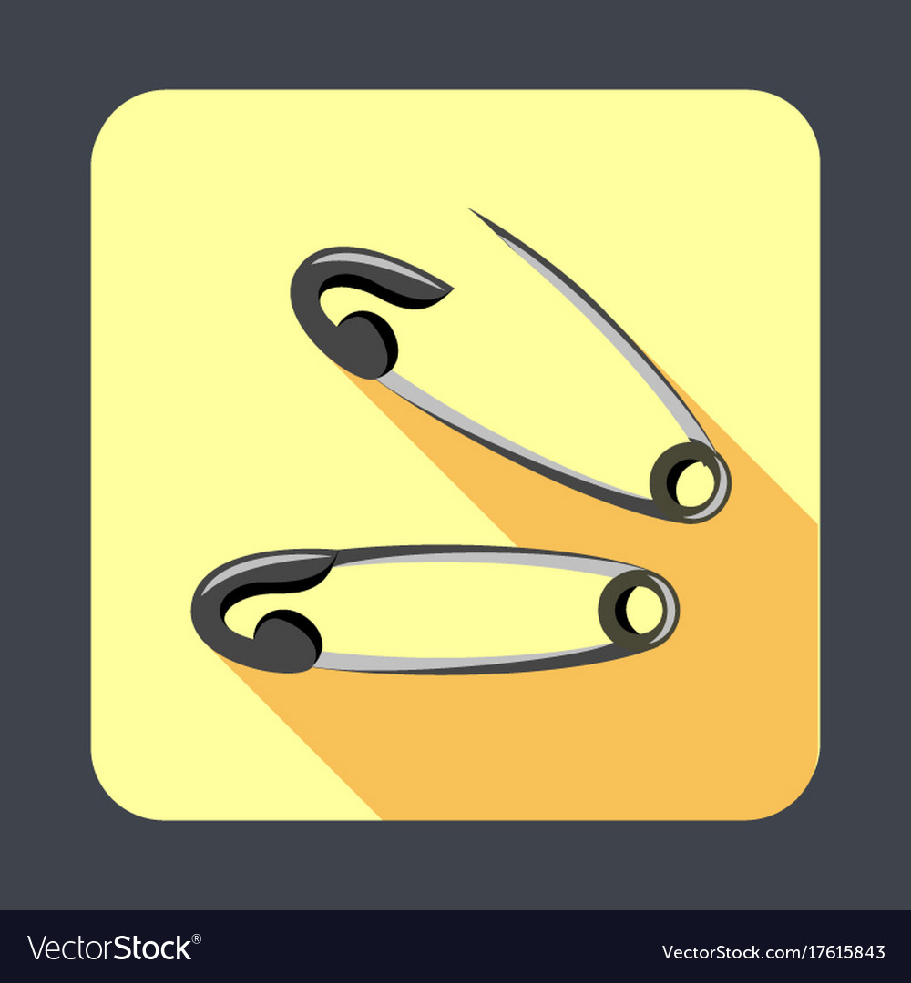

Pony safety pins are designed to be multifunctional for use in sewing, quilting and other projects.

**SAFETY PINS**

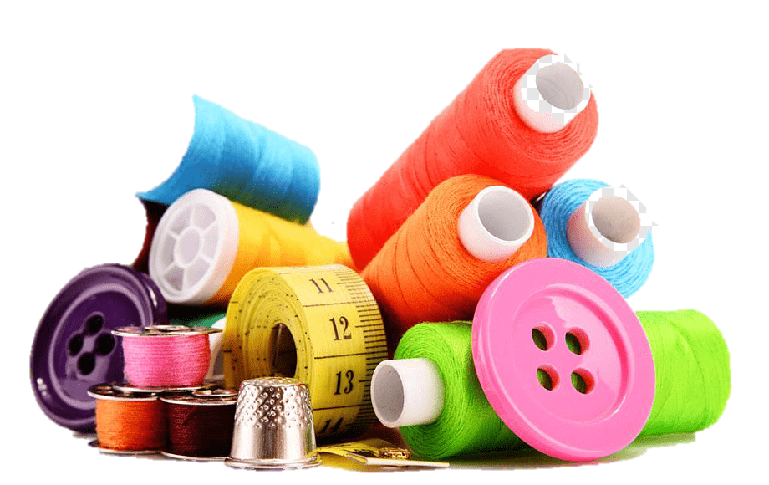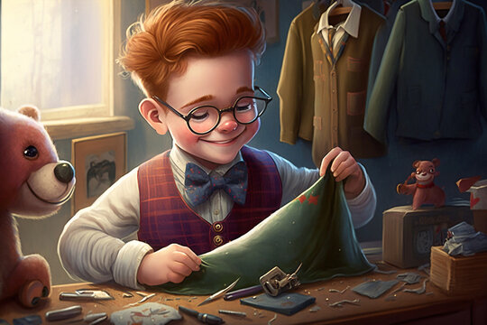

**(Tactile Book)**

**BASIC**

**SEWING TOOLS**

**PINCUSHION**

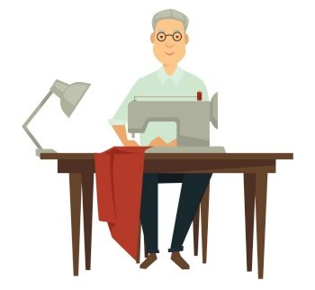

**PINCUSHION**

A pincushion holds straight pins and needles while you are working.