**GUARDIAN’S CERTIFICATION OF WAIVER/PERMISSION**

This it to inform you that permission is hereby granted to our son/daughter Rumar C. Pamparo to participate in the Students’ Training Support Program of the Department of Agriculture – National Fisheries Research and Development Institute (DA-NFRDI) for 500 hours in partial fulfillment of the requirement for the degree [course] , under the College of Infromation and Computing Science in Cagayan State University.

It is understood that my son/daughter will be assigned to both administrative and technical (on-field and laboratory) activities during the duration of the practicum.

I do hereby release, and waive Cagayan State University and DA-NFRDI, and its respective representatives, from any claim, obligation, or liability, relating to injuries, accidents, and illnesses, which may incur by my participation in this internship.

I, the undersigned, have read this and fully understand its terms. I acknowledge that I am signing this waiver freely and voluntarily with full knowledge of its significance, legal intents, and purposes it may serve.

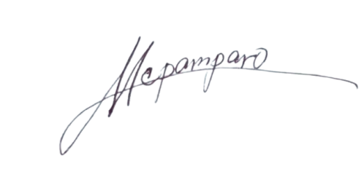

Marietta Capoquian Pamparo

**NAME OF GUARDIAN/SIGNATURE/DATE**

Home Address: #3 Calamansi St. San Gabriel, Tuguegarao city, Cagayan

Contact Number: 09760202622 / 09919327966

Email Address: pamparor@gmail.com