* 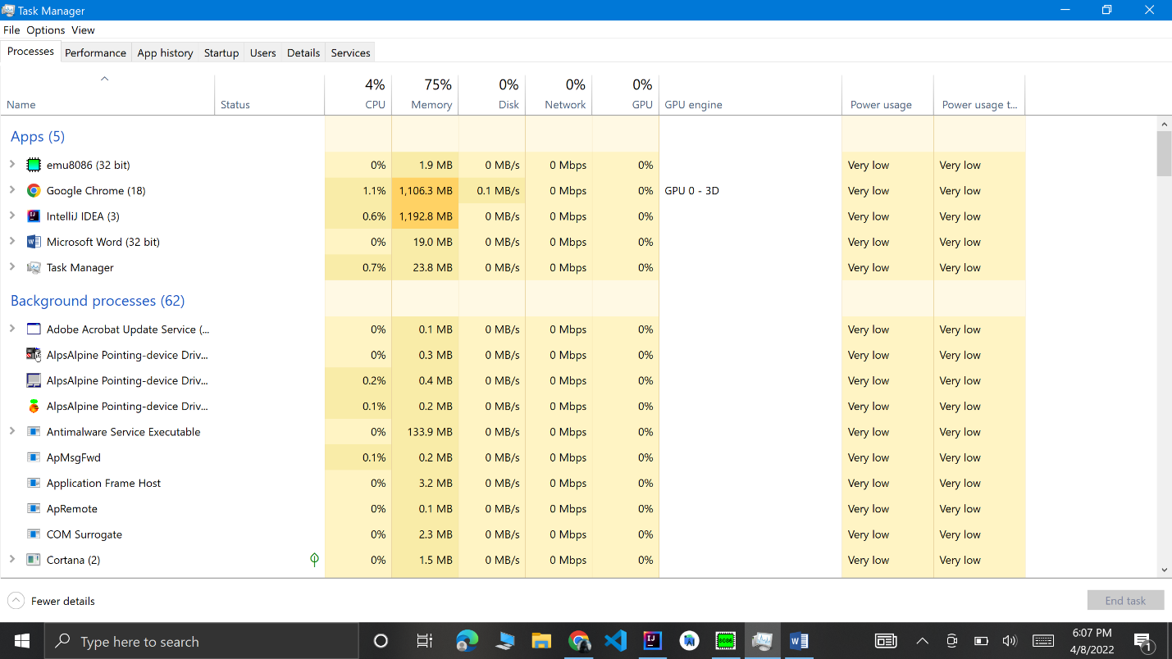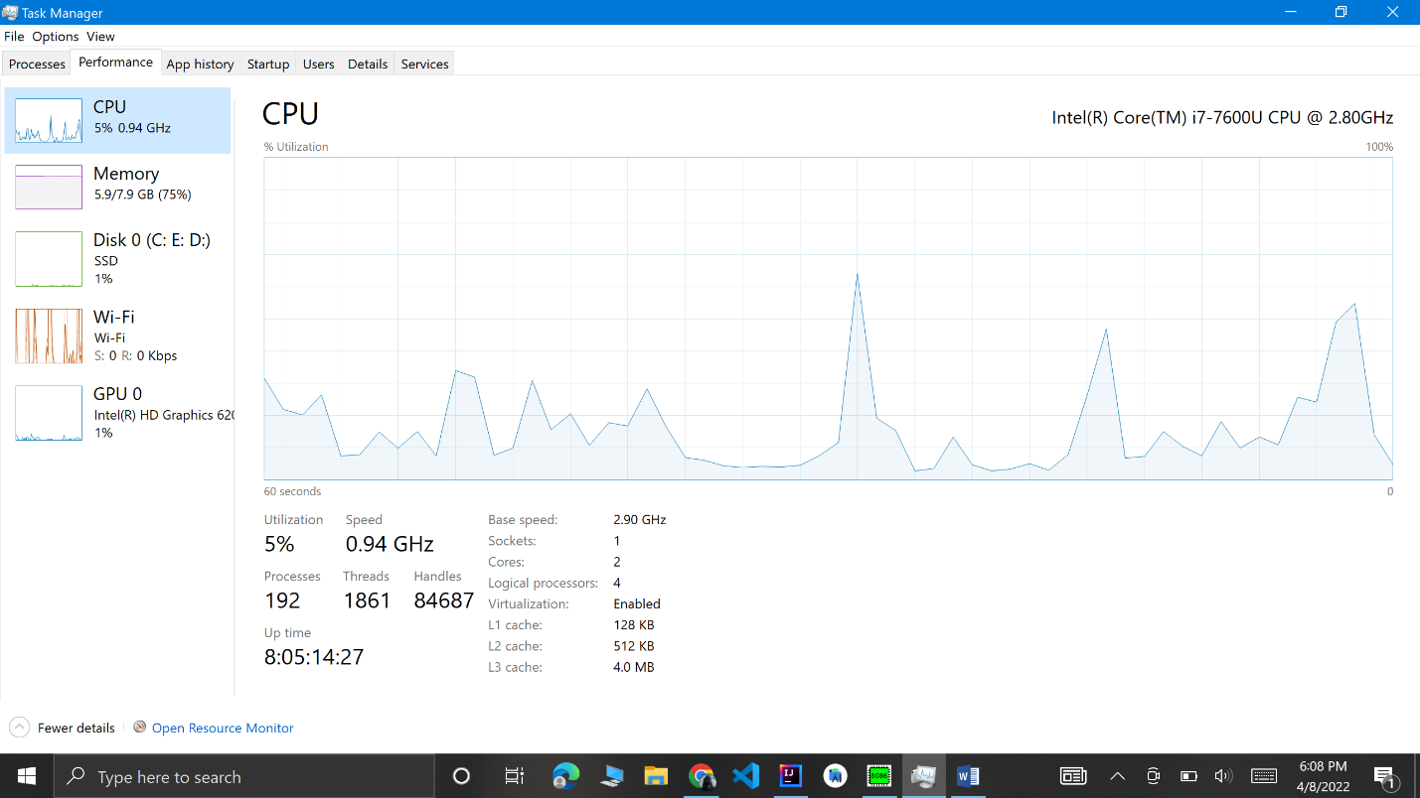 **CPU**: The CPU usage of the process, displayed as a percentage of your total available CPU resources 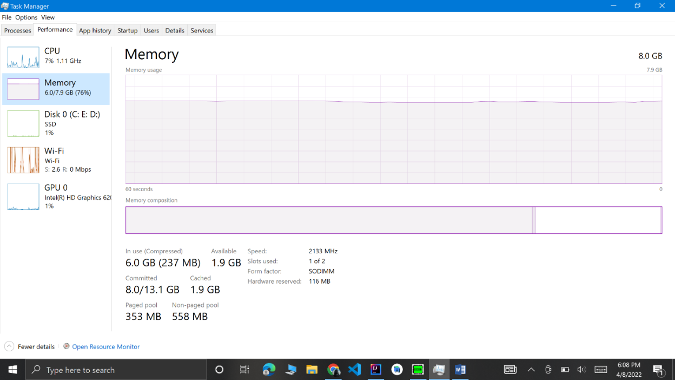 **Memory**: The amount of your system’s physical working memory the process is currently using, displayed in MB or GB.
* 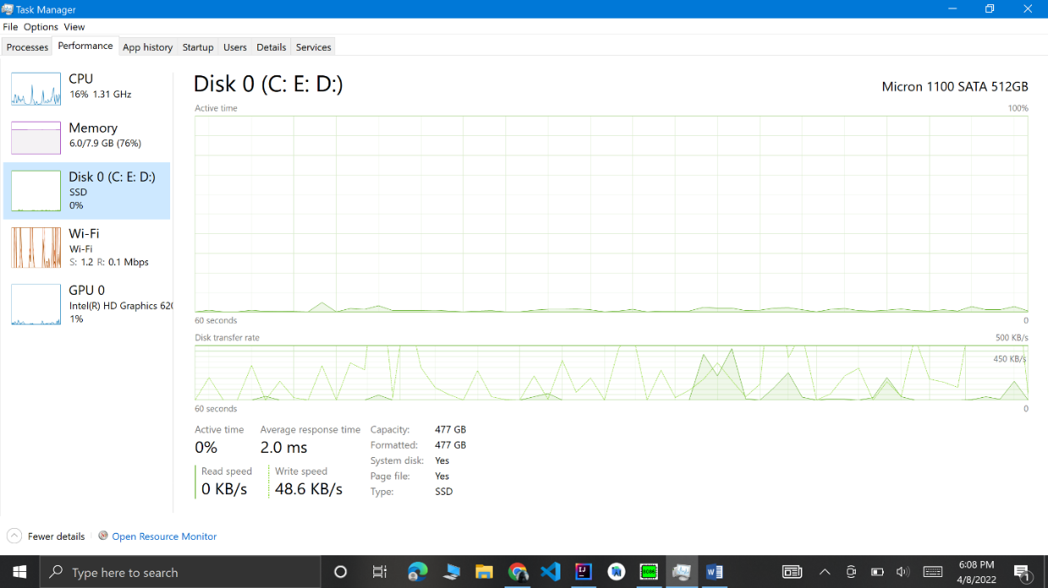 **Disk**: The disk activity a process is generating, displayed as MB/s. If a process isn’t reading from or writing to disk at the moment, it will display 0 MB/s.

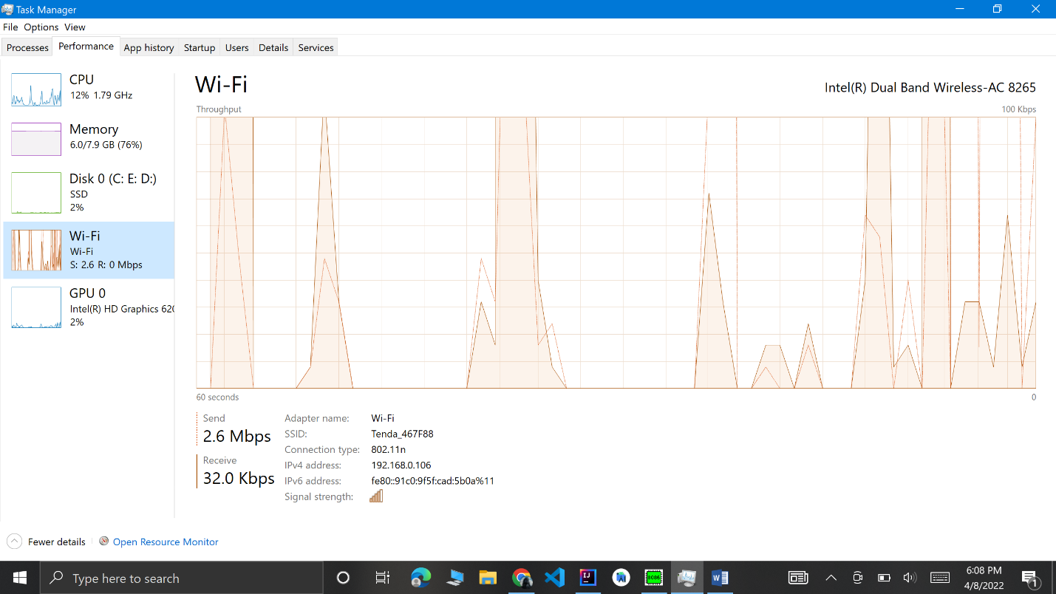

* **Network**: The network usage of a process on the current primary network, displayed in Mbps.

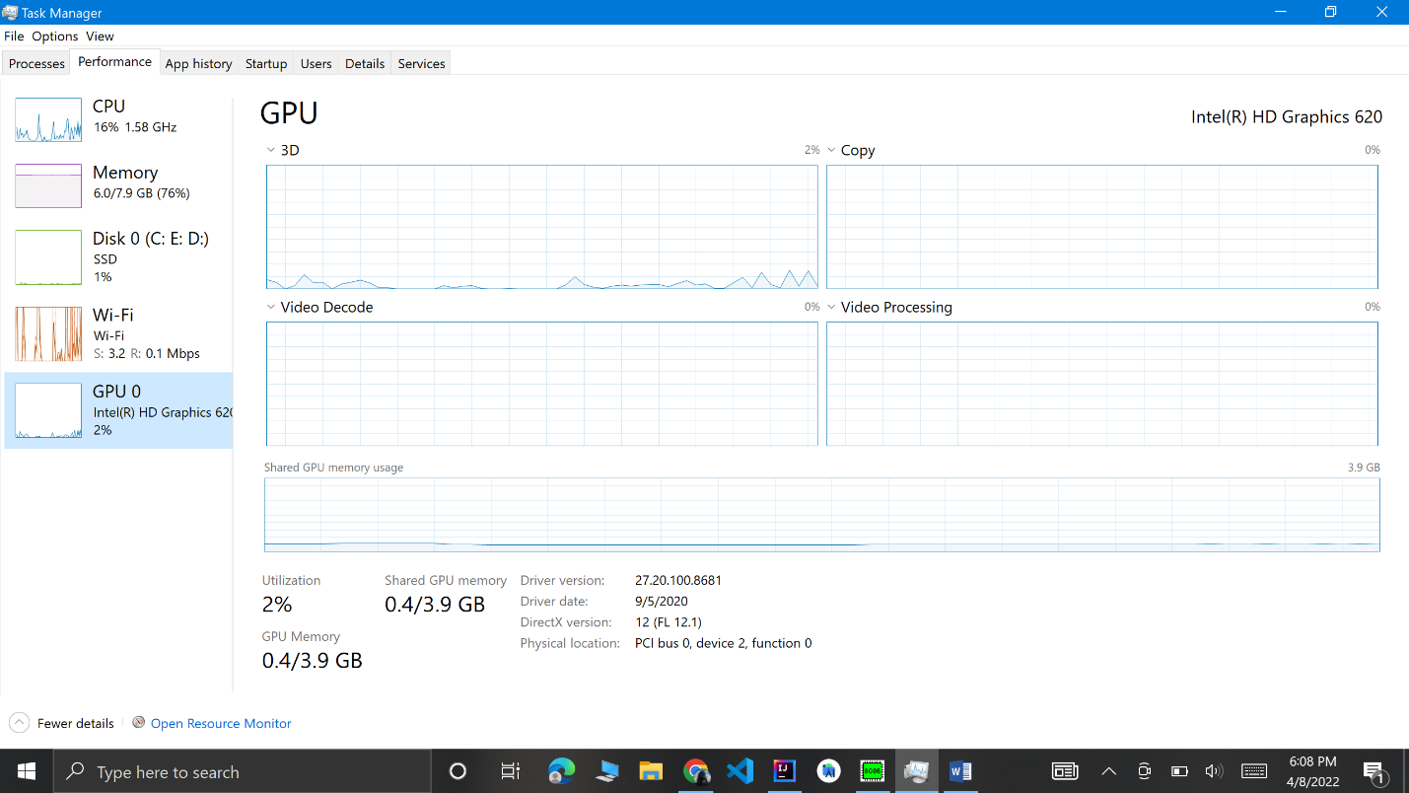

* **GPU**: The GPU (graphics processing unit) resources used by a process, displayed as a percentage of the GPU’s available resources.
* **GPU Engine**: The GPU device and engine used by a process. If you have multiple GPUs in your system, this will show you which GPU a process is using. See the Performance tab to see which number (“GPU 0” or “GPU 1” is associated with which physical GPU.