Experiment No.2
- Problem Statement:
- Program to implement a Queue ADT with a circular array
- Implement a banker's queue. This uses 2 stacks to implement all the operations of a regular queue.

- Theory:
A queue is a linear list of elements in which deletions can take place only at one end, called front, and insertions can take place only at the other end, called the rear. Queue is also called a first-in-first-out (FIFO) lists, since the first element will be out first from the queue. The most fundamental operations in the queue ADT include: enqueue(), dequeue(), peek(), isFull(), isEmpty(). These are all built-in operations to carry out data manipulation and to check the status of the queue.
There was one limitation in the array implementation of queue. If the rear reaches to the end position of the Queue then there might be possibility that some vacant spaces are left in the beginning which cannot be utilized. So, to overcome such limitations, the concept of the circular queue was introduced.
A circular queue is similar to a linear queue as it is also based on the FIFO (First In First Out) principle except that the last position is connected to the first position in a circular queue that forms a circle. It is also known as a Ring Buffer.

- Algorithm:
This algorithm outlines the key operations and logic for the given program that implements a circular queue.
1. Initialize Queue Function
- Input: struct Queue *queue, int size
- Set queue->size to the given size.
- Initialize queue->front and queue->rear to 0.
- Allocate memory for the queue->array of size queue->size.

2. Display Function
- Input: struct Queue *queue
- Check if the queue is empty using the isEmpty function.
- If empty, print "Queue is empty" and return.
- Otherwise, initialize a variable i with queue->front.
- Repeat the following steps until i becomes equal to queue->rear:
- Increment i using circular increment (i + 1) % queue->size.
- Print the element at position i in queue->array.

3. isEmpty Function
- Input: struct Queue *queue
- Check if queue->rear is equal to queue->front.
- If equal, return 1 (queue is empty), otherwise return 0.

4. isFull Function
- Input: struct Queue *queue
- Check if (queue->rear + 1) % queue->size is equal to queue->front.
- If equal, return 1 (queue is full), otherwise return 0.

5. Enqueue Function
- Input: struct Queue *queue, char item
- Check if the queue is full using the isFull function.
- If full, print "Queue Overflow".
- Otherwise, increment queue->rear using circular increment.
- Store the item in queue->array at the new queue->rear position.
- Print "Enqueued element: item".

6. Dequeue Function
- Input: struct Queue *queue
- Initialize a character variable val to '\0'.
- Check if the queue is empty using the isEmpty function.
- If empty, print "Empty queue".
- Otherwise, increment queue->front using circular increment.
- Retrieve the element at the new queue->front position and store it in val.
- Return val.

7. Front Function
- Input: struct Queue *queue
- Check if the queue is empty using the isEmpty function.
- If empty, print "Queue is empty".
- Otherwise, print "The front is: queue->array[(queue->front + 1) % queue->size]".

8. Rear Function
- Input: struct Queue *queue
- Check if the queue is empty using the isEmpty function.
- If empty, print "Queue is empty".
- Otherwise, print "The rear is: queue->array[queue->rear]".

This algorithm outlines the key operations and logic for the given program that implements a queue using two stacks.

1. Initialize Queue Function
- Input: struct Queue *queue, unsigned size
- Create a struct Queue using dynamic memory allocation.
- Initialize two stacks, stack1 and stack2, each with the given size.
- Return the initialized queue.

2. Enqueue Function
- Input: struct Queue *queue, char item
- Transfer elements from stack2 to stack1 until stack2 is empty:
- While stack2 is not empty, pop an element from stack2 and push it onto stack1.
- Push the new item onto stack1 to enqueue it.
- Print "Enqueued element: item".

3. Dequeue Function
- Input: struct Queue *queue
- Transfer elements from stack1 to stack2 until stack1 is empty:
- While stack1 is not empty, pop an element from stack1 and push it onto stack2.
- Check if stack2 is empty:
- If empty, print "Queue Underflow" and return the null character '\0' to indicate an empty queue.
- Pop an element from stack2 to dequeue it and return the dequeued element.

4. isEmpty Function
- Input: struct Queue *queue
- Check if both stack1 and stack2 are empty using the isEmpty_stack function.
- If both are empty, return 1 (queue is empty), otherwise return 0.

5. isFull Function
- Input: struct Queue *queue
- Check if both stack1 and stack2 are full using the isFull_stack function.
- If both are full, return 1 (queue is full), otherwise return 0.

6. Display Function
- Input: struct Queue *queue
- Print "Queue elements: ".
- Create a temporary stack tempStack of the same size as stack1.
- Transfer elements from stack1 to tempStack while printing them:
- While stack1 is not empty, pop an element from stack1, push it onto tempStack, and print the element.
- Transfer elements from tempStack back to stack1:
- While tempStack is not empty, pop an element from tempStack and push it onto stack1.
- Print a newline character to end the display.

- Solution:
- 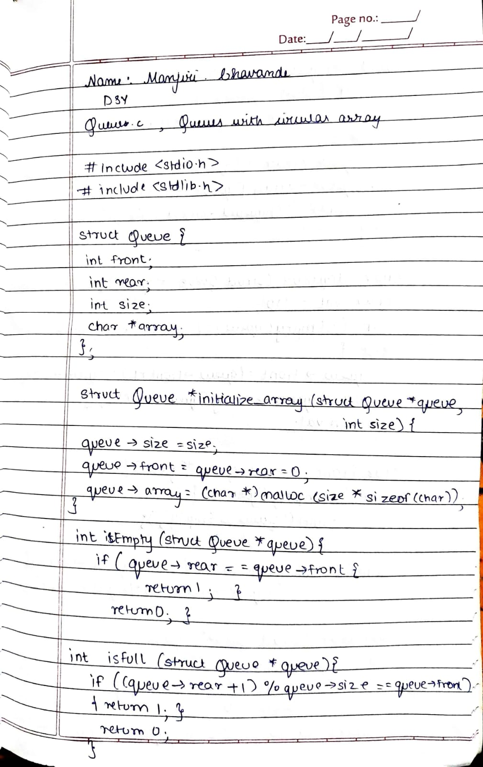
- 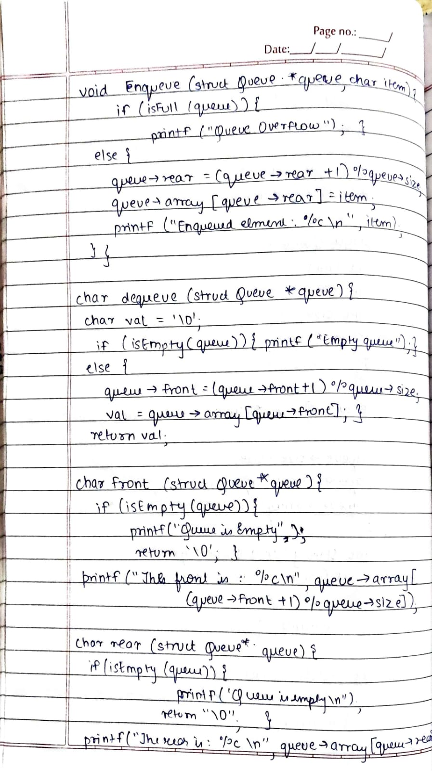
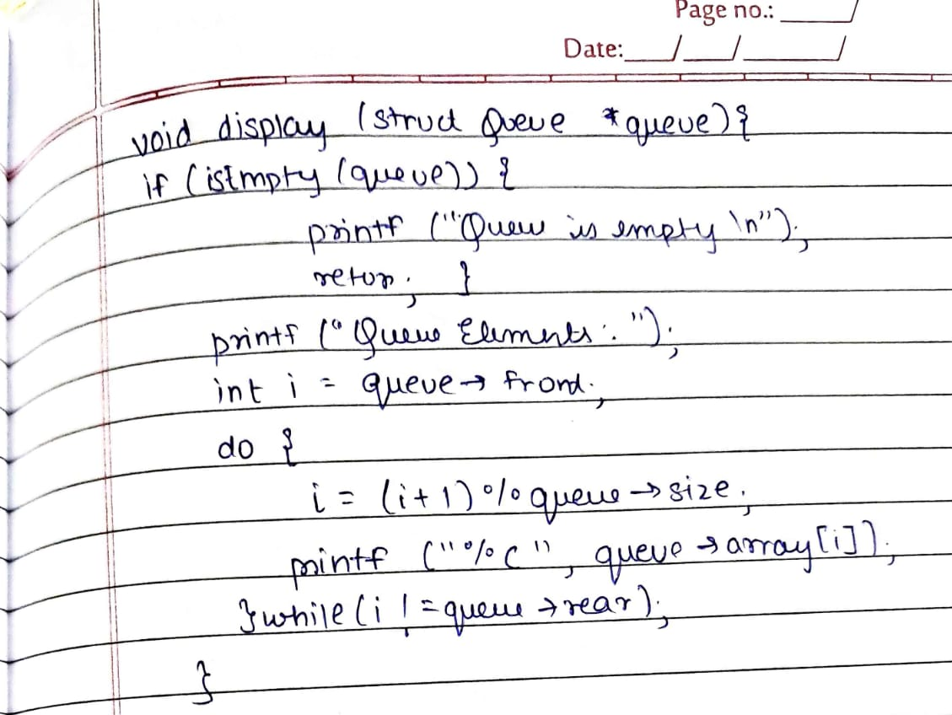

- Code and output
- /*
- * File: queue.c
- * Author: Manjiri Chavande
- * Email: cmanjiri1912@gmail.com
- * Created: September 12, 2023
- * Description: Implement a banker's queue. This uses 2 stacks to implement all the operations of a regular queue

- */

- #include <stdio.h>
- #include <stdlib.h>
- #include "stacks.c"

- // Queue implementation using two stacks
- struct Queue
- {
- struct Stack *stack1; // For enqueue
- struct Stack *stack2; // For dequeue
- };

- struct Queue *initialize_queue(unsigned size)
- {
- struct Queue *queue = (struct Queue *)malloc(sizeof(struct Queue));
- queue->stack1 = initialize_stack(size);
- queue->stack2 = initialize_stack(size);
- return queue;
- }

- void enqueue(struct Queue *queue, char item)
- {
- while (!isEmpty_stack(queue->stack2))
- {
- char temp = pop(queue->stack2);
- push(queue->stack1, temp);
- }
- push(queue->stack1, item);
- printf("Enqueued element: %c\n", item);
- }

- char dequeue(struct Queue *queue)
- {
- while (!isEmpty_stack(queue->stack1))
- {
- char temp = pop(queue->stack1);
- push(queue->stack2, temp);
- }
- if (isEmpty_stack(queue->stack2))
- {
- printf("Queue Underflow\n");
- return '\0'; // Return null character for empty queue
- }
- return pop(queue->stack2);
- }

- int isEmpty(struct Queue *queue)
- {
- return isEmpty_stack(queue->stack1) && isEmpty_stack(queue->stack2);
- }

- int isFull(struct Queue *queue)
- {
- return isFull_stack(queue->stack1) && isFull_stack(queue->stack2);
- }

- void display(struct Queue *queue)
- {
- printf("Queue elements: ");
- struct Stack *tempStack = initialize_stack(queue->stack1->size);

- // First, move all elements from stack1 to tempStack
- while (!isEmpty_stack(queue->stack1))
- {
- char temp = pop(queue->stack1);
- push(tempStack, temp);
- }

- // Then, move all elements from tempStack to stack1 and print them
- while (!isEmpty_stack(tempStack))
- {
- char temp = pop(tempStack);
- push(queue->stack1, temp);
- printf("%c ", temp);
- }

- printf("\n");
- free(tempStack); // Free the temporary stack
- }

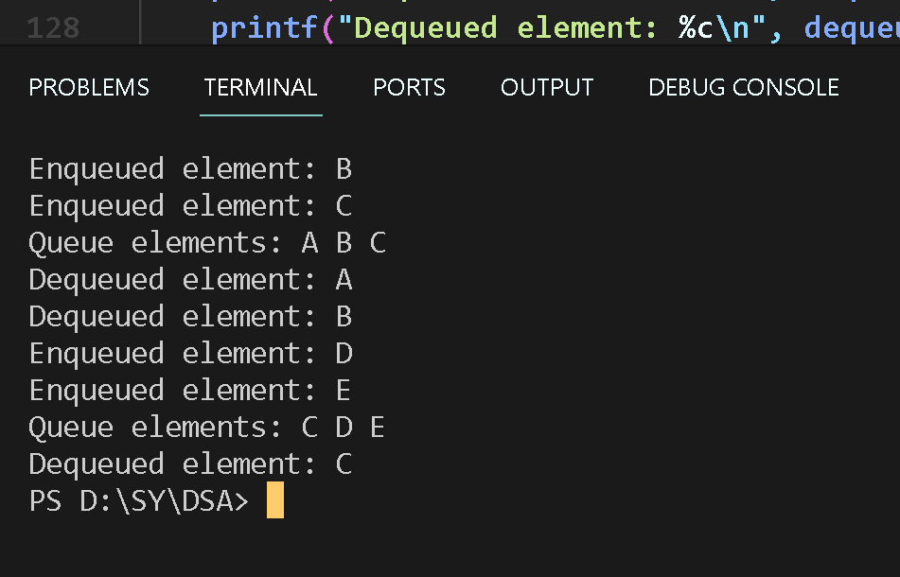

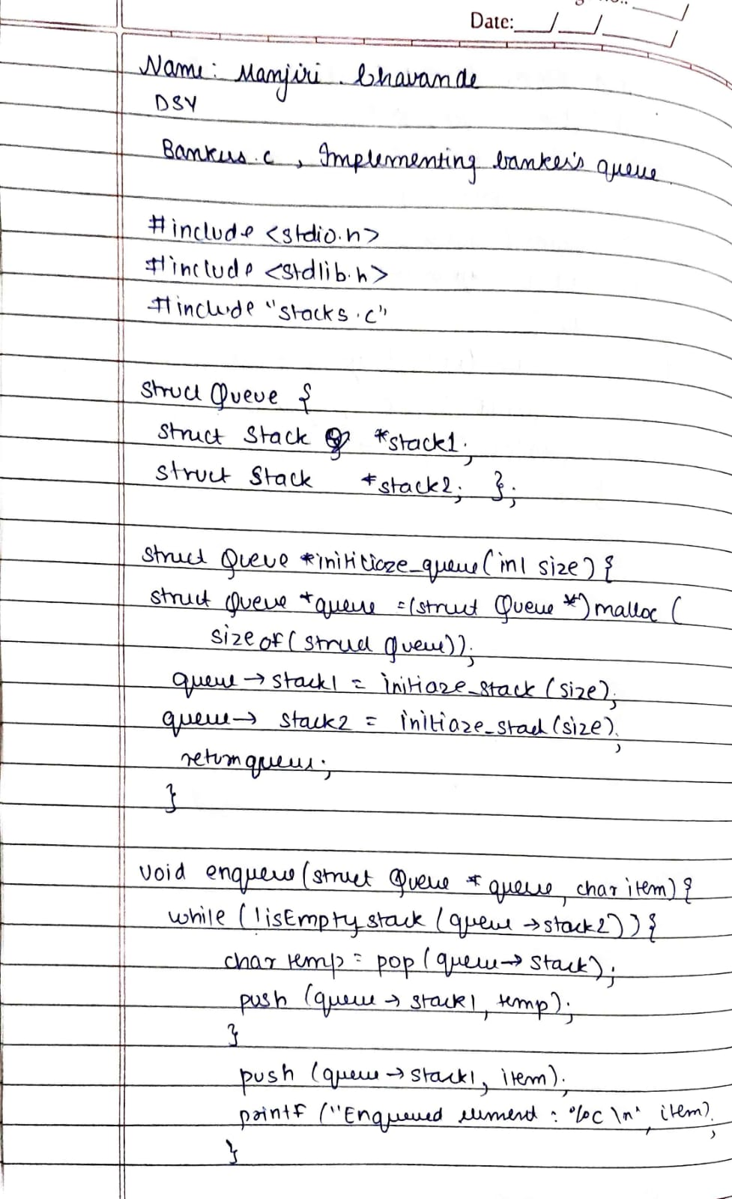
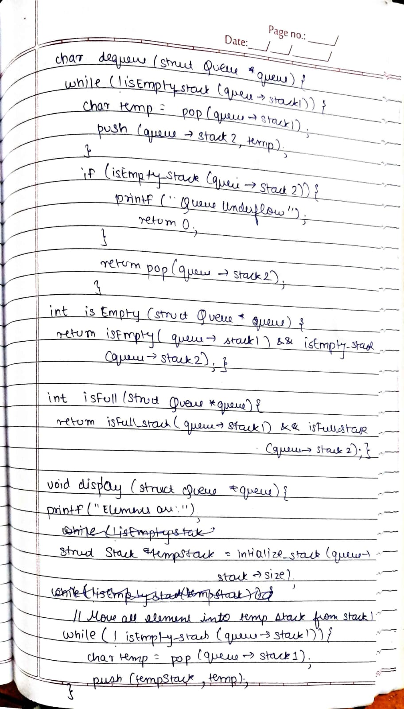

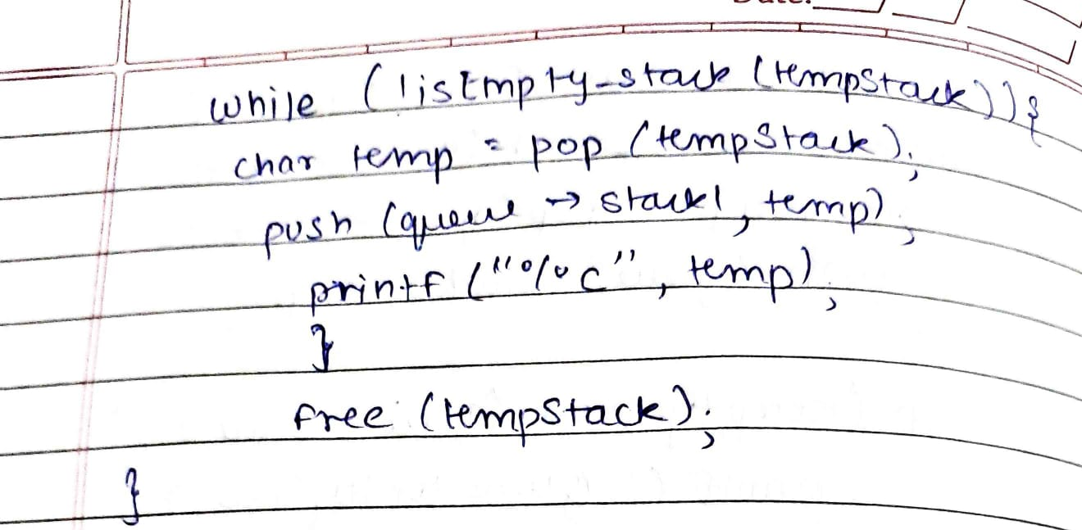
/*
* File: queue.c
* Author: Manjiri Chavande
* Email: cmanjiri1912@gmail.com
* Created: September 12, 2023
* Description: This program implements a Queue ADT with a circular array
*/
#include <stdio.h>
#include <stdlib.h>

struct Queue
{
int front;
int rear;
int size;
char *array;
};

// 0 -> Initialize
struct Queue *initialize_queue(struct Queue *queue, int size)
{
queue->size = size;
queue->front = queue->rear = 0;
queue->array = (char *)malloc(size * sizeof(char));
}

// 0 -> display

// 1 -> isEmpty
int isEmpty(struct Queue *queue)
{
if (queue->rear == queue->front)
{
return 1;
}
return 0;
}

// 3 -> isFull
int isFull(struct Queue *queue)
{
if ((queue->rear + 1) % queue->size == queue->front)
{
return 1;
}
return 0;
}

// 4 -> enqueue
void enqueue(struct Queue *queue, char item)
{
if (isFull(queue))
{
printf("Queue Overflow\n");
}
else
{
queue->rear = (queue->rear + 1) % queue->size;
queue->array[queue->rear] = item;
printf("Enqueued element: %c\n", item);
}
}

// 5 -> dequeue
char dequeue(struct Queue *queue)
{
char val = '\0';
if (isEmpty(queue))
{
printf("Empty queue\n");
}
else
{
queue->front = (queue->front + 1) % queue->size;
val = queue->array[queue->front];
}
return val;
}

// 6 -> front
char front(struct Queue* queue){
if (isEmpty(queue)) {
printf("Queue is empty\n");
return '\0';
}
printf("The front is : %c\n", queue->array[(queue->front + 1) % queue->size]);
}

// 7 -> rear
char rear(struct Queue* queue){
if (isEmpty(queue)) {
printf("Queue is empty\n");
return '\0';
}
printf("The rear is : %c\n", queue->array[queue->rear]);
}

void display(struct Queue *queue)
{
if (isEmpty(queue))
{
printf("Queue is empty\n");
return;
}

printf("Queue elements: ");
int i = queue->front;
do
{
i = (i + 1) % queue->size;
printf("%c ", queue->array[i]);
} while (i != queue->rear);

printf("\n");
}

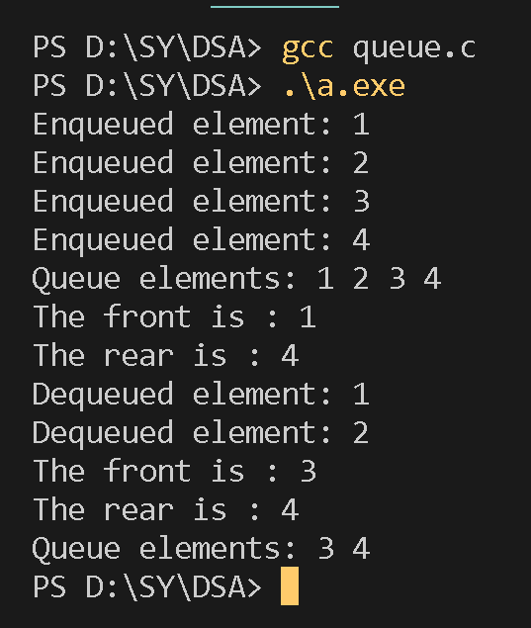
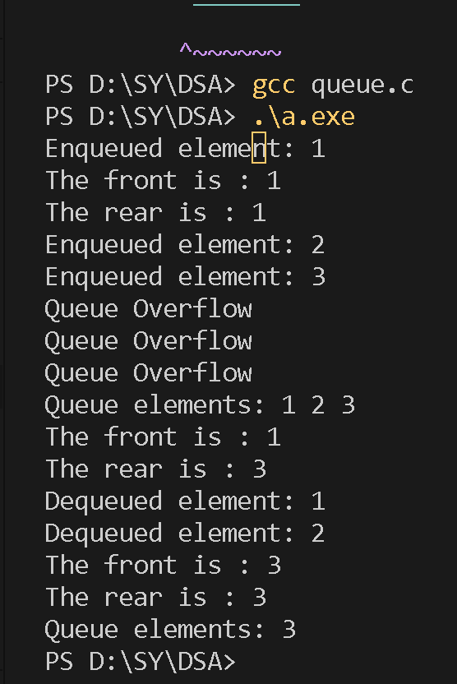

- Conclusion: Thus we have learned to implement circular queues and banker’s queue and perform operations on them.

