Experiment No. 5
Name : Manjiri Chavande | DSE SY COMPS
Division: B batch-A | UID: 2023301003

- Problem Statement

Construct binary tree from postorder and inorder traversal

- Theory
A Binary tree is represented by a pointer to the topmost node (commonly known as the “root”) of the tree. If the tree is empty, then the value of the root is NULL. Each node of a Binary Tree contains the following parts:
- Data
- Pointer to left child
- Pointer to right child
Basic Operation On Binary Tree:
- Inserting an element.
- Removing an element.
- Searching for an element.
- Traversing the tree.

- Algorithm

- Take index’s the root element ( in postorder traversal it starts from the last position i.e: n-1)
- Find the position of the root in inorder
- Root->right (position+1 to inorder’s end)
- Root->left (inorder’s start to position-1)

Note : In case of posorder and inorder we first make a recursive call to the right side of the node and then the left since the index pointer begins from the end of the postorder array

- Solution
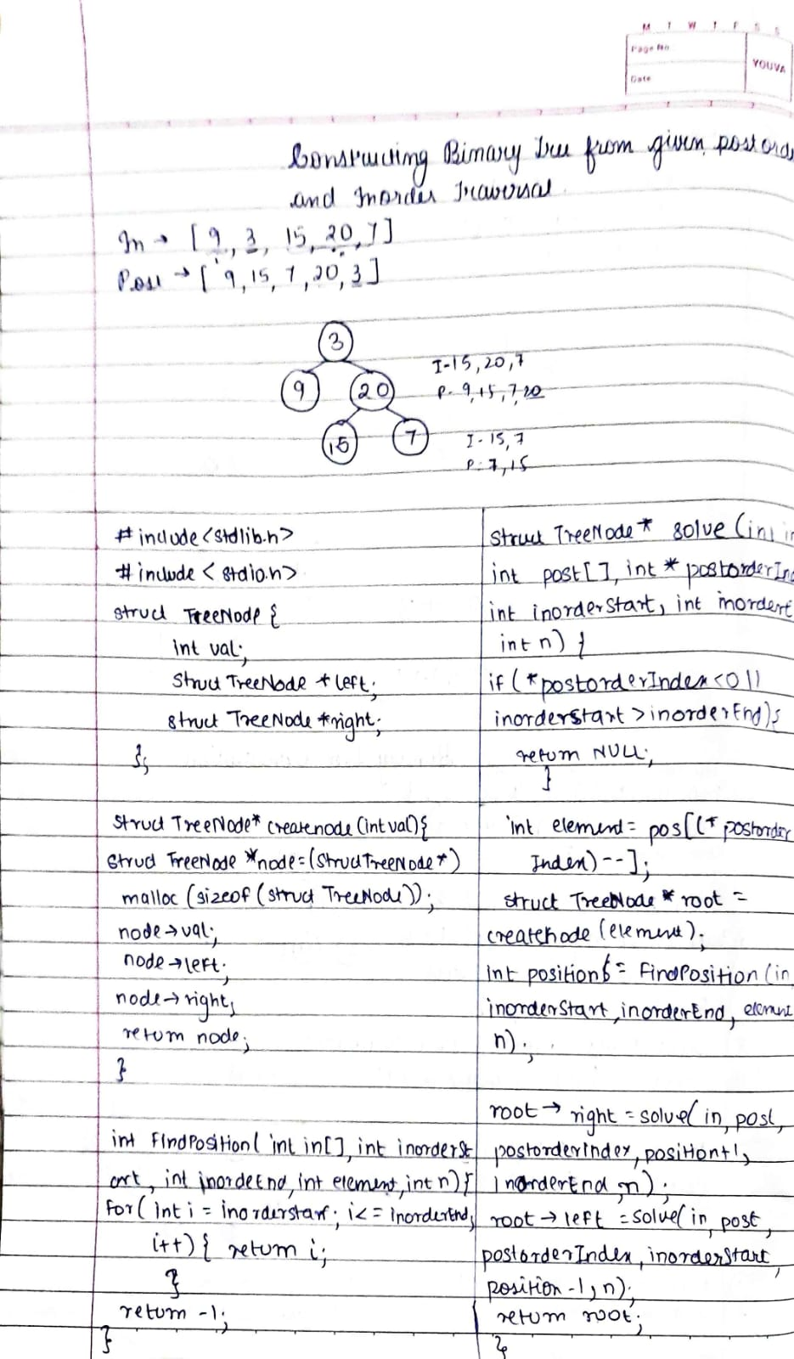

- Code
// Given two integer arrays postorder and inorder
// where postorder is the postorder traversal of a binary tree and
// inorder is the inorder traversal of the same tree, construct and return the binary tree.

// Input: postorder = [9,15,7,20,3], inorder = [9,3,15,20,7]
// Output: [3,9,20,null,null,15,7]

#include <stdlib.h>
#include <stdio.h>

struct TreeNode {
int val;
struct TreeNode *left;
struct TreeNode *right;
};

// Function to create a new node
struct TreeNode* create_node(int val) {
struct TreeNode* node = (struct TreeNode*)malloc(sizeof(struct TreeNode));
node->val = val;
node->left = NULL;
node->right = NULL;
return node;
}

// Function to find the position in the inorder array
int findPosition(int in[], int inorderStart, int inorderEnd, int element, int n) {
for (int i = inorderStart; i <= inorderEnd; i++) {
if (in[i] == element) {
return i;
}
}
return -1;
}

// Function to build the binary tree
struct TreeNode* solve(int in[], int post[], int *postorderIndex, int inorderStart, int inorderEnd, int n) {
if (*postorderIndex < 0 || inorderStart > inorderEnd) {
return NULL;
}

int element = post[(*postorderIndex)--];
struct TreeNode* root = create_node(element);
int position = findPosition(in, inorderStart, inorderEnd, element, n);

// In case of inorder and postorder, we first build the right sub-tree
root->right = solve(in, post, postorderIndex, position + 1, inorderEnd, n);
root->left = solve(in, post, postorderIndex, inorderStart, position - 1, n);

return root;
}

// Wrapper function to call the helper function
struct TreeNode* buildTree(int* inorder, int inorderSize, int* postorder, int postorderSize) {
int postorderIndex = postorderSize - 1; // Start from the last index of postorder
return solve(inorder, postorder, &postorderIndex, 0, inorderSize - 1, inorderSize);
}

// Function to print the preorder traversal
void printBinTree(struct TreeNode* node) {
if (node == NULL) {
printf("null ");
return;
}
printf("%d ", node->val);
printBinTree(node->left);
printBinTree(node->right);
}

- Output
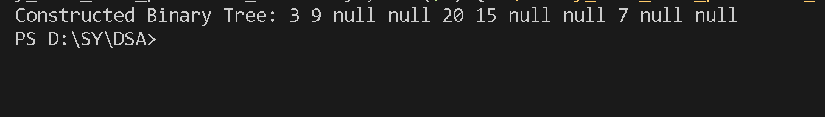
- Test cases

Without inclusion of null
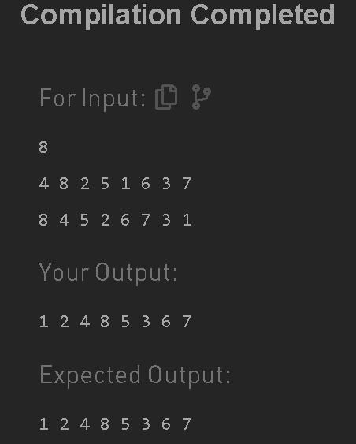
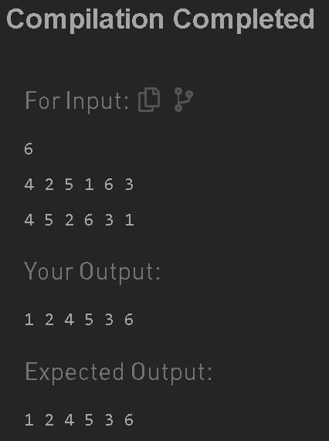

- Conclusion

Thus we have successfully formed a binary tree from the given postorder and inorder.

