Experiment No. 6
Name : Manjiri Chavande | DSE SY COMPS
Division: B batch-A | UID: 2023301003

- Problem Statement

Implement an ADT for storing an AVL Tree and performing given operations on it.
- Theory

AVL tree is a self-balancing binary search tree in which each node maintains extra information called a balance factor whose value is either -1, 0 or +1.
AVL tree got its name after its inventor Georgy Adelson-Velsky and Landis.
There are four types of rotations in AVL trees:
- Left rotation:
This rotation is performed when the right subtree of a node is too tall. The rotation moves the node to the left subtree and balances the tree.
- Right rotation:
This rotation is performed when the left subtree of a node is too tall. The rotation moves the node to the right subtree and balances the tree.
- Left-right rotation:
This rotation is performed when the right subtree of a node is too tall and the left subtree of the right child is also too tall. The rotation first rotates the right child left, and then rotates the node left. This balances the tree.
- Right-left rotation:
This rotation is performed when the left subtree of a node is too tall and the right subtree of the left child is also too tall. The rotation first rotates the left child right, and then rotates the node right. This balances the tree.

- Balance Factor
Balance factor of a node in an AVL tree is the difference between the height of the left subtree and that of the right subtree of that node.
Balance Factor = (Height of Left Subtree - Height of Right Subtree) or (Height of Right Subtree - Height of Left Subtree)
The self balancing property of an avl tree is maintained by the balance factor. The value of balance factor should always be -1, 0 or +1.
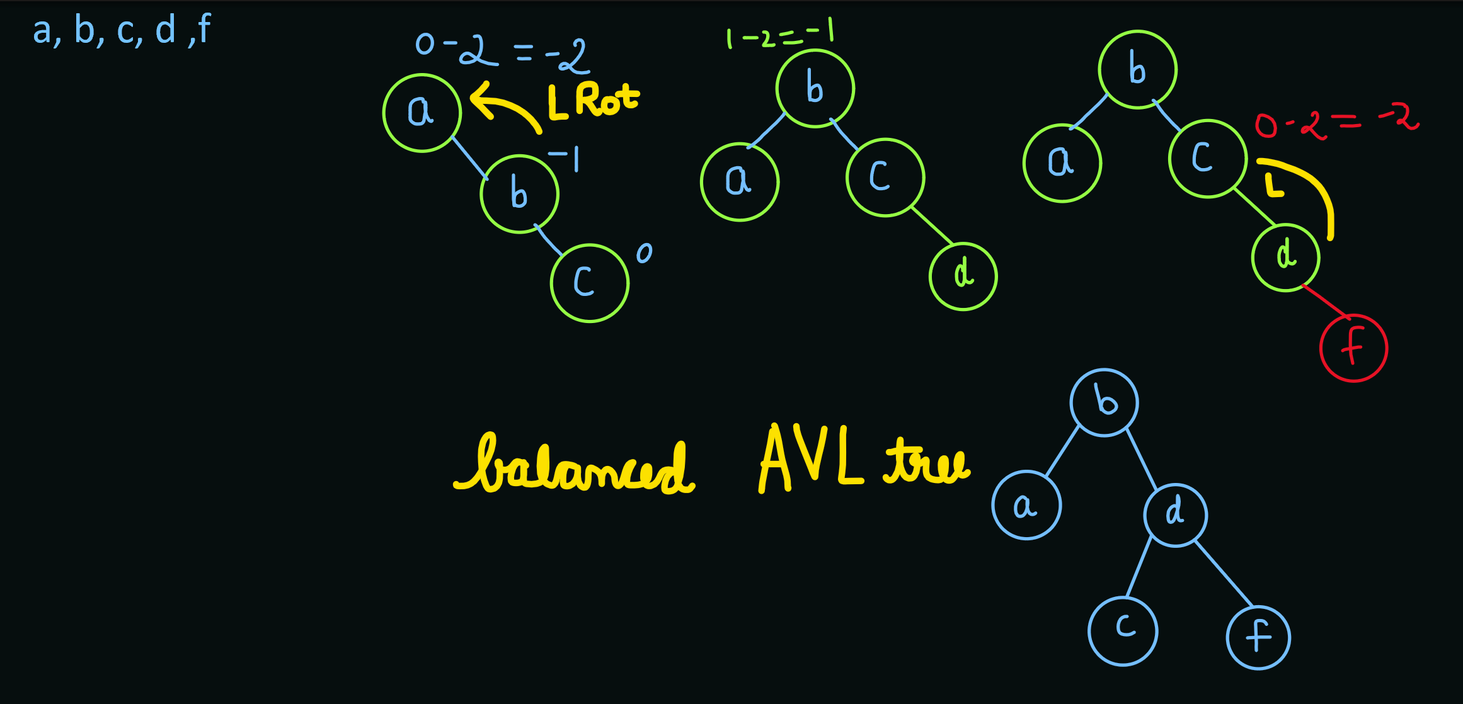

- Algorithm
Function to create a new AVL node with the given data
createNode(data):
- Allocate memory for a new AVL node.
- Set the data of the node to a duplicate of the input data.
- Set the left and right child pointers to NULL.
- Initialize the height of the node to 1.
- Return the newly created node.

Function to print the AVL tree in Inorder traversal
printInorder(root):
- If the root is NULL, return.
- Recursively traverse the left subtree.
- Print the data of the current node.
- Recursively traverse the right subtree.

Function to get the height of the AVL node
getHeight(node):
- If the node is NULL, return 0.
- Otherwise, return the height of the node.

Function to get the balance factor of the AVL node
getBalance(node):
- If the node is NULL, return 0.
- Otherwise, calculate the balance factor of the node.

Function to find the maximum of two integers
max(a, b):
- If 'a' is greater than 'b', return 'a'; otherwise, return 'b'.

Function to perform a right rotation in the AVL tree
rotateRight(y):
- Perform a right rotation around the node 'y' and its left child 'x'.
- Update the heights of the rotated nodes.
- Return the new root of the rotated subtree.

Function to perform a left rotation in the AVL tree
rotateLeft(x):
- Perform a left rotation around the node 'x' and its right child 'y'.
- Update the heights of the rotated nodes.
- Return the new root of the rotated subtree.

Function to insert a new node with the given data into the AVL tree
insert(node, data):
- If the node is NULL, create a new node and return it.
- Recursively insert the new data into the appropriate subtree.
- Update the height of the node and perform necessary rotations to maintain balance.

Function to find the node with the minimum value in the AVL tree
minValueNode(node):
- Start with the given node and loop down to find the leftmost node.
- Return the node with the minimum value.

Function to delete a node with the given data from the AVL tree
deleteNode(root, data):
- If the root is NULL, return.
- Recursively traverse the tree to find the node to delete.
- Handle different cases depending on the presence of children.
- Update the heights and perform necessary rotations to maintain balance.

Function to free the memory used by the AVL tree
freeAVLTree(root):
- If the root is NULL, return.
- Recursively free the memory for each node in the AVL tree.

- Solution

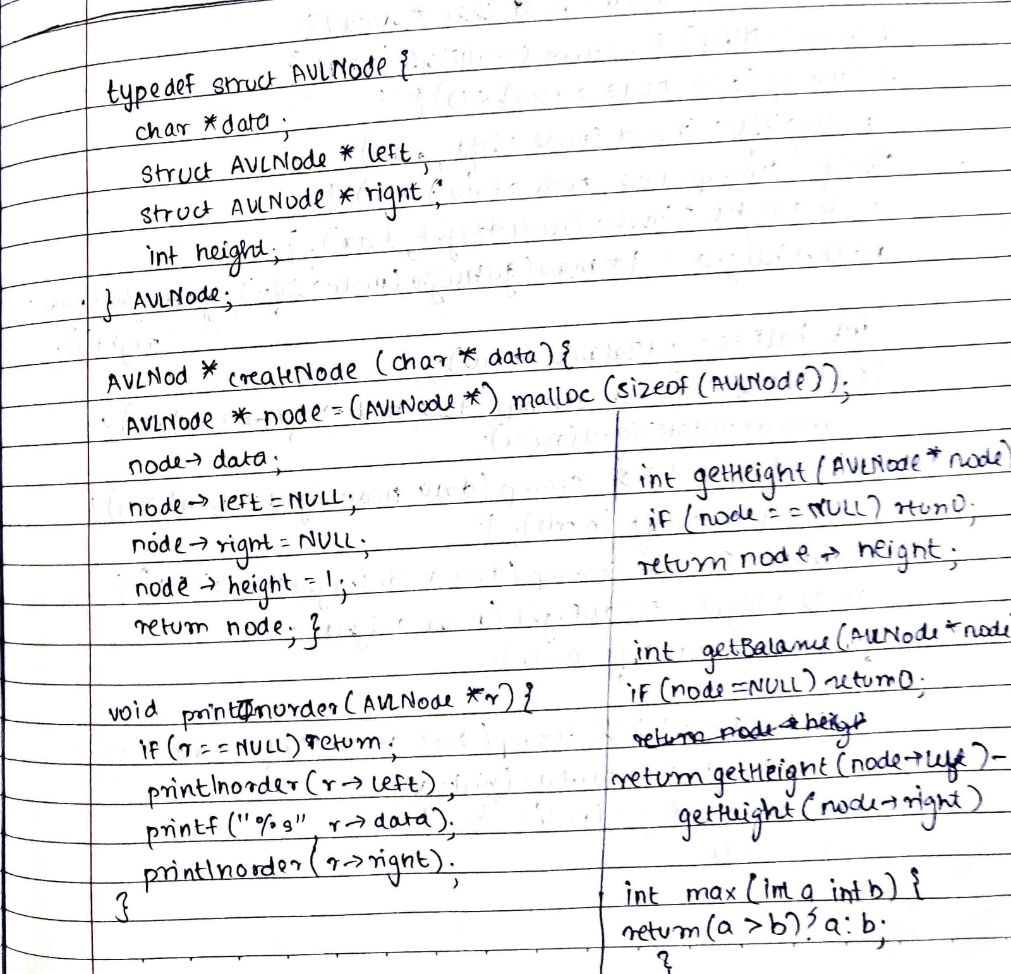



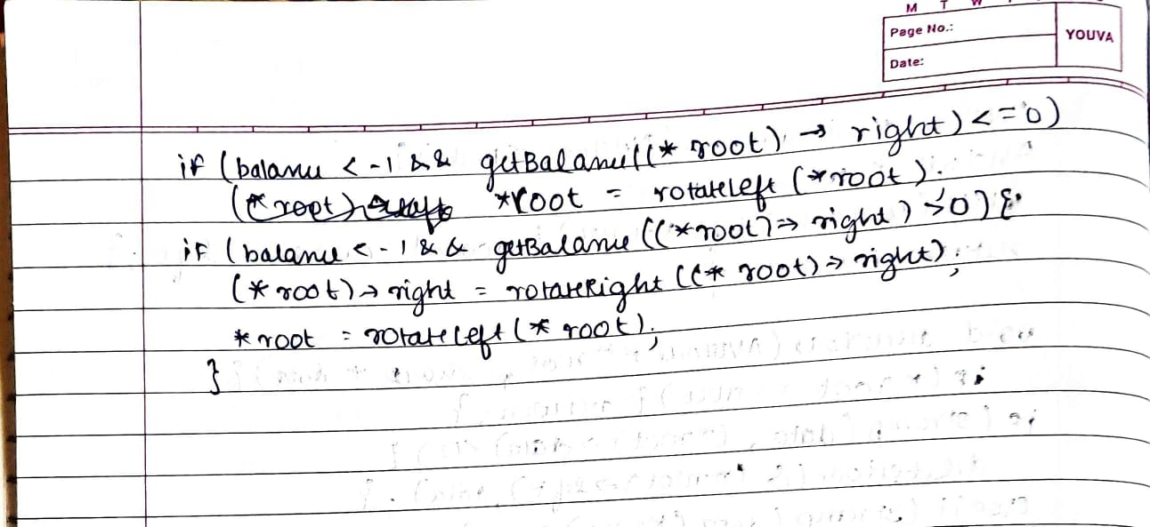
- Code

typedef struct AVLNode
{
char *data;
struct AVLNode *left;
struct AVLNode *right;
int height;
} AVLNode;

AVLNode *createNode(char *data)
{
AVLNode *node = (AVLNode *)malloc(sizeof(AVLNode));
node->data = data;
node->left = NULL;
node->right = NULL;
node->height = 1;
return node;
}

void printInorder(AVLNode *r) // (Left, current node, Right)
{
if (r == NULL)
return;
/* first recur on left child */
printInorder(r->left);
/* then print the data of node */
printf("%s ", r->data);
/* now recur on right child */
printInorder(r->right);
}

int getHeight(AVLNode *node)
{
if (node == NULL)
return 0;
return node->height;
}

int getBalance(AVLNode *node)
{
if (node == NULL)
return 0;
return getHeight(node->left) - getHeight(node->right);
}

int max(int a, int b)
{
return (a > b) ? a : b;
}

AVLNode *rotateRight(AVLNode *y)
{
AVLNode *x = y->left;
AVLNode *T2 = x->right;

x->right = y;
y->left = T2;

y->height = max(getHeight(y->right), getHeight(y->left)) + 1;
x->height = max(getHeight(x->right), getHeight(x->left)) + 1;

return x;
}

AVLNode *rotateLeft(AVLNode *x)
{
AVLNode *y = x->right;
AVLNode *T2 = y->left;

y->left = x;
x->right = T2;

y->height = max(getHeight(y->right), getHeight(y->left)) + 1;
x->height = max(getHeight(x->right), getHeight(x->left)) + 1;

return y;
}

AVLNode *insert(AVLNode *node, char *data)
{
if (node == NULL)
{
return createNode(data);
}

if (strcmp(data, node->data) < 0)
{
node->left = insert(node->left, data);
}
else if (strcmp(data, node->data) > 0)
{
node->right = insert(node->right, data);
}

node->height = 1 + max(getHeight(node->left), getHeight(node->right));
int balfac = getBalance(node);

if (balfac > 1 && strcmp(data, node->left->data) < 0)
{
return rotateRight(node);
}

if (balfac < -1 && strcmp(data, node->right->data) > 0)
{
return rotateLeft(node);
}

if (balfac < -1 && strcmp(data, node->right->data) < 0)
{
node->right = rotateRight(node->right);
return rotateLeft(node);
}

if (balfac > 1 && strcmp(data, node->left->data) > 0)
{
node->left = rotateLeft(node->left);
return rotateRight(node);
}

return node;
}

AVLNode *minValueNode(AVLNode *node)
{
AVLNode *current = node;
// loop down to find the leftmost node
while (current->left != NULL)
{
current = current->left;
}
return current;
}

void deleteNode(AVLNode **root, char *data) {
if (*root == NULL)
return;

if (strcmp(data, (*root)->data) < 0)
deleteNode(&((*root)->left), data);
else if (strcmp(data, (*root)->data) > 0)
deleteNode(&((*root)->right), data);
else {
if (((*root)->left == NULL) || ((*root)->right == NULL)) {
AVLNode *temp = (*root)->left ? (*root)->left : (*root)->right;
if (temp == NULL) {
temp = *root;
*root = NULL;
} else
**root = *temp;
free(temp->data);
free(temp);
} else {
AVLNode *temp = minValueNode((*root)->right);
free((*root)->data);
(*root)->data = strdup(temp->data);
deleteNode(&((*root)->right), temp->data);
}
}

if (*root == NULL)
return;

(*root)->height = 1 + max(getHeight((*root)->left), getHeight((*root)->right));
int balance = getBalance(*root);
if (balance > 1 && getBalance((*root)->left) >= 0)
*root = rotateRight(*root);
if (balance > 1 && getBalance((*root)->left) < 0) {
(*root)->left = rotateLeft((*root)->left);
*root = rotateRight(*root);
}
if (balance < -1 && getBalance((*root)->right) <= 0)
*root = rotateLeft(*root);
if (balance < -1 && getBalance((*root)->right) > 0) {
(*root)->right = rotateRight((*root)->right);
*root = rotateLeft(*root);
}
}

- Test Cases

//H, I, J, B, A, E, C, F, D, G, K, L  deleteNode(&root, "a"); | 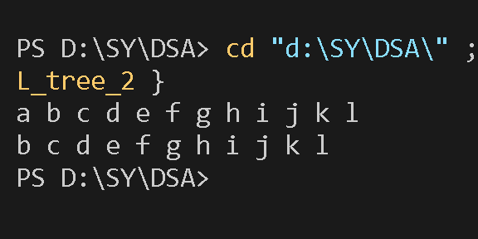
Deleting more than one nodes | 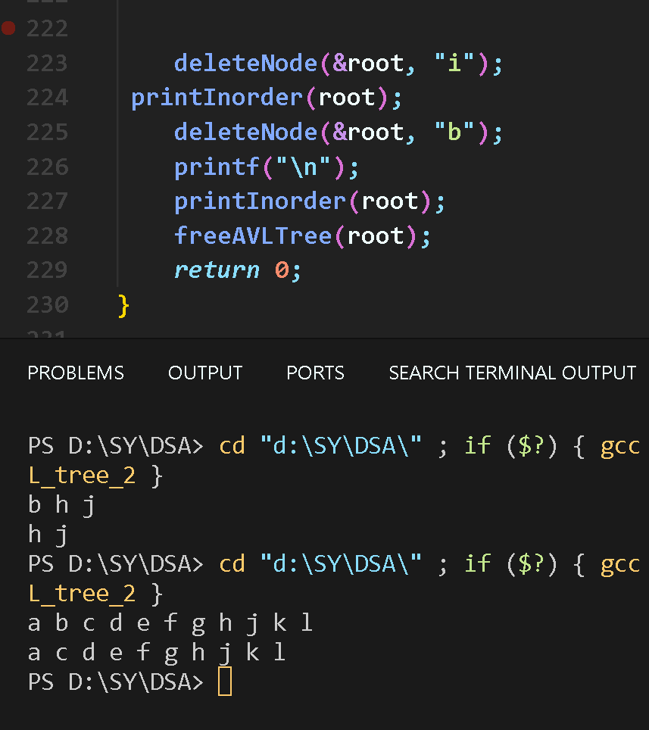

- Output

Deleting “a” | 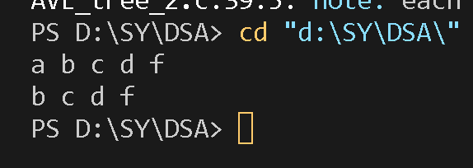
Deleting “b” | 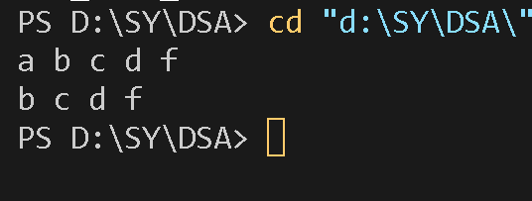
Deleting “f” | 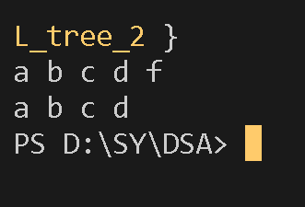
Deleting the root node which does not have any children | 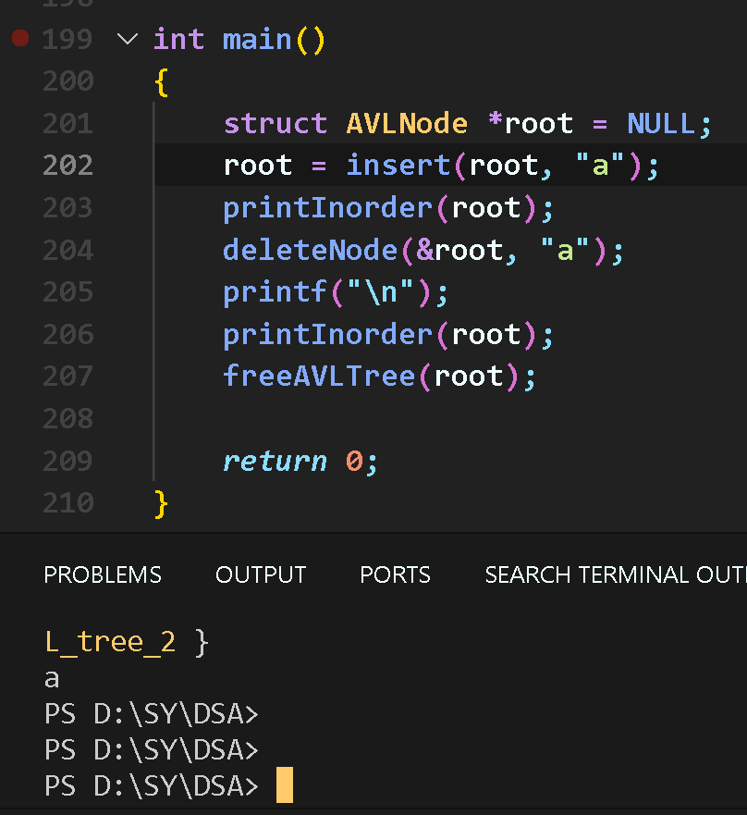

- Conclusion

Thus we have successfully completed all the ADT operations on AVL tree.

