Experiment No. 7
Name : Manjiri Chavande | DSE SY COMPS
Division: B batch-A | UID: 2023301003

- Problem Statement

Create an expression tree from a postorder traversal
Write a function to evaluate a given expression tree
- Theory

A mathematical expression can be expressed as a binary tree using expression trees. Expression trees are binary trees with each leaf node serving as an operand and each internal (non-leaf) node serving as an operator
Some expression tree properties.
- The operands are always represented by the leaf nodes. These operands are always used in the operations.
- The operator at the root of the tree is always given top priority.
- When compared to the operators at the bottom of the tree, the operator at the bottom is always given the lowest priority.
- Because the operand is always present at a depth of the tree, it is given the highest priority of all operators.
- The expression tree can be traversed to evaluate prefix expressions, postfix expressions, and infix expressions.
The implementation of the expression tree is described for the below expression.
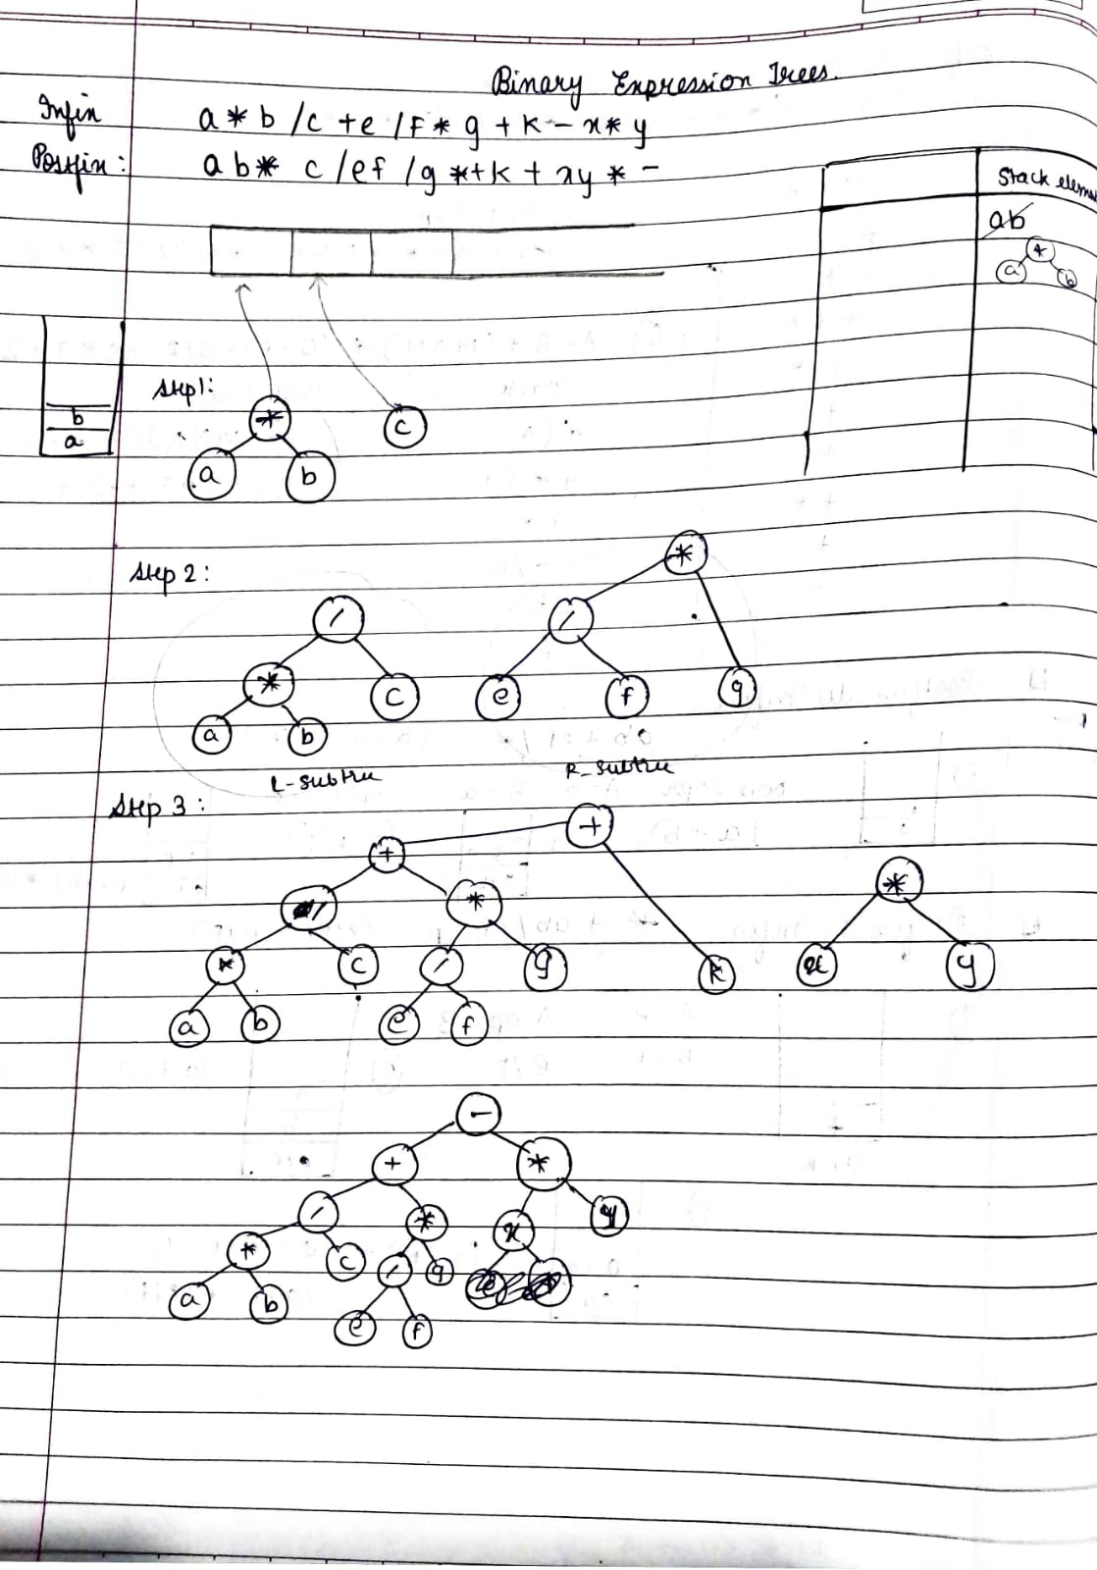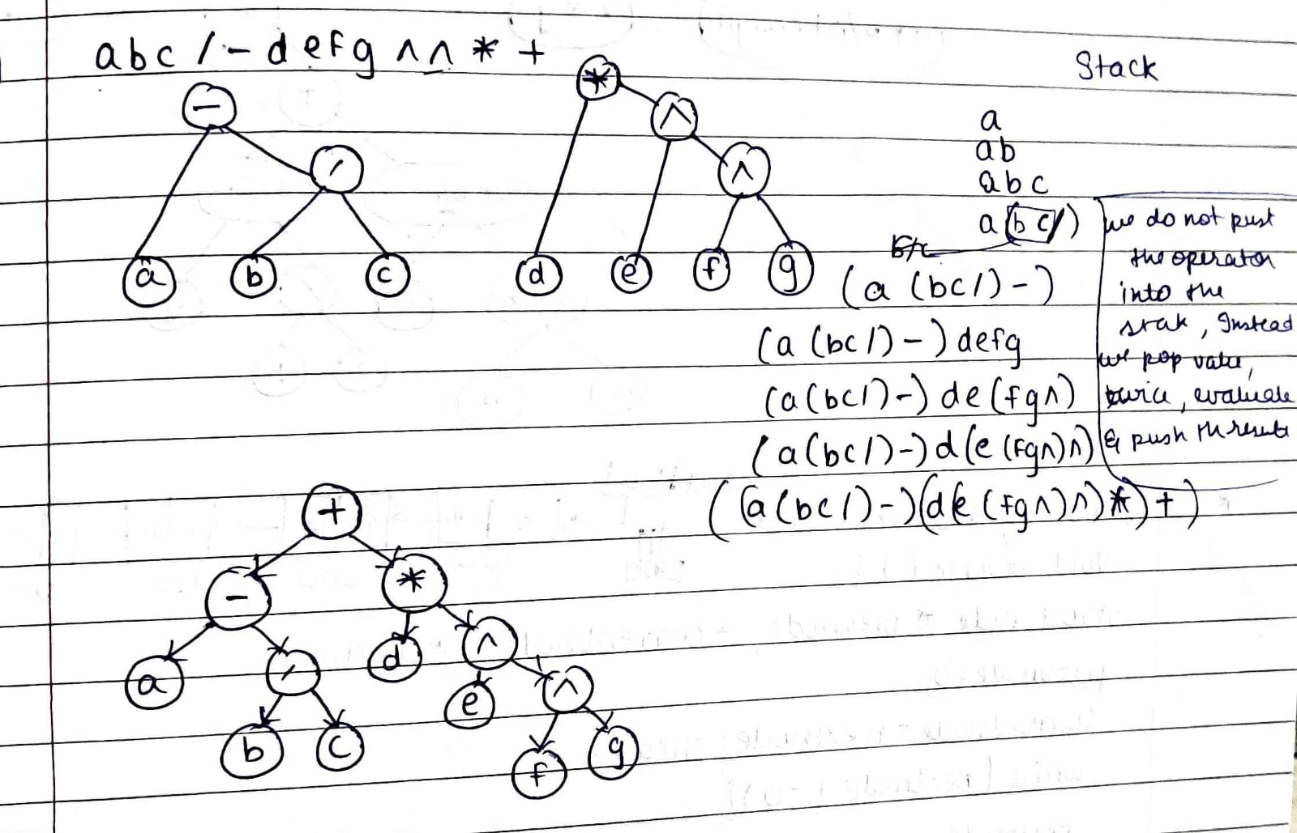

- Algorithm

- Pass a postfix expression (in form of an char array ) as an argument in the create_ET_from_postfix
- Inside the create_ET_from_postfix function
  - Initialize a stack
  - Get the length of the string and run the loop till it meets the base condition of n-1 where n is the size if the array, inorder to skim through the string
  - If it has whitespaces continue
  - Check if the char is an operator :
    - If yes, call the create_node function
    - Pop the top of the stack and assign it to the node->right
    - Pop the next element of the stack and assign it to the node->left
    - Push the node into the stack
    - Display the stack
  - Else the char is an operand:
    - Subtract the value with ‘0’
    - Call the create_node function
    - Push the node into the stack
    - Display the stack
  - If stack is not empty:
      - Pop the stack and return the root
  - Else print the stack is empty

- Pass the created expression tree in the evaluation function
  - If the root type is operand , just return it
  - Else call the evaluation function for the left and right nodes of the tree
  - Evaluate the them and return the result.

- Solution

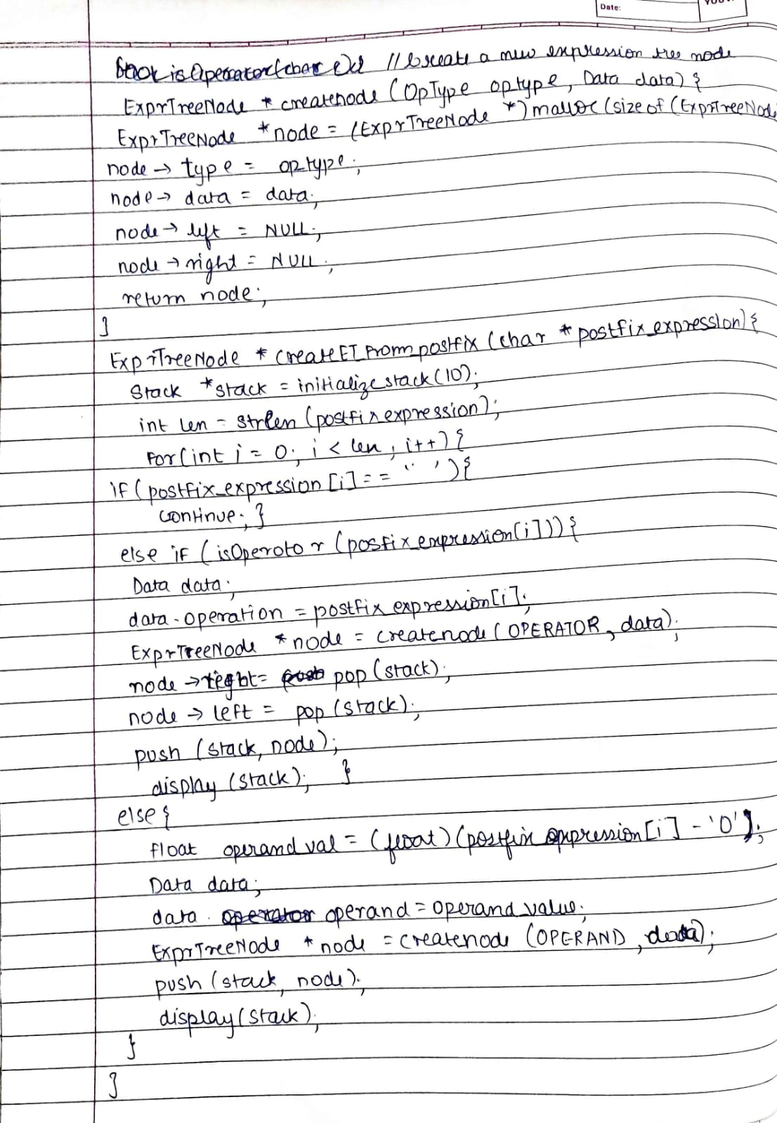
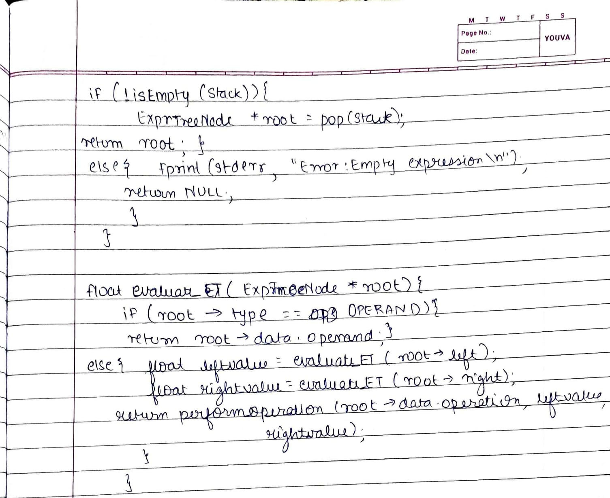
- Code
#include <stdio.h>
#include <stdlib.h>
#include <stdbool.h>
#include <string.h>
#include "stack.c"

// Function to check if a character is an operator
bool isOperator(char c) {
return (c == '+' || c == '-' || c == '*' || c == '/');
}

// Function to perform an operation on 2 operands
float perform_operation(char op, float left, float right){
switch (op) {
case '+':
return left + right;
case '-':
return left - right;
case '*':
return left * right;
case '/':
if (right != 0) {
return left / right;
} else {
fprintf(stderr, "Error: Division by zero\n");
exit(EXIT_FAILURE);
}
default:
fprintf(stderr, "Error: Unknown operator %c\n", op);
exit(EXIT_FAILURE);
}
}

// Create a new expression tree node
ExprTreeNode *create_node(OpType op_type, Data data) {
ExprTreeNode *node = (ExprTreeNode *)malloc(sizeof(ExprTreeNode));
node->type = op_type;
node->data = data;
node->left = NULL;
node->right = NULL;
return node;
}

// Create an expression tree from a postfix expression
ExprTreeNode *create_ET_from_postfix(char *postfix_expression) {
Stack *stack = initialize_stack(10); // Adjust the size as needed

int len = strlen(postfix_expression);
for (int i = 0; i < len; i++) {
if (postfix_expression[i] == ' ') {
continue; // Skip spaces
} else if (isOperator(postfix_expression[i])) {
Data data;
data.operation = postfix_expression[i];
ExprTreeNode *node = create_node(OPERATOR, data);
node->right = pop(stack);
node->left = pop(stack);
push(stack, node);
display(stack);
} else {
// Assuming the operand is a single-digit
float operand_value = (float)(postfix_expression[i] - '0');
Data data;
data.operand = operand_value;
ExprTreeNode *node = create_node(OPERAND, data);
push(stack, node);
display(stack);
}
}

if (!isEmpty(stack)) {
ExprTreeNode *root = pop(stack);
return root;
} else {
fprintf(stderr, "Error: Empty expression\n");
return NULL;
}
}

// Evaluate the expression tree
float evaluate_ET(ExprTreeNode *root) {
if (root->type == OPERAND) {
return root->data.operand;
} else {
float left_value = evaluate_ET(root->left);
float right_value = evaluate_ET(root->right);
return perform_operation(root->data.operation, left_value, right_value);
}
}

- Test Cases

Passing an empty expr | 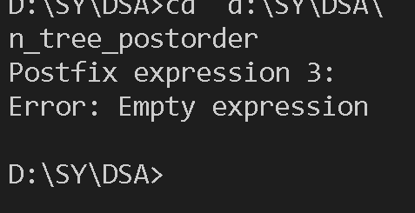
 | 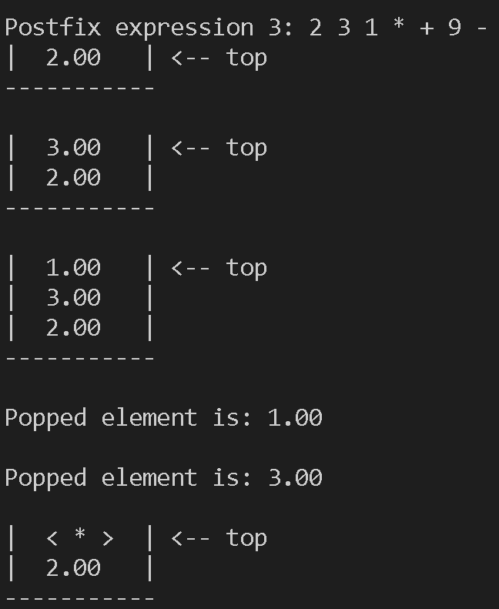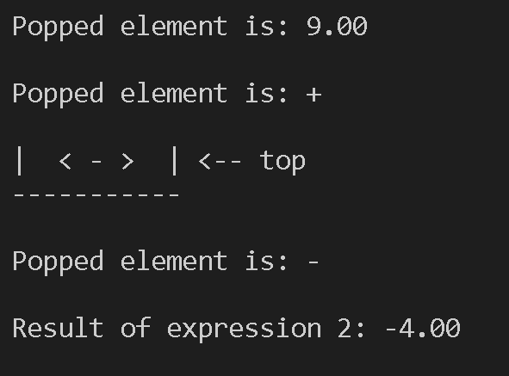

- Output

Expression 1: | 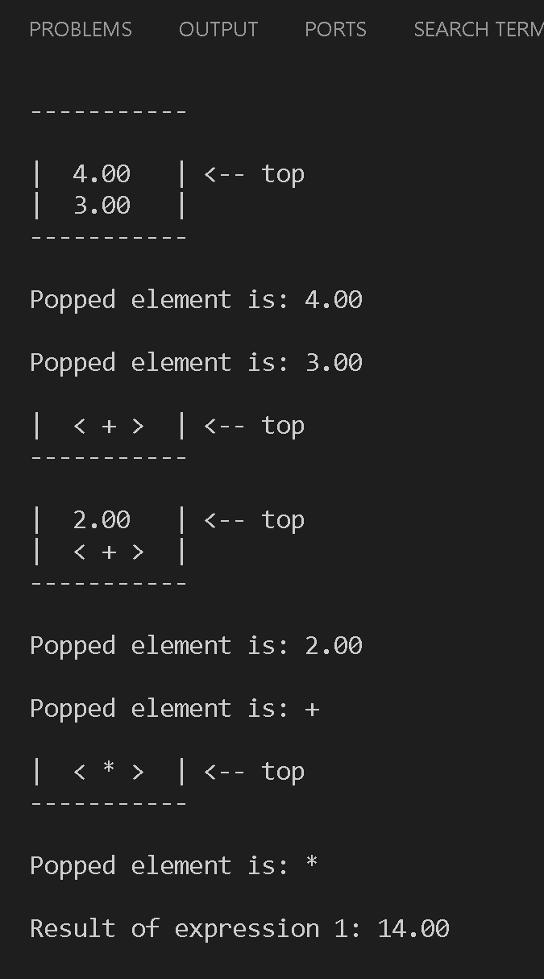
Expression 2: | 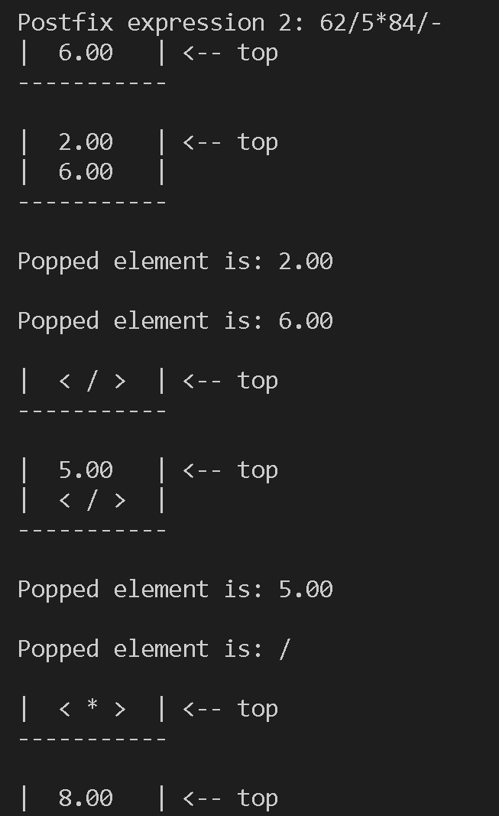  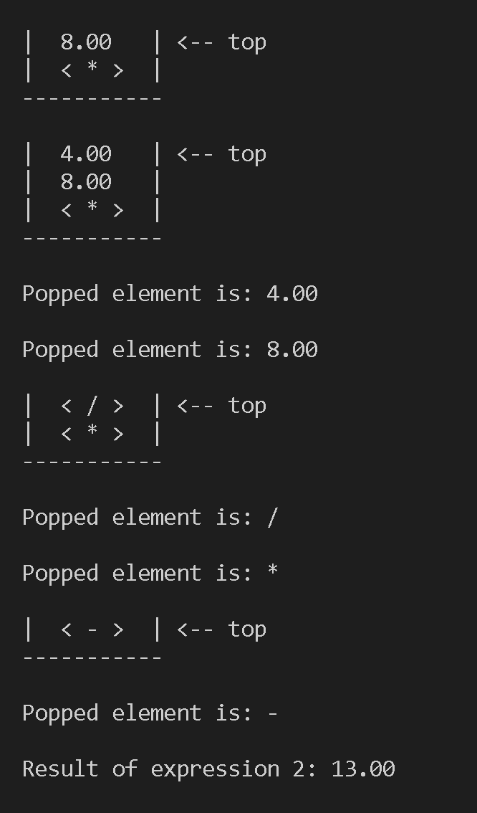
- Conclusion

Thus we have successfully created and evaluated an expression tree from a postfix expression.

