1. **INTRODUCTION**

In today's rapidly evolving healthcare landscape, efficient hospital logistics is pivotal for ensuring seamless operations and optimal productivity. An online hospital logistics system serves as a comprehensive solution that streamlines various administrative tasks and optimizes resource allocation. This system provides effective tools and features for managing hospital transport for staff and patients, along with overseeing the inventory and allocation of medical equipment.

**Essential Components of the "WeCare" Web Application:**

**Hospital Transport Handling:**

* Streamlining the scheduling and management of hospital transport for both staff and patients.
* Optimizing routes for emergency services and patient transfers.
* Providing real-time tracking and communication for efficient transport logistics.

**Medical Equipment Inventory Management:**

* Tracking and managing the inventory of medical equipment, ensuring availability when needed.
* Implementing automated alerts for equipment maintenance and reordering.
* Streamlining the allocation of equipment based on real-time demand.

**Billing and Invoicing:**

* Comprehensive billing module for automated invoice generation and insurance claim handling.
* Transparent financial transactions, reducing billing errors and improving financial management.
* Integration with accounting systems for seamless financial tracking.

**Real-time Analytics and Reporting:**

* Robust analytics tools for tracking key performance indicators and resource utilization.
* Real-time dashboards providing administrators with a comprehensive overview.
* Data-driven decision-making through insightful reports.

**Security and Compliance:**

* Prioritizing patient data security with robust encryption and access controls.
* Ensuring compliance with healthcare regulations for ethical and legal considerations.

As the "WeCare" project progresses, continuous updates and improvements can be implemented, incorporating emerging technologies and addressing evolving healthcare needs. The utilization of cloud services, including a chatbot, adds an additional layer of accessibility and convenience for both healthcare providers and patients. This holistic approach ensures that the online hospital logistics system remains adaptive, efficient, and aligned with the dynamic nature of healthcare delivery.

**1.1 Project Description**

System will consist of three users-

• Admin

• Logistic Providers

• Hospital Chains

**Admin**: The admin will manage the system, ensuring its security and integrity. Admin functions will include creating and maintaining user profiles,

granting appropriate access levels and permissions, and managing user roles

and responsibilities.

**Logistic Providers**: Shuttle and Ambulance rental companies and medical equipment buying and leasing local vendors will be logistic providers of the system.

**Hospital Chains**: These are the hospital chains and individual hospitals who will require these services in their hospital premises. They will use the system to rent ambulance, shuttles, and buy different medical equipment needed for their operations.

**1.2**  **Existing Systems**

Currently, several existing systems in the market offer rental solutions for various needs, and among them, Saamipya, Rentickle, and Furlenco stand out as prominent players in the field of furniture and appliance rentals.

**Saamipya:**

* Saamipya, though reputable, may have room for improvement, particularly in terms of stock availability.
* The website, while serving healthcare professionals effectively, could enhance user experience by addressing minimal stock levels.

**Liberent:**

* Liberent is a rental platform that offers a diverse range of lifestyle products for short terms use.
* Specializing in providing cameras, gaming consoles, and other gadgets, Liberent allows users to access premium equipment without the need for ownership.

**Rentickle:**

* Rentickle focuses on offering furniture and home appliances for rent, catering to the residential and commercial segments.
* The platform provides curated packages for different needs, such as home furniture, office furniture, and appliances.
* Rentickle emphasizes quality and offers well-maintained items to ensure customer satisfaction.

**1.3 Objective**

The primary objective of the "WeCare" system is to enhance the overall efficiency, effectiveness, and patient care within the healthcare ecosystem by providing a comprehensive and integrated online hospital logistics solution. The system aims to streamline administrative tasks, optimize resource allocation, and leverage technology to improve various aspects of hospital operations.

**2. SYSTEM ANALYSIS AND REQUIREMENTS**

**2.1 Functional Requirements**

|  |  |  |
| --- | --- | --- |
| **ID** | **Requirement Name** | **Description** |
| FR1 | Dashboard Display | The system should provide a comprehensive dashboard displaying all details and updates related to medical equipment and ambulances. |
| FR2 | Hospital Info | Information about hospital partners should be available, including details about the hospitals utilizing the services. |
| FR3 | Detailed Analysis | The system should generate detailed reports on medical instruments and ambulance stocks, feedback, etc., represented through various charts for easy analysis. |
| FR4 | Rating System | Users should be able to provide feedback by rating the services. The system should support a rating system for user evaluations. |
| FR5 | Security | Strong security protocols should be implemented to protect user data and prevent unauthorized access to sensitive information. |
| FR6 | Notifications | The system should send out notifications whenever a service, such as an ambulance booking, is made, ensuring timely communication. |
| FR7 | User Registration | Hospital staff and other users should be able to register and log in to the system, allowing them to access relevant functionalities. |
| FR8 | Emergency Transport Management | Hospitals should have the ability to book ambulance transportation services efficiently through the system. |
| FR9 | Hospital Instrument Management | Hospitals should be able to order hygienic medical instruments through the system, streamlining the management of medical equipment. |
| C_FR10 | Admin Operations | Admin functionalities should include managing all details, as well as performing operations such as editing, adding, approving, and overseeing the system |

### 2.2 Non-functional Requirements:

|  |  |  |
| --- | --- | --- |
| **ID** | **Requirement Name** | **Description** |
| Security | * Data Security | Ensure the security of sensitive data, especially patient information and financial transactions. |
|  | * Access Control | Implement strong access control mechanisms to protect system integrity. |
| Performance | * Real-time Responsiveness | The system should respond in real-time to ensure efficient logistics handling. |
| Usability | * User-Friendly Interface | The user interface should be intuitive and user-friendly for all user types. |
| Reliability | * System Uptime | Ensure high system availability to minimize disruptions in hospital logistics operations. |
| Integration | * Third-party Integration | Support integration with external systems, such as accounting software. |
| Maintainability | · System Updates | Design the system to facilitate easy updates and maintenance. |

**Detailed Design**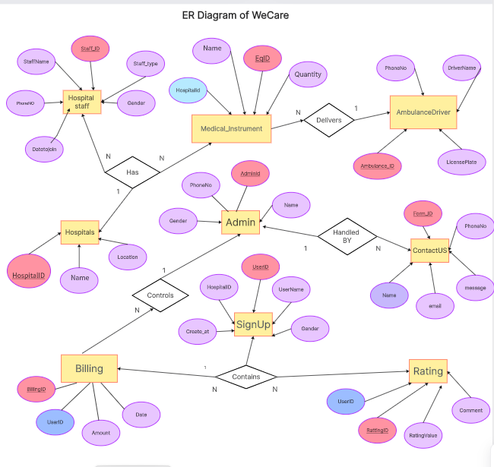

**DFD DIAGRAM**

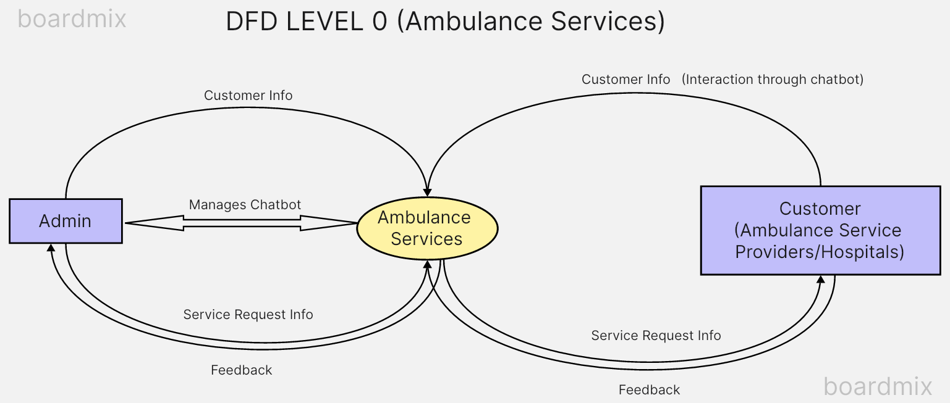

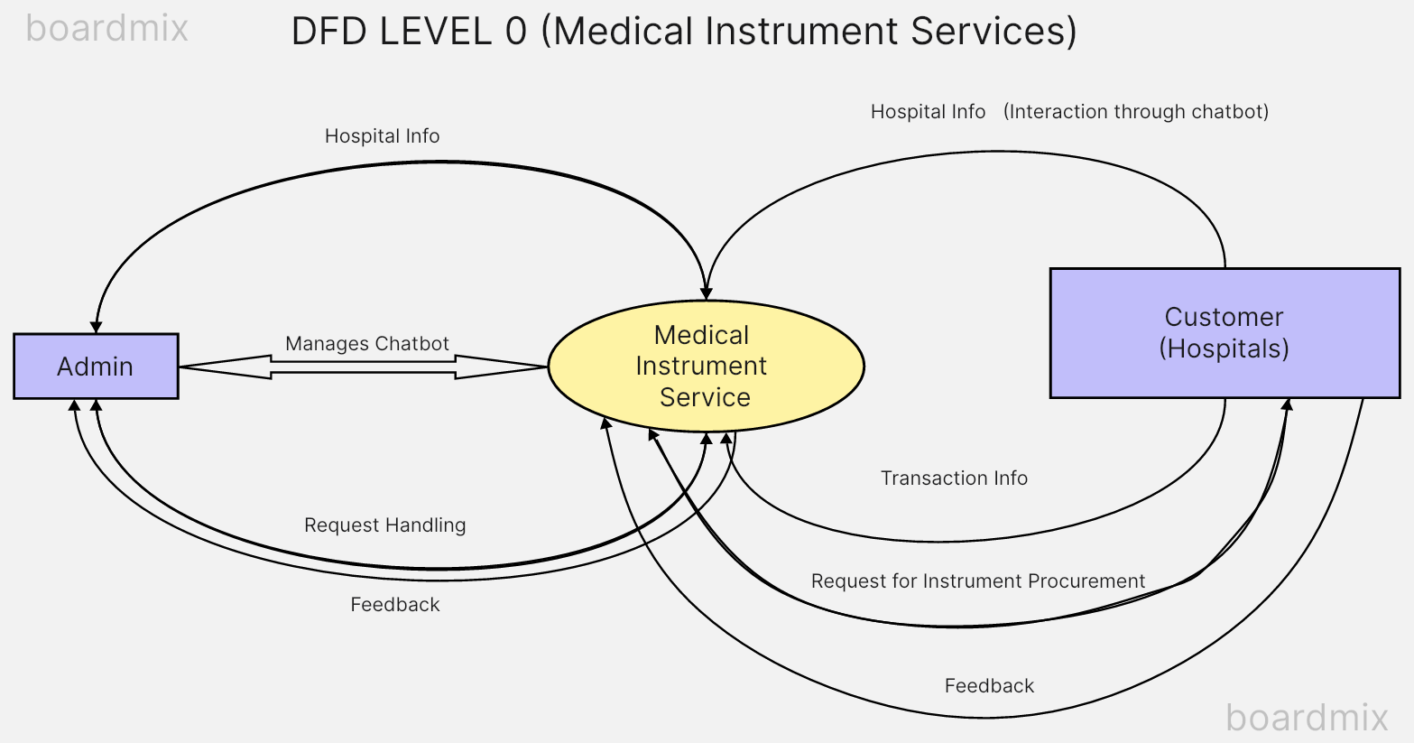

**DFD LEVEL 1**

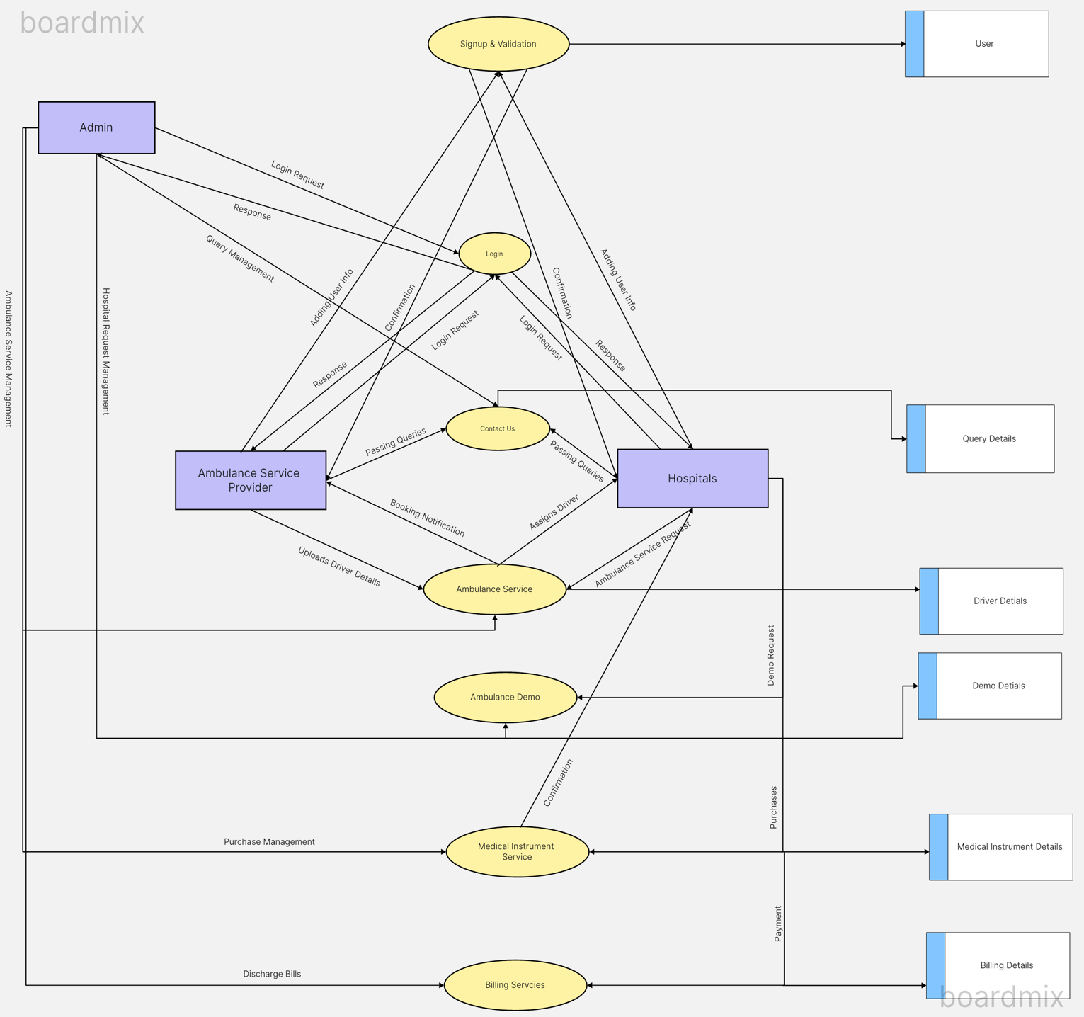

**Timeline Graph**

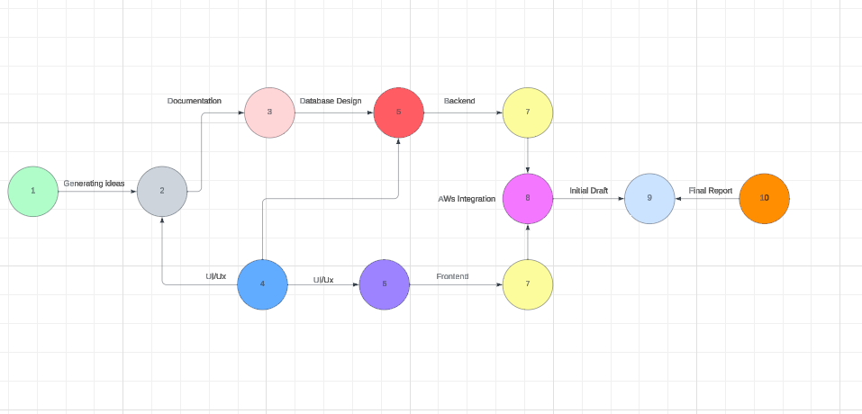

**THANK YOU**