

**PERSONAL PORTFOLIO WEBSITE**

**PRINCE TELLO MIRAS**

**BACHELOR OF SCIENCE IN INFORMATION SYSTEMS**

**2A**

**Submitted By : PRINCE TELLO MIRAS**

**Submitted To : Mrs. JEAN RICHEL LUARDO BAGON SANTANDER**

**Date : APRIL 14, 2025**

**TABLE OF CONTENTS**

Introduction……………………………………………………………………………1

Planning and Research…………………………………………………………………2

Design and Development Process……………………………………………………...3

Content Development………………………………………………………………….4

Testing and Debugging…………………………………………………………………5

Deployment and Maintenance…………………………………………………………..6

Challenges and Solutions………………………………………………………………..7

Conclusion and Reflection………………………………………………………………8

References……………………………………………………………………………….9

Appendices……………………………………………………………………………..10

## **Introduction**

**Project Overview**

Welcome to my personal portfolio website. This platform showcases who I am, my hobbies, and some of the things I enjoy. It includes sections like the homepage, about me, hobbies, gallery, and contact information. Through this website, I aim to share my interests and allow others to connect with me easily in one organized space.

**Target Audience**

* Potential employers and clients in need of web development or creative services.
* Peers and collaborators who wish to view my work or get in touch.

**Scope**

This portfolio website focuses on showcasing key sections that reflect my personal background and interests. The scope of the project includes the following main pages: Home, About, Hobbies, Gallery, and Contact. Each page is designed to provide specific content and functionality that contributes to the overall purpose of the website.

* **Home:** Brief introduction about **PrincePortfolio**, A landing page with a short intro and quick navigation access.
* **About:** A personal narrative detailing **PrincePortfolio**,Includes my background, education, and personal story.
* **Hobbies:** A fun section to share personal interests.
* **Gallery:** Visual showcase of projects or personal images.
* **Contact:** Simple contact form for potential clients to reach out. Client or viewers messages and feedback are sent easily or a dedicated page.

**Planning and Research**

The goal of my portfolio is to introduce myself, share my hobbies, showcase my photos, and provide a way to connect with me through a simple and creative website.

**Problem Statement:**

In today’s digital world, many individuals lack a personal space online to present themselves creatively and professionally. Without a portfolio, it becomes difficult to share personal interests, achievements, and contact information in one organized platform. This project addresses that gap by creating a personal website that highlights who I am, what I enjoy, and how others can reach me.

**Competitor Analysis:**

| **Competitor** | **Strengths** | **Weakness** | **What I Learned** |
| --- | --- | --- | --- |
| Personal Portfolios | Clear personal introduction | Limited interactive content | Importance of engaging intro |
| Hobby Websites | Detailed hobby displays | Poor navigation | Use simple, organized layout |
| | Photo Galleries | | --- |  |  | | --- | | Visual appeal and creativity | Slow loading images | Optimize images for speed |
| | Contact Pages | | --- |  |  | | --- | | Easy communication options | Overcomplicated forms | Keep contact forms simple |

**Sitemap**

The sitemap outlines the structure of my portfolio website, organizing content into clear, easy-to-navigate sections. It ensures visitors can quickly access key pages like the Homepage, About, Hobbies, Gallery, and Contact. This logical layout improves user experience and helps 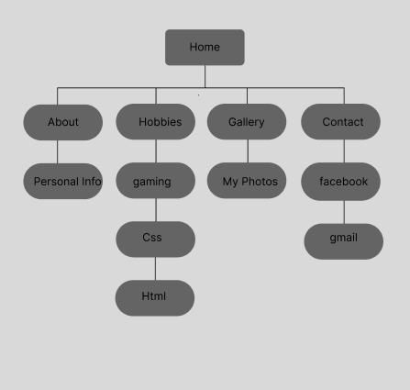showcase my personal and professional identity effectively.

**Wireframes**

The wireframe provides a clear visual guide for the layout and structure of my portfolio website. It outlines the placement of key content and interactive elements across different pages, ensuring a balanced and user-friendly design. By mapping out sections like the Home, About, Hobbies, Gallery, and Contact, the wireframe helps create a cohesive flow that enhances navigation and highlights important information effectively.

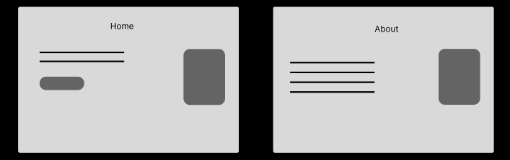

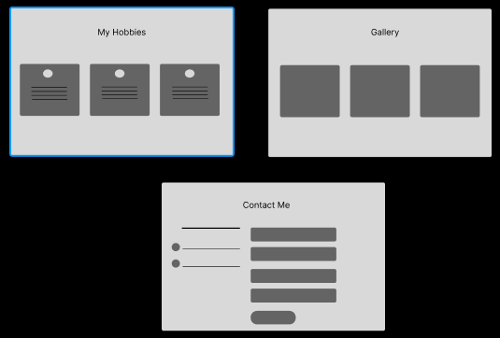

**Design and Development Process**

**A.** **UI/UX Design**

**Color Scheme:**

* **Primary Colors:**
  + Blue, White, and Gray are used for the background and layout, giving the site a clean, professional, and calming look.
* **Text Colors:**
  + Black is used for body text to ensure readability.
  + Blue is used for highlights, links, or headings to maintain visual consistency with the them

**Typography:**

* **Headings**:  
   Use a bold, slightly futuristic sans-serif font to catch attention and reflect a modern style suitable for a personal portfolio.
* **Body Text**:  
   A clean, simple sans-serif font like Arial or Open Sans is used to ensure readability and accessibility.

Branding Choices:

* The use of modern fonts, consistent colors, and minimalistic layout reinforces reliability and creativity.
* The design choices help present who I am effectively to potential clients or employers while differentiating my portfolio from generic templates.

**Accessibility Considerations:** In my personal portfolio website, Icreate a more inclusive experience for all users. I make a design with key accessibility principles in my mind, including semantic elements, contrast, smooth keyboard navigation and structured layout.

● **Screenshot of design mockups (Figma).**

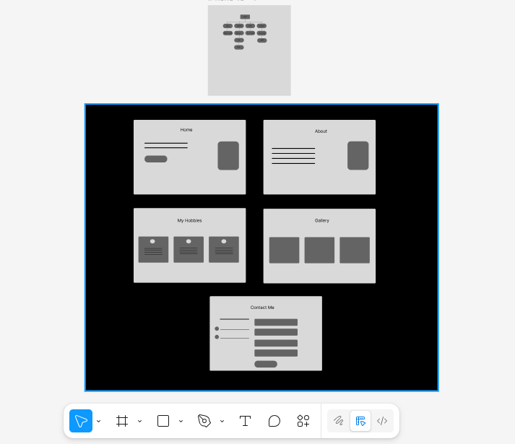

**● Code snippets/screenshots (this code is under development or constructing/Not yet done).**

**HTML Code (Unde Development/Not yet done):**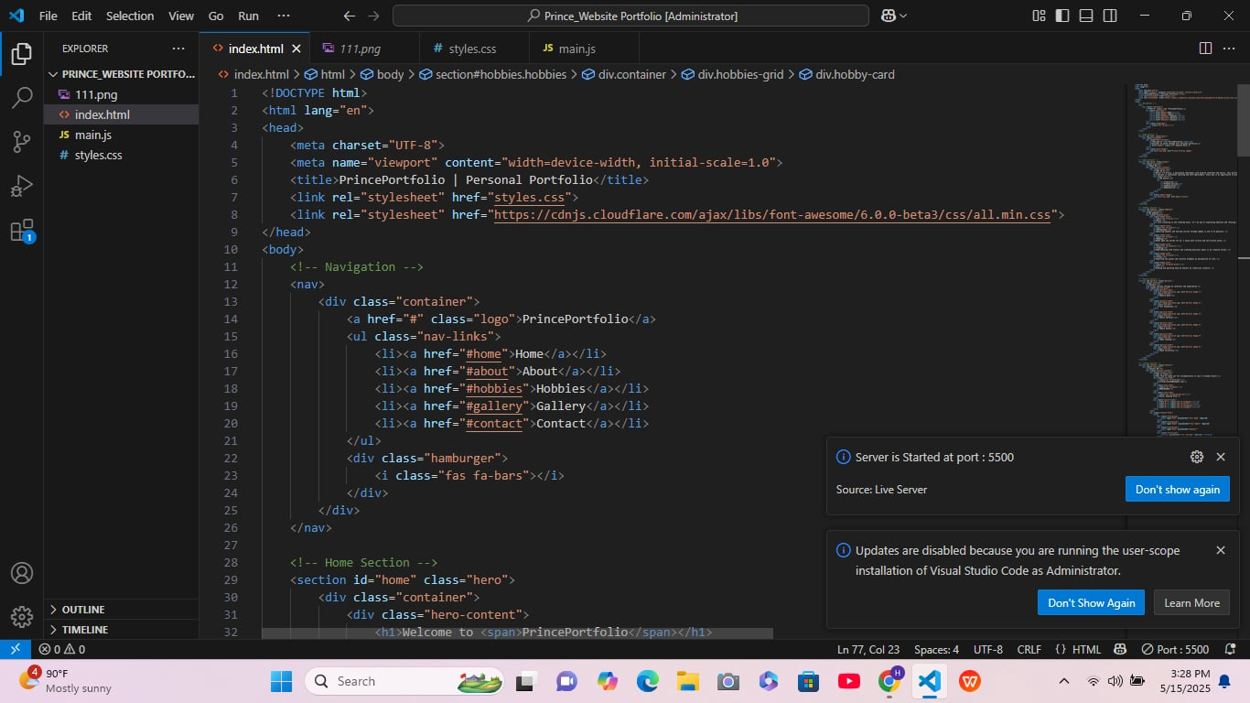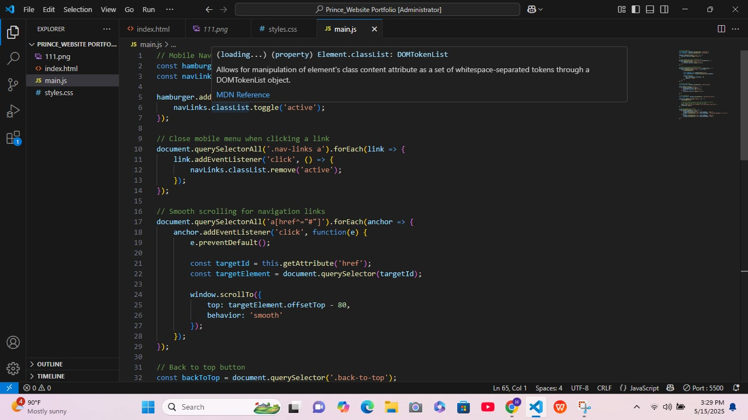

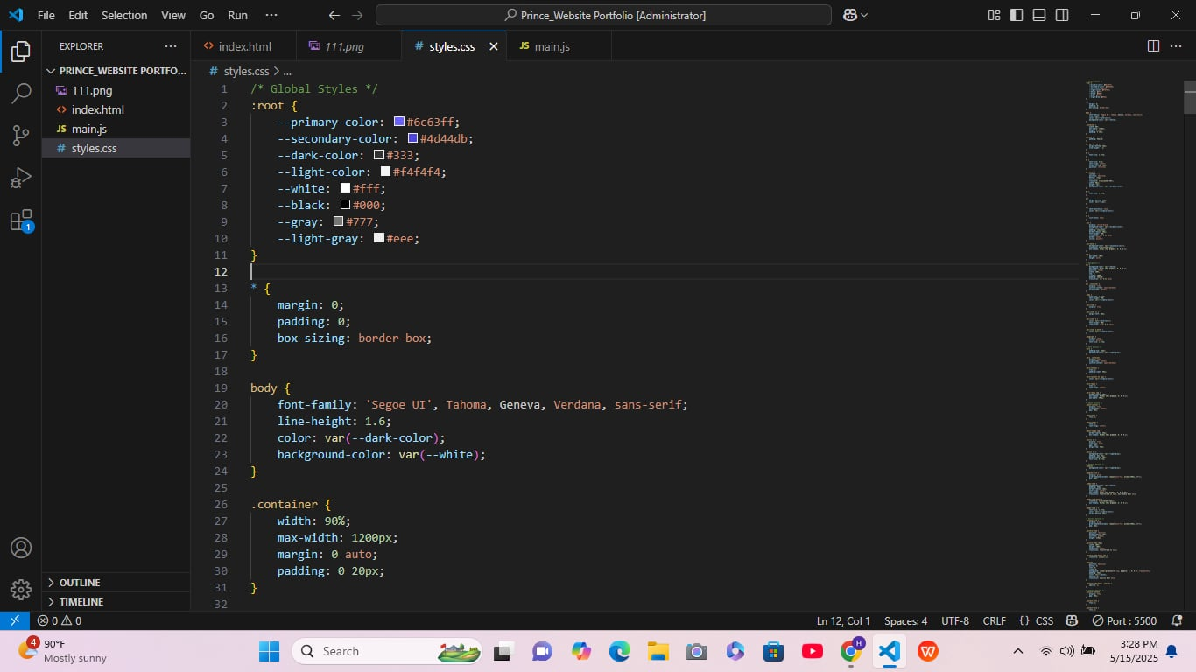

**Content Development**

### 

* Written Content:  
   Each page contains concise and meaningful text that introduces who I am (Homepage), shares my background (About), highlights my interests (Hobbies), displays visuals (Gallery), and offers a way to connect with me (Contact).
* Multimedia Elements:  
   High-quality images are used in the Gallery and Hobbies pages to visually represent my personality and skills. Icons and styled sections improve visual appeal across the site.
* Interactive Elements:  
   The Contact form allows users to send messages directly. Smooth scrolling and hover effects enhance engagement and user interaction throughout the site.
* **SEO Practices**
* I make sure each page on my website has a clear and descriptive title and meta description. This helps search engines show my site better in search results. I organize my content using headings like H1 and H2 to make it easy to read and help search engines understand the structure of my site.
* I also optimize images by giving them meaningful file names and adding alt text, which helps with both SEO and accessibility. To improve user experience, I make sure my website loads fast and works well on all devices, especially mobile phones.
* Finally, I use clean and simple HTML code so search engines can easily understand my site.

**Testing and Debugging**

Thorough testing and debugging were conducted throughout the development of **PrincePortfolio** to ensure a smooth, responsive, and bug-free user experience. The following testing phases were implemented:

Functional Testing

Functional testing was performed to ensure that all website elements work as expected.

| **Feature** | **Test Description** | **Result** |
| --- | --- | --- |
| Navigation Links | Tested links between Home, About, Hobbies, Gallery, and Contact pages | Working |
| Image Display | Verified that images load correctly in the Gallery section | Working |
| Contact Links | Tested links to email and social media platforms | Working |
| Buttons and Hover Effects | Checked visual responses on interaction | Working |

Compatibility Testing

The website was tested on various devices and browsers to ensure it performs well in different environments.

| **Platform** | **Device Type** | **Browser** | **Result** |
| --- | --- | --- | --- |
| Windows 10 | Laptop | Chrome, Edge, Firefox | Compatible |
| Android | Phone | Chrome | Compatible |
| iOS | Phone | Safari | Compatible |
| macOS | Desktop | Safari, Chrome | Compatible |

Performance Testing

Key performance aspects of the website were reviewed to guarantee a fast and efficient experience.

| **Test Type** | **Tool/Method** | **Outcome** |
| --- | --- | --- |
| Load Speed | Manual timing & PageSpeed Insights | Loads in under 2 seconds |
| Image Optimization | Checked image sizes and formats | Optimized images used |
| Code Efficiency | Removed unused CSS/JS, minified files | Optimized for faster performance |

Security Testing

Although the website is static, basic precautions were taken to avoid vulnerabilities.

| **Test** | **Description** | **Result** |
| --- | --- | --- |
| HTTPS | Checked for secure protocol | Secure |
| Link Validity | Checked for broken links or external redirects | All links valid |
| Form Behavior | Verified safe and controlled user input handling | Safe (No user input fields yet) |

Debugging Process

The debugging process included:

* **Browser DevTools**: Used to inspect and correct HTML/CSS/JS errors.
* **Responsive Design Mode**: Tested responsiveness across breakpoints.
* **Console Logs**: Applied in JavaScript to trace and resolve behavior issues.
* **Validation Tools**: HTML and CSS validators used to detect markup issues.

**Deployment and Maintenance**

**Deployment and maintenance** are crucial stages in the website development lifecycle. After building **PrincePortfolio**, it was deployed online to make it accessible to users, and a maintenance plan was created to ensure the website remains functional, updated, and secure over time. These steps help keep the site professional, reliable, and aligned with future goals.

**Hosting Details**

* **Hosting Platform**: GitHub Pages
* **Domain**: The website is currently hosted on GitHub using a default GitHub Pages domain (e.g., https://username.github.io/PrincePortfolio/).
* **Server**: GitHub's static site hosting server

GitHub Pages was chosen due to its simplicity, free hosting for static websites, and easy integration with version control using Git.

**Deployment Process**

1. **Development Completion**: After completing the design and front-end development in Visual Studio Code (VS Code), the project was thoroughly tested.
2. **Version Control**: The project was managed using Git and pushed to a remote GitHub repository.
3. **GitHub Pages Configuration**:  
   * The repository was set to publish from the main branch.
   * The root directory was selected for deployment.
4. **Live Preview**: GitHub Pages automatically generated a live version of the website accessible via its URL.
5. **Verification**: After deployment, the website was tested again to ensure everything displayed and functioned correctly online.

**Future Improvements**

To keep the site up-to-date and improve user engagement, the following future enhancements are planned:

* **Add a Back-End Contact Form**: Implement a back-end script (e.g., using PHP or a service like Formspree) to enable real-time message handling.
* **Project Expansion**: Add more projects to the Gallery section as new work is completed.
* **Performance Optimization**: Further optimize images and scripts as the website grows.
* **Domain Name Purchase**: Acquire a custom domain name for better branding and SEO.
* **Analytics Integration**: Use tools like Google Analytics to track user interactions and improve site content.

**Maintenance Plan**

* **Content Updates**: Periodically update content in the About, Hobbies, and Gallery sections.
* **Link Verification**: Check social media and contact links monthly to ensure they're still valid.
* **Code Review**: Perform quarterly code cleanups to maintain performance and security.
* **Backup**: The GitHub repository serves as a version-controlled backup of all site files.

**Challenges and Solutions**

Creating **PrincePortfolio** involved several stages of design, coding, and testing, which naturally came with challenges. Each problem was addressed with research, patience, and practical solutions that helped improve the overall quality of the website.

**Challenge 1: Responsive Design**

* Problem: The layout did not look right on smaller screens like mobile phones and tablets.
* Solution: Media queries were added in the CSS, and Flexbox/Grid was used to make the layout adjust properly on different screen sizes.

**Challenge 2: Navigation Link Errors**

* Problem: Some navigation links were not working or leading to the wrong sections.
* Solution: Double-checked the href attributes and made sure all internal links pointed to the correct IDs or pages. Fixed broken or misspelled paths.

**Challenge 3: Image Sizing in the Gallery**

* Problem: Images in the Gallery were either stretched or not aligned properly.
* Solution: Used consistent image dimensions and CSS properties like object-fit: cover to ensure a uniform and clean display.

**Challenge 4: Initial Deployment Confusion**

* Problem: The website didn't appear correctly after the first GitHub Pages deployment.
* Solution: Reviewed the repository settings and made sure files were in the correct branch and folder structure. Cleared browser cache and re-uploaded changes.

**Challenge 5: Visual Consistency**

* Problem: Different font sizes and colors made the site look unbalanced.
* Solution: Standardized the use of typography, colors, and spacing across all pages using a consistent CSS style guide.

**Conclusion and Reflection**

**Conclusion**

**PrincePortfolio** successfully achieved its main goal: to serve as a clean, organized, and responsive personal website. It presents essential information about the developer — including personal background, hobbies, gallery of images, and contact links — in a professional and visually appealing way. The website is accessible, user-friendly, and functions well on multiple devices and browsers.

**Reflection**

Throughout this project, I developed a deeper understanding of front-end web development, particularly in structuring responsive layouts and solving design issues. I also gained experience in using GitHub for version control and deployment. One of the most valuable lessons was learning how to debug problems and ensure consistent performance across devices. This project strengthened my creativity, technical skills, and attention to detail — all of which are essential in becoming a better web developer.

Moving forward, I am motivated to enhance PrincePortfolio by adding more features, such as a back-end contact form or project showcase, and to keep improving the design and content based on user feedback.

**References:**

**Pro Coder. (2024a, July 22). *Create a portfolio website using HTML and CSS only – easy tutorial* [Video]. YouTube.** [**https://youtu.be/-u3vE84Wo_U?si=10hIeA5aNqOjzfd3**](https://youtu.be/-u3vE84Wo_U?si=10hIeA5aNqOjzfd3)

**Pro Coder. (2024b, August 22). *Create a responsive portfolio website using HTML, CSS, and JS – easy tutorial* [Video]. YouTube.** [**https://youtu.be/Ap7CjB-dVqE?si=XKnjReXt96pu2ZFE**](https://youtu.be/Ap7CjB-dVqE?si=XKnjReXt96pu2ZFE)

**Figma. (n.d.). *Figma: The collaborative interface design tool.*** [**https://www.figma.com/**](https://www.figma.com/)

**W3Schools. (n.d.). *HTML Tutorial.*** [**https://www.w3schools.com/html/default.asp**](https://www.w3schools.com/html/default.asp)

**W3Schools. (n.d.). *CSS Tutorial*. https://www.w3schools.com/css/default.asp**