AuthentiScan: PSO-Optimized Hybrid Feature Fusion for AI-Generated Instagram Caption Detection
Divisha Varma Balaraju
Independent Researcher
divishabalaraju@gmail.com
Abstract
The proliferation of AI-generated content on social media platforms presents new challenges for authenticity verification and platform integrity. Existing AI text detection systems are predominantly designed for long-form content such as academic papers and news articles, performing poorly on short-form social media text where context is limited and linguistic style is highly informal. This paper presents AuthentiScan, a hybrid detection system specifically designed for Instagram captions, a domain characterized by informal language, emoji use, hashtags, and text typically under 150 words. We propose a three-component feature fusion approach combining TF-IDF statistical features, Sentence-BERT (SBERT) semantic embeddings, and handcrafted linguistic indicators including emoji frequency, em dash usage, and AI-associated vocabulary patterns. Fusion weights are optimized via Particle Swarm Optimization (PSO), enabling the model to learn the optimal contribution of each feature type rather than relying on equal-weight concatenation. Evaluated on a purpose-built, balanced dataset of 1,580 captions sourced from real Instagram posts and four AI systems (ChatGPT, Gemini, Microsoft Copilot, and Perplexity AI), our system achieves 97.47% binary classification accuracy, a 2.22 percentage point improvement over the unweighted baseline. A secondary AI source attribution experiment achieves 90.58% accuracy in identifying which AI system generated a given caption. An ablation study reveals that TF-IDF vocabulary features dominate classification performance, while SBERT provides complementary semantic signal and handcrafted features prove redundant given richer feature representations.
Keywords: AI-generated text detection, short-form NLP, Instagram captions, Particle Swarm Optimization, SBERT, TF-IDF, hybrid feature fusion, social media authenticity, LLM detection

I. INTRODUCTION
The rapid advancement of large language models (LLMs) such as GPT-4, Gemini, and Claude has made AI-generated text increasingly indistinguishable from human writing [3]. On social media platforms, this capability is being leveraged at scale for brand marketing, automated content farms, engagement manipulation, and coordinated influence operations, raising fundamental questions about the authenticity of user-generated content.
Instagram, with over two billion monthly active users, relies heavily on the perceived authenticity of personal captions to drive engagement, community trust, and commercial value. Unlike long-form platforms, Instagram captions are short, informal, and stylistically diverse, making them a particularly challenging domain for automated AI detection. Current AI text detectors such as GPTZero, Turnitin, and DetectGPT are optimized for academic prose, typically requiring hundreds of words to function reliably. These systems fail systematically on text under 150 words, leaving a significant and largely unexplored gap in the detection landscape.
This paper addresses the gap between long-form AI detection and short-form social media content. We make the following contributions:
- A purpose-built, publicly available dataset of 1,580 balanced Instagram captions, comprising 790 human-written and 790 AI-generated samples from four distinct systems, released on Kaggle under CC0 license.
- A hybrid feature fusion architecture with PSO-optimized weights combining TF-IDF, SBERT, and handcrafted linguistic indicators.
- A secondary AI source attribution experiment achieving 90.58% accuracy identifying the generating AI system.
- An ablation study demonstrating the relative contribution of each feature component under free and constrained PSO optimization.
II. MOTIVATION
The necessity for automated detection of AI-generated social media content stems from several converging concerns. User-generated content on platforms such as Instagram operates under an implicit assumption of human authorship, and this expectation forms the basis of engagement, trust, and commercial value. The
deployment of AI-generated captions at scale, whether through automated accounts, coordinated inauthentic behavior, or undisclosed AI-assisted content creation, has the potential to distort engagement metrics, manufacture artificial social proof, and erode platform integrity. Beyond these platform-level concerns, the capacity to detect and attribute AI-generated short-form text provides researchers with tools to empirically study the growing influence of generative AI on informal digital communication. It further enables practical applications in influencer marketing verification, forensic content analysis, and the development of transparency standards for AI-assisted publishing. AuthentiScan is motivated by these needs and is designed explicitly as an analytical instrument rather than a punitive one, recognizing that AI assistance in content creation is not inherently problematic but that its detection, when warranted, requires purpose-built methodology.
III. RELATED WORK
The necessity for automated detection of AI-generated social media content stems from several converging concerns. User-generated content on platforms such as Instagram operates under an implicit assumption of human authorship, and this expectation forms the basis of engagement, trust, and commercial value. The deployment of AI-generated captions at scale, whether through automated accounts, coordinated inauthentic behavior, or undisclosed AI-assisted content creation, has the potential to distort engagement metrics, manufacture artificial social proof, and erode platform integrity. Beyond these platform-level concerns, the capacity to detect and attribute AI-generated short-form text provides researchers with tools to empirically study the growing influence of generative AI on informal digital communication. It further enables practical applications in influencer marketing verification, forensic content analysis, and the development of transparency standards for AI-assisted publishing. AuthentiScan is motivated by these needs and is designed explicitly as an analytical instrument rather than a punitive one, recognizing that AI assistance in content creation is not inherently problematic but that its detection, when warranted, requires purpose-built methodology.
A. AI-Generated Text Detection
Early approaches to AI-generated text detection relied on statistical perplexity metrics derived from language model probability distributions [3]. Gehrmann et al. [4] proposed GLTR, which visualizes token rank distributions to identify AI-generated text. While effective for GPT-2-era outputs, such methods require white-box model access and degrade on newer LLMs. Transformer-based detectors such as RoBERTa fine-tuned on GPT-generated news [5] show strong performance in controlled settings. Mitchell et al. (2023) introduced DetectGPT [9], exploiting log-probability curvature. However, all these approaches target long-form text and transfer poorly to informal short-form content.
B. Short-Form and Social Media Text
Short-form text presents unique challenges due to limited context, high linguistic variability, and non-standard grammar. Eisenstein [6] characterized social media language as a distinct register requiring specialized modeling. Despite this, the AI detection literature has largely ignored short-form domains. Survey work confirms that most benchmark datasets average over 150 words per sample, with the shortest commonly used dataset (HC3) averaging 163.9 words, still exceeding the typical Instagram caption by a factor of eight [13].
C. Metaheuristic Optimization in NLP
PSO, introduced by Kennedy and Eberhart [1], is a population-based metaheuristic inspired by bird flocking behavior. In NLP, PSO has been applied to feature selection, hyperparameter tuning, and ensemble weight optimization. Wang et al. [7] demonstrated PSO-based feature weighting for text classification, achieving statistically significant improvements over uniform combination. Our work extends this paradigm to heterogeneous feature fusion for AI-generated text detection, a novel application of PSO in this domain.
D. Sentence-BERT Embeddings
Reimers and Gurevych [2] introduced SBERT, modifying the BERT architecture with Siamese and triplet network structures to produce semantically meaningful fixed-size sentence embeddings through contrastive learning. Unlike vanilla BERT, which requires cross-encoding sentence pairs, SBERT produces independent sentence-level representations computationally suitable for classification tasks. The all-MiniLM-L6-v2 variant used in this work produces 384-dimensional embeddings with strong performance on semantic similarity benchmarks while maintaining computational efficiency, making it particularly advantageous for short-form text where full BERT encoding provides limited benefit.
IV. DATASET CONSTRUCTION
A. Human Caption Collection
Human captions were manually collected from publicly accessible Instagram profiles across six thematic categories: travel, food, fitness, lifestyle, motivation, and fashion. Collection prioritized authentic personal posts over brand accounts to ensure the data reflects genuine human expression patterns. Accounts were selected for diversity in posting style, follower count, and geographic origin to avoid demographic bias. A total of 850 raw captions were collected, yielding 790 samples after preprocessing and deduplication.
B. AI Caption Generation
AI captions were generated using four commercially available systems: OpenAI ChatGPT, Google Gemini, Microsoft Copilot, and Perplexity AI. To simulate realistic user behavior, captions were generated with explicit length constraints ranging from 10 to 60 words, reflecting how users typically prompt AI tools for social media content generation. This methodology is intentionally representative of real-world usage, as unconstrained AI generation typically produces captions of only 5 to 8 words, which does not reflect practical deployment. Prompts specified topical themes matching the human caption categories to ensure comparable content distribution. Table I shows the source distribution.

TABLE I: AI Caption Source Distribution
AI System | Raw | Post-balance
ChatGPT | 283 | 245
Gemini | 222 | 218
Copilot | 150 | 138
Perplexity | 92 | 87
Total | 747 | 688 → 790

C. Preprocessing and Balancing
All captions underwent standard preprocessing: lowercasing for TF-IDF computation, URL removal, mention stripping, and whitespace normalization. Emoji and punctuation were preserved as discriminative classification signals. Captions under five words were removed. The final dataset was balanced to exactly 790 samples per class (1,580 total) using stratified random sampling, then shuffled. The dataset is publicly available on Kaggle under CC0 license [10].
D. Exploratory Data Analysis
Fig. 1 presents six diagnostic charts from our exploratory analysis. The class distribution confirms perfect 50-50 balance. Word count distributions reveal that human captions exhibit substantially higher variance (std = 19.32) compared to AI captions (std = 12.72), indicating AI models produce more length-consistent output even under varied prompting constraints. Emoji usage shows strong class separation: 184 human captions contain emoji versus near-zero for AI. Em dash usage shows the inverse pattern: AI captions contain significantly more em dashes (129 instances) than human captions (fewer than 30), consistent with known LLM stylistic tendencies. Buzzword usage also shows clear AI-human divergence.

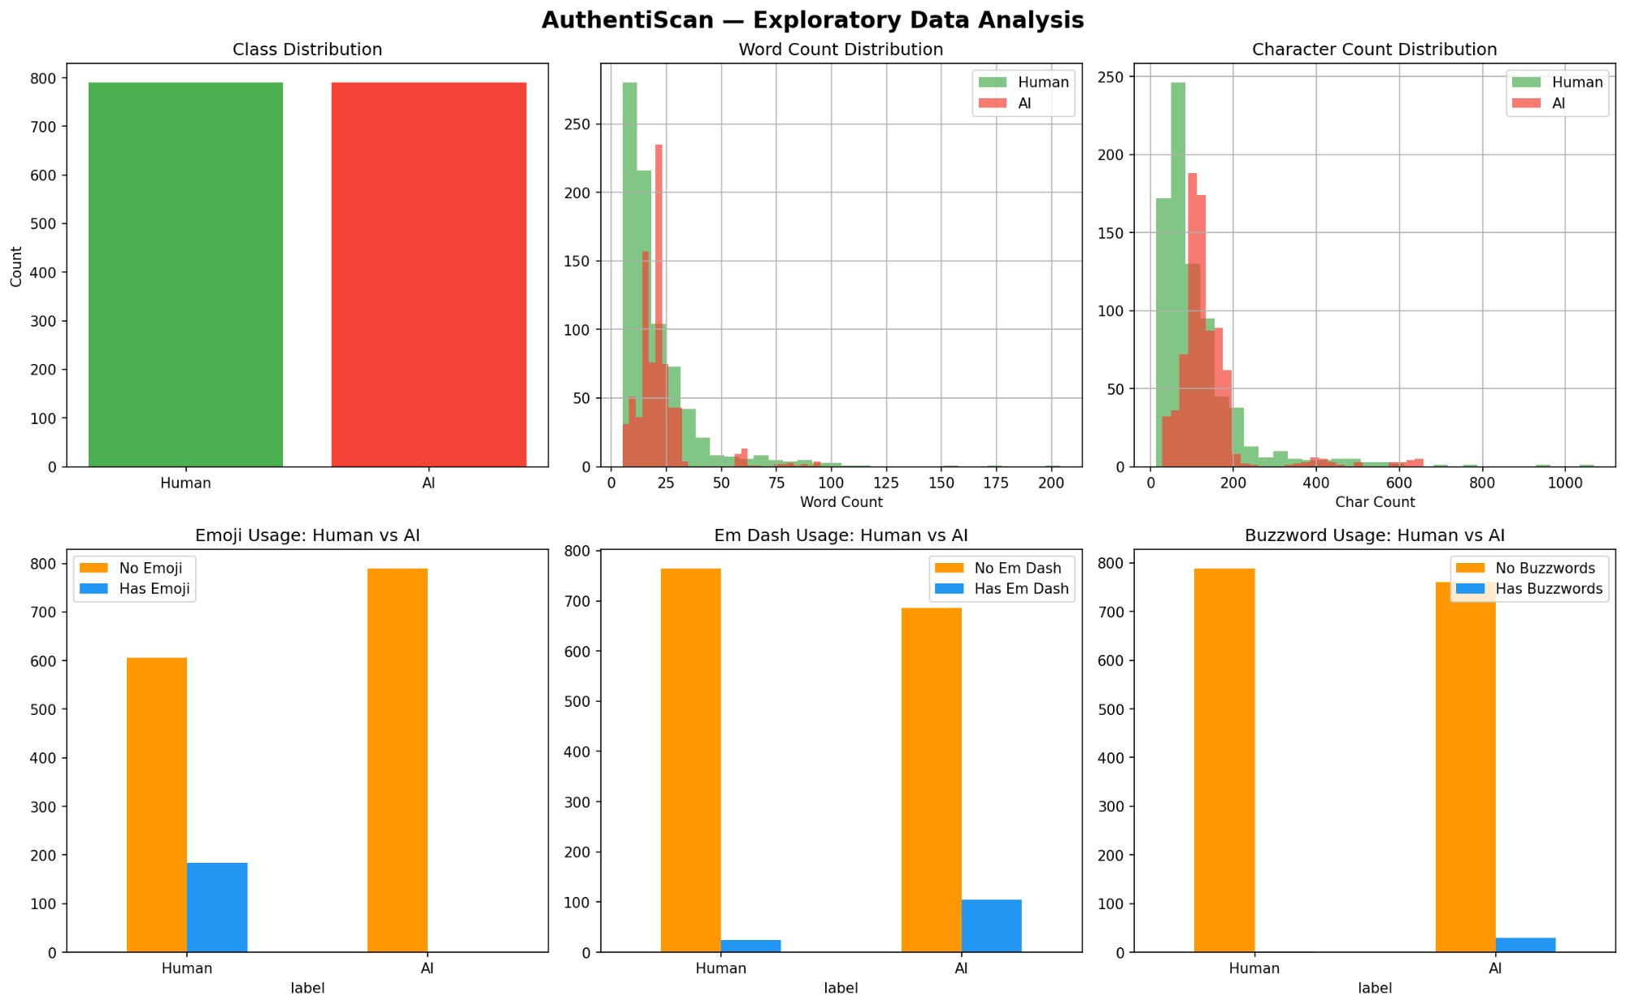
Fig. 1. Exploratory Data Analysis: class distribution, word/character count distributions, and linguistic indicator comparisons (emoji, em dash, buzzwords) between human and AI captions.

V. METHODOLOGY
A. Feature Extraction Pipeline
TF-IDF Features. A TF-IDF vectorizer with a vocabulary ceiling of 5,000 features and bigram range (1,2) was applied to cleaned caption text. The minimum document frequency was set to 2 to filter noise. This component captures vocabulary-level patterns at both unigram and bigram granularity, including characteristic AI lexicon (formal adjectives, structured phrasing) and human colloquialisms (contractions, slang, exclamatory language). The resulting feature matrix has dimensionality 1,580 × 5,000.
SBERT Embeddings. Sentence-level embeddings of dimensionality 384 were generated using the all-MiniLM-L6-v2 SBERT model [2]. Unlike token-level representations, SBERT produces fixed-size sentence embeddings capturing holistic semantic and stylistic patterns at the caption level. This is particularly appropriate for short-form text where individual token statistics are insufficient to characterize writing style.
Handcrafted Linguistic Indicators. Seven binary and numeric features were extracted: word count, character count, emoji presence, em dash presence (— or –), ellipsis presence (...), whether the caption begins with a known AI-associated verb (e.g., 'embrace', 'discover', 'explore'), and presence of AI-associated buzzwords (e.g., 'utilize', 'tapestry', 'nuanced', 'vibrant', 'seamless'). These features encode linguistic signals identified during EDA as discriminative.
B. PSO-Optimized Feature Fusion
Rather than concatenating feature vectors with equal weighting, PSO learns optimal scalar weights for each feature component. The combined weighted feature matrix is defined as:
X = w₁·F₁ ⊕ w₂·F₂ ⊕ w₃·F₃
where F₁ denotes TF-IDF features, F₂ denotes SBERT embeddings, and F₃ denotes handcrafted features. The scalar weights w₁, w₂, w₃ ∈ [0, 2] are optimized by PSO minimizing classification error with swarm size 20 over 30 iterations. PSO's global search mechanism avoids local optima that gradient-based optimization would risk given non-convex interactions between heterogeneous sparse and dense feature spaces.
C. Classifier and Evaluation Protocol
The primary classifier is Logistic Regression with L2 regularization (C=1.0, max_iter=1000), selected for interpretability and strong empirical performance on high-dimensional sparse matrices. Four baseline classifiers were evaluated: Logistic Regression, Random Forest (100 estimators), Linear SVM, and Gradient Boosting. All experiments used an 80/20 stratified train-test split (1,264 training / 316 test samples). For Phase 2 attribution, a multi-class Logistic Regression was trained exclusively on AI captions using the same PSO-optimized weights from Phase 1.
VI. EXPERIMENTS AND RESULTS
A. Baseline Model Comparison
Table II reports accuracy and F1 scores for all baseline classifiers on the unweighted combined feature matrix. Logistic Regression achieved the highest performance at 95.25% accuracy and was selected for PSO optimization.

TABLE II: Baseline Model Comparison
Model | Accuracy | F1
Logistic Regression | 95.25% | 95.33%
Linear SVM | 94.30% | 94.34%
Random Forest | 93.99% | 94.04%
Gradient Boosting | 93.99% | 94.01%

B. PSO Optimization Results
Following PSO optimization, the final model achieved 97.47% accuracy and 97.45% F1 score, representing improvements of 2.22 and 2.12 percentage points respectively over the unweighted baseline. Table III reports the optimized fusion weights.

TABLE III: PSO-Optimized Fusion Weights
Feature | Opt. Weight | Role
TF-IDF | 1.3277 | Primary signal
SBERT | 0.3116 | Complementary
Handcrafted | 0.0000 | Redundant

Fig. 2 presents side-by-side confusion matrices comparing baseline and PSO-optimized models. PSO improvement is concentrated in human caption classification: false positives (human predicted as AI) dropped from 10 to 3, a 70% reduction, while AI detection performance remained unchanged (5 misclassifications in both cases).

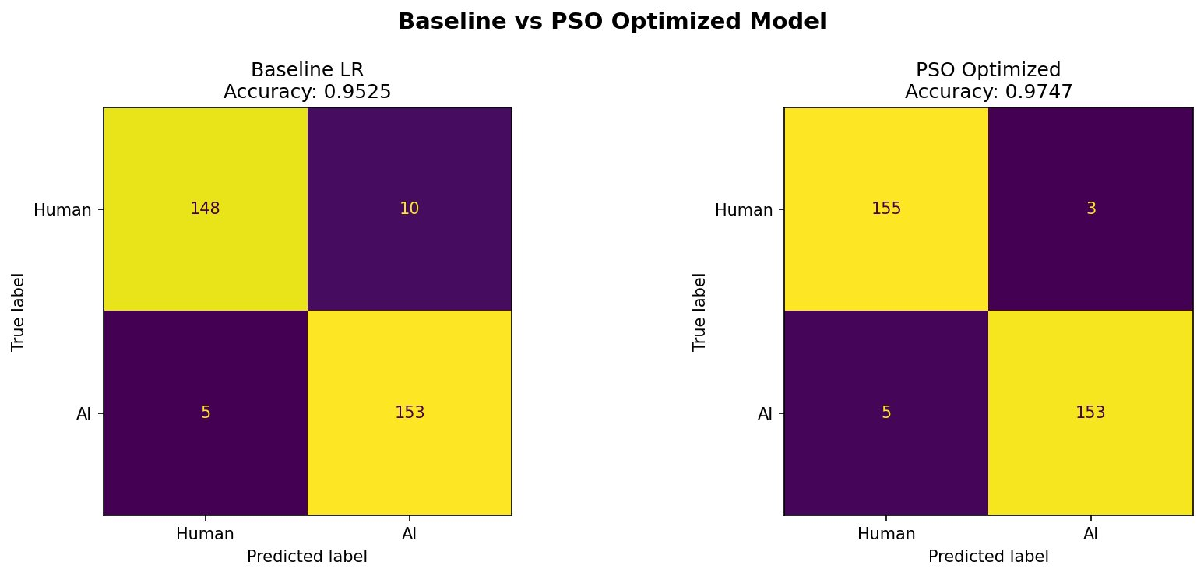
Fig. 2. Confusion matrices for baseline Logistic Regression (left, 95.25%) vs. PSO-optimized model (right, 97.47%). PSO reduces human misclassified as AIfrom 10 to 3 — a 70% reduction in false positives.

C. Ablation Study
To investigate the contribution of handcrafted features, we constrained the PSO handcrafted weight to a minimum of 0.5. As shown in Table IV, forcing inclusion of handcrafted features reduced accuracy by 1.58 percentage points, confirming redundancy when TF-IDF and SBERT representations are available.

TABLE IV: Ablation Study — PSO Constraints
Configuration | Accuracy | HC Weight
Baseline (no PSO) | 95.25% | 1.0 (equal)
PSO unconstrained | 97.47% | 0.0000
PSO forced HC≥0.5 | 95.89% | 0.5848

This result indicates that linguistic patterns captured by handcrafted features such as emoji frequency, em dash presence, and buzzword occurrence are already implicitly encoded within the TF-IDF bigram vocabulary space, rendering explicit feature engineering redundant.
D. Phase 2: AI Source Attribution
The secondary multi-class attribution experiment classified AI captions by generating system. Using PSO-optimized weights on AI captions only, the model achieved 90.58% overall accuracy. Fig. 3 shows the confusion matrix and Table V presents per-class metrics.
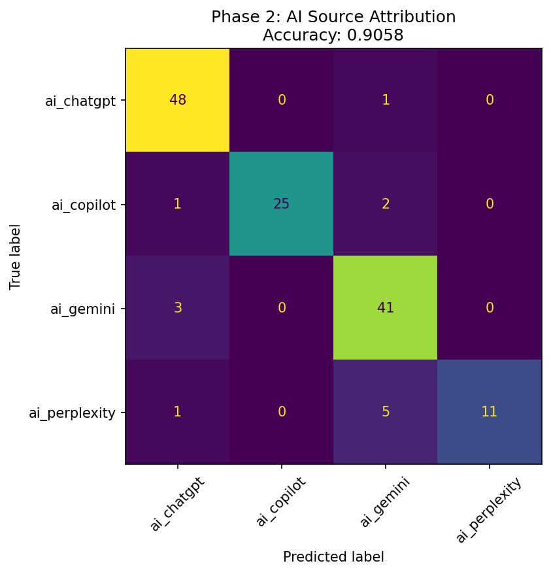
Fig. 3. Phase 2 AI source attribution confusion matrix (90.58% accuracy). Perplexity shows highest confusion with Gemini.

TABLE V: AI Source Attribution Results
System | Prec. | Recall | F1 | n
ChatGPT | 0.91 | 0.98 | 0.94 | 49
Copilot | 1.00 | 0.89 | 0.94 | 28
Gemini | 0.84 | 0.93 | 0.88 | 44
Perplexity | 1.00 | 0.65 | 0.79 | 17
Overall | 0.94 | 0.91 | 0.90 | 138

ChatGPT was most reliably identified (98% recall). Copilot achieved perfect precision, meaning when predicted as Copilot, the model is never wrong. Perplexity showed lowest recall (65%), attributable to its search-augmented generation producing less stylistically consistent outputs and the smallest class representation (87 training samples).
VII. DISCUSSION
A. Feature Importance and Vocabulary Dominance
The PSO-assigned weight of 1.33 for TF-IDF versus 0.31 for SBERT confirms that vocabulary choice is the most discriminative signal. Human captions consistently employ informal, emotionally expressive language including contractions, exclamations, slang, and personal references, while AI captions default to a formal register regardless of prompt informality. This vocabulary divergence is captured comprehensively by the bigram TF-IDF space, rendering handcrafted feature engineering largely redundant. Notably, features such as em dash usage and buzzword presence, which intuitively appear distinctive, are already implicitly represented in the TF-IDF vocabulary, suggesting that domain-specific linguistic intuitions do not necessarily translate into independent predictive value when richer representations are available.
The non-trivial SBERT weight (0.31) indicates that sentence-level patterns contribute meaningfully beyond vocabulary. AI-generated captions tend to exhibit more uniform syntactic structure and higher semantic coherence than human captions, which are often fragmentary and conversational. SBERT embeddings capture this structural regularity as a secondary discrimination signal.
B. Comparison to Existing Methods
Direct comparison with prior work is constrained by the domain novelty, as no existing benchmark evaluates AI detection specifically on Instagram captions. Contextualized against general AI text detection results, our 97.47% accuracy on short-form text is notably strong, as most competitive methods achieve 90 to 95% on long-form content [8], making our results particularly significant given the acknowledged difficulty of the short-form domain.
C. Limitations
Several limitations merit acknowledgment. AI captions were generated with explicit length constraints which may influence feature distributions. Class imbalance across AI sources (ChatGPT: 245, Perplexity: 87) limits Phase 2 reliability for underrepresented systems. As LLMs evolve toward more human-like informal expression, detector performance may degrade without retraining. The dataset is English-language only, limiting multilingual applicability.
D. Ethical Considerations
AuthentiScan is intended as a forensic and analytical instrument. AI-assisted content creation does not inherently constitute deception, as the ethical weight lies in intent and context rather than the tool itself. We caution against deployment in contexts where detection outcomes carry consequential penalties without appropriate human review.
VIII. CONCLUSION
We presented AuthentiScan, a PSO-optimized hybrid feature fusion system achieving 97.47% accuracy for AI-generated Instagram caption detection, representing a 2.22 percentage point improvement over the unweighted baseline. The system combines TF-IDF, SBERT, and handcrafted features with PSO-learned fusion weights. A secondary attribution experiment identifies the generating AI system with 90.58% accuracy across four commercial LLMs. An ablation study confirms TF-IDF as the dominant feature component, with SBERT providing complementary signal and handcrafted features proving redundant given richer representations.
This work contributes a novel PSO-feature fusion methodology for short-form AI detection, a publicly available Instagram caption dataset, and empirical evidence that short-form AI detection is feasible at high accuracy when domain-appropriate representations are employed. Future work should investigate cross-platform generalization, dynamic retraining, multilingual extension, and adversarial robustness against human-edited AI captions.
REFERENCES
[1] J. Kennedy and R. Eberhart, "Particle swarm optimization," Proc. ICNN'95, vol. 4, pp. 1942–1948, 1995.
[2] N. Reimers and I. Gurevych, "Sentence-BERT: Sentence Embeddings using Siamese BERT-Networks," Proc. EMNLP-IJCNLP, 2019.
[3] I. Solaiman et al., "Release Strategies and the Social Impacts of Language Models," arXiv:1908.09203, 2019.
[4] S. Gehrmann, H. Strobelt, and A. Rush, "GLTR: Statistical Detection and Visualization of Generated Text," Proc. ACL, 2019.
[5] R. Zellers et al., "Defending Against Neural Fake News," Proc. NeurIPS, 2020.
[6] J. Eisenstein, "What to do about bad language on the internet," Proc. NAACL, 2013.
[7] Q. Wang, R. Peng, J. Wang et al., "Research on Text
Classification Method of LDA-SVM Based on PSO Optimization,"
Proc. Chinese Automation Congress (CAC), IEEE, pp. 1974–1978, 2019.
[8] N. Prova, "Detecting AI Generated Text Based on NLP and Machine Learning," arXiv:2404.10032, 2024.
[9] E. Mitchell et al., "DetectGPT: Zero-Shot Machine-Generated Text Detection," Proc. ICML, 2023.
[10] D. V. Balaraju, "AuthentiScan: AI vs. Human Instagram Captions Dataset," Kaggle, 2025. [Online]. Available: https://www.kaggle.com/datasets/divishavarmabalaraju/ai-vs-human-instagram-captions
[11] J. Devlin et al., "BERT: Pre-training of Deep Bidirectional Transformers," Proc. NAACL, 2019.
[12] Y. Liu et al., "RoBERTa: A Robustly Optimized BERT Pretraining Approach," arXiv:1907.11692, 2019.
[13] X. Yu et al., "CHEAT: A Large-scale Dataset for Detecting ChatGPT-written Academic Papers," arXiv:2304.12008, 2023.

