The following is the structure of the tables provided by Oracle in Human Resource Schema (HR).

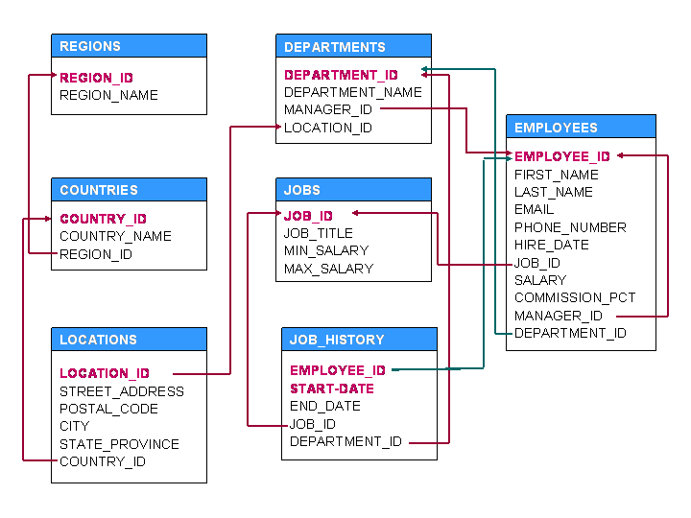  
**Note:** Columns in RED color indicate primary key(s).

**Queries**

1. Display details of jobs where the minimum salary is greater than 10000.

SELECT * FROM JOBS WHERE MIN_SALARY > 10000

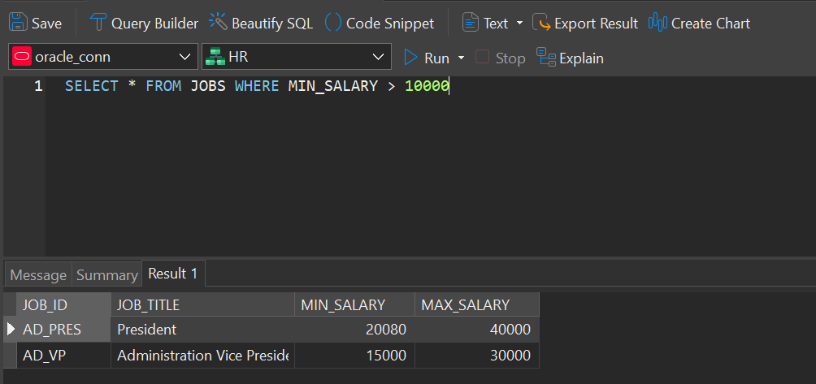

1. Display the first name and join date of the employees who joined between 2002 and 2005.

SELECT FIRST_NAME, HIRE_DATE FROM EMPLOYEES

WHERE TO_CHAR(HIRE_DATE, 'YYYY') BETWEEN 2002 AND 2005 ORDER BY HIRE_DATE

1. Display first name and join date of the employees who is either IT Programmer or Sales Man.

SELECT FIRST_NAME, HIRE_DATE

FROM EMPLOYEES WHERE JOB_ID IN ('IT_PROG', 'SA_MAN')

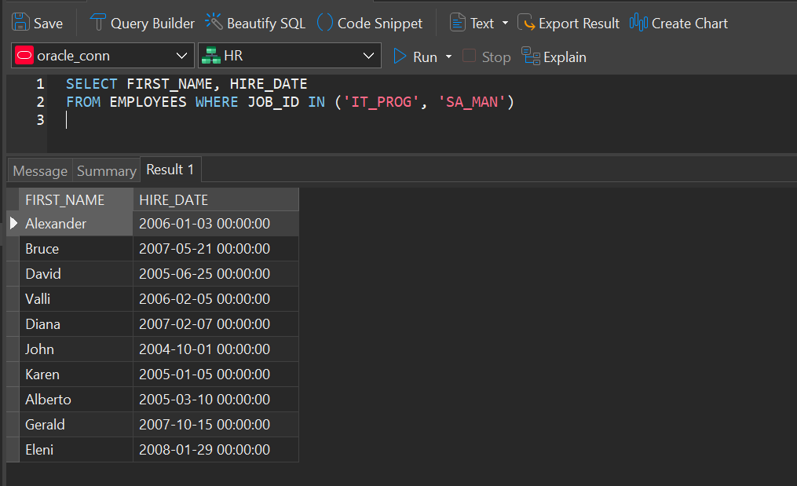

1. Display employees who joined after 1st January 2008.

SELECT * FROM EMPLOYEES where hire_date > '01- 01-2008'

1. Display details of employee with ID 150 or 160.

SELECT * FROM EMPLOYEES WHERE EMPLOYEE_ID in (150,160)

1. Display first name, salary, commission pct, and hire date for employees with salary less than 10000.

SELECT FIRST_NAME, SALARY, COMMISSION_PCT, HIRE_DATE FROM EMPLOYEES WHERE SALARY < 10000

1. Display job Title, the difference between minimum and maximum salaries for jobs with max salary in the range 10000 to 20000.

SELECT JOB_TITLE, MAX_SALARY-MIN_SALARY DIFFERENCE FROM JOBS WHERE MAX_SALARY BETWEEN 10000 AND 20000

1. Display first name, salary, and round the salary to thousands.

SELECT FIRST_NAME, SALARY, ROUND(SALARY, -3) FROM EMPLOYEES

1. Display details of jobs in the descending order of the title.

SELECT * FROM JOBS ORDER BY JOB_TITLE

1. Display employees where the first name or last name starts with S.

SELECT FIRST_NAME, LAST_NAME FROM EMPLOYEES WHERE FIRST_NAME LIKE 'S%' OR LAST_NAME LIKE 'S%'

1. Display employees who joined in the month of May.

SELECT * FROM EMPLOYEES WHERE TO_CHAR(HIRE_DATE, 'MON')= 'MAY'

1. Display details of the employees where commission percentage is null and salary in the range 1000 to 10000 and department is 30.

SELECT * FROM EMPLOYEES WHERE COMMISSION_PCT IS NULL AND SALARY BETWEEN 5000 AND 10000 AND DEPARTMENT_ID=30

1. Display first name and date of first salary of the employees.

SELECT FIRST_NAME, HIRE_DATE, LAST_DAY(HIRE_DATE)+1 FROM EMPLOYEES

1. Display first name and experience of the employees.

SELECT FIRST_NAME, HIRE_DATE, FLOOR((SYSDATE-HIRE_DATE)/365)FROM EMPLOYEES

1. Display first name of employees who joined in 2001. Une image contenant texte, capture d’écran, logiciel, Logiciel multimédia

   Description générée automatiquement

SELECT FIRST_NAME, HIRE_DATE FROM EMPLOYEES WHERE TO_CHAR(HIRE_DATE, 'YYYY')=2001

1. Display first name and last name after converting the first letter of each name to upper case and the rest to lower case.

SELECT INITCAP(FIRST_NAME), INITCAP(LAST_NAME) FROM EMPLOYEES

1. Display the first word in job title.

SELECT JOB_TITLE, SUBSTR(JOB_TITLE,1, INSTR(JOB_TITLE, ' ')-1) FROM JOBS

1. Display the length of first name for employees where last name contain character ‘b’ after 3rd position.

SELECT FIRST_NAME, LAST_NAME FROM EMPLOYEES WHERE INSTR(LAST_NAME,'b') > 3

1. Display first name in upper case and email address in lower case for employees where the fisrt letter of first_name concatenated with last_name and email address are same irrespective of the case.

SELECT UPPER(FIRST_NAME), LOWER(EMAIL) FROM EMPLOYEES WHERE UPPER(FIRST_NAME)= UPPER(EMAIL)

1. Display employees who joined in 2005.

SELECT * FROM EMPLOYEES WHERE TO_CHAR(HIRE_DATE,'YYYY')=2005

1. Display the nu mber of days between system date and 1st January 2011.

SELECT SYSDATE - to_date('01-jan-2011') FROM DUAL

1. Display how many employees joined in each month of the year 2005.

SELECT TO_CHAR(HIRE_DATE,'MM'), COUNT (*) FROM EMPLOYEES

WHERE TO_CHAR(HIRE_DATE,'YYYY')= 2005 GROUP BY TO_CHAR(HIRE_DATE,'MM')

1. Display manager ID and number of employees managed by the manager.

SELECT MANAGER_ID, COUNT(*) FROM EMPLOYEES GROUP BY MANAGER_ID

1. Display employee ID and the date on which he ended his previous job.

SELECT EMPLOYEE_ID, MAX(END_DATE) FROM JOB_HISTORY GROUP BY EMPLOYEE_ID

1. Display number of employees joined after 15th of the month.

SELECT COUNT(*) FROM EMPLOYEES WHERE TO_CHAR(HIRE_DATE,'DD') > 15

1. Display the country ID and number of cities we have in the country.

SELECT COUNTRY_ID, COUNT(*) FROM LOCATIONS GROUP BY COUNTRY_ID

1. Display average salary of employees in each department .

SELECT DEPARTMENT_ID, AVG(SALARY) FROM EMPLOYEES

GROUP BY DEPARTMENT_ID

1. Display job ID, number of employees, sum of salary, and difference between highest salary and lowest salary of the employees of the job.

SELECT JOB_ID, COUNT(*), SUM(SALARY), MAX(SALARY)-MIN(SALARY) SALARY FROM EMPLOYEES GROUP BY JOB_ID

1. Display job ID for jobs with average salary more than 10000.

SELECT JOB_ID, AVG(SALARY) FROM EMPLOYEES

GROUP BY JOB_ID

HAVING AVG(SALARY)>10000

1. Display years in which more than 10 employees joined.

SELECT TO_CHAR(HIRE_DATE,'YYYY') FROM EMPLOYEES

GROUP BY TO_CHAR(HIRE_DATE,'YYYY')

HAVING COUNT(EMPLOYEE_ID) > 10

1. Display departments in which more than five employees have commission percentage.

SELECT DEPARTMENT_ID FROM EMPLOYEES

WHERE COMMISSION_PCT IS NOT NULL

GROUP BY DEPARTMENT_ID

HAVING COUNT(COMMISSION_PCT)>5

1. Display employee ID for employees who did more than one job in the past.

SELECT EMPLOYEE_ID FROM JOB_HISTORY GROUP BY EMPLOYEE_ID HAVING COUNT(*) > 1

1. Display job ID of jobs that were done by more than or equal 2 employees for more than 100 days.

SELECT JOB_ID FROM JOB_HISTORY

WHERE END_DATE-START_DATE > 100

GROUP BY JOB_ID

HAVING COUNT(*)>=2

1. Display department ID, year, and Number of employees joined.

SELECT DEPARTMENT_ID, TO_CHAR(HIRE_DATE,'YYYY'), COUNT(EMPLOYEE_ID)

FROM EMPLOYEES

GROUP BY DEPARTMENT_ID, TO_CHAR(HIRE_DATE, 'YYYY')

ORDER BY DEPARTMENT_ID

1. Display departments where any manager is managing more than 5 employees.

SELECT DISTINCT DEPARTMENT_ID

FROM EMPLOYEES

GROUP BY DEPARTMENT_ID, MANAGER_ID

HAVING COUNT(EMPLOYEE_ID) > 5

1. Change salary of employee 115 to 8000 if the existing salary is less than 6000.

UPDATE EMPLOYEES SET SALARY = 8000 WHERE EMPLOYEE_ID = 115 AND SALARY < 6000

1. Insert a new employee into employees with all the required details.

INSERT INTO EMPLOYEES (EMPLOYEE_ID, FIRST_NAME, LAST_NAME, EMAIL, PHONE_NUMBER, HIRE_DATE,JOB_ID, SALARY, DEPARTMENT_ID)

VALUES (207, 'ANGELA', 'SNYDER','ANGELA','215 253 4737', SYSDATE, 'SA_MAN', 12000, 80)

1. Delete department 20.

DELETE FROM DEPARTMENTS WHERE DEPARTMENT_ID=20

1. Change job ID of employee 110 to IT_PROG if the employee belongs to department 10 and the existing job ID does not start with IT.

UPDATE EMPLOYEES SET JOB_ID= 'IT_PROG'

WHERE EMPLOYEE_ID=110 AND DEPARTMENT_ID=10 AND NOT JOB_ID LIKE 'IT%'

1. Insert a row into departments table with manager ID 120 and location ID in any location ID for city Tokyo.

INSERT INTO DEPARTMENTS (150,'SPORTS',120,1200)

1. Display department name and number of employees in the department.

SELECT DEPARTMENT_NAME, COUNT(*) FROM EMPLOYEES NATURAL JOIN DEPARTMENTS GROUP BY DEPARTMENT_NAME

1. Display job title, employee ID, number of days between ending date and starting date for all jobs in department 110 from job history.

SELECT EMPLOYEE_ID, JOB_TITLE, END_DATE-START_DATE DAYS

FROM JOB_HISTORY NATURAL JOIN JOBS

WHERE DEPARTMENT_ID=30

1. Display department name and manager first name.

SELECT DEPARTMENT_NAME, FIRST_NAME FROM DEPARTMENTS D JOIN EMPLOYEES E ON (D.MANAGER_ID=E.EMPLOYEE_ID)

1. Display department name, manager name, and city.

SELECT DEPARTMENT_NAME, FIRST_NAME, CITY FROM DEPARTMENTS D JOIN EMPLOYEES E ON (D.MANAGER_ID=E.EMPLOYEE_ID) JOIN LOCATIONS L USING (LOCATION_ID)

1. Display country name, city, and department name.

SELECT COUNTRY_NAME, CITY, DEPARTMENT_NAME

FROM COUNTRIES JOIN LOCATIONS USING (COUNTRY_ID)

JOIN DEPARTMENTS USING (LOCATION_ID)

1. Display job title, department name, employee last name, starting date for all jobs from 2000 to 2005.

SELECT JOB_TITLE, DEPARTMENT_NAME, LAST_NAME, START_DATE

FROM JOB_HISTORY JOIN JOBS USING (JOB_ID) JOIN DEPARTMENTS

USING (DEPARTMENT_ID) JOIN EMPLOYEES USING (EMPLOYEE_ID)

WHERE TO_CHAR(START_DATE,'YYYY') BETWEEN 2000 AND 2005

1. Display job title and average salary of employees

SELECT JOB_TITLE, AVG(SALARY) FROM EMPLOYEES

NATURAL JOIN JOBS GROUP BY JOB_TITLE

1. Display job title, employee name, and the difference between maximum salary for the job and salary of the employee.

SELECT JOB_TITLE, FIRST_NAME, MAX_SALARY-SALARY DIFFERENCE FROM EMPLOYEES NATURAL JOIN JOBS

1. Display last name, job title of employees who have commission percentage and belongs to department 30.

SELECT JOB_TITLE, FIRST_NAME, MAX_SALARY-SALARY DIFFERENCE FROM EMPLOYEES NATURAL JOIN JOBS WHERE DEPARTMENT_ID = 30

1. Display details of jobs that were done by any employee who is currently drawing more than 15000 of salary.

SELECT JH.*

FROM JOB_HISTORY JH JOIN EMPLOYEES E ON (JH.EMPLOYEE_ID = E.EMPLOYEE_ID)

WHERE SALARY > 15000

1. Display department name, manager name, and salary of the manager for all managers whose experience is more than 15 years.

SELECT DEPARTMENT_NAME, FIRST_NAME, SALARY

FROM DEPARTMENTS D JOIN EMPLOYEES E ON (D.MANAGER_ID=E.MANAGER_ID)

WHERE (SYSDATE-HIRE_DATE) / 365 > 15

1. Display employee name if the employee joined before his manager.

SELECT E1.FIRST_NAME FROM EMPLOYEES E1 JOIN EMPLOYEES E2 ON (E1.MANAGER_ID=E2.EMPLOYEE_ID)

WHERE E1.HIRE_DATE < E2.HIRE_DATE

1. Display employee name, job title for the jobs employee did in the past where the job was done less than 12 months.

SELECT FIRST_NAME, JOB_TITLE FROM EMPLOYEES E JOIN JOB_HISTORY JH ON (JH.EMPLOYEE_ID = E.EMPLOYEE_ID) JOIN JOBS J ON( JH.JOB_ID = J.JOB_ID)

WHERE MONTHS_BETWEEN(END_DATE,START_DATE) < 12

1. Display employee name and country in which he is working.

SELECT FIRST_NAME, COUNTRY_NAME FROM EMPLOYEES JOIN DEPARTMENTS USING(DEPARTMENT_ID)

JOIN LOCATIONS USING( LOCATION_ID)

JOIN COUNTRIES USING ( COUNTRY_ID)

1. Display department name, average salary and number of employees with commission within the department.

SELECT DEPARTMENT_NAME, AVG(SALARY), COUNT(COMMISSION_PCT)

FROM DEPARTMENTS JOIN EMPLOYEES USING (DEPARTMENT_ID)

GROUP BY DEPARTMENT_NAME

1. Display the month in which more than 2 employees joined in any department located in Sydney.

SELECT TO_CHAR(HIRE_DATE,'MON-YY')

FROM EMPLOYEES JOIN DEPARTMENTS USING (DEPARTMENT_ID) JOIN LOCATIONS USING (LOCATION_ID)

WHERE CITY = 'Seattle'

GROUP BY TO_CHAR(HIRE_DATE,'MON-YY')

HAVING COUNT(*) > 2

1. Display details of departments in which the maximum salary is more than 10000.

SELECT * FROM DEPARTMENTS WHERE DEPARTMENT_ID IN

( SELECT DEPARTMENT_ID FROM EMPLOYEES

GROUP BY DEPARTMENT_ID

HAVING MAX(SALARY)>10000)

1. Display details of departments managed by a person wichh have a S as first letter of First name

SELECT * FROM DEPARTMENTS WHERE MANAGER_ID IN

(SELECT EMPLOYEE_ID FROM EMPLOYEES WHERE FIRST_NAME like 'S%')

1. Display jobs into which employees joined in the year 2001.

SELECT * FROM JOBS WHERE JOB_ID IN

(SELECT JOB_ID FROM EMPLOYEES WHERE TO_CHAR(HIRE_DATE,'YYYY')=’2001')

1. Display employees who did not do any job in the past.

SELECT * FROM EMPLOYEES WHERE EMPLOYEE_ID NOT IN

(SELECT EMPLOYEE_ID FROM JOB_HISTORY)

1. Display job title and average salary for employees who did a job in the past.

SELECT JOB_TITLE, AVG(SALARY) FROM JOBS NATURAL JOIN EMPLOYEES

WHERE EMPLOYEE_ID IN

(SELECT EMPLOYEE_ID FROM JOB_HISTORY)

GROUP BY JOB_TITLE

1. Display country name, city, and number of departments where department has more than 5 employees.

SELECT COUNTRY_NAME, CITY, COUNT(DEPARTMENT_ID)

FROM COUNTRIES JOIN LOCATIONS USING (COUNTRY_ID) JOIN DEPARTMENTS USING (LOCATION_ID)

WHERE DEPARTMENT_ID IN

(SELECT DEPARTMENT_ID FROM EMPLOYEES

GROUP BY DEPARTMENT_ID

HAVING COUNT(DEPARTMENT_ID)>5)

GROUP BY COUNTRY_NAME, CITY;

1. Display details of manager who manages more than 5 employees.

SELECT FIRST_NAME FROM EMPLOYEES

WHERE EMPLOYEE_ID IN

(SELECT MANAGER_ID FROM EMPLOYEES

GROUP BY MANAGER_ID

HAVING COUNT(*)>5)

1. Display employee name, job title, start date, and end date of past jobs of all employees with commission percentage null.

SELECT FIRST_NAME, JOB_TITLE, START_DATE, END_DATE

FROM JOB_HISTORY JH JOIN JOBS J USING (JOB_ID) JOIN EMPLOYEES E ON ( JH.EMPLOYEE_ID = E.EMPLOYEE_ID)

WHERE COMMISSION_PCT IS NULL

1. Display the departments into which no employee joined in last two years.

SELECT * FROM DEPARTMENTS

WHERE DEPARTMENT_ID NOT IN

( SELECT DEPARTMENT_ID FROM EMPLOYEES WHERE FLOOR((SYSDATE-HIRE_DATE)/365) < 2)

1. Display the details of departments in which the max salary is greater than 10000 for employees who did a job in the past.

SELECT * FROM DEPARTMENTS

WHERE DEPARTMENT_ID IN

(SELECT DEPARTMENT_ID FROM EMPLOYEES

WHERE EMPLOYEE_ID IN (SELECT EMPLOYEE_ID FROM JOB_HISTORY)

GROUP BY DEPARTMENT_ID

HAVING MAX(SALARY) >10000)

1. Display details of current job for employees who worked as IT Programmers in the past.

SELECT * FROM JOBS

WHERE JOB_ID IN

(SELECT JOB_ID FROM EMPLOYEES WHERE EMPLOYEE_ID IN

(SELECT EMPLOYEE_ID FROM JOB_HISTORY WHERE JOB_ID='IT_PROG'))

1. Display the details of employees drawing the highest salary in the department.

SELECT DEPARTMENT_ID,FIRST_NAME, SALARY FROM EMPLOYEES OUTER WHERE SALARY =

(SELECT MAX(SALARY) FROM EMPLOYEES WHERE DEPARTMENT_ID = OUTER.DEPARTMENT_ID)

1. Display the city of employee whose employee ID is 105.

SELECT CITY FROM LOCATIONS WHERE LOCATION_ID =

(SELECT LOCATION_ID FROM DEPARTMENTS WHERE DEPARTMENT_ID =

(SELECT DEPARTMENT_ID FROM EMPLOYEES WHERE EMPLOYEE_ID=105)

)

1. Display third highest salary of all employees

select salary

from employees main

where 2 = (select count( distinct salary )

from employees

where salary > main.salary)

**PL/SQL Programs**

1. Write a program to interchange the salaries of employee 120 and 122.

Declare

V_salary_120 employees.salary%type;

Begin

Select salary into v_salary_120

From employees where employee_id = 120;

Update employees set salary = ( select salary from employees where employee_id = 122)

Where employee_id = 120;

Update employees set salary = v_salary_120 Where employee_id = 122;

Commit;

End;

1. Increase the salary of employee 115 based on the following conditions: If experience is more than 10 years, increase salary by 20% If experience is greater than 5 years, increase salary by 10% Otherwise 5% Case by Expression:

declare

v_exp number(2);

v_hike number(5,2);

begin

select floor((sysdate-hire_date) / 365 ) into v_exp

from employees

where employee_id = 115;

v_hike := 1.05;

case

when v_exp > 10 then

v_hike := 1.20;

when v_exp > 5 then

v_hike := 1.10;

end case;

update employees set salary = salary * v_hike

where employee_id = 115;

end;

1. Change commission percentage as follows for employee with ID = 150. If salary is more than 10000 then commission is 0.4%, if Salary is less than 10000 but experience is more than 10 years then 0.35%, if salary is less than 3000 then commission is 0.25%. In the remaining cases commission is 0.15%.

declare

v_salary employees.salary%type;

v_exp number(2);

v_cp number(5,2);

begin

select v_salary, floor ( (sysdate-hire_date)/365) into v_salary, v_exp

from employees

where employee_id = 150;

if v_salary > 10000 then

v_cp := 0.4;

elsif v_exp > 10 then

v_cp := 0.35;

elsif v_salary < 3000 then

v_cp := 0.25;

else

v_cp := 0.15;

end if;

update employees set commission_pct = v_cp

where employee_id = 150;

end;

1. Find out the name of the employee and name of the department for the employee who is managing for employee 103.

declare

v_name employees.first_name%type;

v_deptname departments.department_name%type;

begin

select first_name , department_name into v_name, v_deptname

from employees join departments using (department_id)

where employee_id = ( select manager_id from employees where employee_id = 103);

dbms_output.put_line(v_name);

dbms_output.put_line(v_deptname);

end;

1. Display missing employee IDs.

declare

v_min number(3);

v_max number(3);

v_c number(1);

begin

select min(employee_id), max(employee_id) into v_min, v_max

from employees;

for i in v_min + 1 .. v_max - 1

loop

select count(*) into v_c

from employees

where employee_id = i;

if v_c = 0 then

dbms_output.put_line(i);

end if;

end loop;

end;

1. Display the year in which maximum number of employees joined along with how many joined in each month in that year.

declare

v_year number(4);

v_c number(2);

begin

select to_char(hire_date,'yyyy') into v_year

from employees

group by to_char(hire_date,'yyyy')

having count(*) =

( select max( count(*))

from employees

group by to_char(hire_date,'yyyy'));

dbms_output.put_line('Year : ' || v_year);

for month in 1 .. 12

loop

select count(*) into v_c

from employees

where to_char(hire_date,'mm') = month and to_char(hire_date,'yyyy') = v_year;

dbms_output.put_line('Month : ' || to_char(month) || ' Employees : ' || to_char(v_c));

end loop;

end;

1. Change salary of employee 130 to the salary of the employee with first name ‘Joe’. If Joe is not found then take average salary of all employees. If more than one employee with first name ‘Joe’ is found then take the least salary of the employees with first name Joe.

declare

v_salary employees.salary%type;

begin

select salary into v_salary

from employees where first_name = 'Joe';

update employees set salary = v_salary

where employee_id = 130;

exception

when no_data_found then

update employees set salary = (select avg(salary) from employees)

where employee_id = 130;

end;

1. Display Job Title and Name of the Employee who joined the job first day.

declare

cursor jobscur is select job_id, job_title from jobs;

v_name employees.first_name%type;

begin

for jobrec in jobscur

loop

select first_name into v_name

from employees

where hire_date = ( select min(hire_date) from employees where job_id = jobrec.job_id)

and job_id = jobrec.job_id;

dbms_output.put_line( jobrec.job_title || '-' || v_name);

end loop;

end;

1. Display 5th and 10th employees in Employees table.

declare

cursor empcur is

select employee_id, first_name

from employees;

begin

for emprec in empcur

loop

if empcur%rowcount > 4 then

dbms_output.put_line( emprec.first_name);

exit when empcur%rowcount > 10;

end if;

end loop;

end;

1. Update salary of an employee based on department and commission percentage. If department is 40 increase salary by 10%. If department is 70 then 15%, if commission is more than .3% then 5% otherwise 10%.

declare

cursor empcur is

select employee_id, department_id, commission_pct

from employees;

v_hike number(2);

begin

for emprec in empcur

loop

if emprec.department_id = 40 then

v_hike := 10;

elsif emprec.department_id = 70 then

v_hike := 15;

elsif emprec.commission_pct > 0.30 then

v_hike := 5;

else

v_hike := 10;

end if;

update employees set salary = salary + salary * v_hike/100

where employee_id = emprec.employee_id;

end loop;

end;

1. Create a function that takes department ID and returns the name of the manager of the department.

create or replace function get_dept_manager_name(deptid number)

return varchar is

v_name employees.first_name%type;

begin

select first_name into v_name

from employees

where employee_id = ( select manager_id from departments where department_id = deptid);

return v_name;

end;

1. Create a function that takes employee ID and return the number of jobs done by the employee in the past.

create or replace function get_no_of_jobs_done(empid number)

return number is

v_count number(2);

begin

select count(*) into v_count

from job_history

where employee_id = empid;

return v_count;

end;

1. Create a procedure that takes department ID and changes the manager ID for the department to the employee in the department with highest salary. (Use Exceptions).

create or replace procedure change_dept_manager(deptid number)

is

v_empid employees.employee_id%type;

begin

select employee_id into v_empid

from employees

where salary = ( select max(salary) from employees where department_id = deptid)

and department_id = deptid;

update departments set manager_id = v_empid

where department_id = deptid;

end;

1. Create a function that takes a manager ID and return the names of employees who report to this manager. The names must be returned as a string with comma separating names.

create or replace function get_employees_for_manager(manager number)

return varchar2

is

v_employees varchar2(1000) := '';

cursor empcur is

select first_name from employees

where manager_id = manager;

begin

for emprec in empcur

loop

v_employees := v_employees || ',' || emprec.first_name;

end loop;

-- remove extra , at the beginning

return ltrim(v_employees,',');

end;

1. Ensure no changes can be made to EMPLOYEES table before 6am and after 10pm in a day.

create or replace trigger trg_employees_time_check

before update or insert or delete

on employees

for each row

begin

if to_char(sysdate,'hh24') < 6 or to_char(sysdate,'hh24') > 10 then

raise_application_error(-20111,'Sorry! No change can be made before 6 AM and after 10 PM');

end if;

end;

1. Create a Trigger to ensure the salary of the employee is not decreased.

create or replace trigger trg_employees_salary_check

before update

on employees

for each row

begin

if :old.salary > :new.salary then

raise_application_error(-20111,'Sorry! Salary can not be decreased!');

end if;

end;

1. Create a trigger to ensure the employee and manager belongs to the same department.

**Note:**  This trigger need to read the row that is being modified, which causes mutating problem. The solution to mutating problem is

explained at : [Work around for mutating problem in Oracle Triggers](http://www.srikanthtechnologies.com/blog/oracle/mutatingsolution.aspx). Please check it out.

1. Whenever the job is changed for an employee write the following details into job history. Employee ID, old job ID, old department ID, hire date of the employee for start date, system date for end date. But if a row is already present for employee job history then the start date should be the end date of that row +1.

create or replace trigger trg_log_job_change

after update of job_id

on employees

for each row

declare

v_enddate date;

v_startdate date;

begin

-- find out whether the employee has any row in job_history table

select max(end_date) into v_enddate

from job_history

where employee_id = :old.employee_id;

if v_enddate is null then

v_startdate := :old.hire_date;

else

v_startdate := v_enddate + 1;

end if;

insert into job_history values (:old.employee_id, v_startdate, sysdate, :old.job_id, :old.department_id);

end;

**Note:** Before testing the above trigger, you need to disable UPDATE_JOB_HISTORY trigger, which is already present in HR account, as it does the same.