Data Base Design

Table before creating a new transaction

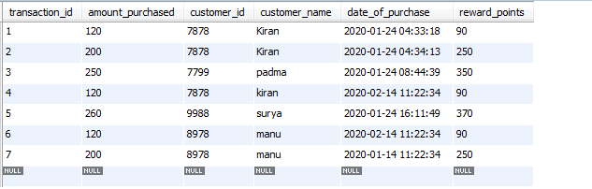

Used postman IDE for RESP API communication

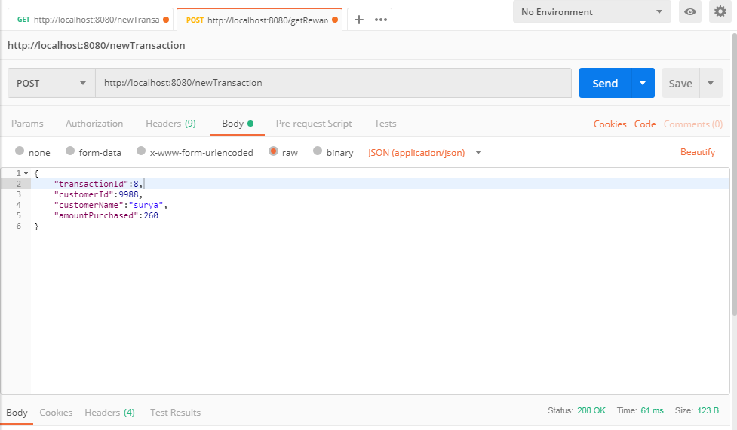

Used Rest controller to created resfull webservices

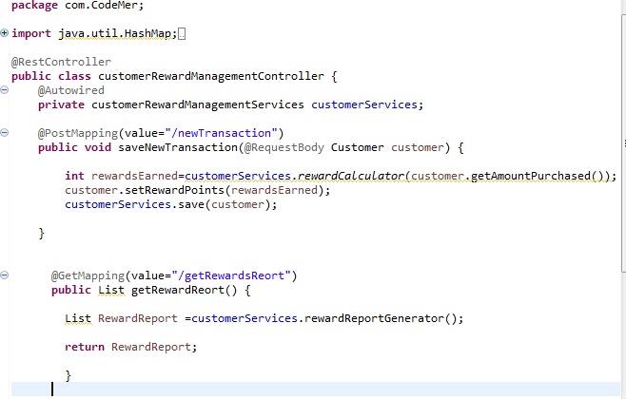

Used STS IDE

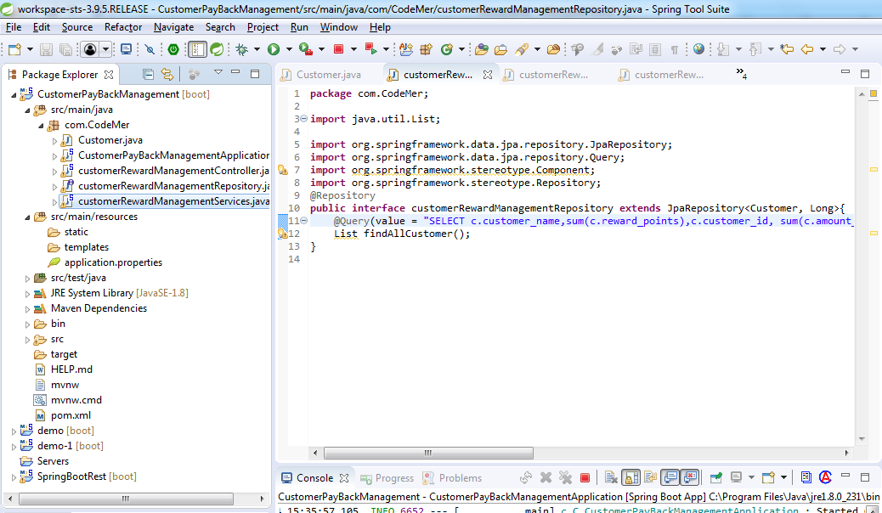

Created transaction user purchase

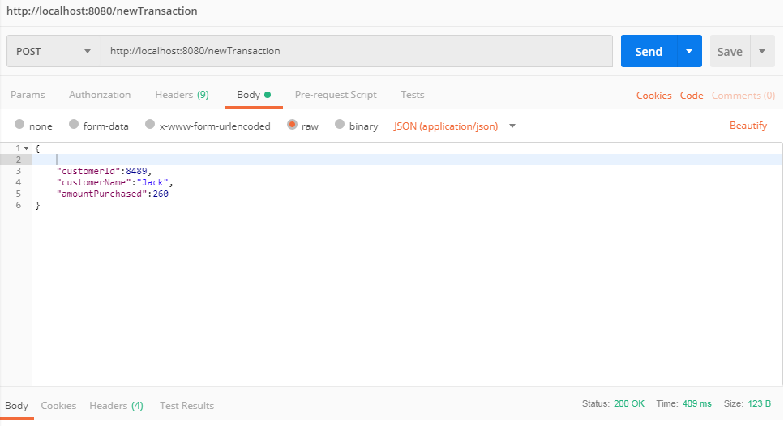

Table Before the request



Table after the request

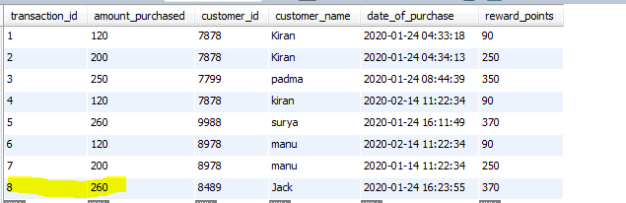

To Get monthly rewards and total rewards of the individual customers

