# Introduction

This is an exercise that tests your ability/knowledge with serialized data, collections, data associations, data modeling, type casting, and several other aspects of OOP/C#.NET. Please review the section as well as the instructions below for how to present answers to each of the questions outlined.

# Background

A small “database” was created that includes the following types: Person, Organization, Vehicle, and Address. Each of these types are called an “Entity”. Each Entity has a way to associate itself to another Entity by using the type “Association”. A property called “Associations” can be found in each Entity which collects those associations. It’s important to note that some of the Entities will include an association while others do not.

In the exercise below, you will need to complete 9 tests. The answers for tests 1 – 8 will need to be written out programmatically while test 9 will require a slightly different response.

The data files are located in the “DataSources” directory from the project directory. Each file includes a collection of a specific type. Here is a breakdown of file to type:

1. Address: Addresses_20220824_00.json
2. Organization: Organizations_20220824_00.json
3. Person: Persons_20220824_00.json
4. Vehicle: Vehicles_20220824_00.json

NOTE: This exercise will require your sample program to programmatically read the data in each of these files.

# Instructions

To get started, download this console app project by doing the following:

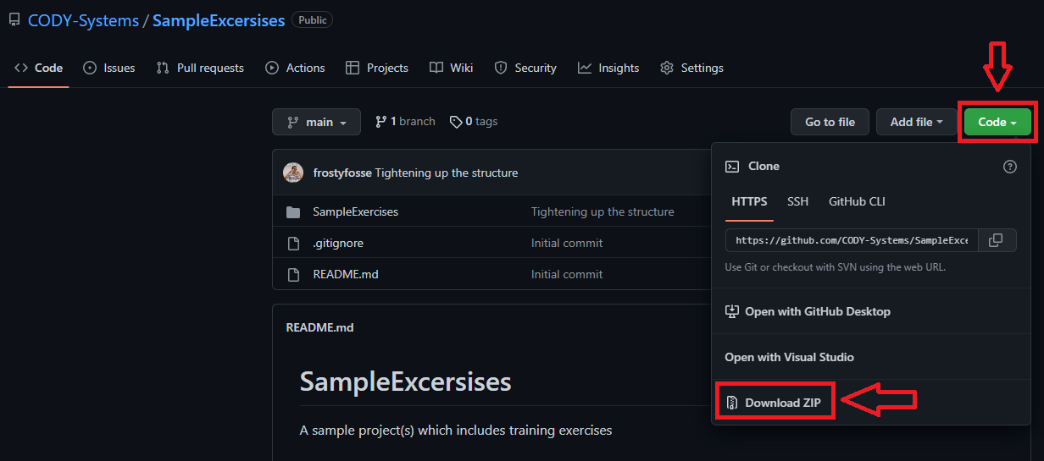

After unzipping the files, you will find a Visual Studio solution file in the SamplesExercises directory to work on this exercise.

Once you are finished, please commit the project to your own personal public repository on GitHub (free) and send an email to your interviewers with the url to that repository. If you are unable to reach them, please send the email to [hr@codysystems.com](mailto:hr@codysystems.com) and they will forward it onto the right group.

For tests 1 – 8, create a workflow which will output answers to the following details:

1. Output results to Console.WriteLine() in Program.cs
2. Include at the question # and the answer at a minimum.
3. NOTE: We will provide answers next to each most questions as a guide, but your answer should be programmatically determined in your work.

If you have any questions about the instructions, please feel free to contact your interviewers. The tests are included on the next page.

|  |  |  |
| --- | --- | --- |
| Number | Test | Answer |
| 1 | Do all files have entities? | TRUE |
| 2 | What is the total count for all entities? | 418 |
| 3 | What is the count for each type of Entity? Person, Organization, Vehicle, and Address | Person: 100 Organization: 106 Vehicle: 103 Address: 109 |
| 4 | Provide a breakdown of entities which have associations in the following manor: - Per Entity Count - Total Count | - Per Entity Count:  Person: 5 Organization: 5 Vehicle: 5 Address: 5 - Total Count: 20 |
| 5 | Provide the vehicle detail that is associated to the address "4976 Penelope Via South Franztown, NH 71024"? | Id: bf897e8d-ca66-4930-9529-0fe0bb57dc86 Make: BMW Model: Explorer Year: 2022 Plate: h5hg0y8 State: <null> Vin: XG2R2OM1XHUO24562 |
| 6 | What person(s) are associated to the organization "Thiel and Sons"? | None |
| 7 | How many people have the same first and middle name? | 94 |
| 8 | Provide a breakdown of entities where the EntityId contains "B3" in the following manor: - Total count by type of Entity - Total count of all entities | Person: 16 Vehicle: 12 Organization: 7 Address: 13 |
| 9 | What improvements would you make to the object model to improve your overall workflow? | Answer will not be provided for this question.   Note: Feel free to change/improve the object model provided if you feel it will improve your workflow. The only constraint is changes cannot require the data in the .json files to change (i.e. The files located in the DataSources directory). Provide a written response to the interviewers on any changes (if any). |