Software Requirements Specification

Peer Evaluation System, Release 1.12

Version 0.12

Prepared by Team Green Apple

May 11, 2006

Table of Contents
Table of Contents 1
Revision History 3
1. Introduction 4
1.1 Purpose 4
1.2 Project Scope and Product Features 4
1.2.1 Project Overview 4
1.2.2 Project Scope 4
1.2.2.1 Setup 5
1.2.2.2 Evaluation 5
1.2.2.3 Reporting 5
1.3 References 5
2. Overall Description 5
2.1 Product Perspective 5
2.2 User Classes and Characteristics 6
2.3 Operating Environment 6
2.4 Design and Implementation Constraints 6
2.5 User Documentation 6
2.6 Assumptions and Dependencies 6
3. System Features 7
3.1 Create, Review and Edit Question Templates 7
3.2 Create, View and Modify Evaluations 7
3.3 Execute Evaluations 8
3.3.1 Description and Priority 8
3.3.2 Stimulus/Response Sequences 9
3.3.3 Functional Requirements 9
3.4 Review Evaluation Results 9
3.4.1 Description and Priority 9
3.4.2 Stimulus/Response Sequences 9
3.4.3 Functional Requirements 10
3.5 Administrative Access and Usage 11
3.5.1 Description and Priority 11
3.5.2 Stimulus/Response Sequences 11
3.5.3 Functional Requirements 11
4. External Interface Requirements 12
4.1 User Interfaces 12
4.2 Hardware Interfaces 12
4.3 Software Interfaces 12
4.4 Communications Interfaces 12
5. Other Nonfunctional Requirements 12
5.1 Documentation Requirements 12
5.2 Performance Requirements 12
5.3 Safety Requirements 12
5.4 Security Requirements 12
5.5 Software Quality Attributes 13
Appendix A: Data Dictionary and Data Model 13
Appendix B: Data Model 14
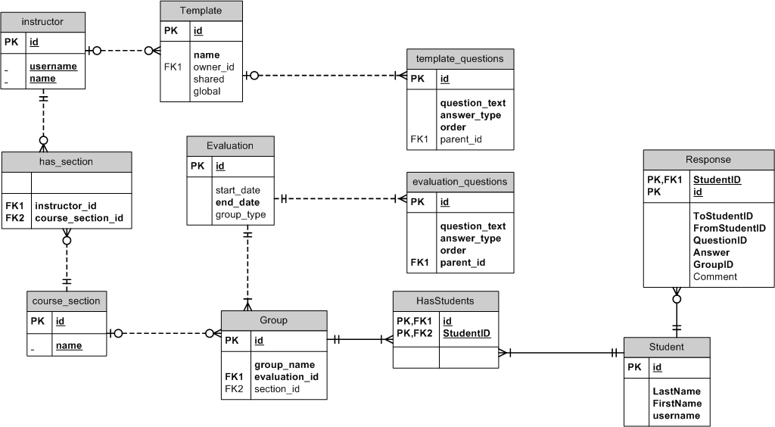 14
Appendix C: Analysis Model (Instructor) 15
Appendix D: Analysis Model (Student) 16
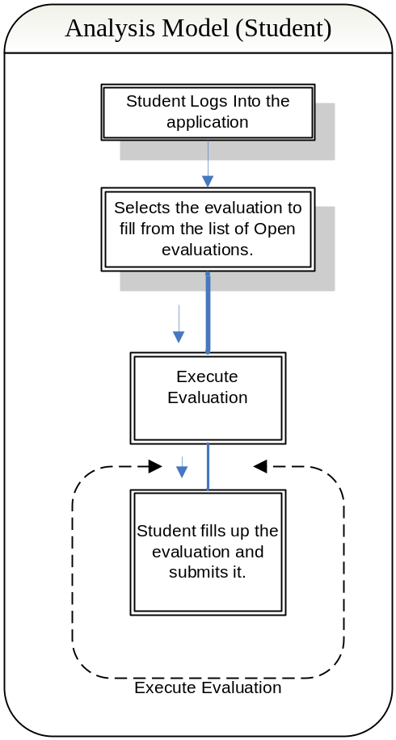 16

Revision History
Name | Date | Reason For Changes | Version
Tom Nichols | 1/15/06 | Initial SRS draft | 0.1 draft
Amber Bahl | 1/15/06 | Added Project Overview and Scope | 0.2
Amber Bahl | 1/15/06 | Added Product Perspective | 0.3
Green Apple | 1/17/06 | Added Sections 2 and 3.1 | 0.4
Amber Bahl | 1/17/06 | Added Functional Requirements | 0.5
Ada Tse | 1/18/06 | Added Sections 3.4.1 and 3.4.2 | 0.6
Amber Bahl | 1/22/06 | Changed sections 3, 4, 5 and Appendix. | 0.7
Amber Bahl | 1/24/06 | Added Data model and changed Appendix. | 0.8
Amber Bahl | 1/24/06 | Added Analysis Models (Student and Instructor) | 0.9
Amber Bahl | 1/27/06 | Removed extra text from feature functionality. | 0.10
Amber Bahl | 2/05/06 | Updated the Data model, and added section 3.5 | 0.11
Matt Anderson | 2/07/06 | Update data model diagram | 0.12

Introduction

Purpose
This SRS describes the software functional and nonfunctional requirements for release 1.0 of the Peer Evaluation System. This document is intended to be used by the members of the project team that will implement and verify the correct functioning of the system. Unless otherwise noted, all requirements specified here are high priority and committed for release 1.0.

Project Scope and Product Features

1.2.1 Project Overview
The RIT Online Learning department is in need of an online peer evaluation system that can enhance the collaborative learning experience. Currently, peer evaluation is supported by the use of online surveys provided by the RIT Clipboard system, which is difficult to setup and lacks good reporting functionalities. As a result, instead of using the tool as part of the early collaboration process where interventions can be apply part way into the project, it is often only used as a determinant of the project final grade. Our team will be responsible to deliver a standalone online evaluation system that will allow easy peer assessment and provide effective feedbacks without burdening faculty and students. The system will be built with future integration into myCourses or other online collaboration systems in mind. The product must be capable of providing multiple levels of access to these carrying sets of functionality.

The product will be a web-based application with functionality that can be determined by the access of user. Creating the product for internet use ensures multi-platform capability without a need for substantial overhead needed to convert the product to function for multiple specific platforms. Multiple levels of access are required in order to properly accommodate both administrative as well as client user functionality.

The administrative staff will have the highest level of access. They will be able to browse all available information and will also be responsible for assigning users a level of access.

1.2.2 Project Scope

The online peer evaluation system can be broken down into three parts: Setup, Evaluation, and Reporting. For the setup, the system needs an easy way for faculty to create groups and add students into group. The setup functionalities will eventually be integrated to the group structure feature provided by the myCourses management system. For evaluation, it is ideal that the faculty can customize their own set of questions, but initially, a static sample of questions will be used. For reporting, the system needs to provide an effective, preferably graphical, representation of the evaluation results. Faculty needs to be able to easily identify the outliers, especially the problematic groups in the class or individuals within the groups. Different representations of the evaluation summaries will be implemented to allow faculty to efficiently assess results. Students will also receive evaluations from their peers, and they must be presented anonymously.

1.2.2.1 Setup
The setup should provide an easy way for the faculty to create groups and add users into groups. The setup feature will eventually be integrated to the group structure feature provided by the myCourses management system.

1.2.2.2 Evaluation
For evaluation purposes the faculty should be able to customize their own set of questions, but initially the development team will implement this feature by using a static set of questions. These questions will either be quantitative or qualitative depending on user requirements.

1.2.2.3 Reporting
For reporting purposes the system needs to provide a graphical representation of the collected data. The basic aim for this would be to easily identify outlier groups and individuals. Different representations of the evaluation summaries will be implemented to allow faculty to efficiently assess results like:
- Pareto Chart
- Pie Chart
- Scatter Chart
Once the evaluations are filled by students the group members should be able to view all comments and concerns. All these evaluations must be presented anonymously.

References
- http://clipboard.rit.edu/
- http://mycourses.rit.edu
- Online Learning Department
- Lutz, Michael (Faculty Mentor)
- Hawker, Dr. J. Scott (Peer Evaluation Templates )

Overall Description

Product Perspective
The RIT Online Learning department is in need of an online peer evaluation system that can enhance the collaborative learning experience. The functionality is prioritized at project inception and time-boxed releases are delivered, at which point additional functionality is incorporated to the code base. Upon each consecutive release, prior development activities may be revisited as necessary to address priority shift and requirements volatility.

The Scrum methodology will be followed by the development team to deliver this application. This project will be completed by a single development team in a span of 15 weeks. Like other Scrum teams this team will mainly consist of a Scrum Master, Product Owner and a group of developers. This project team will typically comprise of developers, QA, UI designers etc. This process model will help mitigate potential risks by providing multiple iterations of development and customer feedback. This process model will also provide backlogs to customer as well as management in order to assess progress.

User Classes and Characteristics
User | Description
Student | A student is a user who will be filling out a review.  The student may fill out multiple reviews for teammates. They must be registered in MyCourses as a member of a class. They are allowed to authenticate and give their review once.
Instructor | Instructors manage the groups for which the evaluations are performed. This role may be performed by an instructor, or a Teachers Assistance (TA). The Instructor constructs, administers and reviews evaluations.
Instructional Designer / Help desk operator | Administrators are allowed to perform all operations of any teacher. This is to facilitate aid to an instructor who needs assistance.
Administrator | Database admin. Can delete old course and review data.  (CONDITIONAL)

Operating Environment
OE-1: The system shall operate with the following Web browsers: Microsoft Internet Explorer versions 6.0, Firefox 1.5, and Safari.
OE-2: The Peer Evaluation System shall run on Microsoft IIS 5.0 or higher.
OE-3: The Peer Evaluation System shall use Microsoft SQL server 2000 for data storage.

Design and Implementation Constraints
CO-1: The system shall be accessible through a web browser and an internet connection.
CO-2: The system shall interface with the current MyCourses system.
CO-3: All web presentation code shall conform to the XHTML transitional 1.0 standard.
CO-4: All code shall be written in C# for the Microsoft .NET platform.
CO-5: The client component of the system needs to be accessible on multiple platforms and from remote locations.

User Documentation
UD-1: All end-user documentation shall be web-accessible and viewable through a web browser.
UD-2: Campus online documentation has historically been through a Macromedia tool. Outside the scope of this spec.

Assumptions and Dependencies
AS-1: RIT Online Learning will provide a mechanism for authentication for all users.
AS-2: Administrators and instructional designer credentials will be stored in the Peer Evaluation system
DE-1: RIT Online Learning will provide a mechanism for accessing course and group information provided from the MyCourses system.
DE-2: RIT Online Learning will be responsible for maintaining the application and the application related data.

System Features

Create, Review and Edit Question Templates

3.1.1 Description and Priority
An instructor can formulate a set of questions and save them as a question template. This template may then be used to create an evaluation.

3.1.2 Stimulus/Response Sequences
Stimulus: Instructor requests to create a new template.
Response: System provides a new form in order to create a set of review questions, and optionally, responses.
Stimulus: Instructor saves an edited template.
Response: The template is added to a list of templates available to the instructor.
Stimulus: Instructor requests to edit an existing template.
Response: The review questions are presented in an editable format. When finished, changes may be saved or discarded.
Stimulus: Instructor requests to delete a template.
Response: The template is removed from the instructor’s list of templates.
    - Functional Requirements
Feature Requirements: Creating Templates (FR-CT)

Feature ID | Feature Name | Description
FR-CT1 | Create Template(s) | The application shall allow the instructor to create a new template.
FR-CT2 | Modify Template(s) | The application shall allow the instructor to modify an existing template (Questions/ Answers).
FR-CT3 | Delete Template(s) | The application shall allow the instructor to delete an existing template.

Create, View and Modify Evaluations

3.2.1 Description and Priority
An Evaluation is created by an instructor with the intent that it will be sent out to students at a future point in time. An evaluation consists of a set of questions, a group type (set of groups) and a scheduled start and end time for submission.

3.2.2 Stimulus/Response Sequences
Stimulus: Instructor requests to create a new evaluation.
Response: System provides a new form in order to create review questions/responses, select a group type, and assign a schedule.
Stimulus: Instructor requests to create a new evaluation from a template.
Response: System provides an evaluation setup form pre-populated with a set of question and responses from the template.
Stimulus: Instructor saves an edited evaluation.
Response: System saves the evaluation to the list of current evaluations for the section.
Stimulus: Instructor requests to view a saved evaluation.
Response: System displays the evaluation in an editable form.
Stimulus: Instructor requests to delete an evaluation.
Response: System asks for a confirmation from the user and removes the evaluation from the system.
    - Functional Requirements
Feature Requirements: Creating Evaluation (FR-CE)

Feature ID | Feature Name | Description
FR-CE1 | Create New Evaluation | The application shall allow instructor to create new evaluation.  Creating an evaluation requires a instructor to select/create questions/responses, select a group type and a schedule.
FR-CE2 | Create New Evaluation from Template | The application shall allow instructor to create new evaluation from template.
FR-CE3 | Saving an Edited Evaluation | The application shall allow the instructor to save the evaluation to the list of previously saved evaluations.
FR-CE4 | Delete a Saved Evaluation | The application shall allow the instructor to delete a previously saved evaluation.
FR-CE5 | Set Evaluation’s open and close date | The application shall provide the instructor with an option to set an open and close date for the evaluation.
FR-CE6 | Immediately close an open Evaluation | The application shall provide an option where the evaluation is immediately closed instead of waiting for the closing date and time.
FR-CE7 | Allow Evaluation to be open immediately | The application shall provide an option where the evaluation is immediately open instead of waiting for the opening date and time.
FR-CE8 | Allow option to close Evaluation when all are submitted | The application shall close evaluations once all the evaluations are submitted.

Execute Evaluations

Description and Priority
When the application opens an evaluation, students are able to access the evaluation. The student will not be able to access the evaluation when it has reached the closing date and time.

Stimulus/Response Sequences
Stimulus: Student requests to access an open evaluation.
Response: System displays the evaluation associated to the student.
Stimulus: Student requests to submit a completed evaluation
Response: System asks for confirmation and saves student responses in the database.

Functional Requirements
Feature Requirements: Execute Evaluations (FR-EE)

Feature ID | Feature Name | Description
FR-EE1 | Access Evaluation | The application shall not display the evaluation before the open date, time and after its close date, time.
FR-EE2 | Submit Evaluation Responses before closing time | The application shall save the students response in the database. Once the evaluation is submitted, the student cannot resubmit the evaluation.
FR-EE3 | Submit Evaluation Responses after closing time | Only the “Open” evaluations are displayed to the Student. All evaluations after the closing date, time are not displayed to the Student.

Review Evaluation Results

Description and Priority
An instructor can view the results of an evaluation once an evaluation has been closed. Results of the students’ responses and other related information is displayed both as a summary and in detailed as necessary for an instructor to assess the results.

Stimulus/Response Sequences
Stimulus: Instructor requests to view an evaluation’s overall result.
Response: System provides a table displaying summary results of all the groups’ scores as evaluated by the student.
Stimulus: Instructor requests to view an evaluation result for a particular group.
Response: System provides a table displaying summary results of all the individual’s scores for the particular group.
Stimulus: Instructor requests to view responses given to a particular individual.
Response: System provides a table displaying all the peers’ responses giving to the particular individual for the evaluation.
Stimulus: Instructor requests to view an evaluation’s result for a particular question.
Response: System provides a table displaying the results for all the groups’ scores for the particular question.
Stimulus: Instructor requests to view a student’s rating habit for the evaluation.
Response: System provides a table displaying how the student rated the peers for the evaluation.
Stimulus*: Instructor requests system to allow evaluation results to be viewed by the students.
Response*: System displays the group’s results to the appropriate students.

Functional Requirements
Feature Requirements: Reporting (FR-R)

Feature ID | Feature Name | Description
FR-R1 | Display general reporting summaries by group | The application shall display the overall average ratings and the distribution of scores within the groups.
FR-R2 | Highlight unusual trends in results | The application shall highlight any unusual trends in the evaluation’s results.
FR-R3* | Display results by questions | The application shall display the average ratings of the groups for each question in the evaluation.
FR-R4 | Display individuals’ average results within a group | The application shall show the average ratings for each individual within the group by expanding the group list.
FR-R5 | Display individuals results in detail | The application shall display the peers’ ratings of a particular individual for all the questions in the evaluation.
FR-R6 | Display peers’ average rating for an individual | The application shall display an individual’s overall average ratings given by each peer.
FR-R7 | Display an individual’s average for each question | The application shall display an individual’s average rating for each question.
FR-R8 | Display individuals’ rating habits | The application shall display how an individual rated his/her peers.
FR-R9* | Display individuals’ results to the students | The application shall display an individual’s evaluation results to the appropriate individual in an anonymous manner if the instructor chooses to make the information available.
FR-R10 | Display submission status of the evaluation forms for all students involved in the project | The application shall display submission status for the evaluation.
FR-R11 | Provide sorting mechanisms | The application shall allow the instructor to sort the results by groups, individuals, and individual ratings.
FR-R12 | Provide a graphical view of the results | The application shall display results in a graphical format

Administrative Access and Usage

Description and Priority
An administrator shall have access to all the courses offered by each instructor. An administrator shall have the option of changing the role and acting as one of the instructors until he pleases.

Note: Once an Administrators role is changed, he/she could always switch back to Administrators roll by clicking a button on the admin panel. After an Administrator changes its role as an instructor it could carry out any of the functionality that could be carried out by any instructor (3.1, 3.2, and 3.4).

Stimulus/Response Sequences
Stimulus: Administrator requests to change its role and act as one of the instructors of the application.
Response: The system changes the role of the Administrator to that of a (selected) instructor.

Functional Requirements
Feature Requirements: Administrative Access and Usage (FR-AA)

Feature ID | Feature Name | Description
FR-AA1 | Change of Role. | An administrator shall have access to all the courses offered by each instructor. An administrator shall have the option of changing the role and acting as one of the instructors until he pleases.

External Interface Requirements

User Interfaces
UI-1: User shall have the ability to access the Peer Evaluation System from many platforms and locations without the need to install software locally.

Hardware Interfaces
No hardware interfaces have been identified.

Software Interfaces
SI-1: MyCourses course management system
SI-1.1: The Peer Evaluation System should be accessible from MyCourses.

SI-2: LDAP authentication system
SI-2.1: The Peer Eval System shall authenticate all users through the campus LDAP directory system.

Communications Interfaces
None.

Other Nonfunctional Requirements

Documentation Requirements
No documentation requirements have been identified.

Performance Requirements
No performance requirements have been identified at this time.

Safety Requirements
No safety requirements have been identified.

Security Requirements
SE-1: Students should not be able to view any personally identifiable review information other than their own.
SE-2: All users should be authenticated before accessing the application.
SE-3: All the evaluations must be presented anonymously to all students.
SE-4: The application shall transfer/save data securely.

Software Quality Attributes
Availability-1: System shall be at least 99.95% available on weekdays (M-F) from 5:00 a.m. to 1:00 a.m. local time
Availability-2: System shall be at least 99% available on weekends from 8:00 a.m. to 10 p.m. local time.

Appendix A: Data Dictionary and Data Model
Term | Description
Evaluation | Set of questions created by a faculty member to be send out to class groups.
Group Type | Defines a particular group set that an instructor may create for a particular section. A section may have many group types, which may consist the same or a different set of groups.
Section | An instance of a course
Template | A templates would consist of questions, and their answer options
MyCourses | A course management system.
Open Evaluation | When an evaluation is created by an Instructor an open date, time is selected by the instructor. This evaluation is available to all the groups once that date, time is reached.
Closed Evaluation | When an evaluation is created by an Instructor an close date, time is selected by the instructor. This evaluation is made unavailable to all the groups once this time is reached.

All features marked as * are low priority features and will be addressed at the end.

Appendix B: Data Model

Figure 1
Complete data model for release 1.0 of the Peer Evaluation System.

Appendix C: Analysis Model (Instructor)
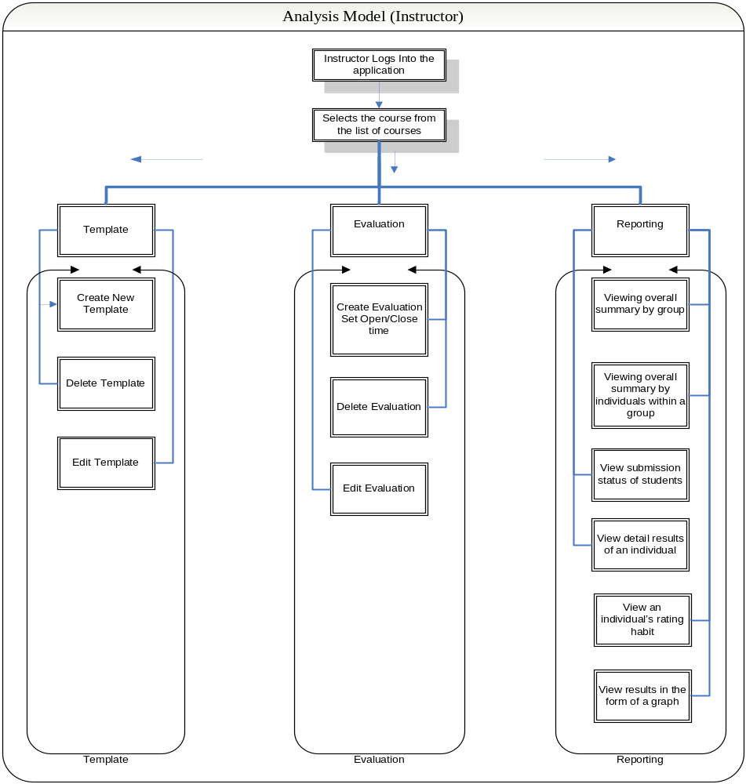
Figure 2
Analysis model for an Instructor.

Appendix D: Analysis Model (Student)
Figure 3
Analysis model for a Student. .

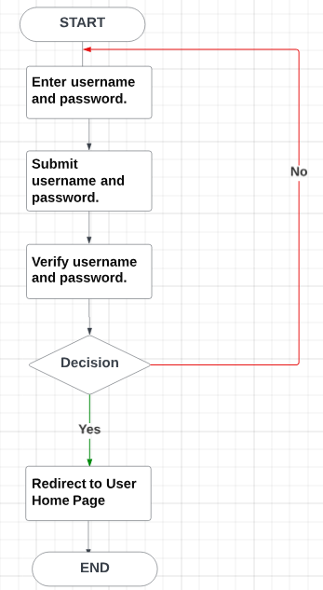Web Interface: The primary interface for users to search for rooms, make reservations, and manage their bookings.

Admin Dashboard: An interface for hotel administrators to manage room inventory, view bookings, generate reports, and perform other administrative tasks.

Mobile Application (Optional): A mobile app version of the booking system for users who prefer to book rooms using their smartphones.

Web Interface: The primary interface for users to search for rooms, make reservations, and manage their bookings.

Admin Dashboard: An interface for hotel administrators to manage room inventory, view bookings, generate reports, and perform other administrative tasks.

Mobile Application (Optional): A mobile app version of the booking system for users who prefer to book rooms using their smartphones.

