Error: Reference source not found
–
Document ID: 0000.doc
Author(s): SUJEETH
Version: 1
Date: April 19, 2024

1. Objective and Scope ......................................................................................................3
2. Project end users ......................................................................................................... 3
3. Functional Requirements ..............................................................................................3
3.1 Hotel Information............................................................................................ 3
3.2 Account Management...................................................................................... 3
3.3 Room Booking…..……...................................................................................... 4
3.4 Secure Payment.............................................................................................. 4
3.5 Reservation Management................................................................................ 4
4. Non-Functional Requirements ...................................................................................... 4
4.1 Modularity… ................................................................................................... 4
4.2 Performance ................................................................................................... 4
4.3 Usability ......................................................................................................... 4
4.4 Security……… ................................................................................................. 4
4.5 Compatability ................................................................................................. 5
5. Features ....................................................................................................................... 5
5.1 User Login....................................................................................................... 5
5.2 Room Booking form......................................................................................... 5
5.3 Room listings................................................................................................... 5
5.4 Responsive Design...........................................................................................5
6. Project process flow ..................................................................................................... 6
7. Class case diagram…..................................................................................................... 7
8. Use case diagram…. ..................................................................................................... 8

Objective and Scope
The primary objective of the Hotel Center Simply project is to create a streamlined and user-friendly online hotel booking website that allows users to efficiently search, select, and reserve hotel rooms according to their preferences. The scope of the product includes the following basic features:
- Provide users with a simple, intuitive booking process to reserve hotel rooms.
- Enable users to search for hotels based on various criteria (e.g., location, price, amenities).
- Offer detailed information about each hotel, including descriptions, photos, room types, and amenities.
- Users will be able to book rooms and manage reservations through the website, and the platform will offer secure payment processing to facilitate transactions.
- Monitoring and reporting features will be provided for business analysis and decision-making purposes.

Project End Users
The project end users for the "Hotel Center" website are travelers seeking to book hotel rooms for their stays and hotel staff who manage reservations, room availability, and hotel information.

Functional requirements

Hotel Information
Detailed information about each hotel should be displayed, including descriptions, photos, room types, and amenities.

Account management
Users should be able to create new accounts and log in using credentials. Users can manage their profiles, including updating personal information and account settings.

Room Booking
Users should be able to select and reserve hotel rooms based on availability. Users can view and modify their reservation details, such as room type and stay duration.

Secure Payment
The system should provide secure payment options for booking reservations. Users should be able to pay using various methods such as credit cards, debit cards, and other payment gateways.

Reservation Management:
Users should be able to view, modify, or cancel their reservations.

Non-functional requirements

Modularity
The website should be structured using separate HTML, CSS, and JavaScript files for better organization and maintainability.

Performance
The website should load quickly and respond to user interactions promptly to provide a seamless user experience.

Usability
The user interface should be intuitive and easy to use, even for users with limited technical knowledge.

Security
User data, including personal information and payment details, should be encrypted during transmission and storage to ensure confidentiality.

Compatability
Ensure compatibility with different browsers and devices to reach a wider audience.

Features

User Login
The modal login feature allows users to log in securely without leaving the current page, enhancing convenience and usability.

Room Booking form
The interactive booking form enables users to easily specify their check-in and check-out dates, select the number of guests and rooms, and choose their preferred room type. This feature streamlines the booking process, allowing users to make reservations quickly and efficiently.

Room listings
Detailed room listings provide users with essential information such as room types, descriptions, prices, and amenities. This feature empowers users to make informed decisions when selecting accommodations, ensuring they find the right fit for their needs and preferences.

Responsive Design
The website's responsive design ensures a seamless user experience across various devices, including desktops, tablets, and smartphones. This feature enhances accessibility and convenience for users, allowing them to access the website and make bookings from any device with ease.

Project process flow

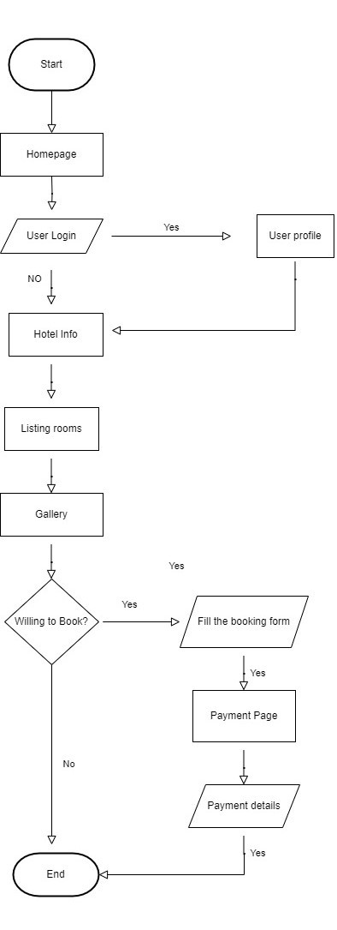

Class diagram

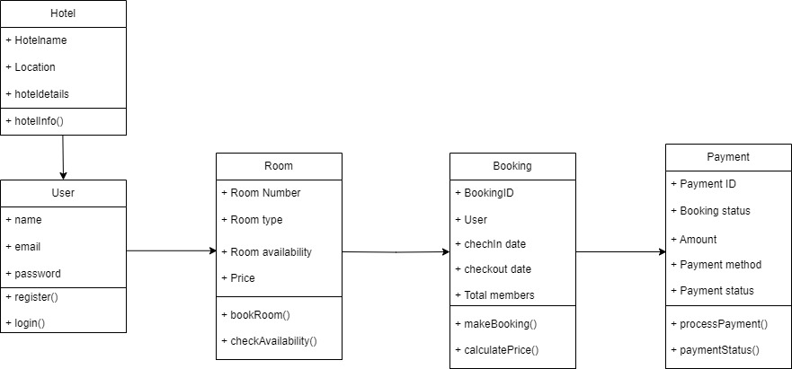

Use case diagram

