COE420L – Software Engineering
Lab 5: Object Modeling and UML Class Diagrams
Project: StudyBuddy – AI-Assisted Flashcard Web Application

Team Members
Full Name | AUS ID | GitHub Username
Samer Salem | B00099718 | samer123293
Tarik Mamlouk | B00102420 | tarikmamlouk
Hanin Hamida | G00101852 | g00101852-design
Karam Sawas | B00100437 | b00100437-sketch

Repository: https://github.com/COE420-Eltop-F26/Study-Buddy

Purpose and modeling basis
The StudyBuddy class model is derived from the approved Lab 3 functional requirements FR-01–FR-20 and use cases UC-01–UC-22, and Lab 4 processes 1.0–6.0 and stores D1–D4. Classes are proposed design abstractions, not claims of implemented source code. Individual contributions and one connected consolidated model are shown below.

Part A – Individual Object Modeling

Exercise 1 & 2 – Samer Salem: Accounts
Individual contributor: Samer Salem (B00099718) | Use cases: UC-01–UC-05. Shared classes are shown as external dependencies and are not attributed solely to this contributor.
Class ID | Class | Purpose / responsibility | Related use case / owner
C01 | User | Registered student and profile owner | UC-01–UC-05 / FR-01–FR-05
C02 | AuthSession | Authenticated session and inactivity state | UC-01–UC-05 / FR-01–FR-05
C03 | AccountService | Registration, login, logout, profile updates and deletion | UC-01–UC-05 / FR-01–FR-05
C04 | Deck | Owned collection of flashcards | UC-06–UC-10 / FR-06–FR-10

Individual UML class diagram
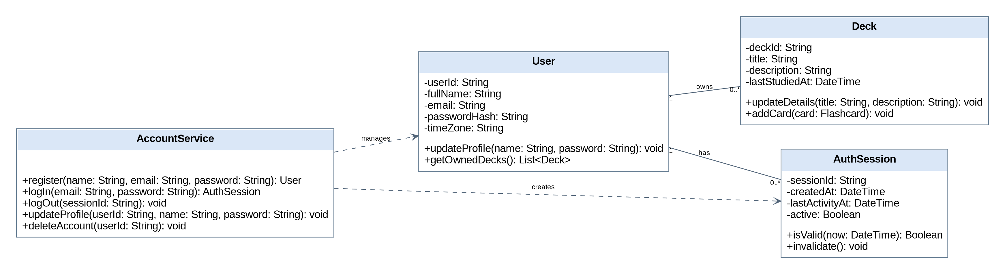

Exercise 1 & 2 – Tarik Mamlouk: Decks and cards
Individual contributor: Tarik Mamlouk (B00102420) | Use cases: UC-06–UC-10. Shared classes are shown as external dependencies and are not attributed solely to this contributor.
Class ID | Class | Purpose / responsibility | Related use case / owner
C01 | User | Registered student and profile owner | UC-01–UC-05 / FR-01–FR-05
C04 | Deck | Owned collection of flashcards | UC-06–UC-10 / FR-06–FR-10
C05 | Flashcard | Question and answer study content | UC-06–UC-10 / FR-06–FR-10
C06 | ManualFlashcard | Manually authored flashcard specialization | UC-06–UC-10 / FR-06–FR-10
C08 | DeckService | Owned deck and card operations | UC-06–UC-10 / FR-06–FR-10

Individual UML class diagram
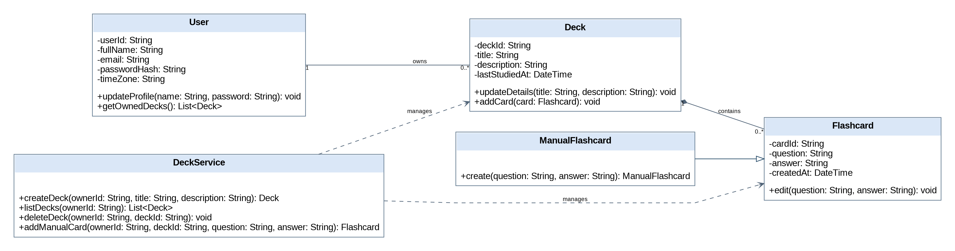

Exercise 1 & 2 – Hanin Hamida: AI generation
Individual contributor: Hanin Hamida (G00101852) | Use cases: UC-11–UC-15. Shared classes are shown as external dependencies and are not attributed solely to this contributor.
Class ID | Class | Purpose / responsibility | Related use case / owner
C01 | User | Registered student and profile owner | UC-01–UC-05 / FR-01–FR-05
C09 | GenerationJob | PDF extraction, candidates and retry status | UC-11–UC-15 / FR-11–FR-15
C10 | GenerationService | PDF extraction, generation and candidate review | UC-11–UC-15 / FR-11–FR-15
C11 | PDFFile | PDF upload payload and size/type validation | UC-11–UC-15 / FR-11–FR-15
C12 | OpenAIClient | External OpenAI generation interface | UC-11–UC-15 / FR-11–FR-15
C07 | AIGeneratedFlashcard | AI candidate with approval state | UC-11–UC-15 / FR-11–FR-15
C05 | Flashcard | Question and answer study content | UC-06–UC-10 / FR-06–FR-10
C04 | Deck | Owned collection of flashcards | UC-06–UC-10 / FR-06–FR-10

Individual UML class diagram
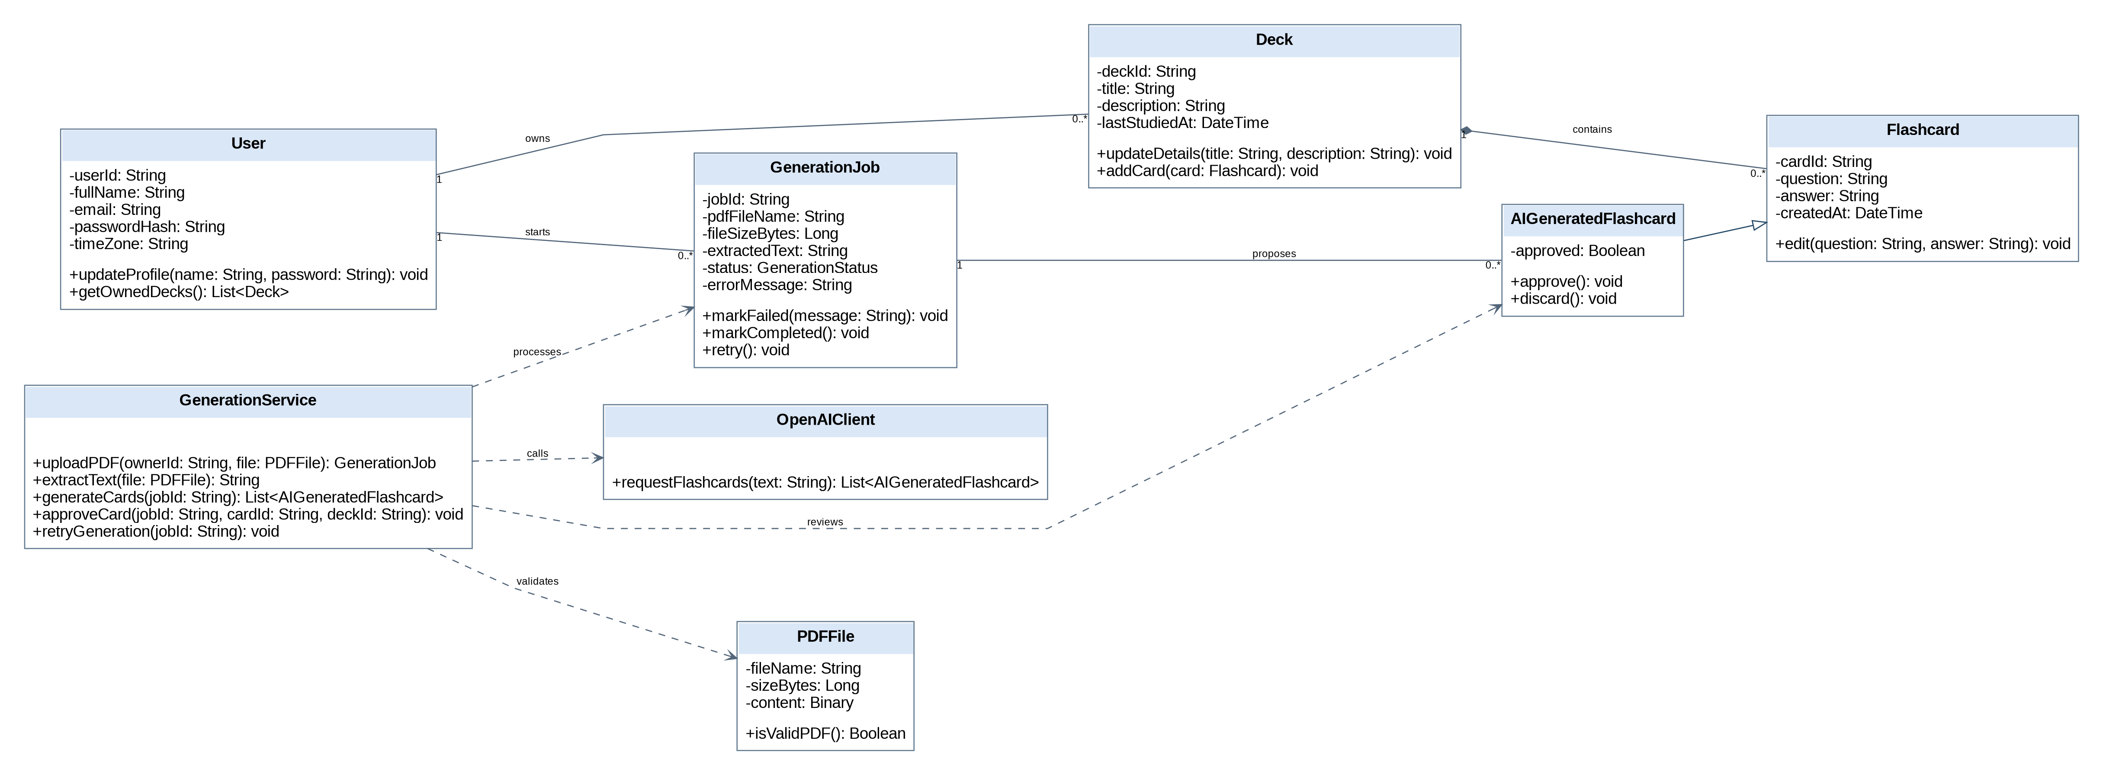

Exercise 1 & 2 – Karam Sawas: Study and analytics
Individual contributor: Karam Sawas (B00100437) | Use cases: UC-16–UC-20. Shared classes are shown as external dependencies and are not attributed solely to this contributor.
Class ID | Class | Purpose / responsibility | Related use case / owner
C01 | User | Registered student and profile owner | UC-01–UC-05 / FR-01–FR-05
C04 | Deck | Owned collection of flashcards | UC-06–UC-10 / FR-06–FR-10
C05 | Flashcard | Question and answer study content | UC-06–UC-10 / FR-06–FR-10
C13 | StudySession | User review session for a chosen deck | UC-16–UC-20 / FR-16–FR-20
C14 | ReviewRecord | Per-card recall rating and review timestamp | UC-16–UC-20 / FR-16–FR-20
C15 | CardSchedule | Current next-due date for a flashcard | UC-16–UC-20 / FR-16–FR-20
C16 | SpacedRepetitionService | Fetch due cards and apply recall ratings | UC-16–UC-20 / FR-16–FR-20
C17 | AnalyticsService | Streak, dashboard and weekly leaderboard computation | UC-16–UC-20 / FR-16–FR-20
C18 | DashboardSummary | Dashboard values for selected period | UC-16–UC-20 / FR-16–FR-20
C19 | StreakSummary | Current and longest streak days | UC-16–UC-20 / FR-16–FR-20
C20 | LeaderboardEntry | User ranking for weekly review activity | UC-16–UC-20 / FR-16–FR-20

Individual UML class diagram
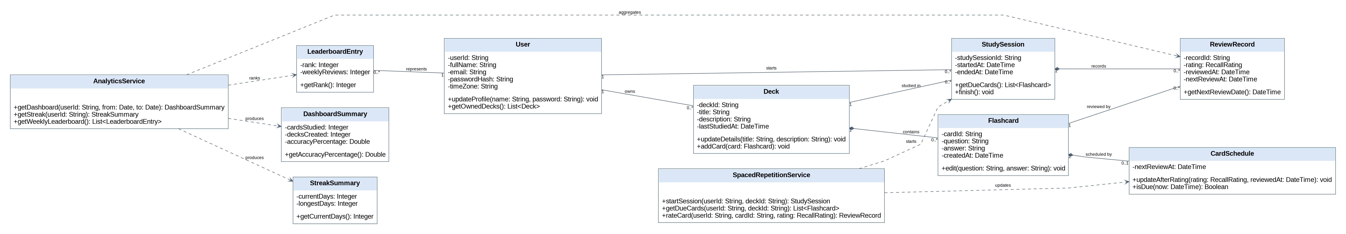

Part B – Team Integration

Exercise 3 – Consolidated inventory and design decisions
The consolidated candidate inventory contains 23 distinct classes. Shared User, Deck and Flashcard definitions appear once. Individual diagram references to these classes are merged, rather than counted as duplicates.
Class ID | Class name | Purpose / responsibility | Traceability | Contributor
C01 | User | Registered student and profile owner | UC-01–UC-05 / FR-01–FR-05 | Samer
C02 | AuthSession | Authenticated session and inactivity state | UC-01–UC-05 / FR-01–FR-05 | Samer
C03 | AccountService | Registration, login, logout, profile updates and deletion | UC-01–UC-05 / FR-01–FR-05 | Samer
C04 | Deck | Owned collection of flashcards | UC-06–UC-10 / FR-06–FR-10 | Tarik
C05 | Flashcard | Question and answer study content | UC-06–UC-10 / FR-06–FR-10 | Tarik
C06 | ManualFlashcard | Manually authored flashcard specialization | UC-06–UC-10 / FR-06–FR-10 | Tarik
C07 | AIGeneratedFlashcard | AI candidate with approval state | UC-11–UC-15 / FR-11–FR-15 | Hanin
C08 | DeckService | Owned deck and card operations | UC-06–UC-10 / FR-06–FR-10 | Tarik
C09 | GenerationJob | PDF extraction, candidates and retry status | UC-11–UC-15 / FR-11–FR-15 | Hanin
C10 | GenerationService | PDF extraction, generation and candidate review | UC-11–UC-15 / FR-11–FR-15 | Hanin
C11 | PDFFile | PDF upload payload and size/type validation | UC-11–UC-15 / FR-11–FR-15 | Hanin
C12 | OpenAIClient | External OpenAI generation interface | UC-11–UC-15 / FR-11–FR-15 | Hanin
C13 | StudySession | User review session for a chosen deck | UC-16–UC-20 / FR-16–FR-20 | Karam
C14 | ReviewRecord | Per-card recall rating and review timestamp | UC-16–UC-20 / FR-16–FR-20 | Karam
C15 | CardSchedule | Current next-due date for a flashcard | UC-16–UC-20 / FR-16–FR-20 | Karam
C16 | SpacedRepetitionService | Fetch due cards and apply recall ratings | UC-16–UC-20 / FR-16–FR-20 | Karam
C17 | AnalyticsService | Streak, dashboard and weekly leaderboard computation | UC-16–UC-20 / FR-16–FR-20 | Karam
C18 | DashboardSummary | Dashboard values for selected period | UC-16–UC-20 / FR-16–FR-20 | Karam
C19 | StreakSummary | Current and longest streak days | UC-16–UC-20 / FR-16–FR-20 | Karam
C20 | LeaderboardEntry | User ranking for weekly review activity | UC-16–UC-20 / FR-16–FR-20 | Karam
C21 | SystemAdministrator | Actor authorized to view monitoring reports | UC-21–UC-22 / Lab 4 process 6.0 | Team
C22 | MonitoringReport | Read-only performance and API metrics | UC-21–UC-22 / Lab 4 process 6.0 | Team
C23 | MonitoringService | Summarize performance and generation/API usage | UC-21–UC-22 / Lab 4 process 6.0 | Team

Consolidated UML class diagram
One connected overall model of the five functional areas and administrator monitoring. The overview below shows the whole model; the four detail views that follow enlarge each quarter so the classes, attributes and methods can be read. The full-resolution PNG is stored in the repository under Project/Object_Modeling/Class_Diagram/.
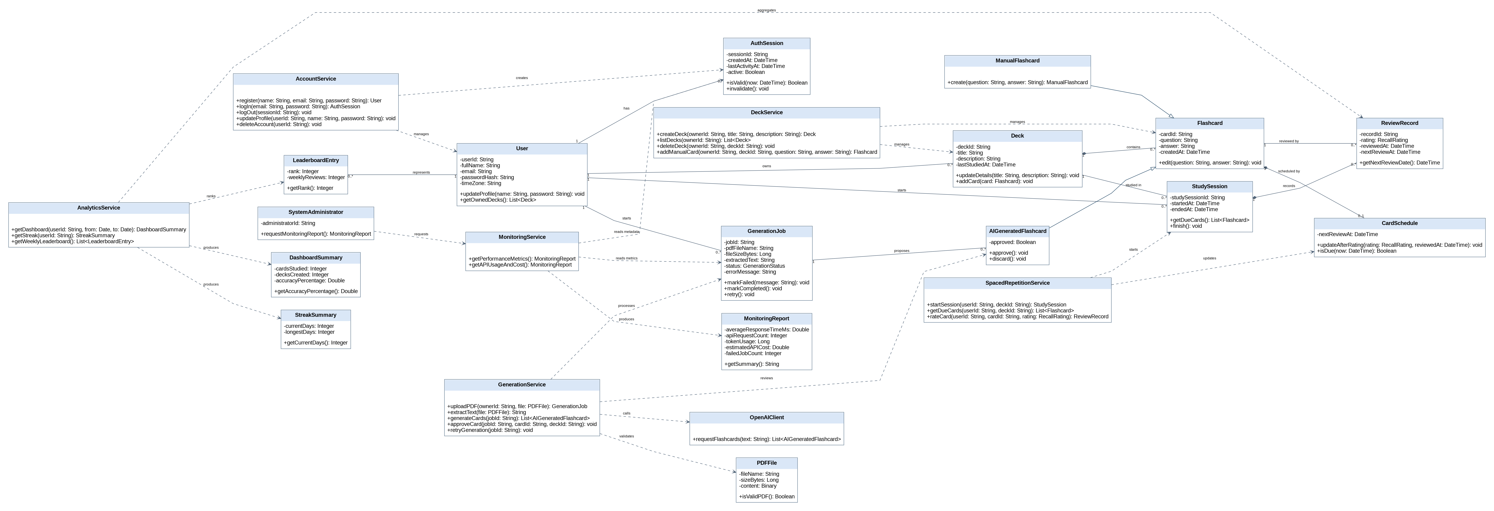
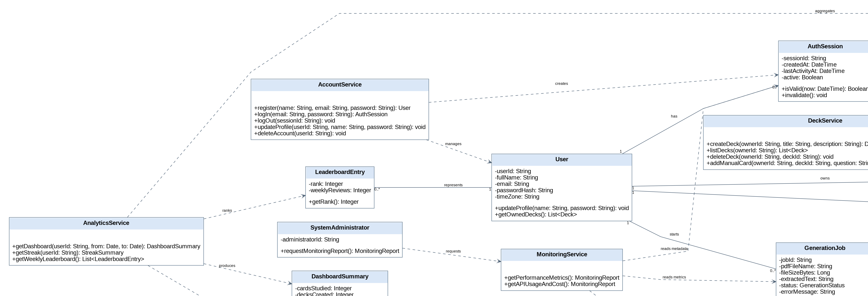
Detail A – upper left
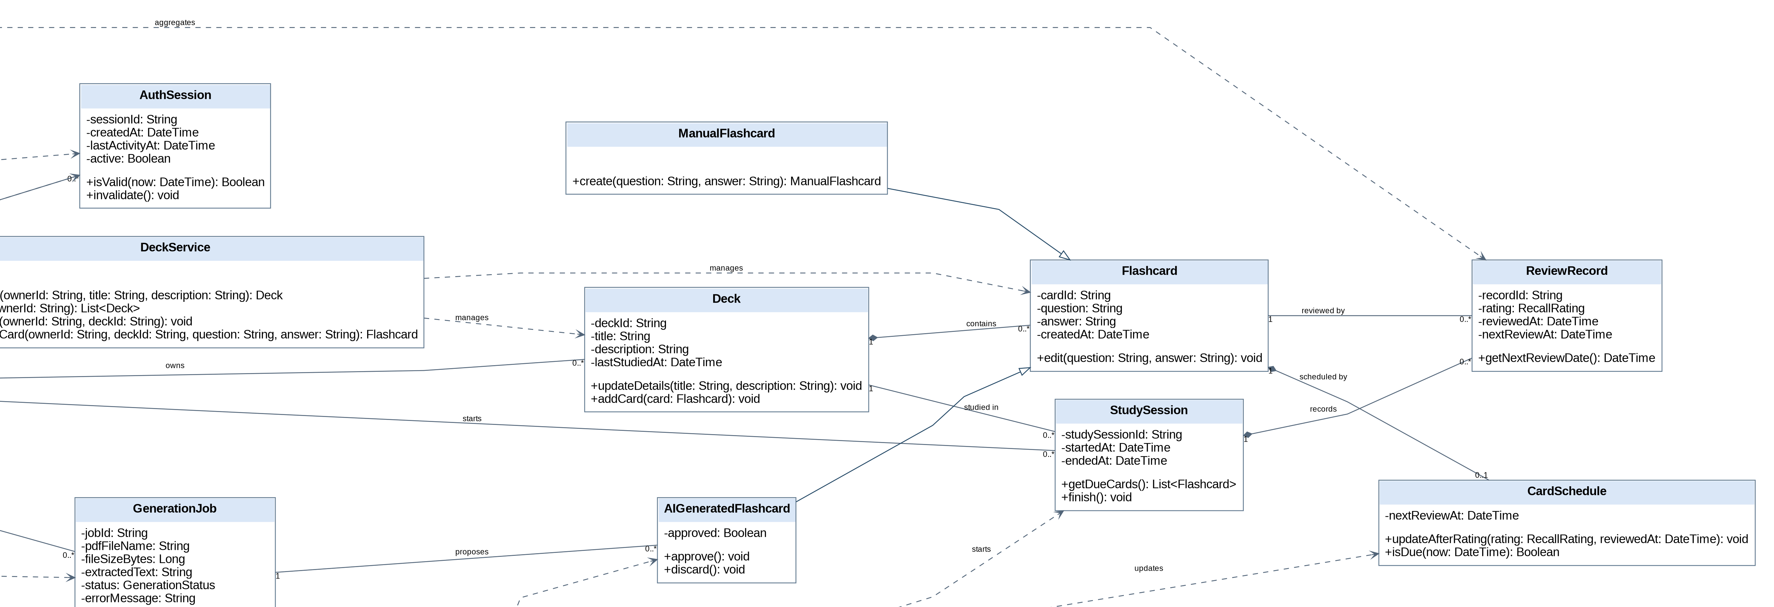
Detail B – upper right
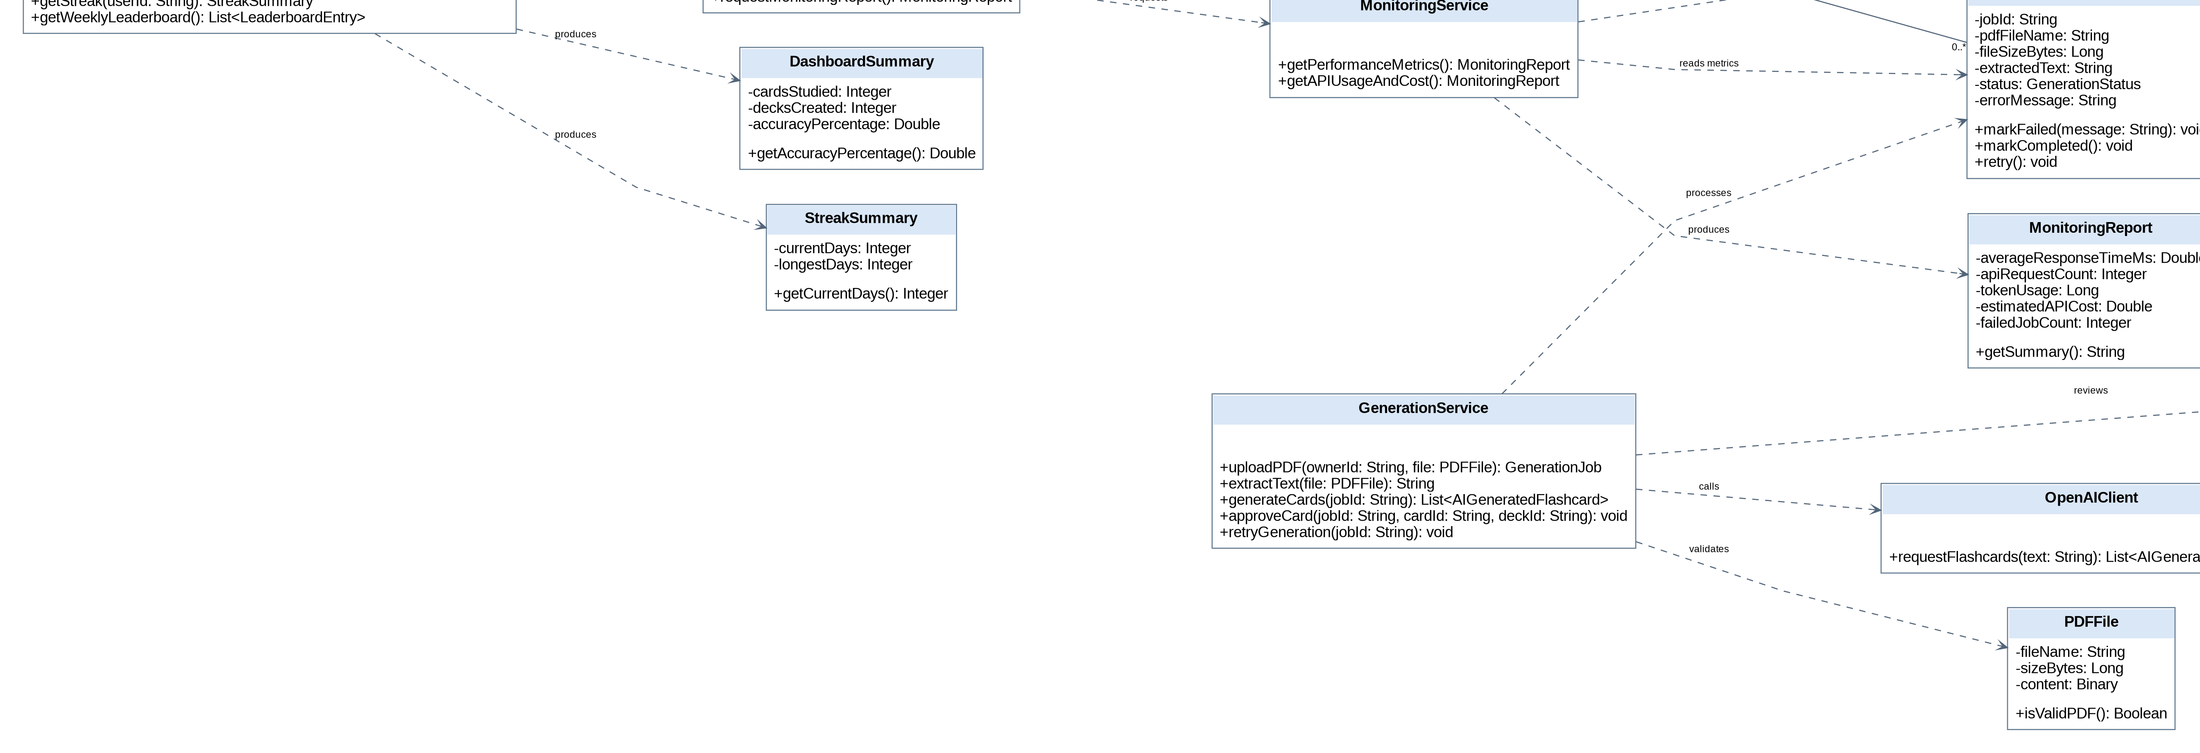
Detail C – lower left
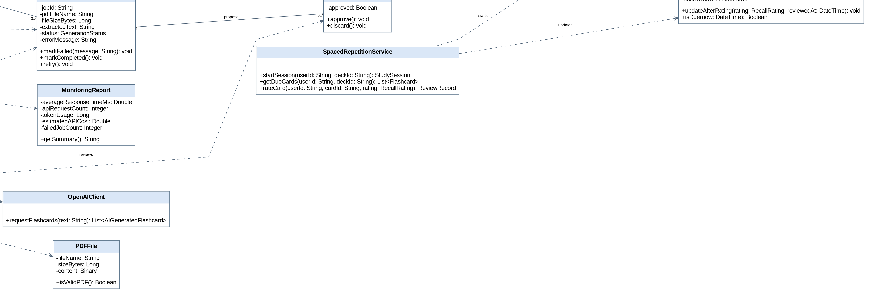
Detail D – lower right

Integration record and rationale
Integration issue | Consolidation decision / rationale
Duplicate shared classes | Merge User, Deck and Flashcard into one common definition; keep references from each team area.
Card specialization | ManualFlashcard and AIGeneratedFlashcard inherit from Flashcard. AI candidates are saved into decks only after approval.
Review history vs current schedule | ReviewRecord records each rating, while CardSchedule records the current next-due state; both correspond to D3.
System monitoring | SystemAdministrator and MonitoringService request read-only MonitoringReport data consistent with process 6.0.
Persistence boundary | No additional persistent DFD stores are invented beyond D1–D4. Domain services and summary objects need not be persistent entities.
Composition and deletion | Deck/Flashcard and StudySession/ReviewRecord are modeled as lifecycle dependencies; actual cascades must satisfy account/deck deletion requirements.
Enumerated types | RecallRating has the values Again, Hard, Good and Easy (FR-17). GenerationStatus has the values pending, completed and failed (FR-15 failure and retry).

Class model consistency and traceability
Lab 4 process / store | Representing classes | Lab 3 traceability
1.0 Manage Accounts / D1 | User, AuthSession, AccountService | FR-01–05; UC-01–05
2.0 Manage Decks and Cards / D2 | Deck, Flashcard, ManualFlashcard, DeckService | FR-06–10; UC-06–10
3.0 AI Generation / D2,D4 | PDFFile, GenerationJob, GenerationService, OpenAIClient, AIGeneratedFlashcard | FR-11–15; UC-11–15
4.0 Spaced Repetition / D2,D3 | StudySession, ReviewRecord, CardSchedule, SpacedRepetitionService | FR-16–17; UC-16–17
5.0 Analytics / D1,D2,D3 | AnalyticsService, DashboardSummary, StreakSummary, LeaderboardEntry | FR-18–20; UC-18–20
6.0 Admin Monitoring / D1,D4 | SystemAdministrator, MonitoringService, MonitoringReport | UC-21–22

Relationship and design verification
Association | Multiplicity | Reason
User — Deck | 1 to 0..* | A student can own multiple decks.
Deck — Flashcard | 1 to 0..* | Each deck contains its cards; delete cascades follow owner.
User — AuthSession | 1 to 0..* | A user can have multiple sessions over time.
User — GenerationJob | 1 to 0..* | Each generation job belongs to one student.
GenerationJob — AI cards | 1 to 0..* | Job may yield multiple candidates.
User — StudySession | 1 to 0..* | Student may begin multiple sessions.
Deck — StudySession | 1 to 0..* | Session works on one selected deck.
StudySession — ReviewRecord | 1 to 0..* | Each review belongs to one study session.
Flashcard — ReviewRecord | 1 to 0..* | A card can have multiple historic reviews.
Flashcard — CardSchedule | 1 to 0..1 | Card may have no schedule before initial review.
LeaderboardEntry — User | 0..* to 1 | A snapshot entry references a single student.

