COE420L – Software Engineering
Lab 6: UML Sequence Diagram Modeling
Project: StudyBuddy – AI-Assisted Flashcard Web Application

Team Members
Full Name | AUS ID | GitHub Username
Samer Salem | B00099718 | samer123293
Tarik Mamlouk | B00102420 | tarikmamlouk
Hanin Hamida | G00101852 | g00101852-design
Karam Sawas | B00100437 | b00100437-sketch
Repository: https://github.com/COE420-Eltop-F26/Study-Buddy

Exercise 1 – Select Major Use Cases
Use Case ID | Name | Primary Actor | Purpose | Reason for Selection
UC-05 | Delete Account | Student | Permanently delete user data | Addresses corrected Lab 4 deletion flow and transactional cleanup.
UC-06 | Create Deck | Student | Create an owned flashcard deck | Covers authentication, deck ownership, and a core CRUD operation.
UC-13 | Generate Flashcards via AI | Student | Generate candidate Q/A from a PDF | Covers PDF validation, external API, success/failure and generation jobs.
UC-14 | Review AI-Generated Flashcards | Student | Edit, approve or discard candidates | Demonstrates iterative conditional approval; only approved cards are saved.
UC-17 | Rate Card Recall | Student | Rate studied flashcards and reschedule them | Covers historical reviews, due schedule, and four recall ratings.
Selected workflows represent all four team areas. UC-13 and UC-14 are separate diagrams because generation and user approval are distinct use cases; the generation result remains a candidate until reviewed.

Exercise 2 – UC-05: Delete Account
Contributor area: Samer Salem. Actor: Student. Participants: Student, AccountService, User, DeckService, SpacedRepetitionService, AuthSession.
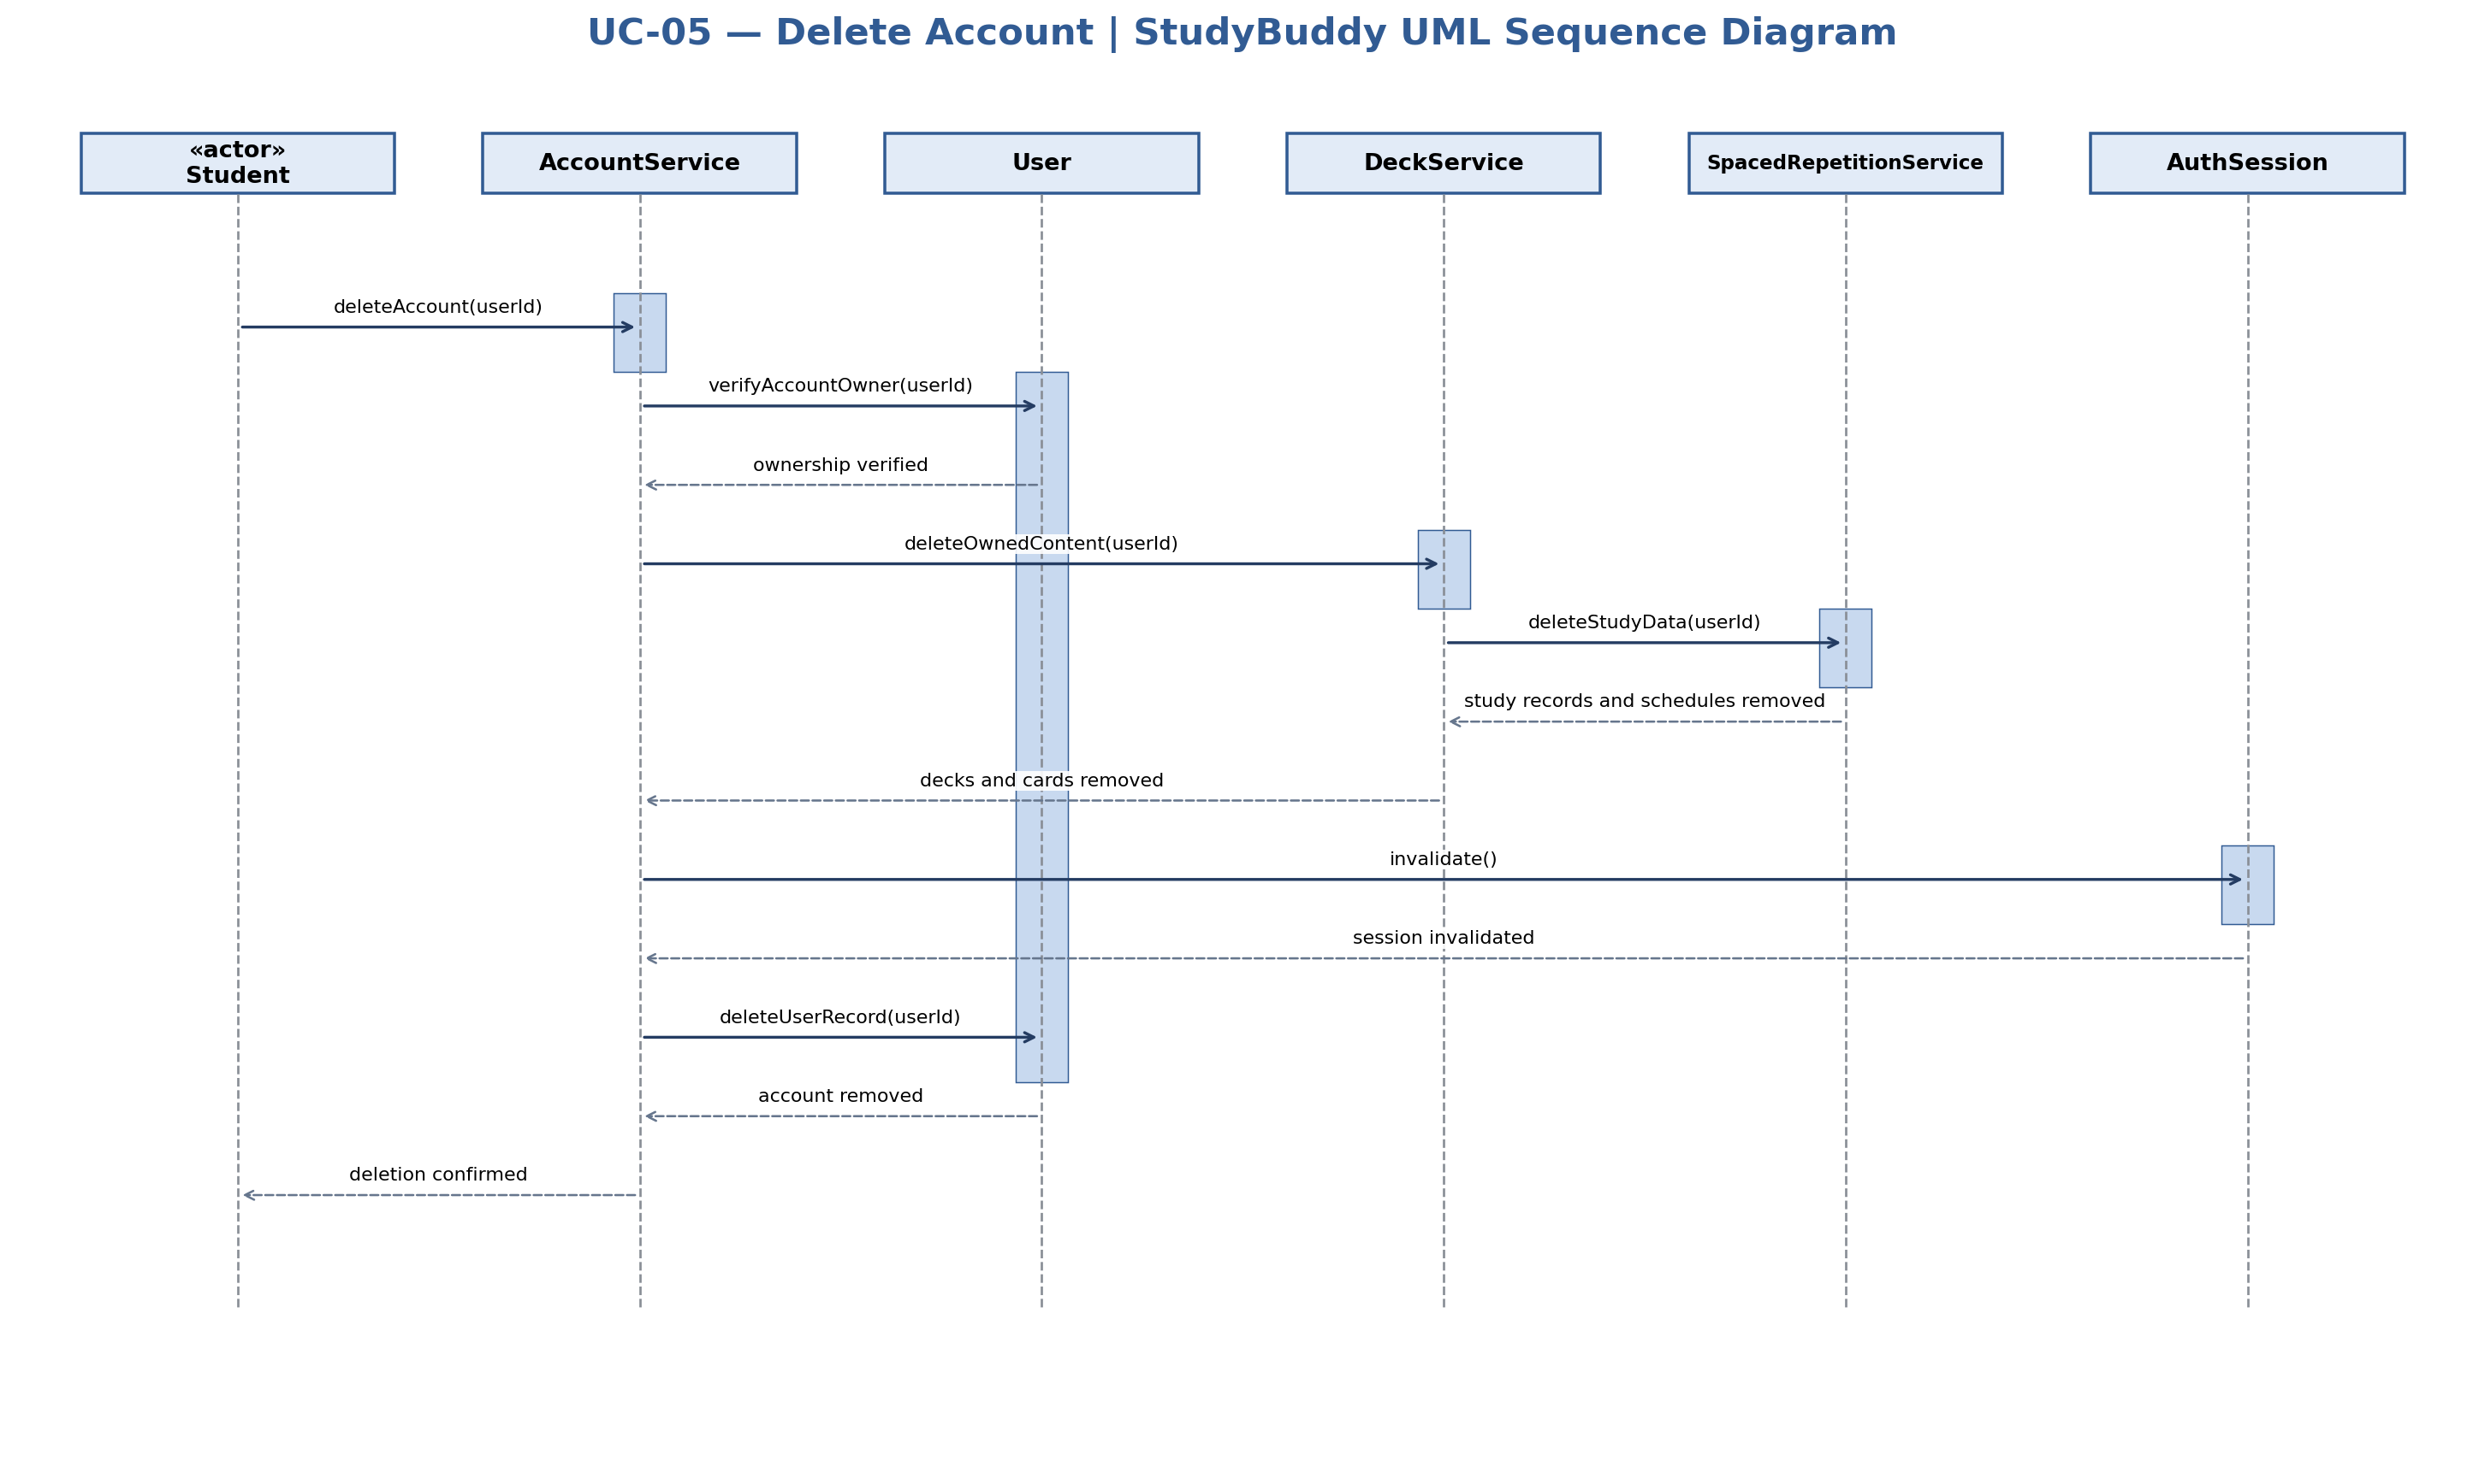

Exercise 2 – UC-06: Create Deck
Contributor area: Tarik Mamlouk. Actor: Student. Participants: Student, AuthSession, DeckService, User, Deck.
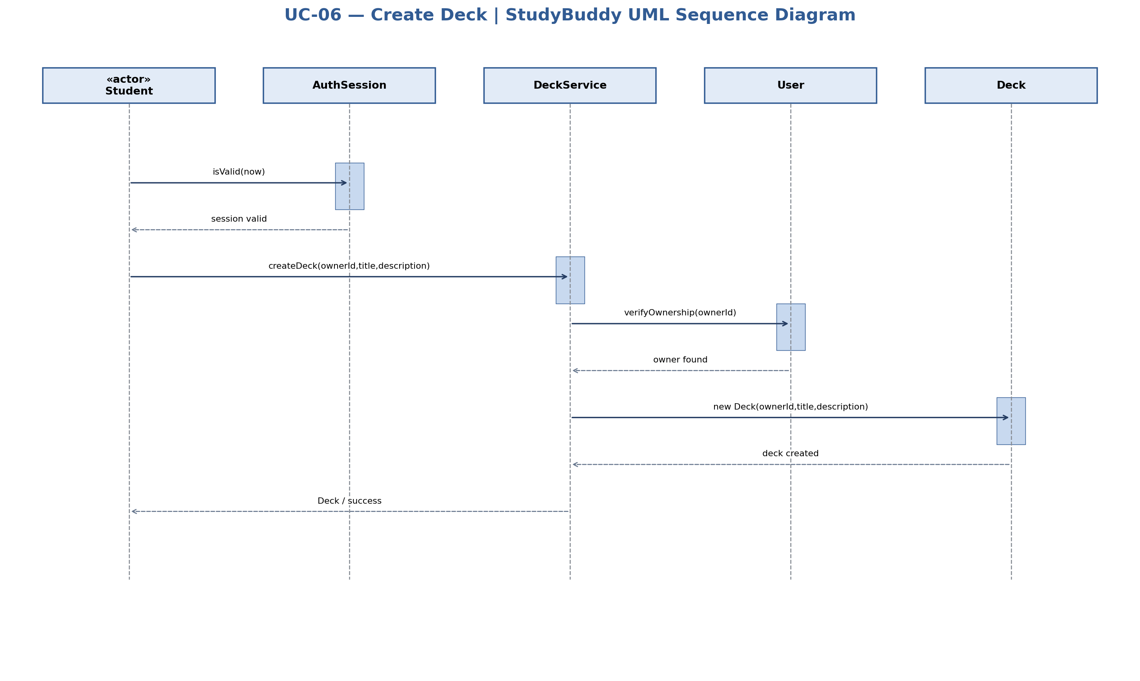

Exercise 2 – UC-13: Generate Flashcards via AI
Contributor area: Hanin Hamida. Actor: Student. Participants: Student, GenerationService, PDFFile, GenerationJob, OpenAIClient.
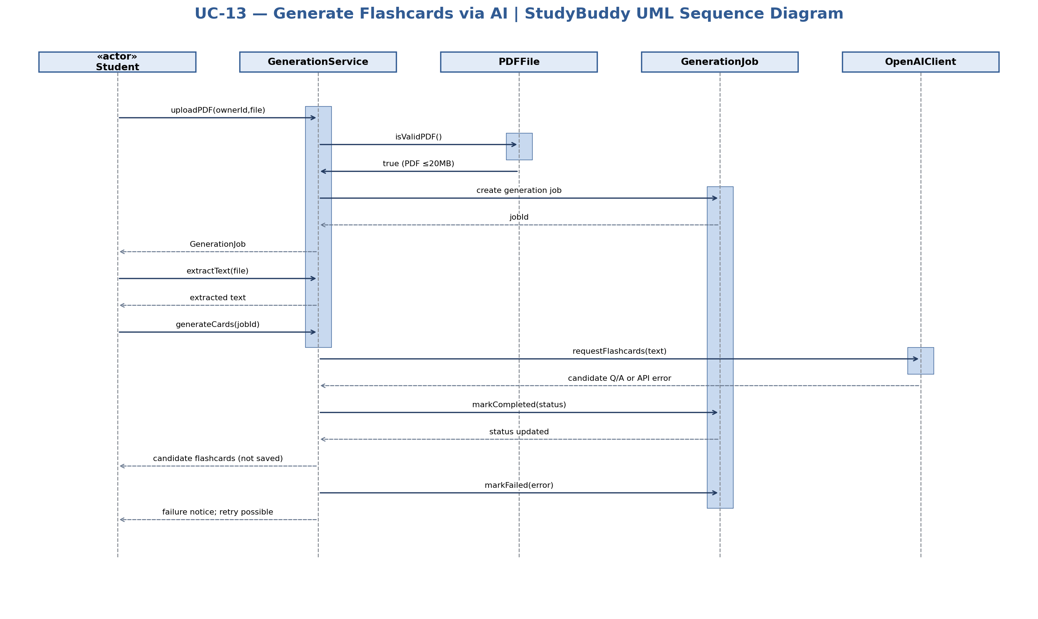

Exercise 2 – UC-14: Review AI-Generated Flashcards
Contributor area: Hanin Hamida. Actor: Student. Participants: Student, GenerationService, GenerationJob, AIGeneratedFlashcard, Deck.
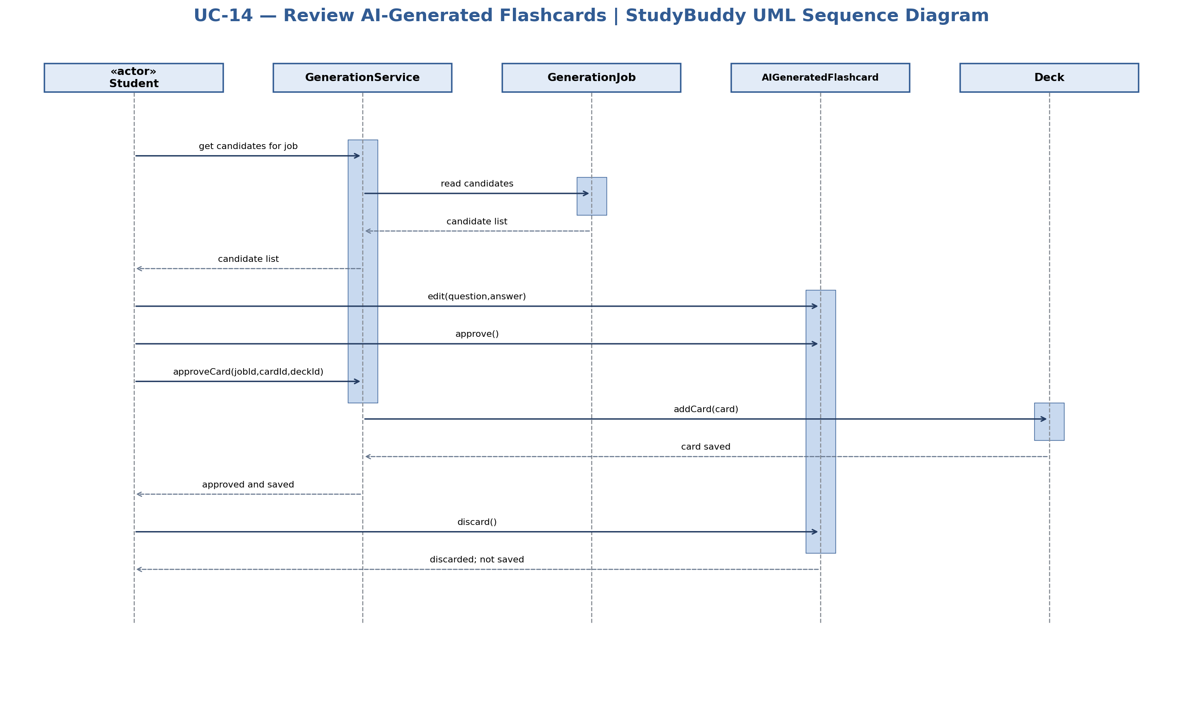

Exercise 2 – UC-17: Rate Card Recall
Contributor area: Karam Sawas. Actor: Student. Participants: Student, SpacedRepetitionService, StudySession, Flashcard, CardSchedule, ReviewRecord.
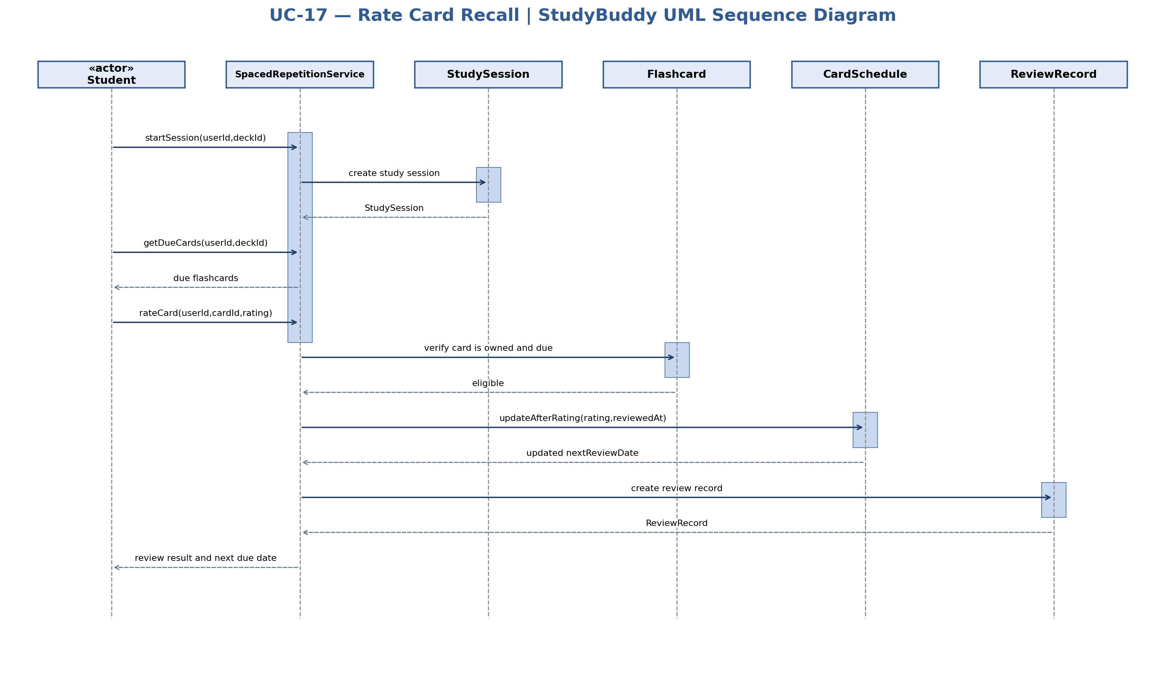

Exercise 3 – Consistency Verification
Diagram | Lab 3 traceability | Lab 5 classes | Lab 4 process / store check
UC-05 | FR-05, NFR-04; UC-05 | AccountService, User, AuthSession, DeckService, SpacedRepetitionService | Corrected Lab 4: deletion affects D1, D2 and D3; atomic cleanup
UC-06 | FR-06; UC-06 | AuthSession, DeckService, User, Deck | Lab 4 process 2.0, store D2; owner/session requirements
UC-13 | FR-11–FR-13, FR-15; UC-13 | PDFFile, GenerationService, GenerationJob, OpenAIClient | Lab 4 process 3.0, store D4 and external OpenAI API
UC-14 | FR-14; UC-14 | GenerationService, GenerationJob, AIGeneratedFlashcard, Deck | Lab 4 process 3.0, approved cards to D2 only
UC-17 | FR-16–FR-17; UC-17 | SpacedRepetitionService, StudySession, Flashcard, CardSchedule, ReviewRecord | Lab 4 process 4.0, stores D2 and D3

Verification findings and class model reconciliation
- Every diagram uses a selected approved use case and the Student actor. The OpenAI API is represented by the existing OpenAIClient class, not by a new internal actor.
- Methods already present in Lab 5 are reused verbatim where possible: deleteAccount, createDeck, uploadPDF, extractText, generateCards, requestFlashcards, approveCard, approve, discard, addCard, startSession, getDueCards, rateCard, updateAfterRating, isValid and invalidate.
- Some design-level calls are not explicitly specified as operations in Lab 5. These must be added to the relevant class operations if the team adopts the diagrams.
- Account deletion is coordinated as one transaction across D1, D2 and D3, addressing the instructor’s Lab 4 deduction. The account owner must be authenticated and authorized; rollback is required by NFR-04.
- The diagrams use lifelines, ordered messages, dashed returns, activation bars, iteration and guarded alt fragments. No additional persistent data stores beyond D1–D4 are assumed.
- The tool-generated sequence diagrams are design models; they do not establish that the application or database transactions have been implemented or tested.

AI Usage Declaration
ChatGPT was used to help review the UML sequence diagrams, check their consistency with previous labs, and verify alignment with the lab requirements.

