COE420L – Software Engineering
Lab 4: Data Flow Modeling and Project Scheduling
Project: StudyBuddy – AI-Assisted Flashcard Web Application
Team Members
Full Name | AUS ID | GitHub Username
Samer Salem | B00099718 | samer123293
Tarik Mamlouk | B00102420 | tarikmamlouk
Hanin Hamida | G00101852 | g00101852-design
Karam Sawas | B00100437 | b00100437-sketch

Repository Link:
https://github.com/COE420-Eltop-F26/Study-Buddy
Exercise 1: Context Diagram
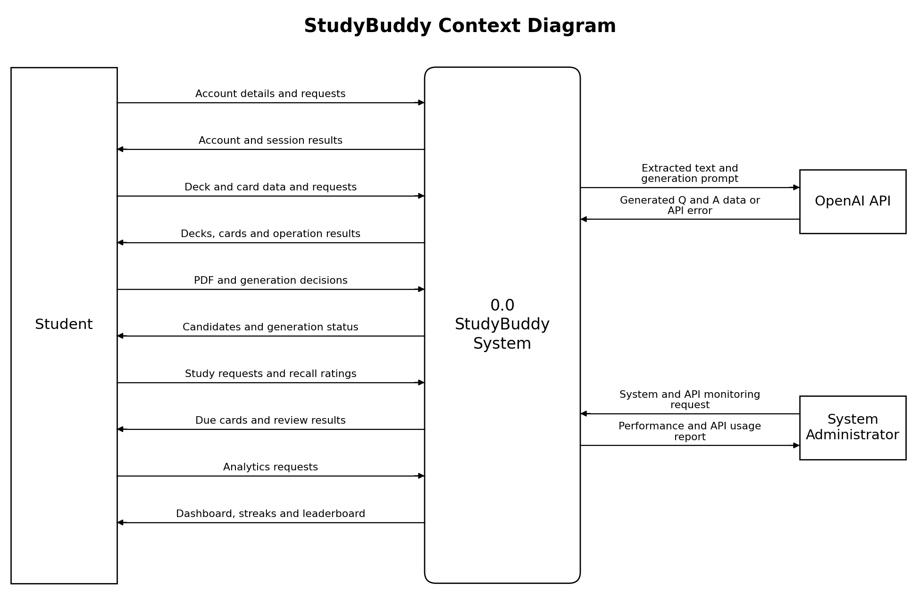
Figure 1. StudyBuddy Context Diagram.

Exercise 2: Level-0 Data Flow Diagram
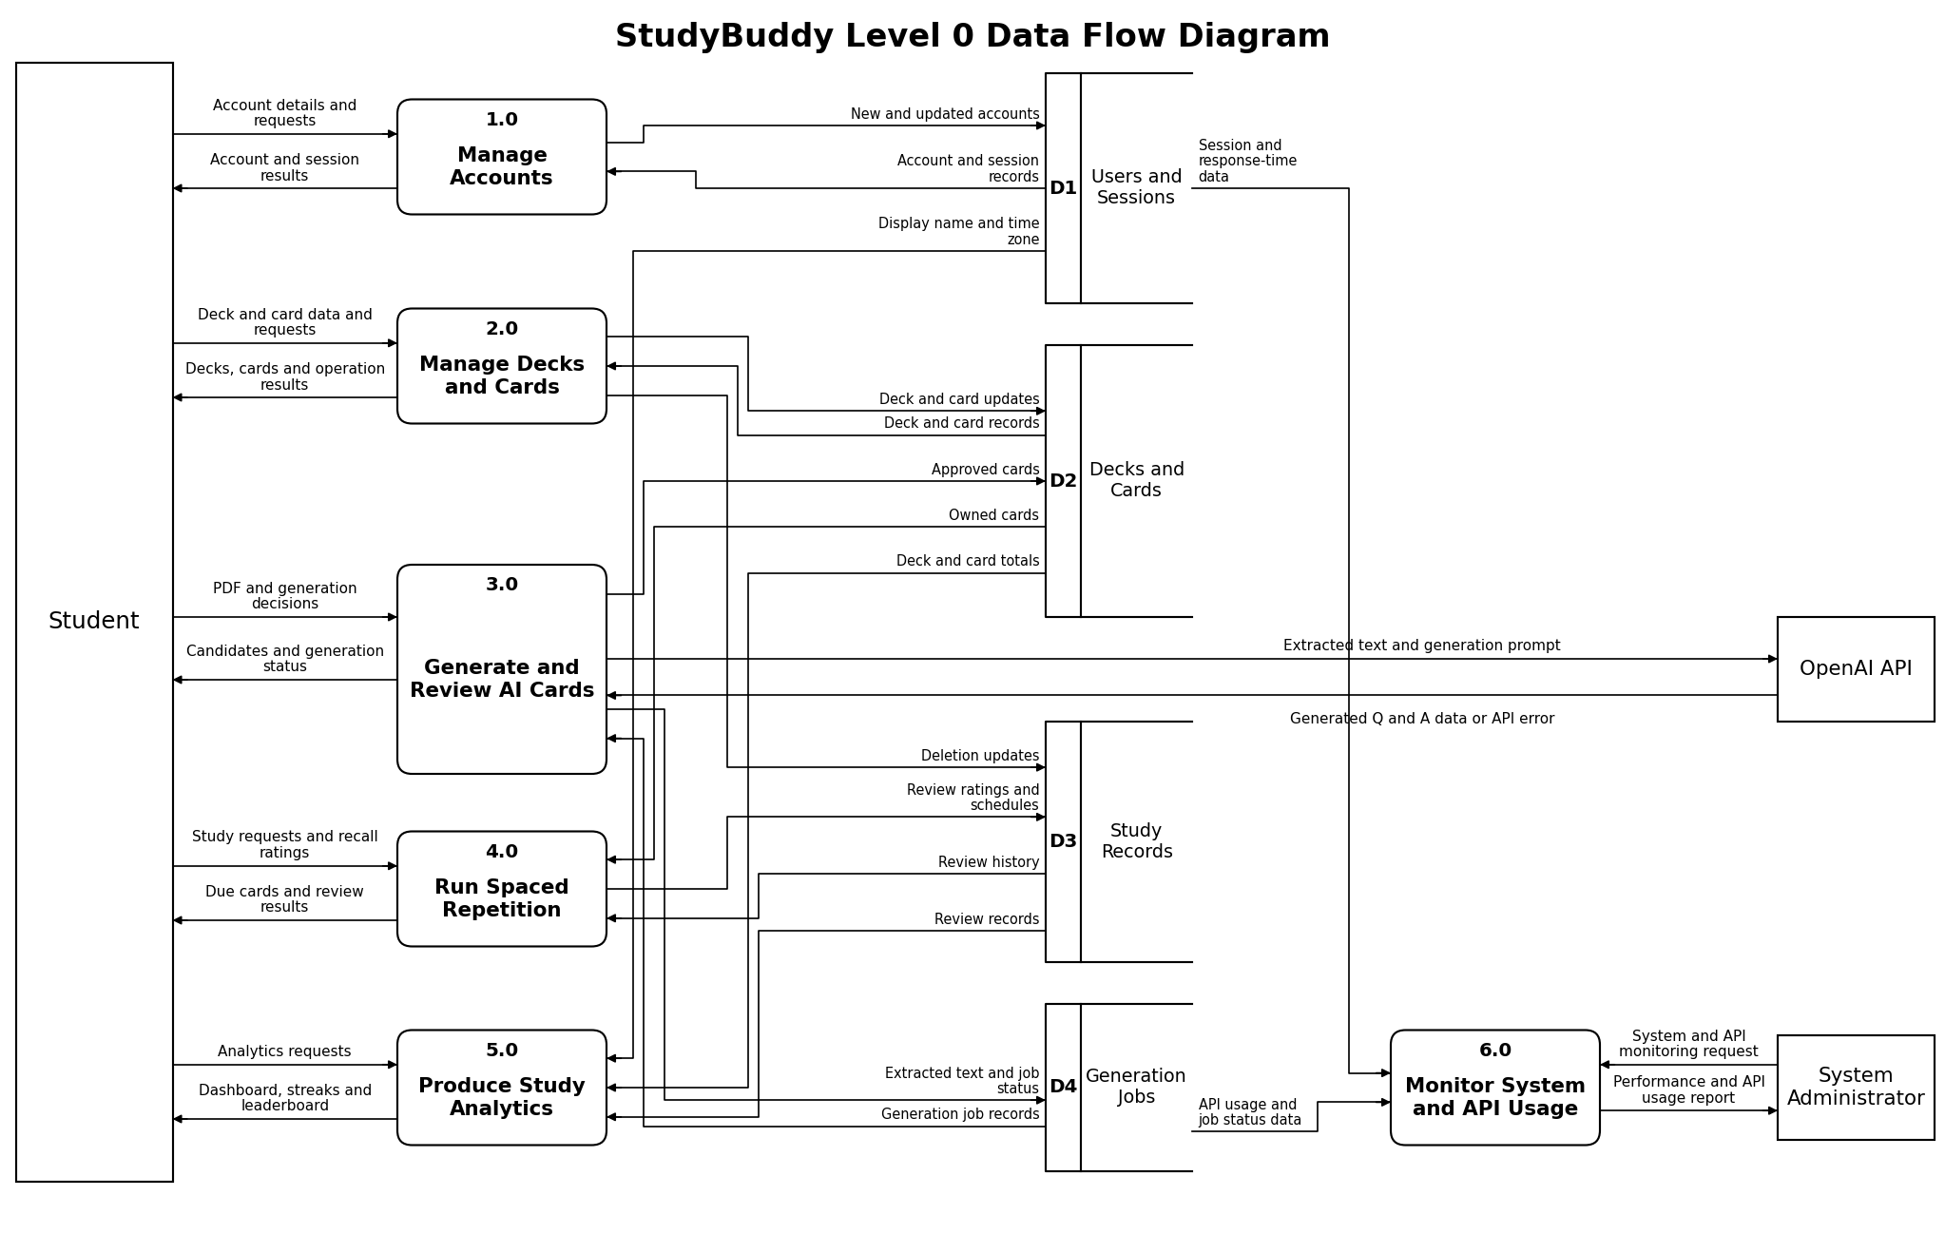
Figure 2. StudyBuddy Level-0 DFD. The data stores D1–D4 are in the middle and each is drawn once; the Student, OpenAI API and System Administrator are each drawn once.

Data Stores
Store | Name | Stored data
D1 | Users and Sessions | Accounts, authentication and session data, display name, time zone.
D2 | Decks and Cards | Deck ownership, card content, deck and card totals.
D3 | Study Records | Review history, ratings, due dates, timestamps and study activity.
D4 | Generation Jobs | Extracted PDF text, generated candidates and AI generation job status.
Exercise 3: Core Processes Matrix
Process number and name | Input data | Output data | Rules
1.0 Manage Accounts | Account details; registration, login, logout, profile update and account deletion requests; user and session records from D1. | Account and session results; new and updated account and session records to D1. | Validate the full name, email and password on registration; store passwords as salted hashes; authenticate credentials; create and end sessions; only the account owner can update the profile or delete the account, and deleting an account removes its decks, cards and study data.
2.0 Manage Decks and Cards | Deck and card data and requests; deck and card records from D2. | Decks, cards and operation results; deck and card updates to D2; deletion updates to D3. | Require a valid session; enforce ownership; validate deck and card fields; create, view, edit and delete only the user's own content; deletion updates related study records.
3.0 Generate and Review AI Cards | PDF and generation decisions (review, edit, discard, approve, retry); generated Q and A data or API error from the OpenAI API; generation job records from D4. | Candidates and generation status; extracted text and generation prompt to the OpenAI API; extracted text and job status to D4; approved cards to D2. | Accept only PDF files up to 20 MB; extract text with Apache PDFBox; send the extracted text to OpenAI; on failure show an error and keep the job data so the user can retry; save only the cards the user has reviewed and approved.
4.0 Run Spaced Repetition | Study requests and recall ratings; owned cards from D2; review history from D3. | Due cards and review results; review ratings and schedules to D3. | Show only the user's own cards that are due; accept Again, Hard, Good and Easy ratings; recalculate the next review date after every rating; record each review.
5.0 Produce Study Analytics | Analytics requests; display name and time zone from D1; deck and card totals from D2; review records from D3. | Dashboard, streaks and leaderboard. | Aggregate the user's study history and totals; calculate accuracy and streaks in the user's time zone; rank weekly activity for the leaderboard; return display data only.
6.0 Monitor System and API Usage | System and API monitoring request; session and response-time data from D1; API usage and job status data from D4. | Performance and API usage report. | Read-only access to D1 and D4 metadata; never modify user, deck, card or study data; summarize response-time and job-status metrics and OpenAI usage and cost for the System Administrator.
DFD Balancing Check
Flow group | Context Diagram | Level-0 DFD
Student → system (5 flows) | Account details and requests; deck and card data and requests; PDF and generation decisions; study requests and recall ratings; analytics requests | Enter 1.0, 2.0, 3.0, 4.0 and 5.0 respectively
System → Student (5 flows) | Account and session results; decks, cards and operation results; candidates and generation status; due cards and review results; dashboard, streaks and leaderboard | Leave 1.0, 2.0, 3.0, 4.0 and 5.0 respectively
System ↔ OpenAI API | Extracted text and generation prompt (out); generated Q and A data or API error (in) | Same two flows between 3.0 and the OpenAI API
System ↔ System Administrator | System and API monitoring request (in); performance and API usage report (out) | Same two flows between 6.0 and the System Administrator
Data stores | None shown in the Context Diagram | D1–D4 appear only in the Level-0 DFD, each drawn once

Exercise 4: Work Breakdown Structure (WBS)
ID | Task name | Description | Predecessors | Days
T1 | Refine StudyBuddy requirements | Consolidate the Lab 2 and Lab 3 requirements, use cases and actors into the final project baseline. | None | 2
T2 | Design database and DAO layer | Design the database tables and the DAO layer for users, decks, cards, study records and generation jobs. | T1 | 3
T3 | Design web UI and navigation | Design the web pages, navigation and wireframes for the student and administrator views. | T1 | 3
T4 | Implement authentication and accounts | Deliver registration, login, logout, profile update and account deletion with session handling. | T2, T3 | 4
T5 | Implement deck and card management | Deliver deck create/edit/delete, manual card entry and deck list views. | T4 | 5
T6 | Implement PDF upload and text extraction | Deliver PDF upload, validation and text extraction. | T4 | 3
T7 | Implement AI generation and review | Connect the OpenAI API, generate candidate cards, review and approve cards, and retry failed jobs. | T5, T6 | 5
T8 | Implement spaced repetition | Deliver study sessions, recall ratings and next-review scheduling. | T5 | 4
T9 | Implement analytics and leaderboard | Deliver streaks, the study dashboard and the leaderboard. | T8 | 4
T10 | Implement admin monitoring dashboard | Deliver the system performance and OpenAI API usage and cost views for the administrator. | T6 | 2
T11 | Integrate, test, and prepare demo | Integrate all modules, run end-to-end tests and prepare the final demonstration and documentation. | T7, T9, T10 | 4

Exercise 5: Gantt Chart
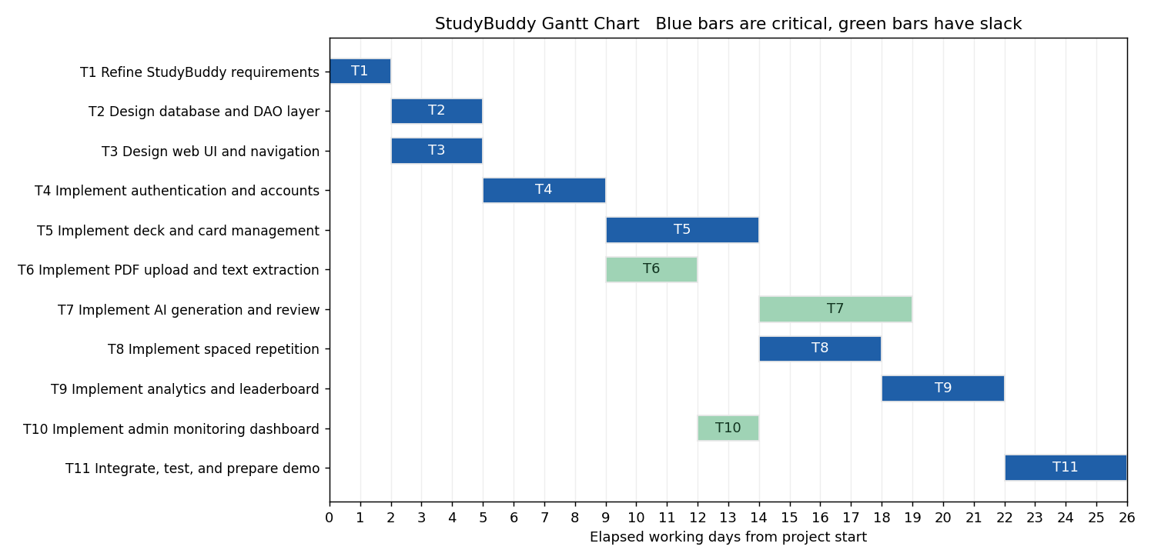
Figure 3. StudyBuddy Gantt Chart (blue bars are critical, green bars have slack).

Exercise 6: Network-Based Scheduling
The expected time E of each task is the duration estimate given for it in the WBS (Exercise 4). Each box shows ES and EF above it, Task / Slack / E inside it, and LS and LF below it. Blue boxes are critical and green boxes have slack. Days are numbered 1 through 26.
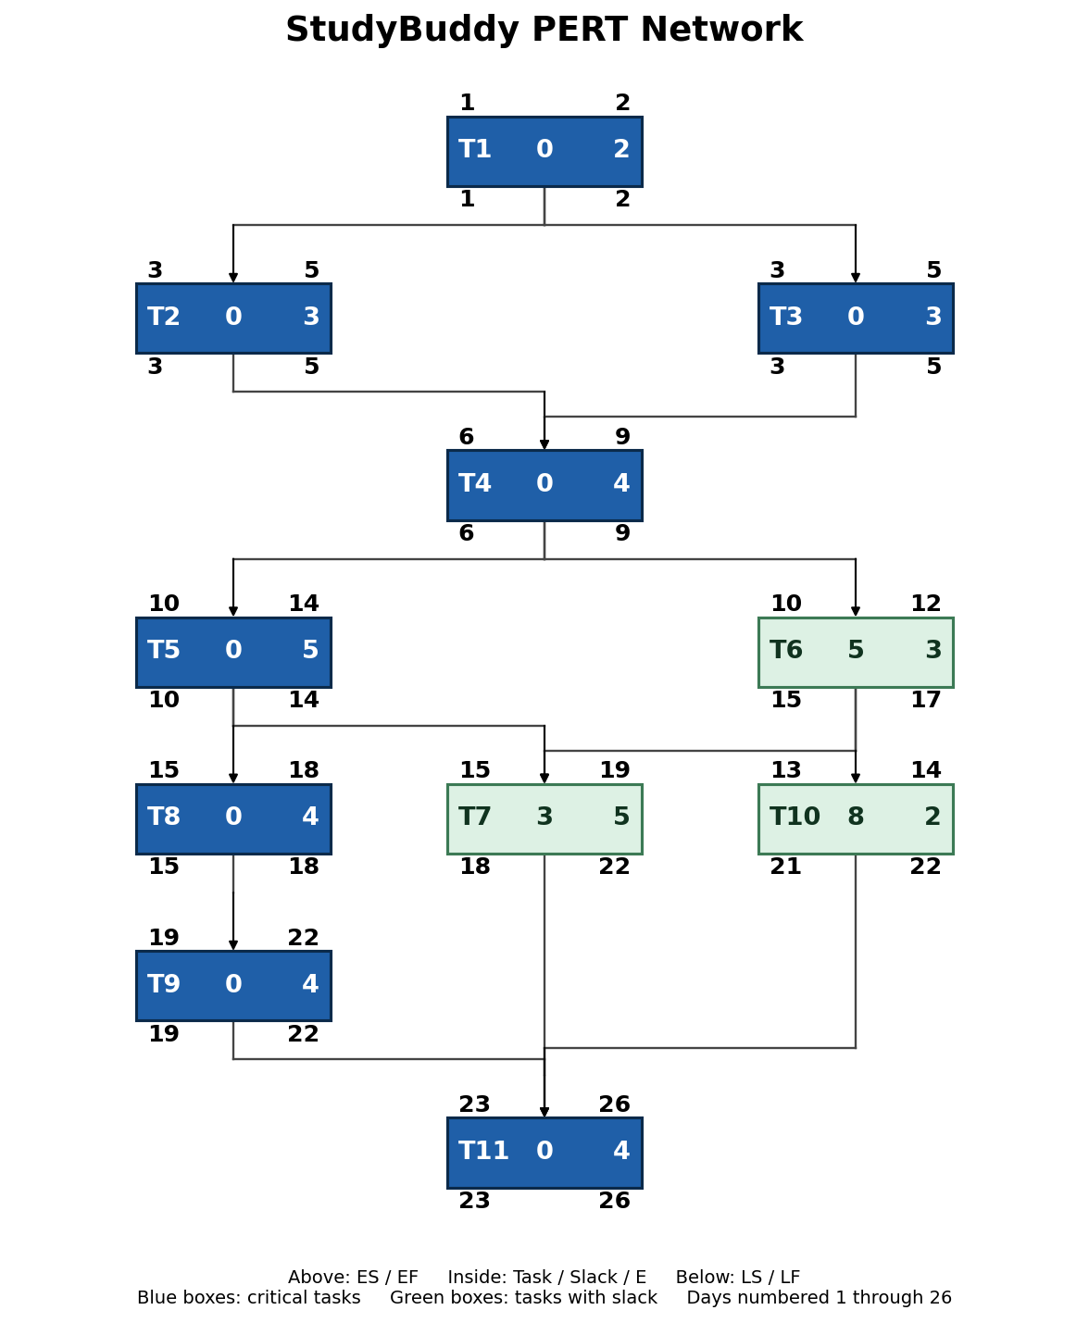
Figure 4. StudyBuddy PERT Network.
Full Forward and Backward Pass Calculations
The values were calculated by hand using ES = max(EF of predecessors), EF = ES + E, LF = min(LS of successors), LS = LF − E and Slack = LS − ES. Day 0 is the project start in these formulas; the diagram numbers days from 1, so its ES and LS values are shown as the formula value + 1.
Task | Forward pass | Backward pass | Slack
T1 | ES = max(0) = 0; EF = 0 + 2 = 2 | LF = min(2, 2) = 2; LS = 2 − 2 = 0 | 0 − 0 = 0
T2 | ES = max(2) = 2; EF = 2 + 3 = 5 | LF = min(5) = 5; LS = 5 − 3 = 2 | 2 − 2 = 0
T3 | ES = max(2) = 2; EF = 2 + 3 = 5 | LF = min(5) = 5; LS = 5 − 3 = 2 | 2 − 2 = 0
T4 | ES = max(5, 5) = 5; EF = 5 + 4 = 9 | LF = min(9, 14) = 9; LS = 9 − 4 = 5 | 5 − 5 = 0
T5 | ES = max(9) = 9; EF = 9 + 5 = 14 | LF = min(17, 14) = 14; LS = 14 − 5 = 9 | 9 − 9 = 0
T6 | ES = max(9) = 9; EF = 9 + 3 = 12 | LF = min(17, 20) = 17; LS = 17 − 3 = 14 | 14 − 9 = 5
T7 | ES = max(14, 12) = 14; EF = 14 + 5 = 19 | LF = min(22) = 22; LS = 22 − 5 = 17 | 17 − 14 = 3
T8 | ES = max(14) = 14; EF = 14 + 4 = 18 | LF = min(18) = 18; LS = 18 − 4 = 14 | 14 − 14 = 0
T9 | ES = max(18) = 18; EF = 18 + 4 = 22 | LF = min(22) = 22; LS = 22 − 4 = 18 | 18 − 18 = 0
T10 | ES = max(12) = 12; EF = 12 + 2 = 14 | LF = min(22) = 22; LS = 22 − 2 = 20 | 20 − 12 = 8
T11 | ES = max(19, 22, 14) = 22; EF = 22 + 4 = 26 | LF = project end = 26; LS = 26 − 4 = 22 | 22 − 22 = 0

Exercise 7: Critical Path
Critical Paths
Critical Path 1: T1 → T2 → T4 → T5 → T8 → T9 → T11
Critical Path 2: T1 → T3 → T4 → T5 → T8 → T9 → T11
Expected project duration: 26 days
Explanation
T2 and T3 both take 3 days after T1 and T4 needs both, so both branches have zero slack. After T4 the longest chain is T5 → T8 → T9 → T11, and every task on it has zero slack, so a delay to any of them delays the whole project. T6 has 5 days of slack, T7 has 3 days of slack because T7 only has to finish before T11 starts on day 23, and T10 has 8 days of slack because it only depends on T6.
All Paths from T1 to T11
Path | Durations | Total (days) | Status
T1 → T2 → T4 → T5 → T7 → T11 | 2 + 3 + 4 + 5 + 5 + 4 | 23 | Not critical
T1 → T2 → T4 → T5 → T8 → T9 → T11 | 2 + 3 + 4 + 5 + 4 + 4 + 4 | 26 | Critical
T1 → T2 → T4 → T6 → T7 → T11 | 2 + 3 + 4 + 3 + 5 + 4 | 21 | Not critical
T1 → T2 → T4 → T6 → T10 → T11 | 2 + 3 + 4 + 3 + 2 + 4 | 18 | Not critical
T1 → T3 → T4 → T5 → T7 → T11 | 2 + 3 + 4 + 5 + 5 + 4 | 23 | Not critical
T1 → T3 → T4 → T5 → T8 → T9 → T11 | 2 + 3 + 4 + 5 + 4 + 4 + 4 | 26 | Critical
T1 → T3 → T4 → T6 → T7 → T11 | 2 + 3 + 4 + 3 + 5 + 4 | 21 | Not critical
T1 → T3 → T4 → T6 → T10 → T11 | 2 + 3 + 4 + 3 + 2 + 4 | 18 | Not critical
Tool-Based Verification
The forward and backward passes were recomputed with a short Python script that reads the same task list, durations and predecessors as the WBS. It returned a project duration of 26 days, the same eight zero-slack tasks (T1, T2, T3, T4, T5, T8, T9, T11) and the same slack values as the manual table above.
Item | Manual result | Script result
Project duration | 26 days | 26 days
Zero-slack tasks | T1, T2, T3, T4, T5, T8, T9, T11 | T1, T2, T3, T4, T5, T8, T9, T11
Non-critical slack | T6 = 5; T7 = 3; T10 = 8 | T6 = 5; T7 = 3; T10 = 8
Integration and Consistency Check
Check | Result
Context vs. Level-0 | The same three external entities (Student, OpenAI API, System Administrator) and the same external data flows appear in both diagrams, so the diagrams balance.
Level-0 vs. Core Processes Matrix | The six processes, their inputs and outputs, and the D1–D4 references in the matrix match the Level-0 DFD flow by flow.
Earlier labs | The six processes cover the five feature groups and System Administration area of the revised Lab 3 (22 use cases UC-01 to UC-22, three actors). The WBS follows the Incremental model chosen in Lab 2.
WBS vs. Gantt vs. PERT | All three use the same eleven tasks (T1–T11), durations and predecessors.
PERT vs. Critical Path | The calculations give 26 days, two critical paths (through T2 or T3) and slack of 5, 3 and 8 days for T6, T7 and T10.

