COE420L Lab 5 Object Modeling for ONE
Name | ID
Nadine Alameldin | g00098602
Razan El Gendy | g00099305
Kholoud Elkholy | g00099492
Tala Abed | g00099746

Repository: https://github.com/COE420-TOPelTOP-F26/ERP-APP
Part A Individual Object Modeling
Exercise 1 Candidate Class Inventories
Tala Abed g00099746 UC-01–UC-05
ID | Class | Responsibility and justification | Use cases
TA-01 | Employee | Submits employee requests and asks policy questions. | UC-01, UC-03, UC-04, UC-05
TA-02 | Manager | Reviews direct reports’ leave and records decisions. | UC-02
TA-03 | EmployeeRequest {abstract} | Shares request identity, status, submission and validation. | UC-01, UC-03, UC-04
TA-04 | LeaveRequest | Stores leave dates, type and reason. | UC-01, UC-02
TA-05 | LeaveBalance | Checks remaining leave days by type. | UC-01, UC-02
TA-06 | ApprovalDecision | Records a reviewer’s decision, comment and time. | UC-02
TA-07 | TravelExpenseClaim | Groups travel expenses and calculates the claim total. | UC-03
TA-08 | ExpenseItem | Stores an expense category, amount and date. | UC-03
TA-09 | Receipt | Stores the receipt supporting an expense item. | UC-03
TA-10 | ITAsset | Tracks borrowable equipment and availability. | UC-04
TA-11 | AssetBorrowRequest | Requests an asset for a specified period. | UC-04
TA-12 | ONEAIAssistant | Answers policy questions using approved documents. | UC-05
TA-13 | PolicyQuestion | Stores an employee’s policy question. | UC-05
TA-14 | AIAnswer | Stores an answer, confidence and source link. | UC-05
TA-15 | PolicyDocument | Provides an approved source for policy answers. | UC-05
Nadine Alameldin g00098602 UC-06–UC-10
ID | Class | Responsibility and justification | Use cases
NA-01 | Employee | Owns attendance, payslips and request history. | UC-06, UC-07, UC-09, UC-10
NA-02 | HRUser | Publishes announcements as an authorized HR employee. | UC-08
NA-03 | Department | Groups employees for directory searches. | UC-07
NA-04 | EmployeeDirectory | Searches by name, department or position. | UC-07
NA-05 | AttendanceRecord | Stores daily entry/exit times and working hours. | UC-06
NA-06 | AttendanceSummary | Summarizes weekly attendance records and totals. | UC-06
NA-07 | Announcement | Stores announcement text and publication time. | UC-08
NA-08 | Notification | Shows an employee a triggered notification. | UC-08
NA-09 | Payslip | Represents an ERP salary statement. | UC-09
NA-10 | PayslipItem | Stores an earning or deduction line. | UC-09
NA-11 | ERPConnector | Retrieves ERP payslips and handles cached fallback. | UC-09
NA-12 | ServiceRequest {abstract} | Shares identity and status across request history. | UC-10
NA-13 | AssetExtensionRequest | Requests a later due date for a loan. | UC-10
NA-14 | RequestStatusChange | Records a request’s status change and author. | UC-10
Razan El Gendy g00099305 UC-11–UC-15
ID | Class | Responsibility and justification | Use cases
RE-01 | SystemUser {abstract} | Defines common sign-in data and behavior. | UC-13, UC-15
RE-02 | EmployeeUser | Uses dashboards, tickets and discrepancy reports. | UC-11, UC-12, UC-14
RE-03 | AdminUser | Manages user roles and permissions. | UC-13
RE-04 | FinanceOfficer | Reviews employee payslip discrepancy reports. | UC-14
RE-05 | Role | Groups permissions assignable to users. | UC-13
RE-06 | Permission | Identifies one system access right. | UC-13, UC-15
RE-07 | Session | Tracks authenticated activity and session expiry. | UC-15
RE-08 | AuthService | Authenticates credentials and creates sessions. | UC-15
RE-09 | Dashboard | Combines attendance, requests, notices and upcoming leave. | UC-11
RE-10 | SupportTicket | Stores an IT issue and ticket number. | UC-12
RE-11 | PayslipRecord | Identifies the payslip being disputed. | UC-14
RE-12 | DiscrepancyReport | Reports an incorrect payslip earning or deduction. | UC-14
RE-13 | DocumentLibrary | Finds authorized company documents. | UC-19 (FR-13)
RE-14 | Document | Stores downloadable document metadata. | UC-19 (FR-13)
Kholoud Elkholy g00099492 UC-16–UC-20
ID | Class | Responsibility and justification | Use cases
KE-01 | Employee | Views profiles, assets, tickets and company content. | UC-16 – UC-20
KE-02 | ITStaff | Confirms asset returns and posts ticket updates. | UC-16, UC-17
KE-03 | EmployeeProfile | Stores personal and contact information. | UC-20
KE-04 | EmergencyContact | Stores an employee’s emergency contact. | UC-20
KE-05 | EmployeeRequest {abstract} | Shares request status and creation time. | UC-16, UC-17
KE-06 | AssetReturnRequest | Requests return of a borrowed asset. | UC-16
KE-07 | AssetLoan | Tracks one borrowing and its due date. | UC-16
KE-08 | ITAsset | Stores equipment details and current status. | UC-16
KE-09 | ITTicket | Supports IT ticket status and update tracking. | UC-17
KE-10 | TicketUpdate | Stores an IT-authored message and status. | UC-17
KE-11 | CompanyAnnouncement | Stores an announcement and publication details. | UC-18
KE-12 | DocumentCenter | Searches authorized company documents. | UC-19
KE-13 | CompanyDocument | Checks document access and supports downloading. | UC-19
Classes represent the records used by the assigned use cases or the behavior required to perform them. Shared concepts are reconciled in the team model.

Exercise 2 Individual UML Class Diagrams
Tala Abed g00099746 UC-01–UC-05
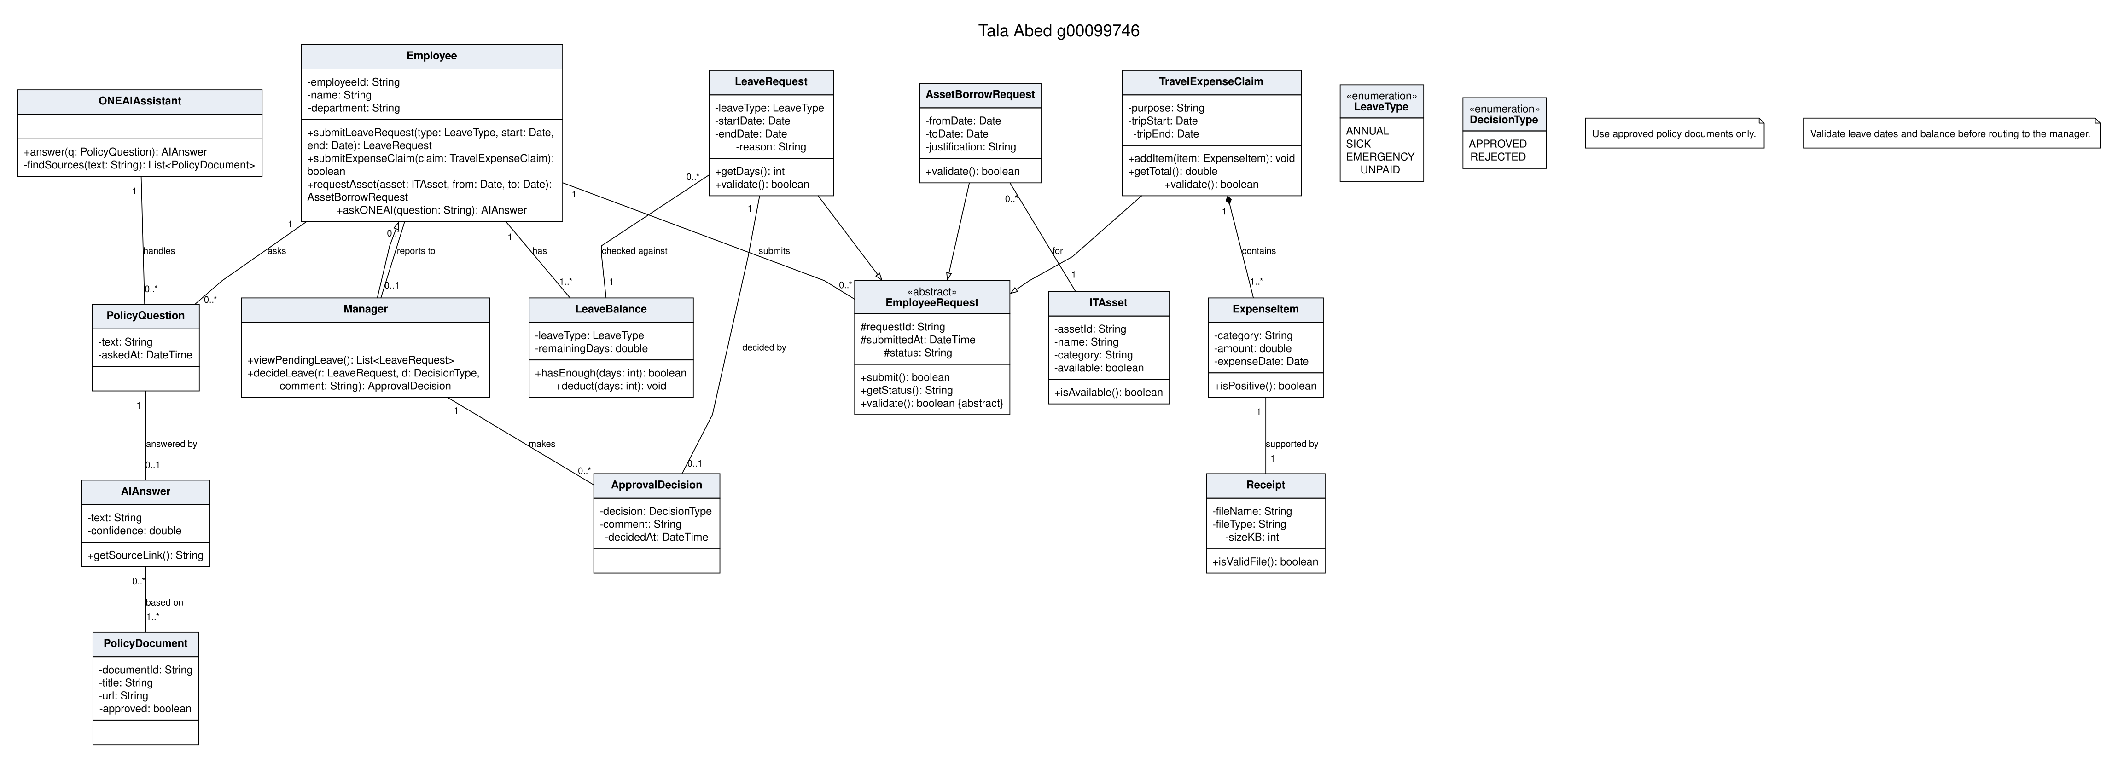
Nadine Alameldin g00098602
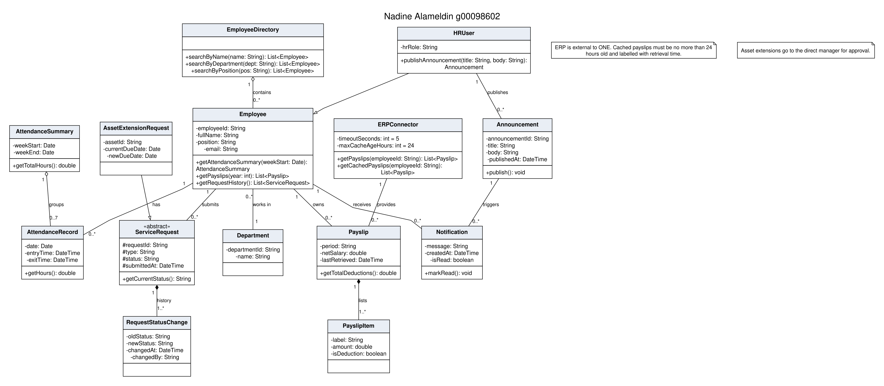
Razan El Gendy g00099305
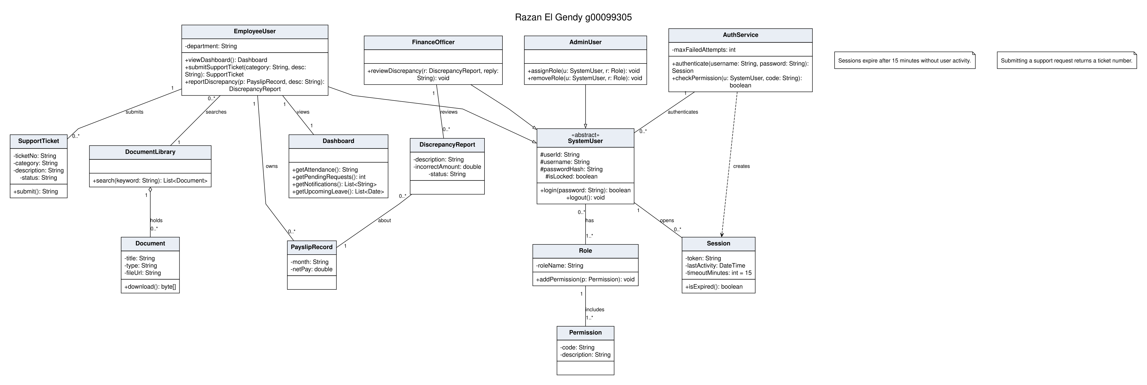
Kholoud Elkholy g00099492
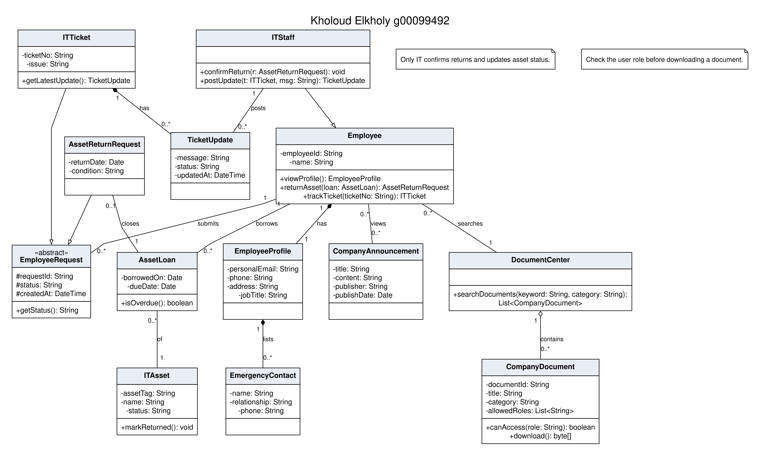

Part B Team Integration
Exercise 3 Review and Consolidate Individual Models
The 56 individual class entries were consolidated into 44 approved classes and 14 enumerations. The main modifications are recorded below.
• Merged duplicate employees and profiles into Employee; combined ticket, payslip, document and announcement classes under consistent names.
• Merged EmployeeRequest and ServiceRequest into Request. Combined borrow, extension and return requests into AssetRequest with a request type; retained AssetLoan to track borrowing history.
• Generalized Receipt into Attachment and RequestStatusChange into AuditEntry. Added ProfileChangeRequest, NotificationService, IntegrationAdapter and AttendanceAdapter; renamed ERPConnector to PayrollAdapter.
• Removed the separate SystemUser hierarchy and AuthService. Employee specializations now own staff responsibilities, while UserAccount, Role and Permission handle authentication and access.
• Checked inheritance, attributes, methods and multiplicities. Staff specialize Employee, six request types specialize Request, and attendance/payroll adapters specialize IntegrationAdapter. Each request has one submitter and an audit history; roles and permissions are shared. Manager, HR, Finance and IT decisions are assigned to the responsible classes.
Approved Team Class Inventory
Source prefixes: TA = Tala, NA = Nadine, RE = Razan, KE = Kholoud. New classes were added during integration to cover missing responsibilities.
ID | Class | Responsibility | Use cases | Source IDs
C01 | Employee | Employee identity, profile and self-service access. | UC-01, 03–07, 09–12, 14–20 | TA-01, NA-01, RE-02, KE-01, KE-03
C02 | Manager | Direct-report leave and extension decisions. | UC-02 | TA-02
C03 | HROfficer | Profile verification and company-content publication. | UC-08 | NA-02
C04 | FinanceOfficer | Expense and payslip discrepancy review. | UC-03, UC-14 | RE-04
C05 | ITStaff | Asset processing and support-ticket updates. | UC-04, UC-12, UC-16, UC-17 | KE-02
C06 | SystemAdministrator | Accounts, roles and permissions administration. | UC-13 | RE-03
C07 | Department | Department membership and announcement targeting. | UC-07, UC-08, UC-18 | NA-03
C08 | EmergencyContact | Employee emergency contact information. | UC-20 | KE-04
C09 | UserAccount | Credentials, authentication and permission checks. | UC-13, UC-15 | RE-01, RE-08
C10 | Role | Named, assignable set of permissions. | UC-13, UC-15, UC-19 | RE-05
C11 | Permission | One system access right. | UC-13, UC-15 | RE-06
C12 | Session | Activity tracking and 15-minute inactivity expiry. | UC-15 | RE-07
C13 | EmployeeDirectory | Searchable employee directory. | UC-07 | NA-04
C14 | AttendanceRecord | Imported entry/exit record and working hours. | UC-06, UC-11 | NA-05
C15 | AttendanceSummary | Attendance totals for a selected period. | UC-06, UC-11 | NA-06
C16 | Dashboard | Personalized attendance, requests, notices and leave. | UC-11 | RE-09
C17 | Request {abstract} | Shared request identity, lifecycle and validation. | UC-10 | TA-03, NA-12, KE-05
C18 | LeaveRequest | Leave type, dates, reason and validation. | UC-01, UC-02 | TA-04
C19 | LeaveBalance | Leave entitlement, usage and remaining days. | UC-01, UC-02 | TA-05
C20 | ApprovalDecision | Reviewer decision, comment, author and time. | UC-02, UC-03, UC-14 | TA-06
C21 | Attachment | Validated and protected uploaded file. | UC-03, UC-12 | TA-09
C22 | AuditEntry | Attributable request action and timestamp. | UC-10 | NA-14
C23 | ProfileChangeRequest | Proposed profile value pending HR verification. | FR-14; UC missing | New
C24 | ExpenseClaim | Travel claim and its expense items. | UC-03 | TA-07
C25 | ExpenseItem | Expense category, amount, date and receipt. | UC-03 | TA-08
C26 | Payslip | ERP payslip and cache retrieval time. | UC-09, UC-14 | NA-09, RE-11
C27 | PayslipLineItem | One payslip earning or deduction. | UC-09, UC-14 | NA-10
C28 | PayslipDiscrepancyReport | Employee’s reported payslip discrepancy. | UC-14 | RE-12
C29 | ITAsset | Equipment identity, details and availability. | UC-04, UC-16 | TA-10, KE-08
C30 | AssetLoan | One borrowing, due date and return. | UC-04, UC-16 | KE-07
C31 | AssetRequest | Borrow, extension or return request. | UC-04, UC-16 (FR-09) | TA-11, NA-13, KE-06
C32 | ITSupportTicket | IT issue, ticket number and progress. | UC-12, UC-17 | RE-10, KE-09
C33 | TicketUpdate | IT-authored ticket message and status. | UC-17 | KE-10
C34 | Document | Authorized policy, form or procedure. | UC-05, UC-19 | TA-15, RE-14, KE-13
C35 | DocumentCenter | Authorized document search and retrieval. | UC-19 | RE-13, KE-12
C36 | ONEAIAssistant | Sourced policy answers and confirmed escalation. | UC-05 | TA-12
C37 | AIQuery | Employee policy question. | UC-05 | TA-13
C38 | AIResponse | Answer, confidence, sources or no-answer flag. | UC-05 | TA-14
C39 | Announcement | HR-published announcement and intended audience. | UC-08, UC-18 | NA-07, KE-11
C40 | Notification | Employee notice linking to its triggering event. | UC-02, UC-08, UC-11 | NA-08
C41 | NotificationService | Notification creation and announcement broadcast. | UC-02, UC-08 | New
C42 | IntegrationAdapter {abstract} | Shared API timeout and failure handling. | UC-06, UC-09 | New
C43 | AttendanceAdapter | Retrieves records from external attendance source. | UC-06 | New
C44 | PayrollAdapter | Retrieves ERP payslips; limits cache to 24 hours. | UC-09 | NA-11

Consolidated UML Class Diagram
The overall diagram and detail views form one model. Shared references identify existing classes.
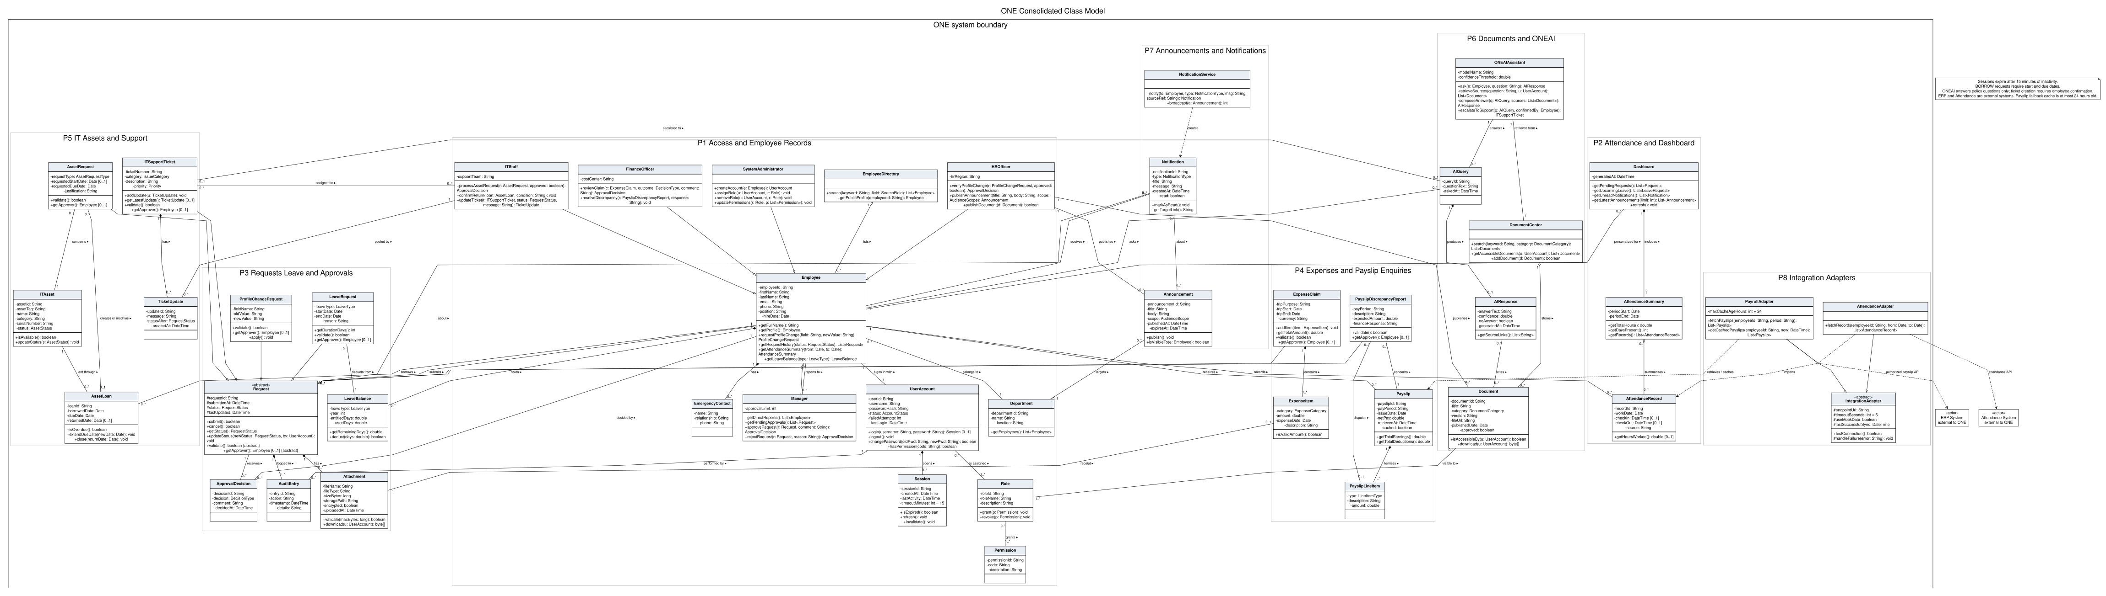
P1 Access and Employee Records
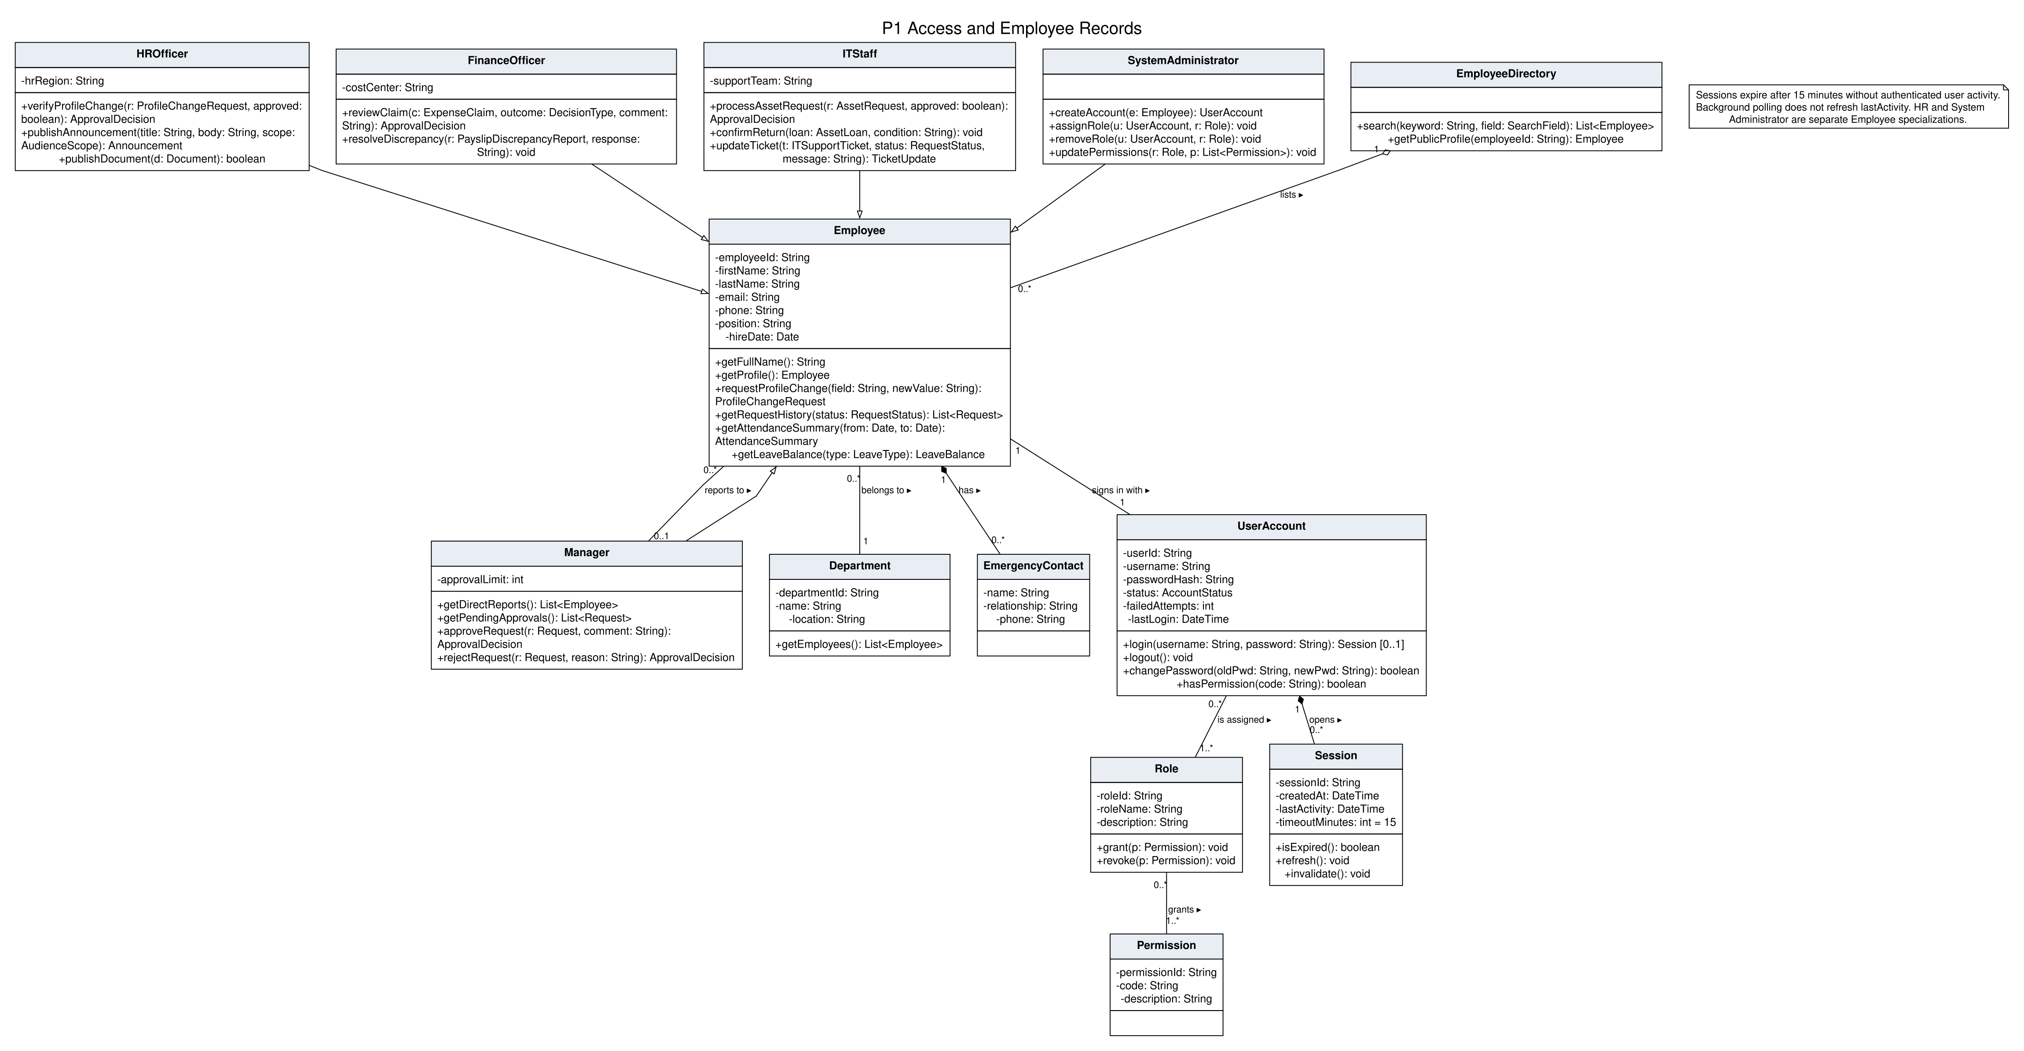
P2 Attendance and Dashboard
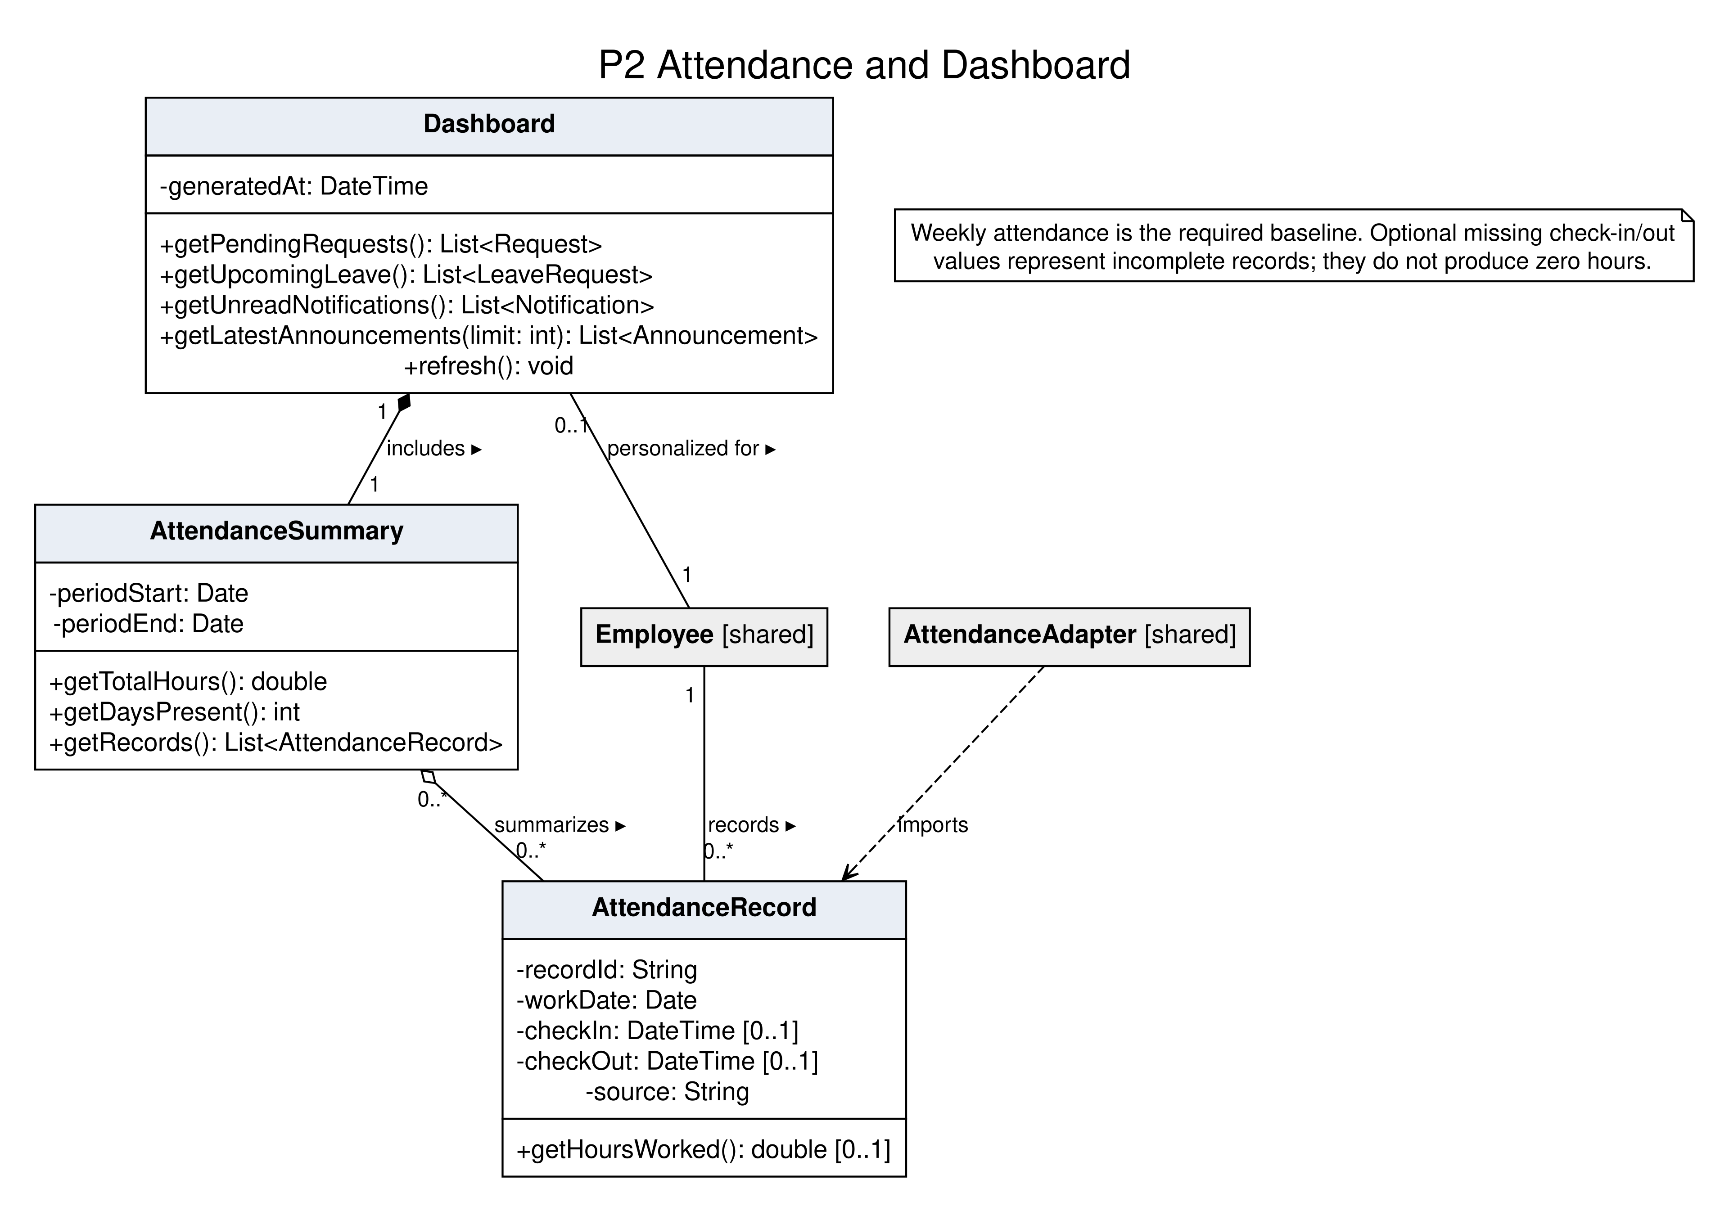
P3 Requests Leave and Approvals
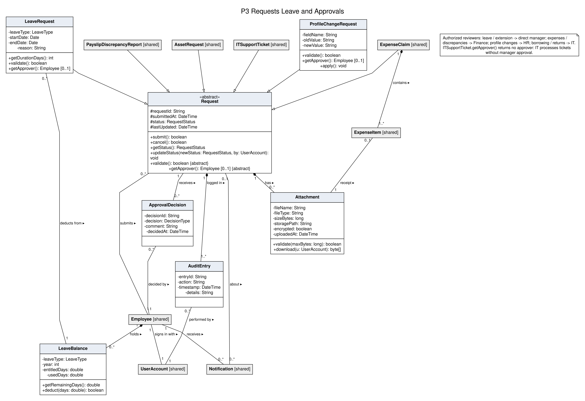
P4 Expenses and Payslip Enquiries
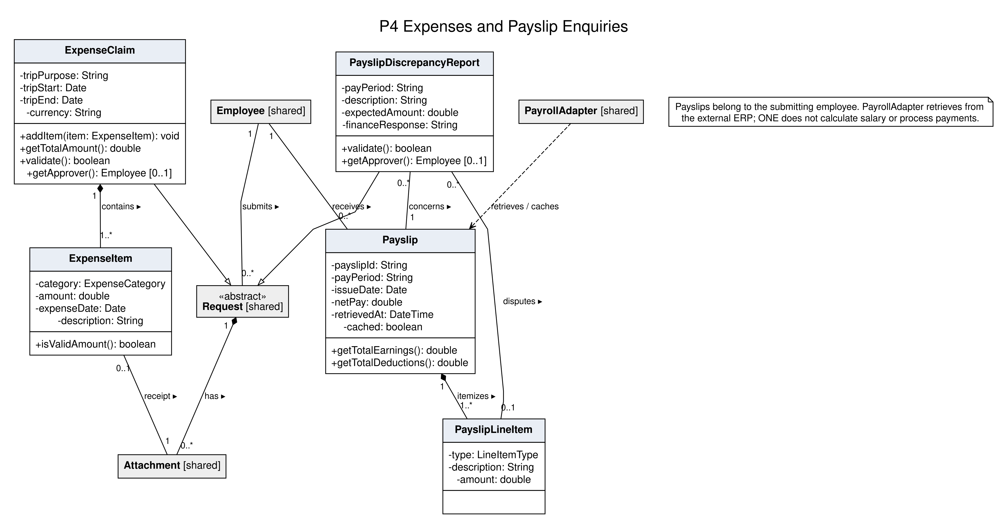
P5 IT Assets and Support
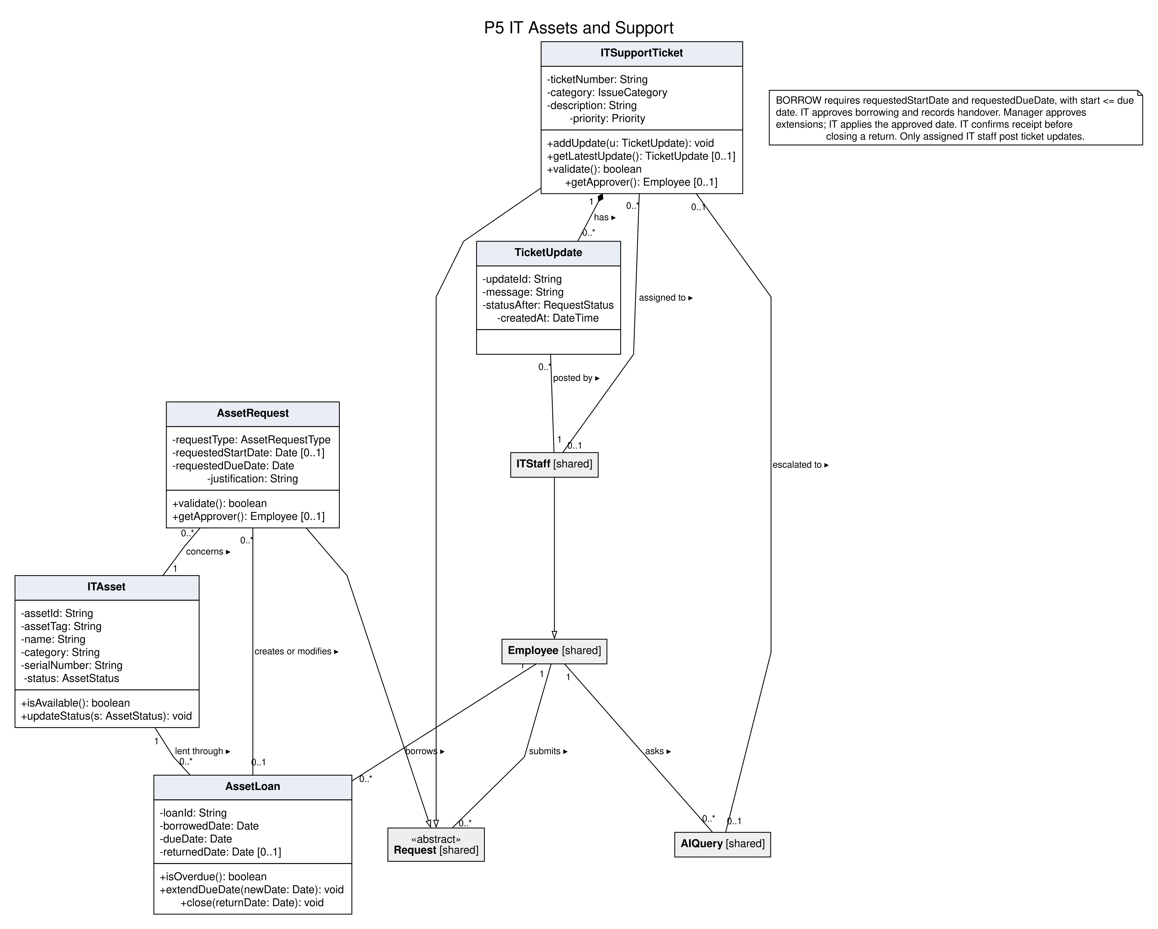
P6 Documents and ONEAI
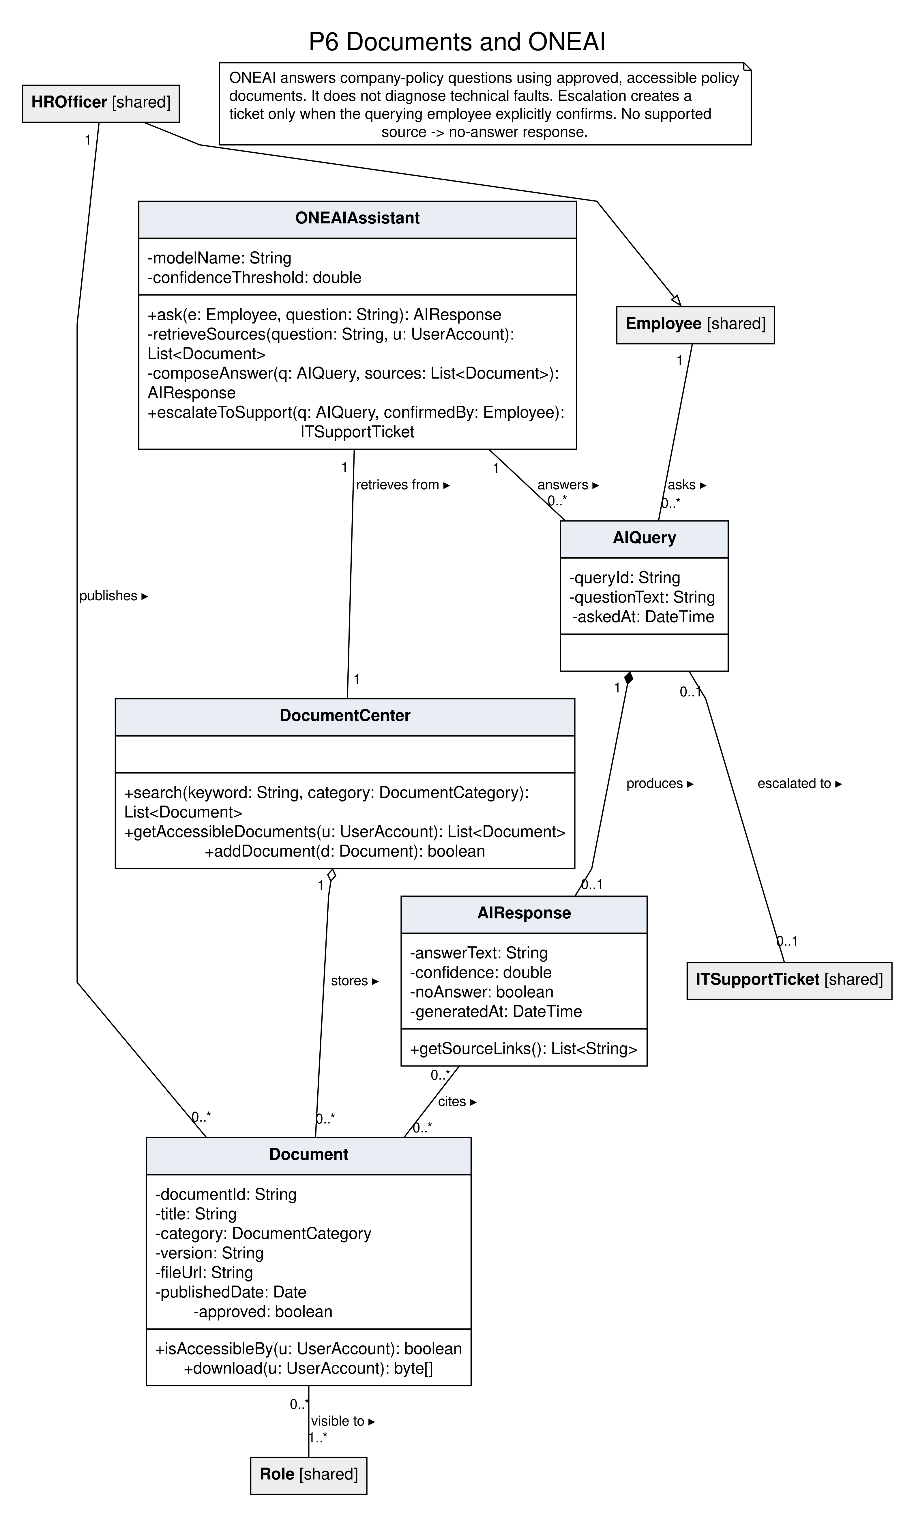
P7 Announcements and Notifications
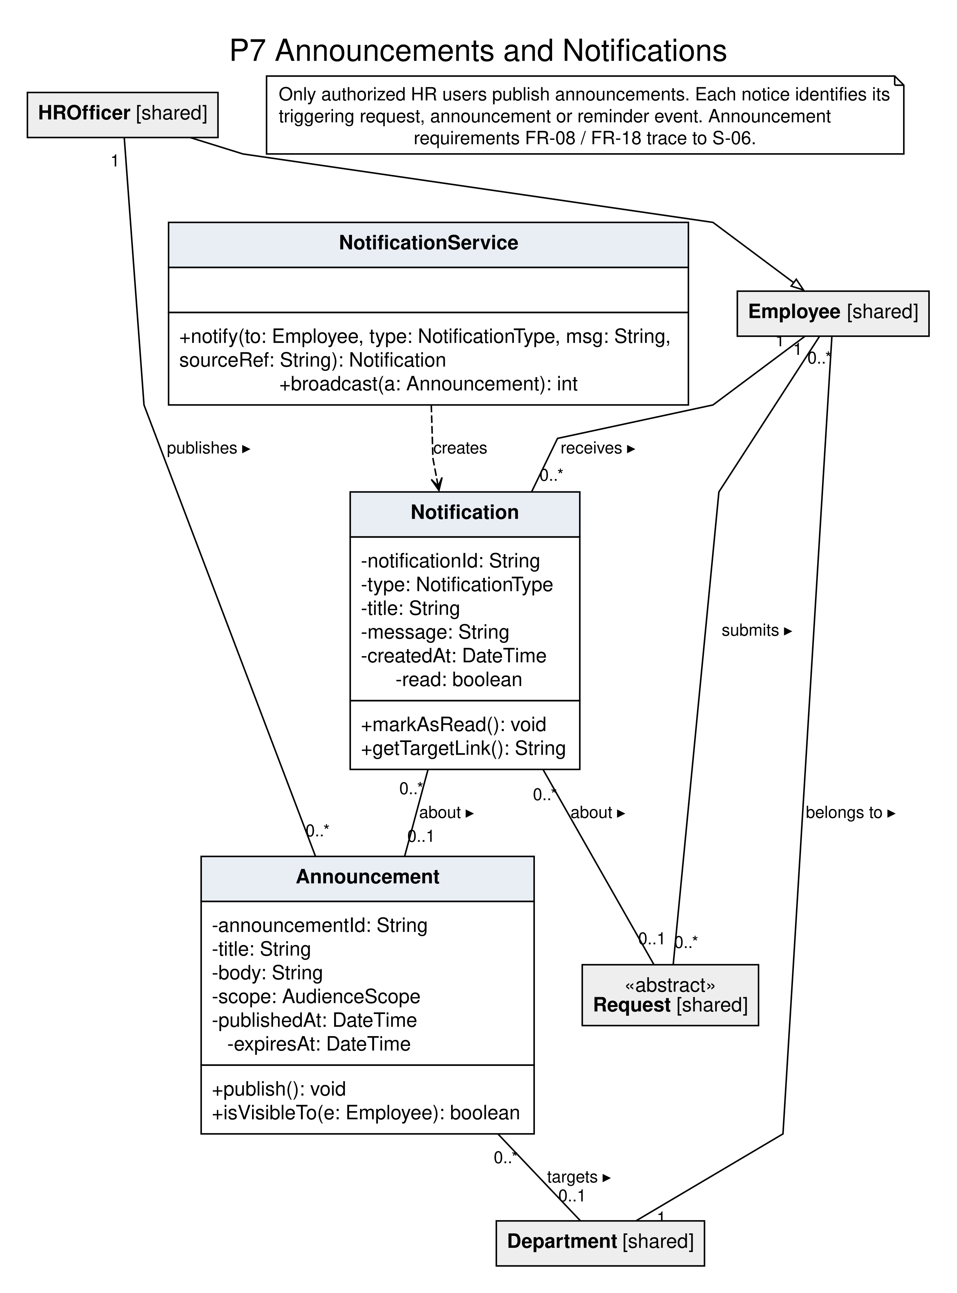
P8 Integration Adapters
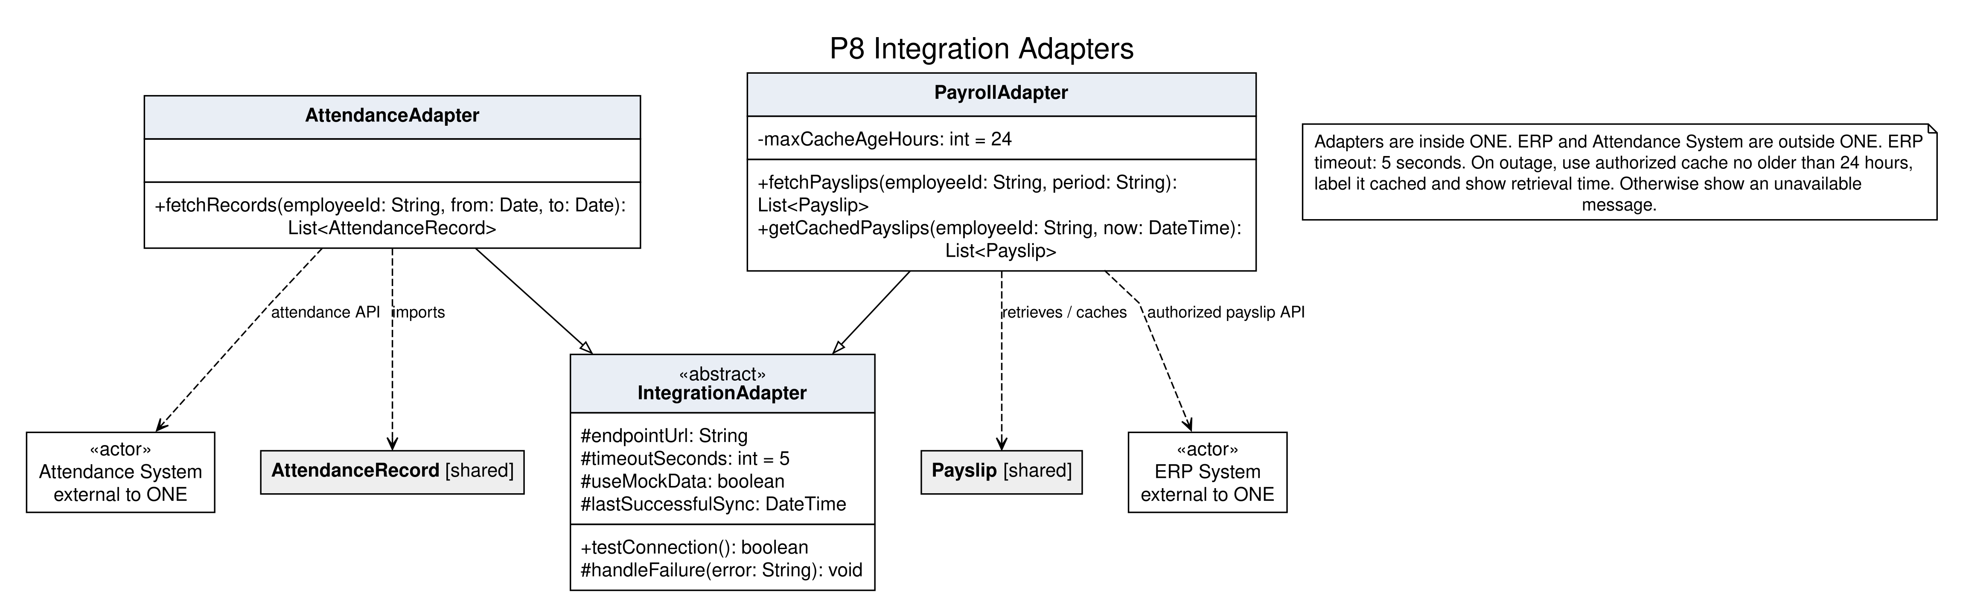

Class Model Consistency and Traceability Check
Use cases or workflow | Requirements | Model support | DFD and store
UC-01, UC-02 | FR-01–FR-03 | LeaveRequest, LeaveBalance, Manager, ApprovalDecision and notifications. | 3.0 / D2
UC-03 | FR-04 | ExpenseClaim, ExpenseItem, Attachment; Finance reviews the claim. | 4.0 / D2
UC-04 | Lab 2 assets scope; S-05 | AssetRequest (BORROW), ITAsset, AssetLoan; IT confirms handover. | 5.0 / D2
UC-05 | FR-05 | ONEAIAssistant, AIQuery, AIResponse and approved accessible Document sources. | 6.0 / D3
UC-06 | FR-06 | AttendanceAdapter imports AttendanceRecord; AttendanceSummary totals weekly hours. | 2.0 / D1
UC-07 | FR-07 | EmployeeDirectory searches Employee by name, department or position. | 1.0 / D1
UC-08, UC-18 | FR-08, FR-18; S-06 | HROfficer publishes Announcement; employees view it and receive notifications. | 7.0 / D3, D2
UC-09 | Lab 2 payroll scope; NFR-07 | PayrollAdapter retrieves external ERP Payslip and line items; bounded cache fallback. | 4.0 / D1
UC-10 | FR-10 | Request and AuditEntry provide history and current status for every request type. | 3.0 / D2
UC-11 | FR-11 | Dashboard shows attendance, pending requests, upcoming leave, announcements and notices. | 2.0 / D1–D3
UC-12, UC-17 | FR-12, FR-17 | ITSupportTicket and TicketUpdate separate submission from status/latest-update viewing. | 5.0 / D2
UC-13, UC-15 | FR-15; administrator scope | UserAccount, Session, Role, Permission and SystemAdministrator enforce access and role changes. | 1.0 / D1
UC-14 | FR-19 | PayslipDiscrepancyReport references the employee’s Payslip; Finance investigates. | 4.0 / D1, D2
UC-16 | FR-16 | AssetRequest (RETURN), AssetLoan and ITStaff.confirmReturn precede asset-status changes. | 5.0 / D2
UC-19 | FR-13 | DocumentCenter searches; Document checks permission before viewing/downloading. | 6.0 / D3
UC-20 | FR-20 | Employee profile fields, Department and EmergencyContact provide authorized profile data. | 1.0 / D1
Profile changes | FR-14; S-02 | ProfileChangeRequest retains proposed values; HROfficer verifies before apply(). | 1.0 / D1, D2
Asset extensions | FR-09; S-05 | AssetRequest (EXTENSION) routes to the direct manager; IT applies the approved date. | 5.0 / D2

D1 stores employee, account, profile, attendance and cached payslip records. D2 stores requests, decisions, audit, attachments, expenses, assets, loans, ticket updates and notifications. D3 stores documents and announcements. Dashboards and summaries are computed; service classes and adapters provide behavior.

