American University of Sharjah
College of Engineering, Department of Computer Science and Engineering
COE420L Software Engineering

Lab 6: UML Sequence Diagram Modeling
Courier Parcel Tracking System
Team 10

Team Member | AUS ID
Sarhan Alzaabi | b00100669
Kevin Alex | b00098368
Muhammad Hammad Khan | b00094579
Ahmed El Sabagh | b00095506

GitHub Repository: https://github.com/COE420-Team10-F26/Courier_parcel_tracking_system
Instructor: Dr. Mustafa Hammad
Lab Instructor: Yara Kaddoura
Fall 2026, November 3

Team Contributions
Each member drew the sequence diagram for one use case in the area they have owned since Lab 3, and all four are in the shared GitHub repository. The team agreed on the selected use cases, the participants and the shared status-change messages before drawing, so the four diagrams match each other and the class diagram.
Name | AUS ID | Lab 6 Work
Sarhan Alzaabi | b00100669 | UC-03 Book Parcel sequence diagram; revisions to Labs 3, 4 and 5 (Assigned notification, Booked to Pending Pickup, Delayed history entry); consistency checklist; review corrections to the UC-09, UC-16 and UC-19 diagrams; selected use cases file; final report
Kevin Alex | b00098368 | UC-09 Assign Parcels to Field Staff sequence diagram; new P2 to D3 flow in the Level-0 DFD and the updated figure in the Lab 4 report
Muhammad Hammad Khan | b00094579 | UC-16 Record Proof of Delivery sequence diagram; notation review of all four diagrams
Ahmed El Sabagh | b00095506 | UC-19 View Parcel Tracking History sequence diagram; README update for Lab 6

1. Exercise 1: Selected Use Cases
The team selected four major use cases from the Lab 3 use case model, one per member (the lab asks for at least three). They are different from one another, they cover all three actors, and together they cover the key stages of a parcel: booking, assignment, delivery and tracking. The IDs are the team-level IDs from the Lab 3 consolidated use case table (Team_Consolidated_Requirements.md). The same use cases, with a contributor column, are in Project/Behavioral_Modeling/Selected_Use_Cases.md.
Table 1.1: Selected use cases
Use Case ID | Use Case Name | Primary Actor | Purpose | Reason for Selection
UC-03 | Book Parcel | Customer | A logged-in customer books a parcel by entering the sender, recipient and parcel details. The system validates them, creates the parcel with a unique tracking number, sets it to Pending Pickup and shows the expected delivery window. | Every parcel in the system starts here. It involves several collaborating objects and has a clear valid/invalid branch shown with guards. It includes UC-04 Generate Tracking Number.
UC-09 | Assign Parcels to Field Staff | Admin | The admin bulk-assigns "Pending Pickup" parcels to one active field staff member. The parcels move to "Assigned", each customer is notified and the staff member gets one summary notification. | It is the core dispatch step that links booking to delivery. It involves many collaborating objects, shows iteration (per staff member, per parcel) and guards, and includes UC-08 and UC-18.
UC-16 | Record Proof of Delivery | Field Staff | A field staff member captures the recipient's name, signature and Emirates ID for a parcel that is out for delivery. The parcel is marked "Delivered" only once the proof is complete, and the customer is notified. | It completes the delivery part of the parcel's life and enforces the rule that a parcel is only marked delivered after proof is captured (FR-15). It includes UC-14 Update Parcel Status.
UC-19 | View Parcel Tracking History | Customer | A customer enters a tracking number and sees the full, timestamped status history of their own parcel, or a "not found" message. | It reads the history that the other three use cases create, so it ties the set together. It shows iteration over the history entries and an alt fragment that checks whether the parcel is found and belongs to the customer.

2. Exercise 2: UML Sequence Diagrams
Each diagram was drawn in a UML modeling tool: draw.io for UC-03, UC-16 and UC-19, and PlantUML for UC-09. The source file of every diagram is in the repository next to its PNG. The team used the same conventions in all four diagrams:
- Participants are only the actor and objects of classes in the Lab 5 class diagram. There are no UI or controller lifelines.
- Message names are operations from the class diagram, with the same parameters. Calls between objects that return a value have a labeled return message; a few void calls also show an unlabeled return to mark the end of the call. «create» messages create objects and are not class operations.
- Guards are written in [ ] and iteration as *[ ]. Alternative flows use alt fragments, with an [else] branch for the main failure case of each use case.
- Every status change follows the same steps: Parcel creates a StatusHistoryEntry, calls [active delay alert] resolve() on DelayAlert, then creates a StatusNotification and calls buildMessage() and send().

2.1 UC-03 Book Parcel (Sarhan Alzaabi, b00100669)
The customer sends bookParcel() to their own Customer object with the recipient and parcel details. The Customer object checks the recipient's phone number, and an alt fragment splits the valid and invalid cases.
- [all fields valid]: a Parcel is created with status Booked, generates its tracking number (the include to UC-04), then sets itself to Pending Pickup with updateStatus(PENDING_PICKUP), which runs the shared status-change block. The Customer object gets the 24 or 48-hour delivery window and returns the parcel, tracking number and window to the customer.
- [else]: the booking is rejected and nothing is created (FR-03). A note on the diagram lists the other FR-03 checks that [all fields valid] covers (no empty field, weight and dimension limits) besides isValidPhone().
- Booked is the status the parcel is created with, so its first history entry is the change from Booked to Pending Pickup, and the first entry UC-19 returns has Booked as its previous status. The [active delay alert] guard is always false here, because a new parcel cannot have a delay alert; a note on the diagram says it is shown because updateStatus() always makes this check.
- Guards: [all fields valid], [else] and [active delay alert].
The diagram is Figure 2.1, on its own landscape page after this section.

2.2 UC-09 Assign Parcels to Field Staff (Kevin Alex, b00098368)
The admin views all parcels (the include to UC-08), gets the unassigned Pending Pickup parcels and checks each staff member's workload before assigning.
- [staff active] (the admin picks an active field staff member, P3) assignParcels() creates an Assignment, and the admin's Administrator object adds each selected parcel to it and validates them.
- An alt fragment splits the result of validateParcels(). [valid = true]: confirmAssignment() sets each parcel to Assigned with updateStatus(ASSIGNED), which runs the shared status-change block, so each customer is notified (FR-09). [else]: the admin is told the parcels are invalid and the assignment is not confirmed (P3: only Pending Pickup parcels can be assigned).
- The Assignment then gets its parcel count and assigned staff member, creates one AssignmentNotification with them and sends the summary to the field staff member (the include to UC-18).
- Iteration: *[for each staff], *[for each parcel p] addParcel(p) and *[for each parcel p] updateStatus(ASSIGNED). Guards: [staff active], [valid = true] and [active delay alert].
The diagram is Figure 2.2, on its own landscape page after this section.

2.3 UC-16 Record Proof of Delivery (Muhammad Hammad Khan, b00094579)
The field staff member views their assigned parcels and sends confirmDelivery() with the recipient's name, signature and Emirates ID. The FieldStaff object first checks the parcel's status, and two nested alt fragments cover every outcome.
- [status = OUT_FOR_DELIVERY]: a ProofOfDelivery is created and checked with isComplete(). [complete]: the FieldStaff object runs its UC-14 operation updateDeliveryStatus(parcel, DELIVERED) (the include to UC-14), which sets the parcel to Delivered with updateStatus(DELIVERED) and runs the shared status-change block, and the proof is returned. [else]: the proof is incomplete, so it is discarded and the parcel is not marked Delivered (FR-15), as a note on the diagram says.
- [else] (not Out for Delivery): the field staff member is told the parcel is not Out for Delivery, so a status cannot be skipped (P4).
- Only parcels assigned to the staff member are used, because they come from viewAssignedParcels() (P4). Guards: [status = OUT_FOR_DELIVERY], [complete], [else] and [active delay alert].
The diagram is Figure 2.3, on its own landscape page after this section.

2.4 UC-19 View Parcel Tracking History (Ahmed El Sabagh, b00095506)
The customer sends trackParcel() with a tracking number to their own Customer object, which looks for the parcel among its own parcels with viewMyParcels(). An alt fragment splits the two cases.
- [found and belongs to customer]: the Customer object gets the parcel's status history, a loop *[for each entry] calls getTransition() on each StatusHistoryEntry, and trackParcel() returns the Parcel with its history (FR-19). A note on the diagram says the entries come in chronological order, as P5 rule 4 requires.
- [else]: the customer gets a "parcel not found" message. This covers a tracking number that does not exist and a parcel that belongs to someone else, since a customer sees only their own parcels (P5 rules 1 and 2).
- The class diagram has no separate customer operation for the history, so the customer starts with trackParcel(), which finds the parcel, and the history comes from Parcel.getStatusHistory(). Nothing in this diagram changes the parcel's status (P5 rule 7).
The diagram is Figure 2.4, on its own landscape page after this section.

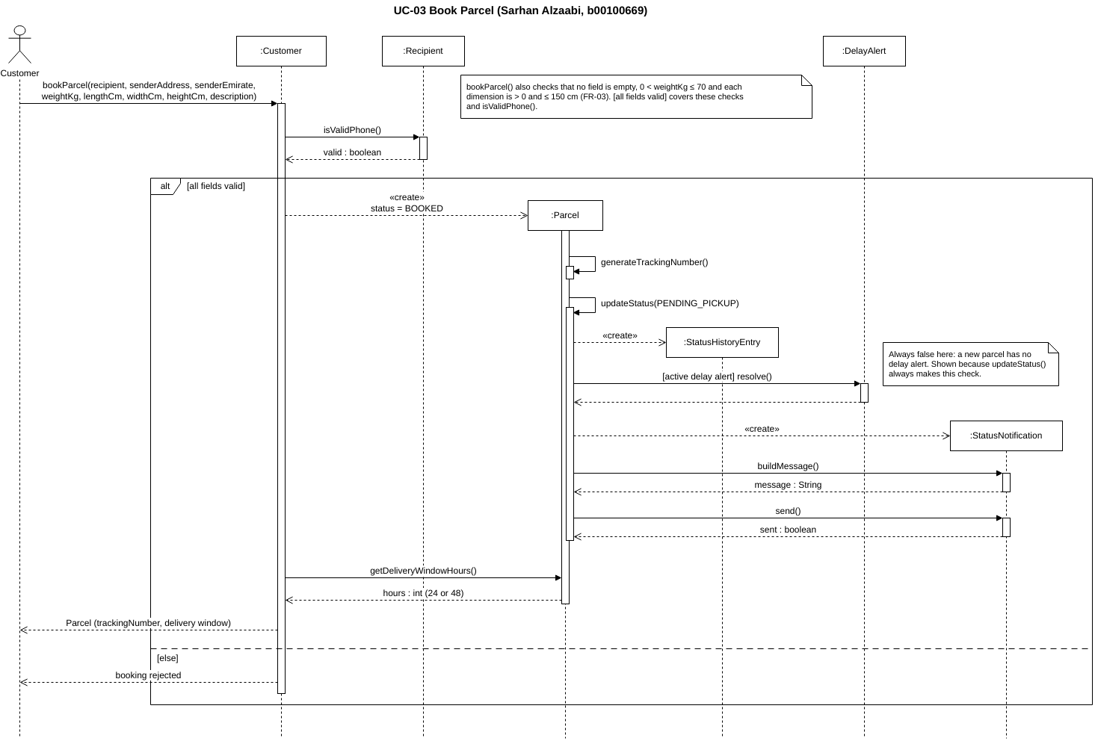
Figure 2.1: UC-03 Book Parcel sequence diagram (SD_UC-03_Book_Parcel.drawio)

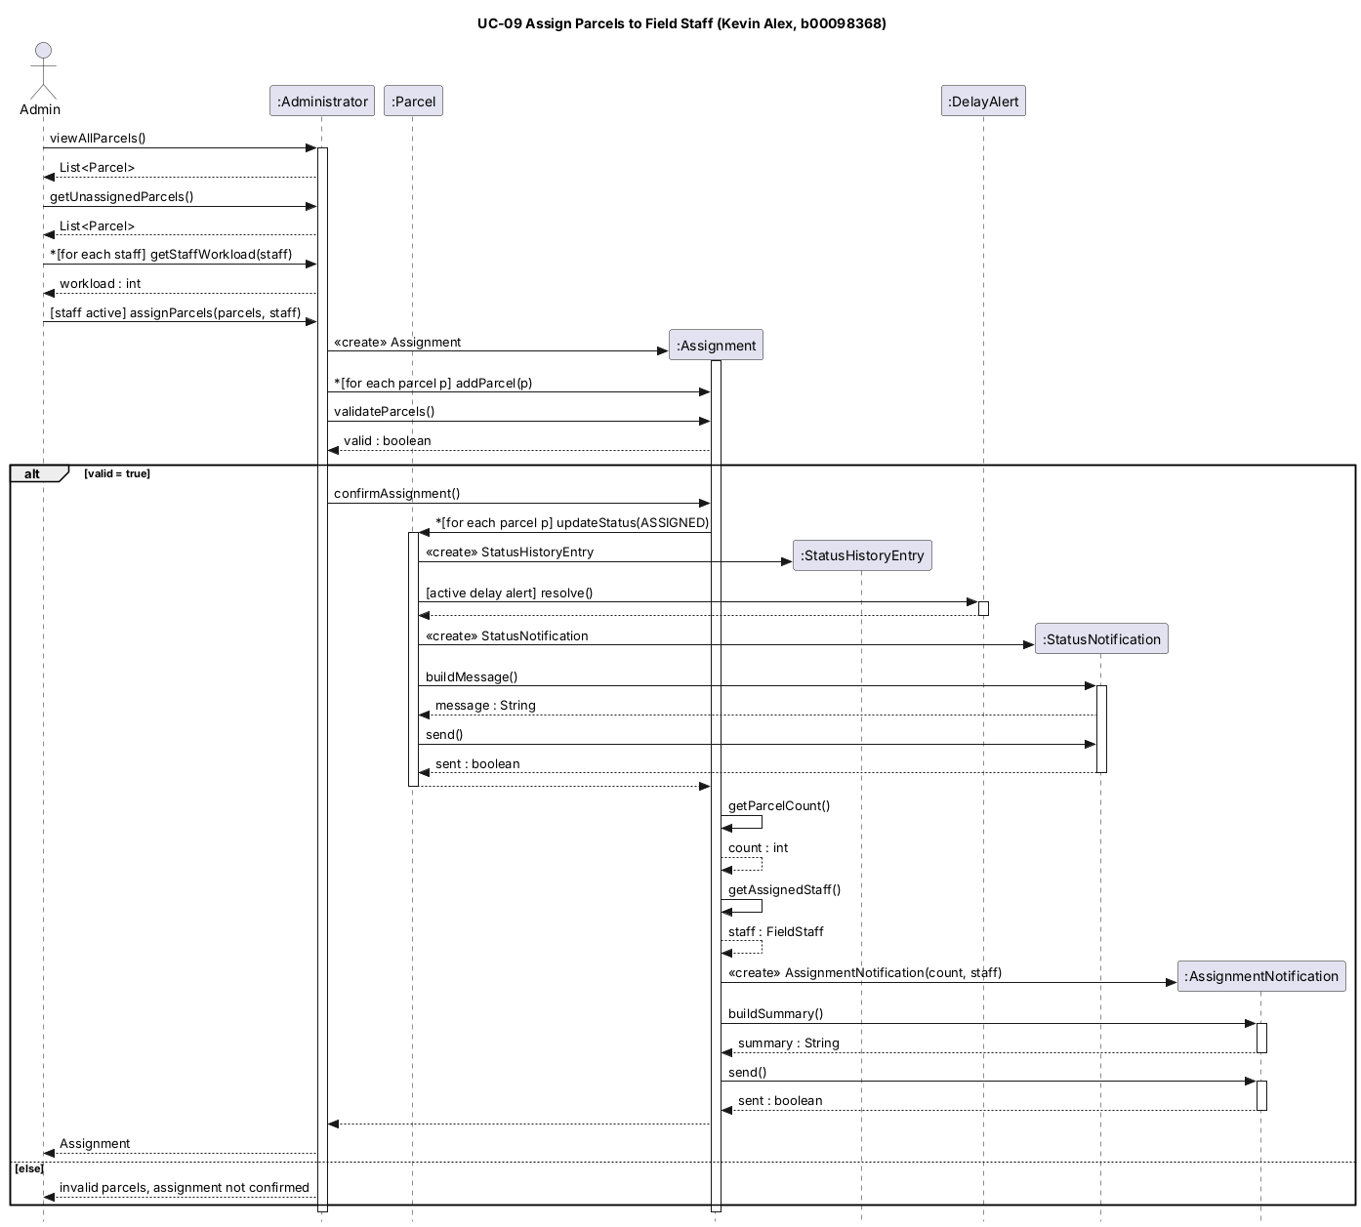
Figure 2.2: UC-09 Assign Parcels to Field Staff sequence diagram (SD_UC-09_Assign_Parcels_to_Field_Staff.puml)

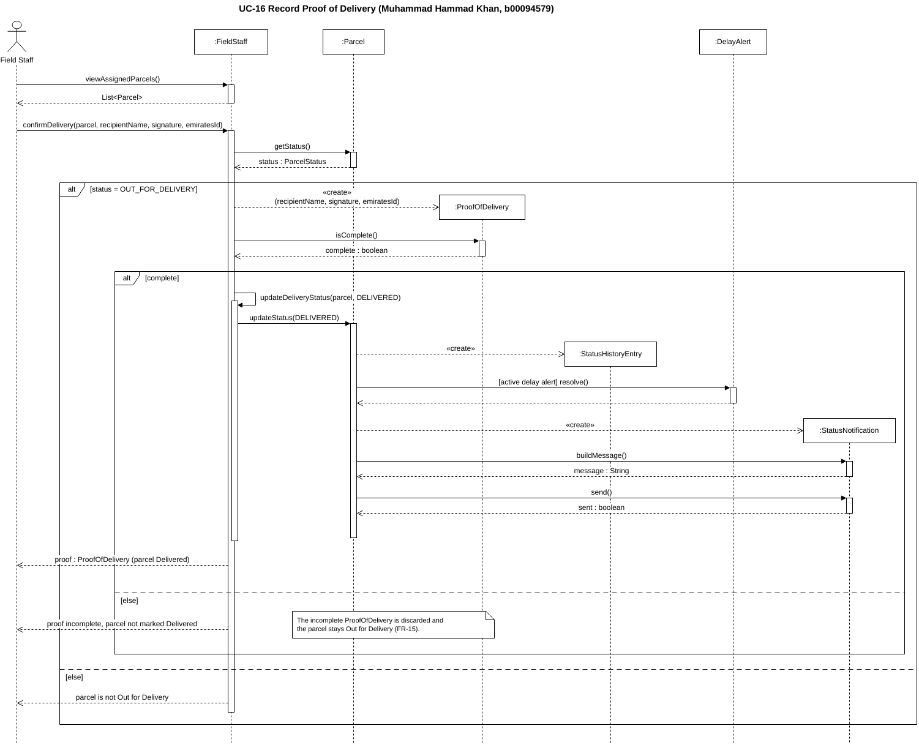
Figure 2.3: UC-16 Record Proof of Delivery sequence diagram (SD_UC-16_Record_Proof_of_Delivery.drawio)

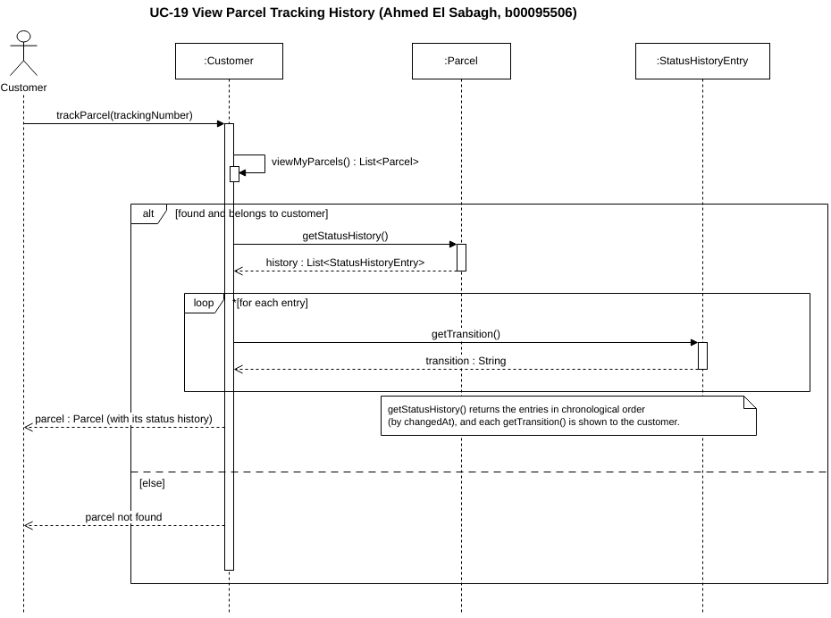
Figure 2.4: UC-19 View Parcel Tracking History sequence diagram (SD_UC-19_View_Parcel_Tracking_History.drawio)

3. Consistency Check
The team reviewed all four diagrams together against the Lab 3 requirements and use cases, the Lab 5 class diagram and the rest of the system.

3.1 Message to operation mapping
Table 3.1 lists every message in the four diagrams except the «create» messages, which create objects rather than call operations.
Table 3.1: Every message in the four diagrams and the class operation it calls
Diagram | Message | Operation in the Lab 5 class diagram
UC-03 | bookParcel(recipient, senderAddress, senderEmirate, weightKg, lengthCm, widthCm, heightCm, description) | Customer.bookParcel(...): Parcel
 | isValidPhone() | Recipient.isValidPhone(): boolean
 | generateTrackingNumber() | Parcel.generateTrackingNumber(): String
 | updateStatus(PENDING_PICKUP) | Parcel.updateStatus(newStatus: ParcelStatus): void
 | [active delay alert] resolve() | DelayAlert.resolve(): void
 | buildMessage(), send() | StatusNotification.buildMessage(): String, Notification.send(): boolean
 | getDeliveryWindowHours() | Parcel.getDeliveryWindowHours(): int
UC-09 | viewAllParcels(), getUnassignedParcels() | Administrator.viewAllParcels(), Administrator.getUnassignedParcels(): List<Parcel>
 | *[for each staff] getStaffWorkload(staff) | Administrator.getStaffWorkload(staff: FieldStaff): int
 | [staff active] assignParcels(parcels, staff) | Administrator.assignParcels(parcels, staff): Assignment
 | *[for each parcel p] addParcel(p), validateParcels(), confirmAssignment() | Assignment.addParcel(parcel), validateParcels(): boolean, confirmAssignment(): void
 | *[for each parcel p] updateStatus(ASSIGNED) | Parcel.updateStatus(newStatus: ParcelStatus): void
 | [active delay alert] resolve() | DelayAlert.resolve(): void
 | buildMessage(), send() | StatusNotification.buildMessage(): String, Notification.send(): boolean
 | getParcelCount(), getAssignedStaff() (results used to create the AssignmentNotification) | Assignment.getParcelCount(): int, Assignment.getAssignedStaff(): FieldStaff
 | buildSummary(), send() | AssignmentNotification.buildSummary(): String, Notification.send(): boolean
UC-16 | viewAssignedParcels() | FieldStaff.viewAssignedParcels(): List<Parcel>
 | confirmDelivery(parcel, recipientName, signature, emiratesId) | FieldStaff.confirmDelivery(parcel, recipientName, signature, emiratesId): ProofOfDelivery
 | getStatus() | Parcel.getStatus(): ParcelStatus
 | isComplete() | ProofOfDelivery.isComplete(): boolean
 | updateDeliveryStatus(parcel, DELIVERED) | FieldStaff.updateDeliveryStatus(parcel: Parcel, newStatus: ParcelStatus): boolean
 | updateStatus(DELIVERED) | Parcel.updateStatus(newStatus: ParcelStatus): void
 | [active delay alert] resolve() | DelayAlert.resolve(): void
 | buildMessage(), send() | StatusNotification.buildMessage(): String, Notification.send(): boolean
UC-19 | trackParcel(trackingNumber) | Customer.trackParcel(trackingNumber: String): Parcel
 | viewMyParcels() | Customer.viewMyParcels(): List<Parcel>
 | getStatusHistory() | Parcel.getStatusHistory(): List<StatusHistoryEntry>
 | *[for each entry] getTransition() | StatusHistoryEntry.getTransition(): String

3.2 A. Consistency with Lab 3: Requirements and Use Cases
Table 3.2: Consistency with Lab 3
Check | Result | How it was verified
Each diagram represents one of the approved use cases | Yes | The four diagrams model UC-03, UC-09, UC-16 and UC-19 from the team use case table in Lab 3 (Team_Consolidated_Requirements.md), one use case per diagram.
The interaction supports the use case's goal | Yes | UC-03 ends with a parcel, tracking number and delivery window returned to the customer; UC-09 ends with an Assignment and its summary sent; UC-16 ends with proof recorded and the parcel Delivered; UC-19 ends with the parcel's history returned.
The sequence reflects the use case's description and flow | Yes | UC-03 follows FR-03 and FR-04 (validation, tracking number, 24/48-hour window) and the include R-01 to UC-04. UC-09 follows FR-08 and FR-09 and starts from the parcel list (include R-03 to UC-08) and sends the summary (include R-05 to UC-18). UC-16 follows FR-15 and P4 (only parcels assigned to the staff member, Out for Delivery first, proof before Delivered) and calls updateDeliveryStatus() (include R-07 to UC-14). UC-19 follows FR-19, P5 rules 1 and 2 (not found, own parcels only) and the chronological order in P5 rule 4.
The messages do not introduce unsupported functionality | Yes | No message goes beyond the approved FRs. Every status change records a history entry (FR-18) and notifies the customer (FR-16, include R-08). UC-19 is read-only, as P5 rule 7 requires. There are no payment, UI or other features outside the scope.

3.3 B. Consistency with Lab 5: UML Class Diagram
Table 3.3: Consistency with Lab 5
Check | Result | How it was verified
The participating objects correspond to classes in the Class Diagram | Yes | Every lifeline is a class from the consolidated Lab 5 diagram: Customer, Administrator, FieldStaff, Recipient, Parcel, Assignment, ProofOfDelivery, StatusHistoryEntry, DelayAlert, StatusNotification and AssignmentNotification. No UI or controller objects were added. Each actor sends its first message to its own User subclass object, because that is where the class diagram puts the operations.
Message names correspond to appropriate class operations | Yes | Every message except the «create» messages is an operation of the receiving class with the same name and parameters (Table 3.1). Return messages on successful calls carry the values that these operations return in the class diagram; failure replies in [else] branches are shown as messages to the actor. UC-19 uses trackParcel() to find the parcel, because the class diagram has no separate customer operation for the history.
Messages are sent between plausible participants | Yes | Messages follow the class diagram's associations: Customer books Parcel, Administrator creates Assignment, Assignment contains Parcel, StatusHistoryEntry records change of Parcel, DelayAlert alerts on Parcel, StatusNotification is about Parcel, AssignmentNotification summarizes Assignment and FieldStaff captures ProofOfDelivery. Where there is no direct association, the receiver is an object the sender was handed as a parameter or return value (the Recipient passed to bookParcel(), the parcels returned by viewAssignedParcels() and viewMyParcels(), and the entries returned by getStatusHistory()).
Required operations are represented in the class model | Yes | All operations used already exist in the Lab 5 class diagram, so the class diagram itself needed no changes for Lab 6. UC-19 reuses trackParcel() to find the parcel instead of adding a new operation.

3.4 C. Consistency with the Overall System
Table 3.4: Consistency with the overall system
Check | Result | How it was verified
The interactions reflect the actual proposed system | Yes | The four diagrams cover the key stages of one parcel: booked and set to Pending Pickup (UC-03), assigned (UC-09), delivered with proof (UC-16) and tracked (UC-19). The steps from Assigned to Out for Delivery belong to UC-14 and UC-15, which are not among the selected use cases.
The actor is consistent with the selected use case | Yes | Customer for UC-03 and UC-19, Admin for UC-09 and Field Staff for UC-16, matching the primary actors in the Lab 3 use case table and Table 1.1.
The sequence of messages is logical | Yes | Objects are created before they receive messages, calls between objects that return a value have a return message, and every status change follows the same steps in UC-03, UC-09 and UC-16: Parcel creates a StatusHistoryEntry, resolves an active DelayAlert if there is one, then creates, builds and sends a StatusNotification. The history entry is logged before the notification, consistent with NFR-19.
The diagrams are understandable and internally consistent | Yes | Each diagram has a title with its use case, lifelines, activation bars, return messages, guards in [ ], and iteration marked with * where it applies (UC-09 and UC-19). Alternative flows are shown with alt fragments that have an [else] reply (all four diagrams), and UC-19 uses a loop fragment for the history entries. Notes explain the points a reader might question. Return messages carry typed values (for example status : ParcelStatus).

3.5 Confirmation
The team confirms that all of the consistency checks listed in the lab sheet (A, B and C above) have been performed and verified for all four sequence diagrams. The mismatches in earlier labs that were found while preparing this lab were fixed, as listed in Section 4.

4. Revisions to Earlier Labs
The lab sheet allows earlier artifacts to be revised to resolve inconsistencies. Three were fixed before the diagrams were drawn, so that the diagrams, requirements, DFD and class model all agree:
- Assigned notification (FR-09). FR-09 says each customer gets an "Assigned" notification, but the Lab 4 matrix did not include it. P3 now says P5 sends each customer an Assigned status notification, and P5 rule 5 now covers every status change recorded in D3 (FR-16). Updated in Core_Processes_Matrix.md and the Lab 4 report.
- Booked to Pending Pickup. No earlier artifact said how a parcel moves from Booked to Pending Pickup, so UC-03 and UC-09 did not connect. Pending Pickup is now set automatically when the booking is confirmed, and it adds a status history entry like every other status change (FR-18). Updated in the Lab 3 status table (Team_Consolidated_Requirements.md and the Lab 3 report), P2 in the Lab 4 matrix and report (P2 now also outputs a status history entry to D3, and D3 is used by P2), the Level-0 DFD (new "Status History Entry" flow from P2 Book Parcel to D3 Status History) and the P2 class list in Class_Model_Consistency_Check.md.
- Delayed history entry (FR-18). P3 now states that setting a parcel to Delayed also adds a D3 entry, because FR-18 requires a history entry for every status change.

5. GitHub Repository
All Lab 6 work is in the same repository used since Lab 1 (https://github.com/COE420-Team10-F26/Courier_parcel_tracking_system). Kevin, Ahmed and Sarhan committed their own diagrams. Muhammad's laptop had a problem with git on the due date, so he sent his draw.io file and Sarhan committed it for him. After the team's final review, Sarhan committed small corrections to the UC-09, UC-16 and UC-19 diagrams, which are the versions shown in Section 2.
Path | Contents
Project/Behavioral_Modeling/Selected_Use_Cases.md | The four selected use cases (Exercise 1)
Project/Behavioral_Modeling/Sequence_Diagrams/ | The four sequence diagrams as PNG, with their draw.io (.drawio) or PlantUML (.puml) source files, all named SD_UC-xx_Use_Case_Name
Project/Data_Flow_Modeling/, Project/Requirements/, Project/Object_Modeling/ | Earlier artifacts revised in Section 4
Documents/COE420_Lab6_Team10.docx | This report

AI Usage Declaration
Team members used AI tools (such as ChatGPT or Claude) in a supporting role while preparing this lab, for example to check the diagrams against the lab sheet, the requirements and the class diagram, find inconsistencies in earlier labs, help lay out diagrams and markdown tables, proofread the writing and format this report. The selected use cases, interactions and messages come from the team's own requirements, use cases and class diagram, and any AI suggestions were reviewed and edited before being included. Every member reviewed the final report and can explain their diagram.

