American University of Sharjah
College of Engineering, Department of Computer Science and Engineering
COE420L Software Engineering
Lab 4: Data Flow Modeling and Project Scheduling
Courier Parcel Tracking System
Team 10
Team Member | AUS ID
Sarhan Alzaabi | b00100669
Kevin Alex | b00098368
Muhammad Hammad Khan | b00094579
Ahmed El Sabagh | b00095506

GitHub Repository: https://github.com/COE420-Team10-F26/Courier_parcel_tracking_system
Instructor: Dr. Mustafa Hammad
Lab Instructor: Yara Kaddoura
Fall 2026, October 13, 2026

Team Contributions
Each member worked on their own part and pushed it to the shared GitHub repository. The Core Processes Matrix was split so that each member wrote the process closest to the area they had in Lab 3.
Name | AUS ID | Lab 4 Work
Sarhan Alzaabi | b00100669 | Context Diagram, P1 and P2 in the Core Processes Matrix, Critical Path, Consistency Check
Kevin Alex | b00098368 | Level-0 DFD, P3 in the Core Processes Matrix, WBS
Muhammad Hammad Khan | b00094579 | P4 in the Core Processes Matrix, Network Diagram
Ahmed El Sabagh | b00095506 | P5 in the Core Processes Matrix, Gantt Chart

1. Context Diagram
The context diagram shows the whole Courier Parcel Tracking System as one process, numbered 0. Around it are the three external entities that use the system: Customer, Field Staff and Admin. These are the same three actors from our Lab 3 use case diagram. At this level we did not show any internal processes or data stores, only what goes in and out of the system.
The diagram was made in draw.io. Every arrow is one-way and labeled with the data it carries.
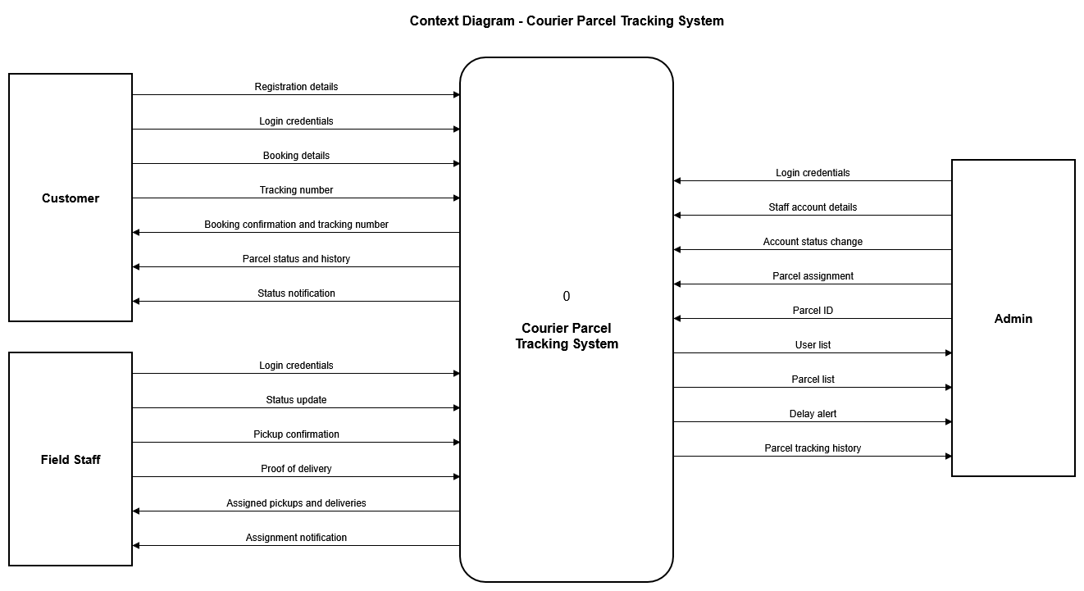
Figure 1.1: Context Diagram
Table 1.1 lists all 22 data flows in the diagram. Each one comes from a Lab 3 functional requirement or use case. For example, Booking details comes from the Book Parcel use case and Delay alert comes from the View Dashboard Delay Alerts use case.
Entity | Data flows into the system | Data flows out of the system
Customer | Registration details  Login credentials  Booking details  Tracking number | Booking confirmation and tracking number  Parcel status and history  Status notification
Field Staff | Login credentials  Status update  Pickup confirmation  Proof of delivery | Assigned pickups and deliveries  Assignment notification
Admin | Login credentials  Staff account details  Account status change  Parcel assignment  Parcel ID | User list  Parcel list  Delay alert  Parcel tracking history
Table 1.1: Context Diagram data flows

2. Level-0 Data Flow Diagram
The Level-0 DFD splits process 0 into five major processes. We did not add processes just to reach the minimum. Each one covers a real part of the system and matches a group of requirements and use cases from Lab 3.
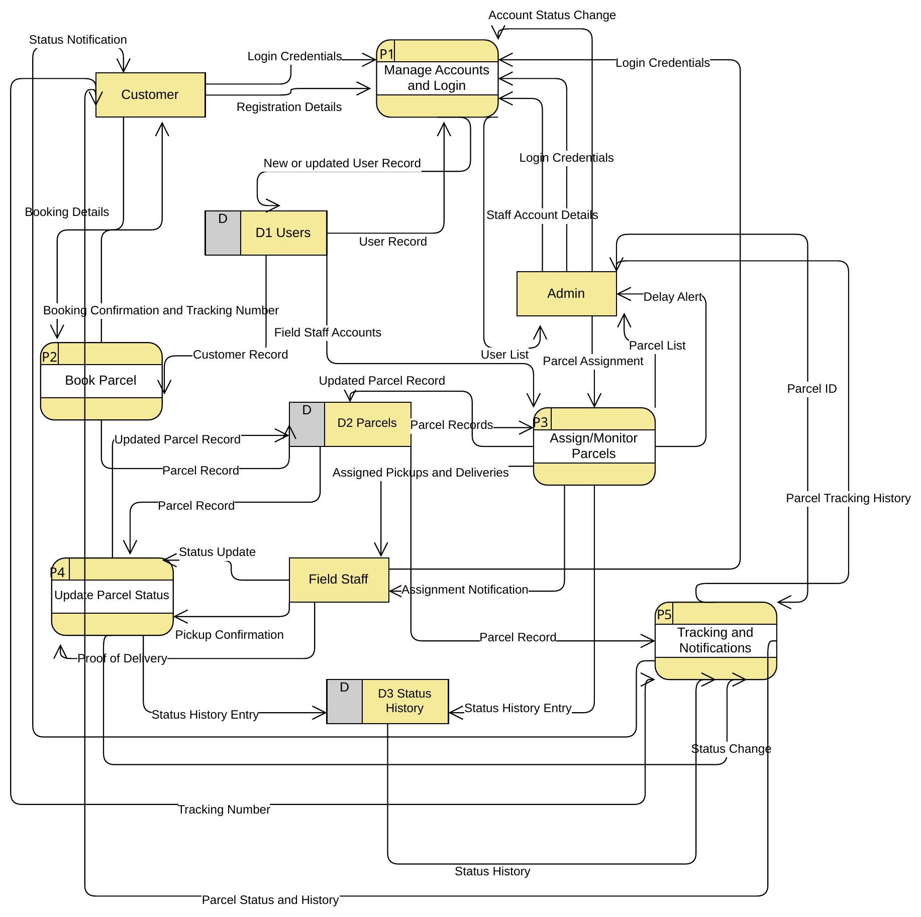
Figure 2.1: Level-0 DFD

2.1 Processes
Process | What it does
P1 Manage Accounts and Login | Registration, login for all three roles, admin-created staff accounts and activating or deactivating accounts.
P2 Book Parcel | Takes the customer's booking, checks it and creates the parcel with a unique tracking number.
P3 Assign/Monitor Parcels | Lets the admin assign parcels to field staff, shows the parcel list and raises delay alerts.
P4 Update Parcel Status | Field staff confirm pickup, move the status forward and record proof of delivery.
P5 Tracking and Notifications | Tracking lookups for customers and admins, and a notification to the customer on every status change.
Table 2.1: Level-0 processes

2.2 Data Stores
Data Store | What it holds | Used by
D1 Users | Customer, field staff and admin accounts with role, account status and, for field staff, the zone set by the admin | P1, P2, P3
D2 Parcels | Parcel and booking details (including recipient details), tracking number, current status, assignments to field staff, pickup time, delivery attempts, proof of delivery and delay alerts | P2, P3, P4, P5
D3 Status History | One timestamped entry per status change, with the status and the responsible actor or location | P3, P4, P5
Table 2.2: Level-0 data stores

2.3 Balancing with the Context Diagram
To check that the two diagrams are balanced, we went through every flow in the context diagram and found where it enters or leaves the Level-0 DFD. All 22 flows appear with the same name and direction, and no new external flows were added at Level-0. Flows like Status Change from P4 to P5 and the reads and writes to D1, D2 and D3 are internal, so they only show up at Level-0.
Entity | Data Flow (Context Diagram) | Direction | Level-0 Process
Customer | Registration details | In | P1
Customer | Login credentials | In | P1
Customer | Booking details | In | P2
Customer | Tracking number | In | P5
Customer | Booking confirmation and tracking number | Out | P2
Customer | Parcel status and history | Out | P5
Customer | Status notification | Out | P5
Field Staff | Login credentials | In | P1
Field Staff | Status update | In | P4
Field Staff | Pickup confirmation | In | P4
Field Staff | Proof of delivery | In | P4
Field Staff | Assigned pickups and deliveries | Out | P3
Field Staff | Assignment notification | Out | P3
Admin | Login credentials | In | P1
Admin | Staff account details | In | P1
Admin | Account status change | In | P1
Admin | Parcel assignment | In | P3
Admin | Parcel ID | In | P5
Admin | User list | Out | P1
Admin | Parcel list | Out | P3
Admin | Delay alert | Out | P3
Admin | Parcel tracking history | Out | P5
Table 2.3: Balancing check (In = entity to system, Out = system to entity)

3. Core Processes Matrix
The matrix uses the same five processes as the Level-0 DFD. The rules column explains the conditions that decide how each process turns its inputs into outputs.
Process No. and Name | Input Data | Output Data | Rules
P1 - Manage Accounts and Login | Registration details (Customer), Login credentials (Customer, Field Staff, Admin), Staff account details (Admin), Account status change (Admin), User record (D1 Users) | New or updated user record (D1 Users), User list (Admin) | Registration is rejected if the email is already registered, a field is empty or the password is under 8 characters. Login only works when the email and password match an active account, a deactivated account cannot log in. The dashboard opened depends on the user's role. Only an admin can create staff or admin accounts and they get a temporary password that must be changed at first login. When the admin creates a field staff account, the admin also sets that staff member's zone (one emirate); zones are never assigned automatically. Deactivating an account keeps its parcel records.
P2 - Book Parcel | Booking details: sender pickup address and emirate, recipient name, phone and address, parcel weight, dimensions and description (Customer), Customer record (D1 Users) | Parcel record (D2 Parcels), Booking confirmation and tracking number (Customer) | Only a logged-in customer can book. The booking is not confirmed if a mandatory field is empty, the recipient's phone is not a valid UAE number (+971 followed by 9 digits), the weight is not more than 0 and at most 70 kg, or any dimension (length, width, height) is not more than 0 and at most 150 cm. Every confirmed booking gets a unique tracking number in the format CPT-XXXXXX, shown on the confirmation page together with the expected delivery window: 24 hours from pickup if the recipient is in the same emirate as the sender, 48 hours if it is in a different emirate.
P3 - Assign/Monitor Parcels | parcel assignment (Admin); parcel records, including last update time (D2 Parcels); field staff accounts (D1 Users) | Assigned pickups and deliveries, assignment notification (Field Staff); parcel list, delay alert (Admin); updated parcel record with assigned staff (D2 Parcels); status history entry (D3 Status History) | Only a logged-in admin can assign parcels, and only confirmed bookings can be assigned to active field staff accounts. Reassigning is allowed only before pickup. Assigning sets the status to Assigned, updates D2, adds a D3 entry (status, timestamp, admin) and notifies the field staff member. An undelivered parcel with no status change for 48 hours is set to Delayed and an alert goes to the admin.
P4 - Update Parcel Status | Status update (Field Staff), Pickup confirmation (Field Staff), Proof of delivery: recipient name/signature/ID (Field Staff), Parcel records (D2 Parcels) | Updated parcel record, including pickup time and proof of delivery (D2 Parcels), Status history entry (D3 Status History), Status change (to P5) | Only a logged-in field staff member can update a status, and only on parcels assigned to them, from their assigned task list. Statuses move forward in specific order: Assigned -> Picked Up -> In Transit -> Out for Delivery -> Delivered. Skipping a step or going backwards is not allowed. The only exception is a failed visit: it is recorded as Attempted with a mandatory note and the parcel goes back to Out for Delivery for a retry, which is the only case where the status moves back a step. A parcel has at most 3 delivery attempts; after the 3rd failed attempt its status becomes Returned to Sender. Confirming pickup changes the status to Picked Up and records the pickup time. A parcel can only be marked delivered after the proof of delivery is captured. Every status change updates the parcel's current status in D2 and it also creates a time stamp entry in D3 containing the status along with the timestamp and the responsible actor/location. P4 does not send the notification itself. It passes the status change to P5, which reads the status history in D3 and sends the notification to the customer.
P5 - Tracking and notifications | Tracking number (Customer); Parcel ID (Admin), for tracking history lookup; Status change (from P4); Parcel record and status history (from Parcel / Status History data stores) | Parcel status and history (to Customer); Status notification (to Customer); Parcel tracking history (to Admin) | 1. Tracking number must exist, otherwise the customer gets a "not found" message and nothing else is shown. 2. A customer sees only their own parcels. 3. Admin can view the full tracking history of any parcel by Parcel ID. 4. History is shown in chronological order, each entry with status, date/time and location or staff. 5. A Status notification is sent to the Customer on every status change from P4 (Picked Up, In Transit, Out for Delivery, Attempted, Delivered, Returned to Sender). 6. Each notification is sent once per status change, no duplicates. 7. Read-only: P5 never changes the parcel status.
Table 3.1: Core Processes Matrix

4. Work Breakdown Structure
The WBS is based on the actual modules of our system instead of a generic Analysis, Design, Coding and Testing list. The modules follow the same split as the Level-0 processes, then integration, testing and deployment come at the end. Durations are in working days.
ID | Task Name | Description | Predecessor(s) | Duration (Days)
T1 | Requirements finalisation | Confirm the functional requirements, actors (Customer, Field Staff, Admin) and scope from Labs 1–3 | None | 2
T2 | Database Design | Design schema for D1 Users, D2 Parcels, D3 Status History | T1 | 3
T3 | User-Interface Design | Sketch out designs for the Login pages, Customer booking and tracking pages, Admin dashboards, Field Staff task list etc. | T1 | 4
T4 | Authentication & Account Management | Implementing functionalities related to Login/Registration, Admin created staff accounts, activation/deactivation of accounts. | T2 | 6
T5 | Parcel Booking Module | Booking form validation, tracking number generation, confirmation page | T2, T4 | 5
T6 | Assignment and Monitoring Module | Admin assigns parcels to field staff, assignment notifications, 48-hour delay flag and alert | T5 | 6
T7 | Status update module | Enforce the status order, pickup confirmation, proof of delivery, failed delivery attempt, writes to D2 and D3 | T5 | 6
T8 | Tracking & notification module | Tracking lookup, history view, customer notification on each status change with no duplicates | T7 | 6
T9 | Implementation of Front End | Build the screens from the T3 designs and connect them to the modules | T3, T4 | 5
T10 | System Integration | Combine each of the modules and verify that data flows as expected from one to the next | T6, T8, T9 | 4
T11 | Testing & bug fixes | Run pipeline end to end, implement any fixes for encountered bugs | T10 | 7
T12 | Deployment preparation & documentation | Deployment setup, user guide, final report | T11 | 3
Table 4.1: Work Breakdown Structure

5. Gantt Chart
The Gantt chart was made in GanttProject 3.3. We entered the same 12 tasks, durations and finish-to-start dependencies as the WBS in Section 4, so no separate set of activities was made for it. GanttProject then worked out the start and finish dates on its own.
The WBS has no calendar dates, so we picked Monday 19 October 2026 as the project start. GanttProject skips weekends, which means the 42 working days finish on Tuesday 15 December 2026. The arrows between the bars show the dependencies.
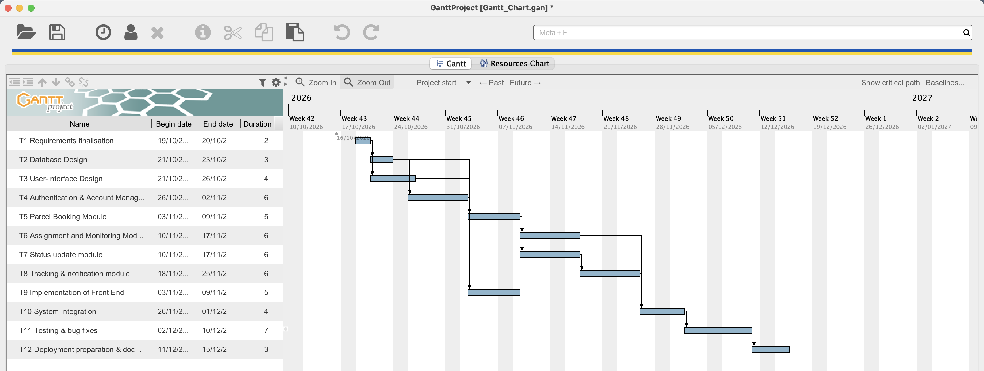
Figure 5.1: Gantt Chart in GanttProject

6. Network-Based Scheduling
The network diagram is task-on-node. Each node shows the task ID, the expected time E, ES, EF, LS, LF and slack. As in the lecture examples, each task has a single duration estimate, so E is the duration from the WBS. The red arrows mark the critical path.
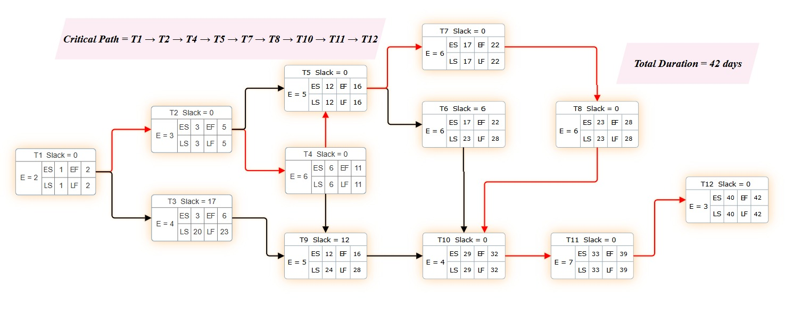
Figure 6.1: Task-on-node network diagram

6.1 Calculations
We used the method from class, where the first task starts on day 1:
- Forward pass: ES = max(EF of predecessors) + 1, and EF = ES + E - 1
- Backward pass: LF = min(LS of successors) - 1, and LS = LF - E + 1. The last task's LF is its EF.
- Slack: LS - ES (which is the same as LF - EF)

The forward pass goes from T1 to T12 to get the earliest times.
ID | Predecessor(s) | E | ES | EF
T1 | None | 2 | 1 (first task) | 1 + 2 - 1 = 2
T2 | T1 | 3 | 2 + 1 = 3 | 3 + 3 - 1 = 5
T3 | T1 | 4 | 2 + 1 = 3 | 3 + 4 - 1 = 6
T4 | T2 | 6 | 5 + 1 = 6 | 6 + 6 - 1 = 11
T5 | T2, T4 | 5 | max(5, 11) + 1 = 12 | 12 + 5 - 1 = 16
T6 | T5 | 6 | 16 + 1 = 17 | 17 + 6 - 1 = 22
T7 | T5 | 6 | 16 + 1 = 17 | 17 + 6 - 1 = 22
T8 | T7 | 6 | 22 + 1 = 23 | 23 + 6 - 1 = 28
T9 | T3, T4 | 5 | max(6, 11) + 1 = 12 | 12 + 5 - 1 = 16
T10 | T6, T8, T9 | 4 | max(22, 28, 16) + 1 = 29 | 29 + 4 - 1 = 32
T11 | T10 | 7 | 32 + 1 = 33 | 33 + 7 - 1 = 39
T12 | T11 | 3 | 39 + 1 = 40 | 40 + 3 - 1 = 42
Table 6.1: Forward pass
The backward pass starts from T12 with LF = 42 and goes back to T1.
ID | Successor(s) | E | LF | LS
T12 | None | 3 | 42 (EF of last task) | 42 - 3 + 1 = 40
T11 | T12 | 7 | 40 - 1 = 39 | 39 - 7 + 1 = 33
T10 | T11 | 4 | 33 - 1 = 32 | 32 - 4 + 1 = 29
T9 | T10 | 5 | 29 - 1 = 28 | 28 - 5 + 1 = 24
T8 | T10 | 6 | 29 - 1 = 28 | 28 - 6 + 1 = 23
T7 | T8 | 6 | 23 - 1 = 22 | 22 - 6 + 1 = 17
T6 | T10 | 6 | 29 - 1 = 28 | 28 - 6 + 1 = 23
T5 | T6, T7 | 5 | min(23, 17) - 1 = 16 | 16 - 5 + 1 = 12
T4 | T5, T9 | 6 | min(12, 24) - 1 = 11 | 11 - 6 + 1 = 6
T3 | T9 | 4 | 24 - 1 = 23 | 23 - 4 + 1 = 20
T2 | T4, T5 | 3 | min(6, 12) - 1 = 5 | 5 - 3 + 1 = 3
T1 | T2, T3 | 2 | min(3, 20) - 1 = 2 | 2 - 2 + 1 = 1
Table 6.2: Backward pass
Putting both passes together gives the slack for every task.
ID | E | ES | EF | LS | LF | Slack (LS - ES) | Critical
T1 | 2 | 1 | 2 | 1 | 2 | 1 - 1 = 0 | Yes
T2 | 3 | 3 | 5 | 3 | 5 | 3 - 3 = 0 | Yes
T3 | 4 | 3 | 6 | 20 | 23 | 20 - 3 = 17 | No
T4 | 6 | 6 | 11 | 6 | 11 | 6 - 6 = 0 | Yes
T5 | 5 | 12 | 16 | 12 | 16 | 12 - 12 = 0 | Yes
T6 | 6 | 17 | 22 | 23 | 28 | 23 - 17 = 6 | No
T7 | 6 | 17 | 22 | 17 | 22 | 17 - 17 = 0 | Yes
T8 | 6 | 23 | 28 | 23 | 28 | 23 - 23 = 0 | Yes
T9 | 5 | 12 | 16 | 24 | 28 | 24 - 12 = 12 | No
T10 | 4 | 29 | 32 | 29 | 32 | 29 - 29 = 0 | Yes
T11 | 7 | 33 | 39 | 33 | 39 | 33 - 33 = 0 | Yes
T12 | 3 | 40 | 42 | 40 | 42 | 40 - 40 = 0 | Yes
Table 6.3: Scheduling values and slack

7. Critical Path
Critical Path:
T1 → T2 → T4 → T5 → T7 → T8 → T10 → T11 → T12
The activities on the critical path are:
ID | Task Name | Duration (Days)
T1 | Requirements finalisation | 2
T2 | Database Design | 3
T4 | Authentication & Account Management | 6
T5 | Parcel Booking Module | 5
T7 | Status update module | 6
T8 | Tracking & notification module | 6
T10 | System Integration | 4
T11 | Testing & bug fixes | 7
T12 | Deployment preparation & documentation | 3
 | Total | 42
Table 7.1: Activities on the critical path
Expected Project Duration:
42 days
Explanation:
From Table 6.3, the tasks with slack 0 are T1, T2, T4, T5, T7, T8, T10, T11 and T12. They have no room to move, so if any of them is late the whole project finishes after day 42. These tasks also connect into one chain from the first task to the last, which is the critical path.
We also checked every path through the network. The critical path should be the longest one, and it is:
Path | Duration (Days)
T1 → T2 → T4 → T5 → T7 → T8 → T10 → T11 → T12 | 42
T1 → T2 → T4 → T5 → T6 → T10 → T11 → T12 | 36
T1 → T2 → T5 → T7 → T8 → T10 → T11 → T12 | 36
T1 → T2 → T4 → T9 → T10 → T11 → T12 | 30
T1 → T2 → T5 → T6 → T10 → T11 → T12 | 30
T1 → T3 → T9 → T10 → T11 → T12 | 25
Table 7.2: All paths through the network
T4 is on the critical path even though T2 also connects straight to T5. T5 can only start when both T2 and T4 are done, and T4 finishes on day 11 while T2 finishes on day 5. So T5 is waiting on T4. The tasks that are not critical are T3 (17 days of slack), T9 (12 days) and T6 (6 days).

7.1 Tool Verification
To check the manual calculation we turned on Show critical path in GanttProject. The tool marks the critical tasks with hatched bars.
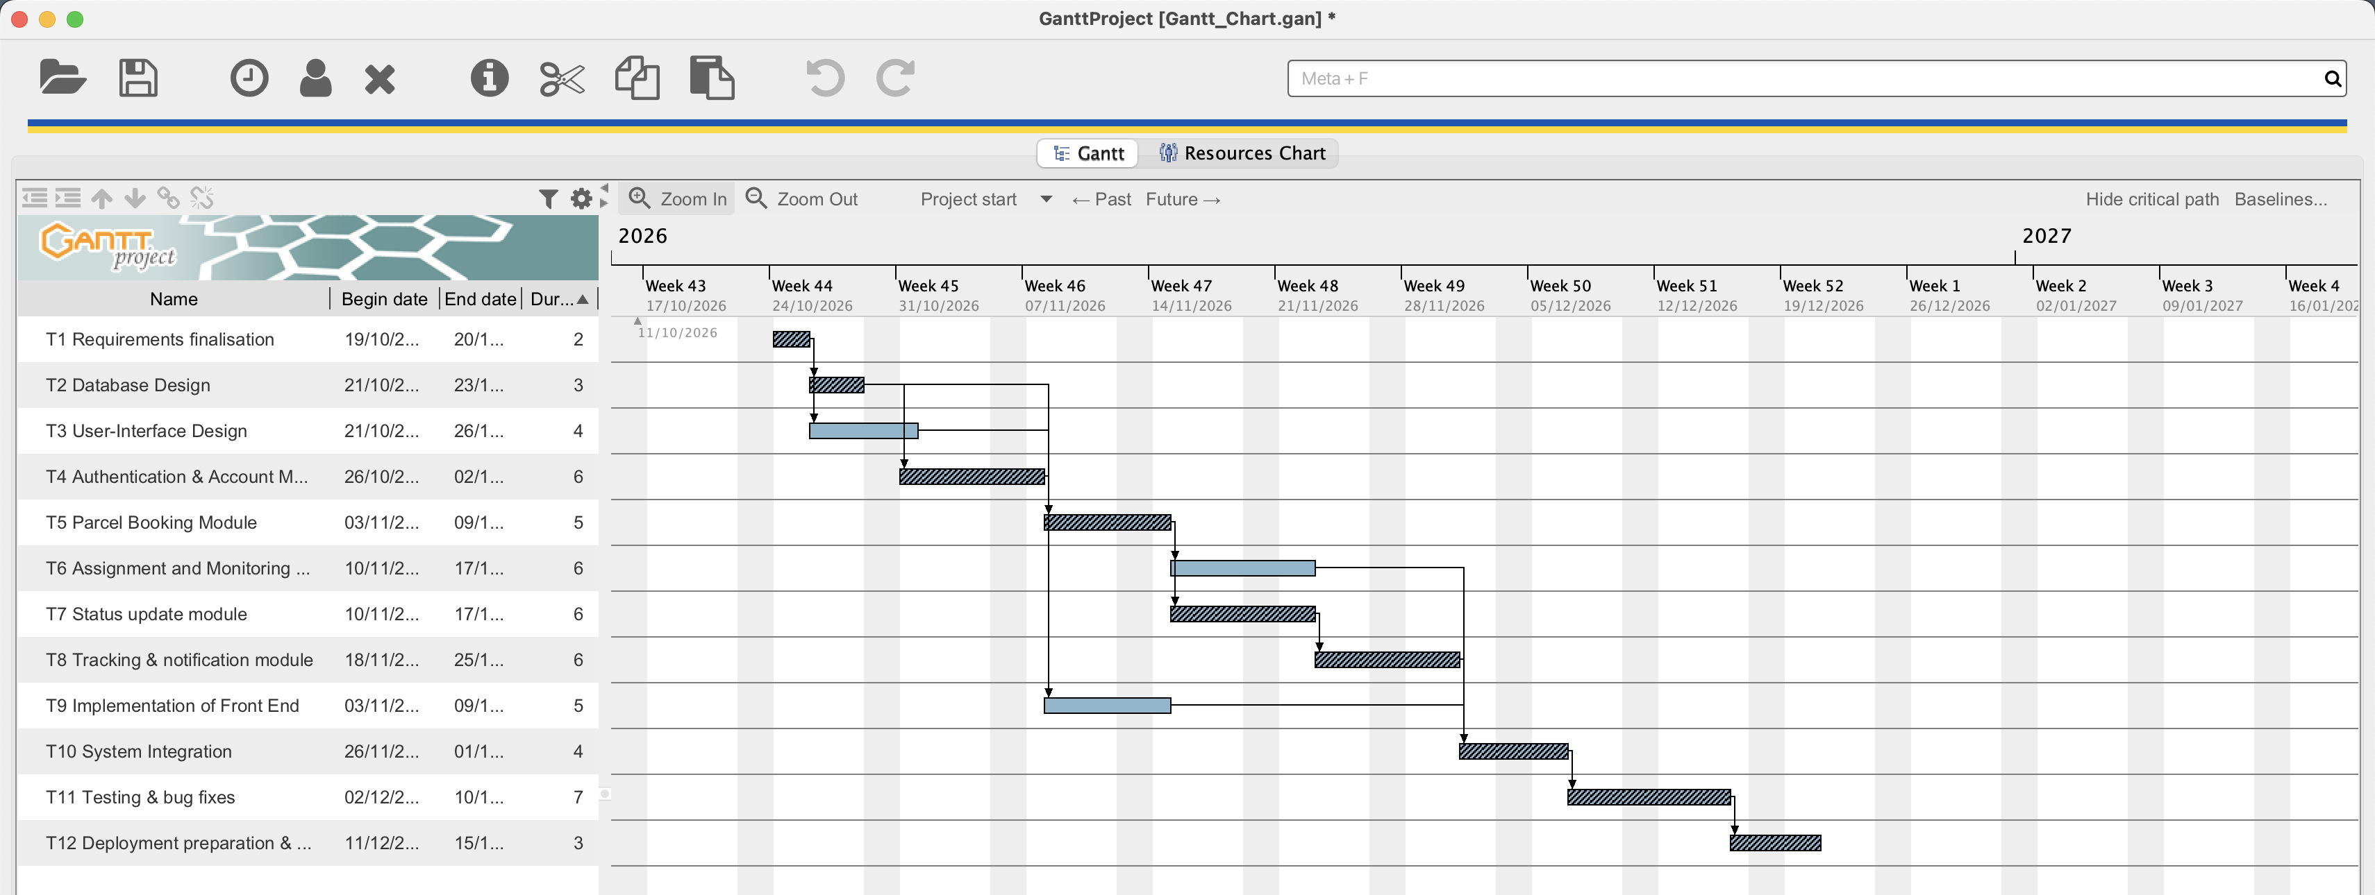
Figure 7.1: Critical path in GanttProject (hatched bars)
GanttProject marks T1, T2, T4, T5, T7, T8, T10, T11 and T12 as critical and leaves T3, T6 and T9 as normal bars. The project ends on the 42nd working day (15 December 2026). This is the same critical path and duration we got by hand in Section 6.

8. Integration and Consistency Check

8.1 Data Flow Modeling
Check | Result | Notes
The Context Diagram represents the proposed system correctly | Yes | The whole system is one process (0) with only external entities and data flows. No internal processes or data stores.
External entities are consistent with UML Use Case actors | Yes | Customer, Field Staff and Admin are the same three actors as the Lab 3 use case diagram.
Level-0 DFD uses the same relevant external entities | Yes | Same three entities, nothing new added at Level-0.
Context Diagram and Level-0 DFD are balanced | Yes | All 22 external flows appear in the Level-0 DFD with the same name and direction (Table 2.3).
Level-0 contains at least five meaningful processes | Yes | P1 to P5, each one comes from a group of Lab 3 requirements and use cases.
Level-0 contains at least two relevant data stores | Yes | D1 Users, D2 Parcels and D3 Status History.
Core Processes Matrix contains the same major processes as the Level-0 DFD | Yes | Same numbers and names, P1 to P5.
DFD processes are consistent with Functional Requirements and Use Cases | Yes | See Table 8.2.
Table 8.1: Data flow modeling checks
Table 8.2 maps each Level-0 process back to the Lab 3 requirements and use cases it comes from.
Process | Functional Requirements (Lab 3) | Use Cases (Lab 3)
P1 Manage Accounts and Login | Sarhan FR-01, FR-02  Kevin FR-01, FR-02, FR-05 | Register Account, Log In, View and Search User Accounts, Deactivate/Reactivate User Account, Create Staff/Admin Account, Change Temporary Password
P2 Book Parcel | Sarhan FR-03, FR-04 | Book Parcel, Generate Tracking Number
P3 Assign/Monitor Parcels | Kevin FR-03, FR-04  Ahmed FR-02, FR-05 | View All Parcels on Dashboard, Assign Parcels to Field Staff, Receive Assignment Notification, View Dashboard Delay Alerts
P4 Update Parcel Status | Hammad FR-01 to FR-05  Ahmed FR-03 | View Assigned Pickups, View Assigned Deliveries, Update Parcel Status, Confirm Pickup, Record Proof of Delivery
P5 Tracking and Notifications | Sarhan FR-05  Ahmed FR-01, FR-04 | Track Parcel, Receive Status Notification, View Parcel Tracking History, Search Tracking History by Parcel ID
Table 8.2: Processes vs Lab 3 requirements and use cases

8.2 Project Scheduling
Check | Result | Notes
WBS activities represent actual project work | Yes | The tasks are this system's actual modules (accounts, booking, assignment, status updates, tracking and notifications), not a generic list.
Gantt Chart activities correspond to WBS activities | Yes | Same 12 tasks, durations and dependencies as the WBS, entered in GanttProject.
Task dependencies are logically defined | Yes | Booking (T5) needs the database (T2) and login (T4), status updates (T7) need booking, and integration (T10) waits for T6, T8 and T9.
Time estimates are realistic and project-specific | Yes | Between 2 and 7 days per task, with more time for the bigger modules and testing.
Expected Times are correctly calculated | Yes | Each task has one estimate in the WBS, used as E in the network diagram.
Network diagram reflects the WBS dependencies | Yes | Every arrow matches a predecessor in the WBS.
ES, EF, LS, LF and Slack calculations are correct | Yes | Worked out by hand in Section 6 and checked with GanttProject in Section 7.1.
Critical Path is correctly identified | Yes | T1, T2, T4, T5, T7, T8, T10, T11, T12. All have slack 0 and it is the longest path at 42 days (Section 7, Table 7.2).
The Critical Path and project duration are verified using an appropriate scheduling/project-management tool | Yes | GanttProject 3.3 shows the same critical tasks and a 42 working day schedule (Section 7.1).
Table 8.3: Project scheduling checks

8.3 Updates to Previous Labs
Doing Lab 4 showed two small inconsistencies in our Lab 3 documents, so we updated them in the repository:
- Delay rule: Lab 3 said a parcel is delayed when it goes past its expected delivery window, without saying what that window is, and one scenario used 6 hours. For Lab 4 we made it a specific rule: a parcel with no status change for 48 hours is flagged as delayed. P3 in the matrix and T6 in the WBS use this rule, and we updated the delay alert requirement (Ahmed's FR-05), the View Dashboard Delay Alerts use case and the delayed parcel scenario, plus the consolidated requirements, to match.
- Tracking number format: The tracking number requirement (Sarhan's FR-04) and P2 use the format CPT-XXXXXX, but two Lab 3 scenarios used TRK-88214 and CPT-2026-000482. We changed them to CPT-088214 and CPT-000482.

AI Usage Declaration
Team members used AI tools (such as ChatGPT or Claude) in a supporting role while preparing this lab, for example to clarify concepts like DFD balancing and CPM, check work that had already been done, learn tool features, proofread the writing, and format the report. All diagrams, process rules, WBS tasks, durations and critical path calculations were produced by the team, and any AI suggestions were reviewed and edited before being included. Every member reviewed the final report and can explain the work.

