American University of Sharjah
College of Engineering, Department of Computer Science and Engineering
COE420L Software Engineering

Lab 7: UML Activity Diagram Modeling
Courier Parcel Tracking System
Team 10

Team Member | AUS ID
Sarhan Alzaabi | b00100669
Kevin Alex | b00098368
Muhammad Hammad Khan | b00094579
Ahmed El Sabagh | b00095506

GitHub Repository: https://github.com/COE420-Team10-F26/Courier_parcel_tracking_system
Instructor: Dr. Mustafa Hammad
Lab Instructor: Yara Kaddoura
Fall 2026, November 10

Team Contributions
Each member drew the activity diagram for the same use case they modeled as a sequence diagram in Lab 6. Kevin and Sarhan answered the review questions for all four diagrams, and Ahmed updated the README. All work is in the shared GitHub repository.
Name | AUS ID | Lab 7 Work
Sarhan Alzaabi | b00100669 | UC-03 Book Parcel activity diagram and its Selected_Workflows.md section; Selected_Workflows.md and AD_Review.md set-up; revisions to Labs 3, 4 and 6 (Section 4); review questions 2 to 10 for all four diagrams; the UC-16 Selected_Workflows.md section, file names and swimlane fix; the fixes found in the review to UC-09 (title, PDF, guards, notification note, lane and action names, action shapes, straight flows), UC-16 (action shapes, request action) and UC-19 (note anchor); one black-and-white style and plain lane names across all four diagrams; added references to the question 12 answers; final report
Kevin Alex | b00098368 | UC-09 Assign Parcels to Field Staff activity diagram and its Selected_Workflows.md section; review questions 1, 11 and 12 for all four diagrams
Muhammad Hammad Khan | b00094579 | UC-16 Record Proof of Delivery activity diagram
Ahmed El Sabagh | b00095506 | UC-19 View Parcel Tracking History activity diagram and its Selected_Workflows.md section; README update for Lab 7

1. Exercise 1: UML Activity Diagrams
The team modeled the same four use cases selected in Lab 6, one per member, as UML activity diagrams. Each diagram was drawn in draw.io, and its .drawio source is in the repository next to its PDF (Table 1.1). The team used the same conventions in all four diagrams:
- Every diagram has a title with its use case and the member who drew it, one initial node, and an activity final node at the end of every path.
- Swimlanes are the actor, System, and Notification (the StatusNotification and AssignmentNotification classes from Lab 5). UC-19 sends no notification, so it has only Customer and System.
- Action names are verb phrases without the actor's name, since the swimlane shows who performs them. Every decision has complementary guards in [ ], and a merge node is used wherever paths rejoin.
- A status change is drawn as "set status" followed by "record status history entry", so the history entry always comes before the notification (FR-18, P5 rule 5). In UC-09 and UC-16 a decision [active delay alert] / [no active delay alert] follows, because a Delayed parcel still counts as its previous status and its alert is resolved at that update (revision R1).
- Every diagram with a notification carries the note: "send() hands the notification to the notification queue and returns at once; failures are retried for up to 24 h (NFR-18) and never block status-history logging (NFR-19) or the rest of the workflow."
- Fork and join nodes are used only for activities that are genuinely parallel.
Table 1.1: The four activity diagrams
Use Case | Primary Actor | Swimlanes | Activity Diagram File | Drawn by
UC-03 Book Parcel | Customer | Customer, System, Notification | AD_UC-03_Book_Parcel.pdf / .drawio | Sarhan Alzaabi
UC-09 Assign Parcels to Field Staff | Admin | Admin, System, Notification | AD_UC-09_Assign_Parcels_to_Field_Staff.pdf / .drawio | Kevin Alex
UC-16 Record Proof of Delivery | Field Staff | Field Staff, System, Notification | AD_UC-16_Record_Proof_of_Delivery.pdf / .drawio | Muhammad Hammad Khan
UC-19 View Parcel Tracking History | Customer | Customer, System | AD_UC-19_View_Parcel_Tracking_History.pdf / .drawio | Ahmed El Sabagh

1.1 UC-03 Book Parcel (Sarhan Alzaabi, b00100669)
The customer enters the pickup, recipient and parcel details and submits the booking, and the system validates them against the FR-03 rules. A decision splits the two outcomes:
- [invalid]: the system shows the errors next to the fields and keeps the entered data (NFR-04). The customer then chooses [correct and resubmit], which goes back to the merge before entering the details, or [cancel], which ends the workflow with nothing created.
- [valid]: the system creates the parcel with status Booked, generates its tracking number (<<include>> UC-04, FR-04), sets the status to Pending Pickup and records the status history entry (P2, FR-18).
- A fork then runs two activities in parallel: the Notification lane sends the Pending Pickup notification to the customer (FR-16), while the system calculates the expected delivery window (24 h if the recipient is in the same emirate as the sender, 48 h if not). They are genuinely parallel because send() hands the notification to the queue and returns at once, and the window does not depend on it. After the join, the customer views the confirmation with the tracking number and delivery window.
- Two notes are on the diagram. The first is the team's notification note (NFR-18, NFR-19). The second explains why there is no delay-alert decision: a newly created parcel cannot have a delay alert.
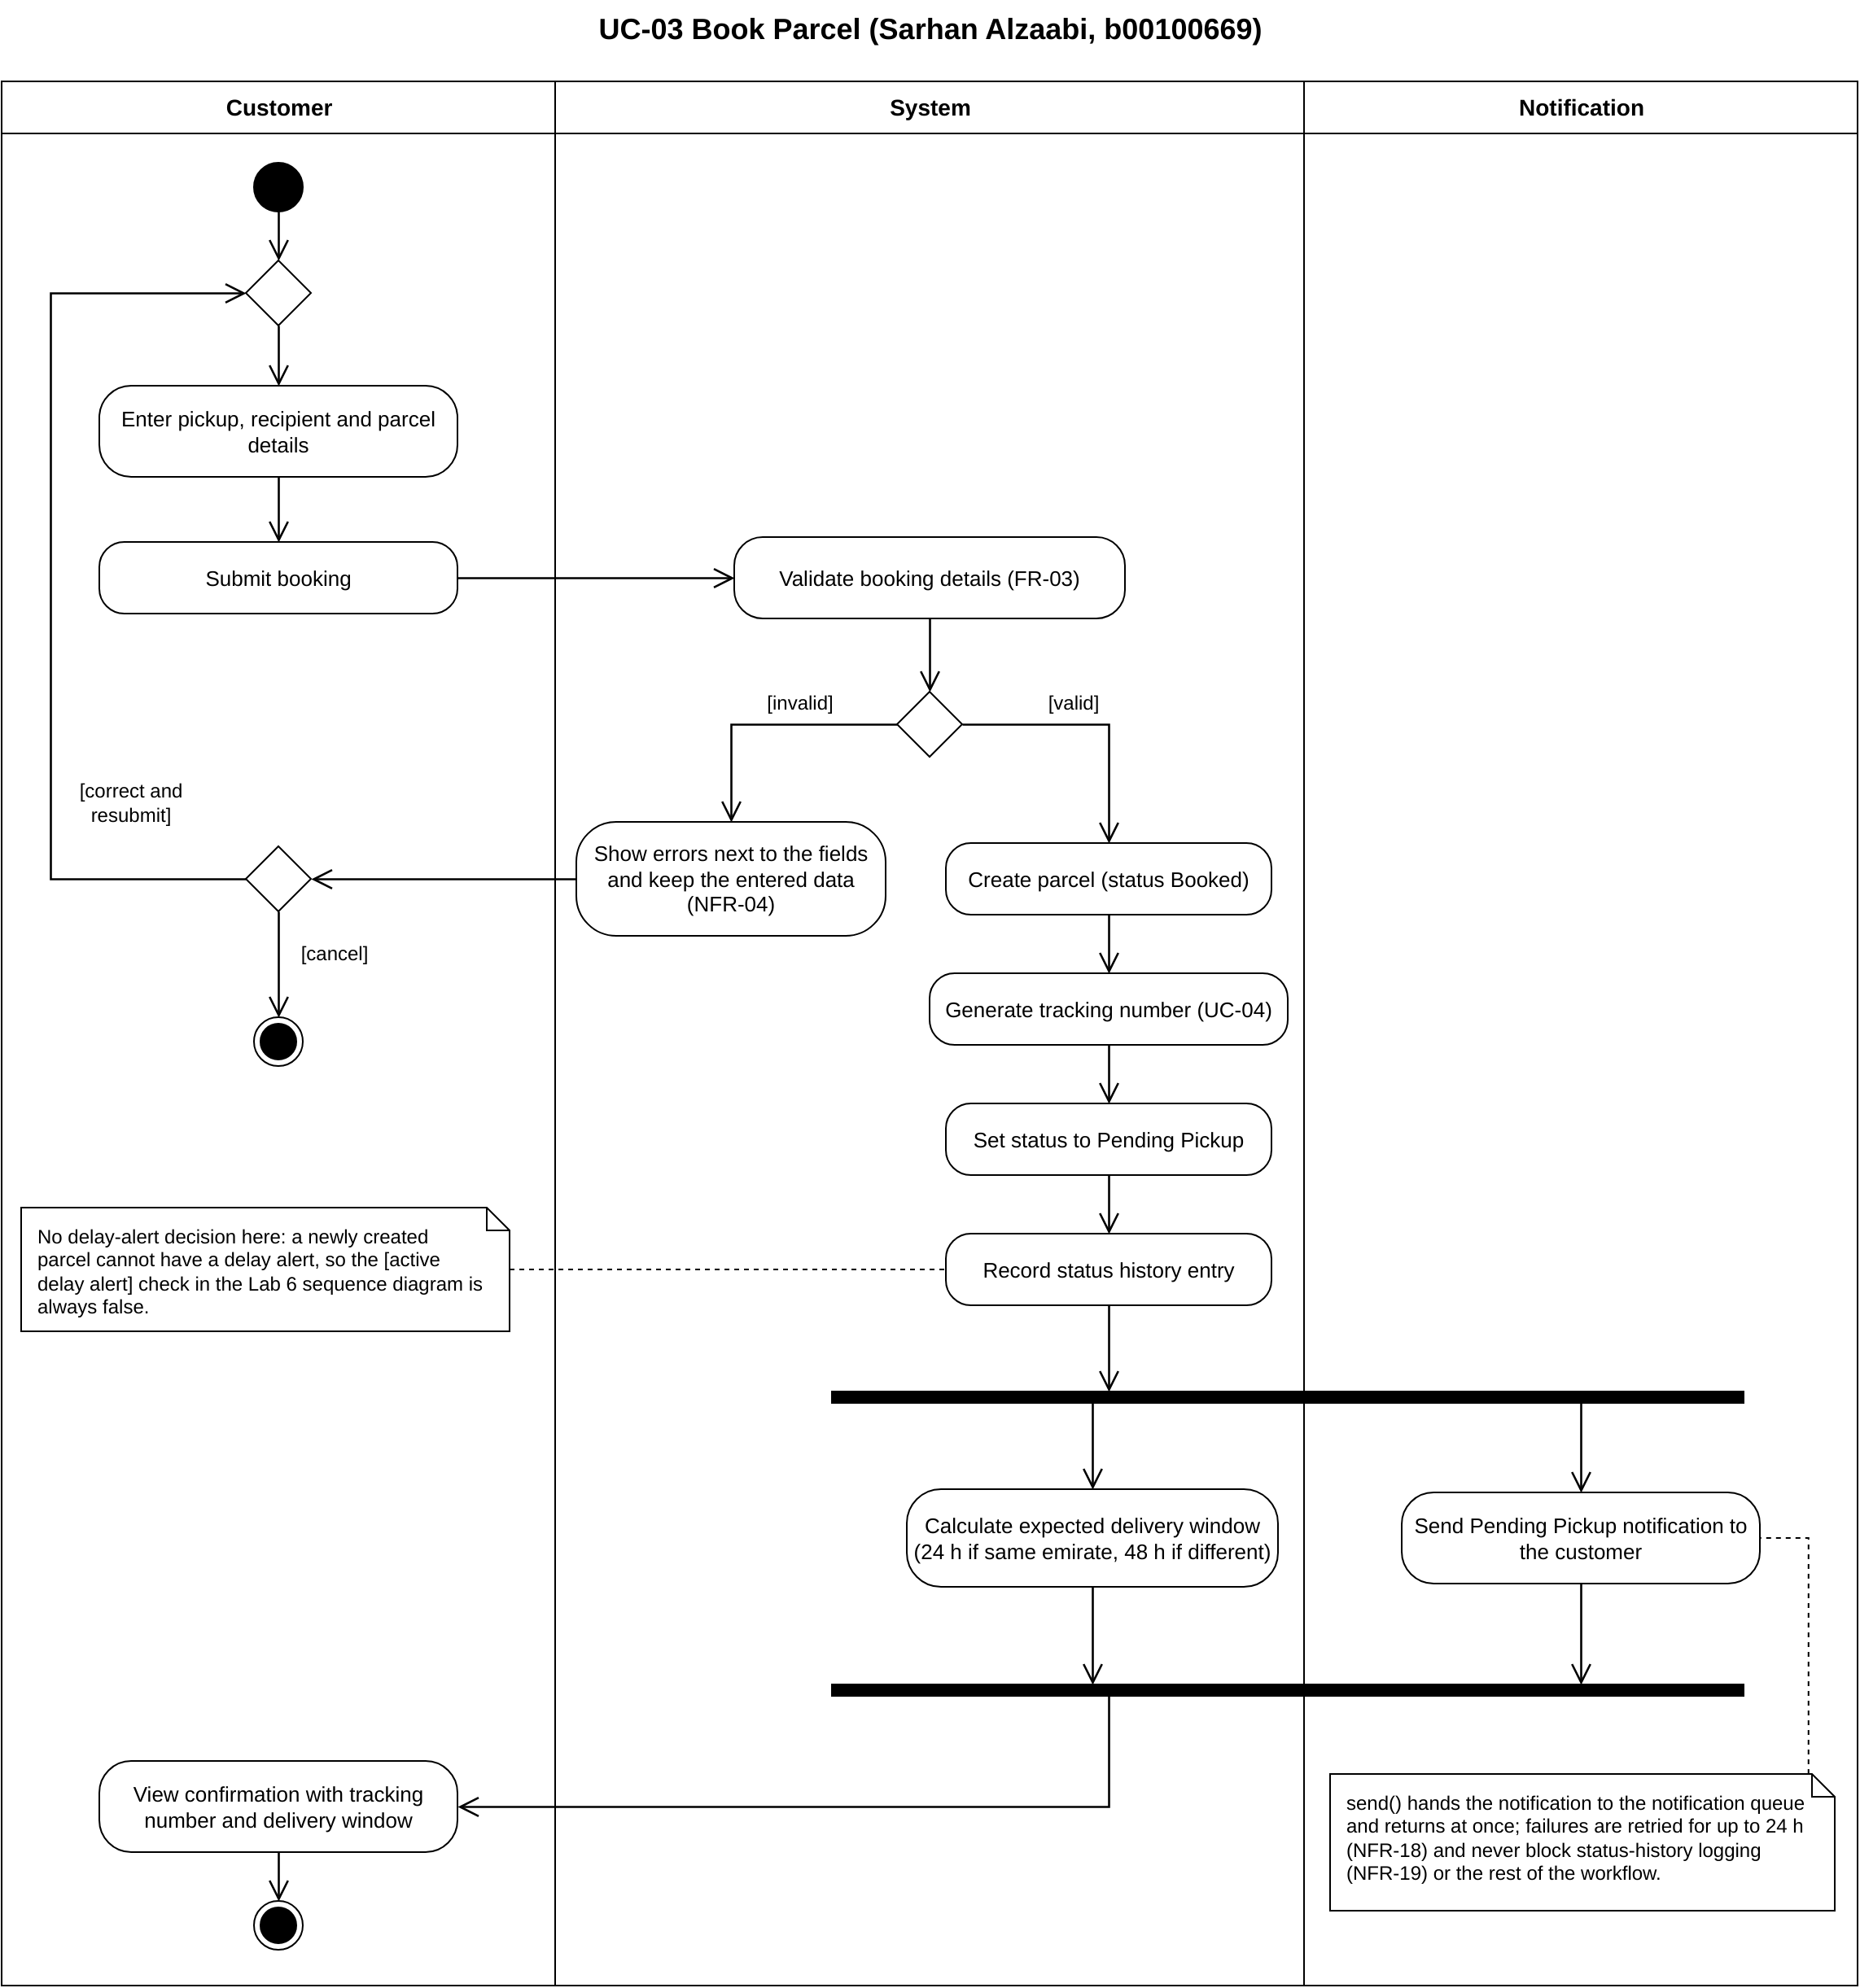
Figure 1.1: UC-03 Book Parcel activity diagram (AD_UC-03_Book_Parcel.pdf)

1.2 UC-09 Assign Parcels to Field Staff (Kevin Alex, b00098368)
The admin requests the parcel list. The system shows all parcels with their status, zone and staff (FR-08, <<include>> UC-08) and then the unassigned Pending Pickup parcels, which include Delayed parcels that still count as Pending Pickup (revision R1). The admin selects parcels, the system shows the active field staff with their workload and zones, and the admin selects a staff member and submits. The system creates the assignment, adds the parcels and validates them: every parcel must be Pending Pickup, or Delayed while Pending Pickup (P3, revision R1).
- [invalid]: a safeguard for a parcel whose status changes before the assignment is submitted. The system shows "invalid parcels, assignment not confirmed". The admin then chooses [try again], which goes back to the merge before requesting the parcel list, or [cancel], which ends the workflow.
- [valid]: the system confirms the assignment and loops over the parcels. For each parcel it sets the status to Assigned and records the status history entry. A decision [active delay alert] / [no active delay alert] resolves any delay alert, and both paths rejoin at a merge (revision R1). The Notification lane then sends the Assigned notification to the customer (FR-09, FR-16).
- On [all parcels done], the system gets the parcel count and the assigned staff member, the Notification lane sends one summary notification to the staff member (FR-17, <<include>> UC-18) and the system shows the confirmation to the admin.
- There is no fork: the summary notification is sent before the confirmation is shown, in the same order as the Lab 6 sequence diagram.
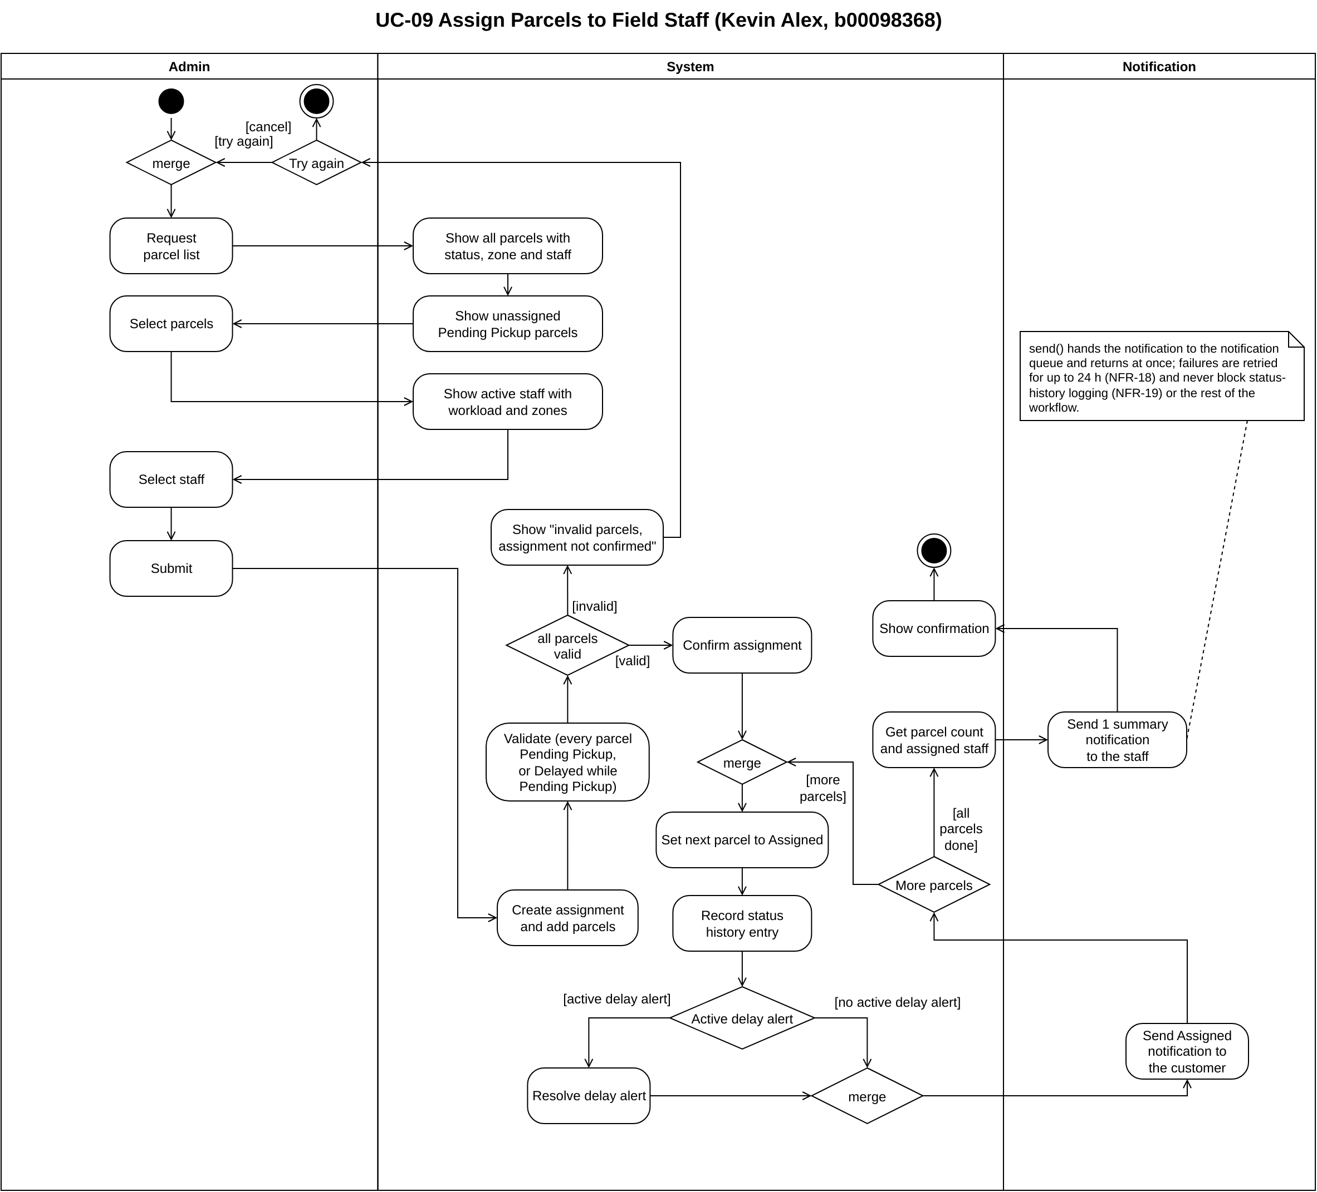
Figure 1.2: UC-09 Assign Parcels to Field Staff activity diagram (AD_UC-09_Assign_Parcels_to_Field_Staff.pdf)

1.3 UC-16 Record Proof of Delivery (Muhammad Hammad Khan, b00094579)
The staff member requests their assigned parcels, the system shows them, and the staff member selects one. After a merge, the staff member enters the recipient's name, signature and Emirates ID and submits them, and the system checks the parcel's status. A decision splits the outcomes:
- [any other status]: the system shows "parcel is not out for delivery" and the workflow ends, so no status step can be skipped (P4).
- [Out for Delivery, or Delayed while Out for Delivery]: the system creates the proof of delivery and checks that it is complete. On [incomplete] it discards the proof and shows "proof incomplete", and the staff member chooses [retry], which goes back to the merge, or [stop], which ends the workflow with the parcel keeping its status (FR-15).
- [complete]: the system sets the status to Delivered through updateDeliveryStatus (<<include>> UC-14, which includes UC-17 for the notification) and records the status history entry. A decision [active delay alert] / [no active delay alert] resolves any delay alert, and both paths rejoin at a merge (revision R1).
- A fork then runs two activities in parallel: the Notification lane sends the Delivered notification to the customer while the system shows the confirmation and proof to the staff member. After the join the workflow ends. The team's notification note (NFR-18, NFR-19) is attached to the send action.
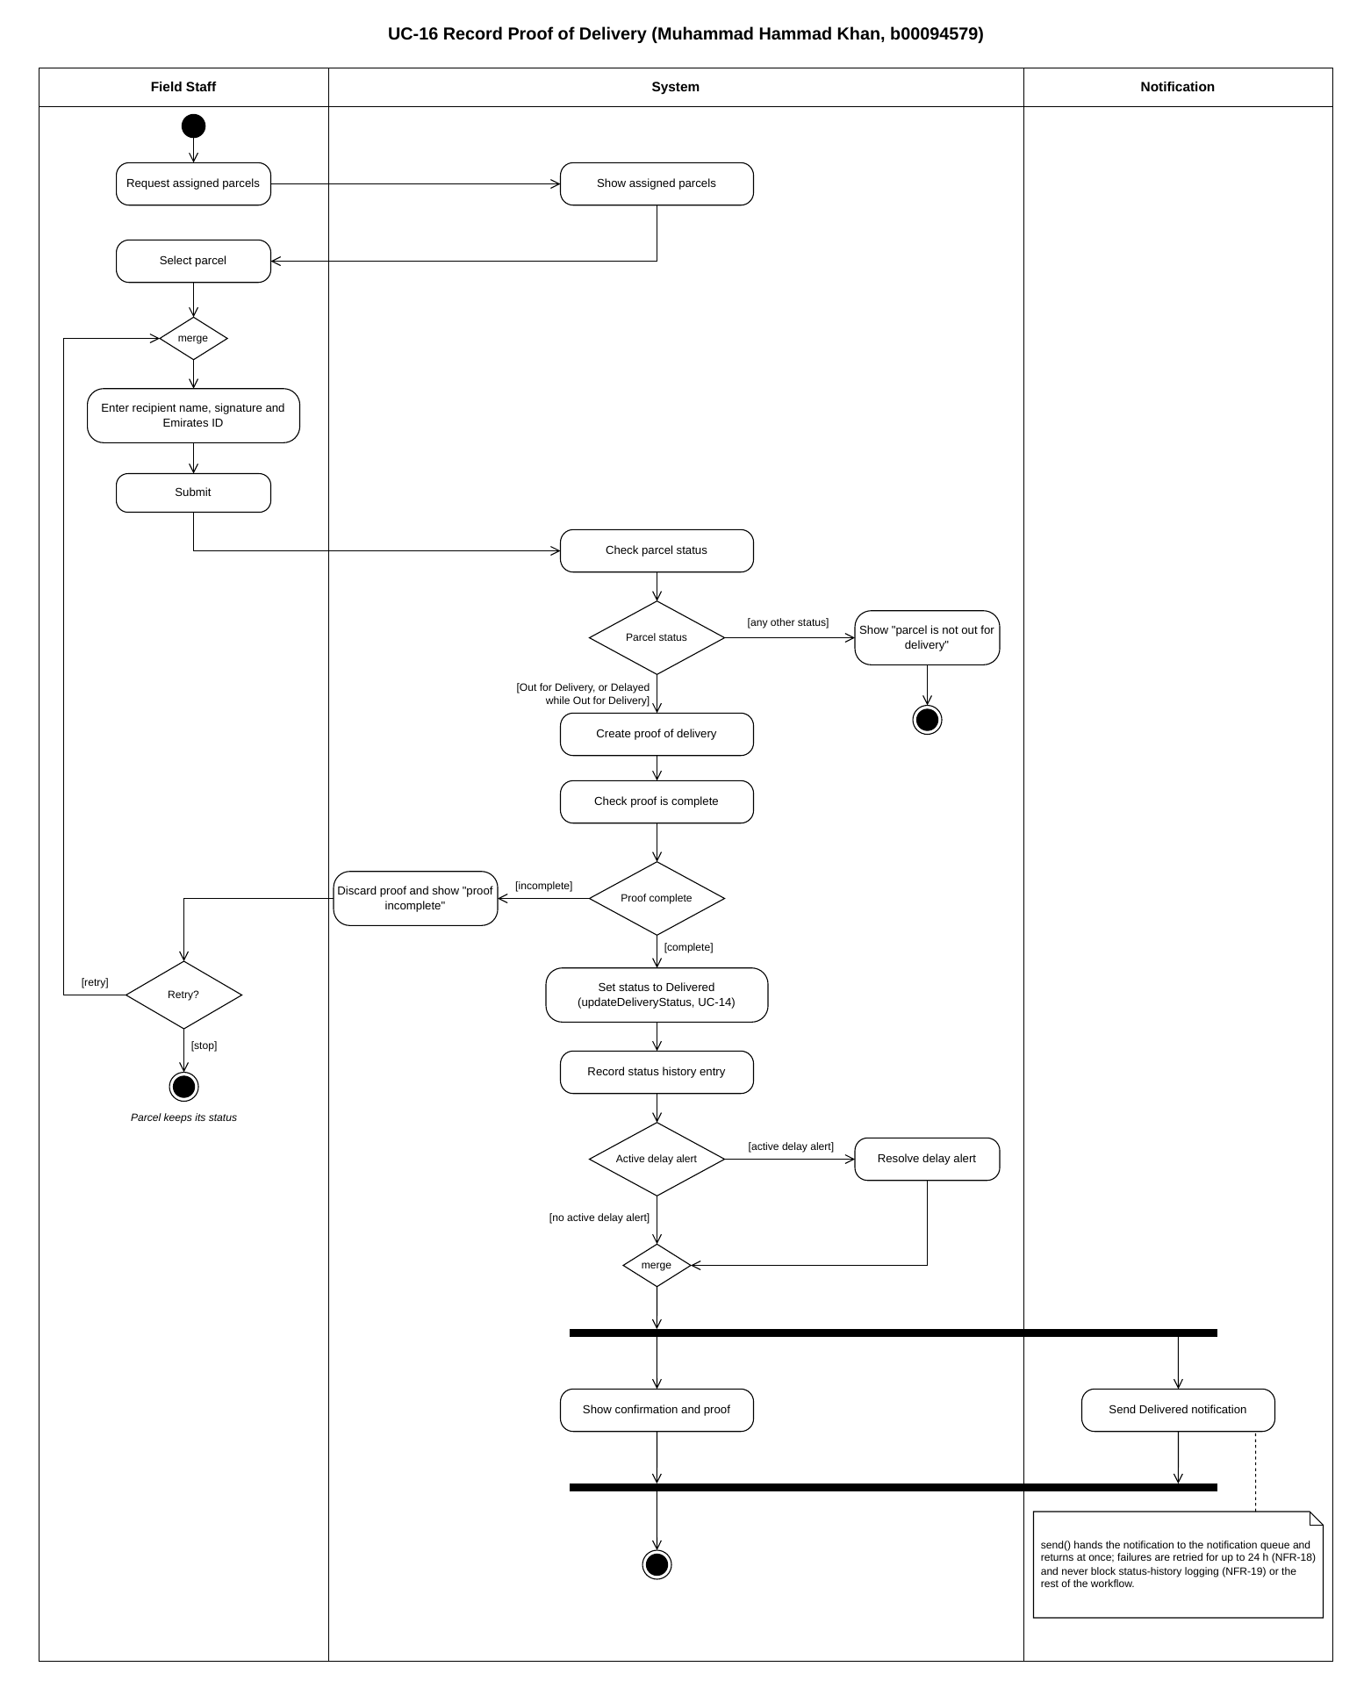
Figure 1.3: UC-16 Record Proof of Delivery activity diagram (AD_UC-16_Record_Proof_of_Delivery.pdf)

1.4 UC-19 View Parcel Tracking History (Ahmed El Sabagh, b00095506)
The customer enters a tracking number, and the system looks for it among the customer's own parcels (viewMyParcels). A decision splits the two outcomes:
- [not found or not own parcel]: the system shows "parcel not found" and nothing else (P5 rules 1 and 2). The customer then chooses [try again], which goes back to the merge before entering the tracking number, or [done], which ends the workflow.
- [found and belongs to customer]: the system gets the status history, oldest first. In a loop it gets each entry's transition text (getTransition), with [more entries] going back to the loop merge and [no more entries] going on. The customer then views the full status history, with the status, date/time and location or staff of each entry (FR-19, P5 rule 4).
- There is no Notification lane and no fork or join. A note on the diagram explains that the workflow is a read-only lookup (P5 rule 7) with nothing genuinely parallel, and a second note says getStatusHistory() returns the entries in chronological order, as in the Lab 6 sequence diagram.
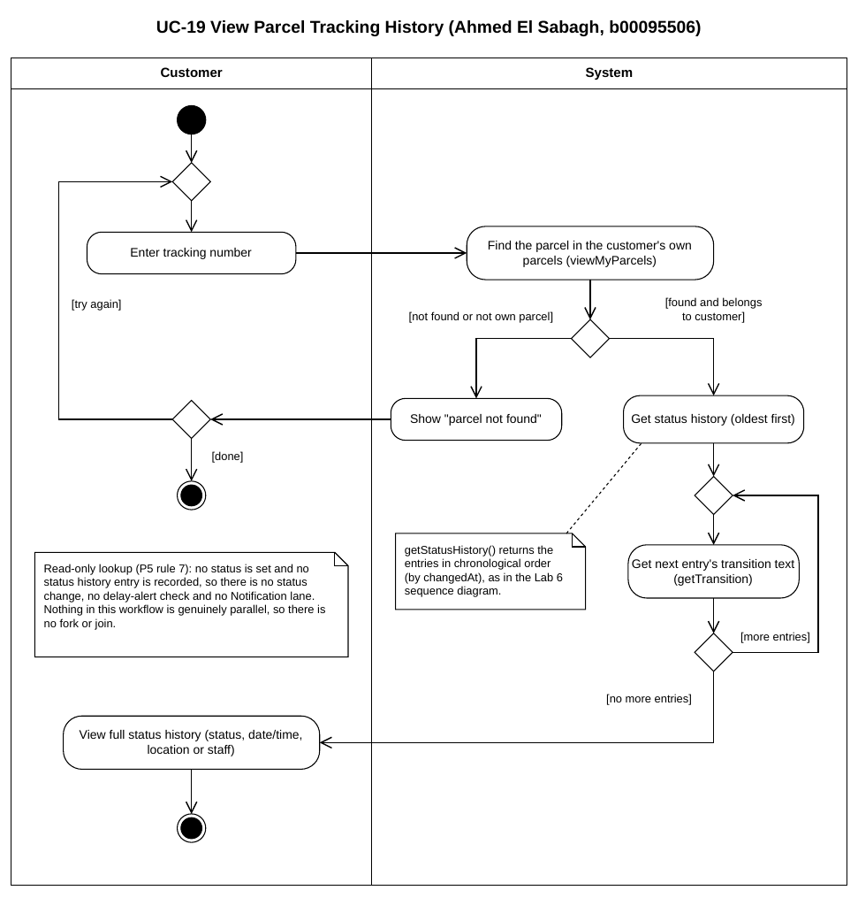
Figure 1.4: UC-19 View Parcel Tracking History activity diagram (AD_UC-19_View_Parcel_Tracking_History.pdf)

2. Review and Validation
Each review question had one owner, who checked all four diagrams and recorded the answers in Project/Behavioral_Modeling/AD_Review.md. Every problem found was fixed before submission, and the answers below are the final ones. Questions 1 and 11 were checked against the Lab 6 sequence diagrams and Lab 5 class operations (Kevin Alex), question 2 against the Lab 3 requirements and use cases and the Lab 4 process rules (Sarhan Alzaabi), questions 3 to 10 against UML activity diagram notation (Sarhan Alzaabi), and question 12 used the findings of question 2 for missing activities (Kevin Alex).

Q1. Does each Activity Diagram correspond to one of the use cases selected in Lab 6?
Diagram | Answer
UC-03 Book Parcel | Yes. UC-03 Book Parcel is one of the four use cases selected in Lab 6 (Lab 6 report Table 1.1, Customer as primary actor). It has its own sequence diagram (Lab 6 report Figure 2.1), so the activity diagram models the same use case.
UC-09 Assign Parcels to Field Staff | Yes. UC-09 Assign Parcels to Field Staff is one of the four selected use cases (Lab 6 report Table 1.1, Admin as primary actor). It has its own sequence diagram (Lab 6 report Figure 2.2), so the activity diagram models the same use case.
UC-16 Record Proof of Delivery | Yes. UC-16 Record Proof of Delivery is one of the four selected use cases (Lab 6 report Table 1.1, Field Staff as primary actor). It has its own sequence diagram (Lab 6 report Figure 2.3), so the activity diagram models the same use case.
UC-19 View Parcel Tracking History | Yes. UC-19 View Parcel Tracking History is one of the four selected use cases (Lab 6 report Table 1.1, Customer as primary actor). It has its own sequence diagram (Lab 6 report Figure 2.4), so the activity diagram models the same use case.

Q2. Is the workflow consistent with the relevant functional requirements and use case description?
Diagram | Answer
UC-03 Book Parcel | Yes. The diagram matches the UC-03 description and S-01. Validation covers the FR-03 checks and P2's booking rules. On [invalid] the errors are shown next to the fields and the entered data is kept (NFR-04), and nothing is created. On [valid] the parcel is created as Booked, gets its CPT-XXXXXX tracking number (FR-04, <<include>> UC-04 by R-01) and is set to Pending Pickup with a status history entry, as P2 and the status table require (FR-18). The Pending Pickup notification is sent after the history entry (FR-16, P5 rule 5) and carries the NFR-18/NFR-19 note. The confirmation shows the tracking number and the 24 h / 48 h delivery window (FR-03, S-01). Being logged in (UC-02) is a precondition, as in the UC-03 description, so it is not drawn. No problems found.
UC-09 Assign Parcels to Field Staff | Yes, after a fix. The diagram matches the UC-09 description and S-03. The admin sees all parcels with status, zone and staff, and the active staff with workload and zones (FR-08, <<include>> UC-08 by R-03). The admin selects several Pending Pickup parcels and one staff member and submits them in one action (FR-09). Only active staff are shown for selection, so parcels can only be assigned to active field staff accounts (P3). Validation allows only Pending Pickup parcels, or Delayed while Pending Pickup (P3 and the Delayed row of the status table). For each parcel the status is set to Assigned and a history entry is recorded (FR-18), any active delay alert is resolved (status table), and the customer gets an Assigned notification (FR-09, FR-16, P5 rule 5). The staff member then gets one summary notification with the parcel count (FR-09, FR-17, <<include>> UC-18 by R-05). Found: the note required on every diagram with a notification was missing ("send() hands the notification to the notification queue and returns at once; failures are retried for up to 24 h (NFR-18) and never block status-history logging (NFR-19) or the rest of the workflow."), so the diagram did not show that notification failures never block the history entry. Fixed: the note is now on the diagram, attached to "Send 1 summary notification to the staff"; its text covers both send actions.
UC-16 Record Proof of Delivery | Yes. The diagram matches the UC-16 description and S-04. The staff member picks a parcel from their own assigned list, so only parcels assigned to them can be updated (FR-12, P4). Before the proof is created, the status is checked: only a parcel that is Out for Delivery, or Delayed while Out for Delivery, can be delivered (P4 status order and the Delayed row of the status table), and any other status is rejected, so no step is skipped. The recipient's full name, signature and Emirates ID are captured as a proof of delivery, and the parcel is marked Delivered only if the proof is complete (FR-15, P4); an incomplete proof is discarded and the parcel keeps its status. Delivered is set through UC-14 (<<include>> by R-07), a status history entry is recorded (FR-18) and any active delay alert is resolved (status table). The Delivered notification is sent after the history entry (FR-16, P5 rule 5, <<include>> UC-17 by R-08) and carries the NFR-18/NFR-19 note. No problems found.
UC-19 View Parcel Tracking History | Yes. The diagram matches the UC-19 description. The customer enters a tracking number, and the system searches only the customer's own parcels, so a number that does not exist and a parcel that belongs to someone else both get "parcel not found" and nothing else (P5 rules 1 and 2). The customer can then try again or stop. When the parcel is found, its complete status history is shown in chronological order, with status, date/time and location or staff for each entry (FR-19, P5 rule 4, the entries recorded under FR-18), which also covers the history review in S-05. Nothing in the workflow sets a status or records history, as the note on the diagram says (P5 rule 7), so there is correctly no notification. Being logged in (UC-02) is a precondition, so it is not drawn. No problems found.

Q3. Does the diagram contain a clearly identifiable initial node and final node?
Diagram | Answer
UC-03 Book Parcel | Yes. One initial node at the top of the Customer lane, and two activity final nodes: one after [cancel] (nothing is booked) and one after "View confirmation with tracking number and delivery window". Every path ends at one of them.
UC-09 Assign Parcels to Field Staff | Yes. One initial node at the top of the Admin lane, and two activity final nodes: one after [cancel] in the Admin lane and one after "Show confirmation" in the System lane. Every path ends at one of them.
UC-16 Record Proof of Delivery | Yes. One initial node at the top of the Field Staff lane, and three activity final nodes: after "parcel is not out for delivery", after [stop] (the parcel keeps its status), and after the join that follows the Delivered notification and confirmation. Every path ends at one of them.
UC-19 View Parcel Tracking History | Yes. One initial node at the top of the Customer lane, and two activity final nodes in the Customer lane: one after [done] and one after "View full status history". Every path ends at one of them.

Q4. Are the actions named clearly and arranged in a logical order?
Diagram | Answer
UC-03 Book Parcel | Yes. Every action is a short verb phrase without the actor's name (for example "Enter pickup, recipient and parcel details", "Validate booking details (FR-03)", "Record status history entry"), and they follow the booking order: enter, submit, validate, create, generate the tracking number, set Pending Pickup, record history, notify and calculate the window, view the confirmation.
UC-09 Assign Parcels to Field Staff | Yes. Every action is a verb phrase without the actor's name, in a logical order: request the list, show the parcels and staff, select parcels and staff, submit, create and validate the assignment, then per parcel set Assigned, record history, resolve any delay alert and notify the customer, then the summary and the confirmation. Found: capitalisation was inconsistent ("Select Parcels" against "show confirmation" and "record history"), and the notification actions did not use the team name "Send ... notification". Fixed: every action now starts with a capital letter, "record history" is now "Record status history entry", and the notifications are "Send Assigned notification to the customer" and "Send 1 summary notification to the staff". Found: the actions were drawn as square rectangles. Fixed: they are now rounded rectangles, the UML action shape.
UC-16 Record Proof of Delivery | Yes. Every action is a verb phrase without the actor's name (for example "Select parcel", "Check proof is complete", "Set status to Delivered (updateDeliveryStatus, UC-14)"), in a logical order: request the assigned parcels, select the parcel, enter and submit the proof, check the status, create and check the proof, set Delivered, record history, resolve any delay alert, then notify and confirm. Found: the actions were drawn as square rectangles. Fixed: they are now rounded rectangles, the UML action shape. Found: the workflow started with the system showing the assigned parcels, with no staff action first, unlike the Lab 6 sequence diagram where the staff member calls viewAssignedParcels(). Fixed: "Request assigned parcels" was added in the Field Staff lane.
UC-19 View Parcel Tracking History | Yes. Every action is a short verb phrase without the actor's name (for example "Enter tracking number", "Get status history (oldest first)", "View full status history (status, date/time, location or staff)"), and the order is logical: enter, find, get the history, get each entry's text, view. Found: the note about getStatusHistory() was anchored to "Get next entry's transition text" instead of the action it describes. Fixed: it is now anchored to "Get status history (oldest first)".

Q5. Are control-flow arrows used correctly?
Diagram | Answer
UC-03 Book Parcel | Yes. Every control flow has an open arrowhead pointing in the direction of the workflow, every action has one incoming and one outgoing flow, and the flows are drawn horizontally or vertically with no crossings. The dashed lines are note anchors, not control flows.
UC-09 Assign Parcels to Field Staff | Yes, after a fix. Every control flow has an open arrowhead pointing in the direction of the workflow, and the loop back from "More parcels" and the [try again] flow both enter a merge. Found: a few flows were drawn diagonally (from "Select parcels", out of "Active delay alert", from "Resolve delay alert", from "Set next parcel to Assigned" and the [cancel] flow to the final node). Fixed: all flows are now horizontal or vertical.
UC-16 Record Proof of Delivery | Yes. Every control flow has an open arrowhead pointing in the direction of the workflow, every action has one incoming and one outgoing flow, and the flows are horizontal or vertical. The [retry] flow goes back into the merge before "Enter recipient name, signature and Emirates ID". The dashed line is the note anchor, not a control flow.
UC-19 View Parcel Tracking History | Yes. Every control flow has an open arrowhead pointing in the direction of the workflow and is drawn horizontally or vertically. The [try again] flow enters the first merge and the [more entries] flow enters the loop merge. The dashed line is the note anchor, not a control flow.

Q6. Are decision branches labeled with meaningful guard conditions?
Diagram | Answer
UC-03 Book Parcel | Yes. Both decisions have complementary guards in [ ]: [valid] / [invalid] after validation, and [correct and resubmit] / [cancel] after the errors are shown.
UC-09 Assign Parcels to Field Staff | Yes, after a fix. Every decision is labeled with its question and has complementary guards. Found: apart from [try again] / [cancel], the guards were written without brackets (valid / invalid, yes / no after "Active delay alert" and yes / no after "More parcels"). Fixed: they are now [valid] / [invalid], [active delay alert] / [no active delay alert] and [more parcels] / [all parcels done].
UC-16 Record Proof of Delivery | Yes. All four decisions have complementary guards in [ ]: [Out for Delivery, or Delayed while Out for Delivery] / [any other status], [complete] / [incomplete], [retry] / [stop], and [active delay alert] / [no active delay alert].
UC-19 View Parcel Tracking History | Yes. All three decisions have complementary guards in [ ]: [found and belongs to customer] / [not found or not own parcel], [try again] / [done], and [more entries] / [no more entries].

Q7. Do alternative paths lead to appropriate outcomes?
Diagram | Answer
UC-03 Book Parcel | Yes. [invalid] shows the errors and keeps the data, then either returns to the details ([correct and resubmit]) or ends with nothing created ([cancel]). [valid] ends with the booking confirmed and the customer notified.
UC-09 Assign Parcels to Field Staff | Yes. [invalid] shows "invalid parcels, assignment not confirmed", then either returns to the start ([try again]) or ends ([cancel]). [valid] assigns every parcel, notifies each customer and the staff member, and ends with the confirmation. The delay-alert branches both rejoin before the customer notification.
UC-16 Record Proof of Delivery | Yes. [any other status] rejects the proof and ends. [incomplete] discards the proof, then either returns to entering it ([retry]) or ends with the parcel keeping its status ([stop]). [complete] ends with the parcel Delivered, the customer notified and the proof shown. The delay-alert branches both rejoin before the fork.
UC-19 View Parcel Tracking History | Yes. [not found or not own parcel] shows "parcel not found" and nothing else, then either returns to entering a tracking number ([try again]) or ends ([done]). [found and belongs to customer] ends with the customer viewing the full history.

Q8. Are merge nodes used appropriately when alternative paths rejoin?
Diagram | Answer
UC-03 Book Parcel | Yes. One merge, before "Enter pickup, recipient and parcel details", joins the initial flow and the [correct and resubmit] flow.
UC-09 Assign Parcels to Field Staff | Yes. Three merges: one before "Request parcel list" (initial flow and [try again]), one before "Set next parcel to Assigned" ("Confirm assignment" and the [more parcels] loop), and one after the delay-alert decision ("Resolve delay alert" and [no active delay alert]).
UC-16 Record Proof of Delivery | Yes. Two merges: one before "Enter recipient name, signature and Emirates ID" ("Select parcel" and [retry]), and one after the delay-alert decision ("Resolve delay alert" and [no active delay alert]).
UC-19 View Parcel Tracking History | Yes. Two merges: one before "Enter tracking number" joins the initial flow and [try again], and the loop merge before "Get next entry's transition text" joins the flow from "Get status history (oldest first)" and [more entries].

Q9. Are fork and join nodes used correctly when parallel activities exist?
Diagram | Answer
UC-03 Book Parcel | Yes. One fork after "Record status history entry" and one matching join before "View confirmation". The two branches are genuinely parallel: "Send Pending Pickup notification" hands the notification to the queue and returns at once (see the note), and calculating the delivery window does not depend on it, so the two have no ordering dependency.
UC-09 Assign Parcels to Field Staff | Yes. There is no fork or join: the summary notification is sent and then the confirmation is shown, in the same order as the Lab 6 sequence diagram, so nothing is drawn as parallel.
UC-16 Record Proof of Delivery | Yes. One fork after the delay-alert merge and one matching join before the final node. "Send Delivered notification" and "Show confirmation and proof" are genuinely parallel, because send() returns at once (see the note) and showing the confirmation does not depend on the notification being delivered, so the two have no ordering dependency; both come after the history entry.
UC-19 View Parcel Tracking History | Yes. There is no fork or join, which is correct: each step needs the result of the one before it, and nothing is genuinely parallel. A note on the diagram explains this (read-only lookup, P5 rule 7).

Q10. Are swimlanes used appropriately to distinguish responsibilities, where needed?
Diagram | Answer
UC-03 Book Parcel | Yes. Three lanes: Customer (enter, submit, the resubmit-or-cancel choice, view confirmation), System (validate, show errors, create, tracking number, status, history, delivery window) and Notification (send the Pending Pickup notification).
UC-09 Assign Parcels to Field Staff | Yes, after a fix. Admin, System and Notification lanes each hold the right actions: the Admin selects and submits and chooses to try again, the System shows, validates and updates, and the Notification lane sends both notifications. Found: the System lane was titled "System (Administrator)", which reads as if the Administrator performs the system actions. Fixed: it is now titled "System".
UC-16 Record Proof of Delivery | Yes. Three lanes: Field Staff (request the assigned parcels, select, enter, submit, the retry-or-stop choice), System (show, check, create, set status, record history, resolve the alert, show the confirmation) and Notification (send the Delivered notification). Found: the "Retry?" decision was in the System lane although retrying is the staff member's choice; fixed by moving it, with its [stop] final node, to the Field Staff lane.
UC-19 View Parcel Tracking History | Yes. Two lanes: Customer (enter the tracking number, the try-again-or-done choice, view the history) and System (find the parcel, show "parcel not found", get the history, get each entry's text). There is no Notification lane because no notification is sent, as the note says.

Q11. Are the modeled activities consistent with the system's intended behavior and the other project models?
Diagram | Answer
UC-03 Book Parcel | Yes. The order matches the Lab 6 UC-03 sequence diagram: validate, create the parcel, generate the tracking number, set Pending Pickup (history entry before the notification), calculate the delivery window, show the confirmation. [invalid] creates nothing, as in the [else] branch. The actions map to Lab 5 operations (bookParcel(), isValidPhone(), generateTrackingNumber(), updateStatus(), getDeliveryWindowHours(), send()). The sequence diagram's [active delay alert] check is not drawn, which is fine because it is always false for a new parcel. No problems found.
UC-09 Assign Parcels to Field Staff | Yes. The order matches the Lab 6 UC-09 sequence diagram: view parcels and workload, select an active staff member, create and validate the assignment, confirm it, then per parcel set Assigned and run the status-change block (history, delay alert, customer notification). Then one summary notification goes to the staff member and the confirmation is shown. [invalid] does not confirm the assignment, as in the [else] branch. The actions map to Lab 5 operations (assignParcels(), addParcel(), validateParcels(), confirmAssignment(), updateStatus(), buildSummary()). No problems found.
UC-16 Record Proof of Delivery | Yes. The order matches the Lab 6 UC-16 sequence diagram: request the assigned parcels (viewAssignedParcels()), pick the parcel, submit the proof, check the status, create and check the proof (isComplete()), set Delivered through UC-14 (updateDeliveryStatus()), then run the status-change block. An invalid status or an incomplete proof leaves the parcel unchanged, as in the two [else] branches. The actions map to Lab 5 operations of FieldStaff, ProofOfDelivery and Parcel. No problems found.
UC-19 View Parcel Tracking History | Yes. The order matches the Lab 6 UC-19 sequence diagram: enter the tracking number (trackParcel()), find the parcel among the customer's own parcels (viewMyParcels()), get the history (getStatusHistory()), get each entry's text in chronological order (getTransition()), then view it. A number that does not exist and a parcel owned by someone else both end in "parcel not found", as in the [else] branch. Nothing changes the parcel's status and no notification is sent, as in the sequence diagram. The actions map to Lab 5 operations (Customer.trackParcel(), Customer.viewMyParcels(), Parcel.getStatusHistory(), StatusHistoryEntry.getTransition()). The try-again-or-done choice is user-side behavior that the sequence diagram does not draw, and it does not contradict it. No problems found.

Q12. Are there any missing activities, unnecessary steps, contradictory paths, or unreachable actions?
Diagram | Answer
UC-03 Book Parcel | No. Missing activities: none, as Q2 found no problems. Unnecessary steps: none, every action comes from FR-03, FR-04, FR-16, FR-18 or NFR-04. Contradictory paths: none, both decisions have complementary guards. Unreachable actions: none, every path ends at one of the two final nodes (Q3, Q7).
UC-09 Assign Parcels to Field Staff | No, after a fix. Missing activities: Q2 found the notification note missing, and it is now on the diagram. Nothing else is missing. Unnecessary steps: none, every action comes from FR-08, FR-09, FR-16, FR-17, FR-18 or the Delayed row of the status table. Contradictory paths: none, all guards are complementary (Q6). Unreachable actions: none, every path ends at one of the two final nodes (Q3, Q7). The Delayed-while-Pending-Pickup case is reachable, because such a parcel still counts as Pending Pickup (status table) and so appears in the list of unassigned Pending Pickup parcels; the [invalid] branch is a safeguard for a parcel whose status changes before the assignment is submitted, as in the Lab 6 sequence diagram.
UC-16 Record Proof of Delivery | No. Missing activities: none, as Q2 found no problems. Unnecessary steps: none, every action comes from FR-12, FR-15, FR-16, FR-18, P4 or the Delayed row of the status table. Contradictory paths: none, all four decisions have complementary guards (Q6). Unreachable actions: none, every path ends at one of the three final nodes (Q3, Q7).
UC-19 View Parcel Tracking History | No. Missing activities: none, as Q2 found no problems. Unnecessary steps: none, every action comes from FR-18, FR-19 or P5 rules 1, 2, 4 and 7. Contradictory paths: none, all three decisions have complementary guards (Q6). Unreachable actions: none, every path ends at one of the two final nodes (Q3, Q7).

3. Consistency with Previous Labs

3.1 Lab 3: Requirements and Use Case Modeling
Table 3.1: Lab 3 requirements reflected in each diagram
Diagram | Lab 3 requirements and use case behavior reflected
UC-03 | FR-03 (booking details, validation, 24/48 h window), FR-04 (tracking number), FR-16 (Pending Pickup notification), FR-18 (history entry), NFR-04 (inline errors, data kept), NFR-18 and NFR-19 (notification note), UC-03 and its <<include>> to UC-04 (R-01), scenario S-01, and the Booked to Pending Pickup order in the status table.
UC-09 | FR-08 (parcel list, staff workload and zones), FR-09 (bulk assignment of Pending Pickup parcels, Assigned status, customer and staff notifications), FR-16, FR-17 (one summary), FR-18, NFR-18 and NFR-19 (notification note), UC-09 and its <<include>> relationships to UC-08 (R-03) and UC-18 (R-05), scenario S-03, and the Delayed rule in the status table (R1).
UC-16 | FR-12 (only the staff member's assigned parcels), FR-15 (name, signature and Emirates ID captured before Delivered), FR-16, FR-18, NFR-18 and NFR-19 (notification note), UC-16 and its <<include>> to UC-14 (R-07), which in turn includes UC-17 for the customer notification (R-08), the P4 status order and the Delayed rule in the status table (R1), and scenario S-04.
UC-19 | FR-19 (complete chronological, timestamped history by tracking number), FR-18 (the entries shown), UC-19, scenario S-05 (reviewing the full history), and P5 rules 1 and 2 ("not found" for a missing or another customer's parcel), 4 (chronological order, with status, date/time and location or staff) and 7 (read-only).

3.2 Lab 5: Object Modeling and Class Diagrams
Actions that the system performs correspond to operations of the Lab 5 classes, as listed in Table 3.2. The Admin actor and swimlane correspond to the Administrator class. Actions performed by the actor (entering, selecting, submitting, viewing) are the actor's inputs to these operations.
Table 3.2: System actions and the class operations they correspond to
Diagram | Action | Class operation in the Lab 5 class diagram
UC-03 | Enter details and submit booking | Customer.bookParcel(...): Parcel
 | Validate booking details | Recipient.isValidPhone(): boolean and the other FR-03 checks covered by bookParcel()
 | Generate tracking number | Parcel.generateTrackingNumber(): String
 | Set status to Pending Pickup, record status history entry | Parcel.updateStatus(newStatus: ParcelStatus): void, which creates a StatusHistoryEntry
 | Send Pending Pickup notification | StatusNotification.buildMessage(): String, Notification.send(): boolean
 | Calculate expected delivery window | Parcel.getDeliveryWindowHours(): int
UC-09 | Request parcel list, show all parcels and the unassigned Pending Pickup parcels | Administrator.viewAllParcels(): List<Parcel>, Administrator.getUnassignedParcels(): List<Parcel>
 | Show active staff with workload and zones | Administrator.getStaffWorkload(staff: FieldStaff): int
 | Submit, create assignment and add parcels | Administrator.assignParcels(parcels, staff): Assignment, Assignment.addParcel(parcel)
 | Validate, confirm assignment | Assignment.validateParcels(): boolean, Assignment.confirmAssignment(): void
 | Set next parcel to Assigned, record history | Parcel.updateStatus(newStatus: ParcelStatus): void
 | Resolve delay alert | DelayAlert.resolve(): void
 | Send Assigned notification to the customer | StatusNotification.buildMessage(): String, Notification.send(): boolean
 | Get parcel count and assigned staff | Assignment.getParcelCount(): int, Assignment.getAssignedStaff(): FieldStaff
 | Send 1 summary notification to the staff | AssignmentNotification.buildSummary(): String, Notification.send(): boolean
UC-16 | Request and show assigned parcels | FieldStaff.viewAssignedParcels(): List<Parcel>
 | Enter recipient name, signature and Emirates ID, submit | FieldStaff.confirmDelivery(parcel, recipientName, signature, emiratesId): ProofOfDelivery
 | Check parcel status | Parcel.getStatus(): ParcelStatus (and the latest history entry for a Delayed parcel)
 | Create proof of delivery, check proof is complete | ProofOfDelivery created by confirmDelivery(), ProofOfDelivery.isComplete(): boolean
 | Set status to Delivered, record status history entry | FieldStaff.updateDeliveryStatus(parcel: Parcel, newStatus: ParcelStatus): boolean, Parcel.updateStatus(newStatus: ParcelStatus): void
 | Resolve delay alert | DelayAlert.resolve(): void
 | Send Delivered notification | StatusNotification.buildMessage(): String, Notification.send(): boolean
UC-19 | Enter tracking number, find the parcel among the customer's own parcels | Customer.trackParcel(trackingNumber: String): Parcel, Customer.viewMyParcels(): List<Parcel>
 | Get status history (oldest first) | Parcel.getStatusHistory(): List<StatusHistoryEntry>
 | Get next entry's transition text | StatusHistoryEntry.getTransition(): String

3.3 Lab 6: Sequence Diagram Modeling
Table 3.3: Each activity diagram against its Lab 6 sequence diagram
Diagram | Same use case and behavior as the Lab 6 sequence diagram
UC-03 | Same steps in the same order as SD_UC-03: bookParcel(), validation with the [all fields valid] / [else] split, Parcel created as Booked, generateTrackingNumber(), updateStatus(PENDING_PICKUP) with its history entry and notification, and getDeliveryWindowHours(). The activity diagram runs the notification and the window calculation in parallel, which does not contradict the sequence diagram because send() returns at once. It also adds the NFR-04 resubmit loop, which the sequence diagram shows as one [else] reply.
UC-09 | Same steps in the same order as SD_UC-09: the parcel list (<<include>> UC-08), the staff workload, assignParcels(), addParcel() and validateParcels() with the [valid = true] / [else] split, the per-parcel updateStatus(ASSIGNED) with its history entry, delay-alert resolution and customer notification, then getParcelCount(), getAssignedStaff() and the summary notification before the reply to the admin. The sequence diagram's [staff active] guard on assignParcels() is covered by showing only active staff for selection.
UC-16 | Same steps in the same order as SD_UC-16 (revised in R3): viewAssignedParcels(), confirmDelivery() with the details, getStatus() with the [Out for Delivery, or Delayed while Out for Delivery] / [else] split and the "parcel is not out for delivery" reply, the ProofOfDelivery created and checked with isComplete() ([complete] / [else], the incomplete proof discarded), then updateDeliveryStatus() and updateStatus(DELIVERED) with the history entry, delay-alert resolution and the Delivered notification. Showing the confirmation in parallel with sending the notification does not contradict the sequence diagram because send() returns at once, and the [retry] loop adds the staff member's next attempt, which the sequence diagram shows as one [else] reply.
UC-19 | Same steps in the same order as SD_UC-19: trackParcel() and viewMyParcels(), the [found and belongs to customer] / [else] split with the "parcel not found" reply, getStatusHistory(), and the iterated *[for each entry] getTransition(), drawn in the activity diagram as a loop with a loop merge. The [try again] loop adds the customer's next attempt, which the sequence diagram shows as one [else] reply.

3.4 Confirmation
The team confirms that all of the consistency checks listed in the lab sheet (Lab 3, Lab 5 and Lab 6 above) have been performed and verified for all four activity diagrams. The mismatches in earlier labs that were found while preparing this lab were fixed, as listed in Section 4.

4. Revisions to Earlier Labs
The lab sheet allows earlier artifacts to be revised to resolve inconsistencies. While planning the activity diagrams, the team found that the Delayed status was not handled the same way across Labs 3 to 6. Five revisions were made before the diagrams were drawn, so that all models agree. They are numbered R1 to R5; these are different from the Lab 3 include relationships R‑01, R‑05, R‑07 and R‑08 cited elsewhere in this report.
- R1. Delayed status (Lab 3). A Delayed parcel had no defined way to be assigned or delivered, yet scenario S-05 has a delayed parcel delivered, and the Lab 5 DelayAlert note and the Lab 6 [active delay alert] guards resolve the alert at the next status update. The Delayed row of the status table now says: "A Delayed parcel still counts as the status it had before the delay (shown by its latest history entry), so it can still be assigned or delivered; its delay alert is resolved at its next status update." Updated in Team_Consolidated_Requirements.md and the Lab 3 report.
- R2. P3 and P4 (Lab 4). P3 said only "confirmed bookings" can be assigned, while FR-09 and the Lab 5 Assignment note say only Pending Pickup parcels. P3 now says "only Pending Pickup parcels can be assigned to active field staff accounts". P4's status order now ends with "(a Delayed parcel counts as its previous status; see the status table)", so it agrees with R1. Updated in Core_Processes_Matrix.md and the Lab 4 report.
- R3. UC-16 sequence diagram (Lab 6). To match R1, the guard [status = OUT_FOR_DELIVERY] is now [Out for Delivery, or Delayed while Out for Delivery], the outer [else] reply is "parcel is not out for delivery", the incomplete-proof note says the parcel keeps its status, and the history entry is created as «create»(previous status, DELIVERED). A new note explains that the status is checked with getStatus() and, if Delayed, from the latest history entry. Updated in SD_UC-16_Record_Proof_of_Delivery.drawio and .png.
- R4. UC-09 sequence diagram (Lab 6). A note at validateParcels() now says "valid = every parcel is Pending Pickup, or Delayed while Pending Pickup (status table)", and the history entry is created as «create» StatusHistoryEntry(previous status, ASSIGNED). Updated in SD_UC-09_Assign_Parcels_to_Field_Staff.puml and .png.
- R5. Lab 6 report. Figures 2.2 and 2.3 were replaced with the revised UC-09 and UC-16 diagrams. The text was updated to match: Section 2.2 now mentions the UC-09 validity note; Section 2.3 uses the new UC-16 guard and reply and mentions the new note; and the UC-16 entry in Table 3.2 says "Out for Delivery, or Delayed while Out for Delivery, first". Updated in Documents/COE420_Lab6_Team10.docx.

5. GitHub Repository
All Lab 7 work is in the same repository used since Lab 1 (https://github.com/COE420-Team10-F26/Courier_parcel_tracking_system), under Project/Behavioral_Modeling/ as the lab sheet requires. All Lab 6 files are kept. Each member committed their own diagram (GitHub usernames: b00100669 is Sarhan Alzaabi, kevinAlex and kevin Alex are Kevin Alex, Dead-Souls is Muhammad Hammad Khan and AhmedSabagh99 is Ahmed El Sabagh). Sarhan committed the UC-16 workflow section, the answers to questions 2 to 10, and the fixes found in the review.
Path | Contents
Project/Behavioral_Modeling/Selected_Workflows.md | The workflow of each of the four use cases: actor, swimlanes, main flow, decisions and guards, merges, forks and joins, and links to the Lab 6 sequence diagram and the activity diagram
Project/Behavioral_Modeling/Activity_Diagrams/ | The four activity diagrams as PDF with their draw.io (.drawio) source files, named AD_UC-xx_Use_Case_Name, following the lab sheet's suggested pattern with the team's own use case IDs
Project/Behavioral_Modeling/AD_Review.md | The team's answers to the 12 review questions for each diagram (Section 2)
Project/Behavioral_Modeling/Selected_Use_Cases.md, Sequence_Diagrams/ | Lab 6 files, all kept; SD_UC-16 (.drawio, .png) and SD_UC-09 (.puml, .png) revised (R3, R4)
Project/Requirements/Team_Consolidated_Requirements.md, Documents/COE420_Lab3_Team10.docx | Revised for R1
Project/Data_Flow_Modeling/Core_Processes_Matrix.md, Documents/COE420_Lab4_Team10.docx | Revised for R2
Documents/COE420_Lab6_Team10.docx | Revised for R5
README.md | Repository structure table updated with the Lab 7 files
Documents/COE420_Lab7_Team10.docx | This report

AI Usage Declaration
Team members used two AI tools in a supporting role while preparing this lab:
- Claude: used to check the diagrams, review answers and report against the lab sheet, the requirements and the Lab 6 sequence diagrams, to find inconsistencies with earlier labs (Section 4), to help lay out the diagrams and markdown files, to proofread the writing and to format this report.
- ChatGPT: used to review the final report against the lab sheet and suggest improvements before submission.
Justification: the tools were used to catch inconsistencies across the many linked models (Labs 3 to 7) and to save formatting time, not to replace the modeling work. The workflows, decisions and actions come from the team's own requirements, use cases, sequence diagrams and class diagram, and every AI suggestion was reviewed and edited before being included. Every member reviewed the final report and can explain their diagram.

