American University of Sharjah
College of Engineering, Department of Computer Science and Engineering
COE420L Software Engineering
Lab 5: Object Modeling and UML Class Diagrams
Courier Parcel Tracking System
Team 10

Team Member | AUS ID
Sarhan Alzaabi | b00100669
Kevin Alex | b00098368
Muhammad Hammad Khan | b00094579
Ahmed El Sabagh | b00095506

GitHub Repository: https://github.com/COE420-Team10-F26/Courier_parcel_tracking_system
Instructor: Dr. Mustafa Hammad
Lab Instructor: Yara Kaddoura
Fall 2026, October 27, 2026

Team Contributions
Each member first modeled the part of the system they owned in Labs 3 and 4, then the team merged the four models into one consolidated class diagram. Every member pushed their own work to the shared GitHub repository, and the final integration fixes were committed together at the end.
Name | AUS ID | Lab 5 Work
Sarhan Alzaabi | b00100669 | Customer area model (User, Customer, Parcel, Recipient); shared the User and Parcel definitions with the team first; integration notes; updates to Labs 3 and 4; final report
Kevin Alex | b00098368 | Admin and assignment model (Administrator, Assignment, Zone); consolidated class diagram
Muhammad Hammad Khan | b00094579 | Field staff model (FieldStaff, DeliveryAttempt, ProofOfDelivery, ParcelStatus); class model consistency and traceability check
Ahmed El Sabagh | b00095506 | Notifications and tracking history model (StatusHistoryEntry, Notification, StatusNotification, AssignmentNotification, DelayAlert); merged class inventory

Part A: Individual Object Modeling
Each member identified the classes for their own area (Exercise 1) and drew an individual UML class diagram in draw.io (Exercise 2). Each diagram focuses on the member's own classes and also shows the classes it links to from other members, as name-only reference boxes (Kevin's diagram shows full copies of the customer-side classes for context). Class IDs use fixed ranges per member (C01-C04, C06-C08, C11-C14, C16-C20) so they stay unique when merged.

1.1 Sarhan Alzaabi (b00100669)
Area: Customer area: registration, login, booking and tracking.
Exercise 1: Class Inventory
Class ID | Class | Purpose | Related use cases | Contributor
C01 | User (abstract) | Holds the login details and account state every user shares (credentials, active/deactivated, temporary password, failed logins and lock time). Customer, Administrator and FieldStaff inherit from it. | UC-02, UC-11 | Sarhan Alzaabi (b00100669)
C02 | Customer | Registers, books parcels and tracks them by tracking number. | UC-01, UC-03, UC-05 | Sarhan Alzaabi (b00100669)
C03 | Parcel | A booked shipment: tracking number, weight/dimensions, current status, timestamps and the expected delivery window. | UC-03, UC-04, UC-05 | Sarhan Alzaabi (b00100669)
C04 | Recipient | The receiver's name, phone, address and emirate for one parcel (the emirate decides the 24h/48h delivery window). | UC-03 | Sarhan Alzaabi (b00100669)
Table 1.1: Sarhan Alzaabi class inventory
Exercise 2: Individual Class Diagram
- User is abstract: every user is a Customer, Administrator or FieldStaff, which inherit the shared login and account details.
- Customer books Parcel (1 to 0..*), and Parcel is delivered to Recipient (1 to 1, composition, since the recipient details only exist as part of that parcel).
- Notes record the booking validation, the CPT-XXXXXX tracking number format and the 24h/48h delivery window.
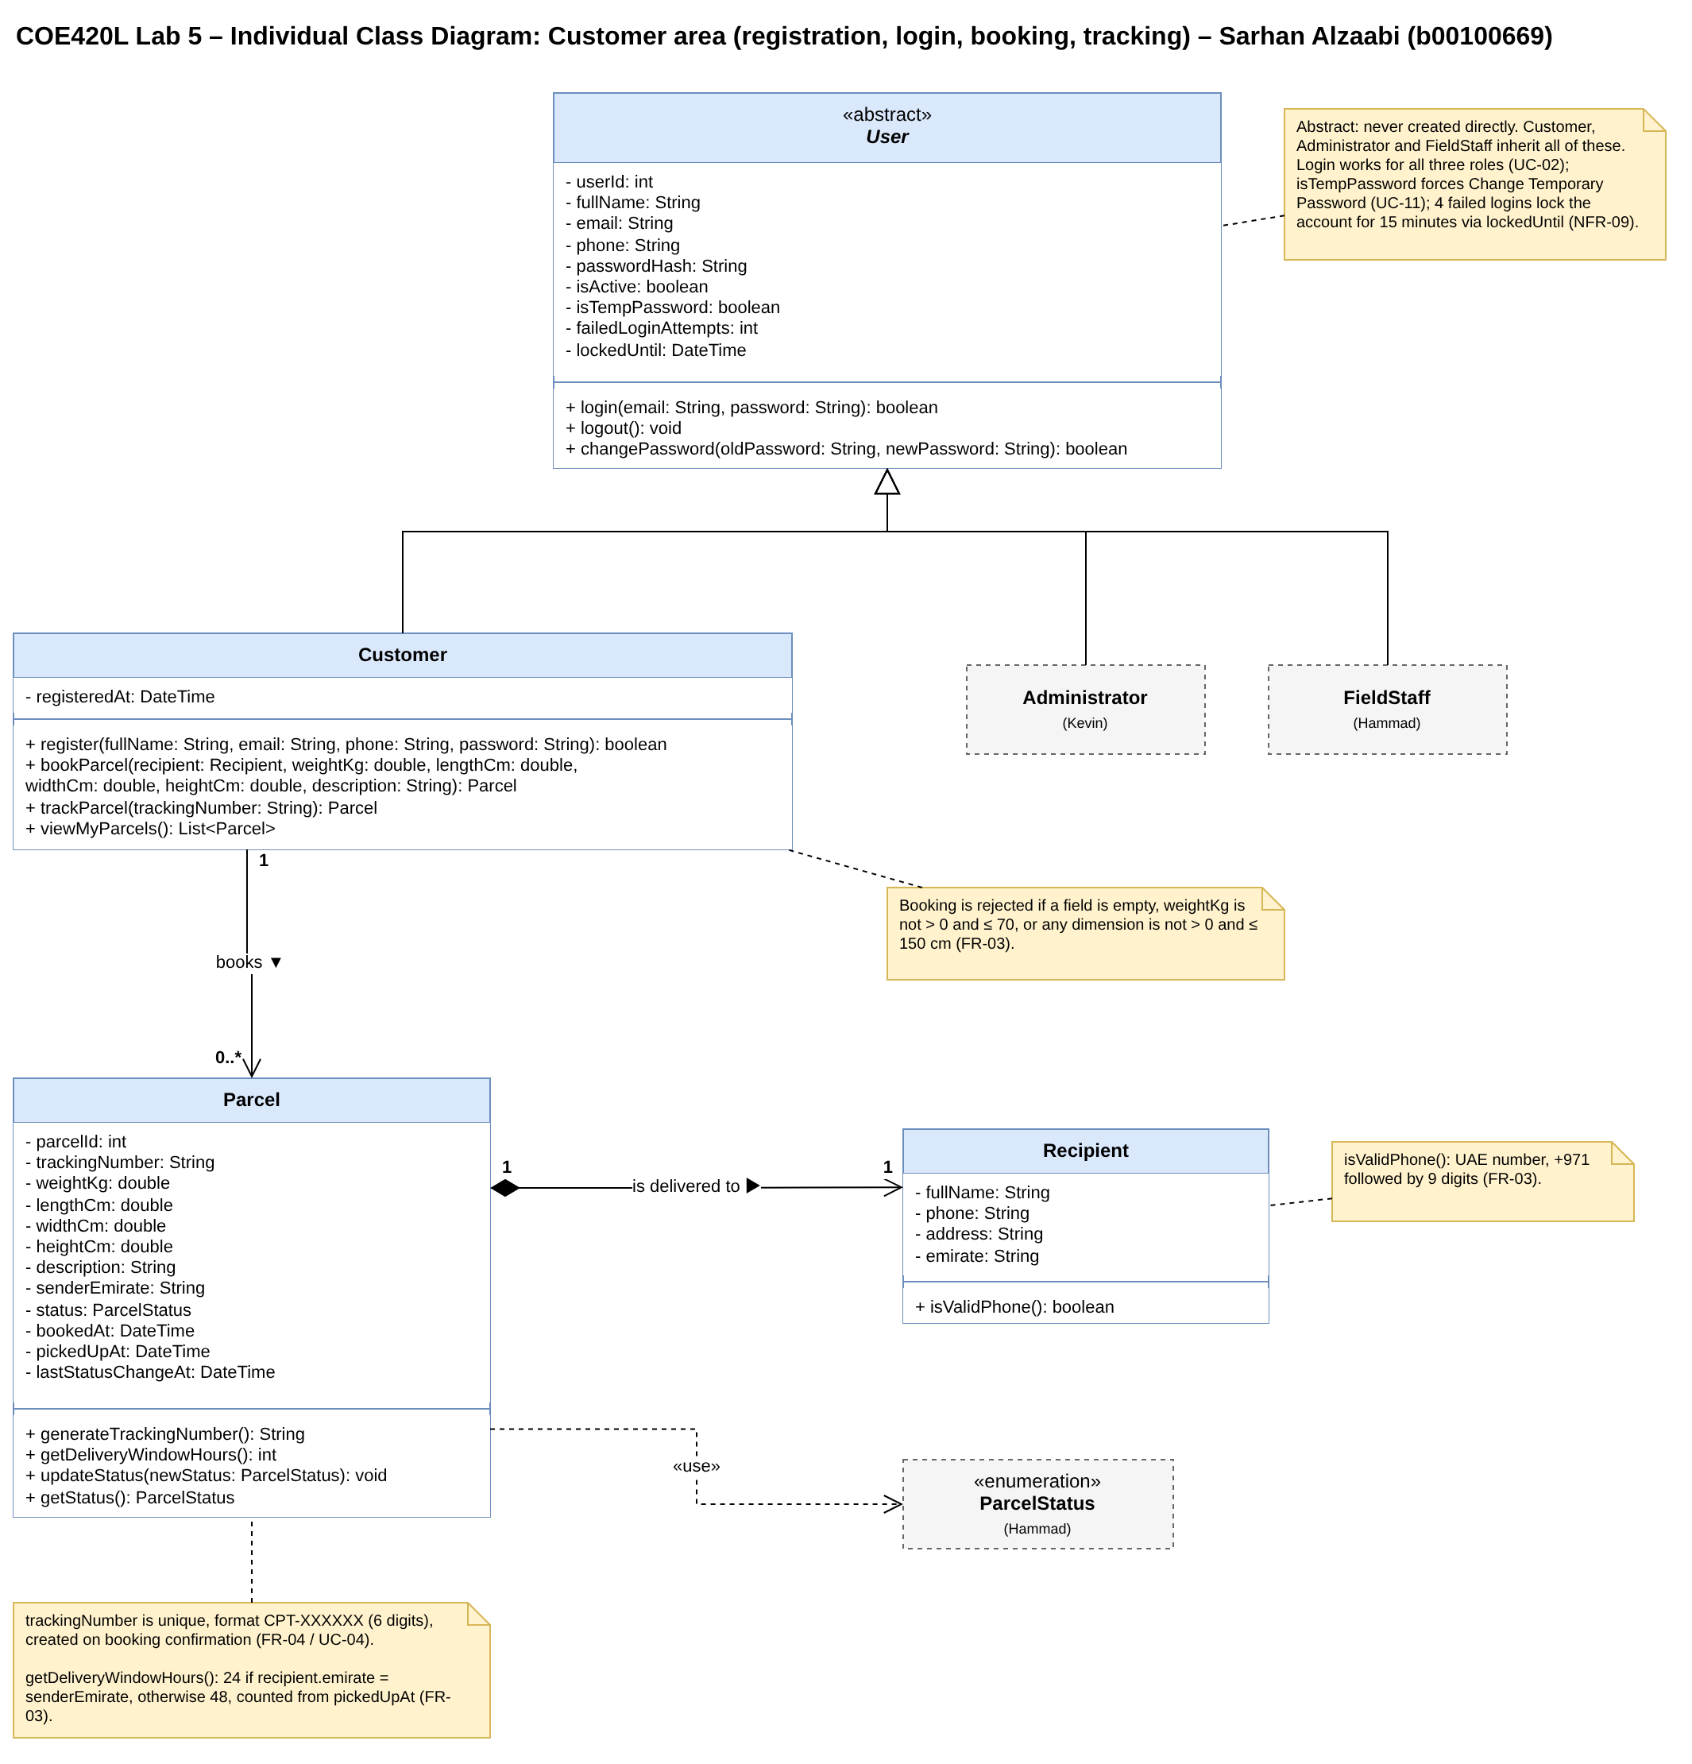
Figure 1.1: Sarhan Alzaabi's individual class diagram

1.2 Kevin Alex (b00098368)
Area: Admin operations and parcel assignment.
Exercise 1: Class Inventory
Class ID | Class | Purpose | Related use cases | Contributor
C06 | Administrator | Manages accounts and oversees deliveries: searches/deactivates/reactivates users, creates staff/admin accounts with a temp password, sets each staff member's zone, views all parcels and assigns Pending Pickup parcels to field staff. | UC-06, UC-07, UC-08, UC-09, UC-10 | Kevin Alex (b00098368)
C07 | Assignment | One bulk assignment action: the set of Pending Pickup parcels an admin gives to one field staff member at one time (one summary notification per assignment). | UC-08, UC-09 | Kevin Alex (b00098368)
C08 | Zone | The one emirate an admin sets for a field staff member; used by the admin to match parcels to staff and see workload by area (never assigned automatically). | UC-08, UC-09, UC-10 | Kevin Alex (b00098368)
Table 1.2: Kevin Alex class inventory
Exercise 2: Individual Class Diagram
- Administrator inherits from User and manages accounts, zones and parcel assignment.
- Administrator creates Assignment (1 to 0..*); each Assignment contains one or more Parcels and is given to one FieldStaff member.
- FieldStaff works in exactly one Zone, which is always set by an admin.
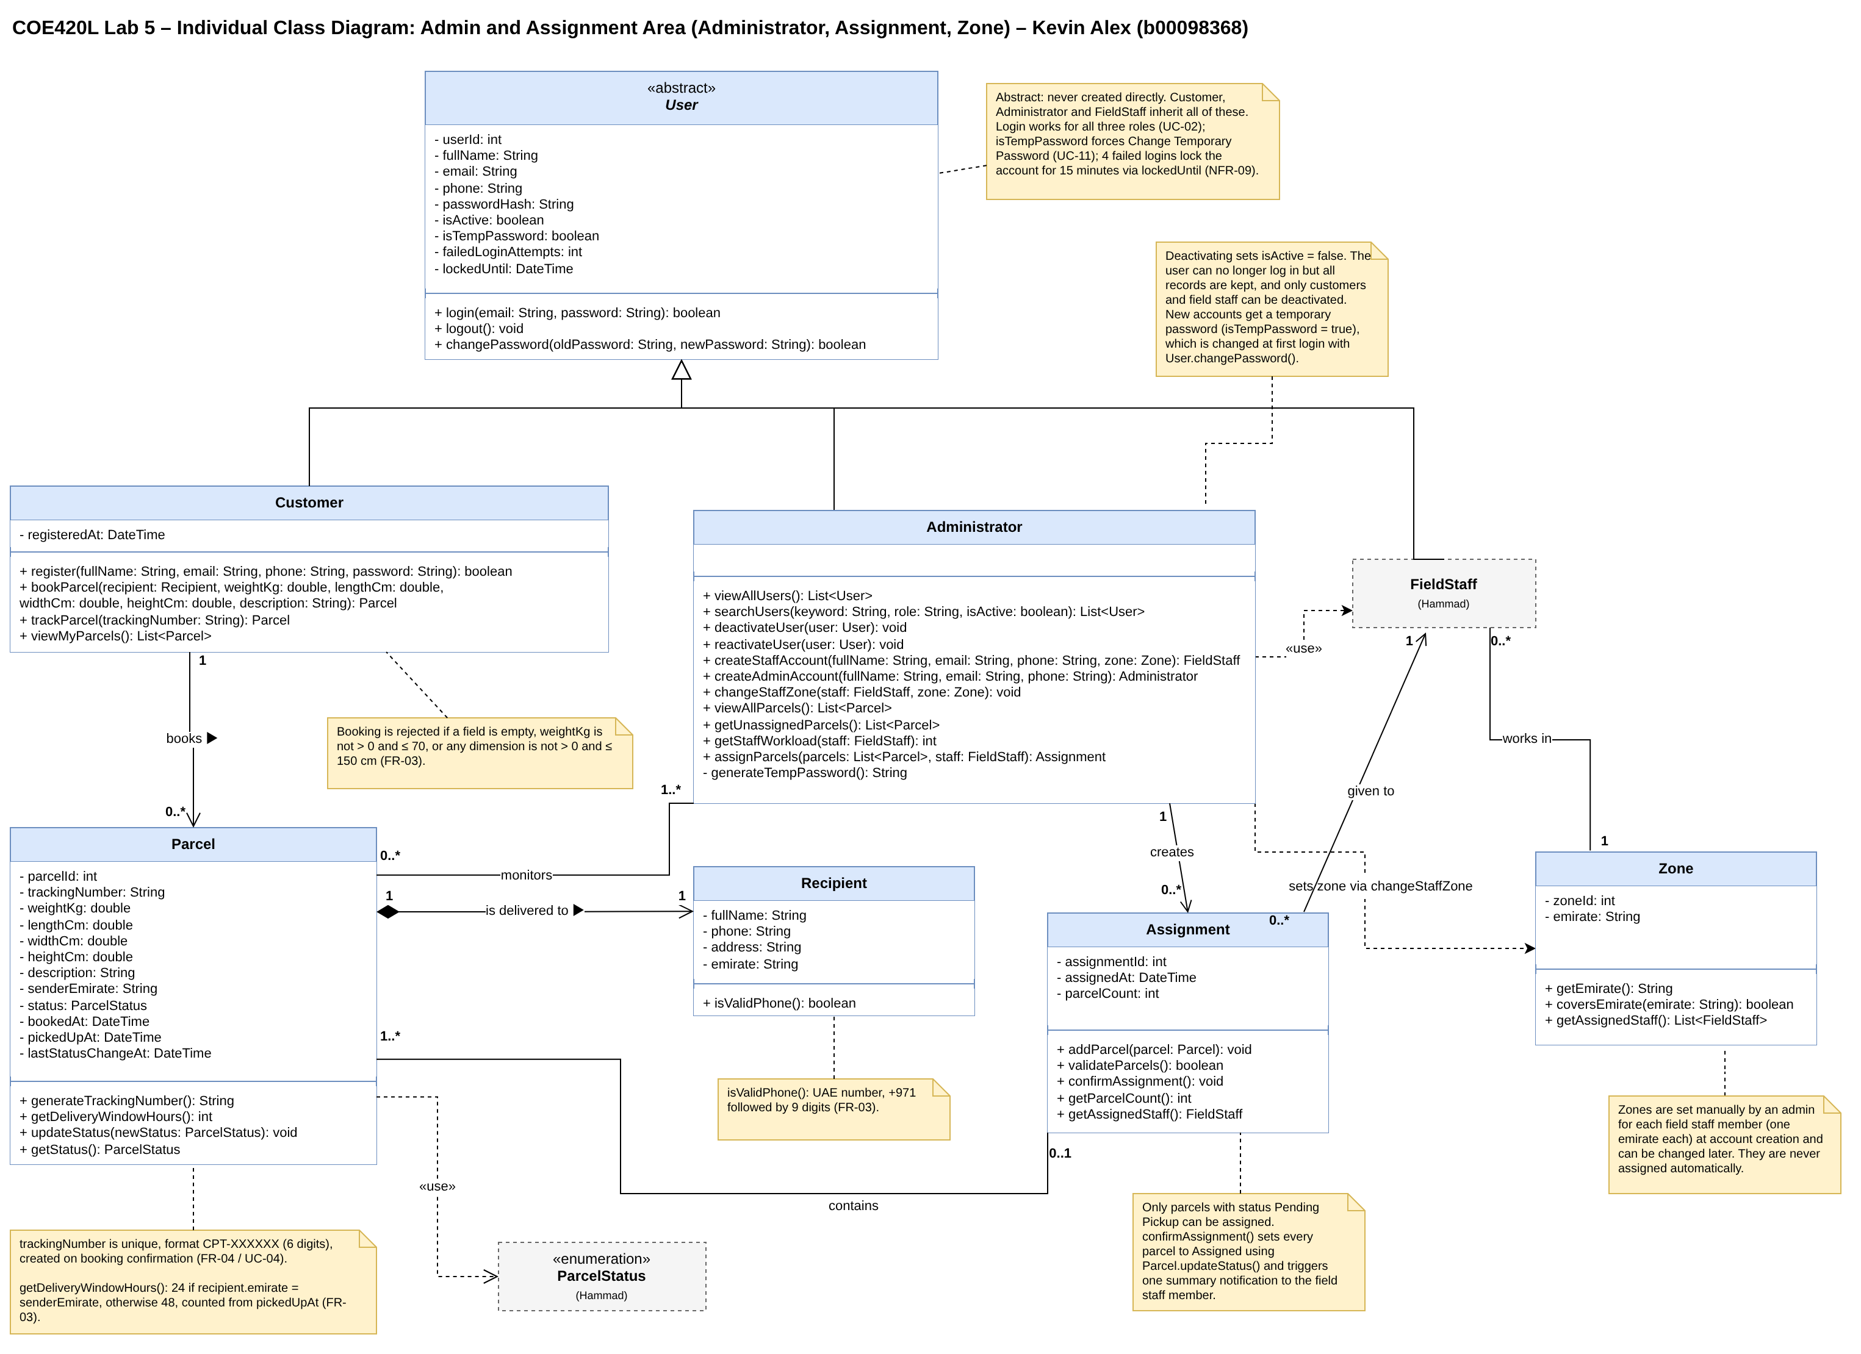
Figure 1.2: Kevin Alex's individual class diagram

1.3 Muhammad Hammad Khan (b00094579)
Area: Field staff operations: pickups, status updates, failed attempts and proof of delivery.
Exercise 1: Class Inventory
Class ID | Class | Purpose | Related use cases | Contributor
C11 | FieldStaff | Delivery staff member (inherits from User). Views the parcels assigned to them, marks them picked up, updates delivery status, records failed attempts and confirms delivery with proof. Works in the one zone the admin sets for them. | UC-12, UC-13, UC-14, UC-15, UC-16 | Muhammad Hammad Khan (b00094579)
C12 | DeliveryAttempt | One try to deliver a parcel: attempt number (max 3), time, success/failure and failure reason. A 3rd failed attempt sends the parcel to Returned to Sender. | UC-14 | Muhammad Hammad Khan (b00094579)
C13 | ProofOfDelivery | Evidence that a parcel was delivered: the recipient's name, their signature, their Emirates ID and the delivery time. | UC-16 | Muhammad Hammad Khan (b00094579)
C14 | ParcelStatus (enum) | The 10 fixed parcel statuses: Booked, Pending Pickup, Assigned, Picked Up, In Transit, Out for Delivery, Attempted, Delivered, Delayed, Returned to Sender. | UC-14, UC-15, UC-16 | Muhammad Hammad Khan (b00094579)
Table 1.3: Muhammad Hammad Khan class inventory
Exercise 2: Individual Class Diagram
- FieldStaff inherits from User and performs DeliveryAttempts (1 to 0..*).
- A Parcel has at most 3 attempts (1 to 0..3) and is confirmed by at most one ProofOfDelivery (1 to 0..1).
- ParcelStatus is an enumeration of the 10 statuses from Lab 3.
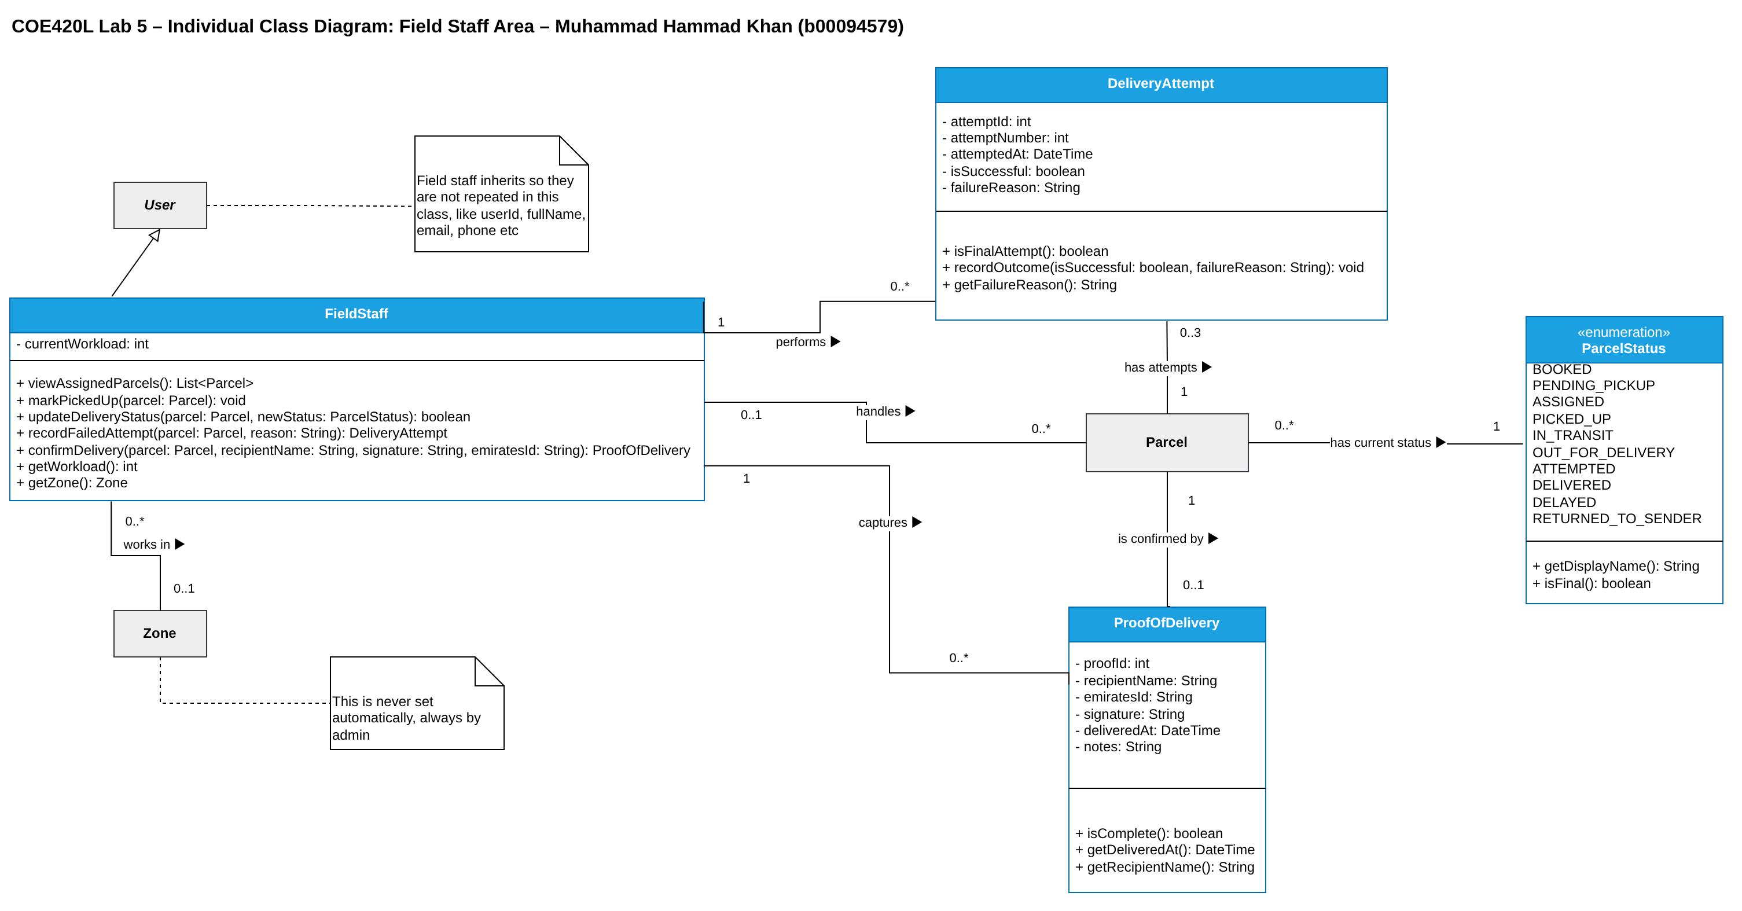
Figure 1.3: Muhammad Hammad Khan's individual class diagram

1.4 Ahmed El Sabagh (b00095506)
Area: Notifications and tracking history.
Exercise 1: Class Inventory
Class ID | Class | Purpose | Related use cases | Contributor
C16 | StatusHistoryEntry | Stores one timestamped parcel status transition, including an optional previous status, required new status, optional actor, and location. | UC-19, UC-21 | Ahmed El Sabagh (b00095506)
C17 | Notification (abstract) | Shared notification content, recipient, delivery timestamps, and delivery/retry state for all notification types. | UC-17, UC-18 | Ahmed El Sabagh (b00095506)
C18 | StatusNotification | Notifies a customer of a parcel status transition. | UC-17 | Ahmed El Sabagh (b00095506)
C19 | AssignmentNotification | Sends the field staff member one summary notification for a bulk assignment. | UC-18 | Ahmed El Sabagh (b00095506)
C20 | DelayAlert | Represents an active or resolved dashboard alert for an undelivered parcel with no status change for 48 hours. | UC-20 | Ahmed El Sabagh (b00095506)
Table 1.4: Ahmed El Sabagh class inventory
Exercise 2: Individual Class Diagram
- Notification is abstract, with StatusNotification and AssignmentNotification inheriting from it.
- Each bulk Assignment has exactly one AssignmentNotification summary.
- StatusHistoryEntry records each status change of a Parcel, and DelayAlert flags an undelivered parcel with no status change for 48 hours.
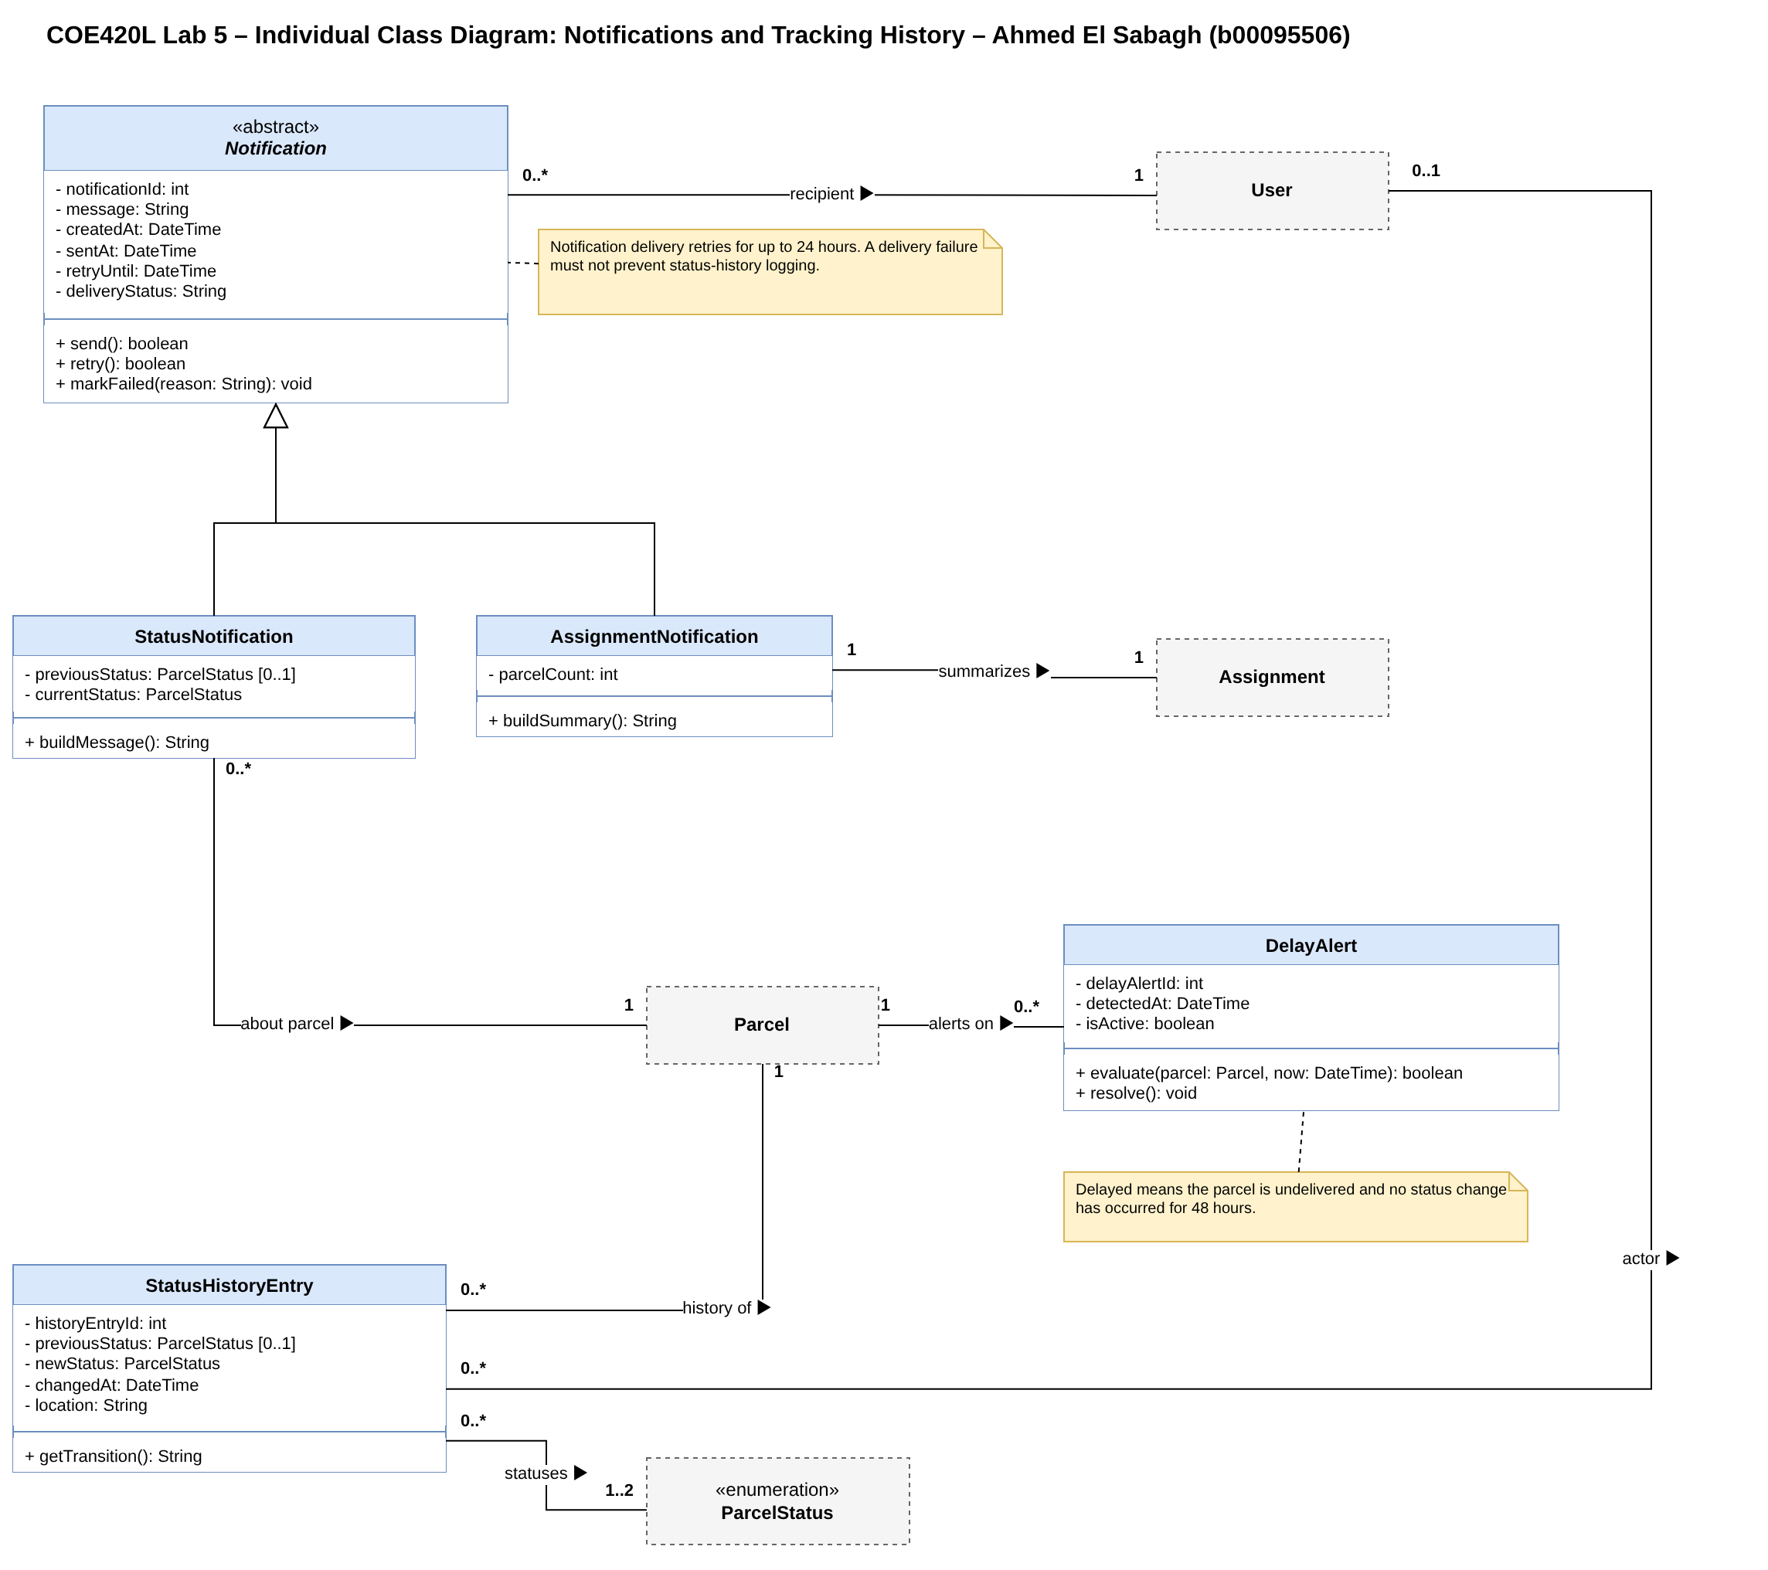
Figure 1.4: Ahmed El Sabagh's individual class diagram

Part B: Team Integration
After the progress discussion the team reviewed the four individual models together, removed duplicates, resolved conflicting design decisions and merged everything into one consolidated class diagram. The full record is in Project/Object_Modeling/Integration_Notes.md.

2.1 Consolidated Class Inventory
The consolidated model has 16 classes. Each class keeps the ID from its owner's individual inventory so it can be traced back.
Class ID | Class | Purpose | Related use cases | Contributor
C01 | User (abstract) | Holds the login details and account state shared by all users, including credentials, activation state, temporary-password state, failed login attempts, and lock time. | UC-02, UC-11 | Sarhan Alzaabi (b00100669)
C02 | Customer | Registers, books parcels, and tracks them by tracking number. | UC-01, UC-03, UC-05, UC-19 | Sarhan Alzaabi (b00100669)
C03 | Parcel | Represents a booked shipment, including its tracking number, dimensions, weight, current status, timestamps, and expected delivery window. | UC-03, UC-04, UC-05, UC-14, UC-15, UC-19, UC-21 | Sarhan Alzaabi (b00100669)
C04 | Recipient | Stores the receiver's name, phone, address, and emirate for a parcel. | UC-03 | Sarhan Alzaabi (b00100669)
C06 | Administrator | Manages user accounts, creates staff/admin accounts, sets staff zones, views parcels, and assigns pending pickups to field staff. | UC-06, UC-07, UC-08, UC-09, UC-10, UC-20, UC-21 | Kevin Alex (b00098368)
C07 | Assignment | Represents one bulk assignment action in which an administrator assigns pending-pickup parcels to one field staff member. | UC-08, UC-09 | Kevin Alex (b00098368)
C08 | Zone | Represents the emirate set by an administrator for a field staff member and used to match parcels and view workload by area. | UC-08, UC-09, UC-10 | Kevin Alex (b00098368)
C11 | FieldStaff | A delivery staff member who views assigned parcels, updates delivery status, records failed attempts, and confirms delivery with proof. | UC-12, UC-13, UC-14, UC-15, UC-16 | Muhammad Hammad Khan (b00094579)
C12 | DeliveryAttempt | Records one parcel delivery attempt, including its number, time, outcome, and failure reason; after three failed attempts the parcel is returned to sender. | UC-14 | Muhammad Hammad Khan (b00094579)
C13 | ProofOfDelivery | Records delivery evidence: the recipient's name, signature, Emirates ID, and delivery time. | UC-16 | Muhammad Hammad Khan (b00094579)
C14 | ParcelStatus (enum) | Defines the parcel statuses: Booked, Pending Pickup, Assigned, Picked Up, In Transit, Out for Delivery, Attempted, Delivered, Delayed, and Returned to Sender. | UC-14, UC-15, UC-16 | Muhammad Hammad Khan (b00094579)
C16 | StatusHistoryEntry | Stores one timestamped parcel status transition, including an optional previous status, required new status, optional actor, and location. | UC-19, UC-21 | Ahmed El Sabagh (b00095506)
C17 | Notification (abstract) | Holds shared notification content, recipient, delivery timestamps, and delivery/retry state for all notification types. | UC-17, UC-18 | Ahmed El Sabagh (b00095506)
C18 | StatusNotification | Notifies a customer when a parcel's status changes. | UC-17 | Ahmed El Sabagh (b00095506)
C19 | AssignmentNotification | Sends a field staff member one summary notification for a bulk assignment. | UC-18 | Ahmed El Sabagh (b00095506)
C20 | DelayAlert | Represents an active or resolved dashboard alert for an undelivered parcel with no status change for 48 hours. | UC-20 | Ahmed El Sabagh (b00095506)
Table 2.1: Consolidated class inventory

2.2 Duplicate Classes
Shared classes appeared in more than one individual diagram. Each was merged into a single copy, using the owner's version.
Class | Owner (full version) | Also appeared in | Resolution
User | Sarhan | Kevin (full copy), Hammad (reference box), Ahmed (reference box) | One User, Sarhan's version; Hammad's inheritance and Ahmed's recipient/actor associations now point to it.
Customer, Recipient | Sarhan | Kevin (full copies) | One copy each, Sarhan's version.
Parcel | Sarhan | Kevin (full copy), Hammad (reference box), Ahmed (reference box) | One Parcel, Sarhan's version; every association from the other models now points to it.
Administrator | Kevin | Sarhan (reference box) | Kevin's full Administrator.
FieldStaff | Hammad | Sarhan (reference box), Kevin (reference box) | Hammad's full FieldStaff.
Zone | Kevin | Hammad (reference box) | Kevin's full Zone.
Assignment | Kevin | Ahmed (reference box) | Kevin's full Assignment.
ParcelStatus | Hammad | Sarhan, Kevin and Ahmed (reference boxes) | Hammad's «enumeration» with the 10 statuses and its two methods.
Table 2.2: Duplicate classes and how they were resolved

2.3 Integration Decisions
These were the conflicting design decisions found while merging, and what the team decided for each.
# | Conflict | Decision | Reason
1 | FieldStaff works in Zone: Hammad had 0..1, Kevin had 1 | Exactly 1 zone per field staff member | The admin always sets a zone when the account is created (FR-10), so a field staff member is never without one.
2 | Parcel status was both an attribute (Parcel.status) and an association (Hammad's "has current status") | Kept the status attribute, typed ParcelStatus, with a «use» dependency; removed the association | The same fact was shown twice.
3 | StatusHistoryEntry's statuses were both typed attributes and an association to ParcelStatus (Ahmed's "statuses") | Kept the typed attributes; removed the association | Same double-modelling as decision 2. The attribute types already show the link to ParcelStatus.
4 | Parcels reached field staff two ways: a direct "handles" association and through Assignment | Kept the Assignment route (Assignment contains Parcel, is given to FieldStaff); removed "handles" | Parcels are only given to staff through an assignment (FR-09), so the direct link was redundant.
5 | Workload appeared three times: FieldStaff.currentWorkload, FieldStaff.getWorkload() and Administrator.getStaffWorkload() | Kept Administrator.getStaffWorkload() only | A stored count can get out of sync with the real assignments, and one method is enough; the admin is the one who uses workload when assigning (FR-08).
6 | Assignment.parcelCount stored the number of parcels | Removed; getParcelCount() counts the parcels in the "contains" association | Same out-of-sync risk as decision 5. AssignmentNotification.parcelCount is kept, because it is a snapshot of what the notification said when it was sent.
7 | Kevin's "monitors" association between Administrator and Parcel | Removed | Viewing parcels is already the viewAllParcels() method, so the association added nothing.
8 | Kevin's «use» dependencies from Administrator to FieldStaff, Zone, Parcel and DelayAlert | Not drawn in the consolidated diagram | They only repeat types that are already visible in the method signatures, and drawing them crossed most of the diagram. The only dependency kept is Parcel «use» ParcelStatus.
9 | ProofOfDelivery used a proof image (proofImagePath), and a leftover recievedByName (sic) attribute | Uses recipientName, signature and emiratesId, no photo | This was fixed in Lab 3 after instructor feedback (FR-15).
10 | Hammad's ParcelStatus methods getDisplayName() and isFinal() were missing from the first merge | Kept | They are part of Hammad's enumeration and isFinal() is useful for Delivered and Returned to Sender.
11 | Kevin's individual inventory used IDs C01-C03 | Changed to C06-C08 | C01-C04 were already Sarhan's; the team ranges keep every ID unique and traceable.
12 | Naming differed between members (notificationID vs userId, * vs 0..*) | In the consolidated diagram, standardised to ...Id for every ID attribute and 0..* for every "many" multiplicity | One consistent style across the whole diagram.
13 | Some association names differed between the individual diagrams and read less clearly as phrases | Renamed in the consolidated diagram: recipient → is sent to, about parcel → is about, history of → records change of, actor → made by, given to → is given to | Each association now reads as a sentence from source to target (e.g. "StatusHistoryEntry made by User"). The multiplicities and meaning are unchanged.
14 | ProofOfDelivery.notes was not set by confirmDelivery() and is not part of FR-15 | Removed in the consolidated diagram | Proof of delivery is exactly name, signature and Emirates ID (FR-15); an attribute nothing sets would always be empty.
Table 2.3: Conflicting design decisions

2.4 Consolidated UML Class Diagram
The consolidated diagram combines all 16 classes in one coherent model. It shows attributes, methods, visibility, data types, parameters and return types, named associations with multiplicities at both ends, the two inheritance hierarchies (User and Notification), the Parcel-Recipient composition and UML notes for the main rules. «use» dependencies that only repeat types already shown in method signatures are left out for readability; the one kept is Parcel «use» ParcelStatus.
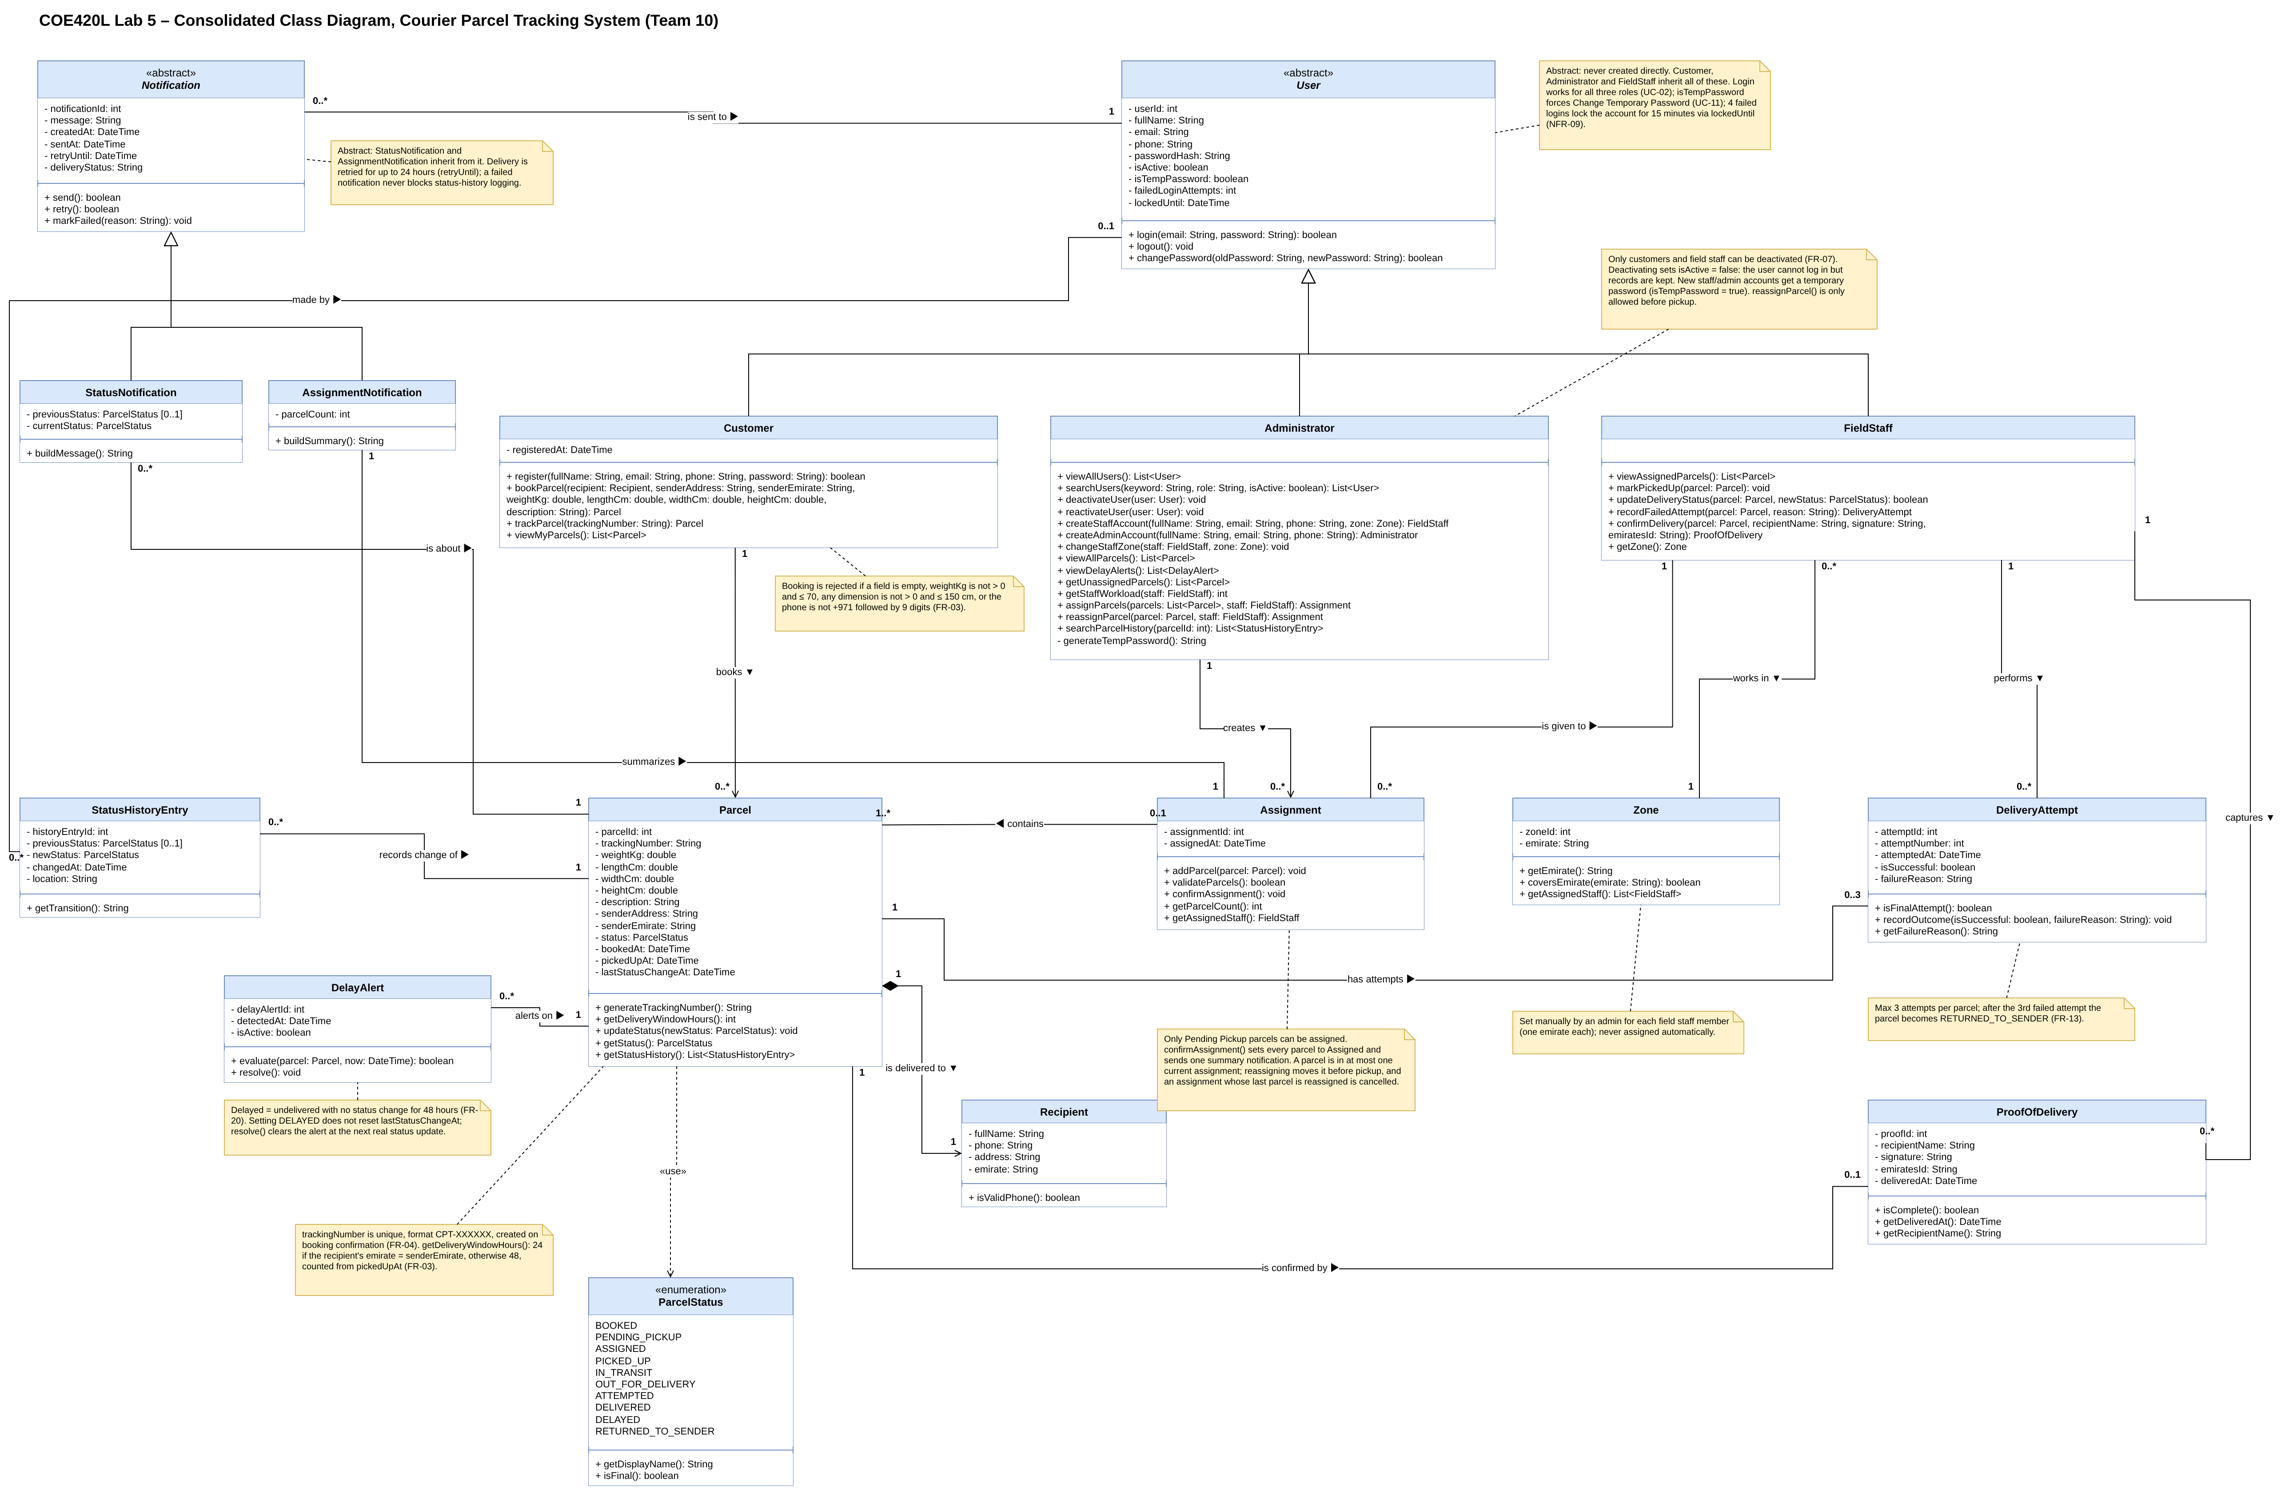
Figure 2.1: Consolidated class diagram (also in Project/Object_Modeling/Class_Diagram/)

2.5 Tidy-ups to the Individual Diagrams
During integration some small presentation fixes were made to the individual diagrams so they meet the lab's notation requirements (titles with name and ID, multiplicities at line ends, notes attached to their classes, typos). The classes and design in each member's model were not changed. The full list is in Integration_Notes.md.

3. Class Model Consistency and Traceability Check
The consolidated model was checked against the Lab 3 consolidated requirements and use cases and the Lab 4 Core Processes Matrix and data stores. Full details are in Project/Object_Modeling/Class_Model_Consistency_Check.md.

3.1 Consistency with Requirements and Use Cases
Class ID | Class | Use cases | FRs
C01 | User (abstract) | UC-02, UC-11 | FR-02, FR-07, FR-10
C02 | Customer | UC-01, UC-03, UC-05, UC-19 | FR-01, FR-03, FR-05, FR-19
C03 | Parcel | UC-03, UC-04, UC-05, UC-14, UC-15, UC-19, UC-21 | FR-03, FR-04, FR-05, FR-13, FR-14, FR-18, FR-19
C04 | Recipient | UC-03 | FR-03
C06 | Administrator | UC-06 to UC-10, UC-20, UC-21 | FR-06 to FR-10, FR-19, FR-20
C07 | Assignment | UC-08, UC-09 | FR-08, FR-09
C08 | Zone | UC-08, UC-09, UC-10 | FR-08, FR-09, FR-10
C11 | FieldStaff | UC-12 to UC-16 | FR-11 to FR-15
C12 | DeliveryAttempt | UC-14 | FR-13
C13 | ProofOfDelivery | UC-16 | FR-15
C14 | ParcelStatus (enum) | UC-14, UC-15, UC-16 | FR-13, FR-14, FR-15
C16 | StatusHistoryEntry | UC-19, UC-21 | FR-18, FR-19
C17 | Notification (abstract) | UC-17, UC-18 | FR-16, FR-17
C18 | StatusNotification | UC-17 | FR-16
C19 | AssignmentNotification | UC-18 | FR-17, FR-09
C20 | DelayAlert | UC-20 | FR-20
Table 3.1: Classes traced to use cases and functional requirements
Every class traces to at least one use case and functional requirement, and all 21 team use cases are covered. The gaps found by the check and in the team's review were all fixed in the consolidated diagram:
Gap | Fix
UC-19 (tracking history) had no method returning a parcel's history | Added Parcel.getStatusHistory(): List<StatusHistoryEntry>
UC-21 (admin looks up history by parcel ID) had no way to find a parcel by its ID | Added Administrator.searchParcelHistory(parcelId: int): List<StatusHistoryEntry>
UC-20 (delay alerts) had no admin method to view alerts | Added Administrator.viewDelayAlerts(): List<DelayAlert>
UC-12 / FR-11 (view pickups) needs the sender's address, but Parcel only had senderEmirate | Added Parcel.senderAddress, and Customer.bookParcel() now takes senderAddress and senderEmirate; booking collects both (see the updates to previous labs)
Lab 4 P3 says "reassigning is allowed only before pickup", but there was no method for it | Added Administrator.reassignParcel(parcel: Parcel, staff: FieldStaff): Assignment. "contains" stays 0..1 on the Assignment side because a parcel belongs to at most one current assignment; reassigning moves it to a new one before pickup. An assignment whose last parcel is reassigned is cancelled, so no assignment is left with 0 parcels and "1..*" still holds (shown in a note)
Table 3.2: Gaps found and how they were fixed

3.2 Consistency with Data Stores
Data store | Classes | Result
D1 Users | User, Customer, Administrator, FieldStaff, Zone | Yes
D2 Parcels | Parcel, Recipient, Assignment, ProofOfDelivery, DeliveryAttempt | Yes. Lab 4 does not say where attempts are stored, so they sit with the parcel record.
D3 Status History | StatusHistoryEntry | Yes
None | Notification, StatusNotification, AssignmentNotification, DelayAlert | Yes, by design. A notification only exists in the notification service's outgoing queue until it is sent or its 24-hour retry window ends (NFR-18), and its ID identifies it while it is queued. A DelayAlert only lives on the admin dashboard while it is active (its ID identifies it there, and resolve() clears it at the next real status update), and it can always be rebuilt from D2 (undelivered, last status change over 48 hours ago). Neither needs a permanent store; a D4 Notifications store would be added only if a notification history were required (see Integration_Notes.md).
Table 3.3: Classes vs Lab 4 data stores

3.3 Relationships and Multiplicities
Relationship | Multiplicity | Result | Reason
User generalizes Customer, Administrator, FieldStaff | n/a | Yes | Genuine generalization: all three share login and account state (UC-02, UC-11).
Notification generalizes StatusNotification, AssignmentNotification | n/a | Yes | Genuine generalization: shared content, recipient and retry state (FR-16, FR-17).
Customer books Parcel | 1 to 0..* | Yes | One customer, many parcels (FR-03)
Parcel is delivered to Recipient (composition) | 1 to 1 | Yes | Recipient exists only within one parcel
Administrator creates Assignment | 1 to 0..* | Yes | FR-09
Assignment contains Parcel | 0..1 to 1..* | Yes | Bulk assignment has one or more parcels
Assignment is given to FieldStaff | 0..* to 1 | Yes | Each assignment has one staff member
FieldStaff works in Zone | 0..* to 1 | Yes | Admin always sets one zone (FR-10)
AssignmentNotification summarizes Assignment | 1 to 1 | Yes | One summary per bulk assignment
Notification is sent to User | 0..* to 1 | Yes | One recipient each
StatusNotification is about Parcel | 0..* to 1 | Yes | Many notifications per parcel
StatusHistoryEntry records change of Parcel | 0..* to 1 | Yes | One entry per status change (FR-18)
StatusHistoryEntry made by User | 0..* to 0..1 | Yes | Actor optional for system changes
DelayAlert alerts on Parcel | 0..* to 1 | Yes | FR-20
FieldStaff performs DeliveryAttempt | 1 to 0..* | Yes | One staff member records many attempts; each attempt is made by one staff member (FR-13)
Parcel has attempts DeliveryAttempt | 1 to 0..3 | Yes | Max 3 attempts (FR-13)
Parcel is confirmed by ProofOfDelivery | 1 to 0..1 | Yes | Proof exists only after delivery
FieldStaff captures ProofOfDelivery | 1 to 0..* | Yes | Each proof is captured by the staff member who delivered the parcel (FR-15)
Table 3.4: Verification of relationships and multiplicities

4. Updates to Previous Labs
The lab allows earlier labs to be revised when inconsistencies are found. The following changes were made in the repository and in the updated Lab 3 and Lab 4 reports in the Documents folder:
- Lab 3 (Oct 17): applied the Lab 3 instructor feedback (login linked to all three actors, Field Staff outside the system boundary, standard status names, tracking separated from history, booking validation, delivery window, failed delivery handling, proof of delivery and testable NFRs).
- Lab 4 (Oct 25): brought the Core Processes Matrix rules (P1-P5) and the D1/D2 data store descriptions in line with the fixed Lab 3 requirements and this class model (zones set by the admin, booking validation and delivery window, Delayed rule, Attempted with max 3 attempts then Returned to Sender, standard status names).
- Lab 3 and Lab 4 (Oct 27): booking now collects the sender's pickup address and emirate, matching Parcel.senderAddress (FR-03, UC-03 and the P2 booking details input).

5. GitHub Repository
https://github.com/COE420-Team10-F26/Courier_parcel_tracking_system
All Lab 5 work is in Project/Object_Modeling/, following the structure in the lab sheet:
- Individual_Models/: each member's individual class diagram (.drawio and .png) and class inventory
- Class_Inventory.md: the consolidated class inventory
- Integration_Notes.md: duplicates, conflicts and integration decisions
- Class_Diagram/: the consolidated class diagram (.drawio and .png)
- Class_Model_Consistency_Check.md: the consistency and traceability check
Each member committed their own individual model, inventory and team task under their own GitHub account. The final integration fixes listed in Integration_Notes.md (diagram tidy-ups, file moves and the consolidated diagram clean-up) were committed together by Sarhan on October 27.

AI Usage Declaration
Team members used AI tools (such as ChatGPT or Claude) in a supporting role while preparing this lab, for example to clarify UML concepts such as composition and multiplicities, check work that had already been done against the lab sheet and earlier labs, help lay out and format diagrams and markdown tables, proofread the writing, and format this report. The classes, attributes, relationships and integration decisions come from the team's own requirements and use cases, and any AI suggestions were reviewed and edited before being included. Every member reviewed the final report and can explain their part of the model.

