American University of Sharjah |  | Instructor: Dr. Mustafa Hammad
College of Engineering |  | Lab Instructor: Khaldoon Alhusari
Department of Computer  Science and Engineering |  | Office: EB2-118 (inside EB2-117)
Department of Computer  Science and Engineering |  | Phone: +971 6 515 4819
P. O. Box 26666, Sharjah, UAE |  | E-mail: kalhusari@aus.edu
 |  | Semester: Fall 2026

COE420L – Software Engineering – Lab 4
Data Flow Modeling and Project Scheduling

Objectives:
By completing this lab, students will be able to:
- Develop a Context Diagram and Level-0 Data Flow Diagram (DFD) for a proposed software system.
- Apply DFD modeling principles to represent external entities, processes, data flows, and data stores.
- Develop a Work Breakdown Structure (WBS) based on the actual development activities of the project.
- Develop a Gantt Chart and network-based project schedule using project activities and dependencies.
- Apply Critical Path Method (CPM) concepts to calculate project scheduling parameters and identify the Critical Path.
Due date: Start of next-next week’s lab.
· A short oral discussion with the lab instructor will be conducted during next week's lab to discuss the progress. Each team should be prepared to explain the work completed so far and discuss any issues or decisions related to this lab’s work. Note that presenting work on a tablet or laptop is explicitly preferred.
· Only one submission per team. Do not forget to include the AUS IDs and names of team members in the lab report.
Note: Using ChatGPT (or any other LLMs/AI tools) without proper declaration and justification will be considered a violation of the AUS integrity code.

General Instructions:
· This lab is a team-based activity.
· Continue working on the same project and GitHub repository used in Labs 1–3.
· All models and schedules must be based on the team's actual proposed software system.
· Students must use an appropriate software tool to create the DFDs, Gantt Chart, and network diagram. Hand-drawn diagrams are not acceptable.
· The team may use any suitable modeling, diagramming, or project-management tool.
· All diagrams and tables must be clearly labeled and professionally organized.
· The work must be consistent with the requirements, Use Cases, actors, and project scope developed in previous labs.
· The team should maintain meaningful GitHub commits that demonstrate team participation.
Submission:
· A full report with responses to all tasks, with team member names and IDs clearly highlighted.
· A link to the GitHub repository created in Lab 1

Exercise 1: Context Diagram
Develop a Context Diagram for the proposed software system.
The Context Diagram provides a high-level view of the system by representing the entire proposed software system as one process and showing its interaction with external entities.
The diagram should include:
- The proposed system as one central process.
- All relevant external entities.
- Data flows entering the system.
- Data flows leaving the system.
- Clear names for all entities and data flows.

Requirements
The Context Diagram must:
- Use the project's actual actors/stakeholders.
- Be consistent with the UML Use Case Diagram from Lab 3.
- Clearly identify incoming and outgoing data flows.
- Avoid including internal processes or internal data stores.
- Be created using a suitable diagramming/modeling tool.

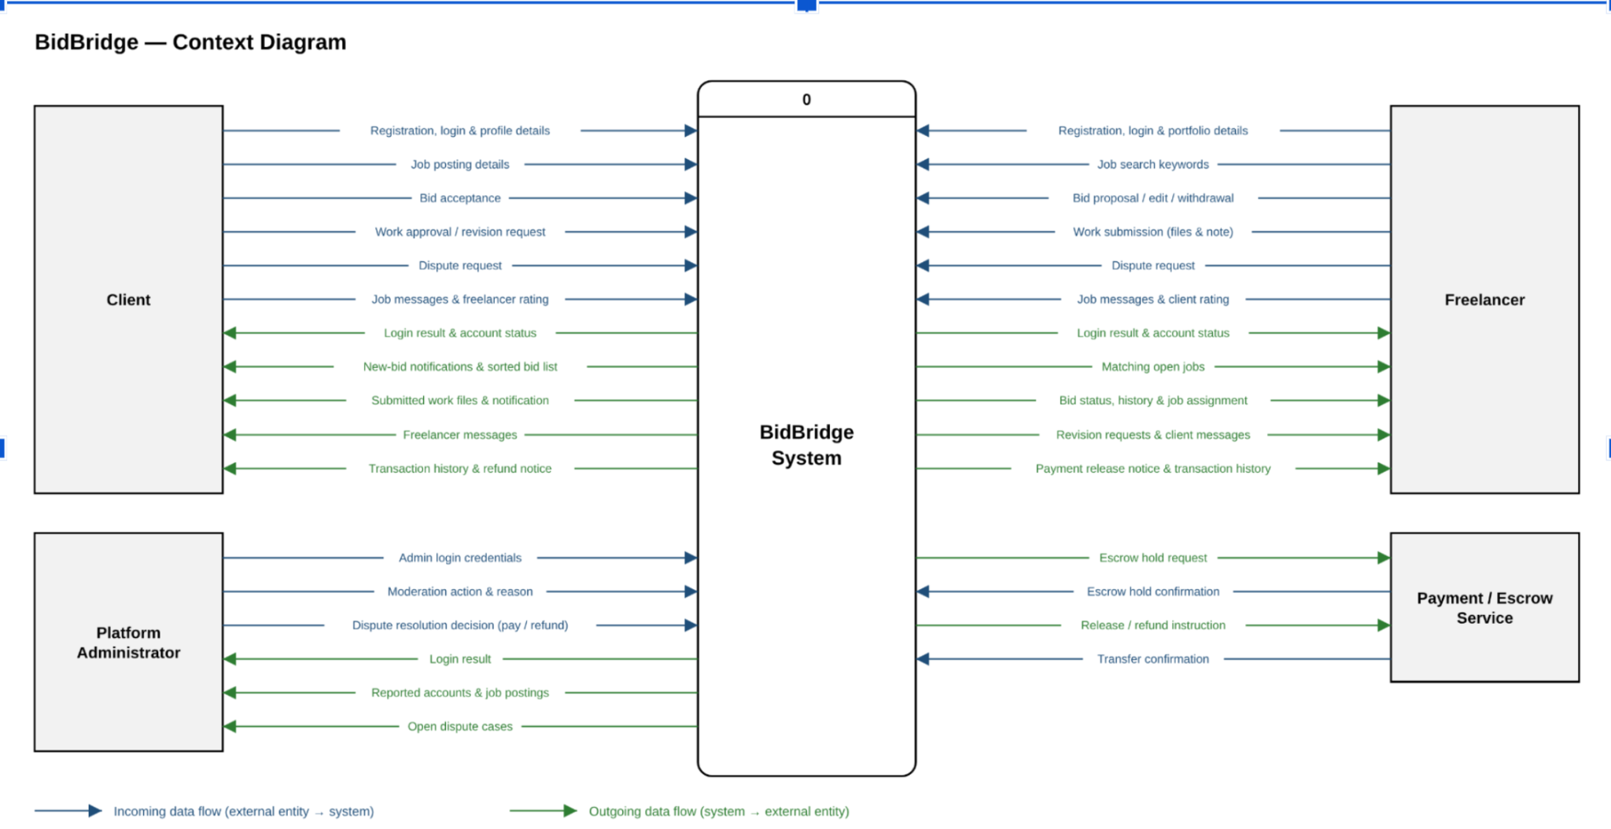

Exercise 2: Level-0 Data Flow Diagram
Develop a Level-0 DFD that decomposes the system represented in the Context Diagram into its major processes.
The Level-0 DFD must include:
- The same external entities represented in the Context Diagram.
- At least 5 major processes.
- At least 2 data stores.
- Data flows between external entities, processes, and data stores.
- Clearly named processes, data flows, and data stores.

Important
1. The Level-0 DFD should cover the major data-processing aspects of the project.
2. The processes should be derived from the team's:
· Functional Requirements
· Use Cases
· Scenarios
· Project scope
3. Do not create processes simply to satisfy the minimum number. Each process should represent a meaningful part of the proposed system.

DFD Balancing and Consistency : The Context Diagram and Level-0 DFD must be balanced. This means that the external inputs and outputs shown in the Context Diagram must be represented consistently in the Level-0 DFD. For example, if an external entity sends Customer Information to the system in the Context Diagram, the Level-0 DFD should show how that information enters an appropriate process. Similarly, information leaving the system in the Level-0 DFD should correspond to the outputs represented at the Context Diagram level.

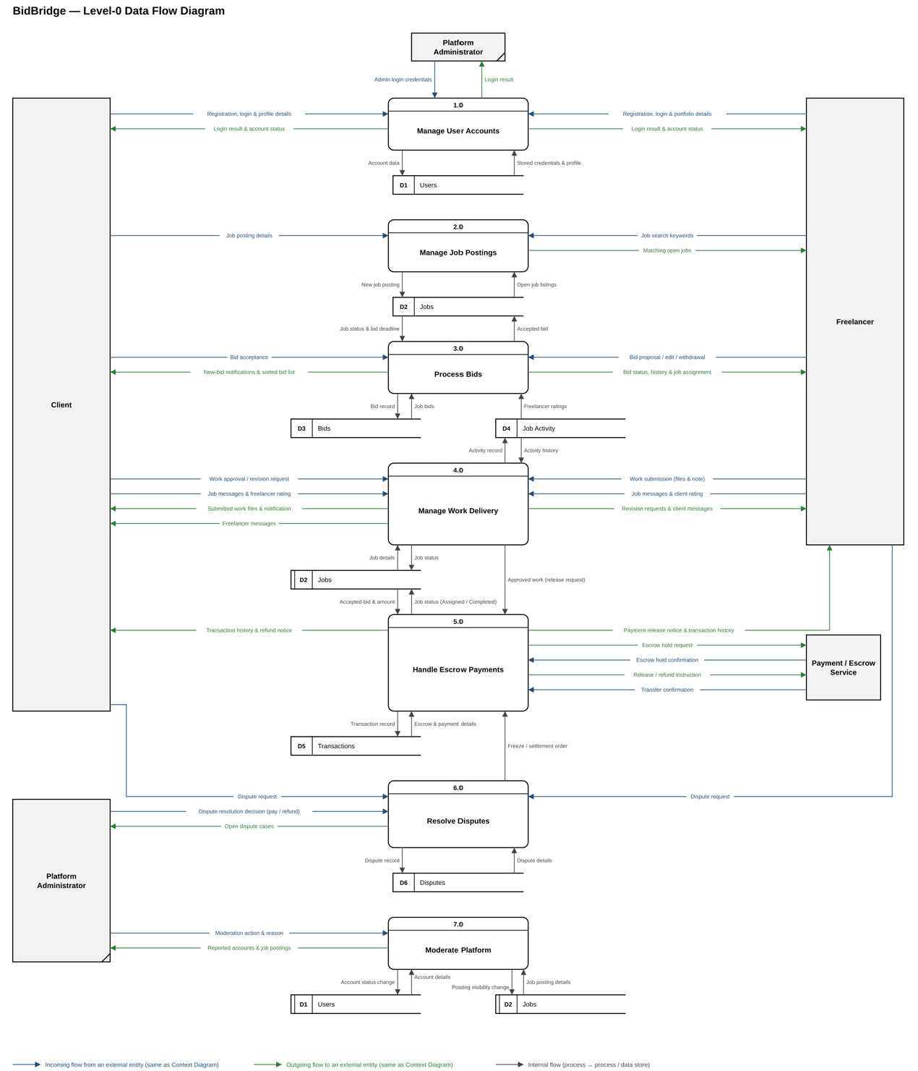

Exercise 3: Core Processes Matrix
Prepare a Core Processes Matrix describing the major processes identified in the Level-0 DFD. The processes in this matrix must be the same major processes represented in the Level-0 DFD.
At least 5 main processes are required.

Required Format
Process No. and Name | Input Data | Output Data | Rules
P1 –
P2 –
P3 –
P4 –
P5 –
Add additional processes if required by the project.

Process Rules
For each process, explain the major rules or conditions that govern how the input data is transformed into output data. The rules should be specific to the proposed system.

Exercise 3: Core Processes Matrix
The processes below are the same major processes shown in the Level-0 DFD. Input and output data use the same flow names as the DFD; the source or destination of each flow is given in square brackets. FR references: (E) Emran Lotfi, (M) Mohamed ElZefzafy; FR-11 to FR-20 are uniquely numbered.

Process No. and Name | Input Data | Output Data | Rules
P1 – Manage User Accounts | • Registration, login & profile details [Client]  • Registration, login & portfolio details [Freelancer]  • Admin login credentials [Administrator]  • Stored credentials & profile [D1 Users] | • Login result & account status [Client, Freelancer]  • Login result [Administrator]  • Account data [D1 Users] | 1. Registration requires an email address, a password and a role of Client or Freelancer (FR-03 M).  2. Login succeeds only if the email and password match the record in D1; otherwise the attempt is rejected and an error message is returned (FR-11).  3. A suspended account cannot log in until an administrator reactivates it (FR-19).  4. All users can update their profile; only freelancers can add skills, a biography and portfolio information (FR-15).
P2 – Manage Job Postings | • Job posting details [Client]  • Job search keywords [Freelancer]  • Open job listings [D2 Jobs] | • Matching open jobs [Freelancer]  • New job posting [D2 Jobs] | 1. Only a logged-in client can create a posting (R-04), and it must include a title, description, required skills and a bid deadline (FR-01 M, UC-17).  2. A new posting is saved with status Open.  3. A search matches keywords against the task title and required skills (FR-04 M).  4. Search results only include jobs that are Open, still accepting bids and not hidden by an administrator (FR-17, FR-19).
P3 – Process Bids | • Bid proposal / edit / withdrawal [Freelancer]  • Bid acceptance [Client]  • Job status & bid deadline [D2 Jobs]  • Job bids [D3 Bids]  • Freelancer ratings [D4 Job Activity] | • New-bid notifications & sorted bid list [Client]  • Bid status, history & job assignment [Freelancer]  • Bid record [D3 Bids]  • Accepted bid [D2 Jobs] | 1. Only a logged-in freelancer can bid (R-05). A bid must include a price, completion time and information about the freelancer (FR-02 M).  2. Bids are accepted only while the job is Open and before its deadline. If the deadline passes with no accepted bid, the job stops accepting bids (FR-17).  3. A bid can be edited or withdrawn only while the job is Open and the bid has not been accepted (FR-13).  4. Each new bid notifies the job's client with the job title, freelancer name, bid price and submission time (FR-16).  5. The client can sort bids by price, delivery time or freelancer rating (FR-12).  6. The client accepts exactly one bid. It is recorded as the accepted bid, but the job only becomes Assigned once P5 confirms the escrow hold (FR-01 E).  7. A freelancer's bid history shows each bid's job, amount, delivery time and status (pending, accepted, rejected or withdrawn) (FR-18).
P4 – Manage Work Delivery | • Work submission (files & note) [Freelancer]  • Work approval / revision request [Client]  • Job messages & freelancer rating [Client]  • Job messages & client rating [Freelancer]  • Activity history [D4 Job Activity]  • Job details [D2 Jobs] | • Submitted work files & notification [Client]  • Freelancer messages [Client]  • Revision requests & client messages [Freelancer]  • Activity record [D4 Job Activity]  • Job status [D2 Jobs]  • Approved work (release request) [P5] | 1. Only the assigned freelancer of an Assigned job can submit work: 1–5 files of at most 25 MB each, plus a submission note. The job then becomes Submitted and the client is notified (FR-02 E).  2. The client of a Submitted job either approves the work or requests a revision. A revision request needs a written comment and returns the job to Assigned (FR-03 E).  3. Approval sends a release request to P5 (FR-04 E).  4. Messages can only be exchanged between the client and the assigned freelancer of an active job, and each message is stored with its sender and timestamp (FR-14).  5. Ratings (1–5 stars) can only be given after the job is completed, and the client and freelancer each rate the other once (FR-05 M).
P5 – Handle Escrow Payments | • Accepted bid & amount [D2 Jobs]  • Approved work (release request) [P4]  • Freeze / settlement order [P6]  • Escrow hold confirmation [Payment Service]  • Transfer confirmation [Payment Service]  • Escrow & payment details [D5 Transactions] | • Escrow hold request [Payment Service]  • Release / refund instruction [Payment Service]  • Job status (Assigned / Completed) [D2 Jobs]  • Transaction record [D5 Transactions]  • Transaction history & refund notice [Client]  • Payment release notice & transaction history [Freelancer] | 1. When a bid is accepted, P5 requests an escrow hold equal to the accepted bid price. The job changes from Open to Assigned only after the hold is confirmed (FR-01 E).  2. On a release request, the escrowed amount goes to the freelancer's platform balance, the job becomes Completed, and a transaction is recorded with the job ID, amount, payer, payee and timestamp (FR-04 E).  3. Escrow under an open dispute is frozen and cannot be released until a settlement order arrives from P6. The order either pays the freelancer or refunds the client (FR-05 E).  4. Users can only view their own transactions, each showing the job ID, amount, payment status, transaction type and timestamp (FR-20).
P6 – Resolve Disputes | • Dispute request [Client]  • Dispute request [Freelancer]  • Dispute resolution decision (pay / refund) [Administrator]  • Dispute details [D6 Disputes] | • Open dispute cases [Administrator]  • Dispute record [D6 Disputes]  • Freeze / settlement order [P5] | 1. Only the client or the assigned freelancer of a job can open a dispute, and only while the job is Assigned or Submitted. A reason is required (FR-05 E).  2. Opening a dispute immediately sends a freeze order to P5 and adds the case to the administrator's list of open disputes.  3. Only an administrator can resolve a dispute, and the resolution must be either pay the freelancer or refund the client. The decision is sent to P5 as a settlement order, and the dispute is closed (FR-05 E, R-03).
P7 – Moderate Platform | • Moderation action & reason [Administrator]  • Account details [D1 Users]  • Job posting details [D2 Jobs] | • Reported accounts & job postings [Administrator]  • Account status change [D1 Users]  • Posting visibility change [D2 Jobs] | 1. Only an administrator can suspend or reactivate accounts, and hide or remove job postings that break platform rules (FR-19).  2. Every moderation action must include a written reason, which is stored with the change (FR-19).  3. A hidden or removed posting no longer appears in search results (P2), and a suspended user can no longer log in (P1).  4. While moderating a posting, the administrator can also suspend the account that posted it (R-11).

Exercise 4: Develop the Work Breakdown Structure (WBS)
A Work Breakdown Structure (WBS) divides a project into smaller, manageable activities. For this lab, the WBS should represent the actual work required to develop the team's proposed software system. The WBS should be based on the team's project rather than a generic list such as:
Analysis → Design → Coding → Testing
Students should identify meaningful project activities related to their own system. Depending on the project, activities may include:
- Requirements refinement
- Database design
- User-interface design
- Authentication implementation
- Specific module development
- Integration
- Testing
- Deployment preparation
The activities should be sufficiently detailed to support project scheduling.
Develop a WBS containing at least 6 major activities required to complete the proposed project. For each activity, provide:
- Task ID
- Task Name
- Description
- Predecessor(s)
- Time Duration in days

Required Format
ID | Task Name | Description | Predecessor(s) | Duration (Days)
T1 | Requirements and Database design | Review the FRs, NFRs, use cases, remove any overlaps. Design the database tables. And general sketches for main pages. | — | 14
T2 | Accounts and login | Registration, login for client, login for freelances and admins, password rules, automatic logout after 15 min. | T1 | 6
T3 | Job posting and Bidding | Clients post jobs, freelancers search and submit bids. Clients compare bids, pick the one they want, bids are blocked after the client deadline. | T2 | 11
T4 | Escrow Payments | A simulated payment service that holds the money when bid is accepted, releases or refunds, and records every transaction | T3 | 8
T5 | Work submission, Messaging, Rating | Freelancers upload completed work and clients approve or ask for revision. Job messages, 1-5 star rating after completion. | T4 | 8
T6 | Admin and Disputes | Admin will have moderation over accounts, jobs, payments, and resolve by paying or refunding. | T4 | 7
T7 | Integration and Testing | Merge all the parts, test use cases, edge cases, check security and performance. | T5, T6 | 10
T8 | Deployment | Set up the hosting environment and database, deploy the prototype | T7 | 4
T9 | Documentation | Write the deployment guide, a short user guide and a known-issues list | T7 | 3

The WBS must:
- Represent the actual project.
- Include logical dependencies.
- Use realistic durations.
- Include enough activities to represent the project meaningfully.
- Provide sufficient information to construct the Gantt Chart and network schedule.

Exercise 5: Gantt Chart
Using the WBS developed in Exercise 4, create a Gantt Chart for the project.
The Gantt Chart should visually represent:
- Project activities
- Start and finish dates or periods
- Activity durations
- Dependencies if applicable
- Overall project timeline
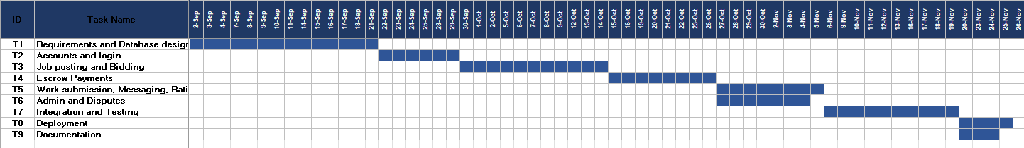

Important
The activities in the Gantt Chart must correspond directly to the activities in the WBS. Do not create a separate set of activities for the Gantt Chart.

Exercise 6: Network-Based Scheduling
Develop a Task-on-Node network diagram using the activities, dependencies, and time estimates developed in the WBS and Gantt Chart.
Each task should be presented in a node and include:
- Task ID
- Expected Time (E)
- ES – Earliest Start
- EF – Earliest Finish
- LS – Latest Start
- LF – Latest Finish
- Slack
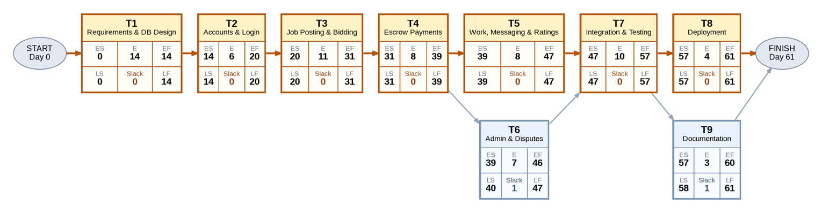
Students may use a different visual layout provided that all required information is clearly displayed. The team should clearly show the calculations used to obtain the scheduling values. Don’t forget to show slack time for each task.

Forward pass: ES = maximum EF of immediate predecessors (or 0 for T1), and EF = ES + E.
T1: ES = 0; EF = 0 + 14 = 14.
T2: ES = 14; EF = 14 + 6 = 20.
T3: ES = 20; EF = 20 + 11 = 31.
T4: ES = 31; EF = 31 + 8 = 39.
T5: ES = 39; EF = 39 + 8 = 47.
T6: ES = 39; EF = 39 + 7 = 46.
T7: ES = max(47, 46) = 47; EF = 47 + 10 = 57.
T8: ES = 57; EF = 57 + 4 = 61.
T9: ES = 57; EF = 57 + 3 = 60.
Project completion = max(EF of T8, EF of T9) = max(61, 60) = 61 days.

Backward pass: For finishing tasks, LF = 61; LS = LF – E. For all others, LF = minimum LS of immediate successors.
T8: LF = 61; LS = 61 – 4 = 57.
T9: LF = 61; LS = 61 – 3 = 58.
T7: LF = min(57, 58) = 57; LS = 57 – 10 = 47.
T5: LF = 47; LS = 47 – 8 = 39.
T6: LF = 47; LS = 47 – 7 = 40.
T4: LF = min(39, 40) = 39; LS = 39 – 8 = 31.
T3: LF = 31; LS = 31 – 11 = 20.
T2: LF = 20; LS = 20 – 6 = 14.
T1: LF = 14; LS = 14 – 14 = 0.
Slack = LS – ES = LF – EF. All critical tasks have 0 days; T6 and T9 have 1 day.

Exercise 7: Critical Path
Using the completed network diagram, identify the Critical Path of the project. The Critical Path is the sequence of activities that determines the project completion time based on the network schedule. Activities on the Critical Path normally have Slack = 0.
The team must:
- Identify the Critical Path.
- List the activities forming the Critical Path.
- Calculate the total expected project duration.
- Explain why these activities form the Critical Path.
- Verify the result using an appropriate scheduling/project-management tool.

Required Format
Critical Path:
T1 → T2 → T3 → T4 → T5 → T7 → T8
Expected Project Duration:
61 days
Explanation:
Provide a brief explanation showing how the Critical Path was determined from the network calculations.
The Critical Path was identified by calculating the Earliest Start (ES), Earliest Finish (EF), Latest Start (LS), Latest Finish (LF), and Slack for each task. The critical path is T1 → T2 → T3 → T4 → T5 → T7 → T8, with a total project duration of 61 days. These activities form the critical path because they all have zero slack, meaning any delay in one of them will delay the entire project. Tasks T6 and T9 are not on the critical path because they each have 1 day of slack and can be delayed by one day without affecting the project's completion date.

Integration and Consistency Check
Before submission, the team must verify that all Lab 4 artifacts are consistent with one another and with previous labs.

Data Flow Modeling
- The Context Diagram represents the proposed system correctly.
- External entities are consistent with UML Use Case actors.
- Level-0 DFD uses the same relevant external entities.
- Context Diagram and Level-0 DFD are balanced.
- Level-0 contains at least five meaningful processes.
- Level-0 contains at least two relevant data stores.
- Core Processes Matrix contains the same major processes as the Level-0 DFD.
- DFD processes are consistent with Functional Requirements and Use Cases.

Project Scheduling
- WBS activities represent actual project work.
- Gantt Chart activities correspond to WBS activities.
- Task dependencies are logically defined.
- Time estimates are realistic and project-specific.
- Expected Times are correctly calculated.
- Network diagram reflects the WBS dependencies.
- ES, EF, LS, LF, and Slack calculations are correct.
- Critical Path is correctly identified.
- The Critical Path and project duration are verified using an appropriate scheduling/project-management tool.

Recommended Repository Structure
Update the same GitHub repository used in Labs 1–3:
Project-Repository/

│

├── README.md

│

├── Team/

│ ├── Team_Members.md

│ ├── Skills.md

│ ├── Contact_Information.md

│ └── CVs/

│

├── Project/

│ ├── Project_Title.md

│ ├── Project_Description.md

│ ├── Scope.md

│ ├── Process_Model.md

│ ├── Risk_Register.md

│ ├── Stakeholders.md

│ ├── Feasibility_Study.md

│ │

│ ├── Requirements/

│ │ ├── Scenarios.md

│ │ ├── Functional_Requirements.md

│ │ ├── Non_Functional_Requirements.md

│ │ ├── Use_Cases.md

│ │ └── Use_Case_Diagram/

│ │

│ ├── Data_Flow_Modeling/

│ │ ├── Context_Diagram/

│ │ ├── Level_0_DFD/

│ │ ├── Core_Processes_Matrix.md

│ │ └── DFD_Consistency_Check.md

│ │

│ └── Project_Scheduling/

│ ├── WBS.md

│ ├── Gantt_Chart/

│ ├── Network_Schedule/

│ └── Critical_Path.md

│

├── Documents/

│

└── Source_Code/


Deliverables
Each team must submit the following:

Data Flow Modeling
- Context Diagram
- Level-0 DFD
- Core Processes Matrix
- DFD Consistency and Balancing Check

Project Scheduling
- Work Breakdown Structure (WBS)
- Gantt Chart
- Task-on-Node network diagram
- Time estimates
- ES, EF, LS, LF, and Slack calculations
- Critical Path identification
- Expected project duration
- Tool-based verification of the Critical Path and project duration

Repository
- Updated GitHub repository containing all required artifacts.
- Meaningful commits showing team participation.

Progress Discussion
During the progress discussion, teams should be prepared to showcase and explain the data flow modeling of their project. Specifically, they should be able to answer:
- How the Context Diagram was derived from the Use Case model.
- Why the selected external entities correspond to the project's actors.
- How the Level-0 processes were identified.
- How the Core Processes Matrix relates to the DFD.
The lab instructor may ask individual team members to explain any part of the team's models or calculations.

Submission and Important Notes
- This is a team-based submission.
- Continue using the same project and GitHub repository established in previous labs.
- All diagrams must be created using a suitable software tool.
- Hand-drawn diagrams are not acceptable.
- The Context Diagram and Level-0 DFD must be balanced.
- The DFD must be consistent with the UML Use Case Diagram developed in Lab 3.
- The Core Processes Matrix must correspond to the Level-0 DFD.
- The WBS, Gantt Chart, and network schedule must represent the same project activities.
- The Critical Path calculations should be performed manually.
- Students should not simply copy generic software-development schedules. Activities, dependencies, and durations must be appropriate for their specific project.
- If Lab 4 reveals inconsistencies in the requirements, Use Cases, scope, or other previous artifacts, the relevant project documents should be updated.
- Students must follow the course AI policy and declare where and how AI tools were used in preparing the lab work.

- AI USED TO HELP FORMAT THE GANTT CHART

