|  |  |  |
| --- | --- | --- |
| **College of Engineering**  **Computer Science & Eng. Dept.**  **Course:** COE420  Software Engineering Lab  **Date**: 10th June 2020 | image1.png | **Course Instructor**: Dr. Khaled El Fakih  **Email**: kelfakih@aus.edu  **Lab Instructor**: Ms Hend ElGhazaly  **Email**: [helghazaly@aus.edu](mailto:helghazaly@aus.edu) |

**Lab 1: Version Control**

* **Objectives:** 
  + Introduction to version control methodology in Git and GitHub.
  + Creating GitHub accounts, organization, repository.
  + Pushing and pulling versions to the remote directory using Git.
* **Before you start:**
  + Agree on who will be *member_A, member_B, member_C, member_D,* in your team.
  + Download the report template from iLearn. Paste the screenshots as you are doing the lab exercises to avoid missing any required screenshots.

You should work **individually** on the lab but **submit only one group report** with all the screenshots.

***Hand in: One team member needs to*** upload **one group** report on iLearn (following the template provided) that includes:

* Cover page with names and IDs of each team member.
* The link to the GitHub repository created.
* Screenshots from Git and GitHub in each exercise.

***Due Date:*** Thursday 11th July, 11L59pm (5% per day will be applied on late submissions).

* **Useful resources:**
  + **Git documentation:** <https://git-scm.com/doc>
  + **About GitHub:** <https://guides.github.com/>
  + **Pro Git Book:** <https://git-scm.com/book/en/v2>
* **Unix Commands:**

ls -> List all files in the present working directory

cd path -> Change director to path

cd .. Move up by one directory

pwd -> Show present working directory

**Exercise 1: Create accounts, organization and repository on GitHub (all team members)__**

* Each team member needs to create an account on *GitHub*.
* Only one team member needs to create an organization and a repository.

***member_A***is the owner of the repository and needs to invite his/her team members. ***member_B, member_C and member_D*** *need* to join the organization to work on the project.

The following is an example of a project details that will be used in the steps below:

**Sample organization name:** COE420-Hend-S20

**Sample Repository Name:** COE420Lab1  
**Team Members:** Hend and Mohamed  
**Users accounts names on GitHub**:

Hend: helghazaly

Mohamed: melghazaly

1. Create an account on GitHub (**all team members**):
   1. Browse[*www.github.com/join*](http://www.github.com/join)and create an account.

Note that the username and organization’s name have to be unique (not used before).

1. Create a new Organization (**member_A only**)

While creating an account, check the box that asks *if you would like to create an organization account* and fill the details (e.g: organization name: COE420-Hend-S20). If you have not checked the option to create an organization account at sign up:

Click on the **+** icon at the top right and select *New Organization*. Select the “***Team for Open Source***” plan and fill the details.

***Figure 1: Creating an organization***

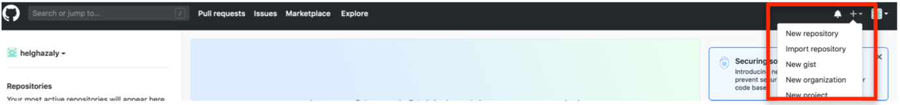

1. Invite organization members **(member_A only)**
2. Enter the username/Full name/email/ name of their GitHub account.
3. Make the other members also **owners** of the organization (e.g. *member_B: Mohamed* also owner *COE420- Hend-S20*) (**Figure 2).**

An invitation will then be sent to the team members. Each team member has to accept the invitation by opening their email and accepting the invitation to join the organization.

***Figure 2: Invite team members to join the organization and make them owners***

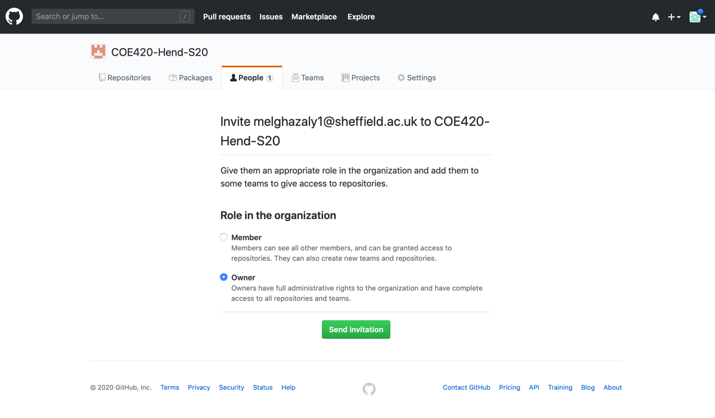

1. Create a new repository within the organization created ***(member_A only)***
2. Go to your organization and click on “***Create a new repository***” or in the upper right corner click **+** and then select ***New repository***
3. Ensure that the owner selected is the name of the organization (*e.g. COE420-Hend-S20*)
4. Name your repository ***COE420Lab1***and write *a* ***short Description****.* The name should be unique to that particular member’s account.
5. Set it to ***Public***
6. Click on *“****Create repository****”* button.

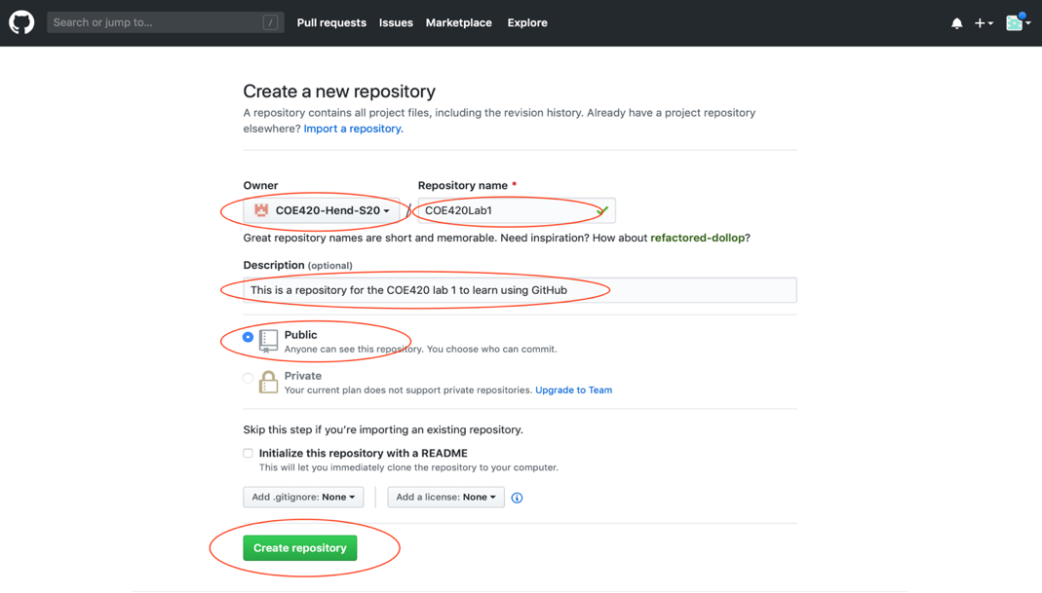

***Figure 3: Create a repository within the organization***

**Exercise 2: Install Git (all team members)__________________________________________**

1. Check if you have Git installed on your computer by running in the terminal:

git --version

1. If you do not have it, download Git on your computer via this link: <https://git-scm.com/downloads>
   1. Click on your operating system and follow the installation instructions.
2. Run git --version in the terminal to verify that it is installed.

*If you have windows you can also use Git Bash:* <https://gitforwindows.org/>

**Exercise 3: Configure your details (all team members)_______________________________**

Create your identity by setting your name and email. This helps in knowing who did what changes to the code when you view all the commits.

1. To configure your details run in the terminal:



git config –-global user.name **yourName**

git config –-global user.email **yourEmail**

***Modify the commands with your details***

* Add in the report screenshot of configuring your details

1. To check the details saved, you can run:

git config –-list

**Exercise 4: Initialize a Git repository (member_A)___________________________________**

1. Create a folder (Lab1) on your computer.
2. Download **Calculations.java** file on iLearn and save it in that folder.
3. In the terminal, navigate to the folder where you saved **Calculations.java**
4. Initialize a git repository by running in the terminal:

git init

This command will generate a hidden **.git** directory for your project, where Git stores all internal tracking data for the current repository.

**Exercise 5: Initial Commit (stage, commit code) (member_A)______________________**

In this exercise, you will stage, commit the *Calculations.java* file and push it to the remote repository. You should do these steps every time you want to commit.

1. In the terminal, run the following command to get the status of the repository and observe the output.

git status

You should see *Calculations.java* in red under the Untracked files listed.

1. Place the Calculations.java file in the *staging* area to commit it.

git add Calculations.java

*You can also use* git add . *to add all the files in the project folder to the staging area instead of adding multiple files individually.*

1. Check the status again

git status

You should see Calculations.java in green under Changes to be committed.

1. Commit the file from the staging area to save it in the local repository.

git commit -m “initial commit”

1. Check the commit details by running:

git log

You should see a similar output:

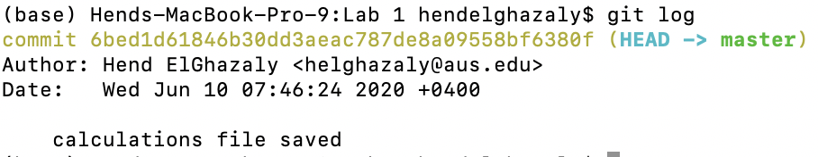

**Note:** The above steps (staging and commit) need to be done every time you want to commit changes to the local repository.

1. Push the local repository content to the remote repository for the other team members to see it.
   1. Run the following to point your local repository to the remote repository:

git remote add origin https://github.com/**COE420-Hend-S20/COE420Lab1.git**

**Modify the link to the name of your organization and repository**

* 1. Push the local repository to the remote repository.

git push origin master

**Note:** Since you are pushing this to remote repository, a *sign-up* window pops up and you need to login to your account.

* Add in the report screenshots showing the commands were run and screenshot from GitHub showing the commit made (you should see it in the repository in GitHub under commits)

**Exercise 6: Pushing changes via Git (member_B, member_C, member_D)_______________**

The following steps need to be done by the rest of the team members:

1. Each memberneeds to clone the repository *COE420Lab1*. Navigate to the project folder (e.g. cd U:/)then run:

git clone https://github.com/**COE420-Hend-S20/COE420Lab1.git**

***Modify the link to the name of your organization and repository***

You should then be able to see Calculations.java file in your project folder.

1. Complete the code in *Calcualtions.java* according to your member number (e.g *member_B* implement the *subtraction*)and push changes made back to the repository:
   1. Open Eclipse or any editor.
   2. Add the feature (e.g. s*ubtraction*) to the Java program.
   3. Save the file.
2. Push the local repository after adding the feature (e.g *subtraction by member_b* )

cd COE420Lab1

git add .

git commit –m “Subtraction implemented”

git push –u origin master

*Sign in to your GitHub account if the window pops up*

**Note:** You may need to pull changes (Exercise 7) before pushing the changes.

* Add in the report screenshots by each team member showing that they made the commits and pushed the changes.

**Exercise 7: Getting Updated Version (all team members)_____________________________**

Each team member should do this step before pushing their changes. *Member_A* should also update his/her local repository with the features added by the other team members:

1. pull changes to get the updated version:

git pull origin master

1. Open Calculations.java file and check that the features are added by the team members

* Add in the report screenshots by each team member showing that they got the most updated version by running the pull command.