Ex1:

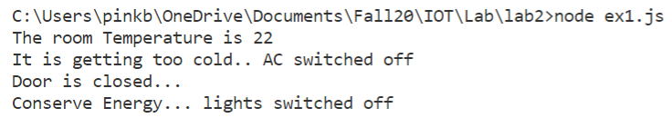

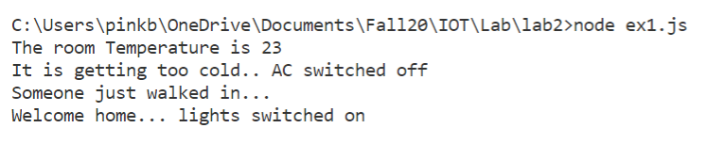

Ex2:

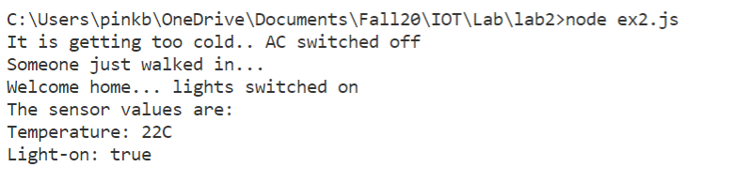

Ex3:

