CLA Documentation

SE 423
Spring 2021
Joe Koszut

Table of Contents
Paths 2
Path Variables 2
Include Options 3
Predefined Symbols 5
File Search Path 6
Command File Preprocessing 7
Memory 8
LSxMSEL 9
LSxCLAPGM 9
Setting Up .c File 10
Setting Up .cla File 11
Notes 12

Paths

  - Path Variables
Resource --> Linked Resources --> Path Variables

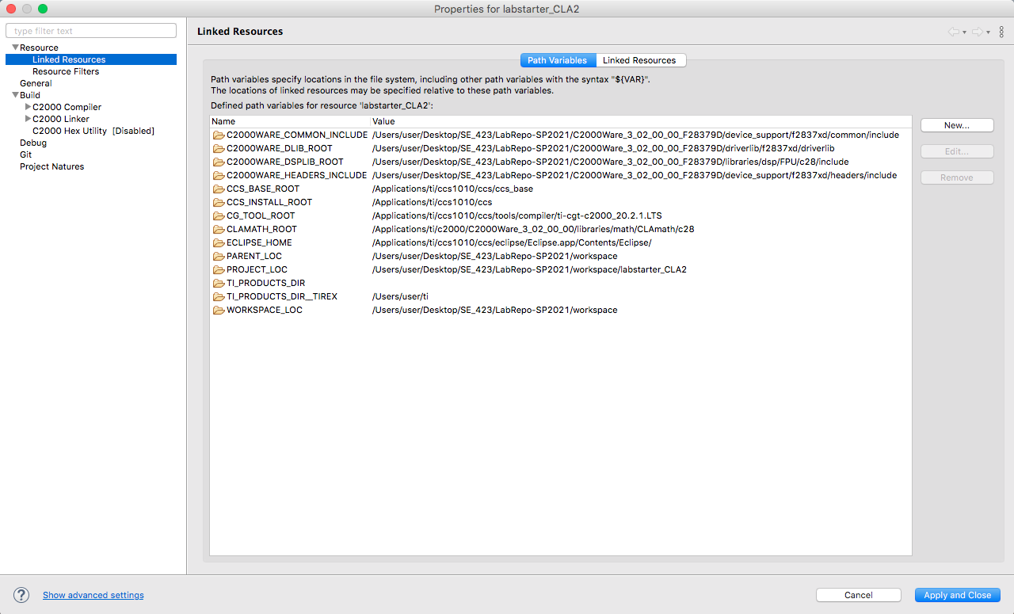
Figure 1. Paths used for Linked Resources.


Figure 2. Zoomed in version of Figure 1.

  - Include Options
Build --> C2000 Compiler --> Include Options

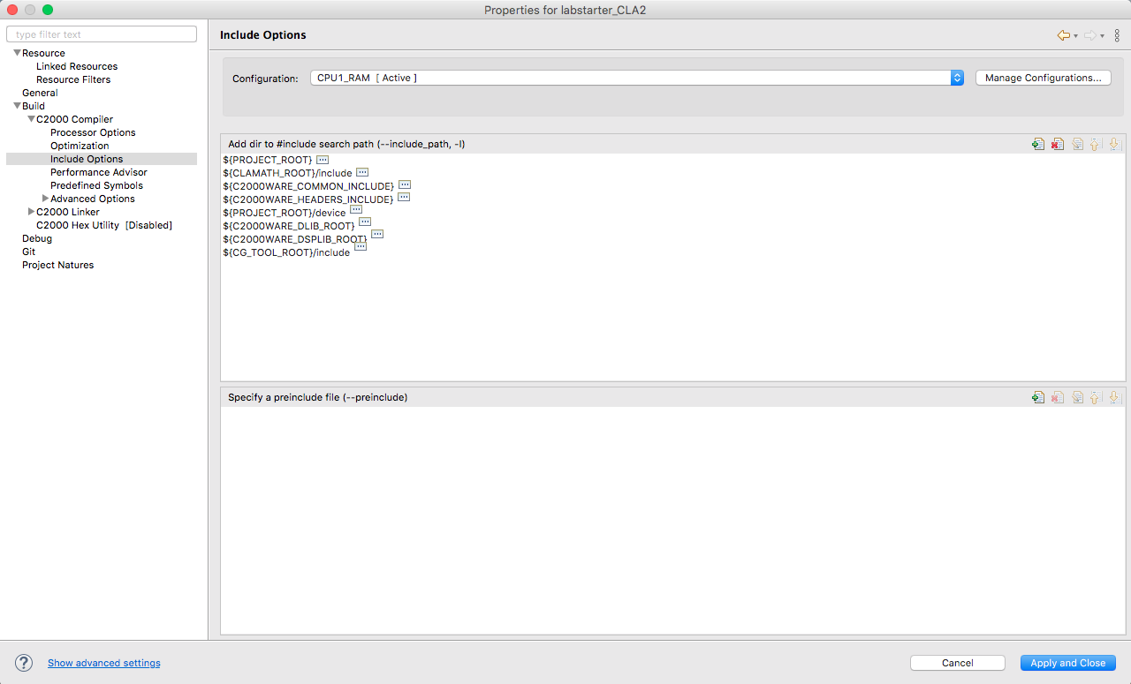
Figure 3. Paths used for include options. Details for each entry shown below.

PROJECT_ROOT:
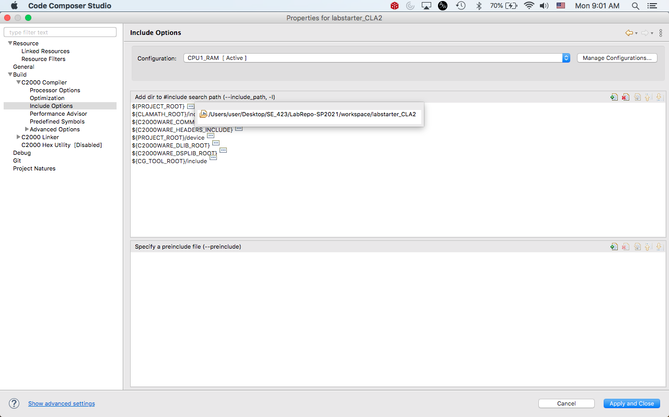

CLAMATH_ROOT/include:
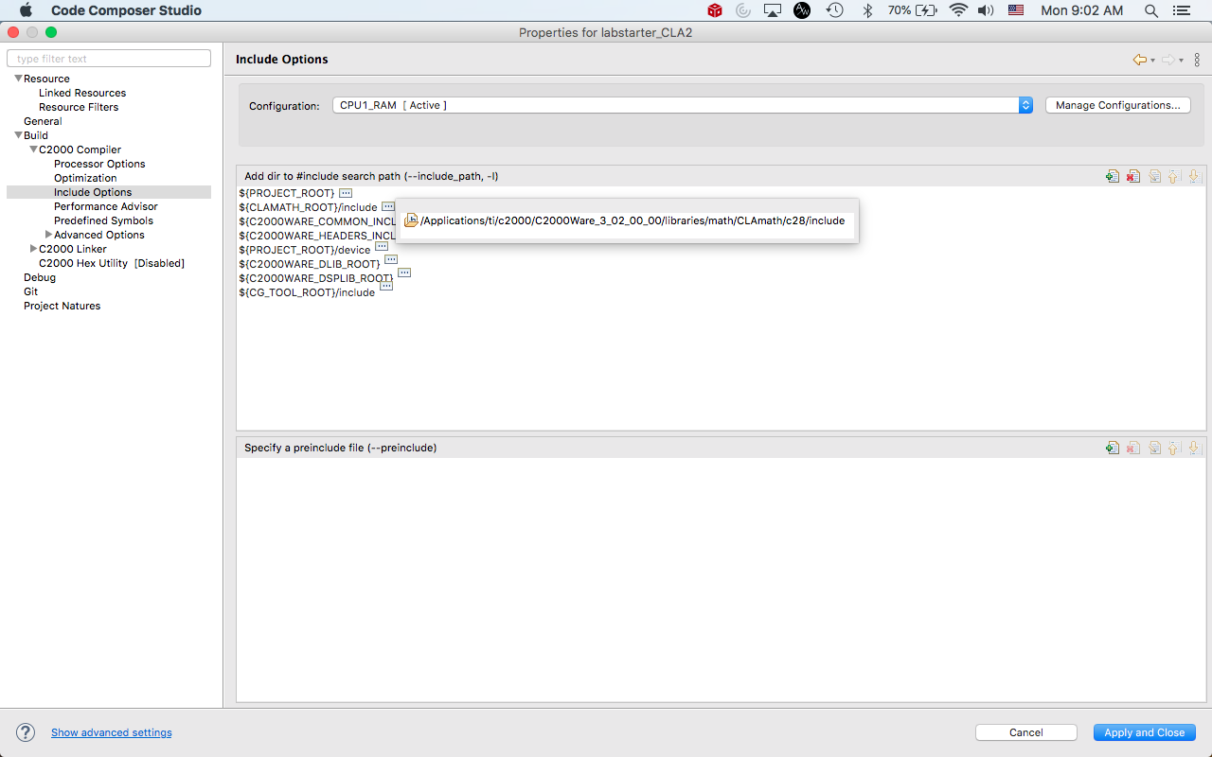

C2000WARE_COMMON_INCLUDE:
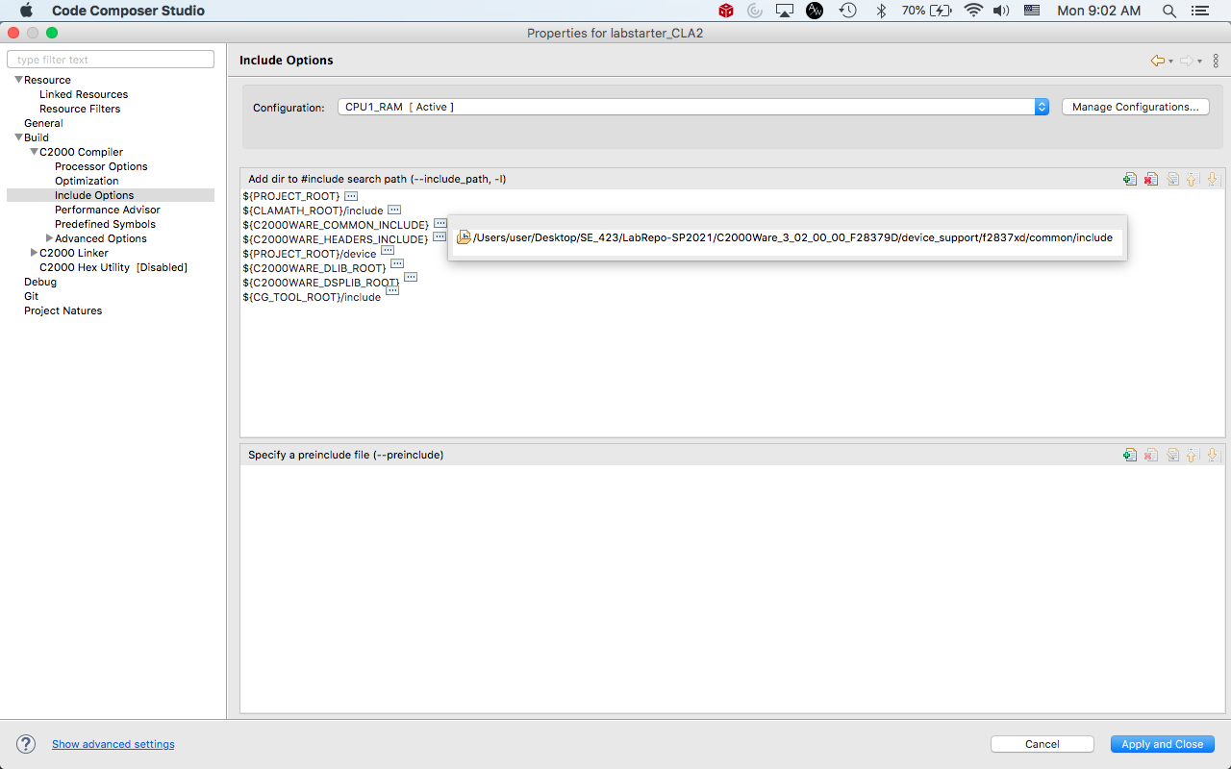

C2000WARE_HEADERS_INCLUDE:
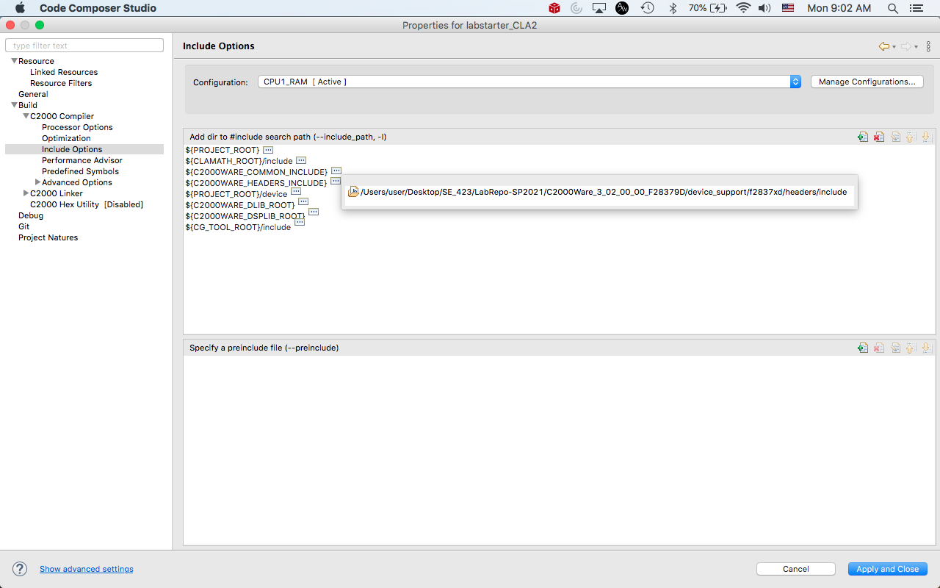

PROJECT_ROOT/device:
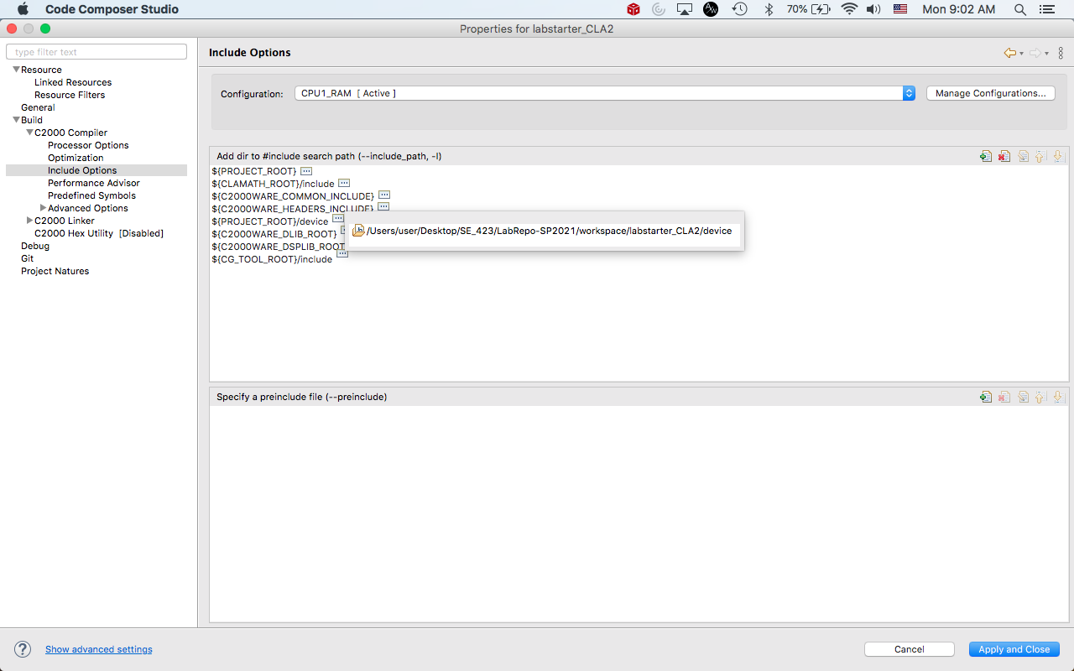
C2000WARE_DLIB_ROOT:
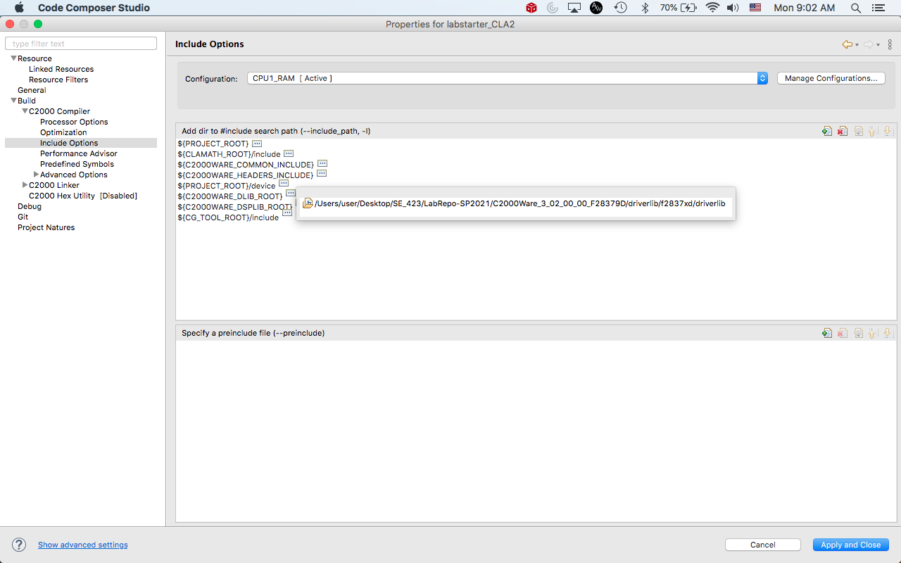

C2000WARE_DSPLIB_ROOT:
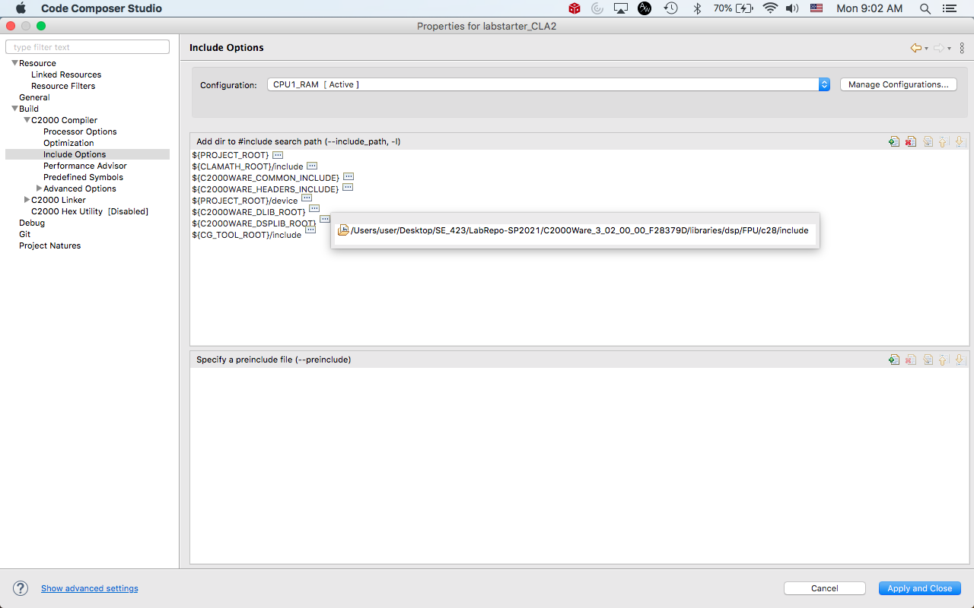

CG_TOOL_ROOT/include:
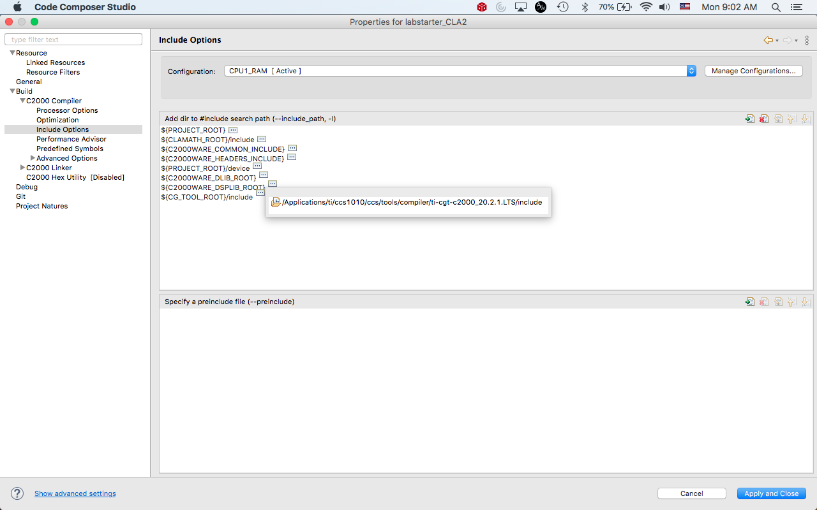

  - Predefined Symbols
Build --> C2000 Compiler --> Predefined Symbols
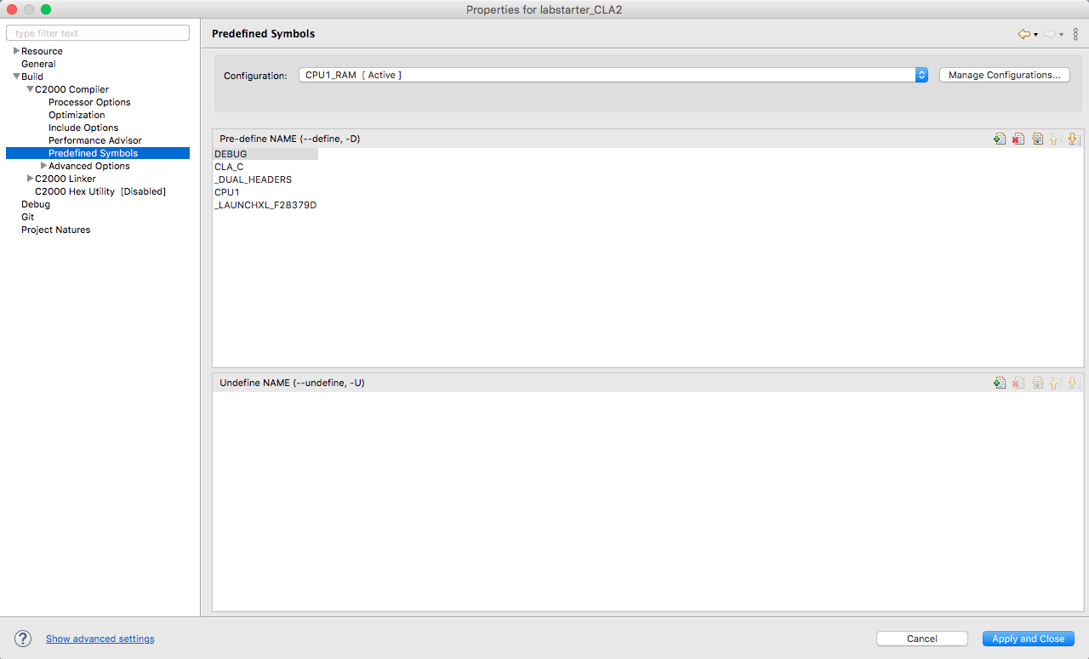
Figure 4. Entries for predefined symbols.


Figure 5. Zoomed in version of Figure 4.

  - File Search Path
Build --> C2000 Linker --> File Search Path

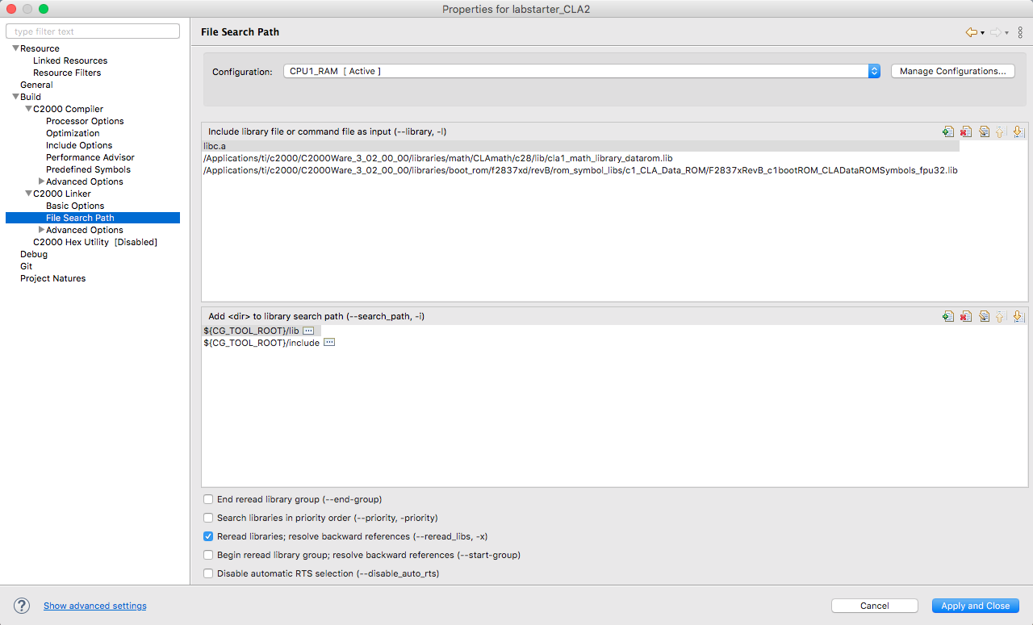
Figure 6. File Search Paths

Library files:


Library search paths:


  - Command File Preprocessing
Build --> C2000 Linker --> Advanced Options --> Command File Preprocessing

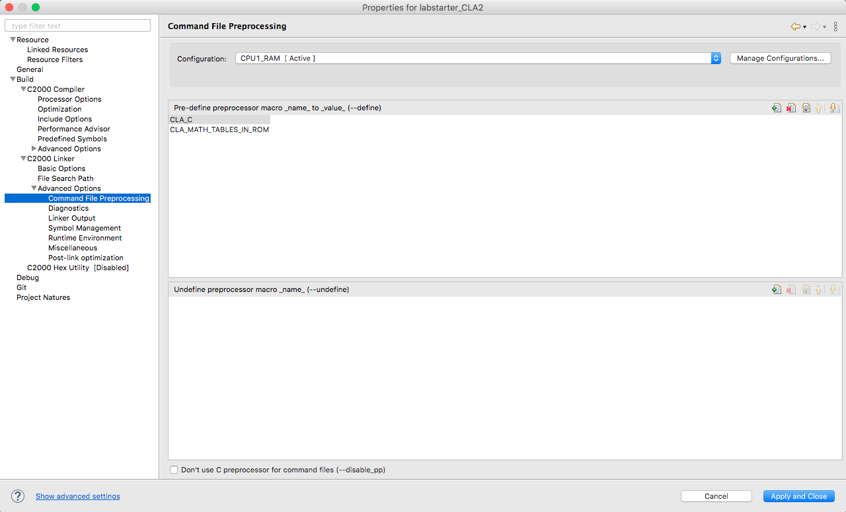

Figure 7. Pre-defined preprocessor macros.

Pre-defines:


Memory

Note that the CLA cannot use GSx RAM. This can be seen from Table 6-1 (pg. 179) of the TMS320F2837xD datasheet.
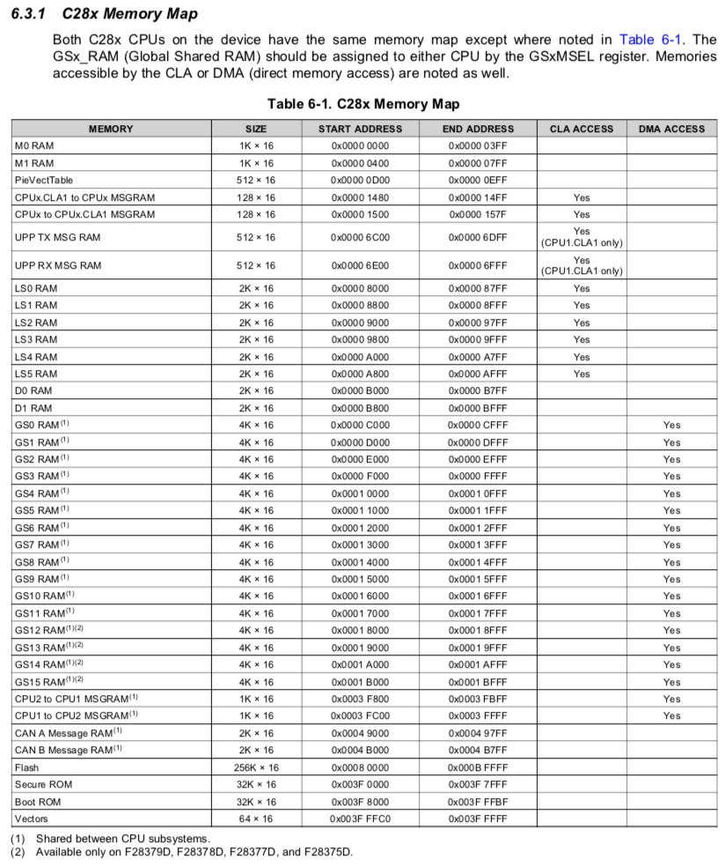

The LSxMSEL and LSxCLAPGM registers are both used in setting up the CLA memory.

  - LSxMSEL
A memory block can be assigned to the CLA by writing a 1 to the memory block's MemCfgRegs.LSxMSEL[MSEL_LSx] bit:
MemCfgRegs.LSxMSEL.bit.MSEL_LS2 = 1;
MemCfgRegs.LSxMSEL.bit.MSEL_LS3 = 1;

  - LSxCLAPGM
A memory block can be configured as a code block or data block by writing to the memory block's MemCfgRegs.LSxCLAPGM[CLAPGM_LSx] bit.

Writing a 0 configures the memory block as a data block:
MemCfgRegs.LSxCLAPGM.bit.CLAPGM_LS2 = 0;

Writing a 1 configures the memory block as a code block:
MemCfgRegs.LSxCLAPGM.bit.CLAPGM_LS3 = 1;

Note that the value of the LSxCLAPGM bit is 0 at reset.

Setting Up .c File

Include the CLA header file:
#include "cla_shared.h"

Set up data to go from CPU to CLA:
#pragma DATA_SECTION(CLAin_Value,"CpuToCla1MsgRAM")
float CLAin_Value = 0;

Set up data to go from CLA to CPU:
#pragma DATA_SECTION(numtimes1,"Cla1ToCpuMsgRAM")
int32_t numtimes1 = 0;

Set up data to be used by only the CLA:
#pragma DATA_SECTION(CLA_enc1,"CLADataLS2")
float CLA_enc1 = 0;

Configure the CLA memory*:
void CLA_configClaMemory(void);

Initialize the CLA*:
void CLA_initCpu1Cla1(void);

* Configure the CLA memory and initialize the CLA in the main function:
CLA_configClaMemory();
CLA_initCpu1Cla1();

Enable the CLA interrupt in main:
PieVectTable.CLA1_1_INT = &cla1Isr1;

Initialize an interrupt to occur at a fixed rate, e.g. ADC interrupt triggered by EPWM5 at 1 msec. Inside this interrupt, force the CLA to start. This will effectively run the CLA at whatever rate the interrupt is set.
Cla1ForceTask1();

Once the CLA is forced to start, it will run and then generate the CLA interrupt inside the .c file once the CLA finishes. Inside this interrupt, things like printing the states and control signal can be done. Simply make sure that any CLA data used in the CLA ISR function is initialized correctly, i.e., using "Cla1ToCpuMsgRAM".

Setting Up .cla File

Include the CLA math header file:
#include <CLAMath.h>

Include the CLA header file:
#include "cla_shared.h"

Include the CLA type definitions header file:
#include "F2837xD_Cla_typedefs.h" // CLA type definitions

Include any desired F2837xD header files:
#include "F2837xD_device.h" // F2837xD peripheral address definitions

Create the CLA1 task function:
__interrupt void Cla1Task1 ( void ) {...}

Define all local CLA1 variables:
float x1,x2,x1dot,x2dot;
float K1 = 5.5782;

A PWM output can be sent from within the CLA as long as it is correctly defined. In the CLA1 task function, setting the PWM can be done the same was as it is done from within the .c file:
setEPWM6Acla(CLA_u);
with the PWM function being set up in the CLA file as
void setEPWM6Acla(float u)
{
float pwmCountMax = 2500.0;
float pwmVal = 0;
if (u > 10) u = 10;
if (u < -10) u = -10;
if (u>0) {
GpioDataRegs.GPACLEAR.bit.GPIO29 = 1;
} else {
GpioDataRegs.GPASET.bit.GPIO29 = 1;
}
pwmVal = fabs(u) * (pwmCountMax / 10.0);
// set compareA compare value
EPwm6Regs.CMPA.bit.CMPA = (int)pwmVal;
}

Notes
- The buffer.h file had BUF_SIZE changed from 4008 to 256. This was done because a size of 4008 was too big, causing the CLA to not work when using flash memory.
- Breakpoints within the .cla file do not work.
- A small number of math operations are not supported for use with CLA. These are shown below, taken from page 9-12 of TI's TMS320F2837xD Microcontroller Workshop manual.
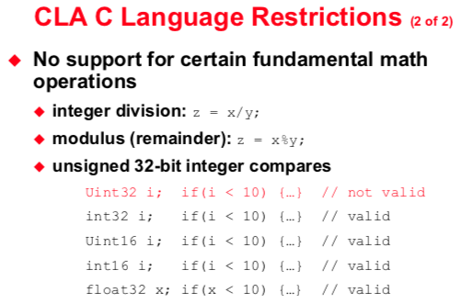
- More detailed information on how the initialization of the CLA memory works can be found on page 704 of TI's TMS320F2837xD Technical Reference Manual.
- More detailed information on building a CLA program can be found on page of TI's TMS320F2837xD Technical Reference Manual.

